01/08/2022
ADDRESSING THE PROBLEM OF STAFF SHORTAGE IN PROPER CARE, UK
university of wales trinity saint david
model name: Problem solving and decision making
lecturer name: chijoke uba
Aleksandra Milenova (2120210)
Contents
INTRODUCTION 2
OVERVIEW OF THE PROBLEM 3
THE FOREIGN WORKFORCE AFFECTED BY BREXIT 4
THE RESULTS FROM THE NURSING AND MIDWIFERY COUNCIL SURVEY 2022 5
EDUCATION AND TRAINING FUNDING 5
PENSION SCHEME AS A BARRIER TO THE RETENTION 7
PAY AND BENEFITS 7
8
EMPHASIS ON SAFETY 8
UNAPPRECIATION AND UNSUPPORTIVE TEAM AS A REASON FOR LEAVING 8
LACK OF OPPORTUNITIES AND CAREER DEVELOPMENT 8
INNOVATION 9
PANDEMICS 9
TOXIC ENVIRONMENT 9
LEVEL OF DISCRIMINATION 9
PESTLE ANALYSIS - OVERVIEW 10
PESTLE ANALYSIS OF PROPER CARE 11
FISHBONE DIAGRAM 13
FINDING A SOLUTION 14
RECOMMENDATION 14
EVALUATION 14
ACTION PLAN 15
CONCLUSION 15
REFERENCE 17

INTRODUCTION
It is well known that for any organization to grow and remain stable on top its team should be skilled and deal with the problem they face on the way. In other words, problem solving and decision making plays crucial skills in the organisation’s team. It is all about the logical process and the course of action that will be taken to solve a certain problem. How did this problem occur and why? What are the causes that made this issue so important to deal with it immediately and has this threatful impact on the organisation? These are the aims of this investigation. To understand the problem and its nature and to solve it or at least minimize the causes of the problem so the impact on the organization will be low. Therefore, the structure of the report will be to identify what are the macro-external factors that have an impact on the organization using PESTLE analyses. Afterwards, to back up those factors with evidence and give an overview. At the early end will be used a fishbone diagram to identify only those factors that have the most impact on and causes the problem. The recommendations will follow evaluated with a grid table.

OVERVIEW OF THE PROBLEM
Shortages in the workforce are policy contingent and they vary in different healthcare systems. Common criteria to describe the financial and demand pressure that health systems experience is ‘hard to fill vacancies’ or tends in ‘volume of current vacant posts. It has been recently reported the shortage of NHS staff and their mental health community providers. The number of open vacancies is growing every year. In some areas is crucial. The same issue is relying on different social care departments. This staff shortage is mostly ignored through the years. The staff members are not enough to cover every shift and give good patient care. The workforce is currently a threat that Proper Care face. This problem has already big impact on the service quality, care quality, patients, staff, and partners. Without staff hospitals and other social care, departments can fall apart. To this moment the working conditions become tougher. This directly impacts the shifts, and the overtimes become mandatory. This causes the hospital’s staff a lot of pressure and stress. The service and care quality to that moment is very poor, some of the patients need more care and attention which is not provided (Nursing Shortage, 2003). Many nurses report that the salary they receive does not reflect their education, experience, or on their skills (Mee and Carey. 2001).
Also, the number of total open vacancies are arising over the years. The provided information in Table 1 from ‘NHS Vacancy Statistics England April 2015 – March 2022’ in which is calculated the opened full-time equivalent (FTE) vacancies, providing a better and detailed understanding, categorised by aggregate national, regional and sector levels, calculated at the end of respective quarter.
Table 1: (NHS Vacancy Statistics England April 2015 – March 2022 Experimental Statistics - NHS Digital, 2022)

It can be easily seen that in the last calculation in March 2022 the open full-time equivalent vacancies are 105,855 in total for all regions, in all sectors. The number of open vacancies for nurses is also arising the last calculation shows that they reached a total number of open FTE vacancies of 38,972 shown in Table 2.
Table 2: (NHS Vacancy Statistics England April 2015 – March 2022 Experimental Statistics - NHS Digital, 2022)

The section is based on the PESTLE structure to be easy to follow. The first evidence that the investigation has is related to one of the political factors that involve the foreign workforce affected by Brexit. Then will be considered the results from the Nursing Midwifery Council survey 2022.

THE FOREIGN WORKFORCE AFFECTED BY BREXIT
As known the European Union (EU) has been providing the UK with a net inflow of nurses through the years. After the UK officially exit the EU the total percentage of foreign workforce dropped down to 5.4% EU trainees (Baker, 2021). The net inflow has turned into the net outflow, leaving a lot of NHS roles open.

THE RESULTS FROM THE NURSING AND MIDWIFERY COUNCIL SURVEY 2022
The Nursing and Midwifery Council conducted a survey called ‘Leavers’ survey 2022’. They have been running it since 2017 to answer the most important question ‘Why are people leaving the NMS register?’. In 2021 the total annual leavers were 22,549 nurses. This year in 2022 they ask 21,035people to participate, unfortunately only 6,458 agreed to be part of the survey. They found that the fifth most common reason for leaving the register was ‘Leaving the UK’ with 12% (Nursing and Midwifery Council, 2022). The most common answers for leaving this year are retirement (42.9 per cent), personal circumstances (21.7 per cent), and too much pressure (18.3 per cent). The provided illustration in Table 4, represents the optional answers that the participants chose.
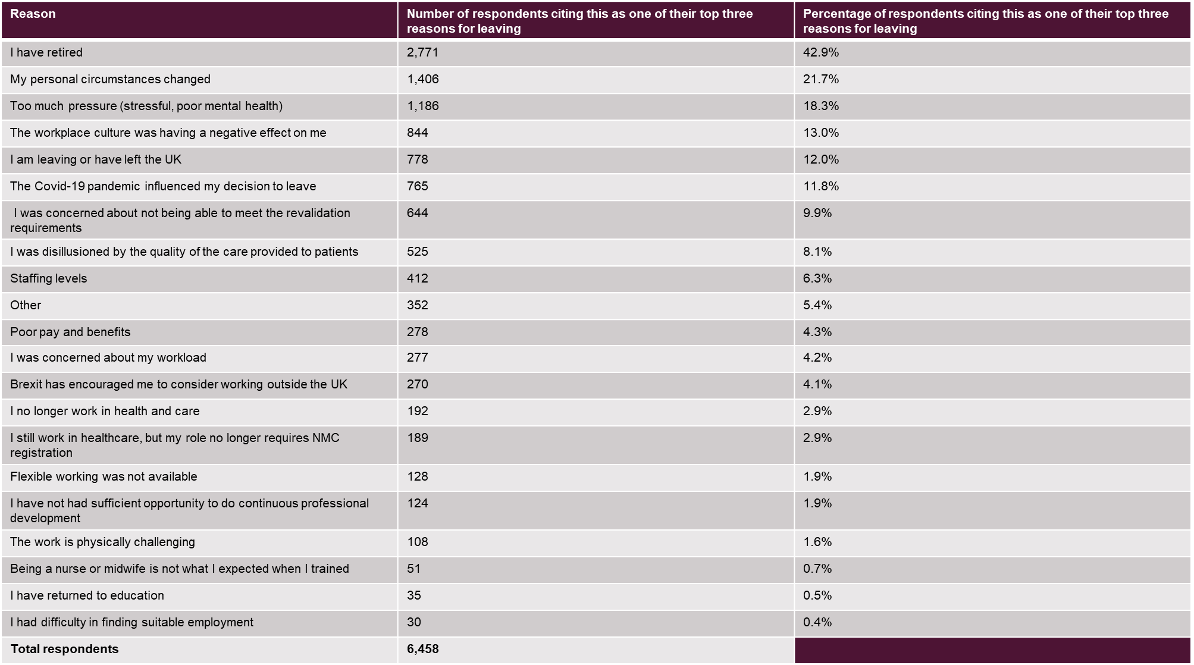
Table 3: The Nursing and Midwifery Council survey results from 2022 (Nursing and Midwifery Council, 2022).

EDUCATION AND TRAINING FUNDING
The data illustrated in Figure 1cas a pipeline is presenting the undergraduate nurses' training for students starting in 2014. The student qualified can join the NHS at the earliest 2017. It is showing that the numbers of undergraduate applicants aren't accepted and placed in the training which means they are near 35,610 over 57,420 applicants (The Health Foundation, 2019). This leads to the point that over 62% of them are not placed in training causing fewer people to be trained and then join the NHS workforce if they are qualified. The procedure for accepting the applicants is the main cause of fewer people joining. The procedures are less likely to attract new people as they are made on high expectations. Either if they are attracted a lot of the applicants are not accepted, and the current terms and policies for accepting new applicants cause a trip to the plan to recruit more staff. Currently, the training of new staff is depending on the level of the training funding.

PENSION SCHEME AS A BARRIER TO THE RETENTION
Applicants: 57,420
Not accepted: 35,610
(62%)
Training
attrition: 4,140 (19%)
Join NHS
trusts: 14,310 (81%)
Full-time equivalent
starters: 12,450 (87%)
Enter primary, other
health or residential
care setting: 2,470
(14%)
Enter non-health
work: 890 (5%)
Placed
in training:
)
21
,810 (38%
Qualified: 17,670
(81%)
Figure 1: (The Health Foundation, 2019)
The NHS pension scheme was cited as a barrier to retention. Many experienced workers cited that they have been impacted by the wider pension policy. They suggest more flexibility.

PAY AND BENEFITS
Poor pay and benefits as a reason for leaving. This reason for leaving was cited by 137 out of 6,458 people that toked part in the ‘Leavers’ survey’ (2022). The participant also stated that the pay they receive in the UK does not reflect the high-stress environment they deal with in their workplace. Also was mentioned that Australia provides significantly better working conditions and salaries. The share of NHS revenue spent on staff from 2013 to 2021 is shown in Figure 2.

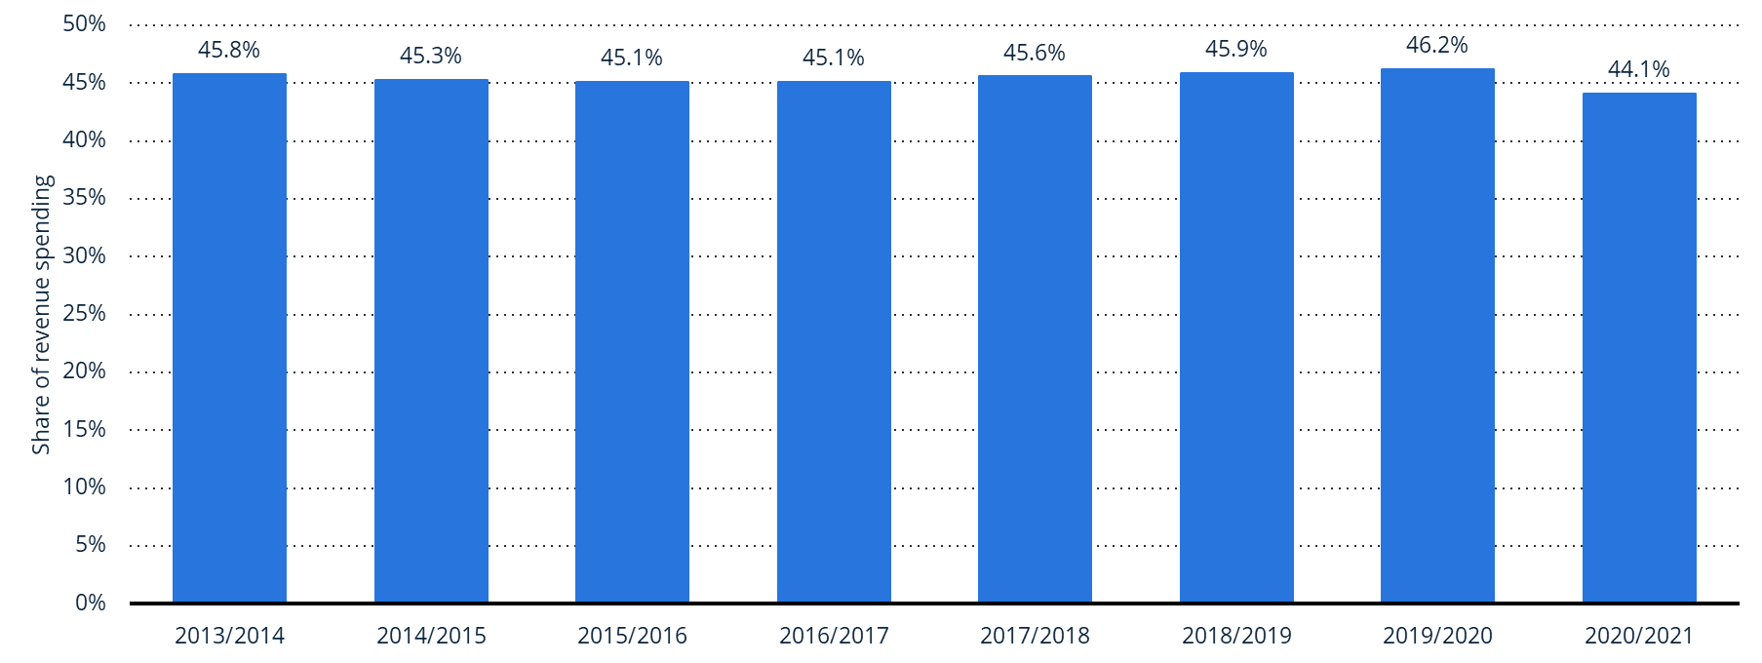
Figure 2: Share of the NHS revenue spending on staff (Michas, 2022)

EMPHASIS ON SAFETY
Many people report and give recommendations for a better and safer environment. One of their reasons for leaving is the lack of a safe ratio between staff to patients and people using their services. Poor management from the leading team on the other side lack of drive to change and take responsibility to find a solution to the problem. Due to the lack of staff, the remained staff in the workplace stated, that they did not receive the support needed. They were experiencing overworking, unreasonably long shifts which caused them too much pressure to handle such pressure was cited by 58 respondents that toked part in Leavers’ survey 2022.

UNAPPRECIATION AND UNSUPPORTIVE TEAM AS A REASON FOR LEAVING
Many individuals that worked and partnered with NHS commented that were feeling unsupported, devalued, and unappreciated by their managers, co-workers or the government. These working conditions were reported from different workplaces and positions as hospitals, general practice surgeries, remotely workers and managerial positions.

LACK OF OPPORTUNITIES AND CAREER DEVELOPMENT
People report that NHS does not provide and invest in their career development, this sends negative outcomes which results in losing staff and failing to attract skilled professionals which also is one of the reasons some employees are leaving the NHS workforce.

INNOVATION
Innovation in the internal environment should be considered. The investments in new equipment and automation in the organisation will help by unloading the staff with the unskilled work that can be done fully by machines. Therefore, they can focus on more important tasks. There are some comments from patients and people who used the services and reported the slow organized appointment and files caused due to computer calculation, speed, and power.

PANDEMICS
Covid-19 as a reason for leaving. One of the most frequently selected options for the survey ‘Leavers’ survey’ (2022) was ‘The Covid-19 pandemic influenced my decision to leave.’ with 765 out of 6,458 people. Most of them were from abroad and during the pandemic wanted to join their relatives. Others stated the responsibilities they carried had increased during that time (109; 4.6%) and pressure caused by the Covid-19 vaccine mandate (29; 1.2%). Many reported that they were worried about their health and safety caused of the lack of adequate PPE equipment. During that time and staff shortage, the remaining personnel had to constantly change their work environment and duties due to moving between different hospitals.

TOXIC ENVIRONMENT
The sickness absences have also managed to increase caused by the stressful environment that staff work in. The highest ranked reasons for sickness absence are psychics caused by the toxic environment shown in Figure 3.
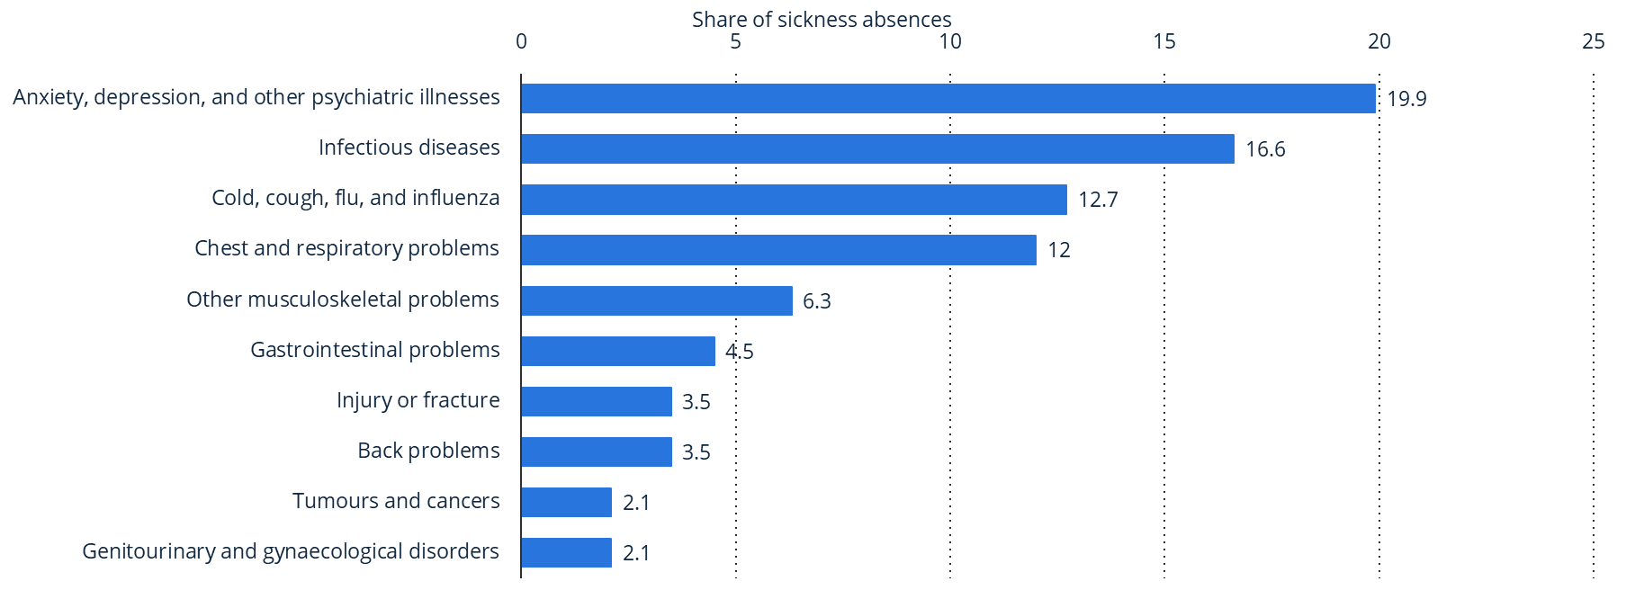
Figure 3: Share of sickness absences ().

LEVEL OF DISCRIMINATION
Cited by (113; 4.8%) people the reason for their leaving is the discrimination level in their workplace and the toxic environment. Nurse, aged 61-65, Wales, mental health nursing gave a more detailed explanation about the experience:
“I was working within a Community Mental Health Team. A Social Worker joined the team as the ‘integrated Team Manager’ and within 18 months the entire team of nurses and social workers had left due to her bullying and lack of compassion for patients. I was the last to leave but had to after the stress resulted in me collapsing at work.”
(Nursing and Midwifery Council, 2022 p.14)
The problem of staff shortage is one of the biggest threats that Proper care faces at that moment, to be able to understand and identify the factors causing it, was applied PESTLE analysis and a fishbone diagram.

PESTLE ANALYSIS - OVERVIEW
The factors mentioned in the overview section were only a few, to identify all the factors that impact the organisation and result in negative outcomes is used the PESTEL analysis. The PESTEL analysis is an important tool which helps an organisation to evaluate the macro-external factors which can influence it. It is also an abbreviation which stands for Political, Economic, Social, Technological, Environmental, and Legal factors (Peterdy, 2022) shown in Figure 4.
Figure 4: PESTle analysis.

Political
- These factors are all about how and to what degree a government intervenes in the economy or a certain industry.
Economical
- Economic factors are determinants of a certain economy’s performance. Factors that impact their products and services price, and demand and supply models.
Social
- This dimension of the general environment represents the demographic characteristics, norms, customs, and values of the population within which the organization operates.
Technological
- These factors pertain to innovations in technology that may affect the operations of the industry and the market favourably or unfavourably.
Environmental
- These factors are all about the legal aspects that affect the organisation (Farooq, 2022).
Legal
- The environmental factors can be explained as everything whether internal or external that surrounds and impact the growth, operations, and survival of an organisation (Farooq, 2022)

PESTLE ANALYSIS OF PROPER CARE
PESTLE analysis is used there to identify the macro-external factors that cause the problem and have a crucial impact on the organisation. As shown in Table 4, the organization has many external influences that in some way give negative results. The constantly changing political environment does not allow the organization's leading team to stick to one strategy. They must be flexible to change strategies and ways of working to keep on top of things.

Political | - Tax and legislation changes  - Constantly changing political environment  - Government policies  - Global trade agreements and restrictions  - Political stability  - Education and training funding  - Additional risks in the short and medium-term policies  - Brexit legislation
Economical | - Exchange rate  - Interest rate  - Inflation  - Unemployment rate
Social | - High patient expectations  - Lifestyle  - Emphasis on safety  - Health consciousness  - Average disposable income level  - Population grow rate  - Education level  - Attitudes toward work, career, leisure, and retirement  - Work-life balance
Technological | - Improved healthcare  - Automation  - Computer calculation speed/power  - Security in cryptography  - Internet connectivity  - Innovation
Environmental | - Future pandemics  - Environmental restrictions imposed by in-country government  - Green environment  - Psychically toxic environmental
Legal | - Litigation cost  - Employment law  - Common Law  - Health and safety regulations  - Discrimination Law
Table 4: Pestle analyses of Proper care.
Some of the listed factors are more important and by important, it means they are the main factors that cause the problem and have a solid impact on the organisation. As mentioned earlier in the investigation will be provided some evidence to back up the factors listed in Table 4.
The next section will consider them more deeply to identify how these factors form the problem and keep it growing.

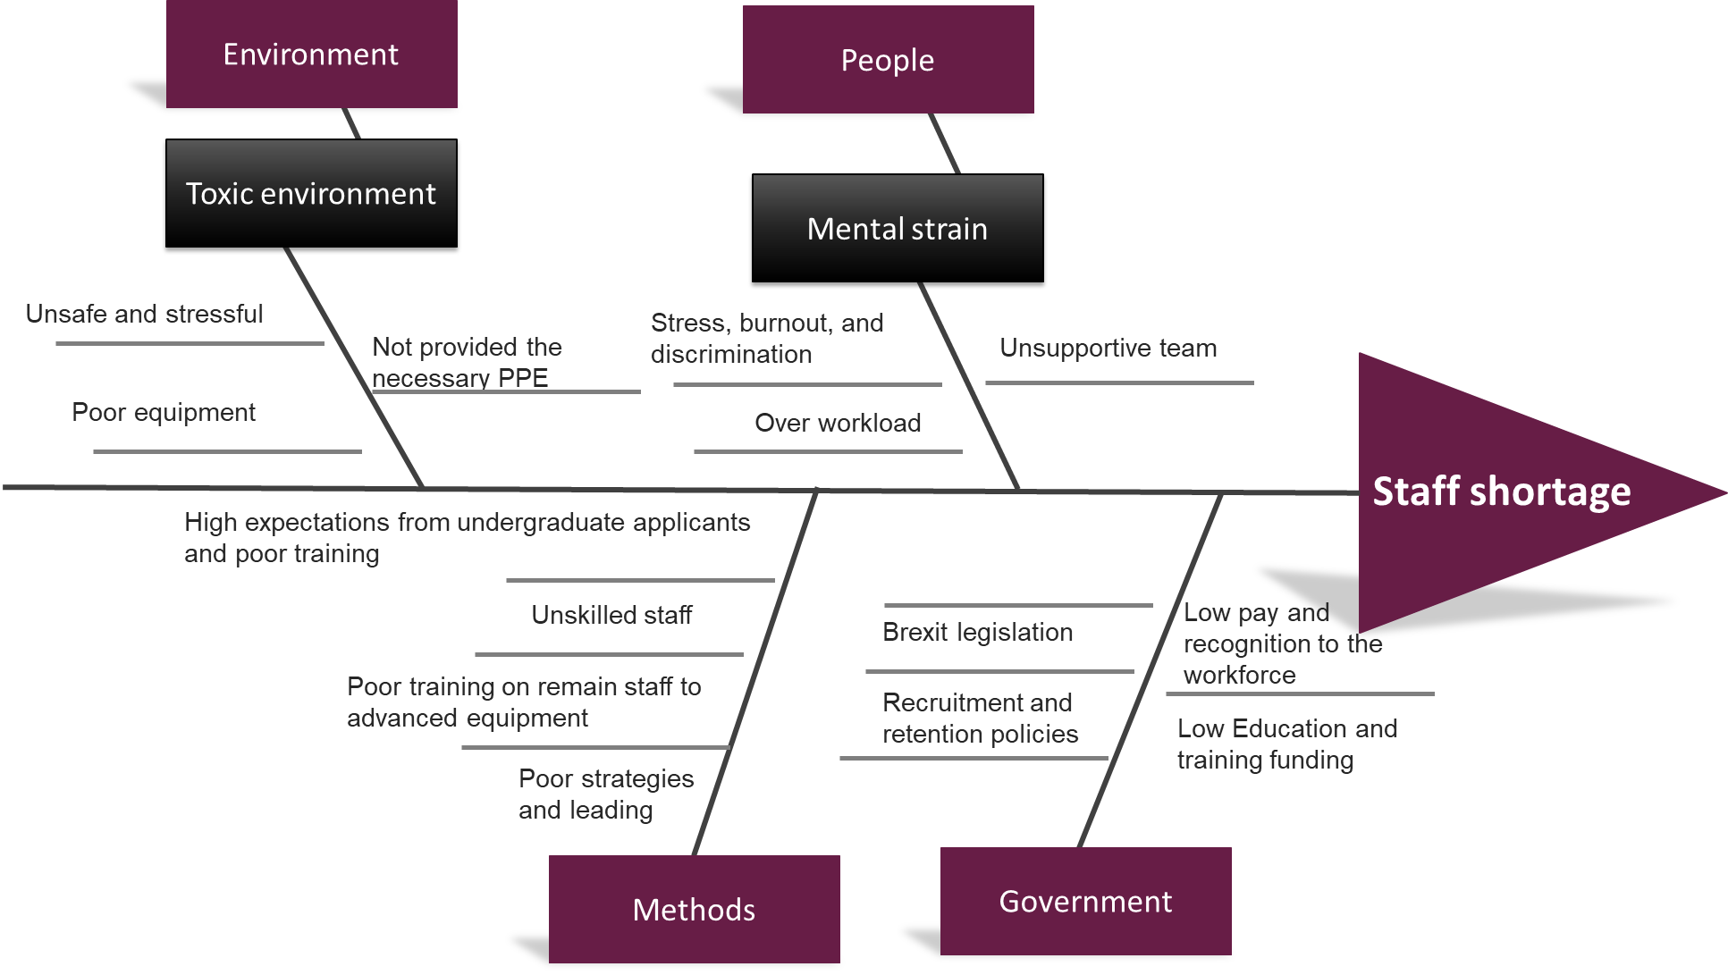
FISHBONE DIAGRAM

Now that the causes are identified the next step is to give and evaluate the possible solution to the problem using the grid evaluation tool.

FINDING A SOLUTION

RECOMMENDATION
- Funding and supporting new students and trainees will increase the supplement in the future.
  - This directly targets the problem by providing new staff supplements who can join the NHS workforce later. This also attracts students to graduate in the health and care field.
- Giving the time and training the staff is needed to adapt whit new technology devices and futures.
  - Training to the new and remaining staff when new technology is introduced in the hospitals and other sectors to use them with confidence and in a safe manner.
- The models and strategies should be considered for evaluation by the leading NHS teams.
  - Looking at the evidence in some sectors the leading process is very poor. The leading team in every sector must constantly evaluate strategies and ways to improve the environment for the staff and their stakeholders. Deal with problems that they face while working.
- Taking care of the remaining workforce will reduce leaving positions.
  - Create opportunities and career developments for the remaining staff.
  - Create a better working environment and provide the needed support and working conditions
  - Better pay, benefits and recognition will reduce living remain roles
  - Ensuring the safety standards are met at their highest level
  - Ensuring there are acceptable shifts and working hours

EVALUATION
Options | Factors
Options | Increase the supplement of new staff | Retention | Successful leading staff | Quality patient care | Total
Options | 5 | 5 | 5 | 5 | Total
Supply of new staff by funding the education and training of new students. | 5 | 4 | 5 | 5 | 19
Pay and Reward | 3 | 3 | 3 | 0 | 9
Opportunities for career development | 4 | 4 | 4 | 0 | 12
Recruiting the right skilled people | 3 | 0 | 5 | 5 | 13
International Recruitment. Retention affected by Brexit. | 5 | 2 | 5 | 5 | 17

In the Grid table evaluate the possible solution that can target the problem. The highest score in the table is 19 on ‘Supply of new staff by funding the education and training of new students’. The next section explains the action plan of the process and how the possible solutions work.

ACTION PLAN
To apply the evaluated solution in a working process. The training funding must arise to attract new students. As discussed early in the report the students and trainees face difficulties with supporting themselves during their studies. The financial support given to them must include both the cost of leaving and the cost of tuition fees. As provided in Figure 1 the expectations from the applicant are very high if they drop down by 1/3 more of them will be placed in training.

CONCLUSION
It was reported that Proper care faces a threatful staff shortage that has a significant impact on the organization its staff and patients. However, the supplements of new staff are depending on how many applications will be accepted for training and on the plan to attract more new people by providing and supporting them through their studies. This will directly target the problem of staff shortage and its impact on the organisation. The mandatory overtime will be reduced and more flexibility in the shifts will be provided. This also will reduce the retention of remaining staff who cited this as a reason for their leaving.

REFERENCE
Baker, C., 2021. NHS staff from overseas: statistics.
Drennan, V. and Ross, F., 2019. Global nurse shortages—the facts, the impact and action for change. British Medical Bulletin, 130(1), pp.25-37.
Farooq, U., 2022. How Legal Factors affect Business Environment | Marketing Tutor. [online] Marketing Tutor. Available at: <https://www.marketingtutor.net/legal-factors-affect-business-environment/> [Accessed 15 July 2022].
Mee, C.L. and Carey, K.W., (2001). Nurses 2001 salary survey. Nursing, 31(3), pp. 44-7.
Michas, F., 2022. Topic: NHS staff shortage. [online] Statista. Available at: <https://www.statista.com/topics/9575/nhs-staff-shortage/#topicHeader__wrapper> [Accessed 14 July 2022].
Nursing Shortage, 2003. Directed by: Kramer N. Alexander Street
NHS Digital. 2022. NHS Vacancy Statistics England April 2015 – March 2022 Experimental Statistics - NHS Digital. [online] Available at: <https://digital.nhs.uk/data-and-information/publications/statistical/nhs-vacancies-survey/april-2015---march-2022-experimental-statistics#resources> [Accessed 8 July 2022].
Peterdy, K., 2022. PESTEL Analysis. [online] Corporate Finance Institute. Available at: <https://corporatefinanceinstitute.com/resources/knowledge/strategy/pestel-analysis/> [Accessed 15 July 2022].
The Health Foundation, 2019. Closing the gap: Key areas for action on the health and care workforce.

