The consultancy report of the feasibility for Lidl to open convenience stores



MAY 2020

MODULE NAME: organisational consultancy (M6X01422)
Name: hongli shang
Student Number: 1904764

Executive Summary
Purpose of this report was analysing the feasibility for Lidl to open convenience stores. Three objectives were achieved including environment analysis of Lidl, advantages and disadvantages of convenience format and evaluation of both side as well as recommendations to enhance its performance.
The second part explained internal and external environment of Lidl by applying SWOT analysis. Its strengths included low-price condition and quick expansion while weaknesses were low customer loyalty and market share (Uttley, 2018). As for opportunities, proximity and time saving have become important considerations, which made convenience format more popular (Gahinet and Cliquet, 2018). However, it also resulted in intensive competition in convenience market and price wars were also possible to happen. These were two threats of Lidl.

The third part was about the implementation of primary and secondary research. Online questionnaire was conducted, and 53 valid questionnaires were collected. Through leveraging various academic resources including database as MarketLine and e-journals as Journal of Retailing, a detailed secondary research was achieved. Besides, their limitations were considered as well.
In part4, findings of primary and secondary research were provided. Advantages of convenience format included boosting expansion, attracting new customers and increasing bargaining power towards suppliers (MarketLine, 2018) which were proved by primary research. Disadvantages were higher prices than average stores, limited choice of items and increasing operation cost (Ozair, 2017). However, the results of questionnaires indicated price was not a significant barrier of Lidl while limited choice and potential cost may be barriers for Lidl to open convenience stores. The primary research also indicated that participants preferred self-service checkout, and groceries and chilled food were welcomed in convenience stores. Moreover, performance of convenience market in recent years was also considered in secondary research as a reference for Lidl to make decisions.
Through all the analysis, the conclusion was there were active possibilities for Lidl to open convenience stores, but risks were also existed. Therefore, three recommendations were provided to improve its performance including 1) selecting items elaborately, 2) introducing more self-checkout machines and 3) closing earlier on Sunday.

Table of Contents
Executive Summary 1
1.0 Introduction 2
1.1 Brief Introduction of Lidl 2
1.2 Project Justification 2
1.3 Aim and Objectives of the Project 3
2.0 Environmental Analysis 4
2.1 SWOT Analysis of Lidl 4
2.1.1 Strengths 4
2.1.2 Weaknesses 4
2.1.3 Opportunities 5
2.1.4 Threats 5
3.0 Research Methodology 7
3.1 Primary Research 7
3.1.1 Ethical Consideration 7
3.1.2 Process of Implementation 7
3.1.3 Advantages and Limitations 8
3.2 Secondary Research 8
3.2.1 Relative Information That Support the Project 9
3.2.2 Diverse Types of Academic Resources 9
3.2.3 Limitations of Secondary Research 9
4.0 Findings and Analysis 10
4.1 The Analysis of Primary Research 10
4.1.1 The Basic Information of Participants 10
4.1.2 The Existed Competitive Advantages of Lidl 12
4.1.3 The Potential Failure of Lidl’s Convenience Stores 13
4.1.4 Public Perspectives to Improve Lidl’s Performance 15
4.2 Literature Review 16
4.2.1 Advantages of Convenience Format 16
4.2.2 Disadvantages of Convenience Format 17
4.2.3 The Performance of Convenience Stores 19
5.0 Conclusions 21
6.0 Recommendations 23
Reference 24
Appendices 29

1.0 Introduction

1.1 Brief Introduction of Lidl
In retailing industry, a hard discounter refers to a retailer with austere stores, limited and concentrated assortment as well as low prices of items (Vroegrijk et al., 2016). Currently, it is considered as an ambitious format to compete with supermarkets (MarketLine, 2015). Among them, Lidl, based on Germany, is one of the successful retailers that relies on a low-price reputation to witness a continuous growth (Vroegrijk et al., 2016). Since the retailer opened its first store in the UK in 1994, Lidl has become a competitive rival of traditional ‘big four’-Tesco, Sainsbury’s, Asda and Morrisons. For example, the market share of Lidl has incremented from 1.3% in 2000 to 5.9% in 2018 (Makortoff, 2019). Till now, it has owned exceeding 760 stores in the UK with 22000 employees (Lidl, 2020).
To compete with discounters, most supermarkets have endeavoured to develop in convenience market. Owning convenience stores is regarded as an alternative format of hard discounters, which are equally competitive (MarketLine, 2015). With relatively small store areas and distinct geographical advantage, it is effective to increase exposure of the organisation.
However, given that average stores are initially smaller than its competitors and the choice of items is limited, Lidl has not explored the convenience market yet (MarketLine, 2014). Moreover, the prices of items in convenience stores are generally higher than that of supermarkets which is not correspond to the image of low-price in Lidl (MarketLine, 2018). Therefore, whether the convenience format is suitable for Lidl is worth to analyse which is also the purpose of the report.

1.2 Project Justification
On the one hand, the strategy of opening convenience stores has been implemented by most of Lidl’s competitors in order to tackle the threat from hard discounters. Even Aldi, which is also an aggressive hard discounter, launched the brand- Aldi Local to enhance shopping convenience (Aldi, 2020). Therefore, Lidl is faced with more intense competition and finding new growth points is imperative (MarketLine, 2015).
On the other hand, Lidl itself is ambitious to expand quickly. Owning around 760 stores, it aims to open 1000 stores in the UK by 2023 (Chambers, 2019). Convenience format is fairly in line with its ambition considering small stores and advantageous locations make it possible to increase the exposure (So-young, 2019).

1.3 Aim and Objectives of the Project
The overall aim of the project is to explore the possibility for Lidl to implement the convenience format in order to achieve further development. Besides, there are three specific objectives that are considered.
- To provide a general analysis of the market environment that Lidl operates in so that a better understanding of its situation is formulated.
- To discuss benefits and disadvantages of convenience stores for Lidl respectively and evaluate which side outweighs.
- To provide targeted recommendations according to the outcome of analysis to promote its growth in retailing industry.

- Environmental Analysis
  - SWOT Analysis of Lidl
SWOT Analysis is generally considered as an effective method to analyse the environment of an organisation which was developed by Humphrey in 1960s (Madsen, 2016). Its advantage is that this framework includes both internal and external analysis so that a completed picture of Lidl can be achieved. However, a limitation is that it neglects possibilities that companies can leverage new resources to create new strengths. Strengths, weaknesses, opportunities and threats of Lidl are summarised below.
    - Strengths
Initially, the most significant strength of Lidl is its reputation of low price (Gómez-Lobo et al., 2015). Through a series of actions, such as limited categories of the same commodity, crossed trained employees and displaying products in shipping boxes (Ozair, 2017), Lidl embeds the strategy of cost leadership (Porter, 1985). Relying on low-cost condition, Lidl can apply a more competitive price strategy than its competitors considering the character of low price is attractive to customers (Ozair, 2017).
Moreover, the rapid growth is another strength of Lidl (Samuel, 2015). In the UK, it is one of the fastest growing retailers with 760 stores as well as over 22000 employees (Lidl, 2020). Not only does it focus on the customers on budget, it also aims to expand in prosperous areas such as London (Bill, 2015).

2.1.2 Weaknesses
On the one hand, the situation of the loyalty of customers in Lidl is not positive. There are barely loyalty programs of Lidl in the UK. Even the tactic of loyalty card is not adopted in Lidl (MarketLine, 2014). Considering the loyalty of customers is also a significant business goal of an organisation, the situation is not beneficial to Lidl (Shaikh et al., 2018).
On the other hand, the market share of Lidl is relatively low (Uttley, 2018). Although it has witnessed a quick expansion within decades, the market share of Lidl is quite low compared with other supermarkets. For example, its market share was approximately 5.9% in 2018 while Tesco enjoyed over 25% of whole market value which was around 4 times more than that of Lidl (Uttley, 2018).

2.1.3 Opportunities
There have been several considerable changes of consumption habits these years. In retailing industry, proximity and time saving contribute to the increase of patronage (Gahinet and Cliquet, 2018). As a result, a more convenient and flexible way of shopping is required (MarketLine, 2017). Correspondingly, relying on a long opening time and the role of neighbourhoods of communities, convenience stores are becoming popular (Rybaczewska and Sparks, 2020).
The prosperity of convenience format indicates that customers are becoming less sensitive to prices but paying more attention to a more convenient shopping experience (Gahinet and Cliquet, 2018).

2.1.4 Threats
The first threat comes from behaviours of competitors. More and more retailers have realised that convenience sector is advantageous for them to compete with hard discounters (MarketLine, 2015). For instance, among 1428 stores of Sainsbury’s, 820 stores are convenience format (Sainsbury’s, 2019). In terms of Tesco, there are around 2500 convenience stores in 2018 while the number of its supermarket is 923 (IGD, 2018).
As a result, the potential price war becomes the second threat. In fact, there have been several rounds of price wars among retailers (Ozair, 2017). According to historic evidence, given smaller economic scale, Lidl suffered more than its competitors during the price war (MarketLine, 2014).
The Figure 2-1 indicates the environmental analysis of Lidl.
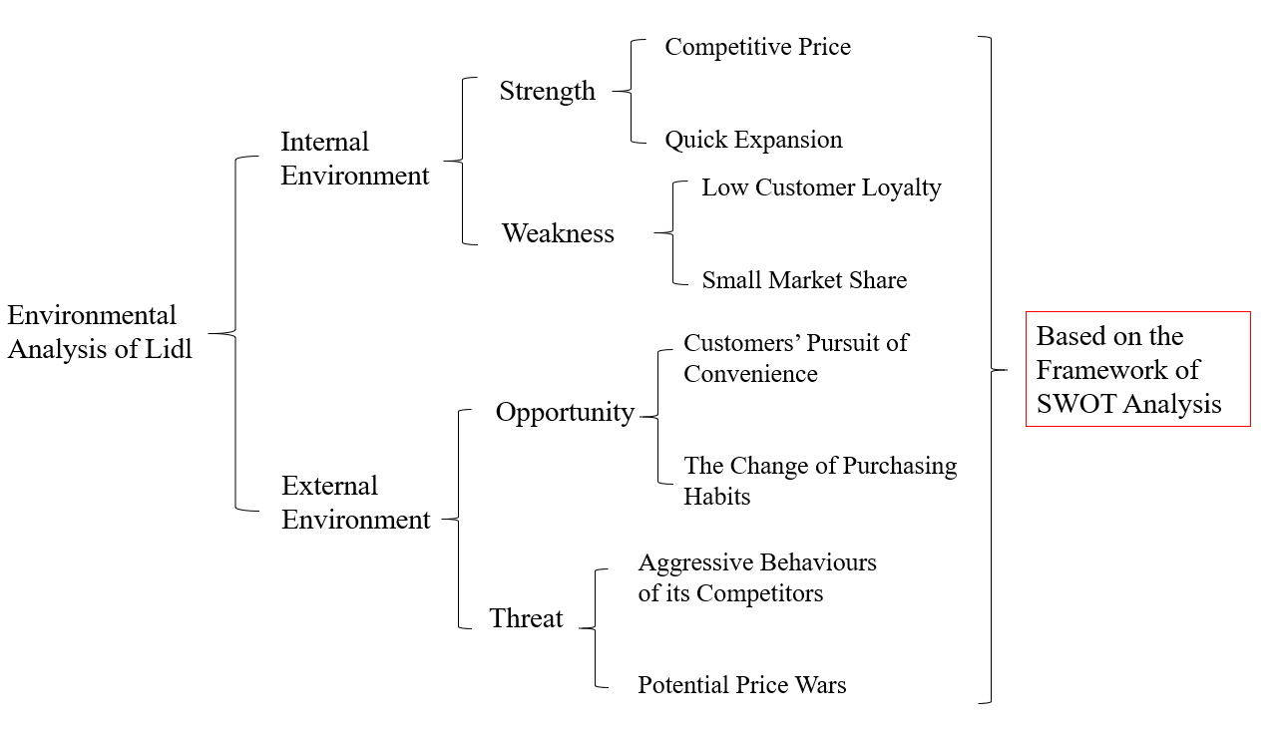
Figure 2-1 The Environmental Analysis of Lidl

3.0 Research Methodology
A research methodology is a specific method that researchers apply during the process of research (Bradley, 2010). This part is an overview of research methods that have been involved in the report, including their justification and details of the implementation, as well as their limitations.

3.1 Primary Research
Primary research refers to collecting the first-hand information through conducting specific research activities by researchers themselves including survey, interview, questionnaire and focus group (Bradley, 2010). This method is important in the research and details are provided below.

3.1.1 Ethical Consideration
Ethical approval can make sure the research is conducted in an ethical and controlled way so that participants can be confident to be involved. Initially, the approved Ethic Form has been attached in the appendices. Besides, a consent form has been involved to ensure that participants understand how the research was conducted and how the data was used.
Furthermore, the collected information was reserved in a password-protection computer and only available for those involved in the project so that the privacy of participants can be protected fairly. Moreover, the result was also available for participants who would like to have access to it.

3.1.2 Process of Implementation
First, a questionnaire was determined with 15 questions which could be divided into four parts: self-information, perceived competitive advantages of the organisation, potential failure of convenience format and public suggestions. A completed questionnaire is attached in the appendices.
Next, the online questionnaire was generated via the software of Google Forms and then it was spread randomly online. Initially, the expected number of collected questionnaires was 50. In the end, the actual collected number was 58 among which valid questionnaires were 53 while the invalid number was 5 considering five of them have no shopping experience in Lidl. Furthermore, the analysis of collected questionnaires was carried out with graphs in the part 4.0.

3.1.3 Advantages and Limitations
In terms of advantages, primary research makes it possible to collect the information of public attitudes towards the proposal of opening convenience stores for Lidl, including its competitive advantages perceived by the public, the potential failure of convenience format and public suggestions of enhancing its performance.
The primary research has been conducted through online questionnaire considering it is relatively convenient to analyse and makes a wide range of samples possible (Stieger and Reips, 2010). Moreover, online format can save budgets and time compared with paper-printed questionnaires.
As for disadvantages, due to the time limitation, the primary research was only conducted by approximately 4 weeks from 28 March to 25 April. Therefore, the number of samples is just marginally higher than expectation.
Second, most participants of the primary research were students of the University so that there may be a represent limitation of the research.

3.2 Secondary Research
Secondary research is generally based on published or compiled academic resources which are relative to the project (Bradley, 2010). Through the profound and complete secondary research, the researcher can have a clear understanding of the project. Moreover, considering it is timesaving and most information is available to the public, the secondary research can improve the research efficiency (Bradley, 2010). The available resources of secondary research include academic journals, books and government publishers and websites.
Secondary research is also an important research method in this report and the following is details of how it is conducted.

3.2.1 Relative Information That Support the Project
First, having a clarified and complete profile of the organisation is the first objective of the report which can be achieved by secondary research, including its strengths, weaknesses and external environment it faces. The part 2.0 is a result of research.
Second, it is necessary to collect academic information of advantages and disadvantages of convenience format which is the basis of project decisions. Moreover, the framework of Porter’s Five Forces is applied to support the findings. Detailed results are discussed in the part 4.0.
Furthermore, the general performance of convenience sector can be considered as a reference of evaluating the feasibility to open Lidl convenience stores.

3.2.2 Diverse Types of Academic Resources
To gather the required information, various academic resources are considered via the library resources of University, Google Scholar as well as organisational websites. Types of resources include e-journals such as Retailing and Consumer Services and Journal of Retailing, database as MarketLine and websites of Lidl and other supermarkets.

3.2.3 Limitations of Secondary Research
The first limitation is that results of other scholars’ research may be not necessarily specific to the project (Bradley, 2010). As a result, if only depending on the secondary research, the decision making may be deflected.
Moreover, in terms of the limitation of secondary research in this report, constrained by time and budget, the research may not be perfectly exhaustive. However, it does not have considerable influence of reliability of results towards the analysis of this report.

4.0 Findings and Analysis
In this part, the detailed analysis of primary and secondary research has been conducted. The response of participants towards competitive advantages of Lidl, potential failure to open convenience stores and public suggestions to improve its performance have been analysed in primary research. As for secondary research, advantages and disadvantages of convenience format have been considered and the present performance of convenience market has also been explained.

4.1 The Analysis of Primary Research
The purpose of the primary research is to prove competitive advantages of Lidl, test the potential failure of Lidl’s convenience stores and collect public recommendations to improve its performance. Therefore, the analysis can be divided into several sections sorted by questions.

4.1.1 The Basic Information of Participants
The first four questions aim at displaying a basic scenario of participants, including their occupation, shopping habits and shopping experience in Lidl. Figure 4-1 is the result of these questions.
There are 91.4% participants who are students and 3 full-time work, 1 part-time work and 1 unemployed participants respectively. 53 people claimed that they have shopped in Lidl that forms the basis of the next analysis.
When it comes to the shopping time, 86.8% customers tend to shop half an hour or more one time, which provides Lidl with potential opportunities to increase exposure with attracting those customers. Moreover, the shopping habits of participants also prove that convenience stores are in line with the change of consumption habits with 58.6% customers prefer small purchasing volume but visiting stores more frequently.
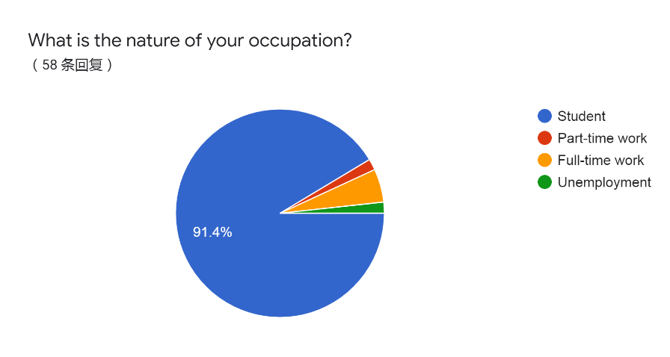
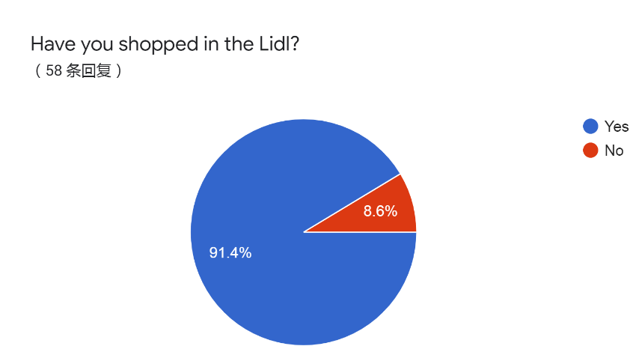
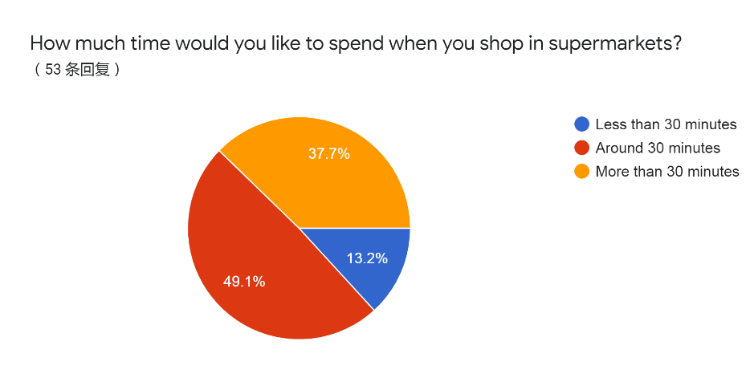
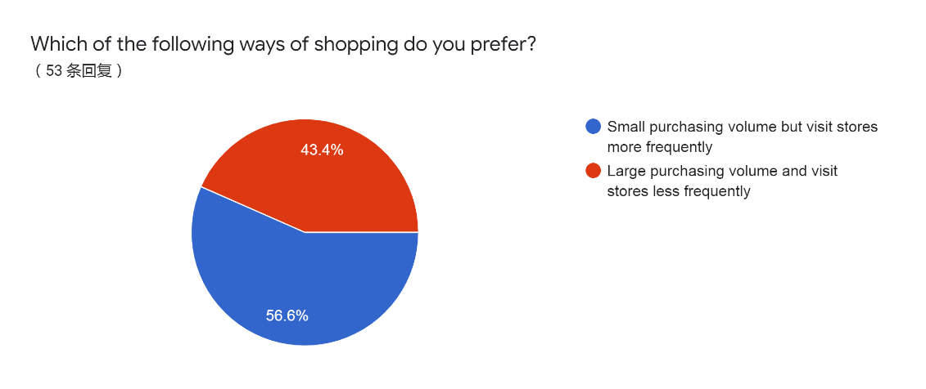
Figure 4-1 The Basic Information of Participants

4.1.2 The Existed Competitive Advantages of Lidl
As noted above, compatitive advantages of Lidl includes quick expansion and price. The result shows that the public perceived these advantages with 64.2% participants appreciated Lidl’s reasonable prices of items and 92.5% agreed convenience stores are beneficial to expand quickly for Lidl.
The low price is generally related to the low quality (MarketLine, 2015). However, the result indicates that only 28.3% participants agree that opinion in Lidl. Besides, the most attractive point of Lidl’s convenience stores would be the proximity which is also conformed with advantages of convenience stores analysed in the report. Firgure 4-2 is the initial result of this section.
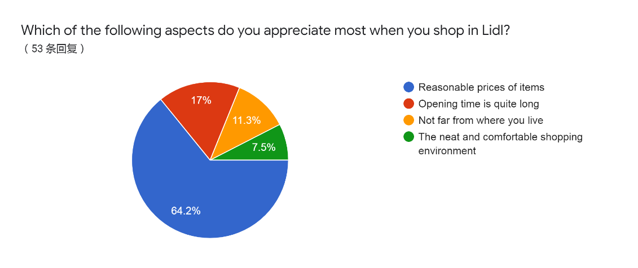
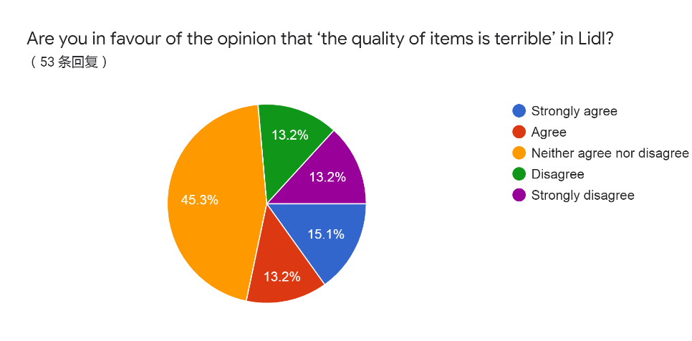
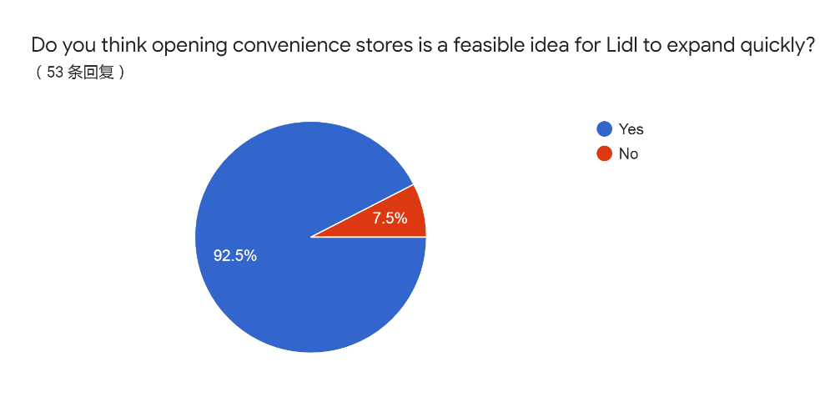
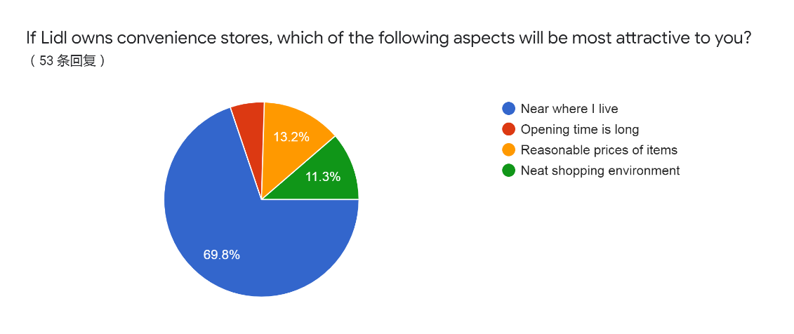
Figure 4-2 The Competitive Advantages of Lidl

4.1.3 The Potential Failure of Lidl’s Convenience Stores
The potential failure for Lidl to own convenience stores includes potential higher price than that of average stores, less choice and potential higher operation cost. In the questionnaire, there are three questions developed to test public responses towards these aspects which are displayed in Figure 4-3.
First, around 80% participants would like to shop in Lidl’s convenience stores even though prices of items would be a bit higher. Therefore, the price obstacle for opening convenience stores has limited influence in Lidl.
Second, more than half people believed more limited choice of items would affect their shopping decision in Lidl and 84.9% participants agreed that convenience format tends to increase operation cost, which means these would be barriers of convenience stores for Lidl.
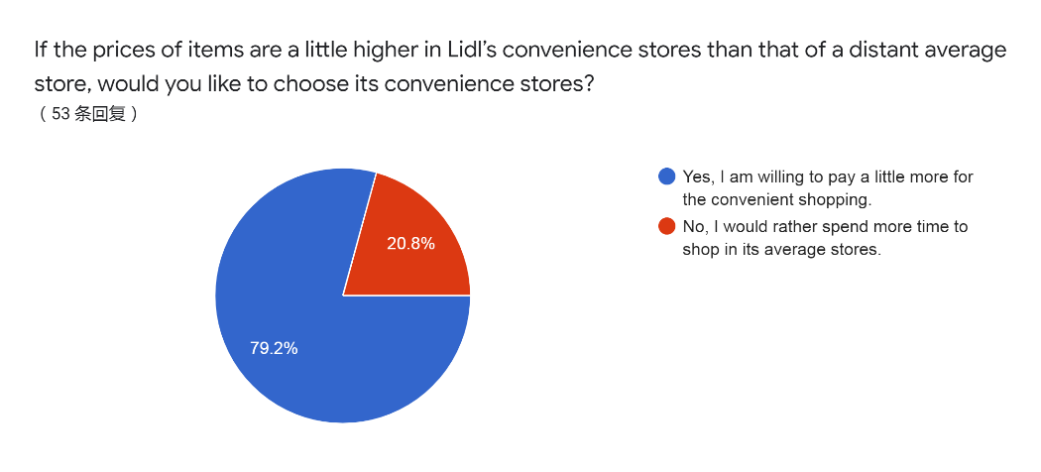
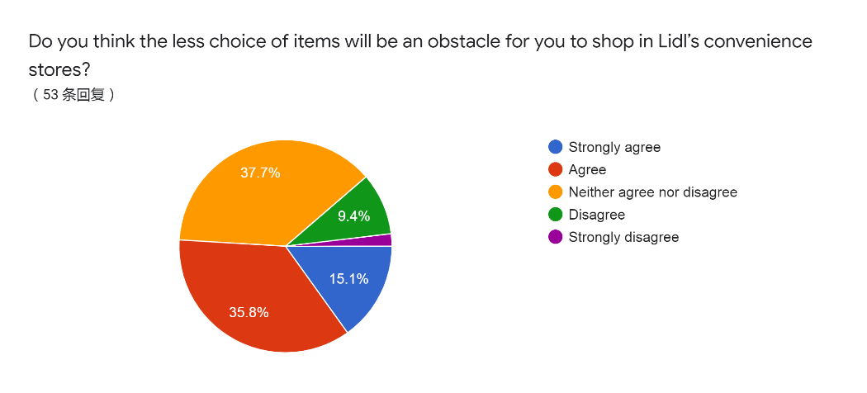
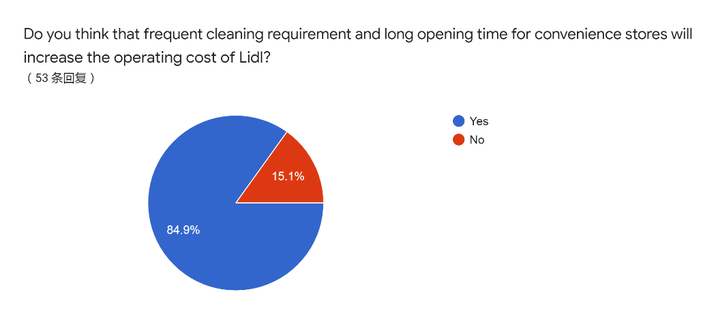
Figure 4-3 The Test of Potential Failure of Convenience Stores

4.1.4 Public Perspectives to Improve Lidl’s Performance
The last section of questions aims to collect public recommendations of Lidl as shown in Figure 4-4.
When it comes to categories of items, groceries and snack are most popular. Chilled food and soft drinks are suboptimal. Moreover, most people believe that opening from 6 a.m. to 11 p.m. except Sunday is most feasible for Lidl’s convenience stores. With 56.6% customers prefer self-service checkout, introducing more self-checkout machines is advisable. Besides, one of participants believed that more employees is helpful to enhance customer service in Lidl.
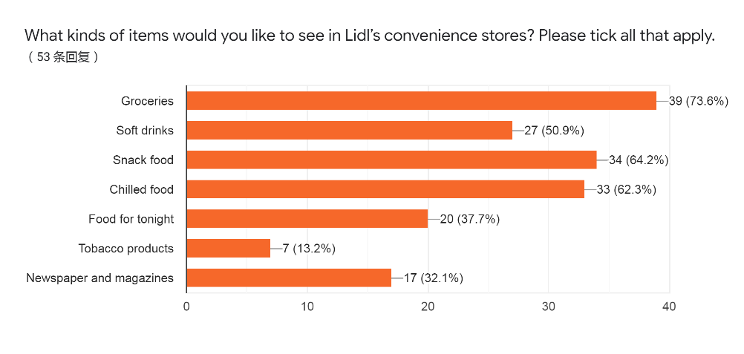
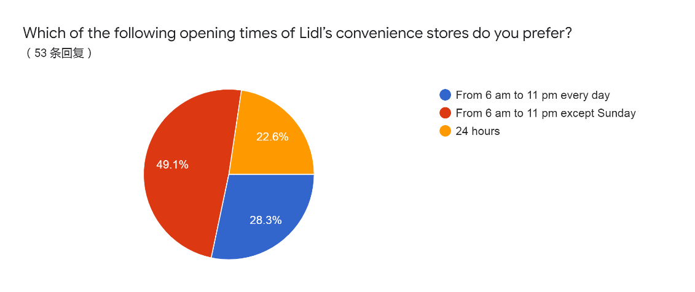
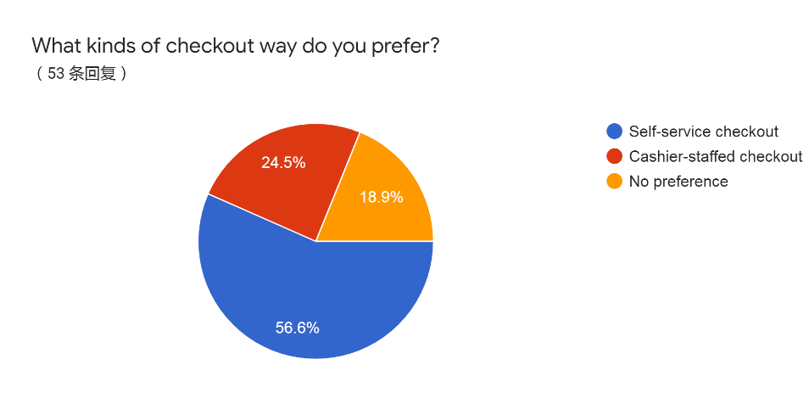
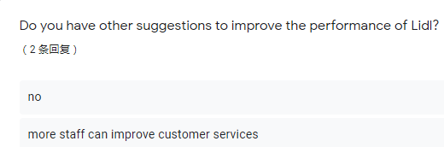
Figure 4-4 Public Recommendations of Lidl

4.2 Literature Review
Convenience stores generally refer to smaller scale of businesses compared with supermarkets that retail groceries and daily food (Rummo et al., 2015). They can be independent neighbourhood stores or belong to a supermarket brand. Stores discussed in the report refer to the latter. Those stores are usually located in areas with dense population in order to attract customers as much as possible (MarketLine, 2015). Moreover, relatively small store areas and limited choices as well as long opening time are also apparent characters of convenience format. Both advantages and disadvantages of this format are considered as the premise of strategic decision.

4.2.1 Advantages of Convenience Format
Boosting quick expansion. As noted above, the market share of Lidl is still low with approximately 5.9% compared with the traditional ‘big four’ which account for over half of retail sales in total (MarketLine, 2020). Naturally, a significant ambition of Lidl is to pursue expanding at a faster rate (Lidl, 2020). Convenience format makes it possible for the organisation to achieve flexible growth relying on the competitive location and small areas (MarketLine, 2015). For example, Sainsbury’s owns 820 convenience stores among its total 1428 stores (Sainsbury’s, 2019) and hard discounter, Aldi, has owned a new brand Aldi Local which has convenient character (Aldi, 2020). Considering the aim of Lidl to open 1000 stores by 2023 (Chambers, 2019), it is a sensible way to achieve it.
Attracting new customers. Based on the strategy of cost leadership, a considerable number of Lidl’s customers are people who have relatively high sensitivity of price (MarketLine, 2018). However, consumption habits are changing with an increasing living standard and socio-demographic factors (Rybaczewska and Sparks, 2020). In terms of retailing industry, proximity and time have become important concerns (Gahinet and Cliquet, 2018). Convenience stores are welcomed by commuters and others who are reluctant to take indulgent trips to shop far away. It is reported that the average customer visits the local store is 3.8 times per week (Association of Convenience Store, 2019). As a result, convenience format is advantageous for Lidl to expand its targeted customers.
Increasing bargaining power towards suppliers. When it comes to analyse organisations’ behaviours, Porter’s Five Forces Theory is a significant tool which have five dimensions: Buyer Power, Supplier Power, Substitute, New Entrants and Degree of Rivalry (Tanakorn and Sittha, 2013). The third advantage of convenience format is related to the dimension of supplier power which refers to the extent that suppliers can affect behaviours of the organisation. Widespread convenience stores allow the organisation to connect with more local suppliers in order to take advantage of the most competitive supply resources (Wolf, 2011). Therefore, it is beneficial for Lidl to maintain a low-cost position.

4.2.2 Disadvantages of Convenience Format
Potential high prices than that of average stores. On the one hand, considering convenience stores are generally located in competitive places, the renting tends to be higher than that of supermarket (Sainsbury’s, 2020). On the other hand, due to items in convenience stores are usually less than that of superstores, the delivery and distribution cost is much higher so that prices of items in convenience stores are generally higher. Taking Tesco for example, the Table 4-1 displays the price comparation of several kinds of groceries between Tesco Metro and Tesco supermarket from which prices of the former are generally higher than that of the latter. Given that one of significant advantages of Lidl is low price, convenience format may weaken its low-price advantage (MarketLine, 2018).
Much less choice for customers. Constrained by relatively small store areas, categories of items in convenience stores are limited. Most of them are groceries, drinks, chilled food and other daily food (Hervert-Escobar et al., 2017). There are no premium or bulky items in convenience stores which are difficult for customers to transport without a car (Aldi, 2020). For customers, their various needs for items may not be satisfied perfectly. In terms of Lidl, there are initially only one or two brands for the same commodity which limits the choice of customers (MarketLine, 2018). The convenience format tends to limit that choice further which can be considered as a disadvantage for Lidl.
Potential increasing of operation cost. For one thing, an appreciable character of convenience stores is its long opening time. For instance, the opening time of Tesco Express is exceeding 16 hours (Tesco, 2020). It leads to a higher payment for lighting and employees. Moreover, the more frequent cleaning and placing requirement may also increase the cost. For another, the rent of convenience stores is usually more expensive than average supermarkets due to the competitive location (MarketLine, 2015). For example, Sainsbury’s states that the high rent is one reason of why prices are different between its large and convenience stores (Sainsbury’s, 2020).
Table 4-1 The Price Comparation Between Tesco Metro and Tesco Superstore
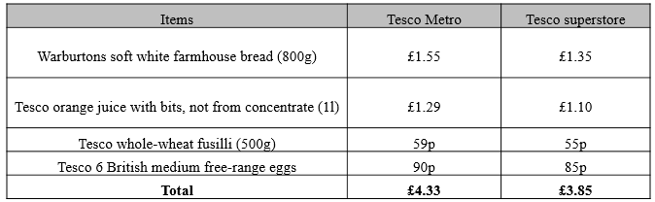

4.2.3 The Performance of Convenience Stores
On the one hand, there are several factors that may restrain the development of convenience stores. For example, the public concern of growing obesity is an important issue (Zhou et al., 2020). Several categories of items such as candy, soft drinks and snacks are displayed in most convenience shops (Hervert-Escobar et al., 2017). Therefore, convenience format is generally regarded as a main source of obesity, especially child obesity. Correspondingly, measures to deal with the problem usually tends to increase the cost of convenience stores, for instance, posting calorie information of items (Tran et al., 2019).
On the other hand, the development of convenience sector cannot be ignored. In 2019, the convenience sector generated around £40.3 billion sales in total and contributed to £8.8 billion in Gross Value Added as well (Association of Convenience Stores, 2019). Among exceeding 45000 convenience stores in mainland UK, approximately 31% stores belong to symbol groups. Moreover, convenience stores of main supermarkets also perform well. When it comes to numbers of those stores, ‘big four’ witnesses gradual increase (IGD, 2018). The table 4-2 illustrates the total number of both convenience stores and traditional superstores of ‘big four’ in 2018. Moreover, with the influence growth of millennials, different priorities have emerged including convenience and unique experience (MarketLine, 2017) which provides fabulous opportunities for convenience format. Being more flexible and quicker to response to changes of behavioural habits, convenience format can witness a continuous growth (MarketLine, 2017).
Table 4-2 The number of different types of stores of ‘big four’ in 2018
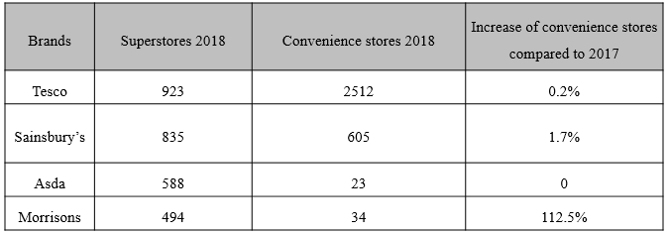
Source: IGD, 2018

5.0 Conclusions
To sum up, the overall aim of the project is to explore whether is it possible for Lidl to open convenience stores. Three specific objectives to achieve the purpose have been analysed respectively.
The first objective is conducting environment analysis of Lidl. Through applying SWOT analysis, both internal and external analysis have been achieved. Strengths of Lidl include competitive price and quick expansion rate (Ozair, 2017). Its weakness reflects on low customer loyalty and market share (Shaikh et al., 2018). Externally, opportunities are changes of consumption habits. People appreciate convenient shopping increasingly so that proximity and time have become significant factors of their shopping decisions (Gahinet and Cliquet, 2018). However, there are also threats that most of its competitors have realised benefits of convenience sector and the competition has become more intensive. Potential price wars may happen which is another threat for Lidl (MarketLine, 2015).
Moreover, advantages and disadvantages of convenience stores are analysed through primary and secondary research. Benefits include boosting expansion, attracting new customers and improving bargaining power towards suppliers, which have been proved through primary research (Rybaczewska and Sparks, 2020). Disadvantages are potential higher price, limited choice of items and potential higher operation costs. The result of primary research indicated that the obstacle of price has limited influence for Lidl while limited choice and potential costs are barriers for Lidl to open convenience stores.
Via the explanation of performance in convenience sector these years, although there are restricts such as the blame of public obesity, the merit of convenience stores which enhances the flexibility of organisation towards customers’ demands has accelerated the development of convenience market which contributed to £8.8 billion in GVA in the UK in 2019 (Association of Convenience Stores, 2019).
Therefore, an overall conclusion can be drawn that there are positive possibilities for Lidl to open convenience stores, but risks are also existed.

6.0 Recommendations
To facilitate the success of Lidl’s convenience stores, there are three recommendations provided.
- Selecting of items elaborately. It is advisable for Lidl to take full advantage of limited displays of items by providing most popular commodity. According to the research, groceries, snack and chilled food are eligible in its convenience stores.
- Introducing self-checkout machines. Based on the analysis, 56.6% participants prefer self-service checkout so that introducing more self-checkout machines could promote customers’ patronage of stores.
- Closing stores earlier on Sunday. Opening from 6 a.m. to 11 p.m. except Sunday are appreciated by most participants according to the primary research. Closing stores earlier in Sunday can also reduce operation costs for Lidl’s convenience stores.

Reference
Aldi (2020) About us. [Online] Available at:
https://www.aldirecruitment.co.uk/about-us/ (Accessed: 12 March 2020).

Association of Convenience Stores (2019). The Local Shop Report 2019. https://www.acs.org.uk/sites/default/files/acs_local_shop_report_2019.pdf (Accessed: 21 February 2020).

Bradley N. (2010). Marketing research: tools & techniques 2nd ed., Oxford: Oxford University Press.

Chambers S. (2019) Lidl to open 230 stores in challenge to big four supermarkets - German discounter to accelerate the pace of expansion. The Times, 10 November [Online] Available at:
https://www.thetimes.co.uk/article/lidl-to-open-230-stores-in-challenge-to-big-four-supermarkets-h9gqggwkv (Accessed: 12 March 2020).

Gahinet M. and Cliquet G. (2018). Proximity and time in convenience store patronage: Kaïros more than chronos. Journal of Retailing and Consumer Services. 43(2018). pp.1-9.

Gómez-Lobo A., Jiménez J. L. and Perdiguero J. (2015). The entry of a hard discount supermarket: price effects. Investigaciones Regionales - Journal of Regional Research, (31), pp.143–154.

Hervert-Escobar L., Esquivel-Flores O. A. and Ramirez-Velarde R. V. (2017). Optimal pricing model based on reduction dimension: A case of study for convenience stores. International Conference on Computational Science. 108(2017). pp.2079-2089.

IGD (2018). UK GROCERY STORE NUMBERS 2018. [Online] Available at: https://www.igd.com/Portals/0/Downloads/Research/UK-grocery-stores-table.pdf (Accessed: 14 March 2020).

Lidl (2020). About us. [Online] Available at: https://www.lidl.co.uk/about-us (Accessed: 12 March 2020).

Madsen D. Ø. (2016) SWOT Analysis: A Management Fashion Perspective. International Journal of Business Research. 16(1). pp. 39-56.

Makortoff K. (2019). Lidl attains its biggest UK grocery market share at 5.9%. The Guardian, 20 August [Online] Available at:
https://www.theguardian.com/business/2019/aug/20/lidl-attains-biggest-uk-market-share (Accessed: 12 March 2020).

MarketLine (2014). Supermarket Price Wars-A response to the rise of discount retailers. Available at:
https://advantage-marketline-com.ezproxy.uwtsd.ac.uk/Analysis/Details/supermarket-price-wars-a-response-to-the-rise-of-discount-retailers-28085 (Accessed: 13 March 2020).

MarketLine (2015). The Big 6 UK Food Retailers: How supermarkets are responding to the discounter threat. [Online] Available at: https://advantage-marketline-com.ezproxy.uwtsd.ac.uk/Analysis/details/the-big-6-uk-food-retailers-how-supermarkets-are-responding-to-the-discounter-threat-29268 (Accessed: 31 March 2020).

MarketLine (2017). Millennial Consumers- Understanding key trends driving consumer behaviours. [Online] Available at: https://advantage-marketline-com.ezproxy.uwtsd.ac.uk/Analysis/ViewasPDF/millennial-consumers (Accessed: 28 March 2020).

MarketLine (2018). Aldi and Lidl: Discounters reach record market share in a challenging climate. [Online] Available at: https://advantage-marketline-com.ezproxy.uwtsd.ac.uk/Analysis/ViewasPDF/aldi-and-lidl-62591 (Accessed: 31 March 2020).

MarketLine (2020). Food & Grocery Retail in the United Kingdom. [Online] Available at:
https://advantage-marketline-com.ezproxy.uwtsd.ac.uk/Analysis/ViewasPDF/united-kingdom-food-grocery-retail-94903 (Accessed: 26 March 2020).

Ozair, N., (2017). Lidl-Collaboration with Heidi Klum as discount supermarket targets new apparel market, MarketLine. Available at: https://advantage-marketline-com.ezproxy.uwtsd.ac.uk/Analysis/ViewasPDF/lidl-collaboration-with-heidi-klum-as-discount-supermarket-targets-new-apparel-market-49734 (Accessed: 13 March 2020).

Porter, M., (1985). Competitive advantage—Creating and Sustaining Superior Performance. Free Press, New York.

Rummo, P., Meyer, K., Boone-Heinonen, J., Jacobs, D., Kiefe, C., Lewis, C., Steffen, L. and Gordon-Larsen, P. (2015). Neighborhood Availability of Convenience Stores and Diet Quality: Findings From 20 Years of Follow-Up in the Coronary Artery Risk Development in Young Adults Study. American Journal of Public Health, 105(5), pp.E65–E73.

Rybaczewska, M. and Sparks, L. (2020). Locally-owned convenience stores and the local economy. Journal of Retailing and Consumer Services, 52, pp.1-7.

Sainsbury’s (2019). Annual Report and Financial Statements 2019. [Online] Available at:
https://www.about.sainsburys.co.uk/~/media/Files/S/Sainsburys/documents/reports-and-presentations/annual-reports/sainsburys-ar2019.pdf (Accessed: 12 March 2020).

Sainsbury’s (2020). Why are prices different between your large and convenience stores? [Online] Available at: https://help.sainsburys.co.uk/help/prices-payment/convenience-store-prices (Accessed: 28 March 2020).

Samuel, S. (2015). ALL ABOUT ALDI. AND LIDL. Canadian Grocer, 129(2), p.15.
Bill, P. (2015). Is the Shard 2.0 coming soon to Paddington?; Lidl goes large in London; parliamentary refit. The Estates Gazette, p.58.

Shaikh, A.A., Karjaluoto, H. and Häkkinen, J. (2018). Understanding moderating effects in increasing share-of-wallet and word-of-mouth: A case study of Lidl grocery retailer. Journal of Retailing and Consumer Services, 44, pp.45–53.

So-young, K. (2019). The changing role of convenience stores in South Korea. British Food Journal, 121(7), pp.1642–1654.

Stieger, S. and Reips, U.-D. (2010). What are participants doing while filling in an online questionnaire: A paradata collection tool and an empirical study. Computers in Human Behavior, 26(6), pp.1488–1495.

Tanakorn R. and Sittha J. (2013). Using Porter’s Five Forces Model for Analysing the Competitive Environment of Thailand’s Sweet Corn Industry. International Journal of Business and Social Research, 3(3), pp.174–184.

Tesco (2020). Store Locator. [Online] Available at: https://www.tesco.com/store-locator/uk/ (Accessed: 31 March 2020).

Uttley E. (2018). Aldi and Lidl- Discounters reach record market share in a challenging climate. MarketLine. Available at: https://advantage-marketline-com.ezproxy.uwtsd.ac.uk/Analysis/ViewasPDF/aldi-and-lidl-62591 (Accessed: 13 March 2020).

Vroegrijk, M., Gijsbrechts, E. and Campo, K. (2016). Battling for the Household's Category Buck: Can Economy Private Labels Defend Supermarkets Against the Hard-Discounter Threat? Journal of Retailing, 92(3), pp.300–318.

Wolf, J. (2011). Sustainable Supply Chain Management Integration: A Qualitative Analysis of the German Manufacturing Industry. Journal of Business Ethics, 102(2), pp.221–235.

Zhou, S., Cheng, Y., Cheng, L., Wang, D., Li, Qi., Liu, Z., Wang, H. (2020). Association between convenience stores near schools and obesity among school-aged children in Beijing, China. BMC Public Health, 20(1), p.150.

Appendices
Appendix A- Ethic form
Appendix B- Initial Questionnaire
Part 0 Self information
1.I hereby acknowledge that the data collected within this questionnaire will be anonymous and confidential and will be used solely by the University of Wales Trinity Saint David for academic purposes only.
Yes
No
2.What is the nature of your occupation?
Student
Part-time work
Full-time work
Unemployment
Other: _____________________________________
3.How much time would you like to spend when you shop in supermarkets?
Less than 30 minutes
Around 30 minutes
More than 30 minutes
4.Which of the following ways of shopping do you prefer?
Small purchasing volume but visit stores more frequently
Large purchasing volume and visit stores less frequently

Part 1 Competitive advantage
1.Which of the following aspects do you appropriate most when you shop in Lidl?
Reasonable prices of items
Opening time is quite long
Not far from where you live
The neat and comfortable shopping environment
Other: ______________________________
2.Are you in favour of the opinion that ‘the quality of items is terrible’ in Lidl?
Strongly agree
Agree
Neither agree nor disagree
Disagree
Strongly disagree
3.Do you think opening convenience stores is a feasible idea for Lidl to expand quickly?
Yes
No
4.If Lidl owns convenience stores, which of the following aspects will be most attractive to you?
Near where I live
Opening time is long
Reasonable prices of items
Neat shopping environment
Other: __________________

Part 2 Potential failure
1.If the prices of items are a little higher in Lidl’s convenience stores than that of a distant average store, would you like to choose its convenience stores?
Yes, I am willing to pay a little more for the convenient shopping.
No, I would rather spend more time to shop in its average stores.
It depends on ______________.
2.Do you think the less choice of items will be an obstacle for you to shop in Lidl’s convenience stores?
Strongly agree
Agree
Neither agree nor disagree
Disagree
Strongly disagree
3.Do you think that frequent cleaning requirement and long opening time for convenience stores will increase the operating cost of Lidl?
Yes
No

Part 3 Public suggestions
1.What kinds of items would you like to see in Lidl’s convenience stores? Please tick all that apply.
Groceries
Soft drinks
Snack food
Chilled food
Food for tonight
Tobacco products
Newspaper and magazines
Other: ___________________
2.Which of the following opening times of Lidl’s convenience stores do you prefer?
From 6 am to 11 pm every day
From 6 am to 11 pm except Sunday
24 hours
Other: ________________________
3.What kinds of checkout way do you prefer?
Self-service checkout
Cashier-staffed checkout
4.Do you have other suggestions to improve the performance of Lidl?
_______________________________________________________

