The Role of Teamworking
Group Written Report
Student Name | Student Number
Saveta Victoria Stefan | 2216451
Ionel Stefan  Andrei Bodiu | 2216967  2315630

LCBB4006 Academic Skills
Bachelor of Arts Business Management
Lecturer’s Name: Valentina Bartali

Executive Summary
The report explored the role of teamwork in the workplace and its importance in enhancing performance. The study established that every team member has something unique to offer, and teams allow them to do so, making them feel important and valued. When a member contributes toward attaining their common goals, it boosts their motivation and morale to continue performing better as individuals and team members. Consequently, the report identified the various theories associated with managing groups. The report established that various theories and frameworks have been developed to help in building and managing teams. These theories explore how individuals work together, collaborate, communicate, and attain their goals. They also help to comprehend stages of team development, the roles and responsibilities of team members, and the factors influencing team performance and satisfaction.

Contents
Executive Summary 2
Introduction 4
Team Work 4
Teamwork concepts 5
Norms 5
Common Goals 5
Team members’ selection and roles 5
Theories associated with managing groups 5
Tuckman’s stages of Group Development 5
STAR Team Model 6
Belbin’s Team Roles 7
Lencioni's Five Dysfunctions of a Team 9
Situational Leadership Model 10
The Importance of Teamwork 11
How Teamwork can Affect University Students Performance 12
Teamwork enhances essential social skills. 12
Teamwork Enhances Learning 12
Enhances spirit of cooperation and commitment to the task 12
Recommendations 13
Conclusion 13
Reference List 13
Appendix 15

Introduction
Teamwork is one of the most critical factors for success, as different kinds of tasks, including complex ones, become easier and faster to perform through collaboration. Working as a team enables individuals to tackle complex projects and daring goals that would not be possible if they were working alone. In its simplest form, teamwork happens when a group of individuals works together to complete a task (Reiter-Palmon et al., 2017). This concept also relates to the team's cohesiveness, including the ability to establish a positive working environment and how they identify the skills and strengths that every member brings to the team (Urionabarrenetxea, Fernández-Sainz, and García-Merino, 2021). This report explores the role of teamwork by defining teamwork and exploring the various theories/concepts associated with managing groups. The report also provides some examples of teamwork and discusses how teamwork can affect the performance of a university student.

Team Work
Team working involves a group of individuals working together for common goals, with every member contributing to completing the task or project (Akmal, 2015). Team working is the process of cooperation that enables individuals to achieve exceptional outcomes in their respective teams (Akmal, 2015). Every team member forms an integral part of the team and contributes immensely to the attainment of the common goal. Therefore, every team’s success depends on the existing synergy between the team members and the working atmosphere established by the members (Hoegl and Parboteeah, 2003). More importantly, Reiter-Palmon et al. (2017) asserts that team working depends on the individual skills, working, and the working atmosphere, as these the most critical factors that influence performance of any team.
When different individuals work together toward a common goal, there is the likelihood for their organization to flourish as it enhances efficiency and promotes better ideas (Urionabarrenetxea, Fernández-Sainz, and García-Merino, 2021). Teamwork is instrumental in improving the quality of the efforts put in by members, thus increasing the efficiency of the task being performed (Hoegl and Parboteeah, 2003). More importantly, teamwork creates a productive and friendly working environment by encouraging unity of purpose among team members. This aspect helps to improve individual and team performance as the members collaborate and support one another. Also teamwork makes things easier, especially when handling complex tasks, as members share different ideas to help develop quality solutions.

Teamwork concepts

Norms
Norms are agreeable rules or standards teams must uphold to identify each member's performance behaviour. Well-organized teams prefer to have norms to help them understand members' attitudes towards teamwork contribution. Norms also help to know the rules before the joining of new members of the team (Akmal, 2015). Also, without these agreeable rules, differences of opinion among members can hinder the attainment of the team's common goal.

Common Goals
Goals are another core concept of teamwork, as they are focused on completing work and enhancing team performance. Every team must have clarity of purpose by setting common goals in the form of measurable and concrete objectives. This aspect enables members to understand the impact of their contributions on attaining the overall goal (Akmal, 2015).

Team members’ selection and roles
Purposefully select team members based on the most desirable traits and attributes, including leadership, expertise, shared sense of responsibility, interpersonal skills, and experience. After carefully selecting members, use and develop roles based on the team needs, including task, maintenance, and organizational roles (Akmal, 2015). Task roles contribute to project completion; maintenance roles add positivity to the team, while organizational roles could include supervisor or team leader (Hoegl and Parboteeah, 2003).

Theories associated with managing groups
Team management entails organizing, motivating, and leading a group of individuals to attain a common goal. This aspect involves applying various frameworks or theories that help to understand teamwork, what motivates team members, and how to improve their performance. The most fundamental aspect of teamwork involves comprehending team dynamics based on individual temperament and team situation. This section covers the theories and frameworks of managing groups to enable teams to perform optimally and manage conflicts effectively.

Tuckman’s stages of Group Development
Ackman's stages of group development are one of the most widely utilized team management theories that describe how a team evolves. Bruce Tuckman proposed this theory in 1965, stating that a team goes through five development stages: forming, storming, norming, performing, and adjourning, as shown in figure in the appendix (Fall and Wejnert, 2005). Every stage plays a vital role in establishing a highly purposeful team. Managers can use this theory to identify the exact stage their teams are in and the actions they may need to take to help them move toward the next stage.
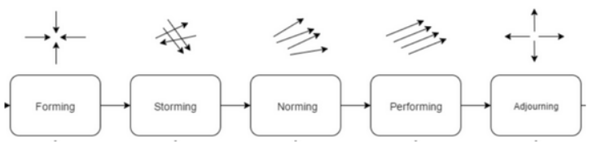
- Forming: Forming is the first stage of team development, where team members get to know one another, establish roles, and set expectations (Fall and Wejnert, 2005). During this stage, members tend to behave independently because of the lack of trust. Moreover, during this stage, members discuss their interests, skills, background, and project goals and timelines. Also, members discuss more about regulations or rules and the individual roles every member will play in the team.
- Storming: During the storming stage, team members start experiencing challenges, conflicts, and disagreements as they strive to align their methods and goals (Fall and Wejnert, 2005). Members' egos start showing at this stage, and tempers will likely start flaring, leading to disagreements on performing a certain task. This stage requires a strong leader to guide the team.
- Norming: During the norming stage, members resolve their differences, develop norms, and cooperate more effectively as they work together towards a common goal. Every member understands their role and works hard to complete their tasks. During this stage, individuals may opt to work separately but frequently consult one another to guarantee well-organized and effective workflow (Fall and Wejnert, 2005). Because of the team cohesion, each member is responsible for their tasks and to one another.
- Performing: Members work creatively, smoothly, and efficiently in this stage towards their goal. They understand every member's weaknesses and strengths, and they are well-known to one another to offer a helping hand (Fall and Wejnert, 2005). Moreover, during this stage, everyone is motivated and confident, and they operate with minimal supervision, thus sparking creativity.
- Adjourning: At the end of the project, the team is disbanded. This stage can be very emotional, especially when members have grown close to one another.

STAR Team Model
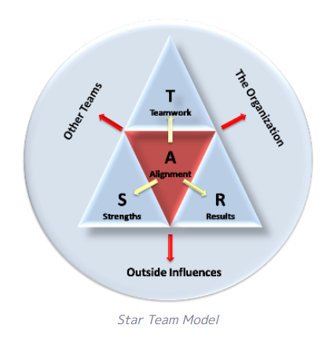
The star team model offers the content or substance to Tuckman's team development stages, the situation, and surroundings. This model plays a vital role in helping determine what teams and team leaders need to focus on. Based on this model, individual strengths, especially when pursuing significant goals in making a difference, are vital for being happier. The strengths of individuals' relationships tend to be the strongest linkage to discovering contentment in life (Reiter-Palmon et al., 2017). Consequently, developing this form of teamwork can create a happier workplace.

(Source: Teamwork Theories | the STAR team model - The Happy Manager (the-happy-manager.com) )
Based on this model, effective teamwork occurs when people thrive as they develop and utilize their strengths. This aspect focuses on individual strengths and where their best contribution can be made. After identifying individual strengths, these individuals are brought together to build relationships. As these individuals continue working together well after building relationships, it leads to effective teamwork, as shown in Figure 2 in the appendix. Similarly, when individual strengths and teamwork combine as they pursue meaningful goals, performance flows naturally, and the team achieves rewarding and meaningful results. Leaders must match every member’s strengths with powerful teamwork and the emphasis on significant results. The model can help team leaders and organizations create the working conditions for effective teams and happier workplaces

Belbin’s Team Roles
Belbin's Team roles theory examines the roles that team members can play depending on their weaknesses and strengths (Prichard and Stanton, 1999). The theory identified nine fundamental roles that each team must consider when working in the team, including plant, resource investigator, shaper, co-ordinator, team worker, monitor evaluator, specialist, and compete finisher (Prichard and Stanton, 1999). Every role has a unique input and possible drawbacks for the team. Based on this theory, team role is the tendency to interrelate with others, contribute, and behave in a certain manner (Prichard and Stanton, 1999). The theory divides the team roles into three categories, including action-oriented, people-oriented, and cerebral.

Action-oriented Roles | Shaper  Implementer  Complete finisher | -flourishes under pressure  -Vibrant  -bravery to triumph over challenges  -Dependable, resourceful, and well organized.  -Also turns ideas into action  -anxious  -looks for mistakes and blunders  -Timely delivery | -Prone to provocation  -upsets others’ feelings  -Slow to react to new ideas  -inflexible  -unwilling to assign tasks to other members
People-oriented roles | Co-ordinators  Team worker  Resource investigator | -Conviction  -simplifies objectives  -Helps in making vital decisions  -delegates tasks  -supportive, diplomatic, and sensitive  -averts friction  -pays attention  -keen, outgoing  -searches prospects | -They can be controlling  -often unable to make up their mind in critical circumstances  -They expect too much from members
Cerebral Roles | Plant  Monitoring Evaluator  Specialist | -imaginative, unconventional, and inventive  -resolve complex issues  -clear-headed, tactical -explores all the alternatives  -arbitrates correctly  -dedicated, enthusiastic  -Offers skills and information not available | -they are very worried about communicating well forgetting vital aspects of the team  -often don’t have the desire and the knack to motivate members  -Their contributions can be minimal
Categories | Team Roles | Strengths | Weaknesses allowed

These team roles illustrate the behavioural pattern that exemplifies a team member’s behaviour towards another member in facilitating the team’s progress. This theory enables a team or a team member to benefit from self-knowledge and adjust behaviour to suit the external situation.

Lencioni's Five Dysfunctions of a Team
This theory summarizes the fundamental obstacles that deter teams from reaching their full potential. The five common obstacles that affect the teams' effectiveness include lack of trust, conflict or fear, lack of commitment, avoidance of accountability, and inattention to results. Every dysfunction builds on previous dysfunction, thus creating a vicious cycle that undermines the team's performance (Laemers, 2021). When team members hardly trust one another, they will hardly engage in constructive conflict, leading to a lack of commitment. This lack of commitment is likely to result in avoidance of accountability, ultimately affecting the team's performance (Laemers, 2021). There is a need to address every dysfunction.
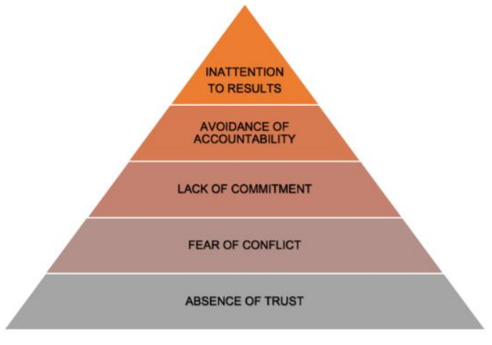
- Lack of trust: when members hardly trust one another, they will hardly seek help or take risks.
- Fear of conflict: due to a lack of trust, members avoid engaging in conflict amongst themselves, thus hampering innovation and progress that emanates from constructive conflict.
- Lack of commitment: Members will hardly commit to performing their tasks when there is a lack of trust and fear of conflict, thus affecting the team's overall performance.
- Avoidance of accountability: lack of commitment results in avoidance of accountability
- Inattention to results: lack of commitment and avoidance of accountability means that members focus more on personal goals and not on team goals, prompting them to lose sight of the expected results, hampering the team's overall performance

Situational Leadership Model
This model holds that there is hardly one ideal team leadership method. Based on this model, leading teams depends on the team members' maturity level and the prevailing situation (Funk, 2022). Consequently, the model suggests four fundamental leadership styles to lead teams: coaching, directing, delegating, and supporting. Every leadership style matches the diverse amalgamation of relationship behaviours and tasks. For instance, directing tend to be low on relationship but high on tasks, making it ideal for team members who are high on commitment and low on competence.
( Source: Situational Theories of Leadership | Principles of Management (lumenlearning.com) )
Similarly, coaching tends to be high on both relationship and task, making it ideal for leading members who are low on commitment and competence (Funk, 2022). Supporting tends to be high on relationship and low on task, making it ideal for leading team members who are low on commitment and high on competence. Lastly, delegating tends to be low on both relationship and task, making it ideal for leading team members high on commitment and competence.
Team leaders can utilize this framework to evaluate their team members' maturity levels, adjust their leadership styles accordingly, and help their members develop and grow.

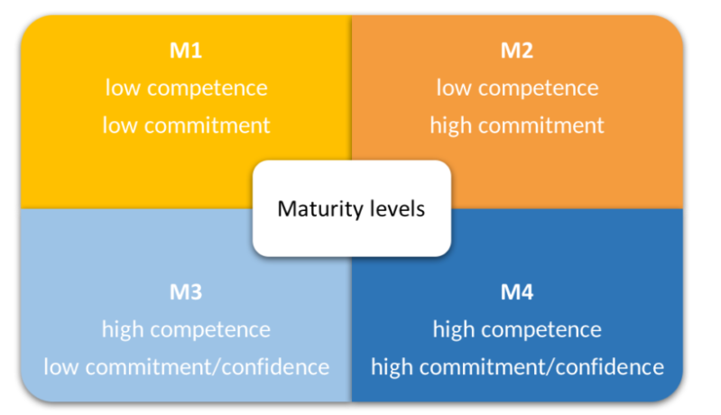
The Importance of Teamwork

Teamwork improves efficiency
Teamwork plays a vital role in improving the quality of efforts put in by members, thus increasing the efficiency of the work being performed. Furthermore, teamwork helps to create a productive and friendly working atmosphere by encouraging unity among team members (Mishra and Mishra, 2022). This aspect is instrumental in improving the members and the overall team performance as members support and cooperates.
Teamwork cultivates effective communication
Communication is vital to any successful teamwork, as team members must communicate with one another to create clear goals and cohesion (Mishra and Mishra, 2022). Communication begins by establishing team synergy and friendship. Often, team leaders use team-building activities to build team synergy and comradeship. Effective teams that demonstrate effective communication tend to be more productive and efficient and create a pleasant work environment.
Teamwork improves brainstorming and problem-solving skills.
Teamwork is also instrumental in improving brainstorming, a vital method of helping teams think outside the box. Teamwork involves members sharing ideas for various initiatives, including processes, projects, or products (Mishra and Mishra, 2022). Team leaders must build a working atmosphere where members feel comfortable sharing and communicating their ideas and thoughts on a particular initiative. In this respect, teamwork increases the chances of making smart decisions because of the diverse ideas, leading to improved solutions.
Stress Reduction
Teamwork is instrumental in reducing stress, including fostering trust among team members. When members trust one another, they support one another during difficult moments, thus combating stress and boosting morale (Mishra and Mishra, 2022). Furthermore, the sense of shared responsibility among team members is vital in helping reduce stress. Reducing stress is a critical aspect of enhancing individual and team performance.
Enhances Creativity and Innovation
Teamwork brings together more ideas, skills, and experience in the team's toolbox. Team members communicating openly and regularly cultivate a sense of friendship and trust. This strategy enables members to share ideas freely, resulting in greater creativity and innovation (Mishra and Mishra, 2022). Similarly, teamwork promotes using different members' perspectives, offering skills, insights, and diverse approaches to generate creative ideas.

How Teamwork can Affect University Students Performance

Teamwork enhances essential social skills.

Teamwork is vital in enhancing vital social and communication skills, including effective speaking and active listening. When university students work as a team, they learn how to listen to and communicate with their coaches and lecturers to undertake their roles effectively (De Prada, Mareque, and Pino-Juste, 2022). Moreover, such students can also learn how to listen to and communicate with one another to function as a cohesive team. More importantly, teamwork enables students to express their opinions and ideas confidently and effectively in a team environment. For example, we formed a self-managed team of six students to complete a research project at the end of the semester. This team helped to improve my social skills as we maintained regular communication among members through a WhatsApp group that enabled us to share more about our project progress.

Teamwork Enhances Learning
When university students work together on assignments or research projects, they get the opportunity to learn from one another's weaknesses and strengths. Consequently, teamwork contributes to a deeper comprehension of the subject matter and promotes a collaborative learning atmosphere, leading to enhanced learning and performance (De Prada, Mareque, and Pino-Juste, 2022). Moreover, collaborating with coursemates can offer students new ideas and fresh perspectives, leading to creative thinking and innovative solutions. For instance, we established a functional team in our area of specialization to work on a research project. We shared responsibilities amongst ourselves, with our lecturer as our supervisor who designed our responsibilities and to whom we all reported.

Enhances spirit of cooperation and commitment to the task
Moreover, teamwork also affects university students' performance by enhancing their spirit of cooperation and commitment to their tasks. As they cooperate, team members share vital skills and experience, which enhances their knowledge base, improving their performance (Mishra and Mishra, 2022). For instance, when we formed our project team to complete our end-semester research project, we allocated tasks based on our abilities (De Prada, Mareque, and Pino-Juste, 2022). The lecturer was the project leader who assigned responsibilities and monitored our work. There was a sense of cooperation and commitment to our tasks, which helped us to complete our research project on time.

Recommendations
Based on the Star Team Model, good team leadership entails establishing a working environment that allows individuals and ideas to thrive, individuals to converge, and performance to flow. Therefore, this report recommends team leaders form effective teamwork in workplaces by balancing developing individuals' strengths and establishing good connections and relationships between individuals to achieve meaningful and challenging team goals. Furthermore, the report recommends team leaders to Belbin's team roles theory to identify members' most preferred team roles. There is a need for team leaders to strive to balance all the nine roles to establish an effective team.

Conclusion
Teamwork entails working with other people to help them attain their full potential and common goals. Therefore, teamwork is one of the most desirable skills employers seek in their employees because of its ability to build trust among team members. More importantly, teamwork enhances productivity, makes team members happier, and fosters a sense of community in the workplace. Therefore, teamwork is very instrumental in organizations, and this section explores the importance of adopting teamwork in organizations. Various frameworks and theories have been established to help team leaders in building and managing their teams. These theories help leaders comprehend how teams function, what motivates team members, and how they can improve their performance to achieve the team's common goals.

Reference List
Akmal, K. (2015) 'Personality traits influence on team cohesiveness and performance: The moderating effect of leadership,' Information and Knowledge Management, 5(4), pp. 104– 109. Available at: https://core.ac.uk/download/pdf/234671952.pdf (Accessed: 30 October 2023).
De Prada, E., Mareque, M. and Pino-Juste, M. (2022) ‘Teamwork skills in higher education: Is University Training contributing to their mastery?’, Psicologia: Reflexão e Crítica, 35(1). Available at: 10.1186/s41155-022-00207-1 (Accessed: 30 October 2023).
Fall, K.A. and Wejnert, T.J. (2005) ‘Co-leader stages of development: An application of Tuckman and Jensen (1977)’, The Journal for Specialists in Group Work, 30(4), pp. 309– 327. Available at: 10.1080/01933920500186530 (Accessed: 30 October 2023).
Funk, P. (2022) Leadership theories traits into the situational leadership model [Preprint]. Available at: 10.14293/s2199-1006.1.sor-.ppqzril.v1 (Accessed: 31 October 2023).
Hoegl, M. and Parboteeah, K.P. (2003) ‘Goal setting and team performance in innovative projects': Small Group Research, 34(1), pp. 3–19. Available at: 10.1177/1046496402239575 (Accessed: 31 October 2023).
Laemers, S. (2021) 'The five dysfunctions of a team — a leadership fable,' Research in Hospitality Management, 11(3), pp. 267–267. Available at: 10.1080/22243534.2021.2006940 (Accessed: 31 October 2023).
Mishra, K.E. and Mishra, A.K. (2022) 'The importance of teamwork,' Intentional Leadership, pp. 49–57. Available at: 10.4324/9780367822170-11 (Accessed: 7 November 2023).
Prichard, J.S. and Stanton, N.A. (1999) 'Testing Belbin's Team Role Theory of Effective Groups,' Journal of Management Development, 18(8), pp. 652–665. Available at: 10.1108/02621719910371164 (Accessed: 7 November 2023).
Reiter-Palmon, R. et al. (2017) ‘Theories and models of teams and groups’, Small Group Research, 48(5), pp. 544–567. Available at: 10.1177/1046496417722841. (Accessed: 10 November 2023)
Urionabarrenetxea, S., Fernández-Sainz, A. and García-Merino, J.-D. (2021) 'Team diversity and performance in management students: Towards an integrated model,' The International Journal of Management Education, 19(2), p. 100478. Available at: 10.1016/j.ijme.2021.100478. (Accessed: 17 November 2023)

Appendix
Group Members | Individual Roles | Responsibilities
Saveta Stefan | Shaper and Implementer | - Challenging my team members to improve  - Motivating members  - probing norms  - discovering the finest strategies to resolve issues  - To ensure that members don’t become complacent  - To get things done in the team - Turning the team’s thoughts and ideas into realistic plans and actions
Andrei Bodiu | Complete finisher, Team worker and Plant | - Ensuring the team’s project is completed thoroughly  - Ensuring the team’s project has no omissions and errors  - Paying attention to every detail of the project  - Pushing the team to complete the job on time  - Offer support and ensure team members work together effectively  - Act as a negotiator in the team  - Focuses on building a strong team by enhancing cohesion  - Helping members get along  - Creative innovator tasked with generating new approaches and ideas
Ionel Stefan | Coordinator, Resource investigator and Monitor-Evaluator | - Exploring available options  - Developing contracts  - Negotiating for resources on behalf of the team  - Identifying and working with key stakeholders to attain the team’s goals  - Tasked with evaluating and analyzing ideas that other members generate  - cautiously consider the benefits and drawbacks of all the available alternatives before making final decisions  - To guide the team to achieve its objectives  - To listen to all the team members to understand their strengths and weaknesses  - Delegate tasks effectively based on the members’ strengths

