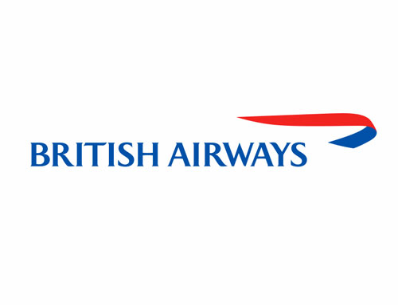


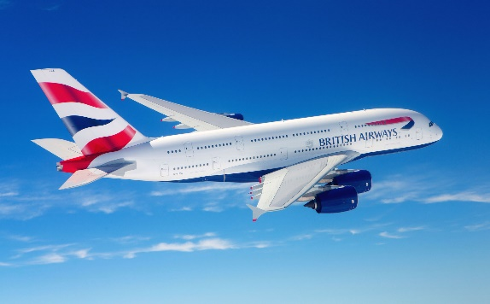
MODULE: INTRODUCING THE MODERN WORKPLACE
MODULE CODE: LCBB4003
ASSIGNMENT TITLE: ASSESSEMENT 1
ORGANISATIONAL BEHAVIOUR OF BRITISH AIRWAYS

STUDENT NAME: ELENA ALINA GRIGORAS
STUDENT ID: 2112864

LECTURER NAME: DR. APARNA VENKATESAN

CONTENTS

Introduction 3
Organisational structure of British airways 4
The way it is suitable for effective organisational performances to achieve goals 4
Organisational culture in British airways 5
The way this culture is suitable for effective organisational performances to achieve goals…5
Based on behavioural approach, factors affecting individual behaviour in the workplace 6
Personal factors 6
Environmental factors 7
Organisational factors 7
Conclusion 8
References 8

INTRODUCTION
In order to achieve success as well as a unique and steady level of competitiveness, it is vital to have a vibrant business culture that stimulates and encourages people. Putting money into fundamental management practises has been shown to have a major influence on employee engagement, achievement, and retention. People are able to relax, strengthen connections and improve their performance when given time to do so. Good corporate culture increases in efficacy over time since it fosters positive employee attitudes and works pretty effectively to improve overall morale. The airline business needs both culture and organisation to function well. This paper will cover the optimal organisational structure and culture to guarantee organisational success in order to fulfil the business objectives of British airways, as well as the workplace behavioural approach.
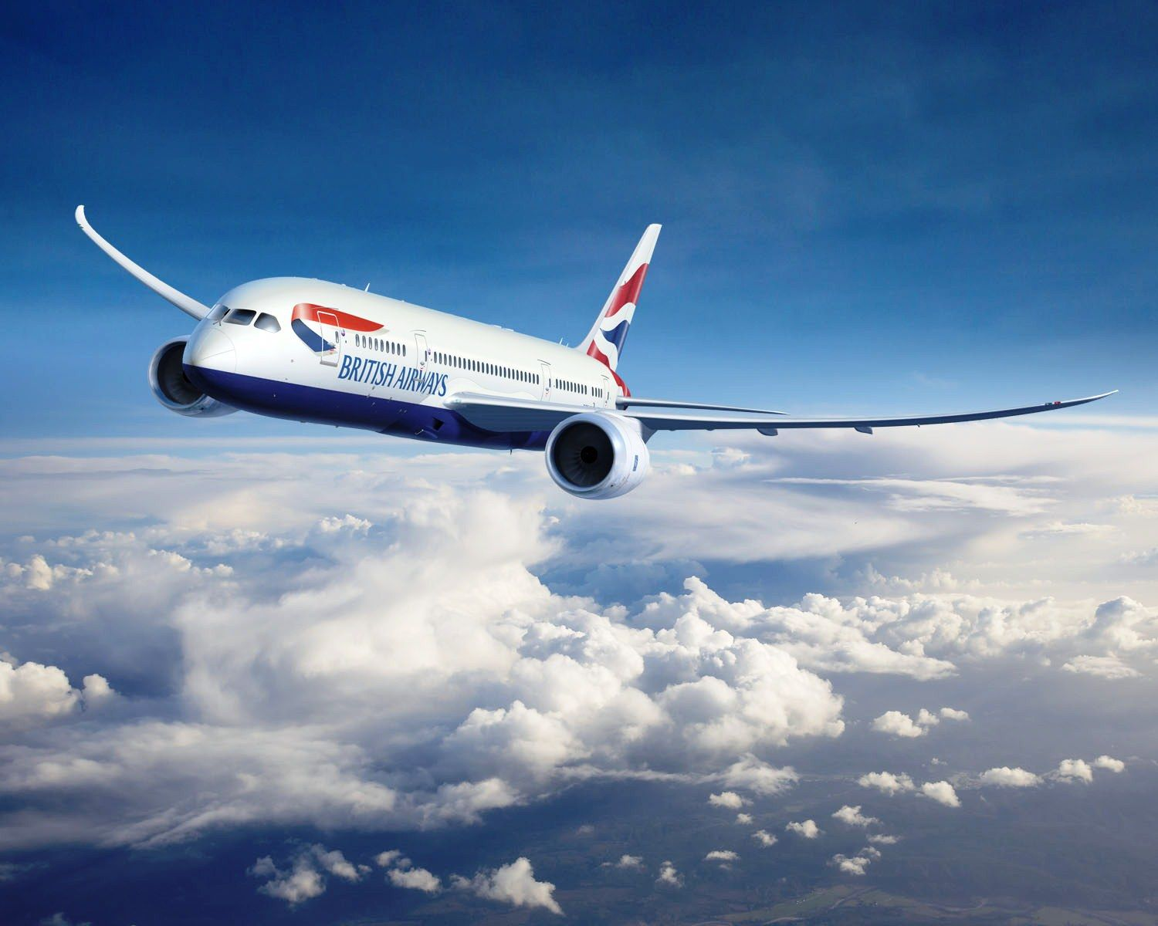
Photo source: wallpapercave.com

THE ORGANISATIONAL STRUCTURE OF BRITISH AIRWAYS
As a Public Limited Business, British Airways is owned by its shareholders who are considered to be separate legal persons from the company itself. These owners acquire shares on the stock exchange market. Before it was privatised, British Airways made use of a more formal and organised centralised system that included regulations and norms due to the scale and operations of the company (Erthal and Marques, 2018). However, throughout the last few years, a considerable adjustment has been made in the shape of a decrease in the number of management levels and the organisation now has a formal structure with responsibilities spanning a variety of roles. As a consequence of this, the organisational structure of British Airways is straightforward since there is only one level of hierarchy inside the company. This level divides managing directors at the very top from workers working at the very lowest. British Airways is run by a leadership team consisting of six different people. Among the various leadership roles are Commercial Director, Chief Information Officer, Director of Engineering, Director of Investments and Alliances, Director of People and Organizational Effectiveness, and General Counsel (British Airways, 2017). These executives are largely responsible for making executive decisions, but when it comes to acts that aren't on the executive level, they are helped by 11 directors. Further up the organisational hierarchy, the influential duties are delegated to lower-level employees, and the company as a whole utilises a merged team structure with workers who are project-based. The matrix organisational structure or the system organisational structure are also typical names for this.

THE WAY IT IS SUITABLE FOR EFFECTIVE ORGANISATIONAL PERFORMANCES TO ACHIEVE GOALS
The manner in which an organisation will function in order to accomplish its aims and objectives is determined, in large part, by its organisational structure. According to Janijevic (2013), British Airways has a straightforward organisational structure, which consists of a limited number of management levels yet a comprehensive system of oversight. The airline has adopted a divisional organisational structure in response to the characteristics of its business, which centre on the needs of the client. The advantages of using this strategy are that it provides a clear explanation of work tasks, that it requires very little time to make judgements, and that it makes monitoring across departments very easy for supervisors. This results in an increase in efficiency since people are given chances to apply the myriad of abilities that they possess. They have a flat hierarchical structure, which requires them to collaborate at all levels, including strategic, where the board of directors decides on the long-term approach; strategic, which provides the information to the top management; and operational, which compels the data into meaningful communications in order for the organisation to function conveniently and efficiently.
ORGANISATIONAL CULTURE IN BRITISH AIRWAYS
Issues pertaining to culture have an effect on the functioning of the organisation at all levels, and culture is comprised of shared beliefs, routines, and behaviours. The organisational structure of a corporation is a representation of its culture, management style, and the mentality of its leaders, in addition to the environment in which the firm is expected to operate (Alvesson, 2016). As a result of its scale and presence around the globe, British Airways has a more established organisational structure, complete with specific regulations and processes. A key shift that has taken place over the last several years is the reduction of the number of management layers between the chief executive and the principal line of employees who deal directly with consumers, from nine to five. It now incorporates a small arbitrary group that works in conjunction with the formal framework, and the responsibilities of this group have been decreased or reimagined in relation to the various roles. In order to preserve its leading market position, British Airways opted for a corporate culture that accurately represents the company's cultural purpose and the role it plays. This provides the company's workers with a wealth of options to broaden their skill sets and grow in other aspects of their careers. The cultural norm of British Airways is to respect individuals of all origins, ethnicities, sexes, ages, cultures, and faiths equally without prejudice and to work with people of all different backgrounds, nationalities, and sexes. In addition to this, one of their goals is to always provide the best possible degree of pleasure to the consumers they serve. They create a welcoming environment for all of their customers when they board their flights and make certain that their passengers' safety is never compromised in any way. British Airways places a high priority on the wellbeing of each and every one of its passengers, which is why the company has made it its aim to offer a safe environment for each and every one of its passengers at all times (Martinez Cano et al., 2018). The culture of British Airways strives to create a good environment for their employees as well as their clients in terms of the safety of their aircraft and the quality of their customer service.

THE WAY THIS CULTURE IS SUITABLE FOR EFFECTIVE ORGANISATIONAL PERFORMANCES TO ACHIEVE GOALS
The cultural practice of British Airways is a good example of how the theoretical framework of Schein's cultural model may be used. In its long history, British Airways has been involved in a number of mergers and acquisitions. They employed individuals of a variety of racial and religious backgrounds, as well as other backgrounds. In addition, British Airways has achieved a great deal of success, but just like any other business, it also has certain shortcomings. (Roszkowska and Melé, 2021) state that British Airways has been through one crisis after another, from mishaps at terminal 5 to strikes by cabin workers.
British Airways places high importance on its organisational culture since it assists the company in establishing its values, and beliefs, how employees should interact with one another, and the direction of the business. Additionally, it assists in the development of balance within the company. According to Riwo-Abudho, et al. (2013), the culture of British Airways is at the centre of its organisational culture, and this holds true regardless of whether the environmental shift is internal or external. For instance, if there is an increase in the number of competitive competitors, the organisational culture of the company has to react or attempt to change in order for the company to continue to thrive in the industry. Beliefs, language, behaviour, values and signals are considered to be British Airways' principles due to the fact that they offer a cultural identity and a stable working environment for all of the company's workers. And considering that Schein places a strong emphasis on the relationship between leadership and corporate culture, it would be reasonable to apply his theoretical framework, artefacts, values, and assumptions to the cultural practises of British Airways.

BASED ON BEHAVIOURAL APPROACH, FACTORS AFFECTING INDIVIDUAL BEHAVIOUR IN THE WORKPLACE
The term "individual conduct at work" refers to the manner in which a person acts or interacts when they are on the job. Individual behaviour is how a person reacts to various circumstances and exhibits sentiments such as happiness, irritability, love, and rage, amongst many other emotions. It refers to a particular activity carried out by a single person. The study of individual behaviour sheds light on how people act in professional settings. The performance of an organisation is significantly influenced by the actions of its individual members. Productivity will grow as a direct consequence of positive conduct. The firm will suffer significant harm and financial losses as a result of the negative conduct. In a dynamic and competitive industry, businesses need to put a far greater emphasis on the ways in which people, teams, and processes affect behaviour inside the workplace, as well as the ways in which items or even external market tactics are deployed (Booth and Melling, 2017). The purpose of this research is to conduct an analysis of the organisational behaviour of British Airways by describing the most significant problems that are present inside the firm and proposing realistic alternative remedies. The behavioural approach identifies the following as some of the elements that influence an individual's behaviour.

PERSONAL FACTORS
Gender: A person's gender is an unchangeable attribute since the capacity to be a man or a woman is determined by their genes. The widespread perception that women are substantially more emotionally vulnerable than males leads to a high employee turnover rate. This is due to the fact that an increasing number of women are resigning from their employment to pursue other interests.
Personal qualities include things like an employee's skin colour, complexion, eyesight, height, weight, nose size, and other traits that impact their behaviour. Psychological characteristics are a subset of personal characteristics. An individual who has acceptable physical characteristics also have an appealing demeanour, dresses properly and conducts themselves kindly in the job (Buchanan and Huczynski, 2019).
Age is a genetic characteristic that is determined by the individual's date of birth. Young people are often portrayed as being more driven to achieve their goals, as well as more efficient, energetic, risk-taking, and inventive than older generations.
The religious beliefs and practises of a person have an effect on their conduct in a variety of settings, including the workplace. People who have a strong sense of religion tend to adhere to stricter standards of morality, ethics and codes of behaviour while they are carrying out their responsibilities.
Instead of referring to an individual's physical characteristics, we talk about their personalities when we talk about how they build their psychological systems. People may be distinguished from one another by a variety of traits, such as patience, extroversion, superiority, aggression and so on (Helmreich and Merritt, 2017).
Values are overarching beliefs that serve as a foundation for particular behaviours and decisions in response to a wide range of situations. The concept is one that is held by a person and is founded on strong, positive and laudable ideas.

ENVIRONMENTAL FACTORS
The environment has a powerful influence on individual behavior.
Level of employment: The work possibilities that are available in a nation have a significant impact on the behaviour of individuals living in that country. If there are fewer work possibilities, a person will stay at the same level of employment regardless of how content they are with their current position. If there are additional employment prospects available, employees will leave their current occupations to pursue them (Caliskan, 2019).
The general economic environment has a huge influence on the ways in which people behave in groups. This is because the economic condition in such a nation. Stability in their employment situation and a reliable income are two of the most crucial motivating elements for this kind of worker.
Prior to beginning work for any company, the rate of one's wages is one of the most crucial considerations for any potential employee. Because of this, the salaries that one gets at their current job play a significant role in determining whether or not they will remain with their current employer or look for work elsewhere.
A person's conduct may be influenced, in a roundabout way, by a variety of political circumstances. In the event that the political climate remains stable, there will be a significant increase in the number of prospects for permanent employment.
ASPECTS RELATED TO THE ORGANISATION
The following organisational elements are examples of those that have been shown to have an effect on individual behaviour:
Physical Facilities: Research has shown that the physical environment of a workplace has a significant impact on employees' behaviours. It encompasses elements like as lighting, cleanliness, temperature, the amount of noise present, the office furniture, the number of employees and so on (Eysenck, 2015).
Structure and Design are concerned with the design of organisational departments as it relates to the structure of the organisation. The position that a person has in a hierarchical structure has an effect on the individual behaviour of that person.
Reward System: The entire performance of an organisation as well as its personnel may be significantly improved with the implementation of a just reward system.

CONCLUSION
The structure and culture of a company influence employee performance and show the efficiency and productivity of that specific company. Every company, including British Airways, has specific objectives that must be fulfilled. Furthermore, a positive work environment assists businesses in achieving their goals. As a result, it is essential to maintain a good work framework to increase individual behaviour.

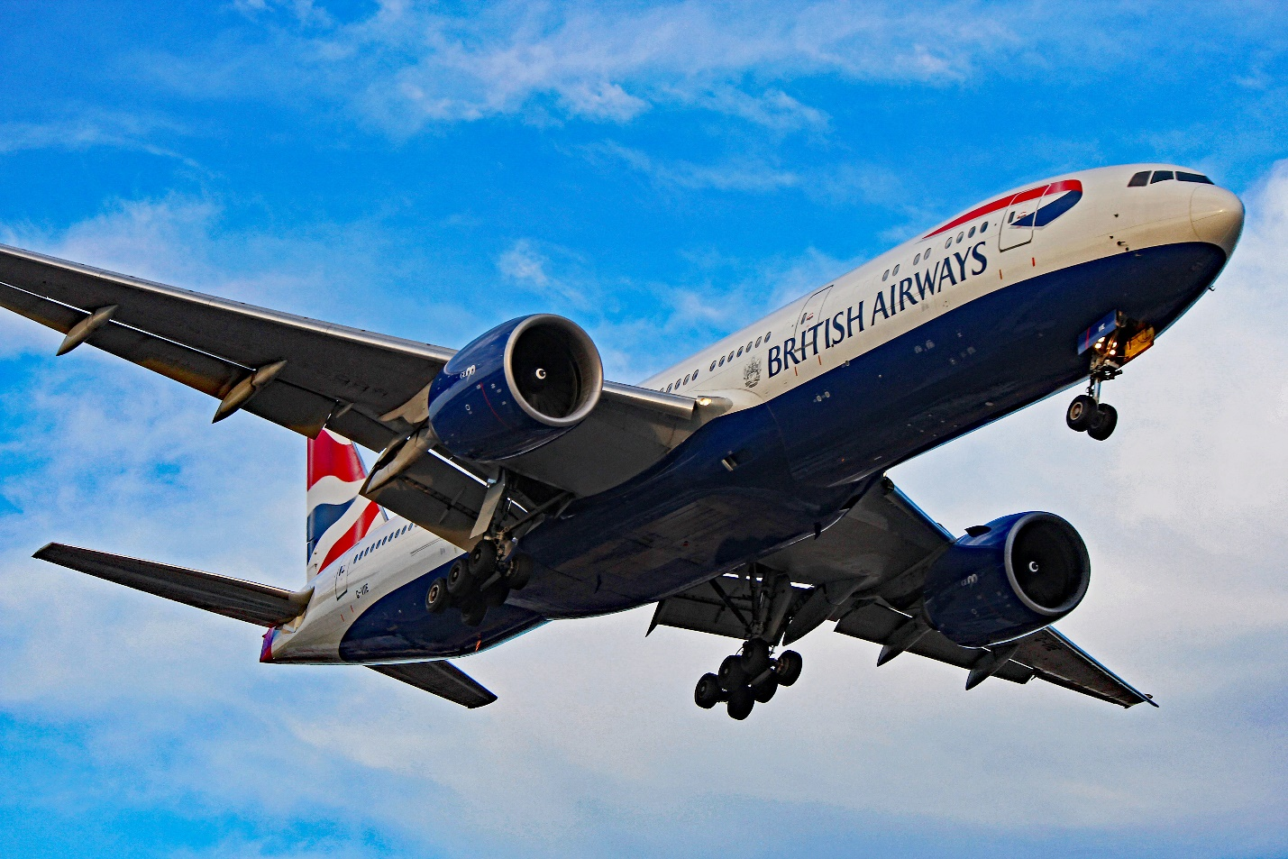
Photo source: http://airplanes.itsabouttravelling.com

REFERENCES
1. Alvesson, M. (2016) Organizational culture. Los Angeles, LA: SAGE.
2. Booth, A. and Melling, J. (2017) “Workplace cultures and business performance: British Labour 3. Relations and industrial output in comparative perspective*,” Managing the Modern Workplace, pp. 1–26. Available at: https://doi.org/10.4324/9781315593654-1.
4. Buchanan, D.A. and Huczynski, A. (2019) Organizational behaviour. Upper Saddle River, USR: Pearson.
5. Caliskan, S., 2019. Individual Behaviour, Regulatory Liability, and a Company’s Exposure to Risk: The Deterrent Effect of Individual Sanctions in UK Competition Law. S. Caliskan,'Individual Behaviour, Regulatory Liability, and a Company’s Exposure to Risk: The Deterrent Effect of Individual Sanctions in UK Competition Law'Journal of European Competition Law & Practice.
6. Erthal, A. and Marques, L., 2018. National culture and organisational culture in lean organisations: a systematic review. Production Planning & Control, 29(8), pp.668-687.
7. Eysenck, H., 2015. Personality at work: The role of individual differences in the workplace. Personality and Individual Differences, 15(1), p.113.
8. Helmreich, R.L. and Merritt, A.C., 2017. Culture at work in aviation and medicine: National, organizational and professional influences. Routledge.
9. Janićijević, N., 2013. The mutual impact of organizational culture and structure. Economic annals, 58(198), pp.35-60.
10. Martínez-Caro, E., Cegarra-Navarro, J.G. and Alfonso-Ruiz, F.J., 2020. Digital technologies and firm performance: The role of digital organisational culture. Technological Forecasting and Social Change, 154, p.119962.
11. Riwo-Abudho, M., Njanja, L. and Ochieng, I., 2013. Impact of organization characteristics on sustainable competitive advantage during strategic change in airlines.
12. Roszkowska, P. and Melé, D., 2021. Organizational factors in the individual ethical behaviour. The notion of the “organizational moral structure”. Humanistic Management Journal, 6(2), pp.187-209.
13. Shahzad, F., Luqman, R.A., Khan, A.R. and Shabbir, L., 2012. Impact of organizational culture on organizational performance: An overview. Interdisciplinary journal of contemporary research in business.

