Ionut Marius Rosu (1910143)
M5X01981 History and Theory 2
How can a building be more than a space?
The Smithsonian Museum of African American History and Culture

Introduction

This essay will discuss how the Smithsonian`s National Museum of African American History and Culture is not only a building designed functionality in mind, but also a building where the design takes a big emphasis on honouring a culture and it`s people.
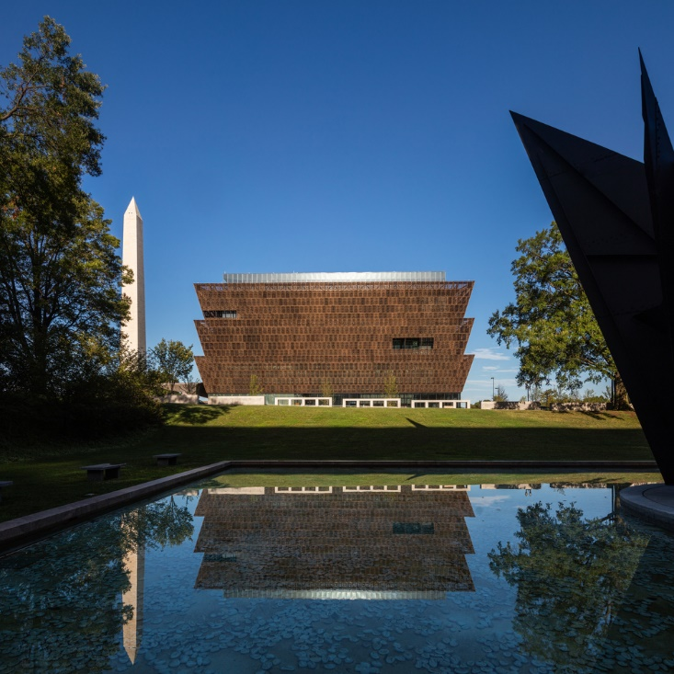
Smithsonian Museum of African American History and Culture. Source:(Smithsonian National Museum of African American History and Culture / Freelon Adjaye Bond/SmithGroup, 2019)

Historical Context

Cutting the ribbon for the museum was a moment long waited by the African American community. The first propositions for opening a museum for their culture came from African American Civil War veterans, over a hundred years ago. In 2003 , the United States president at the time, George W. Bush signed the legislation needed to build the museum, legislation that was previously overlooked for decades. After it was built , the museum was inaugurated by none other than President Barack Obama, the first and to this day, the only African American president of the United States. Inauguration took place before President Obama left the Oval Office. Furthermore, the former President Obama is featured in one of the museum`s expositions. (Minutillo, 2016)
African Americans are imbedded into the United States history. From the first slaves that got off the ships, after they were kidnapped from their lands, to the soldiers who helped the North win the American Civil War, it seemed natural that they would want a monument of their own, where their history, culture and efforts would be honoured and recognized. Unfortunately , even though slavery in the United States was abolished, there was still a segregation issue when it came to the American social environment. This social segregation could be a reason a reason why building of the monument has been pushed back for so many years. Society has evolved and the 2003 signing of the legislation was an important step towards fulfilling the African American people`s desire. Another sign of the society`s evolution is that an African American President “cut the ribbon” at the inauguration.
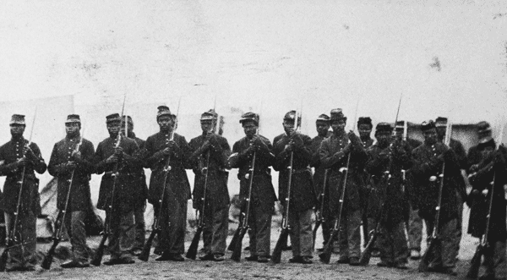
Soldiers of the 1st Louisiana Native Guard, the first all African American Regiment that fought in the American Civil War. Source : (Mclaughlin, 2016)
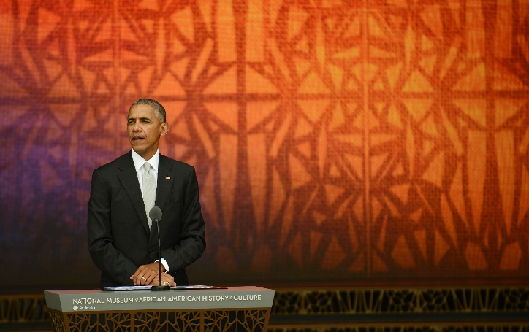
President Barack Obama at the Inauguration of the museum. Source: (Reilly, 2016)
Location
The Smithsonian National Museum of African American History and Culture occupies the last five acres of Washington D.C.`s National Mall, on a site across the Washington Monument, where once was the epicentre of the slave trade in the United States. (Cornachio, n.d.)

Design Consideration
The design team was formed by Adjaye Associates ( a world leading Black-owned architecture practice, lead by Sir David Frank Adjaye , the winner of the 2021 RIBA Royal Gold Medal), in collaboration with The Freelon Group, David Brody Bond LLP and Smith Group JJR. Their proposal, which won the competition held for designing this museum, was called Corona by it`s designers, after an African word which translated to English means “crown”. (Cornachio, n.d.)
The Smithsonian National Museum of African American History and Culture was also the winner of the “Design of the year 2017” award, chosen by the judges of Dezeen Magazine , where it was described by them as a “major turning point in architecture”. (Morby, 2018)
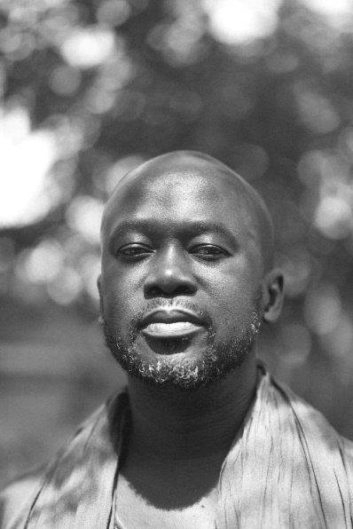 Sir David Adjaye. Source: (Who We Are - Adjaye Associates, n.d.)

Sir David Adjaye`s approach for the project was to establish a meaningful relationship between the building and the site, as well as a relationship between the building`s design and the African American heritage in the United States. (Smithsonian National Museum of African American History and Culture / Freelon Adjaye Bond/SmithGroup, 2019)
This was an important decision , because the museum`s building had to be designed with consideration to it`s context as well as consideration to the museum`s subject, the African American history and culture.
The museum also has a subtility into the landscape, given by the fact that more than 50% of it`s surface is buried below the ground level, with only five storeys rising above the surface.The main focus points when considering the design of the building were: the “corona” shape of the building, the porch ( which is an extension of the building into it`s contextual landscape), and the bronze façade. (Smithsonian National Museum of African American History and Culture / Freelon Adjaye Bond/SmithGroup, 2019)
The design also includes a triple height gallery and a theatre set underground. (Cornachio, n.d.)
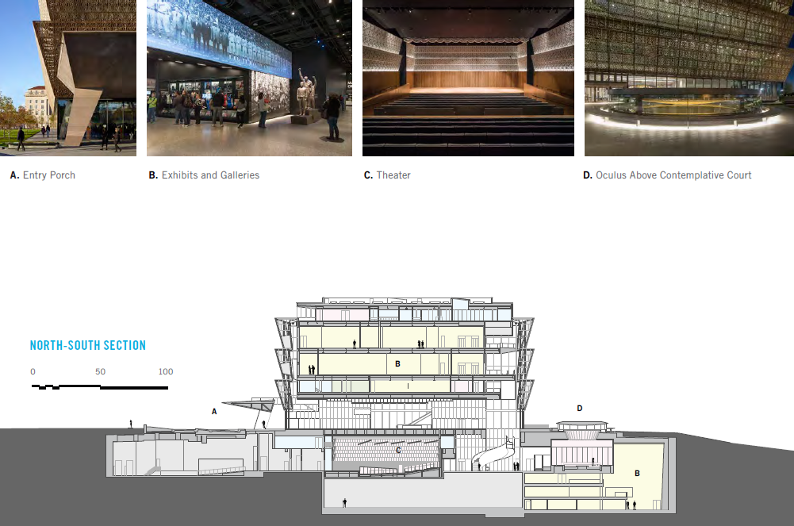
Section showing the building and interior spaces. Source: (unknown author, n.d.)
The “Corona”
The stepping of the façade has been designed in three layers, in order to symbolize the struggles and achievements of African Americans. Inspiration for the stepped design came from one of the sculptures located in the museum`s collection. To be more precise the building`s silhouette draws inspiration from the crown of an African Yoruba sculpture. (Cornachio, n.d.)
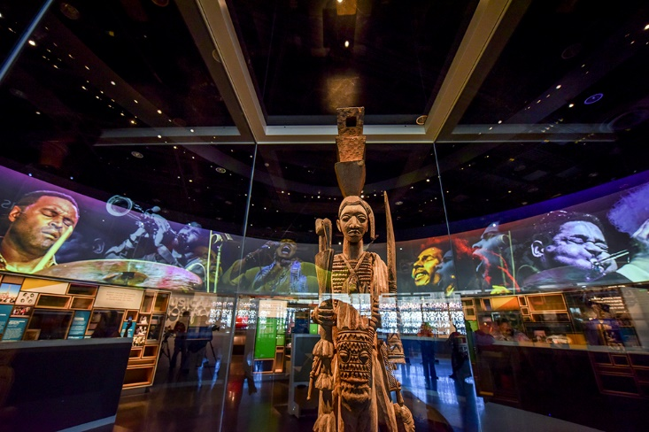
The statue from which`s crown the museum design is inspired from. Source: (Cornachio, n.d.)
Further looking to honour the people to whom the museum is dedicated, the designers looked for inspiration into the museum`s collection. The African Yoruba sculpture`s crown gave the designers a starting point. Clear similarities can be seen between the crown and the museum`s building. Also it can be said that at a symbolic level, the crown has become a building. The crown have always been a symbol of power, and it can be said that because the building is shaped like a crown, it now gives power to the African Americans. Power to be seen, heard, honoured and respected.
The crown also borrows elements from the Washington Monument, with a close match of the 17 degree angle of the monument`s capstone while the interior panel sizes and patterns take inspiration from the monument`s cladding stones. (Smithsonian National Museum of African American History and Culture / Freelon Adjaye Bond/SmithGroup, 2019)
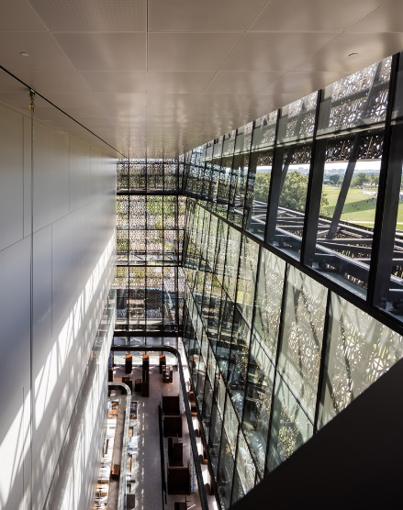 The interior cladding stones inspired by the Washington Monument. Source: (Smithsonian National Museum of African American History and Culture / Freelon Adjaye Bond/SmithGroup, 2019)
Carefully treating the context with respect, the design of the building is tied with the Washington Monument as well. This creates a bridge between the history of the United States and the history of the African American people. This architectural bridging shows the connection between the two in a way that expresses the fact that the two histories are intertwining and an integral part of the United States.
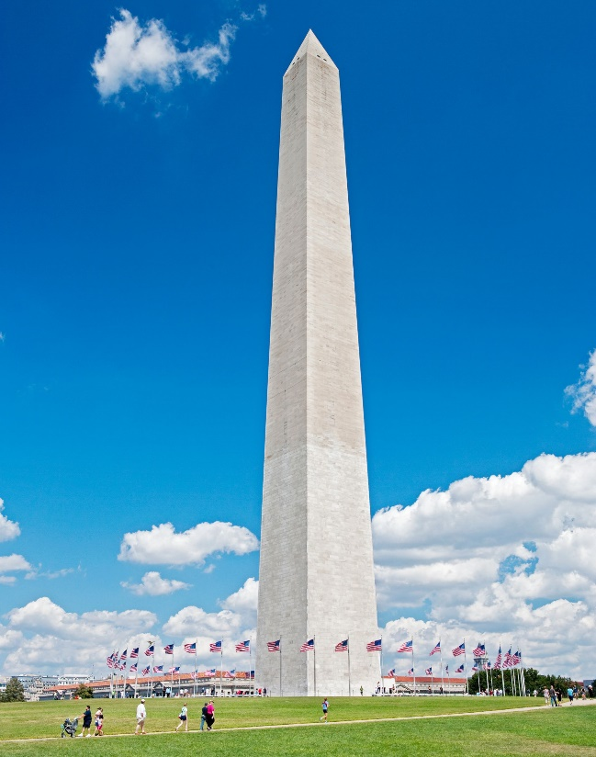 The Washington Monument. Source: (The Washington Monument, n.d.)

The Façade
The façade tiers are ornated with cast aluminium panels which are held by architecturally exposed structural steel (AESS) frames, that are suspended from the façade by steel outriggers. Panel design was inspired by Southern American ironworks, which were often forged by African American slaves. After studying ironwork ornaments from South Carolina to New Orleans, the designers mapped out a historic grille that contained the common points of the designs, and digitally created a modern take of these designs. (Cornachio, n.d.)
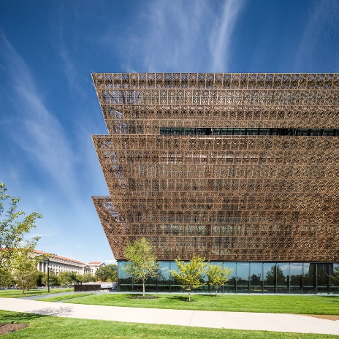 The bronze façade panels wrapping around the building. Source: (Cornachio, n.d.)
It could be said that this move does honour the slaves and their craftsmanship. In a period where African Americans had little to no rights, and they were seen only as “objects” and threated in disgraceful ways, their work and skills were rarely recognised. Not only that but many skilled workers disappeared without ever being mentioned. These panels draw the attention to the skills possessed by the slaves by giving their design a modern interpretation and using this on the building raised in the honour of their people. Not only that , but their work is the “finish of the crown” , is what clothes the symbol of power.
There are four panel types with varying degrees of opacity, ranging between 65%-90% . this is due to the fact that the panels are oriented in such way that they allow for natural light to come in and flood the public spaces, while protecting the exhibition areas from direct sunlight and glare. The original designs specified the use of genuine bronze panels. Unfortunately , due to budgetary issues, this idea was scrapped , because the manufacture of genuine bronze panels proved to be to high cost and the panels required too much maintenance once installed. This lead to a collaboration between the design team and Valsper, collaboration that resulted in the creation of a simulated bronze coating for the cast aluminium panels used today. This coating was obtained by mixing Valspar`s standard “Black Fluoropon” metal coating shade with three custom made shades that were specifically made for this project: African Sunset, African Sunrise and African Rose. (Cornachio, n.d.)
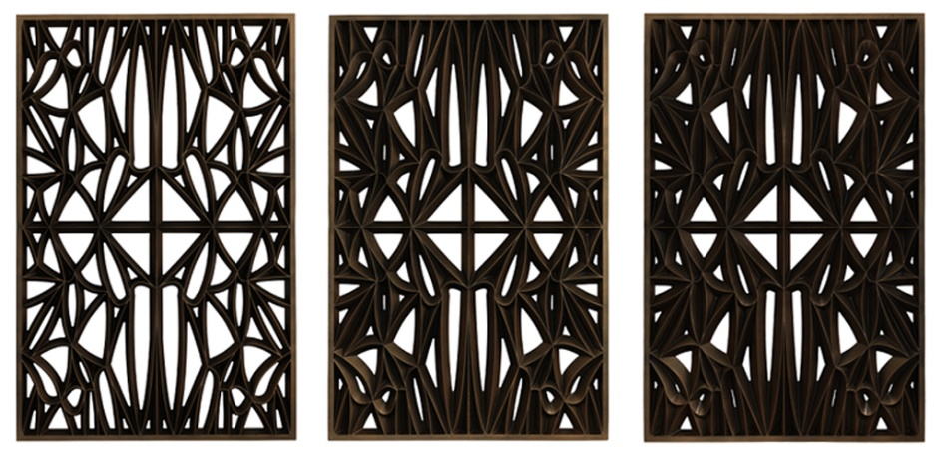
The different panel types used to clad the museum. Source: (Cornachio, n.d.)
The name of the custom colour shades is a further reference to the roots of the people in who`s honour this building has been raised. This coating names are not only a reminder of the origin of African Americans, but also a reference to the warmth and beauty of their origins.
The hand coating of the panels has been chosen in detriment of mechanical coating , in order to give the panels a natural shade variation , to which a pigmented clear coating was added for an increased level of depth. Project architect Hal Davis arguments the move as a way to express African American culture differently than by using stone. The panels display different shades of bronze , depending on the time of day , seasons, and exposure to elements. (Cornachio, n.d.)
Again , the panels are furthering the idea and concept of honouring the African American culture. The different shades of bronze that appear in correspondence with the external factors are used as a metaphor in order to show the different faces of African American culture.
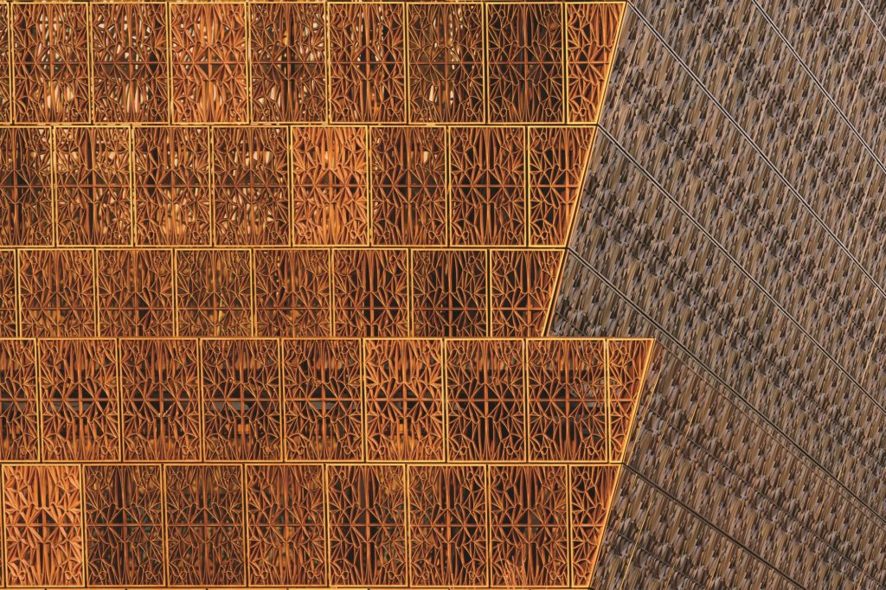
The different shades of bronze displayed by the panels. Source: (Cornachio, n.d.)

Moving towards the interior , the narrative created by the bronze coloured panels is carried on by the bronze trimmed terrazzo floors. Same floors “speckled with African marble”, apart from continuing the narrative of historic and cultural references showcased by the façades , are also painted by the patterning of the outside panels. This leads to a complex dance of light and shadow. Looking from the inside-out, the patterned panels also frame views of the Memorial Grounds. (Cornachio, n.d.)
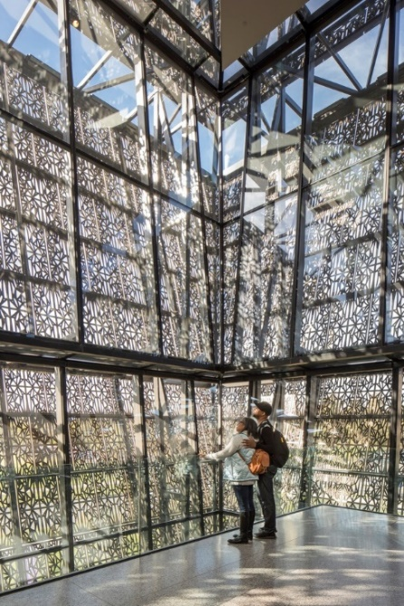View from the interior, showing the panels, floors and the dynamic of lighting. Source: (Cornachio, n.d.)
The inside can be considered a continuation of the outside. The building displays the same references to African American culture. This time, the exterior bronze coloured panels use the flooring as a canvas to paint their shadow and remind about their craftsmen`s stories in another way. The dynamic changes a bit because this time the shadows casted by the panels onto the floor, will inevitably be cast on the visitors as well , and this time, the interaction between the visitors and the panels makes the visitors an integral part of the narrative.
It can also be said that these panels have an important role into the design, because by wrapping the building on the outside , they can be seen by everyone and that they were used as a series of paintings that tell a part of the African American story.

The Porch
The Porch and a central water feature are the elements that define and compose the South entry. This porch is the buildings extension into the landscape, and it creates an outdoor room that has the role to soften the passage between the interior and exterior spaces. With a depth of 50 m , the setback doesn`t stand apart from any other buildings that can be found on the Mall`s Northern side. With the help of the upward tilting of the Porch`s roof, the water below it casts it`s reflection on the aforementioned roof. This covered area serves as a shelter from the hot summer days, by creating a microclimate where breezes of air are combined with the cooling waters. The Porch`s rooftop has an outdoor patio that can be accessed from within the building via a mezzanine level. (Smithsonian National Museum of African American History and Culture / Freelon Adjaye Bond/SmithGroup, 2019)
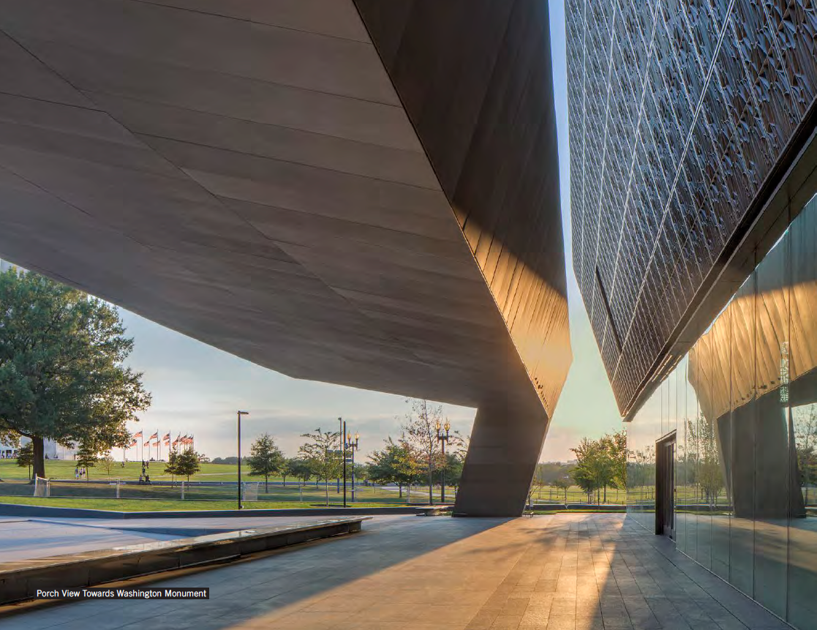
The Porch. Source: (author unknown, n.d.)
It can be said that the Porch is a relaxation space. The most interesting thing about it is that it has it`s own microclimate used to cool down the space and it`s users. Another utility of it is that it creates a soft passage between the outdoor and indoors spaces. This provides a linear passage between the spaces for the users and visitors, which enhances the experience felt while using the building and also helps the visitors immerse themselves into a soft transition from everyday life or the outside weather to the experience of visiting a museum and find out information about that museum`s collection. Also by reflecting the water on the Porch`s roof it creates the illusion of fluidity to the roof, which softens the impact of an otherwise solid and static element.

The Inside Galleries
Vast open spaces, without restrictive columns, natural flooding light, a dynamic material palette that includes precast concrete, timber and a glass box wrapped by a bronze lattice guide the visitors inside the building on a journey of history and emotion. The underground ambiance changes to “contemplative and monumental” with the help of a triple height history gallery. Moving up into the building, the views become a focus point for the visitors walking around the “corona” as they take pleasure into looking at “unrivalled panoramas” of the Mall, Federal Triangle buildings and Monument Grounds. (Smithsonian National Museum of African American History and Culture / Freelon Adjaye Bond/SmithGroup, 2019)
The building uses its design, play of light and materials to induce a certain feeling into the gallery spaces , in order to give an immersive story to it`s visitors. But that`s not the whole story. The spaces around the galleries make use of their surroundings and actually transform the building`s context into an “outdoor museum”, by framing the neighbouring buildings into unforgettable views.
The inside galleries follow the tiered pattern, starting from the underground. For a fully immersive experience, the visitors should start their tours from the lowest level, where the story of African Americans begins with low lit galleries that showcase expositions about slavery. The exhibition opens up into larger spaces, as visitors ascend from the lower spaces, with the help of ramps decorated like historic galleries. On their ascension from the underground, the visitors can observe large exhibits, like a Jim Crowe-era railroad passenger car, and a plane used by the Tuskegee Airmen. On the ground floor, the visitors are welcomed by the contemplative court and a cafeteria that offers a menu comprised of soul food. Moving up the building , the galleries are still on the darker side , to contrast the light filled spaces outside them, in order to keep the visitors engaged. The journey inside the building ends at the top level gallery , which offers views of Washington D.C. (Minutillo, 2016)
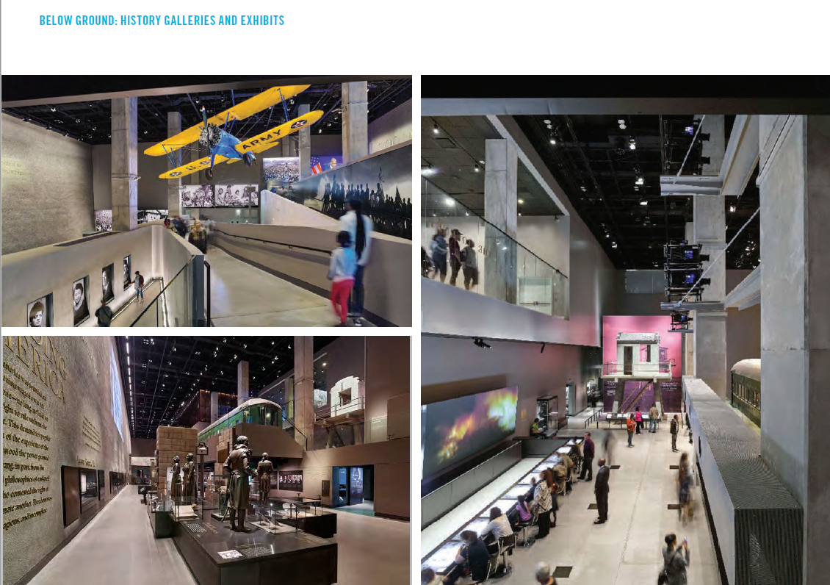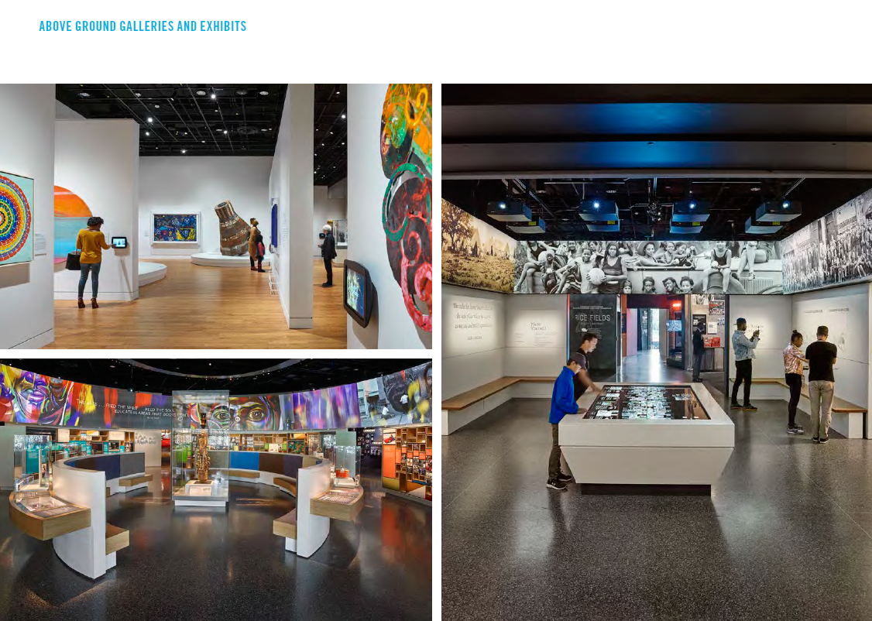
Examples of the gallery spaces from the museum. Source: (author unknown, n.d.)

Conclusion
Judges of the “Design Museum” competition selected the building for it`s role as a “reminder that design enables a diverse conversation and can challenge the dominant political discourse”. (Cornachio, n.d.)
Considering the volatility of the racial problems in the United States at the time, the Smithsonian National Museum of African American History and Culture showcased a design that through it`s way of referencing and honouring a culture, provided a bridge over the gap that was created by the socio-political environment at the time. The pilasters of the “bridge” are : the three layers of the building ( referencing the crown of the statue), the bronze panels ( referencing the craftsmen, forgers and slaves) and the location of the museum (in the National Mall, across the Washington Monument , where an old slave market used to be). This building shows the world the best of a culture that for centuries was considered inferior, and that has many times proved that it can stand tall next to all the others.

Word count: 2377 words, without references.

Reference List:
n.d. [ebook] pp.10,11,15, 22. Available at: <https://www.aiadc.com/sites/default/files/048%20-%20SmithsonianInstitution-NationalMuseumofAfricanAmericanHistoryandCulture.pdf> [Accessed 21 March 2021].
Cornachio, J., n.d. Architectural Details: David Adjaye’s Museum of African American History. [online] Journal. Available at: <https://architizer.com/blog/practice/details/architectural-details-david-adjaye-smithsonian/> [Accessed 20 March 2021].
Mclaughlin, W., 2016. 1st Louisiana Native Guard: The All Black Regiment Which Fought For The South And The North In The Civil War. [online] WAR HISTORY ONLINE. Available at: <https://www.warhistoryonline.com/instant-articles/1st-louisiana-native-guard-black-regiment-fought-south-north.html> [Accessed 21 March 2021].
Minutillo, J., 2016. National Museum of African American History and Culture by Freelon Adjaye Bond/Smith GroupJJR. [online] Architecturalrecord.com. Available at: <https://www.architecturalrecord.com/articles/11964-national-museum-of-african-american-history-and-culture> [Accessed 21 March 2021].
Morby, A., 2018. Adjaye's African American history museum wins Design of the Year 2017. [online] Dezeen. Available at: <https://www.dezeen.com/2018/01/25/david-adjaye-smithsonian-national-museum-of-african-american-history-and-culture-wins-design-of-the-year-2017/> [Accessed 20 March 2021].
Reilly, K., 2016. Read Obama's Speech at the Museum of African American History and Culture. [online] Time. Available at: <https://time.com/4506800/barack-obama-african-american-history-museum-transcript/> [Accessed 21 March 2021].
ArchDaily. 2019. Smithsonian National Museum of African American History and Culture / Freelon Adjaye Bond/SmithGroup. [online] Available at: <https://www.archdaily.com/794203/smithsonian-national-museum-of-african-american-history-and-culture-adjaye-associates> [Accessed 20 March 2021].
n.d. The Washington Monument. [image] Available at: <https://www.dkfindout.com/uk/earth/landmarks-world/washington-monument/> [Accessed 21 March 2021].
Adjaye Associates. n.d. Who We Are - Adjaye Associates. [online] Available at: <https://www.adjaye.com/who-we-are/> [Accessed 21 March 2021].

