

University of Wales Trinity Saint David
Birmingham Campus

Module Code: LCMB7023
Assessment Component 1: Individual Report
Innovating New Working Practices and Breeding an Environment Where Talent May Grow
Student Name: | Manav Prajapati
Student ID Number: | 2605419
Programme: | MBA International Business
Module: | Human Capital Management
Lecturer: | Eno Maycock (Birmingham)
Word Count: | 2553 Words
Submitted on: | 13th October, 2026

Table of Contents
List of Abbreviations 3
Task A: Designing Innovative Working Practices 4
1. Critical Evaluation: Traditional Work Design versus Contemporary Innovative Working Practices 4
2. Recommended Innovative Working Practices for NHSX 6
Task B: Creating an Environment Where Talent Grows 9
1. How Organisations Create Environments Where Talent Flourishes 9
2. Talent Growth Strategy for NHSX 10
Task C: Reflective Report 12
1. AI as a Strategic Decision-Support Tool in HRM 12
2. Reflective Analysis: Three Examples of Using AI 12
3. Personal Capability Development Plan 13
References 14
Appendix 17

List of Figures
Figure 1: The Ability, Motivation and Opportunity (AMO) Framework Applied to NHSX
Figure 2: The Job Demands-Resources (JD-R) Balance at NHSX
Figure 3: Three Pillars of Innovative Work Design at NHSX
Figure 4: Three Theories of Talent Flourishing
Figure 5: The NHSX Talent Growth Strategy
Figure 6: Rolfe et al.'s Reflective Framework Applied to My Use of AI
List of Tables
Table 1: Mechanistic versus Organic Work Design at NHSX
Table 2: Personal Capability Development Plan
Table 3: Integrated 12-Month Roadmap (Appendix B)

List of Abbreviations
Short Form | Full Form
NHSX | NexSpace Health Systems
MBA | Master of Business Administration
HR | Human Resources
HRM | Human Resource Management
AI | Artificial Intelligence
HPWS | High-Performance Work Systems
HIWS | High-Involvement Work Systems
AMO | Ability, Motivation and Opportunity
JD-R | Job Demands-Resources
SDT | Self-Determination Theory
STS | Sociotechnical Systems
EX | Employee Experience
eNPS | Employee Net Promoter Score
UX | User Experience
GDPR | General Data Protection Regulation
CIPD | Chartered Institute of Personnel and Development
ICO | Information Commissioner's Office
UK | United Kingdom
UAE | United Arab Emirates

Task A: Designing Innovative Working Practices

1. Critical Evaluation: Traditional Work Design versus Contemporary Innovative Working Practices
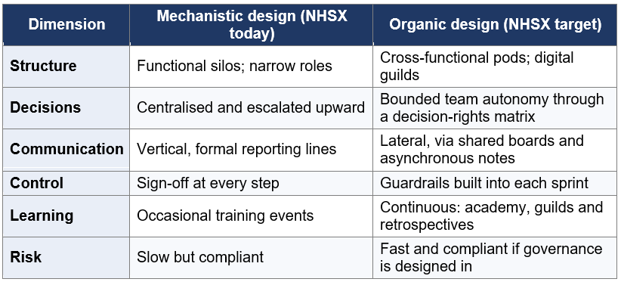
NHSX’s mechanistic structure silos, centralised control and narrow roles protects clinical safety but slows decisions and limits innovation. The challenge is selective redesign: balancing platform exploitation with exploration of new AI products. Ambidexterity requires more organic teamwork and autonomy, supported by governance proportionate to clinical risk.
Table 1: Mechanistic versus Organic Work Design at NHSX (Source: Adapted from Burns and Stalker, 1961; Gibson and Birkinshaw, 2004; NHSX applications are the author's own analysis)
High-performance work systems (HPWS) bundle practices that build employees' ability, motivation and opportunity to perform, known as the AMO framework (Appelbaum et al., 2000; Boxall and Purcell, 2016). The evidence is broadly supportive. Huselid (1995) and Combs et al. (2006) associate HPWS with higher productivity and lower turnover, while Delery and Doty (1996) show that the fit between practices and strategy matters more than any single practice. The evidence is also contested. Ramsay, Scholarios and Harley (2000) found little support for a simple "mutual gains" story, with HPWS linked to greater commitment but also to work intensification, and Guest (2017) argues that wellbeing should be treated as an outcome in its own right, not a by-product. HPWS therefore suit NHSX's knowledge workers (Figure 1) only if success is judged on employee as well as financial outcomes.
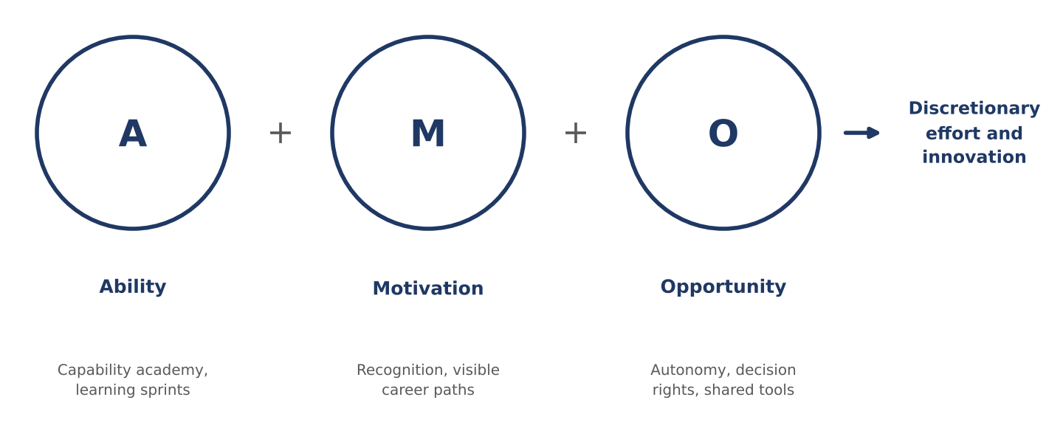
Figure 1: The Ability, Motivation and Opportunity (AMO) Framework Applied to NHSX (Source: Adapted from Appelbaum et al., 2000; Boxall and Purcell, 2016; NHSX applications are the author's own analysis)
The job demands-resources (JD-R) model explains why. Demands such as workload and time pressure deplete energy, whereas resources such as autonomy, feedback and supportive leadership sustain engagement and buffer strain (Bakker and Demerouti, 2007, 2017). Flexible and high-involvement practices can themselves become demands: Kelliher and Anderson (2010) found that flexible workers reported greater work intensification, because they reciprocated autonomy with extra effort. At NHSX, where managers already struggle to balance wellbeing with performance, innovation practices must be designed so that resources grow faster than demands (Figure 2).
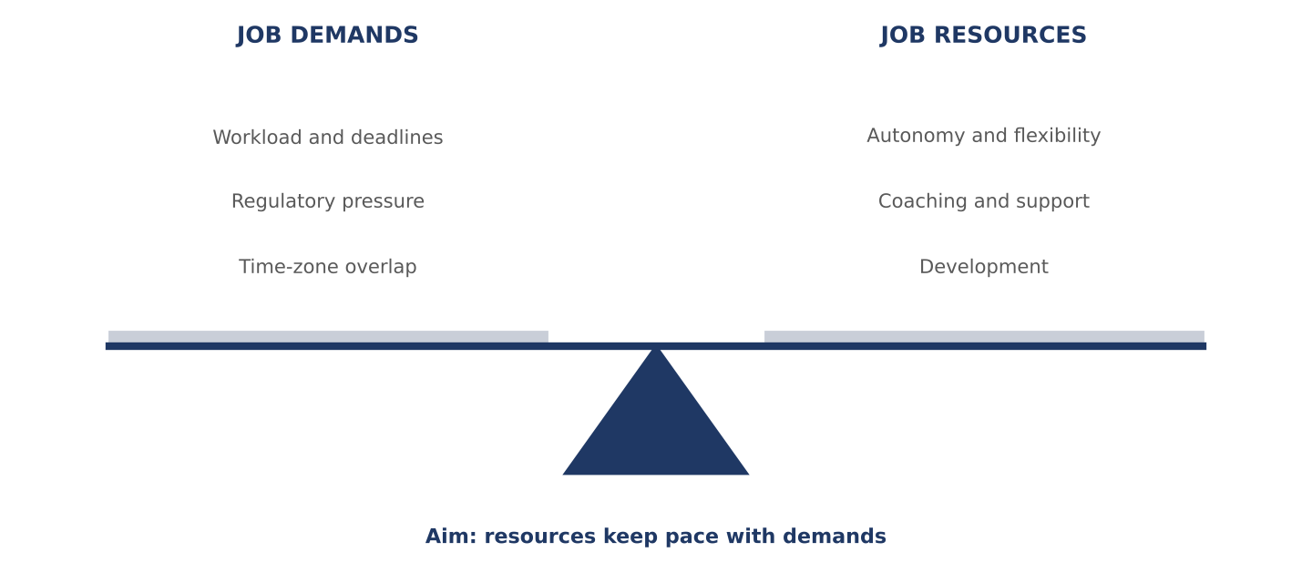
Figure 2: The Job Demands-Resources (JD-R) Balance at NHSX (Source: Adapted from Bakker and Demerouti, 2007, 2017; NHSX examples are the author's own analysis)

High‑involvement work systems (HIWS) extend participation by pushing power, information and rewards downward (Lawler, 1986). Self‑determination theory explains why: autonomy, competence and relatedness fuel intrinsic motivation (Ryan and Deci, 2000). HIWS directly address NHSX’s slow decisions and limited creativity, but autonomy must be bounded in clinical software. Sociotechnical principles such as minimal critical specification (Cherns, 1976) suggest defining only essential constraints and leaving the rest to teams through clear decision rights. Cultural expectations also matter: autonomy may be interpreted differently across the UK, India and the UAE (Hofstede, 1980), so involvement should be introduced through dialogue.

Agile working provides the operating mechanism. Short cycles, cross‑functional teams and rapid feedback replace sequential hand‑offs, but agile succeeds only when leaders genuinely release control. Compliance‑critical work still requires fixed gates.

Hybrid working extends autonomy but carries relational risks. Remote work improves autonomy and reduces conflict (Gajendran and Harrison, 2007) but can weaken relationships and visibility (Bloom et al., 2015). Outcomes depend on management quality (Allen et al., 2015), aligning with NHSX’s cross‑border collaboration challenges.

Sociotechnical systems theory integrates these insights: digital tools, AI platforms and agile routines must be designed together with roles and norms. Evidence supports a combined design, but effects depend on implementation quality, context and resourcing. NHSX should pilot, measure and adjust rather than adopt practices wholesale.

2. Recommended Innovative Working Practices for NHSX
Building on this evidence, I recommend an integrated design resting on three pillars: flexible working, employee autonomy and digital collaboration technologies (Figure 3). Each pillar answers a specific NHSX weakness, and together they form an HPWS/HIWS bundle in which the practices reinforce one another.
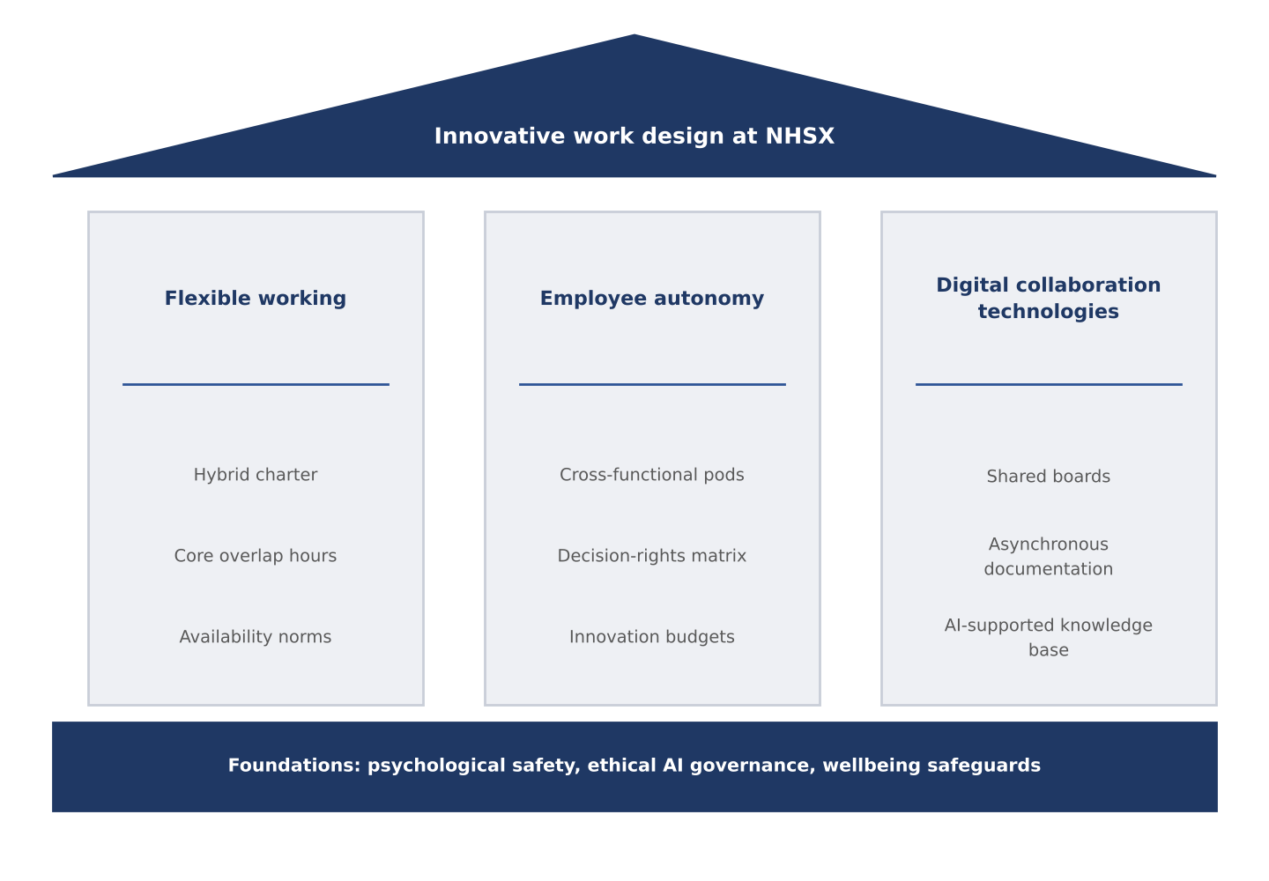
Figure 3: Three Pillars of Innovative Work Design at NHSX (Source: Author's own synthesis, drawing on Lawler, 1986; Wenger, 1998; Kelliher and Anderson, 2010)

Pillar 1: Flexible Working

A hybrid charter would set anchor days for live collaboration, shared core overlap hours across the UK, India and the UAE, and flexible time around them for focused work. Clear availability norms would prevent the intensification risk noted by Kelliher and Anderson (2010), while promotion and project allocation based on contribution rather than visibility would counter proximity bias (Bloom et al., 2015). The rationale draws on AMO (flexibility widens opportunity), JD‑R (control buffers demands) and SDT (choice supports motivation). Expected outcomes include lower burnout, stronger cross‑time‑zone collaboration and improved retention.

Pillar 2: Employee Autonomy

Cross‑functional pods of six to ten people would own problems end to end in two‑week sprints, with safety and compliance checks built into the definition of done. A decision‑rights matrix would clarify which decisions pods take independently, consult on or escalate. Innovation budgets and protected discovery time would give autonomy substance. This reflects organic design, high involvement and SDT’s autonomy and competence needs. Leaders shift from approvers to coaches, requiring explicit support.

Pillar 3: Digital Collaboration Technologies

A unified digital workspace with shared boards, asynchronous documentation and an AI‑supported knowledge base would enable work across time zones. Global guilds would rebuild knowledge flow through communities of practice. Sociotechnical principle s require pairing tools with norms on documentation and response times to avoid overload.

Expected Outcomes and Measurement
The model should deliver faster decisions and shorter delivery cycles, lower attrition through autonomy and flexibility, stronger innovation and cross-border collaboration, and reduced burnout through better job resources. These would be measured through cycle time and deployment frequency (delivery), eNPS and attrition among high performers (retention), collaboration ties identified by network analysis of cross-country interaction, and clinical-quality indicators, so that speed is never traded for safety. Baselines set in the first two months of the roadmap (Appendix B) allow comparison with pilot pods. Piloting with two or three pods before scaling limits the risk of an initial productivity dip.

Task B: Creating an Environment Where Talent Grows

1. How Organisations Create Environments Where Talent Flourishes
NHSX's loss of high performers, and managers' difficulty balancing wellbeing with performance, suggest that its human capital is not yet being converted into sustained advantage. Human capital theory treats skills as assets that yield returns on investment (Becker, 1964), and strategic talent management concentrates that investment on pivotal roles (Collings and Mellahi, 2009). Mitchell et al. (2001) add that people stay when they experience fit, links and a high sacrifice of leaving, all of which weaken when growth pathways are unclear. Three theories explain how organisations can build such an environment in practice (Figure 4): the learning organisation, growth mindset and self-determination theory.
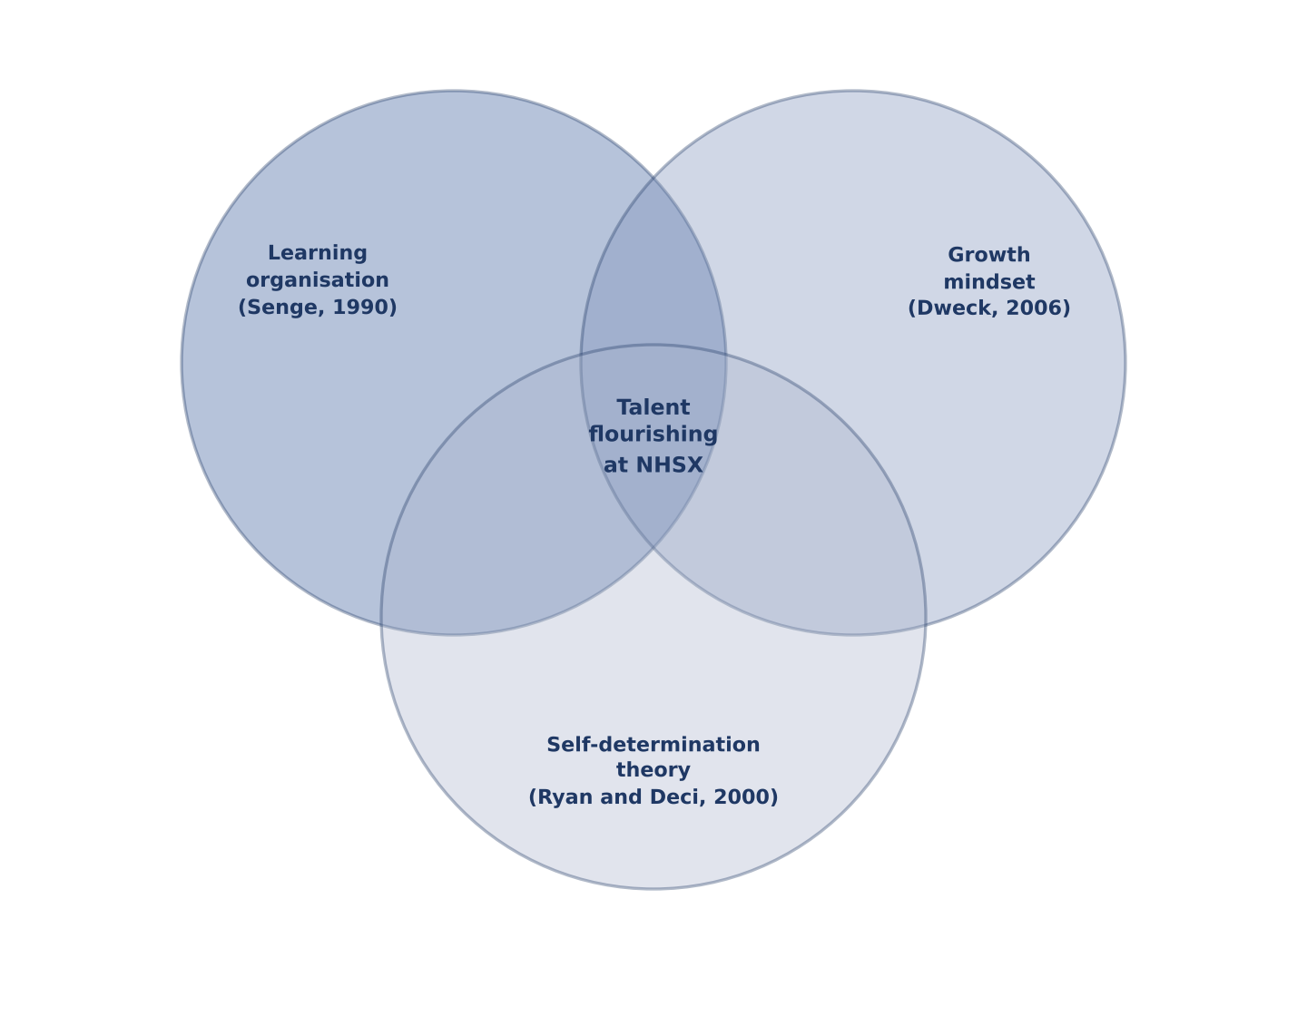
Figure 4: Three Theories of Talent Flourishing (Source: Author's own synthesis, drawing on Senge, 1990; Dweck, 2006; Ryan and Deci, 2000)
Senge's (1990) learning organisation holds that organisations learn when five disciplines operate together: personal mastery, mental models, shared vision, team learning and systems thinking. This embeds learning in everyday work and not only in training events, which matters at NHSX because AI-enabled healthcare demands continuous upskilling in technical, clinical and ethical domains. Systems thinking is especially relevant to a business with silos, because it asks teams to see how their work affects the whole. Critics note that Senge's model is idealistic and hard to operationalise; Garvin, Edmondson and Gino (2008) respond with practical building blocks: a supportive learning environment, concrete learning processes and leadership that reinforces learning.
Dweck's (2006) growth mindset, the belief that ability develops through effort, strategy and feedback, supplies the individual-level counterpart. People with a growth mindset treat setbacks as information, and leaders who model this encourage the experimentation that NHSX needs for innovation. The evidence is more modest than the popular literature implies: in educational settings, Sisk et al. (2018) found only weak overall effects of mindset interventions on achievement. Mindset should therefore be supported by organisational conditions and not treated as a stand-alone cure. The most important condition is psychological safety, the shared belief that the team is safe for interpersonal risk-taking (Edmondson, 1999), which predicts learning behaviour and error reporting (Edmondson and Lei, 2014), both vital where patient safety and ethical AI are at stake. A manager who can discuss workload openly can recalibrate expectations before burnout leads to resignation.
Self-determination theory (SDT) explains why development efforts succeed or fail at the level of motivation. Ryan and Deci (2000) argue that intrinsic motivation and wellbeing depend on three psychological needs: autonomy, competence and relatedness. A learning programme imposed without choice may build competence but frustrates autonomy, whereas job crafting, in which employees reshape tasks, relationships and the meaning of their work (Wrzesniewski and Dutton, 2001; Tims and Bakker, 2010), meets the autonomy need directly. Mentoring and cross-border teamwork serve relatedness. The risk is that unmanaged crafting creates role ambiguity or uneven workloads, so it needs manager dialogue and clear boundaries.
The three theories overlap but are complementary: Senge describes the organisational system, Dweck the mindset that makes people use it and SDT the motivational needs that sustain it. A limitation is that all three originate mainly in Western settings, so NHSX should test their fit across its UK, India and UAE teams (Hofstede, 1980).

2. Talent Growth Strategy for NHSX
Figure 5 translates the three theories into the NHSX Talent Growth Strategy, six strands organised under three headings. It works as a system and not a menu: mentoring fails without psychological safety, and mobility is empty without learning.
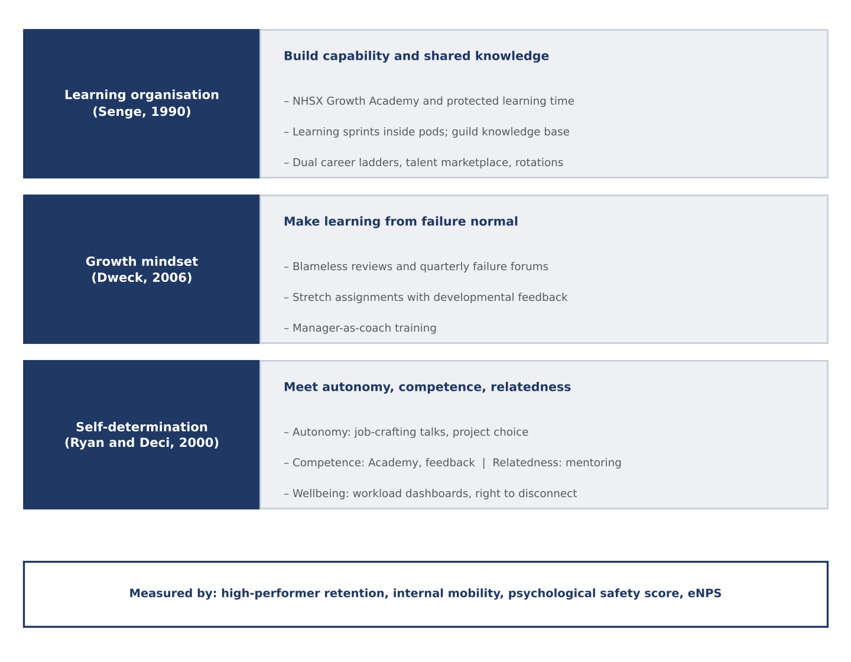
Figure 5: The NHSX Talent Growth Strategy (Source: Author's own synthesis, drawing on Senge, 1990; Dweck, 2006; Ryan and Deci, 2000; Mitchell et al., 2001)

Learning Organisation (Senge): Build Capability and Shared Knowledge
Learning and capability. An NHSX Growth Academy would offer blended learning in AI and data science, clinical knowledge, ethical AI and product management, tied to a shared vision of safer, smarter healthcare. Protected learning time, for example half a day a fortnight, and periodic "learning sprints" inside pods would link study to real work, while lessons would be captured in the guild knowledge base to support team learning.
Careers and mobility. Dual career ladders would let specialists progress in expertise without having to manage people, for example AI engineer to principal engineer to AI ethics lead. An internal talent marketplace would advertise projects and roles, and cross-border rotations would build links across the UK, India and the UAE, which Collings, Mellahi and Cascio (2019) identify as important in global talent management. These measures strengthen fit, links and the sacrifice of leaving (Mitchell et al., 2001).

Growth Mindset (Dweck): Make Learning from Failure Normal
Safe-to-learn culture. Managers would be trained to model curiosity, admit mistakes and respond constructively to bad news. Psychological safety would be tracked through short surveys (Edmondson, 1999), and failed experiments and incidents reviewed through blameless post-mortems and quarterly failure forums where teams share lessons across countries.
Relationships and coaching. Manager-as-coach training would shift managers from judging to developing, with feedback that praises effort and strategy, and stretch assignments would be framed as development and not tests. Mentoring would support newly promoted staff, and reverse mentoring would let junior technical staff brief senior leaders on emerging tools.

Self-Determination (Ryan and Deci): Meet Autonomy, Competence and Relatedness
Autonomy and job crafting. Annual job-crafting conversations would let employees propose tasks to expand, reduce or reshape, and give them a voice in project choice. Managers would agree feasible adjustments in line with team goals and regulatory constraints.
Wellbeing and EX. Workload dashboards would track overtime, late-night working and meeting load, supported by right-to-disconnect norms and inclusive access to development for part-time, remote and neurodivergent staff. Because monitoring can feel intrusive, indicators should be aggregated, transparent and governed by data-protection principles (ICO, 2023).

Measuring Impact
Success would be tracked through retention of high performers, internal mobility rate, psychological safety scores, eNPS, learning hours completed and workload indicators, reviewed in the same governance forum as the work-design pilots so that talent strategy and work design stay aligned. The strategy is phased across twelve months (Appendix B). Retention effects may take longer than a year to show, so leading indicators such as safety scores and mobility applications are important.

Task C: Reflective Report

1. AI as a Strategic Decision-Support Tool in HRM

AI can strengthen HR decision‑making by improving attrition prediction, skills matching and engagement analysis (Marler and Boudreau, 2017; Tambe, Cappelli and Yakubovich, 2019). For NHSX, these tools would enhance workforce planning and help spot burnout early. Yet risks remain: biased historical data (Raghavan et al., 2020), opaque models (Pasquale, 2015) and the potential for surveillance. Legal limits such as UK GDPR Article 22, the Data Protection Act 2018 and the Equality Act 2010 apply, alongside rules in India and the UAE (ICO, 2023). Ethical use requires transparency, bias audits, human oversight and accountability. As an HR professional, I must interpret AI critically and keep decisions human‑centred.

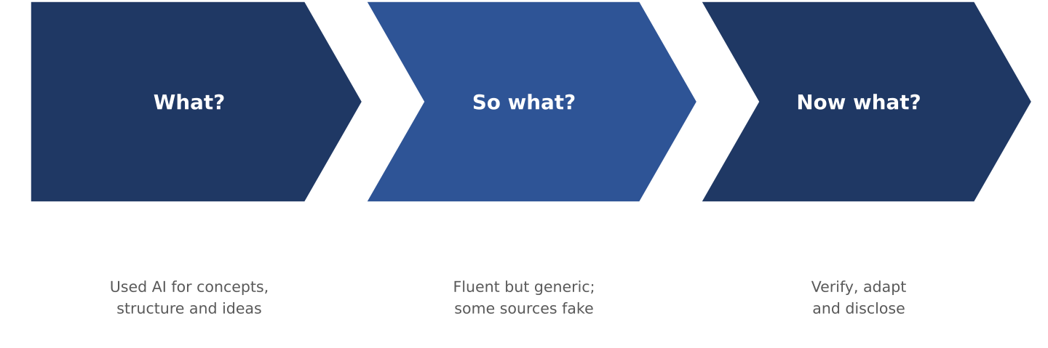
2. Reflective Analysis: Three Examples of Using AI
Figure 6: Rolfe et al.'s Reflective Framework Applied to My Use of AI (Source: Adapted from Rolfe, Freshwater and Jasper, 2001)
I used Rolfe, Freshwater and Jasper's (2001) framework (Figure 6), which asks three questions: What? So what? Now what? Its simplicity suits learning from a tool's strengths and failures, although it gives less structure for exploring feelings, so I note these within the "what" stage (Moon, 2004).
Example 1: Clarifying concepts. What? AI explained theories such as HPWS, STS and SDT in plain language and helped me orient quickly. So what? Its summaries were fluent but sometimes simplified, and I only noticed by reading the original sources. Fluent text feels authoritative, which exposed my tendency to prioritise efficiency over depth. Now what? I use AI for orientation only and verify every claim against the source.
Example 2: Structuring the report. What? AI proposed a logical structure for Tasks A to C. So what? Its ideas were often generic and could have applied to any organisation, and an unquestioned structure would have weakened relevance to NHSX. Now what? I rebuilt the argument around the case's specific problems (silos, cross-border collaboration and attrition) and treat AI as a planning partner, not the author.
Example 3: False references. What? When I asked AI to suggest supporting references, it produced citations that looked plausible but were inaccurate or did not exist. So what? I felt alarmed, because including them would have been an academic-integrity breach, and I saw that generative models predict plausible text and do not retrieve truth. This is the same verification discipline HR needs when AI generates people data. Now what? I check each source in a library database or publisher record before use and disclose AI use (Appendix A).
Across the three examples, AI increased my efficiency and breadth but could not replace critical evaluation, ethical awareness or human judgement, the foundations of responsible HR practice.

3. Personal Capability Development Plan
To strengthen my employability, understood as the adaptive capacity to identify and realise career opportunities (Fugate, Kinicki and Ashforth, 2004), I will develop five capabilities aligned with the HR competency domains of people, business and technology (Ulrich et al., 2008) and the CIPD (2021) Profession Map. Table 2 sets out goals, actions and success measures.

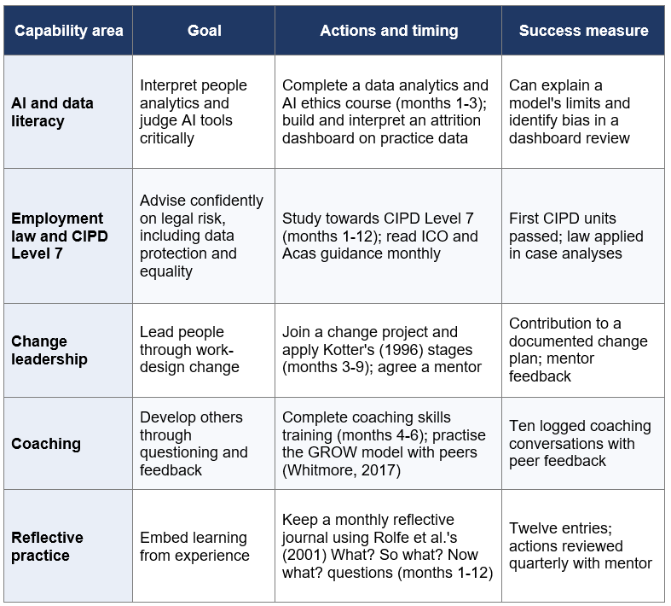
Table 2: Personal Capability Development Plan (Source: Author's own analysis)
These capabilities mirror the NHSX roadmap: I intend to practise what I recommend, namely psychologically safe learning, coaching and the ethical use of AI.

References
Allen, T.D., Golden, T.D. and Shockley, K.M. (2015) 'How effective is telecommuting? Assessing the status of our scientific findings', Psychological Science in the Public Interest, 16(2), pp. 40-68.
Appelbaum, E., Bailey, T., Berg, P. and Kalleberg, A.L. (2000) Manufacturing advantage: Why high-performance work systems pay off. Ithaca, NY: Cornell University Press.
Bakker, A.B. and Demerouti, E. (2017) 'Job demands-resources theory: Taking stock and looking forward', Journal of Occupational Health Psychology, 22(3), pp. 273-285.
Bakker, A.B. and Demerouti, E. (2007) 'The job demands-resources model: State of the art', Journal of Managerial Psychology, 22(3), pp. 309-328.
Becker, G.S. (1964) Human capital: A theoretical and empirical analysis, with special reference to education. New York: Columbia University Press.
Bloom, N., Liang, J., Roberts, J. and Ying, Z.J. (2015) 'Does working from home work? Evidence from a Chinese experiment', Quarterly Journal of Economics, 130(1), pp. 165-218.
Boxall, P. and Purcell, J. (2016) Strategy and human resource management. 4th edn. London: Palgrave Macmillan.
Burns, T. and Stalker, G.M. (1961) The management of innovation. London: Tavistock.
Cherns, A. (1976) 'The principles of sociotechnical design', Human Relations, 29(8), pp. 783-792.
CIPD (2021) CIPD Profession Map. London: Chartered Institute of Personnel and Development.
Collings, D.G. and Mellahi, K. (2009) 'Strategic talent management: A review and research agenda', Human Resource Management Review, 19(4), pp. 304-313.
Collings, D.G., Mellahi, K. and Cascio, W.F. (2019) 'Global talent management and performance in multinational enterprises: A multilevel perspective', Journal of Management, 45(2), pp. 540-566.
Combs, J., Liu, Y., Hall, A. and Ketchen, D. (2006) 'How much do high-performance work practices matter? A meta-analysis of their effects on organizational performance', Personnel Psychology, 59(3), pp. 501-528.
Data Protection Act 2018, c. 12. London: The Stationery Office.
Delery, J.E. and Doty, D.H. (1996) 'Modes of theorizing in strategic human resource management: Tests of universalistic, contingency, and configurational performance predictions', Academy of Management Journal, 39(4), pp. 802-835.
Dingsøyr, T., Nerur, S., Balijepally, V. and Moe, N.B. (2012) 'A decade of agile methodologies: Towards explaining agile software development', Journal of Systems and Software, 85(6), pp. 1213-1221.
Dweck, C.S. (2006) Mindset: The new psychology of success. New York: Random House.
Edmondson, A.C. and Lei, Z. (2014) 'Psychological safety: The history, renaissance, and future of an interpersonal construct', Annual Review of Organizational Psychology and Organizational Behavior, 1, pp. 23-43.
Edmondson, A. (1999) 'Psychological safety and learning behavior in work teams', Administrative Science Quarterly, 44(2), pp. 350-383.
Equality Act 2010, c. 15. London: The Stationery Office.
Floridi, L. and Cowls, J. (2019) 'A unified framework of five principles for AI in society', Harvard Data Science Review, 1(1).
Fugate, M., Kinicki, A.J. and Ashforth, B.E. (2004) 'Employability: A psycho-social construct, its dimensions, and applications', Journal of Vocational Behavior, 65(1), pp. 14-38.
Gajendran, R.S. and Harrison, D.A. (2007) 'The good, the bad, and the ugly of telecommuting: A meta-analysis of psychological mediators and individual consequences', Journal of Applied Psychology, 92(6), pp. 1524-1541.
Garvin, D.A., Edmondson, A.C. and Gino, F. (2008) 'Is yours a learning organization?', Harvard Business Review, 86(3), pp. 109-116.
Gibson, C.B. and Birkinshaw, J. (2004) 'The antecedents, consequences, and mediating role of organizational ambidexterity', Academy of Management Journal, 47(2), pp. 209-226.
Guest, D.E. (2017) 'Human resource management and employee well-being: Towards a new analytic framework', Human Resource Management Journal, 27(1), pp. 22-38.
Hofstede, G. (1980) Culture's consequences: International differences in work-related values. Beverly Hills, CA: Sage.
Huselid, M.A. (1995) 'The impact of human resource management practices on turnover, productivity, and corporate financial performance', Academy of Management Journal, 38(3), pp. 635-672.
Information Commissioner's Office (2023) Guidance on AI and data protection. Wilmslow: ICO.
Kelliher, C. and Anderson, D. (2010) 'Doing more with less? Flexible working practices and the intensification of work', Human Relations, 63(1), pp. 83-106.
Kotter, J.P. (1996) Leading change. Boston, MA: Harvard Business School Press.
Lawler, E.E. (1986) High-involvement management. San Francisco, CA: Jossey-Bass.
Marler, J.H. and Boudreau, J.W. (2017) 'An evidence-based review of HR analytics', The International Journal of Human Resource Management, 28(1), pp. 3-26.
Mitchell, T.R., Holtom, B.C., Lee, T.W., Sablynski, C.J. and Erez, M. (2001) 'Why people stay: Using job embeddedness to predict voluntary turnover', Academy of Management Journal, 44(6), pp. 1102-1121.
Moon, J.A. (2004) A handbook of reflective and experiential learning: Theory and practice. London: RoutledgeFalmer.
Nonaka, I. and Takeuchi, H. (1995) The knowledge-creating company. New York: Oxford University Press.
Pasquale, F. (2015) The black box society: The secret algorithms that control money and information. Cambridge, MA: Harvard University Press.
Raghavan, M., Barocas, S., Kleinberg, J. and Levy, K. (2020) 'Mitigating bias in algorithmic hiring: Evaluating claims and practices', Proceedings of the 2020 Conference on Fairness, Accountability, and Transparency, pp. 469-481.
Ramsay, H., Scholarios, D. and Harley, B. (2000) 'Employees and high-performance work systems: Testing inside the black box', British Journal of Industrial Relations, 38(4), pp. 501-531.
Rolfe, G., Freshwater, D. and Jasper, M. (2001) Critical reflection in nursing and the helping professions: A user's guide. Basingstoke: Palgrave Macmillan.
Ryan, R.M. and Deci, E.L. (2000) 'Self-determination theory and the facilitation of intrinsic motivation, social development, and well-being', American Psychologist, 55(1), pp. 68-78.
Senge, P.M. (1990) The fifth discipline: The art and practice of the learning organization. New York: Doubleday.
Sisk, V.F., Burgoyne, A.P., Sun, J., Butler, J.L. and Macnamara, B.N. (2018) 'To what extent and under which circumstances are growth mind-sets important to academic achievement? Two meta-analyses', Psychological Science, 29(4), pp. 549-571.
Tambe, P., Cappelli, P. and Yakubovich, V. (2019) 'Artificial intelligence in human resources management: Challenges and a path forward', California Management Review, 61(4), pp. 15-42.
Tims, M. and Bakker, A.B. (2010) 'Job crafting: Towards a new model of individual job redesign', SA Journal of Industrial Psychology, 36(2), pp. 1-9.
Trist, E.L. and Bamforth, K.W. (1951) 'Some social and psychological consequences of the longwall method of coal-getting', Human Relations, 4(1), pp. 3-38.
UK General Data Protection Regulation (Regulation (EU) 2016/679 as it forms part of the law of England and Wales, Scotland and Northern Ireland).
Ulrich, D., Brockbank, W., Johnson, D., Sandholtz, K. and Younger, J. (2008) HR competencies: Mastery at the intersection of people and business. Alexandria, VA: SHRM.
Wenger, E. (1998) Communities of practice: Learning, meaning, and identity. Cambridge: Cambridge University Press.
Whitmore, J. (2017) Coaching for performance: The principles and practice of coaching and leadership. 5th edn. London: Nicholas Brealey.
Wrzesniewski, A. and Dutton, J.E. (2001) 'Crafting a job: Revisioning employees as active crafters of their work', Academy of Management Review, 26(2), pp. 179-201.

Appendix

Appendix A: Statement on the Use of Generative AI
Generative AI tools (Copilot and ChatGPT) were used to clarify theoretical concepts, to suggest an initial structure for the report and to brainstorm capability areas for the personal development plan, as reflected on in Task C, Section 2. Because AI-suggested references can be inaccurate or fabricated, every source cited in this report was checked against a library database or publisher record before inclusion. The author remains responsible for the content, argument and referencing of this report.

Appendix B: Integrated 12-Month Roadmap
Table 3 integrates Tasks A, B and C into a single twelve-month sequence. Diagnostics and safeguards come first so that later changes are evidence-based, and AI-supported processes are introduced only after bias audits and human oversight are in place.
Months | Phase | Key actions | Success indicators
1-2 | Diagnose and safeguard | Baseline diagnostics (attrition, cycle time, eNPS, collaboration network); psychological safety survey and manager briefings; bias audits of any HR analytics | Baselines set; audit report accepted by governance forum
3-5 | Launch structures | Roll out pilot pods and global guilds; agree decision-rights matrix; launch NHSX Growth Academy | Pods operating; Academy enrolment; decision cycle time
5-7 | Embed flexibility and trust | Adopt hybrid charter; introduce stretch roles; implement human-in-the-loop processes for AI HR tools | Charter adopted; stretch roles filled; human override rate
7-9 | Pilot and evaluate | Evaluate pilots against baselines; open internal talent marketplace; review reflective practice | Pilot results; mobility applications; psychological safety score
9-12 | Scale and sustain | Scale pods; run job-crafting conversations; launch coaching programme; extend capability development | Retention of high performers; eNPS; delivery and clinical-quality indicators
Table 3: Integrated 12-Month Roadmap (Source: Author's own analysis)

