DIGITAL SKILLS AND RESEARCH METHODS
Isata Mansaray
ID-1814013

Executive Summary
The report will lime light the use of modern technology in the workplace and will give an emphasis on the various ways tablets, smart phones ,web based emails can be used for better and effective communication in an organisation. The use of these tools have improved the workplace and this been discussed too. Moreover, it has reflected on the implication of the various social media tools that can develop networking and connection among all the employees.

Table of Contents
Executive Summary 2
Introduction 4
Use of web-based Email in the workplace 4
Improving workplace with the help of web-based mails 4
Use of Tablets and Smartphone in the workplace 4
Comparison between the two chosen providers 5
Use of web based email and tablets, smart phones for employability 6
Social Media as a Tool for Marketing 6
Importance of Twitter in work place 7
Importance of Face book work place 7
Importance of LinkedIn in the workplace 8
Use of Social Media as Information Gathering and Communication within the Workplace 8
Conclusion 10
References List 11

Introduction
Technology has brought a revolution in this age of modernisation and globalisation. This is called the Digital revolution and it considers the technological advancement from the analogue to mechanical and electronic devices and finally to digital technology. Modern workplace has implemented number of technological tools like mobile phones, web abased mails, smart phones and son. The report will focus on the effectiveness of these tools. Further, it will even concentrate on the various social media tools like Twitter, Facebook that even carries significance in the workplace.

Use of web-based Email in the workplace
Use of web-based email can help in enhancing efficiency as well as productivity of the business. E-mail can be used to send a price of information or letter to the employees and the clients of an organisation. E-mail is cheaper and faster means of communication and it is even convenient way of messaging people (De Cocker et al, 2016). Moreover, it records the messages sent and one can give back to the messages, which they want to review and reconsider. E-mail has the advantage of sending electronic files as photos, text documents, and data sheet to more than one contact simultaneously by attaching the files. Thus, it saves time and money too.

Improving workplace with the help of web-based mails
Web based mails is the best way of communicating with the employees in the workplace. It has brought various improvements too. It helps in making people communicate with more than one people at a time and thus saves time. It helps the employees reach global audience and thus improves the way they work. It helps in driving revenue and delivers targeted messages that can improve the workplace condition. It helps in easy sharing of information and keep the employees knowledgeable. People have the flexibility to access messages any time and thus remain always aware and informed (Mark et al., 2016).

Use of Tablets and Smartphone in the workplace
Tablet technology has been continuing to gets its elevated position in the workplace. It provides the business with an enhanced functionality and enables employees to access very important information at any place and at any time. Smart Phones are equally important in the workplace and are used to share information and even involve in formal chat among the employees. A tablet Apple’s iPad or Amazon’s product Kindle Fire can be used to display a slide presentation or a video. Use of a tablet instead of using laptop makes an easier set up and it makes the overall system less cumbersome. For an example, if a store manager is not in the store but needs to look at the store’s stock, tablet can help in getting the data.
Smart phones are used to enhance communication between the management and the field workers. For an example, a salesperson can be in touch with their line manager with the help of call conferencing and a review meet of an organisation can even be organised on video conferencing. Smart phone usage has enhanced the effectiveness of the employee and this in turn has enhanced productivity (Okoshi et al., 2016). For an example, an employee with the Smartphone can use Microsoft office and do any work on excel sheet or word file and send that instantly to the required place. In telecommunication, the nodal officers give tower locations and call detail records to the concerned department within no time.

Comparison between the two chosen providers

Criteria | Web-based Emails | Tablets and Smartphones
Communication | Initiates formal communication in workplace | Initiates formal and informal communication in workplace
Verification | Can be used for verification and future considerations | Can or cannot be used for verification and future considerations
Significance | Used to send formal letters and messages to more than one employee at a time | Used for enhancing the productivity level and reduce the cumbersomeness of laptops or desktops
Drawbacks | Easy leakage of confidential information by cybercrime and infringement of copyright | Develop distraction and confusion in the workplace.

Table 1: Contrast between web-based emails and tablets and smart phones
(Source: Müller et al., 2015)

Use of web based email and tablets, smart phones for employability
Both web based email and tablets as well as smart phones can increase employability. Email is often used to send job offers to the candidates who are suitable for a particular job. For an example, the HR Manager can send a job offer letter to one or more than one candidate and thus initiate their employability. E-mail can help promoting and advertising the job vacancy in the concerned organisation and thus can increase employability. Use of smart phones and tablets can even help in employing more employees (Simmers et al., 2018).With one single click people can see the vacancies in their desired organisation and can thereby apply for the position. Employer on the other hand can use the smart phone or the tablet to check the candidates resume and if required select them as per their profiles. Tablets are lighter and hassle free device that can even help in selecting candidates from the job portals and can even help in getting in touch with the candidate directly.

Social Media as a Tool for Marketing
Social media platforms have brought revolutionary changes in the way business operates. With the accessibility of internet and advancement in technology, every company now uses several social media tools such as Linked In, Facebook and Twitter to reach out to the targeted and potential customers. The social media platforms have assisted the companies to create an online presence about their business. In this way, even customers can easily access the website of the company; know about its new products, services and the company performances. It has become an effective medium for the businesses for carrying out their marketing through various ways and understand the behavior, tastes and preferences of the customers by analyzing their search history (Leonardi and Vaast, E., 2017).
Business has become easier and cost-effective now. The companies use these tools to boost the brand awareness and earn maximum profit. It also acts as a mechanism for feedbacks. As customers can directly write a feedback on the online platform, it is visible to the world. A positive feedback creates a good image and reputation of the company. However, a negative feedback can disrupt the name of the organization. This has made the company cautious in launching their products online and they put all their efforts to give the most valuable results to retain their reputation. Social media poses a threat when it comes to security and safety (Wakefield and Wakefield, 2016). Often times, the personal and professional information of the employees and the clients can be leaked and used by hackers and fraudulent sites. Thus, the rise of social media has opened doors for breaching and infringement of information.

Importance of Twitter in work place
Twitter is one of the most effective social media tool and can be used for business purpose to directly communicate with the clients and employees on a daily basis. It will help them to keep a track on the history of the company, new developments and launch of the new products. The business can reach out to the vast number of people by launching the new products on Twitter, which are then visible by the followers. Compelling articles and slogans like “Buy one get one free” and appealing pictures on Twitter about the company’s history and new products can drive the attention of the people (Parise et al., 2015). This will enhance sale and create a brand image of the company. Business can also use quirky languages, promote various events and comment on several awards through Twitter. However, the disadvantage of this social media platform is that it can display negative feedbacks which can disrupt and harm the reputation of the company. Added to this, there are technical risks associated with Twitter such as attack from unscrupulous malware, virus and spyware and sudden hanging of mobile or tabloids during the use of Twitter.

Importance of Face book work place
Facebook has been a valuable medium through which the business are able to connect with a large number of clients and targeted audience on a daily basis. It also creates an effective brand awareness and exposes the presence of the business to the potential customers. The companies can also escalate the online visits by providing links on the websites (Bačík et al., 2015). The Face book advertisements enable the business to target the specific demographics according to their personal interest, age and gender. It is a two-way communication where the employees within the workplace can directly communicate with the customers and improve the services based on the feedbacks.
The major drawback of using Face book is that it requires investment on time and resources. A business requires a social media specialist to run the page and give ample time to create compelling and engaging content. The specialists who look after the page might often be incompetent and ineffective due to the lack of training (Ng, 2016). Added to this, the budget for running a Face book page is often high and a start-up can find difficulty in investing a huge sum for Face book. Unhappy and dissatisfied customers can ruin the name of the company by providing negative feedbacks. Face book often distracts the employees from providing productive work.

Importance of LinkedIn in the workplace
Linked In is used in the workplace to create formal relation with various clients. It is the best medium through which a company can find new employees, clients as well as associated for the workplace. It is a useful medium to create a brand loyalty and reach out to the audience (Hacker, 2017). Through Linked In, the company can also analyze the position and profit of the competitors. By delivering effective articles and blogs on Linked In , a business scan also enhance reputation. The major disadvantage of Linked In is that it has the potential to convey wrong information about the company and the job seekers must often might it complex to connect, as there are no frequent responses form the company.

Use of Social Media as Information Gathering and Communication within the Workplace
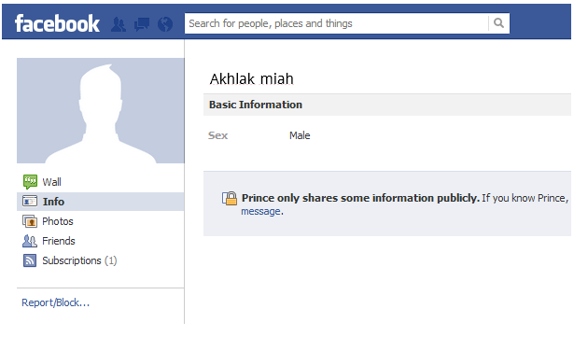
Akhlak miah
Figure 1: Facebook Account
(Source: https://www.facebook.com/Akhlak miah.50746444)
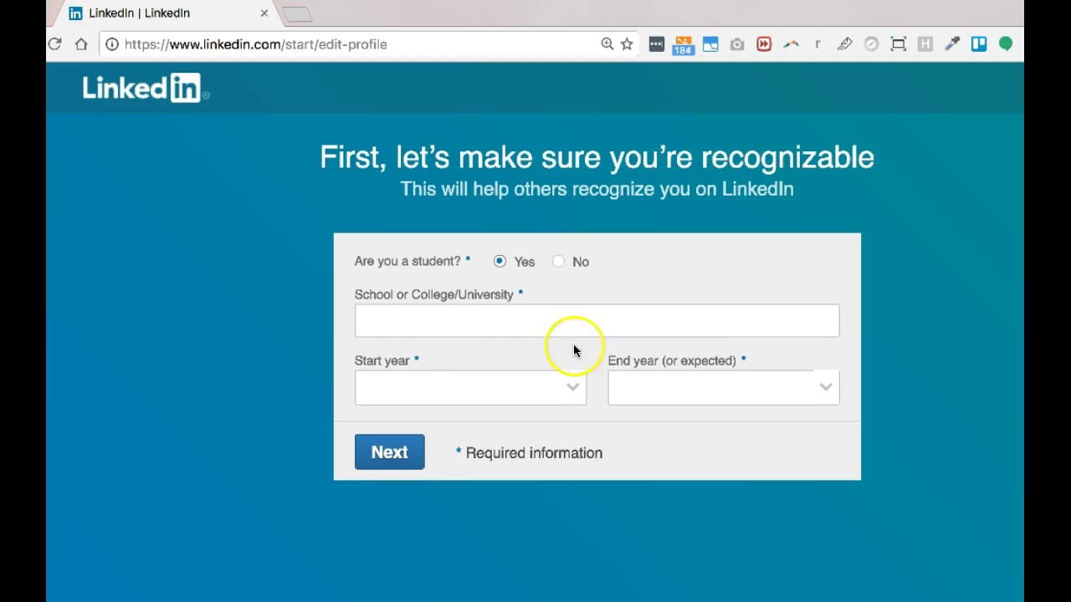
Figure 2: LinkedIn Account
(Source: https://www.linkedin.com/feed/?trk=onboarding-landing
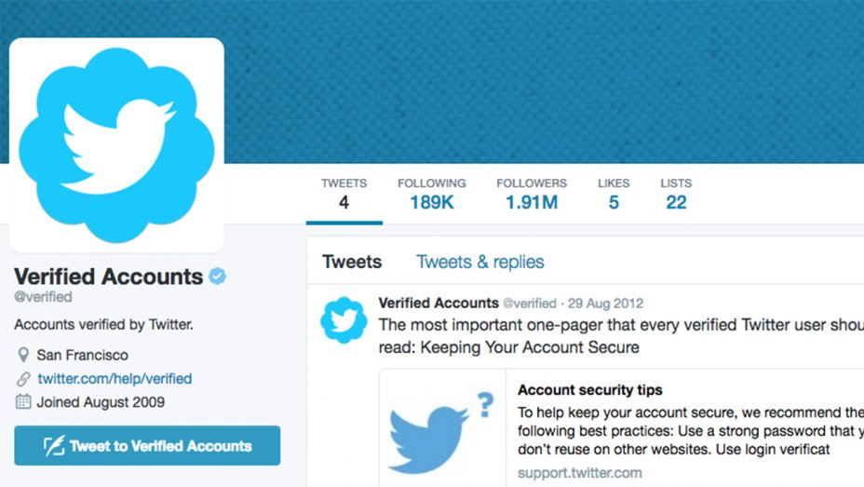
Figure 3: Twitter Account
(Source: https://twitter.com/Prince Okyere60150192)

Social media today like Face book, Twitter and Linked In are extensively used by the businesses to connect with the potential clients and customers. It regularly assists the companies to know about the competitors. It is only due to social media platform that companies make improvements and research adequately before launching a product. It has also enhanced effective communication within the workplace by creating connection and bond between the employees and the customers. The platform is even used by the respective organization to communicate vital information to the members of the company. The business and professional people mostly use twitter and Kinked In while Face book is used by all generation to stay connected.

Conclusion
Thus, it can be concluded that various technologies today are used by businesses to deliver important message and enhance communication. These technologies are the web-based emails as well as tablets and smart phones. Social media tools such as Linked In , Facebook and Twitter are used to stay connected , create brand image and reputation, However, this has also increased the rate of cybercrime and cyber bullying which needs to be checked.

References List
Bačík, R., Fedorko, R., Kakalejčík, L. and Pudło, P., 2015. The importance of Facebook ads in terms of online promotion.Journal of Applied Economic Sciences, 10(5), p.35.
De Cocker, K., De Bourdeaudhuij, I., Cardon, G. and Vandelanotte, C., 2016. The effectiveness of a web-based computer-tailored intervention on workplace sitting: a randomized controlled trial. Journal of medical Internet research, 18(5).
Hacker, S., 2017. Pleasure, power and technology: Some tales of gender, engineering, and the cooperative workplace. Routledge.
Leonardi, P.M. and Vaast, E., 2017. Social media and their affordances for organizing: A review and agenda for research.Academy of Management Annals, 11(1), pp.150-188.
Mark, G., Iqbal, S.T., Czerwinski, M., Johns, P., Sano, A. and Lutchyn, Y., 2016, May. Email duration, batching and self-interruption: Patterns of email use on productivity and stress. In Proceedings of the 2016 CHI Conference on Human Factors in Computing Systems (pp. 1717-1728). ACM.
Müller, H., Gove, J.L., Webb, J.S. and Cheang, A., 2015, December. Understanding and comparing smartphone and tablet use: Insights from a large-scale diary study. In Proceedings of the Annual Meeting of the Australian Special Interest Group for Computer Human Interaction (pp. 427-436). ACM.
Ng, T.W., 2016. Embedding employees early on: The importance of workplace respect. Personnel Psychology,69(3), pp.599-633.
Okoshi, T., Nozaki, H., Nakazawa, J., Tokuda, H., Ramos, J. and Dey, A.K., 2016. Towards attention-aware adaptive notification on smart phones. Pervasive and Mobile Computing, 26, pp.17-34.
Parise, S., Whelan, E. and Todd, S., 2015. How Twitter users can generate better ideas. MIT Sloan Management Review,56(4), p.21.
Simmers, C.A. and Anandarajan, M. eds., 2018. The Internet of People, Things and Services: Workplace Transformations. Routledge.
Wakefield, R. and Wakefield, K., 2016. Social media network behavior: A study of user passion and affect. The Journal of Strategic Information Systems, 25(2), pp.140-156.

