School of Sport, Health & Outdoor Education

Assessment Feedback Sheet

Student No./Name:
Module: Introduction to Health and Exercise Psychology

Module Code: SHSS4066

Personal Evaluation – to support your academic progress please complete the section below BEFORE submitting your work.
What do you consider to be the best aspects of this work?
Which aspects do you consider could have been improved in this piece of work?
What have you found most satisfying whilst undertaking this submission?
ASSESSMENT CRITERIA | Learning  Outcomes |  | GRADE
ASSESSMENT CRITERIA |  |  | Poor  < 20% | Weak  20-29% | Unsatisfactory  30-39% |  | Satisfactory  40 – 49% | Good  50 – 59% | Very Good  60 – 69% | Excellent  70 – 84% |  | Exceptional  85– 100% | %
1. Introduction:  Review of appropriate literature relating to mood state and exercise / physical activity.  (approx. 500 words) | 1,2,3 |  |  |  |  |  |  |  |  |  |  |  | 30%
2. Method:  Outline the participants, procedures and design of the study (approx. 200 words) | 1 |  |  |  |  |  |  |  |  |  |  |  | 15%
2. Results:  Descriptive statistics, use of tables, figures and associated narrative (approx. 250 words) | 1,3 |  |  |  |  |  |  |  |  |  |  |  | 25%
3. Discussion:  Discussion of your findings in light of previous research & practical implications.  Use of appropriate resources (approx. 550 words) | 2,3,4 |  |  |  |  |  |  |  |  |  |  |  | 30%
It is expected that students will present work that is proof read, correctly referenced and adheres to the Assessment Checklist. Therefore a range of 0 – 10 marks will be deducted for non-completion of any of the points on the checklist below.
TUTOR COMMENTS:
Submission date: 5/4/19 via Turnitin |  | Return date:  (at least within 4 weeks) |  |  |  | Tutor: Alison Connaughton |  |  |  |  | Mark:

Introduction

Physical activity is one the most promising nonpharmacological, non-invasive and cost-effective approaches to health promotion (Lachman et al, 2018). However, despite overwhelming evidence highlighting the benefits of exercise to physical and mental health much of the agnosticism remains in modern life (Koch et al, 2018; Deci and Ryan, 1985). Lee et al (2012) postulate that physical inactivity presents as many risk factors to both physical and mental health as smoking and obesity. Many varying professions can positively affect these statistics from public health and general practitioners to educators and personal trainers. Indeed, Franco et al (2005) highlight that for men and women who have led relatively inactive lives, positive changes can be made to longevity (up 3.7 years in total life expectancy) by commencing a regular exercise regime, even from the age of 50 years old. Further, research suggests that physical activity can significantly enhance mental health and reduce the symptoms of anxiety, depression and stress (Di Lorenzo et al, 1999). Additionally, Raglin (1990) posits that physical activity can improve mental wellbeing as much as psychotherapy interventions. Further still, Mikkelsen et al (2017) highlight that just 20-40 minutes of moderate exercise can improve mood state for several hours.

A growing body of evidence is highlighting that physical activity needs more than interventionist approaches to its use, rather habitual activity from an early age, so as to normalise and solidify the behaviour to take forward into adulthood, is necessary (Ahn and Fedewa, 2009; Koch et al, 2018; Telama et al, 2005). Indeed, coupled with the recent increase in social media use and the current ‘fitspiration’ trend, children and especially young adults may need more than just regular exposure to physical activity to adopt a healthy regime around its positive effects as well as its negative ones (Easton et al, 2018).

Amidst the many current political crises, the United Kingdom’s Government Health policy has moved to that of a ‘Prevention is better than cure’ approach (Department of Health and Social Care, 2018). Whilst it has been widely acknowledged that this is broadly what is required, concerns over the lack of provision for those in the worst financial and health positions, in need of physical and mental health care interventions the most, may be exacerbated post Brexit (United Nations, 2018; Local Government Association, 2018; Cambridge Economics, 2018).

Deci and Ryan (2000) postulate, according to the derived perceived locus of causality, that exercise regimes adopted on an intrinsically motivated basis, where the participant can select an activity that is enjoyable, interesting and pleasurable will facilitate habituative adherence. Whilst many extrinsic motivations can aid adherence to exercise for this study it was decided that the only constraint on the participants would be that of the time taken to complete the exercise (Deci, 1971). With this in mind and given the fact that so many positive physical health behaviours are linked to good mental state, the study was conducted to highlight the positive effects on mood state any form of exercise can have, at any age in adulthood and for any gender (Lee et al, 2012). Indeed, participants for this research are as diverse a group as possible to affirm the growing body of evidence suggesting that physical activity is as important as a healthy diet (Warburton et al, 2006; World Health Organisation 2018).

Methodology

The research was undertaken using 18 participants with and age range of 18-60 years old with a mean age of 35.44 years old. Involved in the study were 5 males and 11 females, 2 participants chose not to identify their gender. As there were no restrictions put on what form of exercise the participant could engage in, the range and types vary widely (see below) from high intensity interval training (HIIT) to brisk walking. All participants, however, were asked to exercise for 20 minutes.
Table 1. Participant Breakdown by Gender, Activity and Age
Participant | Gender | Activity | Age
1 | Male | Brisk walk | 49
2 | Female | Brisk walk | 48
3 | Female | Brisk walk | 29
4 | Male | Urban walk | 58
5 | Female | Country walk | 60
6 | Male | Running intervals | 29
7 | Female | Dance | 22
8 | Female | Weight training | 20
9 | Female | Walk | 18
10 | Female | Cardio - gym | 19
11 | Female | Boxing | 31
12 | Female | Circuits | 30
13 | Female | HIIT | 39
14 | Male | Rugby | 24
15 | Female | Yoga | 47
16 | Male | Turbo Training | 39
17 | Not Given | Distance run | 50
18 | Not Given | Brisk Walk | 26
 |  | Mean Age | 35.44
 |  | Standard Deviation | 13.66
 |  |  | Range 18-60

Prior to commencing the exercise, the participants were asked to complete two mood state questionnaires in order to ascertain psychological state pre-exercise. The same questionnaires were subsequently completed post-activity, in order to highlight the positive, or negative, effects of 20 minutes of physical activity.

The first questionnaire to be completed was the Brunel Mood Scale (BRUMS) (Terry et al, 2003). This mood scale is a continuation of the work in the Profile of Mood States (McNair et al, 1992). The BRUMS contains 24 mood descriptors that participants are asked to score on a 5-point scale. After which scores are collated and reflected in 6 mood indicator sub-scales, being anger, confusion, depression, fatigue, tension and vigour.

The second questionnaire given to participants was the Exercise-Feelings Inventory (EFI) (Gauvin and Rejeski, 1993). The EFI contains 12 mood descriptors that participants are asked to score, again on a 5-point scale. Once the questionnaire has been completed, scores are reflected in 4 sub-scale mood indicators, being positive engagement, revitalization, tranquillity and physical exhaustion.

The results from the 18 participants for both BRUMS and EFI pre- and post-activity were collated using the Statistical package for Social Sciences (SPSS) software and shared on a private user database for interrogation by the assessment team.

Results

The results for the BRUMS questionnaire are highlighted in Table 2 (below). In all sub-scale indicators, bar fatigue, more positive results were recorded post physical activity compared to pre-activity. The results for the participants were collated to provide mean scores for each sub-scale and given a standard deviation (SD) score to represent the expected variance around the mean (Leys et al, 2013). Included in the table is the coefficient of variation (CV) score. CV when greater than 1 indicates a high variance of score and lower than 1 indicates a low variance of score (Brown, 1998).

Table 2. Brunel Mood Scale Mean, SD and CV results pre- and post-activity
 | Before Exercise
BRUMS | Mean | SD | CV
Anger | 3.44 | 3.90 | 1.13
Confusion | 3.13 | 3.24 | 1.04
Depression | 4.74 | 4.05 | 0.86
Fatigue | 5.85 | 3.99 | 0.68
Tension | 3.96 | 3.65 | 0.92
Vigour | 3.08 | 2.12 | 0.69
 | After Exercise
BRUMS | Mean | SD | CV
Anger | 0.72 | 1.45 | 2.00
Confusion | 1.11 | 1.94 | 1.74
Depression | 1.94 | 2.55 | 1.31
Fatigue | 5.88 | 4.14 | 0.70
Tension | 1.29 | 1.80 | 1.39
Vigour | 6.04 | 3.08 | 0.51

As seen in Table 2, the vigour sub-scale saw the greatest variance from pre- to post-activity, closely followed by depression and anger. Fatigue increased after physical activity. These differences are highlighted in Figure 1 (below) and illustrate the drop in sub-scales such as anger and depression and the spike in vigour post-activity.
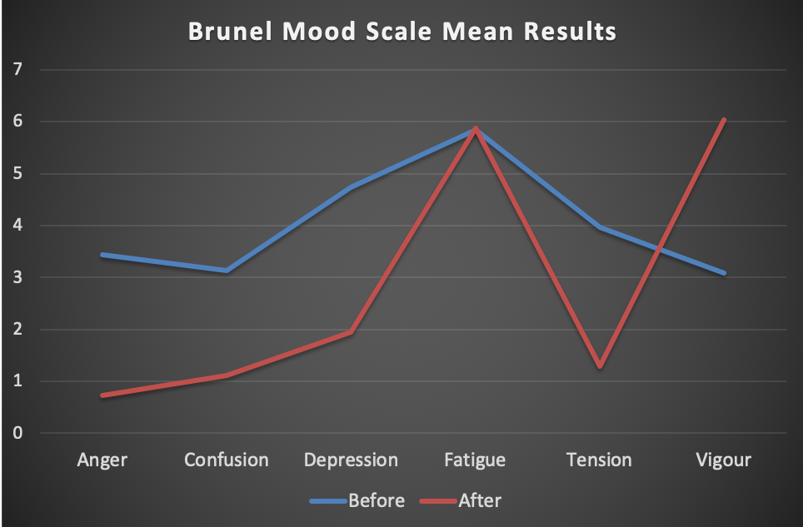
Figure 1. Brunel Mood Scale Mean Results
Results for the EFI analysis for pre- and post-activity are listed in Table 3 (below). These figures are less varied, as illustrated by the SD and CV scores for both pre- and post-activity. Three out of four sub-scales highlight positive improvements.

Table 3. Exercise-Feeling Inventory Results
 | Before Exercise
EFI | Mean | SD | CV
Positive Engagement | 4.72 | 2.76 | 0.58
Revitalization | 3.61 | 2.93 | 0.81
Tranquillity | 4.17 | 2.46 | 0.59
Physical Exhaustion | 5.72 | 3.08 | 0.54
 | After Exercise
EFI | Mean | SD | CV
Positive Engagement | 7.72 | 2.87 | 0.37
Revitalization | 7.56 | 2.85 | 0.38
Tranquillity | 7.33 | 2.72 | 0.37
Physical Exhaustion | 6.33 | 3.34 | 0.53

Figure 2 (below) illustrates the mean results increases post-activity, with revitalization showing the biggest increase. Both positive engagement and tranquillity also saw large increases. CV variances within the EFI results highlight little difference between participants scores for both the pre- and post-activity results.
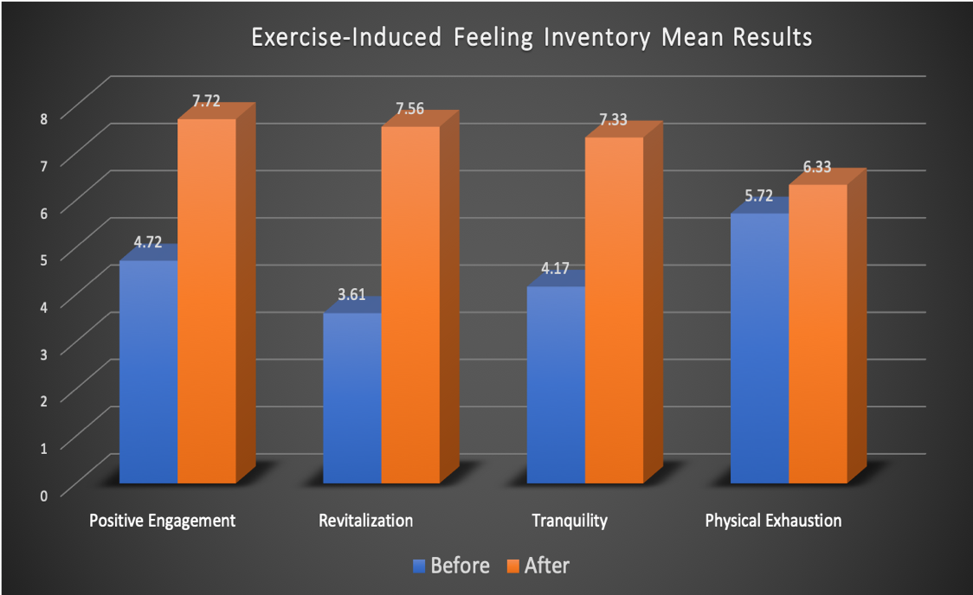
Figure 2. Exercise-Feeling Inventory Mean Results Bar Chart

As with the BRUMS results, EFI exposed an increase in post-activity physical exhaustion. Figure 2 clearly highlights the consistent uplift in positive engagement, revitalization and tranquillity post-activity.

Discussion

The resounding evidence this study provides is that of improved mood state in all exercises undertaken by all participants without exception. Some exercises provided greater increases, however, this may not be conclusive based on the small group size of the participants and with this in mind it is suggested that a larger scale study of the activities highlighted as yielding the greatest results is undertaken. In isolation the participant who undertook 20 minutes of high intensity interval training displayed the most positive change in mood state and therefore supports the findings of many of the current literature regarding this form of activity (Heggelund et al, 2011; Arnardottir et al, 2007; Wu et al, 2015; Nicolo and Giradi, 2016).

Ryan et al (2009) assert that modern life has led to a paradigm shift from society being predominantly active to now almost completely sedentary and highlights that better understanding of how to motivate groups to adopt a more active lifestyle is critical. Olafsen et al (2017) further the highlight the pressures in the workplace in modern life and suggest employers need to more by creating supportive social contexts to promote full functioning and organismic wellness in their employees, that will benefit all involved.

Ekkekakis et al (2011) suggests that self-regulated intensity training not only improves cognitive response but leads to greater self-efficacy and better adherence to exercise. Further, Ekkekakis et al (2011) calls for exercise guidelines to make use of evidence regarding increases or decreases in pleasure for particular exercises and specific age groups. The self-determination theory as proposed by Deci and Ryan (1985) adds weight to the suggestion that being the main driver in regard to health and well-being, backed up by the knowledge given in formative years regarding the importance of physical activity is, perhaps, the best way to alter the current sedentary trends.

Prinsloo et al (2013) posit that in an age of increased physical and mental ill health, exercise interventions should be treated as important as medical ones. Further still and in line with the findings of this study Prinsloo et al (2013) demonstrate that even single session exercise to increase heart rated improved scores in energized feelings, mindfulness and relaxation.

Unfortunately for some, as highlighted by Schvey et al (2017), being overweight may psychologically affect chances of adherence to exercise. With this in mind the notion of this study, backed up by its findings, suggests that any form of physical activity can improve mood state, although more education and training need to be provided for physical activity professionals in order to better serve those most in need (Schvey et al, 2017).

The ultimate aim of this research was to reaffirm the numerous studies that have highlighted the importance of physical activity in regard to mood state, mental health and general health. Furthermore, it has highlighted that irrespective of what type of physical activity is undertaken the most important single factor is participation.

Word Count
References

Ahn, S. and Fedewa, A.L. (2009) ‘A meta-analysis of the relationship between children’s physical activity and mental health’, Journal of Pediatric Psychology, 36 (4), pp. 385-397. (Accessed: 28 March 2019). DOI: 10.1093/jpepsy/jsq107.

Brown, C.E. (1998) ‘Coefficient of Variation’. Available at:
https://link.springer.com/chapter/10.1007/978-3-642-80328-4_13 (Accessed: 25 March 2019)

Cambridge Econometrics (2018) The impact of Brexit on poverty in the UK: The Joseph Rowntree Foundation. Available at:
http://www.camecon.com/wp-content/uploads/2018/09/FINAL-REPORT-The-impact-of-Brexit-on-poverty-in-the-UK.pdf (Accessed: 25 March 2019).

Deci, E.L. (1971) ‘the effects of externally mediated rewards on intrinsic motivation’, Journal of Personality and Social Psychology, 18 (1), pp. 105-115. (Accessed: 26 March 2019). DOI: 10.1037/h0030644.

Deci, E.L. and Ryan, R.M. (2000) ‘Self-determination theory the facilitation of intrinsic motivation, social development and well-being’, American Psychologist, 55 (1), pp. 68-78. (Accessed: 23 March 2019). DOI: 10.1037//0003-066X.55.1.68.

Deci, E.L. and Ryan, R.M. (1985) ‘General causality orientations scale: self-determination in personality’, Journal in Research in Personality, 19 (2), pp. 109-134. (Accessed: 22 March 2019). DOI: 10.1016/0092-6566(85)90023-6.

Department for Health and Social Care (2018) Prevention is better than cure: Our vision to help you live well for longer. Available at:
https://assets.publishing.service.gov.uk/government/uploads/system/uploads/attachment_data/file/753688/Prevention_is_better_than_cure_5-11.pdf (Accessed: 25 March 2019).

DiLorenzo, T.M., Bargman, E.P., Stucky-Ropp, R. Brassington, G.S. (1999) ‘Long-term effects of aerobic exercise on psychological outcomes’, Preventative Medicine, 28 (1999), pp. 75-85. (Accessed: 23 March 2019). DOI:10.1006/PMED.1998.0385.

Easton, S., Morton, K., Tappy, Z., Francis, D. and Dennison, L. (2018) ‘Young people’s experiences of viewing the fitspiration social media trend: qualitative study’, Journal of Medical Internet Research, 20 (6), pp. 1-11. (Accessed: 28 March 2019). DOI: 10.2196/jmir.9156.

Franco, O.H., Laet, C., Peeters, A., Jonker, J., Mackenbach, J. and Nusselder, W. (2005) ‘Effects of physical activity on life expectancy with cardiovascular disease’, American Medical Association Archived Internal Medicine, 165, pp. 2355-2360. (Accessed: 26 March 2019). DOI: 10.1011/archinte.165.20.2355.

Gauvin, L. and Rejeski, W.J. (1993) ‘The exercise-induced feeling inventory: Development and initial validation’. Available at: https://www.acefitness.org/ptresources/pdfs/AssessmentForms/16-EFI-Survey.pdf
Accessed: 22 March 2019.

Koch, E.D., Tost, H., Braun, U., Gan, G., Giurgiu, M., Reinhard, I., Zipi, A., Meyer-Linenberg, A., Ebner-Priemer, W. and Reichert, M. (2018) ‘Mood dimensions show distinct within-subject associations with non-exercise activity in adolescents: an ambulatory assessment study’, Frontiers in Psychology, 9 (268), pp. 1-11. (Accessed: 24 March 2019). DOI: 10.3389/fpsyg.2018.00268.

Lachman, M.E., Lipsitz, L., Lubben, J., Castaneda-Sceppa, C. and Jette, A.M. (2018) ‘When adults don’t exercise: behavioural strategies to increase physical activity in sedentary middle-aged and older adults’, The Gerontological Society of America, 2 (1), pp. 1-12. (Accessed: 28 March 2019). DOI: 10.1093/geroni/igy007.

Leys, C., Ley, C., Klein, O., Bernard, P. and Licata, L. (2013) ‘Dectecting outliers: do not use standard deviation around the mean, use absolute deviation around the mean’, Journal of Experimental Social Psychology, 49 (2013), pp. 764-766. (Accessed: 25 March 2019).
Lee, I.M., Shiroma, E.J., Lobelo, F., Puska, P., Blair, S.T. and Katzmarzyk, P.T. (2012) ‘Effect of physical inactivity on major non-communicable disease worldwide: an analysis of burden of disease and life expectancy’, The Lancet, 380, pp. 319-329. (Accessed: 25 March 2019). DOI: 10.1016/S0140-6736(12)61031-9.
Local Government Association (2018) LGA responds to NHS Digital figures from the National Child Measurement Programme. Available at:
https://www.local.gov.uk/about/news/lga-responds-nhs-digital-figures-national-child-measurement-programme (Accessed: 25 March 2019).

Mikkelsen, K., Stojanovska, L., Polenakovic, M., Bosevski, M. and Apostopoulos, V. (2017) ‘Exercise and mental health’, Maturitas, 106, pp. 48-56. (Accessed: 28 March 2019). DOI: 10.1016/j.maturitas.2017.09.003.

McNair, D.M., Lorr, M. and Dropplemann, L.F. (1992) ‘Revised manual for the Profile of Mood States’. San Diego: CA. Educational and Industrial Testing Services.

Raglin, J.S. (1990), ‘Exercise and mental health. Beneficial and detrimental effects’, Sports Medicine, 9 (6), pp. 323-329. (Accessed: 27 March 2019). DOI: 10.2165/00007256-199009060-00001.

Ryan, R.M., Williams, G.C., Patrick, H. and Deci, E.L. (2009) ‘Self-determination theory and physical activity: the dynamics of motivation in development and wellness’, Hellenic Journal of Psychology, 6 (2009), pp. 107-124. (Accessed: 24 March 2019). DOI: unavailable

Schvey, N.A., Sbrocco, T., Bakalar, J.L., Ress, R., Barmine, M., Gorlick, J., Pine, A., Stephens, M. and Tanafsky-Kraff, M. (2017) ‘The experience of weight stigm amoung gym members with overweight and obesity’, American Psychological Association, 2 (4), pp. 292-306. (Accessed: 28 March 2019). DOI: 10.1037/sa0000062.

Telama, R., Yang, X. and Raitakari, O. (2005) ‘Physical activity from childhood – a 21-year tracking study’, American Journal of Preventive Medicine, 28 (3), pp. 267-273. (Accessed: 26 March 2019). DOI: 10.1016/j.amepre.2004.12.003.

Terry, P.C., Lane, A.M. and Fogarty, G.J. (2003) ‘Construct validity of the POMS-A for use with adults’, Psychology of Sport and Exercise, 4, pp. 125-139. (Accessed: 22 March 2019). DOI: 10.1016/S1469-0292(01)00035-8.

United Nations (2018) Statement on the Visit to the United Kingdom, by Professor Philip Alston, United Nations Special Rapporteur on extreme poverty and human rights. Available at: https://www.ohchr.org/Documents/Issues/Poverty/EOM_GB_16Nov2018.pdf 19/11/18 (Accessed: 25 March 2019).

Warburton, D.E.R., Nicol, C.W. and Bredin, S.S.D (2006) ‘Health benefits of physical activity: the evidence’, Canadian Medical Association, 174 (6), pp. 801-809. (Accessed: 26 March 2019). DOI: 10.1503/cmaj.051351.

WHO (2018) ‘More active people for a healthier world’. Available at:
https://apps.who.int/iris/bitstream/handle/10665/272722/9789241514187-eng.pdf?ua=1 Accessed: 27 March 2019.

