

A study of the design and production of an Intrusion Detection System

By
Harry Woollands (2214706), Jacob Smelt (2215291), Martin White (2218704) and Daniel Bridgewater (2218703)

Supervisor: Stephen Mosey
Second Marker: Stalin Jacobs

Project submitted as part of the requirements for the award of the BEng (Hons) Embedded Electronics (Embedded Electronics Degree Apprenticeship)

July 2024
Contents
Abstract 4
Introduction 4
Components list 6
Literature Review 9
Autonomous Animal Detection 9
Monitored Security Surveillance 11
Literature Comparison 12
Background Research 13
Radio Module Comparisons 13
Power Source Comparison 13
PIC Processor Comparison 14
Programming Language Comparison 15
Sensor Selection 15
Development Methodology 16
Software Design 16
Receiver 16
Transmitter 18
Design & Implementation 21
KiCad 21
Implementation 25
Results & Evaluation 25
Results 25
Evaluation 29
Conclusion & Recommendation 29
Reflections 30
Martin 30
Jacob 30
Harry 30
Daniel 31
References 31
Bibliography 32
Appendices 32

Figure 1. A gantt chart for the project 4
Figure 2. Receiver PCB 6
Figure 3. Transmitter PCB 6
Figure 4. 180 ohm resistor 7
Figure 5. Red LED 7
Figure 6. PIC 18f4520 7
Figure 7. Outdoor junction box 8
Figure 8. Lora radio module. 8
Figure 9. PIR sensor 8
Figure 10. Block Diagram of the system produced by The Institute of Technology 10
Figure 11. Image showing Armadillo video guard. [3] 12
Figure 12. A flowchart for the software 16
Figure 13. Receiver Lora setup code 17
Figure 14. Receiver Radio Module Setup Code. 17
Figure 15. Receiver Radio Module message received code. 18
Figure 16. Receiver Buzzer code 18
Figure 17. Transmitter setup code 18
Figure 18. Transmitter Radio module code 19
Figure 19. Transmitter PIR detection sensor code 20
Figure 20. Receiver Radio Module Setup Code. 20
Figure 21. Transmitter character counter 20
Figure 22. Schematic of the transmitter board. 21
Figure 23. CAD drawing of the transmitter PCB. 22
Figure 24. Schematic of the receiver board. 23
Figure 25. CAD drawing of the receiver PCB. 24
Figure 26. Breadboarded test setup 25
Figure 27. External image of the transmitter unit 26
Figure 28. Internal images of the transmitter unit 27
Figure 29. Internal images of the transmitter unit 28
Figure 30. The receiver unit 28

Abstract
This report will detail the design programming and production of a personnel detection system. The aim of this project is to produce a cheaper alternative to current detection systems already on the market, without sacrificing its accuracy and quality. To do this we designed a circuit and printed a PCB using KI cad software, in conjunction with prototyping to develop a compact system. To code the system, we used a CAD software called Proteus and flashed this code onto a PIC 18f4520. Unfortunately, the system failed and therefore we had to start fault finding. This fault finding revealed that we had a software problem which in the time frame we where unable to resolve.
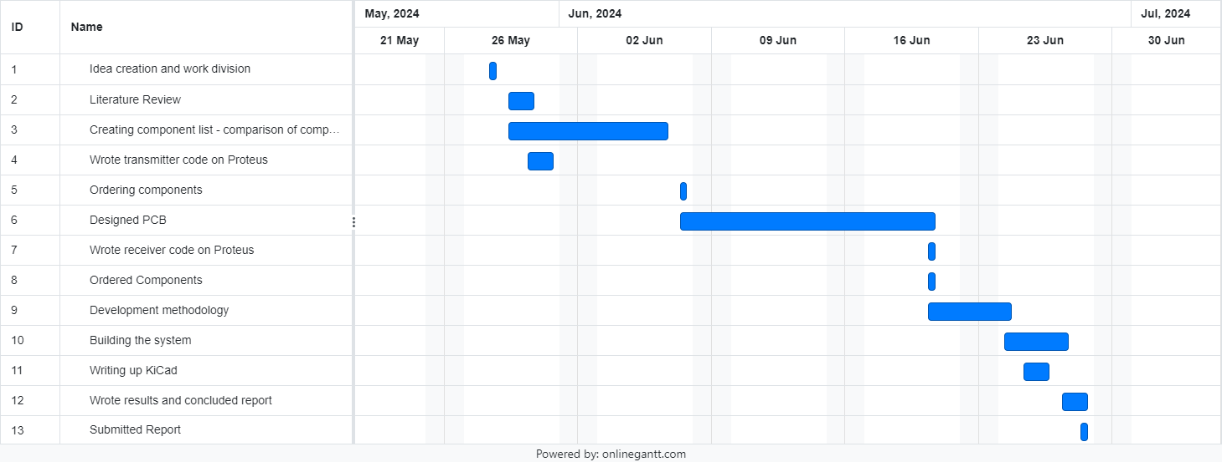
Figure 1. A gantt chart for the project

Introduction
In the modern day and era, monitoring and maintaining large areas can be challenging and expensive. This report documents our attempts to create a cheaper yet still effective method for this issue utilising Passive Infrared Sensors. These systems provide real time detection and alerting by identifying thermal emissions from targets. The use of wireless technology allows it to be deployed across a range of different environments. This makes the devices ideal for diverse environments such as military perimeters, critical infrastructure, public spaces, and agricultural perimeters. Integrated with enhanced algorithms, theses sensors can improve detection accuracy and reduce false positives, thereby enhancing situational awareness and response speeds for the users. This report will explore the capabilities, advantages, and applications of PIR sensor-based threat detection systems in contemporary security frameworks.
This assignment contains research about existing products, which include elements that we have taken inspiration from. Following that, comparisons were conducted between different commercial off the shelf (COTS) items to determine which were the most suitable for the project, by exploring the each of their capabilities and applications. The report will then detail the design process involved in the implementation of our system. The results of our testing will follow, which we will analyse to determine whether our objectives of the project have been satisfied. Finally, the report will conclude with recommendations on future progression of work in this area as well as what has been learnt from this iteration of the project.

Components list

- Receiver PCB – This is a specially designed PCB used as the receiver for the intrusion system, it has an LED light and a buzzer to alert the user of an intruder.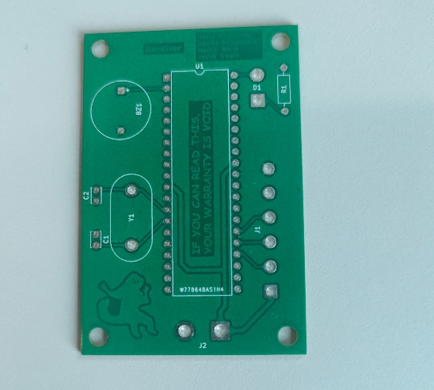
Figure 2. Receiver PCB
- Transmitter PCB - This is a specially designed PCB used as the transmitter in the system and has space for a radio module for the communications and also connectors for the four PIR sensors
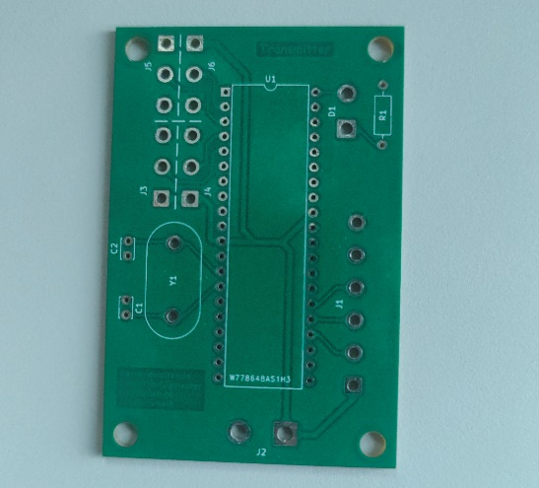
Figure 3. Transmitter PCB
- Crystal oscillator 4 MHz – this crystal oscillator is used as an external clock for the PIC to run from, making it more accurate
- Buzzer – the buzzer used is a piezo electric buzzer and is incorporated into the design to alert the user there is an intruder via sound
- Capacitors – the capacitors are used in conjunction with the crystal oscillator to make its oscillations steady
- Resistors – the resistor used in this circuit is purely for component protection, it is used as a current limiting resistor for the LED and has a value of 180 ohms.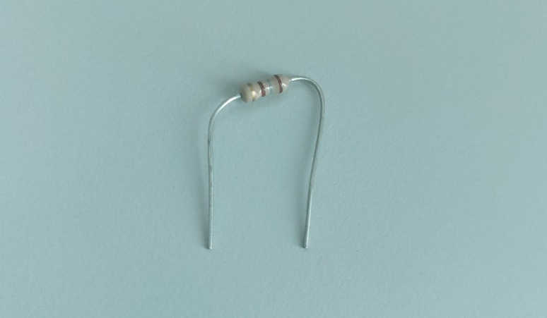
Figure 4. 180 ohm resistor
- LED’s – The Led in this system is used to alert of an intruder via light, its colour is red.
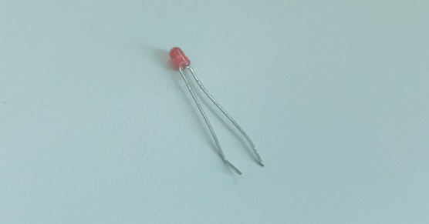
Figure 5. Red LED
- PIC 18f4520 – The Pic is used as the brains of the system and is talked about in more depth later on in this report. We are using a Pic instead of normal gate logic as this allows for us to use the PIC to control our radio module so that the transmitter and receiver can communicate with each other. Using a Pic also means that we can program it to do different things, making our circuit versatile instead of just being able to do one job
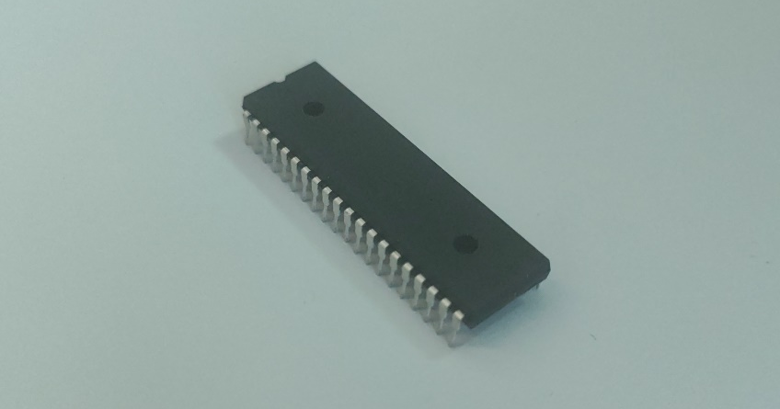
Figure 6. PIC 18f4520
- Diall single outdoor junction box * 2 – These boxes are used to house the receiver and transmitter PCB’s and also the PIR sensors
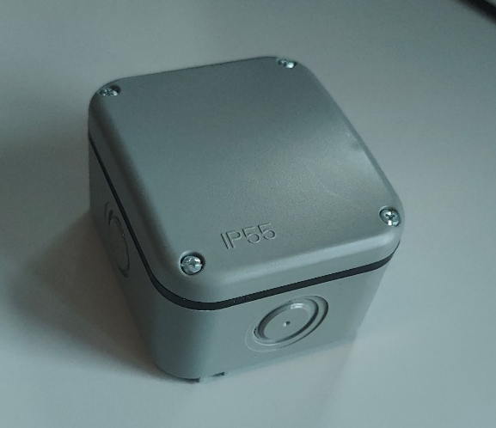
Figure 7. Outdoor junction box
- Radio module – The radio module that we have chosen is the Reyax RYLR896 UART Interface 868/915MHz LoRa ® Antenna Transceiver Module, also talked about in more detail later in the report
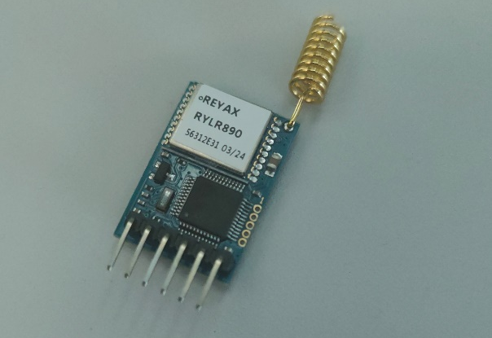
Figure 8. Lora radio module.
- PIR sensors – The PIR sensors We chose are the HR-SR501. These PIR sensors have a range of approximately 7 metres
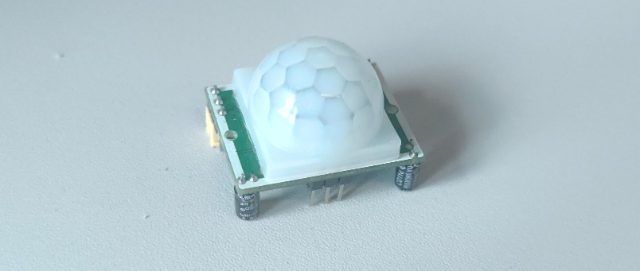
Figure 9. PIR sensor

Literature Review

Autonomous Animal Detection
Animal intrusion is one of the challenges within the agriculture industry. Intruders can lead to a large destruction of crops, reducing production yield leading to losses. As well as crops, intruders can often kill other animals, adding to the losses.
Farmers have attempted to use a variety of different methods of preventing intruders, such as scarecrows, fencing and the use of chemicals. However, all these methods have their drawbacks. For example, scarecrows lose effectiveness over time, as animals become used to their presence, fencing can be effective, however can prove to be expensive if required across the whole farm, and chemicals can cause damage to fields, as well as potentially harming animals.
The Institute of Technology, Mumbai, India, conducted some research [1] into using Passive Infar-Red and Ultrasonic sensors to detect animal intruders. They placed several PIR sensors with a detection range of 5 meters around a field's perimeter. This allowed detection 2.5 meters into the field and 2.5 meters outside of it. The system also allows for the classification of animals according to their heights. To achieve this, multiple PIR sensors are placed vertically at different heights, and depending on which sensors detect motion, the animal can be determined. Alongside the sensors, a camera, a display, a GSM module, and buzzers are included within the system. When motion is detected, the GSM module sends a text message to the owner of the system, notifying them of the presence of an intruder. At the same time, the camera takes a snapshot, uploading it to the display, providing an image of the intruder. Finally, a buzzer emits a sound, alerting anyone nearby of the presence of an intruder. Figure 10 below shows the block diagram of the system that is used. The buzzer outputs a specific sound depending on which intruder is present.

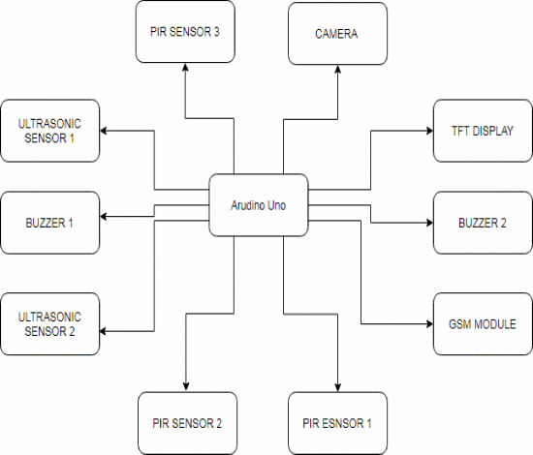
Figure 10. Block Diagram of the system produced by The Institute of Technology

The system is described as highly effective in protecting agricultural fields from animal intrusions. It uses a combination of PIR and ultrasonic sensors to accurately detect unauthorized movement, activating a buzzer for deterrence. The system covers a substantial area and distinguishes between animals and authorized persons, reducing false alarms. It is cost-efficient, environmentally friendly, and minimizes the need for human supervision, requiring it only during activation. The GSM module enhances security by providing real-time updates. Its low power requirement ensures safety from electric shocks. Overall, this system offers a modern, efficient, and safe solution for crop protection, significantly improving on traditional methods that were previously described.

Monitored Security Surveillance
Break-ins and thefts are a massive issue within areas that are not occupied 24 hours such as warehouses and building sites. This can lead to companies losing lots of their profits and their assets can be damaged.
Rather than having a 24 hour security team to monitor the full site no matter how large that may be, a device called the PID armadillo video guard 360 [2] was created, these devices incorporates a long life battery, a 360 degree viewing angle made up with three 120 degree cameras, 12 motion sensors, 3 bright lights, an armoured housing with a 110 decibel warning system, a GPS receiver, and a built in communication system to transmit the video feed and alerts wirelessly. The system works by using multiple PIR (passive infrared sensor) sensors to detect the movement of heat, this then sends an alert to a receiving centre and activates the video feed transmission, this receiving centre then looks at the video feed and decides if personnel need to be dispatched.
This is a good method however it requires a subscription type purchase as it is monitored by the company that creates these armadillo systems. The video feed is watched by real humans, this decreases the number of false callouts and activations. When the system is activated, it emits a very loud sound and activates the bright lights, scaring the intruder and deterring them. These units also have a very distinguishable look meaning that thieves can recognise them, and they will be deterred without even needing to activate the system.

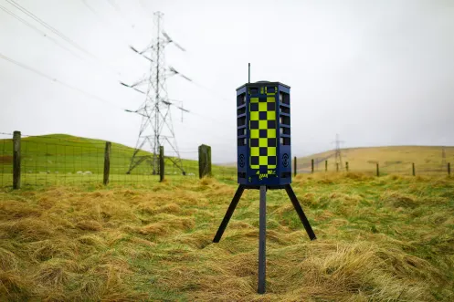
Figure 11. Image showing Armadillo video guard. [3]

Literature Comparison
Both prior works yield useful insight into how the aims of our project can be achieved. Regrettably, scarecrows have no effect on humans and fences are expensive, so building an electronic device of some description is justified. Ideally our device would not require a subscription to operate, so it can be deployed for long periods of time, and distinguishing between different heights is not necessary because it only needs to detect movement and not form.
The aim is for the system to function independently of human oversight, although due to cost and time constraints it won’t be possible to automatically determine the identity of the human intruder. Because of this constraint, video cameras won’t be feasible to implement, so just using PIR sensors is perfectly suitable for our purposes.
Considering the aim for no ongoing subscriptions, GSM won’t be a suitable method of alerting the facility owner of an intrusion because cellular mobile connections require a regular payment to operate. Therefore, we’ve explored alternative reliable radio communication technologies in the next section.

Background Research

Radio Module Comparisons
The system will require some form of wireless communication, so two different radio modules were compared. The first module is the FS1000A, which a simple amplitude-modulated one-way design operating at 433MHz. According to its datasheet, the range is dependent on the supply voltage, and is approximately 20 meters at 3 volts. This is much shorter than an ideal range of at least 100 meters and boosting the supply voltage would increase power draw. Furthermore, an amplitude modulated signal means the communication is more susceptible to interference, which is undesirable for an alarm system where reliability is paramount.
The second radio module, the RYLR896, utilises LoRa technology to achieve multiple kilometres of range by frequency-modulating the signal. This is possible because changes in frequency are much easier to distinguish from interference as opposed to changes in amplitude. As a result, this module is far more suitable for our system, the chances for messages to be received successfully received by the base station is greatly improved. The operating frequency is also much higher, at 868MHz, which possibly contributes to the data rate being much higher than that offered by the FS1000A. Additionally, each RYLR896 module can both send and receive signals, potentially allowing for mesh network topologies to repeat messages from other nodes, further increasing range and reliability. We will therefore be choosing this module for use in our alarm system.

Device | RYLR896 | FS1000A
Range | 4.5-15km | 20-200m (depending on supply voltage)
Speed | 115200 baud | 4KB/s
Bidirectional | Yes | No
RF Power | 15dBm | 10mW
Modulation | FM | AM
Frequency | 868MHz | 433MHz
Datasheet | RYLR896_EN.pdf | 433mhz_rf-tx&rx.pdf
Table 1. Summarised comparison of radio modules.

Power Source Comparison
The system will require some form of power, and therefore it is necessary to compare different types of power sources. The first form of power is solar power. Solar panels provide are an environmentally friendly power source, as well as being renewable. However, their power output can be unreliable, as it varies according to the amount of sunlight they receive. The second form of power source is batteries, a non-renewable power source. Batteries are a convenient source of power as they are easy to acquire, as well as providing a consistent source of power regardless of weather conditions.
The cost to purchase and install solar panels or batteries is an important comparison point to consider. Solar panels can be expensive to initially purchase and install, however, if used over a long period of time, or located in a particularly sunny area, then the initial investment in the solar panels can pay off. In contrast, batteries can be relatively cheap to purchase and are very easy to install. However, if used over a long period of time, the cost of continuously purchasing new batteries can become quite expensive. One way to counteract this though, is the use of rechargeable batteries, which can be charged back to full capacity without the need to use new ones. However, this would still require the use of at least two sets of batteries to maintain the system, as batteries would still be needed within the system whilst the first set are charging.
Overall, we determined that we would use batteries as our power source for the system. Their reliability, cost, and the ease of installation makes them ideal a project such as this. [4]

PIC Processor Comparison
When it came down to picking the Microcontroller for our project, we had to choose which PIC would benefit us more. We compared the likes of a PIC12F1822 or other models, but eventually decided on the PIC18F4520. This was due to its superior performance (up to 10 MIPS at 3V vs the PIC12F1822 at 8MIPS which worked in our favour as we only have 3V available to power the board as we have two 1.5V AA batteries), more extensive program memory (32KB vs the PIC12F1822 at 3.5KB), and larger RAM (1536 bytes vs the PIC12F1822 at 128bytes). It offers UART which is a two- wire protocol for exchanging serial data. UART stands for Universal Asynchronous Receiver / Transmitter therefore allowing an exchange of data with the radio module. The PIC’s higher versatility and performance make it suitable for more complex applications, especially when matched with its low acquisition cost. [5][6]

Programming Language Comparison
Since our circuit makes use of a PIC microcontroller to process digital information, it would be necessary to write some software to control its behaviour. Initially we considered the possibility of writing the software in native Assembly instructions.
While Assembly could work, complex operations are difficult to implement due to the verbose nature of processor instructions, as the programmer must tediously write every single step involved. Consequently, controlling peripherals by precisely manipulating file registers and even writing simple flow control becomes quite challenging, with the resulting code being difficult to read by a human. This would therefore constrain the system's complexity.
Then we explored the possibility of using MicroPython, which offers a friendly development environment for microcontrollers. Some PICs are supported [7], however the minimum requirements state it would need to possess relatively vast amounts of memory [8], which is expensive and would significantly increase the material costs.
Eventually we settled on using C, as it struck a balance between readability, performance, and features. C was designed when computers had limited resources, which make it perfect for operating within the constricted memory of microcontrollers, while still abstracting enough complexity for a human to easily follow the program’s behaviour.

Sensor Selection
For our sensor selection we had two different sensors in mind, these sensors where ultrasonic sensors and passive infrared sensors (PIR). When looking into these sensors we opted for the PIR sensors as we are using them to detect movement of people (infrared) rather than detection of distance of objects (ultrasonic). The ultrasonic sensors are also very short range compared to the PIR sensors so would not be of much use in our system.
When selecting the PIR sensors for our project we took into consideration, cost, integrability and useability. We compared a few different commercial off the shelf (COTS) models and ended up going for four of the HC-SR501 Infrared sensors. These sensors have a sensor angle of approximately 100 degrees, this means that if we use four of them, one on each side of a box, then we can cover the full 360 degrees around the box. When looking into the sensors we could purchase just the sensor unit or the sensor unit with a control board built in. We opted for the sensor with the control board built in as this meant that we could change the delay and sensitivity of the sensors to fine tune our intrusion system easily. These sensors with the integrated control board worked out at around £1.84 each making them very cheap compared to the single PIR sensors without a control board from RS components which where £8.94 each. Due to this we opted for the cheaper option which also allowed more functionality and tuneability.

Development Methodology
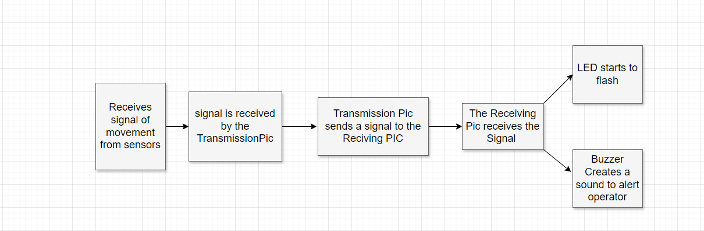
Figure 12. A flowchart for the software

Software Design

Receiver
A 30-byte character buffer is reserved in global scope so that all functions can store and access incoming radio messages. This isn’t currently used in the receiver, but in future versions it may process LoRa messages to identify which specific node has sent the message, which it could then show on a screen or trigger some node-specific behaviour. For example, the pattern of beeps could be determined by which node has sent the intrusion alert.
The first thing done by the receiver is to invoke our LoRa radio setup function, passing the unique address for this node as an argument. Among other things, this will configure the radio’s address to be 1. All transmitters are programmed to send their messages to address 1, which is the receiver. Following successful initialisation, a short beep is emitted, and the onboard LED are turned on to indicate the device is armed.
Then the PIC enters an infinite loop to wait until the radio reports an incoming message over RS232. Currently any communication from the radio will trigger the alarm, because the radio will only alert the PIC when a message is received, there is only one transmitter capable of generating that message.
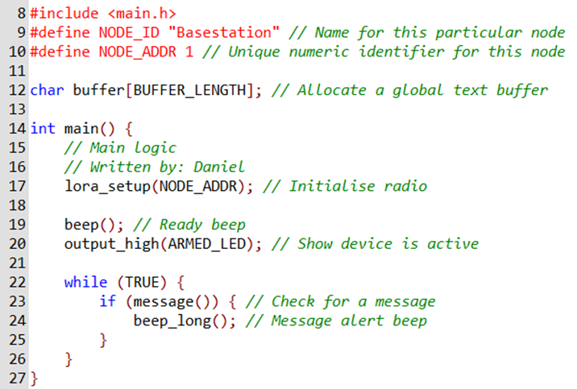
Figure 13. Receiver Lora setup code
The ‘lora_setup’ subroutine within the receiver code is used to setup the radio module so that is ready to receive and carry out instructions. Firstly, the reset pin is set to low, and then high which tells the module to stop any instructions it may be doing, and prepare for the next set of instructions. Following this, four AT commands are sent to the radio module. These AT commands are specified in the radio module’s datasheet. First is AT+RESET, a command that ensures that the module is ready to receive commands. Next, is AT+ADDRESS, a command that gives an identity to the receiver. After, that is AT+BAND, a command that sets the centre frequency that’s the receiver and transmitter communicate on. The datasheet specifies to use 868500000 Hz (868 MHz). This frequency is used as it is a frequency that doesn’t need permission to operate on. Finally, the AT+NETWORKID command is used, and is set to 5. Again, this is specified within the radio module’s datasheet. After each of the AT command, a delay is introduced using the ‘gets’ function. This delay is required as there needs to be some time after each command for the radio module to reply to say it has understood the command, before moving onto the following command. Figure 14 below shows the code for the lora_setup routine.
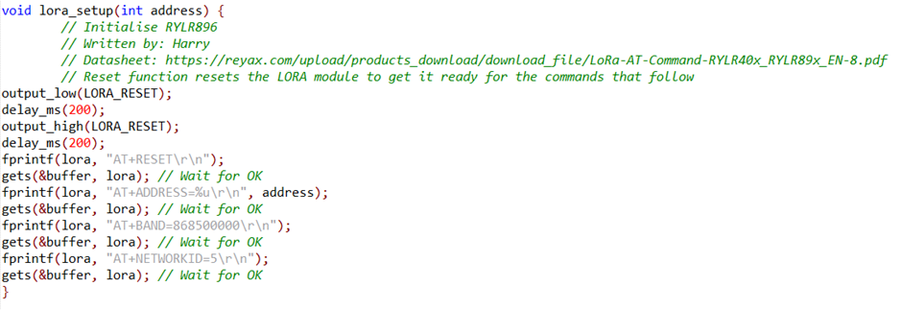
Figure 14. Receiver Radio Module Setup Code.
The ‘message’ subroutine within the receiver code is used to check if data has been received from the radio module. To do this, an if statement is used, with a kbhit function inside of it. The kbhit function is used to check when the radio module sends a message to the PIC. kbhit returns true if the lora stream has a message in it. If there is no message received, then false is returned. Figure 15 below shows the code for the message routine.
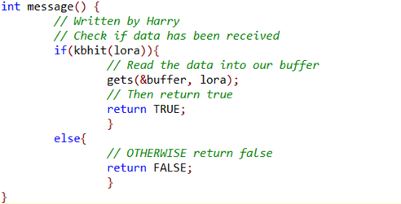
Figure 15. Receiver Radio Module message received code.
The Code enables a high output signal to pin A0 on the PIC which has been connected to a buzzer causing the buzzer to produce a sound there is then a 2 second (2000ms) delay before then returning the pins power output to low therefore stopping the buzzer from producing sound. This function is embedded in “beep_long.”
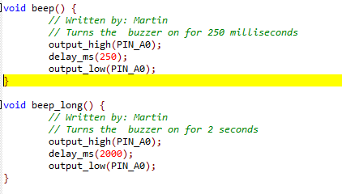
Figure 16. Receiver Buzzer code

Transmitter
There are some notable differences with the code running on the transmitter. Firstly, a different node identifier and address are specified. No two LoRa radios may occupy the same address, and the identifier is a human-readable name for this particular device.
Figure 17. Transmitter setup code

The LoRa setup proceeds as normal. A 90 second wait period is included afterwards so the PIR sensor has enough time to stabilise. This period is requested by the datasheet, so a busy loop is included to indicate the PIC is waiting by blinking the LED. Once the PIR sensor has been given enough time to calibrate, the blinking stops, and a short beep is emitted to indicate the device is armed. The LED is kept off to conserve battery power.
The PIC then enters a loop to wait until any of the PIR sensors detect a person. Once this happens, a message is prepared by copying text to the global buffer. In this case, NODE_ID is “North Fence”, so the buffer will contain “North Fence alarm tripped!”. Next, our routine for transmitting messages to the base station is invoked, which reads from the buffer and instructs the radio to send the message.
Following transmission of the message, there is a minimum 5 second wait period to prevent the message from being sent repeatedly. Additionally, if the PIR sensor does not reset within the 5 second period, the PIC will continue waiting until it does. This behaviour is to minimise the number of duplicated transmissions and reduce the chance for message collision if multiple nodes were to transmit simultaneously.
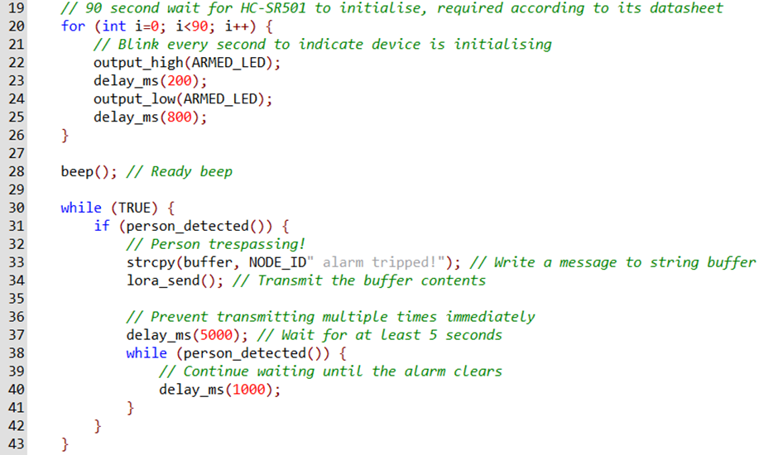
Figure 18. Transmitter Radio module code

The following piece of code in figure 19 is used to read the PIR sensors and then return true to an integer if there is activity on the sensors. If there is no activity detected, then the default value is False.
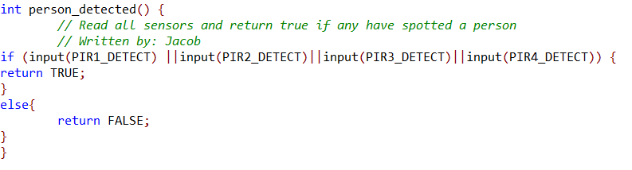
Figure 19. Transmitter PIR detection sensor code
Within the transmitter code, the same ‘lora_setup’ routine is used that was in the receiver code. This is because both the receiver board and the transmitter board use the same radio module. Having the same code for both the transmitter and receiver means that both radio modules can reset in time for the incoming messages from one another.
Figure 20. Receiver Radio Module Setup Code.
This section of code will count the number of letters in the information stream so that the radio module will know how large a signal is being received so that the module can work out how long the message that’s being transmitted will be.
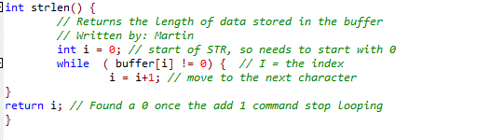
Figure 21. Transmitter character counter

Design & Implementation

KiCad
To design the PCB’s, a piece of software called KiCad was used. KiCad is used for electronic designs, in our case, PCB designs. For the project, it was necessary to design two PCB’s, a transmitter PCB and a receiver PCB. For both boards, a schematic was created first, followed by a CAD design.
The first PCB that we made was the transmitter board, which can be seen below in Figure 22. In the centre of the schematic is a PIC18F4520, our PIC of choice. Connected to Port A of the PIC are the PIR sensors. The PIR sensors are 3-pin sensors, with their data pin connected to the PIC. Also, on Port A is a crystal oscillator, a circuit that provides a regular signal to execute each instruction. On Port B, an LED is connected, which lights up when motion is detected. Connected to Port C is the radio module. Finally, power and ground are connected to the top and bottom of the PIC, as well as placed separately away from the PIC, so that the PCB can receive power.
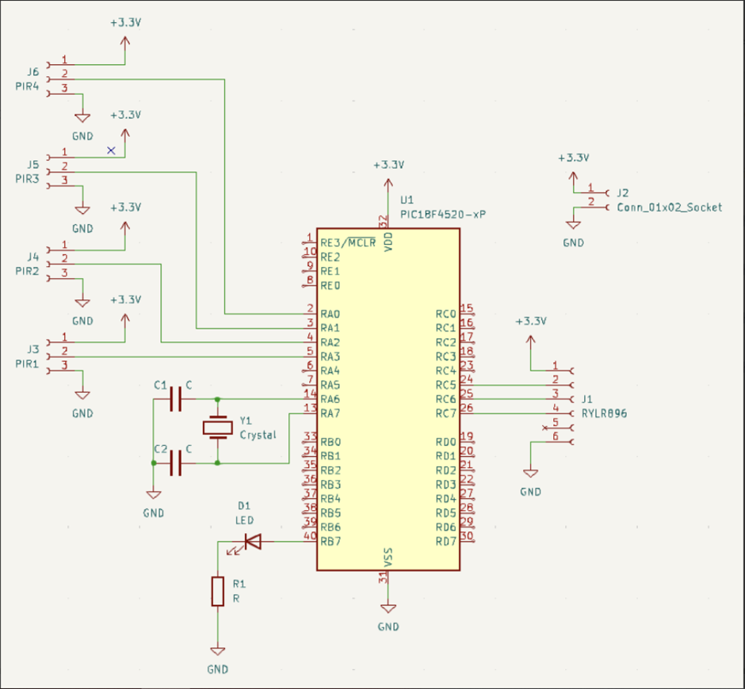
Figure 22. Schematic of the transmitter board.
Next, the schematic needed to be transformed into a CAD design, so that the PCB’s could be printed. To do this, the ‘send to PCB’ function was used, which creates a new window. This window contains all of the component mounting points, which were then reorganised to make the most efficient PCB. The biggest challenge we had to consider was arranging the components in a way that their connection lines did not cross one another. This was particularly challenging, as it was necessary to have all the connections on one layer, to make a single-layer PCB. Initially, this proved impossible, as we were unable to avoid the ground connections crossing. To solve this, we drew the perimeter of the PCB around the components, and filled the perimeter with copper. This meant that all connector holes that hadn’t been connected went straight to ground, removing the need to connect the ground pins with connection lines, and therefore there was no crossing of connections. This enabled us to make the PCB on single layer. Penultimately, the name of the board, as well as the names of the team members. Finally, in each corner of the PCB, a 3mm diameter hole was cut out, in order for the PCB to be screwed into the case. Figure 23 below shows the CAD drawing of the transmitter board.
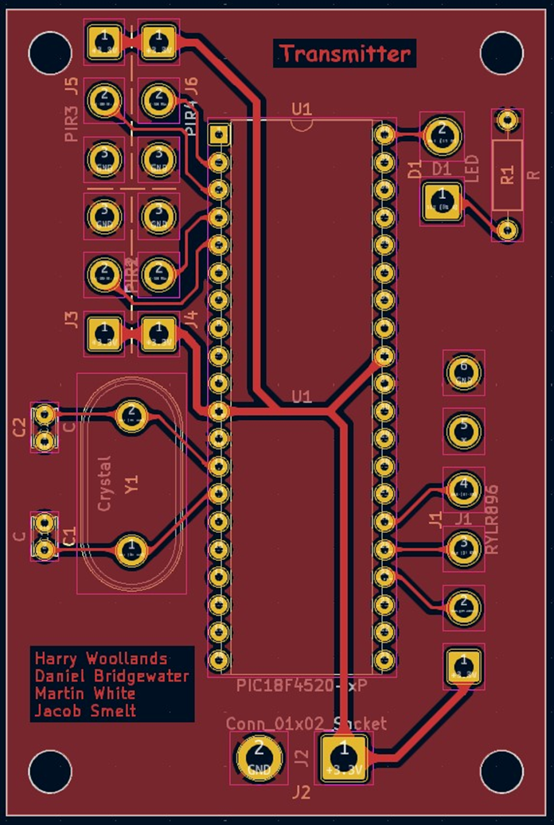
Figure 23. CAD drawing of the transmitter PCB.
This process then had to be repeated when making the receiver PCB. The one difference between the receiver board and the transmitter board is that the PIR sensors have been replaced with a buzzer. When motion is detected with the PIR sensors on the transmitter board, the buzzer and LED activate on the receiver board, showing that movement has been detected. Figure 4 below shows the schematic of the receiver board.
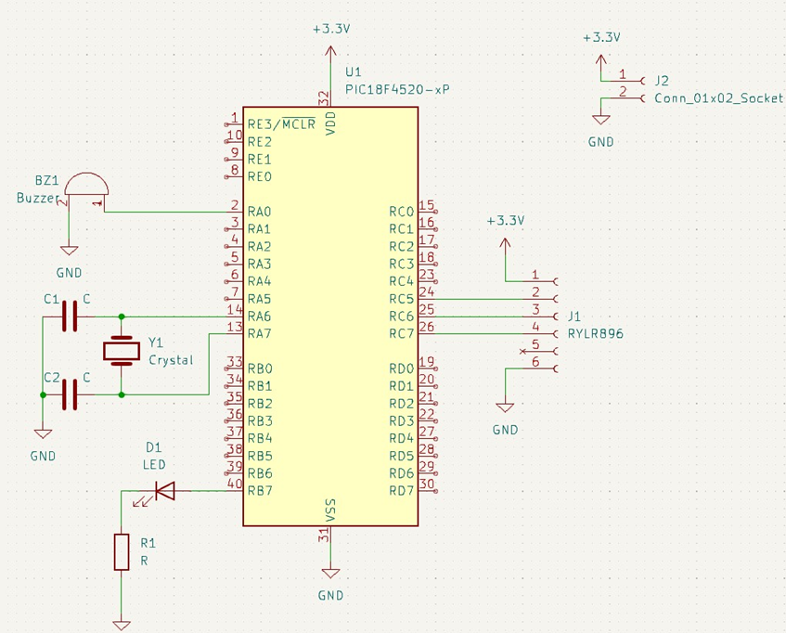
Figure 24. Schematic of the receiver board.

Once again, the schematic was transformed into a CAD drawing. The component layout on the receiver board for the components that were on the transmitter board remained in the same position, with the buzzer taking the place of the PIR sensors. Figure 25 below shows the CAD drawing of the receiver PCB.
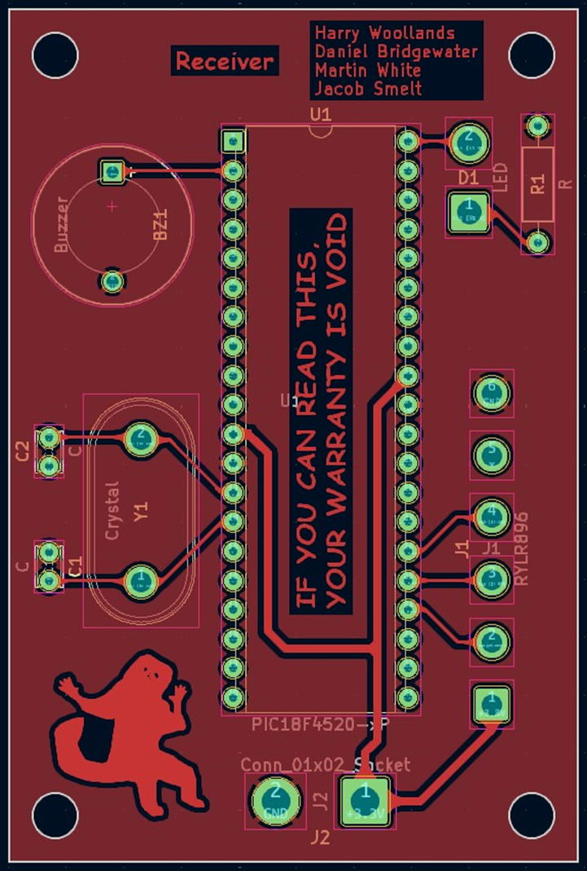
Figure 25. CAD drawing of the receiver PCB.
After both CAD drawing had been completed, they were exported as Gerber files. Gerber files are a file format used specifically for PCB designs. These files were uploaded to pcbway.com, a PCB manufacturing website. Alongside these files, the specifications of the PCB were detailed, such as dimensions, number of layers, and material. Once these were correct, the PCB’s were ordered.

Implementation

Results & Evaluation

Results
When it came to testing the system, we provided power to the board and unfortunately the system had faults and did not function as intended. We used a multimeter to make sure that the PIC chip was receiving power on the pins that needed to have power, and we confirmed that they were. We also checked that the LED and the buzzer that is soldered onto the board to make sure they were functioning as intended when isolated from the system.
We then took the PCB apart and went back to a simple breadboarded concept for testing purposes. When all the parts were connected up, we also noticed that the breadboarded test only worked intermittently. At first, we thought it may have been due to lose wires, however upon much more testing and further investigation we realised that the system only worked when a small static charge was applied to the MCLR (Master Clear) pin. This pin controls when the PIC chip is operating, and a presence of voltage allows it to function.
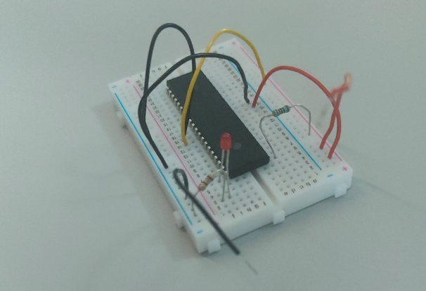
Figure 26. Breadboarded test setup

Due to this discovery we decided to investigate disabling the MCLR in the software by defining it as disabled, although this seemed to work, we also placed a pull up resistor between the MCLR pin and the positive power rail to also help disable the resetting of the system. Once these modifications where in place we retested the breadboarded system and it began to work flawlessly.
Unfortunately, when we reinstalled the components onto the PCB, once again the system failed, we theorised this could be due to a PCB manufacturing or design error, however further testing would be required for this to be accurately identified.
Despite not getting the system fully operational when using the PCB’s, we still assembled the project as if it were functional. This assembly proved that our design fitted exactly into the case as intended. This also shows that if we managed to get the PCB functioning, then the project would have met our initial specifications.
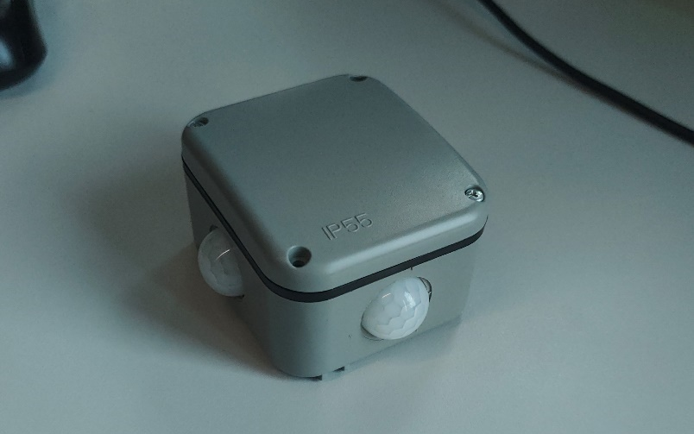
Figure 27. External image of the transmitter unit
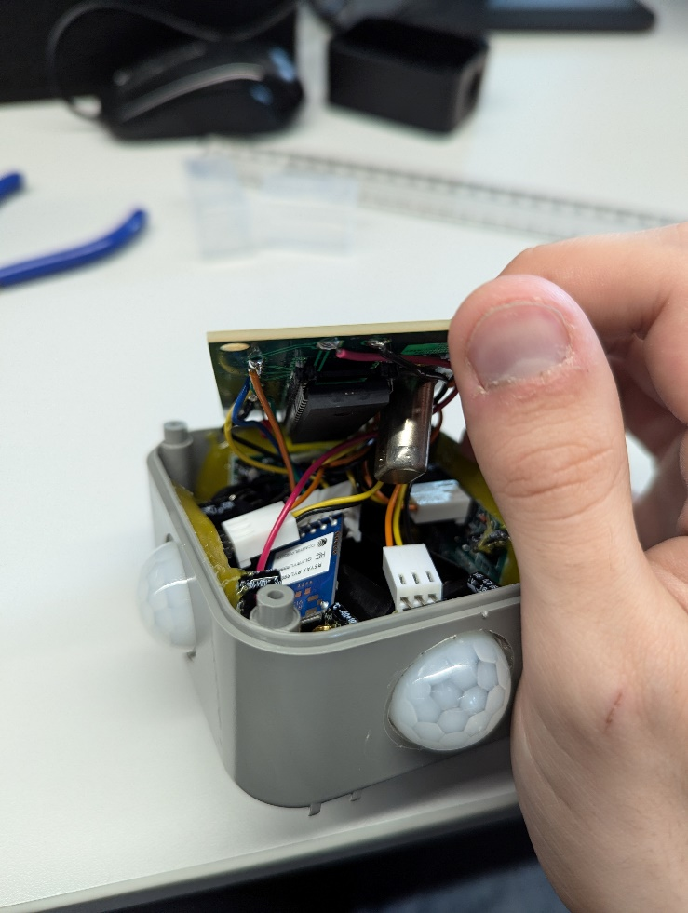
Figure 28. Internal images of the transmitter unit
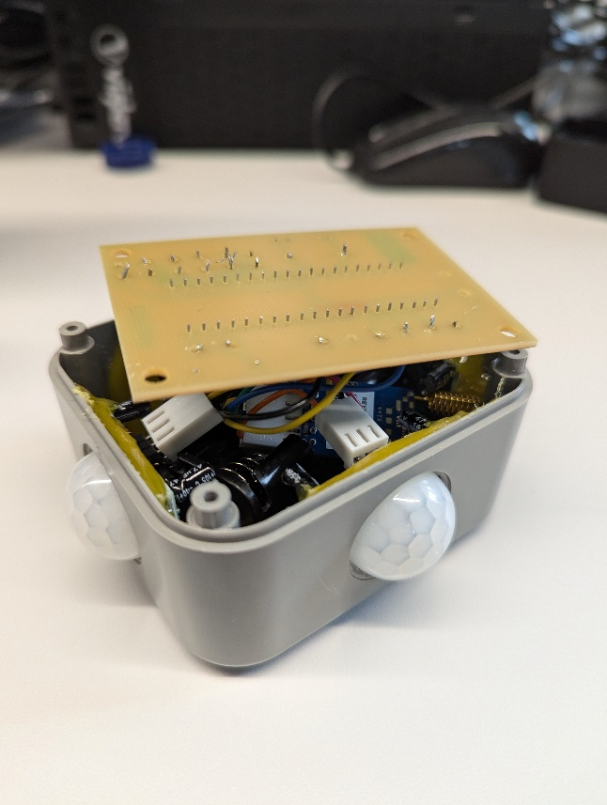
Figure 29. Internal images of the transmitter unit
Receiver:
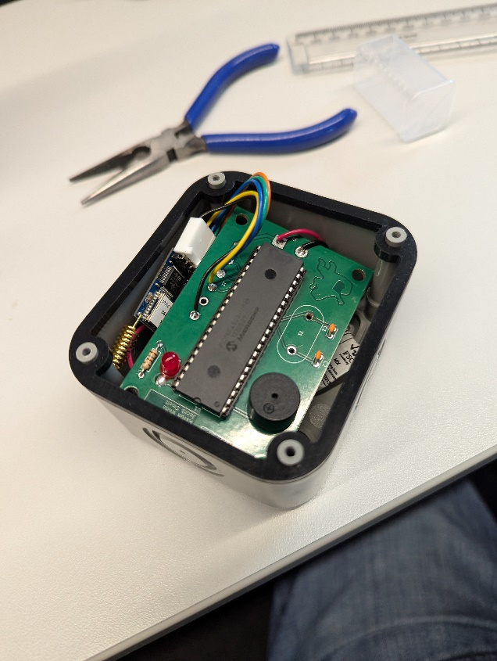
Figure 30. The receiver unit

Evaluation
The data we collected when testing using the oscilloscope revealed that the PIC was executing our selective pieces of code, and then the Lora Radio module was responding. However, some aspects of the program were not working as intended. Therefore, the output components on the PCB such as the buzzer and LED were not activated as intended. This leads us to believe that our issue lies within the PIC software, rather than within the PCB’s themselves. This was backed up by placing probes on the relevant pins of the PIC Microcontroller.
Were the project successful, our system would have been a much cheaper alternative to the systems seen in our literature review. Unfortunately, we were unable to get the system working as we all would’ve liked. If we were to do this project again we would use a different type of control board, such as a Raspberry Pi, or Pico Pi. This would have allowed for simpler code, which would have made it significantly easier to diagnose the software issue we have. This would also make our project future proof, as there are more advanced interfaces, allowing for connecting different sensors to it. If we hand more amount of time to complete the project, we also would have allocated more time to prototype our system, which potentially could have eliminated software issues.

Conclusion & Recommendation
In conclusion, even though our system did not work, we have learnt the challenges involved with planning, preparation, design, and prototyping of a security product. While our initial efforts did not yield a successful outcome, we demonstrated that the previous tests were partially successful.
Furthermore, our complications with getting the PIC functioning prevented us from proceeding with integrating the radio module and testing the PIR sensors.
For future work, using a different microcontroller such as a Atmega or Pi Pico would greatly increase development speed. We could also use stripboard or veroboard to prototype our designs instead of committing to a PCB in the first stage, because we found faults in the PCB design.
If we were to do this project again, we would utilise our time more effectively as well as work more concisely as a team, to enable us to produce our outcome more efficiently therefore providing us with more time to correct errors such as the PCB boards design.

Reflections

Martin
During the development of this group project, I gained a better understanding of the necessities and the usefulness of motion detection systems. I learnt about how PIR sensors can be implemented. I gained a larger knowledge of the distinct types of PIC processors available that the differences between them and as a group we learned how challenging working with PICs can be.
I learnt how to solder on one sided PCBS as well as learnt about the designing process that allows you to create a PCB. I was also able to gain more experience with coded in C to program a PIC board which we had to program.
If we were to attempt this project again, I would have used something like veroboard instead of PCB designing, this is as there would be no lead time on waiting for the PCB to arrive for us to realise that we potentially made a mistake in the design.

Jacob
During the course of this project I have learnt and developed many skills such as financial awareness when buying parts, coding in C, how to work as a team, teaching the other team members how to prepare components for use and also how to read data sheets for components such as the PIC and the PIR sensors. All of these skills have enabled me to successfully aid in the assembly of the intruder system, and although it doesn’t quite work as intended, with a bit more time I think we would be able to get some new PCBs made and make the project function as intended.

Harry
Throughout the duration of this project, I have developed both my hardware and software skills, as well as furthered my leadership and practical skills. I have acquired hands on experience with a radio module that I have not previously used and have discovered how to code the module, so it performs as required. The radio module is coded using C, and therefore I have combined my existing skills from previously using the language with the new knowledge I have gained. As Project Manager for the group, I have enjoyed the challenges that come with overseeing the success of the project, as well as distributing the workload in such a way that I maximise the variety of expertise and skills that each member of the group has, so that everyone has been utilised as best as possible. In addition to my leadership role, I have enjoyed furthering my practical skills, through soldering components onto PCBs, and the modification of the case using hand tools.
If I was to do this project again, I would focus on prioritising the tasks differently. Having done this project, it is clear that the most challenging aspect of the project was trying to make the system work on the PCB. I would have prioritised designing the PCB first, which would have meant that there would’ve been more time spent with the PCB, meaning that we could’ve spent longer diagnosing the issues, and hopefully rectifying them so that it could’ve worked, which unfortunately, has not been the case for this project.

Daniel
This project has been an invaluable learning experience for me, for a number of technical and organisational elements. Before this project I’d never created a PCB before, never used PIC microprocessors in a real circuit, and had little experience working with others. All of my skills in these areas have improved significantly.
When the PCB was being manufactured, I’d accidentally omitted one of the copper layers in the zip file we gave to the fabricator. This led to the backside of the transmitter boards being blank, forcing us to spend extra time carefully soldering the topside. When the boards were assembled, I then spent multiple days troubleshooting why the PIC wasn’t functioning due to my unfamiliarity with the platform, which cost a lot of valuable assembly time. While I did manage to get it working reliably in the breadboard, it did not work properly in the PCB, and there wasn’t any remaining time to both fully troubleshoot the hardware and adjust the code to get the peripherals working. In future, I will make sure to allow proper time for troubleshooting unforeseen problems, especially when using unfamiliar equipment.
Aside from technical aspects, I also learnt a lot about how to work as a member of a team. The vast majority of my prior professional and personal work has been solo endeavours, and this project has prepared me for how to interact with other team members to achieve more than would be possible by myself.

References
[1]
S. Yadahalli, A. Parmar, and A. Deshpande, “Smart Intrusion Detection System for Crop Protection by using Arduino,” IEEE Xplore, Jul. 01, 2020. https://ieeexplore.ieee.org/document/9182868
[2]
infosol, “Armadillos protect COP26,” DeterTech, Sep. 06, 2022. https://detertech.com/armadillos-protect-cop26/ (accessed May 28, 2024).
[3]
VP PLS, “PID Armadillo VideoGuard 360 | Vp ESS | Vp ESS,” www.vp-ess.com. https://www.vp-ess.com/products/communications/security/cctv-systems/pid-armadillo-videoguard-360/ (accessed Jun. 14, 2024).
[4]
T. Gill, “Are Solar Batteries Worth it in the UK?,” The Eco Experts, Feb. 18, 2022. https://www.theecoexperts.co.uk/solar-panels/are-storage-batteries-worth-it
[5]
“PIC18F4520,” www.microchip.com. https://www.microchip.com/en-us/product/PIC18F4520 (accessed Jun. 23, 2024).
[6]
“Pic12f1822,” MicroChip. https://www.microchip.com/en-us/product/pic12f1822 (accessed Jun. 23, 2024).

Bibliography
[7]
D. P. George, “MicroPython for PIC,” GitHub, Apr. 03, 2015. https://github.com/micropython/micropython/tree/master/ports/pic16bit (accessed Jun. 18, 2024).
[8]
J. Mussared, “MicroPython Readme,” GitHub, Aug. 30, 2022. https://github.com/micropython/micropython/blob/master/README.md (accessed Jun. 18, 2024).

Appendices
Form filled out by martin
APPLICATION FOR ETHICAL APPROVAL

In order for research to result in benefit and minimise risk of harm, it must be conducted ethically. A researcher may not be covered by the University’s insurance if ethical approval has not been obtained prior to commencement.

The University follows the OECD Frascati manual definition of research activity: “creative work undertaken on a systematic basis in order to increase the stock of knowledge, including knowledge of man, culture and society, and the use of this stock of knowledge to devise new applications”. As such this covers activities undertaken by members of staff, postgraduate research students, and both taught postgraduate and undergraduate students working on dissertations/projects.

The individual undertaking the research activity is known as the “principal researcher”.

Ethical approval is not required for routine audits, performance reviews, quality assurance studies, testing within normal educational requirements, and literary or artistic criticism.

Please read the notes for guidance before completing ALL sections of the form.

This form must be completed and approved prior to undertaking any research activity. Please see Checklist for details of process for different categories of application.

Delete the Guidance Notes at the end of the form BEFORE submitting your application

SECTION A: About You (Principal Researcher)
1 | Full Name: |  | Martin White
2 | Tick all boxes which apply: |  | Member of staff: | ☐ | Honorary research fellow: | ☐
3 | Undergraduate Student | ☒ | Taught Postgraduate Student | ☐ | Postgraduate Research Student | ☐

4 | Institute/Academic Discipline/Centre: | University Of Wales Trinity St David
5 | Campus: | IQ
6 | E-mail address: | 2218704@student.uwtsd.ac.uk
7 | Contact Telephone Number: | 07307390312
 | For students:
8 | Student Number: | 2218704
9 | Programme of Study: | Embedded Electronic Systems
10 | Director of Studies/Supervisor: | Steve Mosey

SECTION B: Approval for Research Activity
1 | Has the research activity received approval in principle?  (please check the Guidance Notes as to the appropriate approval process for different levels of research by different categories of individual) |  | YES | ☒ | NO | ☐
 |  |  |  |  | Date
2 | If Yes, please indicate source of approval (and date where known): Approval in principle must be obtained from the relevant source prior to seeking ethical approval | Research Degrees Committee |  | ☐
3 |  | Institute Research Committee |  | ☐
4 |  | Other (write in) |  | ☒ | Project Set By Lecturer

SECTION C: Internal and External Ethical Guidance Materials
 | Please list the core ethical guidance documents that have been referred to during the completion of this form (including any discipline-specific codes of research ethics, and also any specific ethical guidance relating to the proposed methodology). Please tick to confirm that your research proposal adheres to these codes and guidelines.
1 | UWTSD Research Ethics & Integrity Code of Practice | ☐
2 | UWTSD Research Data Management Policy | ☐
3 |  | ☐

SECTION D: External Collaborative Research Activity
1 | Does the research activity involve collaborators outside of the University? |  | YES | ☒ | NO | ☐
2 | If Yes, please provide the name of the external organisation and name and contact details for the main contact person and confirmation this person has consented to their personal data being shared.as part of this collaboration.
3 | Institution | DSTL
4 | Contact person name | Neil Miles
5 | Contact person e-mail address | Nmiels@dstl.gov.uk
6 | Has this individual consented to sharing their details on this form? |  | YES | ☐ | NO |  |  | ☒
7 | Are you in receipt of a KESS scholarship? |  | YES | ☐ | NO |  |  | ☒
8 | Is your research externally funded |  | YES | ☒ | NO |  |  | ☐
9 | Are you specifically employed to undertake this research in either a paid or voluntary capacity? | Voluntary | YES | ☐ | NO |  | ☒
10 |  | Employed | YES | ☒ | NO |  | ☐
11 | Is the research being undertaken within an existing UWTSD Athrofa Professional Learning Partnership (APLP) | If YES then the permission question below does not need to be answered. | YES | ☐ | NO |  |  | ☒
12 | Permission to undertake the research has been provided by the partner organisation | (If YES attach copy)  If NO the application cannot continue | YES | ☒ | NO |  |  | ☐

Where research activity is carried out in collaboration with an external organisation
13 | Does this organisation have its own ethics approval system? | YES | ☒ | NO | ☐
14 | If Yes, please attach a copy of any final approval (or interim approval) from the organisation

SECTION E: Details of Research Activity
1 | Indicative title: | Threat detector
2 | Proposed start date: | 27/05/2024 | Proposed end date: | 7/08/2024
3 | Introduction to the Research (maximum 300 words)  Ensure that you write for a Non-Specialist Audience when outlining your response to the three points below:  Purpose of Research Activity  Proposed Research Question  Aims of Research Activity  Objectives of Research Activity  Demonstrate, briefly, how Existing Research has informed the proposed activity and explain  What the research activity will add to the body of knowledge  How it addresses an area of importance.
4 | Purpose of Research Activity  This is for our group project, We are researching methods for motion detection and how they can be implemented into security based solutions  (this box should expand as you type)
5 | Research Question  How can motion detection devices be used in a defence format and the implementation into a system for a deterrent against intruders  (this box should expand as you type)
6 | Aims of Research Activity  To Develop a working prototype for a detection and alerting system using wireless transmission between IR sensors and transmitter with a buzzer and LED connected to a receiver.  (this box should expand as you type)
7 | Objectives of Research Activity  Research different methods for detection within security systems and how they are implemented and how they differ from our own design  (this box should expand as you type)
8 | Proposed methods (maximum 600 words)  Provide a brief summary of all the methods that may be used in the research activity, making it clear what specific techniques may be used. If methods other than those listed in this section are deemed appropriate later, additional ethical approval for those methods will be needed.
9 | During the testing procedure we need to ensure that we will not be interfering with any other IR or wireless systems. The solution to this is keeping a very low power output as to not interfere with the surrounding area.  (this box should expand as you type)

10 | Location of research activity  Identify all locations where research activity will take place.
11 | University of Wales Trinity St David IQ building Swansea  (this box should expand as you type)
12 | Research activity outside of the UK  If research activity will take place overseas, you are responsible for ensuring that local ethical considerations are complied with and that the relevant permissions are sought. Specify any local guidelines (e.g. from local professional associations/learned societies/universities) that exist and whether these involve any ethical stipulations beyond those usual in the UK (provide details of any licenses or permissions required). Also specify whether there are any specific ethical issues raised by the local context in which the research activity is taking place, for example, particular cultural and/or legal sensitivities or vulnerabilities of participants.
13 | (this box should expand as you type)

14 | Use of documentation not in the public domain: Are any documents NOT publicly available? | NO | ☒
14 |  | YES | ☐
15 | If Yes, please provide details here of how you will gain access to specific documentation that is not in the public domain and that this is in accordance with prevailing data protection law of the country in question and England and Wales.  (this box should expand as you type)

SECTION F: Scope of Research Activity
1 | Will the research activity include: | YES | NO
2 | Use of a questionnaire or similar research instrument? | ☐ | ☒
3 | Use of interviews? | ☐ | ☒
4 | Use of diaries? | ☐ | ☒
5 | Participant observation with their knowledge? | ☐ | ☒
6 | Participant observation without their knowledge? | ☐ | ☒
7 | Use of video or audio recording? | ☒ | ☐
8 | Access to personal or confidential information without the participants’ specific consent? | ☐ | ☒
9 | Administration of any questions, test stimuli, presentation that may be experienced as physically, mentally or emotionally harmful / offensive? | ☐ | ☒
10 | Performance of any acts which may cause embarrassment or affect self-esteem? | ☐ | ☒
11 | Investigation of participants involved in illegal activities? | ☐ | ☒
12 | Use of procedures that involve deception? | ☐ | ☒
13 | Administration of any substance, agent or placebo? | ☐ | ☒
14 | Working with live vertebrate animals? | ☐ | ☒
15 | Other primary data collection methods, please explain in this box  For example, ‘focus groups’. Please indicate the type of data collection method(s) in this box and tick the accompany box. | ☒ | ☐
16 | Details of any other primary data collection method:  Circuit Measurement methods  (this box should expand as you type) | ☒ | ☐
If NO to every question, then the research activity is (ethically) low risk and may be exempt from some of the following sections (please refer to Guidance Notes).

If YES to any question, then no research activity should be undertaken until full ethical approval has been obtained.

SECTION G: Intended Participants
1 | Who are the intended participants: | YES | NO
2 | Students or staff at the University? | ☐ | ☒
3 | Adults (over the age of 18 and competent to give consent)? | ☐ | ☒
4 | Vulnerable adults? | ☐ | ☒
5 | Children and Young People under the age of 18? (Consent from Parent, Carer or Guardian will be required) | ☐ | ☒
6 | Prisoners? | ☐ | ☒
7 | Young offenders? | ☐ | ☒
8 | Those who could be considered to have a particularly dependent relationship with the investigator or a gatekeeper? | ☐ | ☒
9 | People engaged in illegal activities? | ☐ | ☒
10 | Others (please identify specifically any group who may be unable to give consent) please indicate here and tick the appropriate box. | ☐ | ☒
11 | Other – please indicate here:  (this box should expand as you type) | ☐ | ☒

12 | Participant numbers and source  Provide an estimate of the expected number of participants. How will you identify participants and how will they be recruited?
13 | How many participants are expected? | 0  (this box should expand as you type)
14 | Who will the participants be? | n/a  (this box should expand as you type)
15 | How will you identify the participants? | n/a  (this box should expand as you type)

16 | Information for participants: | YES | NO | N/A
17 | Will you describe the main research procedures to participants in advance, so that they are informed about what to expect? | ☐ | ☐ | ☒
18 | Will you tell participants that their participation is voluntary? | ☐ | ☐ | ☒
19 | Will you obtain written consent for participation? | ☐ | ☐ | ☒
20 | Will you explain to participants that refusal to participate in the research will not affect their treatment or education (if relevant)? | ☐ | ☐ | ☒
21 | If the research is observational, will you ask participants for their consent to being observed? | ☐ | ☐ | ☒
22 | Will you tell participants that they may withdraw from the research at any time and for any reason? | ☐ | ☐ | ☒
23 | With questionnaires, will you give participants the option of omitting questions they do not want to answer? | ☐ | ☐ | ☒
24 | Will you tell participants that their data will be treated with full confidentiality and that, if published, it will not be identifiable as theirs? | ☐ | ☐ | ☒
25 | Will you debrief participants at the end of their participation, in a way appropriate to the type of research undertaken? | ☐ | ☐ | ☒
26 | If NO to any of above questions, please give an explanation
27 | (this box should expand as you type)

28 | Information for participants: | YES | NO | N/A
29 | Will participants be paid? | ☐ | ☐ | ☒
30 | Is specialist electrical or other equipment to be used with participants? | ☐ | ☐ | ☒
31 | Are there any financial or other interests to the investigator or University arising from this study? | ☐ | ☐ | ☒
32 | Will the research activity involve deliberately misleading participants in any way, or the partial or full concealment of the specific study aims? | ☐ | ☐ | ☒
33 | If YES to any question, please provide full details
34 | (this box should expand as you type)

SECTION H: Anticipated Risks
1 | Outline any anticipated risks that may adversely affect any of the participants, the researchers and/or the University, and the steps that will be taken to address them.  If you have completed a full risk assessment (for example as required by a laboratory, or external research collaborator) you may append that to this form.
2 | Full risk assessment completed and appended? |  | Yes | ☒
2 |  |  | No | ☒
3 | Risks to participants  For example: emotional distress, financial disclosure, physical harm, transfer of personal data, sensitive organisational information
4 | Risk to Participant:  n/a  (this box should expand as you type) | How will you mitigate the Risk to Participant  n/a  (this box should expand as you type)
5 | If research activity may include sensitive, embarrassing or upsetting topics (e.g. sexual activity, drug use) or issues likely to disclose information requiring further action (e.g. criminal activity), give details of the procedures to deal with these issues, including any support/advice (e.g. helpline numbers) to be offered to participants. Note that where applicable, consent procedures should make it clear that if something potentially or actually illegal is discovered in the course of a project, it may need to be disclosed to the proper authorities
n/a

(this box should expand as you type)
6 | Risks to investigator  For example: personal safety, physical harm, emotional distress, risk of accusation of harm/impropriety, conflict of interest
 | Risk to Investigator:  Risks in association to lab  (this box should expand as you type) | How will you mitigate the Risk to Investigator:  We will ensure the careful use of tools while in the lab enviroment  (this box should expand as you type)
7 | University/institutional risks  For example: adverse publicity, financial loss, data protection
 | Risk to University:  n/a  (this box should expand as you type) | How will you mitigate the Risk to University:  n/a  (this box should expand as you type)

8 | Disclosure and Barring Service
9 | If the research activity involves children or vulnerable adults, a Disclosure and Barring Service (DBS) certificate must be obtained before any contact with such participants. | YES | NO | N/A
10 | Does your research require you to hold a current DBS Certificate? | ☐ | ☐ | ☐

SECTION I: Feedback, Consent and Confidentiality
1 | Feedback  What de-briefing and feedback will be provided to participants, how will this be done and when?
n/a

(this box should expand as you type)
2 | Informed consent  Describe the arrangements to inform potential participants, before providing consent, of what is involved in participating. Describe the arrangements for participants to provide full consent before data collection begins. If gaining consent in this way is inappropriate, explain how consent will be obtained and recorded in accordance with prevailing data protection legislation.
n/a

(this box should expand as you type)
3 | Confidentiality / Anonymity  Set out how anonymity of participants and confidentiality will be ensured in any outputs. If anonymity is not being offered, explain why this is the case.
n/a
(this box should expand as you type)

SECTION J: Data Protection and Storage
In completing this section refer to the University’s Research Data Management Policy and the extensive resources on the University’s Research Data Management web pages (http://uwtsd.ac.uk/library/research-data-management/).
1 | Does the research activity involve personal data (as defined by the General Data Protection Regulation 2016 “GDPR” and the Data Protection Act 2018 “DPA”)? | YES | NO
 | “Personal data” means any information relating to an identified or identifiable natural person (‘data subject’). An identifiable natural person is one who can be identified, directly or indirectly, in particular by reference to an identifier such as a name, an identification number, location data, an online identifier or to one or more factors specific to the physical, physiological, genetic, mental, economic, cultural or social identity of that natural person. | ☐ | ☒
2 | If YES, provide a description of the data and explain why this data needs to be collected:
 | (this box should expand as you type)
3 | Does it involve special category data (as defined by the GDPR)? | YES | NO
 | “Special category data” means sensitive personal data consisting of information as to the data subjects’ –  (a) racial or ethnic origin,  (b) political opinions,  (c ) religious beliefs or other beliefs of a similar nature,  (d) membership of a trade union (within the meaning of the Trade Union and Labour Relations (Consolidation) Act 1992),  (e) physical or mental health or condition,  (f) sexual life,  (g) genetics,  (h) biometric data (as used for ID purposes), | ☐ | ☒
4 | If YES, provide a description of the special category data and explain why this data needs to be collected:
 | (this box should expand as you type)

5 | Will the research activity involve storing personal data and/or special category data on one of the following: | YES | NO
6 | Manual files (i.e. in paper form)? | ☐ | ☒
7 | University computers? | ☐ | ☒
8 | Private company computers? | ☐ | ☒
9 | Home or other personal computers? | ☐ | ☒
10 | Laptop computers/ CDs/ Portable disk-drives/ memory sticks? | ☐ | ☒
11 | “Cloud” storage or websites? | ☐ | ☒
12 | Other – specify: | ☐ | ☒
13 | For all stored data, explain the measures in place to ensure the security of the data collected, data confidentiality, including details of password protection, encryption, anonymisation and pseudonymisation:
 | (this box should expand as you type)
14 | All Data Storage
15 | Will the research activity involve any of the following activities: | YES | NO
16 | Electronic transfer of data in any form? | ☒ | ☐
17 | Sharing of data with others at the University? | ☒ | ☐
18 | Sharing of data with other organisations? | ☐ | ☒
19 | Export of data outside the European Union or importing of data from outside the UK? | ☐ | ☒
20 | Use of personal addresses, postcodes, faxes, emails or telephone numbers? | ☐ | ☒
21 | Publication of data that might allow identification of individuals? | ☐ | ☒
22 | Use of data management system? | ☐ | ☒
23 | Data archiving? | ☐ | ☒
24 | If YES to any question, please provide full details, explaining how this will be conducted in accordance with the GDPR and DPA (and/or any international equivalent):
The Test will be electronically transferring signals between a transmitter and reciver from an IR sensor.

The findings will be shared with our university lecturer

(this box should expand as you type)
25 | List all who will have access to the data generated by the research activity:
Steve Mosey
Harry Woollands
Daniel Bridge Water
Jacob Smelt
Martin White

(this box should expand as you type)
26 | List who will have control of, and act as custodian(s) for, data generated by the research activity:
Harry Woollands
Daniel Bridge Water
Jacob Smelt
Martin White

(this box should expand as you type)
27 | Give details of data storage arrangements, including security measures in place to protect the data, where data will be stored, how long for, and in what form. Will data be archived – if so how and if not why not.
Data will be stored on computer hard drives for the duration of the project and will be deleted from university systems at the end of the academic year

(this box should expand as you type)
28 | Please indicate if your data will be stored in the UWTSD Research Data Repository (see https://researchdata.uwtsd.ac.uk/ ). If so please explain. (Most relevant to academic staff)
No it will not

(this box should expand as you type)
29 | Confirm that you have read the UWTSD guidance on data management (see https://www.uwtsd.ac.uk/library/research-data-management/) | YES | ☒
29 |  | NO | ☐
30 | Confirm that you are aware that you need to keep all data until after your research has completed or the end of your funding | YES | ☒
30 |  | NO | ☐

SECTION K: Declaration
31 | The information which I have provided is correct and complete to the best of my knowledge. I have attempted to identify any risks and issues related to the research activity and acknowledge my obligations and the rights of the participants.  In submitting this application I hereby confirm that I undertake to ensure that the above named research activity will meet the University’s Research Ethics and Integrity Code of Practice which is published on the website: https://www.uwtsd.ac.uk/research/research-ethics/
 | Signature of applicant: | Martin White | Date:25/06/2024

For STUDENT Submissions:
32 | Director of Studies/Supervisor: |  | Date:
33 | Signature: |  | Date:

For STAFF Submissions:
34 | Academic Director/ Assistant Dean: |  | Date:
35 | Signature: |  | Date:

Checklist: Please complete the checklist below to ensure that you have completed the form according to the guidelines and attached any required documentation:
☒ | I have read the guidance notes supplied before completing the form.
☒ | I have completed ALL RELEVANT sections of the form in full.
☒ | I confirm that the research activity has received approval in principle
☒ | I have attached a copy of final/interim approval from external organisation (where appropriate)
☐ | I have attached a full risk assessment (and have NOT completed Section H of this form) (where appropriate) ONLY TICK IF YOU HAVE ATTACHED A FULL RISK ASSESSMENT
☒ | I understand that it is my responsibility to ensure that the above named research activity will meet the University’s Research Ethics and Integrity Code of Practice.
☒ | I understand that before commencing data collection all documents aimed at respondents (including information sheets, consent forms, questionnaires, interview schedules etc.) must be confirmed by the DoS/Supervisor, module tutor or Academic Director.
☒ | I have deleted the guidance notes before submitting the PG2 for consideration

RESEARCH STUDENTS AND STAFF ONLY
All communications relating to this application during its processing must be in writing and emailed to pgresearch@uwtsd.ac.uk , with the title ‘Ethical Approval’ followed by your name.
You will be informed of the outcome of your claim by email; therefore it is important that you check your University and personal email accounts regularly.
STUDENTS ON UNDERGRADUATE OR TAUGHT MASTERS PROGRAMMES should submit this form (and receive the outcome) via systems explained to you by the supervisor/module leader.

This form is available electronically from the Academic Office web pages: https://www.uwtsd.ac.uk/academic-office/appendices-and-forms/

Application Process

All staff research projects and all research students must submit the Ethical Approval Form to the University Research Ethics Committee via the Academic Office (pgresearch@uwtsd.ac.uk). Staff research directly in relation to personal study for taught undergraduate or Masters programmes should be submitted via the Institute procedures explained below.

Taught masters and taught undergraduate research Ethical Approval Forms are considered within Institutes. Institutes will provide details of the specific processes for this. Where the Ethical issues within any single ethical application are of particular concern the Institute will refer these to the University Research Ethics Committee. Any student activity that involves the collection of primary data needs to undergo Ethical approval, this includes assignment work as well as dissertations.

Notes for guidance in completion of this form

Section A: About You
Please complete all relevant sections

Section B: Approval for research activity
Research proposals must be approved in principle before applying for Ethical Approval. The proposal approval only becomes final when the ethical approval is received.

The process for proposal approval varies according the individual and programme of study:
Research students, by application on form PG1 to the Research Degrees Committee
Taught students by review of research proposal within Institutes (Institutes provide specific details of these processes)
Staff, by agreement by the Academic Director/Assistant Dean

Section C: External Ethical Guidance materials
Many discipline areas are required to operate with the discipline specific codes of research ethics (for example health, psychology, education etc.), any such codes must be listed and you must tick to confirm that you have consulted with these.

Section D: External Collaborative Research Activity
Provide details of the external collaborative partners, where appropriate you might want to submit a copy of the external collaboration agreement with the Ethical Approval Form. If the partner requires the research to be subject to its own internal Ethical approval process then please provide details of that process and a copy of any final (or interim) approvals received from the organisation.

Section E: Details of Research Activity
Remember that the individuals reviewing this Ethical Approval Form may not have seen your research proposal, and also may not be experts in the specific area of your research. The information provided should therefore be jargon free and clearly stated.

Indicative Title: please use the same title as used on the research proposal.

Purpose: the Ethical approval process will want to ensure that the methods you propose are adequate and appropriate to address the research aims and objectives. Excessive additional data collection can be seen as unethical.

Proposed Methods: the Ethical approval process seeks to ensure that you understand the methods that are intended, and that the implementation of those methods will be appropriate and without unnecessary impact on respondents. This section must explain how the methods described will lead to the collection of necessary and sufficient data, but not excessive data. Please be specific.

Location: this needs to mention geographical location and also local situation (for example, within Local Authority Offices in Cardiff, using a private room but close to other individuals). If you are collecting data within an organisational setting then you need to explain the permissions that you have obtained to do this.

Research Activity outside of the UK: please complete this section in detail, and note any guidance you have received. Also describe your own familiarity (or not) with the location that you will be utilising.

Section F: Scope of Research Activity
Please tick ALL of the research activities that might be undertaken. If any additional types of activity are intended then please add an extra box and describe these.

If you have answered no to all questions in F then sections G and I do not need to be completed. . Signatures are still required in section K.

Section G: Intended Participants
Please tick all categories that might apply.

Numbers & Source: if you are using a series of different methods or research activities please list numbers for each stage/phase. Be clear about how you will find respondents. Will you use intermediaries, and if so how? How will you ensure compliance with your sampling strategy?

Information for participants: all participants should be appropriately informed about the research, what is expected of them and what will happen to the information that they provide. The Ethical review process does not ask to see this documentation, but requires this to be reviewed and approved by the Director of Studies in the case of research students, the supervisor/module tutor in relation to students on taught programmes and the Academic Director/Assistant Dean in relation to staff research.

Section H: Anticipate Risks
All research carries some level of risk. The answers you provide to questions in this section will be reviewed to ensure that you have an appropriate understanding of the type of risks involved and how you can mitigate against these risks. If you have completed a full risk assessment, as required for example for laboratory work, field work, clinical tests, diving operations, or by a collaborative partner, you may append that to this form. In that case, please tick the box indicating this has been provided. You will not then be required to complete Section H.

Risk to participants Think very carefully about how your actions/questions/discussions might affect the people you are involving as participants. You might identify the risk as small but it would still be a risk. Many types of question have the potential to make respondents less content with their life / job; you need to recognise and try to ameliorate any such effects
If these are business owners, time with you may reduce profit.
In some locations physical risk is very real to both participants and yourself, please consider this.

Risk to you, the researcher Think about where you will meet people, if there are any dangers involved in the location. If you are meeting people as individuals think about using a public place. In general do not visit people in their own homes or remote locations. If you are talking to individuals about certain issues think about how their responses might affect you emotionally. What about the risk of collecting insufficient data?

Risk to the University When undertaking your research, you are acting as a member of the University (student or staff). Professionalism is important, so it is important to be well organised and well prepared. Punctuality, clarity etc. are all part of this. What will you do to ensure this? You must ensure you do not harm the good name of the University in any way and do nothing to undermine the reputation of the research it conducts and sponsors. Upholding high standards of conduct and integrity are vital in this regard. You must also conduct the research in such a way to minimise the potential for claims of negligence made against the University, its researchers and any collaborating individual or organisation. In this respect you should always comply with ethical, legal and professional frameworks, obligations and standards as required by statutory and regulatory authorities, as well as the university’s Research Integrity and Ethics Code of Practice. Research misconduct in this respect can take many forms, including:
fabrication: making up results or other outputs (eg, artefacts) and presenting them as if they were real
falsification: manipulating research processes or changing or omitting data without good cause
plagiarism: using other people’s material without giving proper credit
failure to meet ethical, legal and professional obligations: for example failure to declare competing interests; misrepresentation of involvement or authorship; misrepresentation of interests; breach of confidentiality; lack of informed consent; misuse of personal data; and abuse of research subjects or material
improper dealing with allegations of misconduct: failing to address possible infringements such as attempts to cover up misconduct and reprisals against whistle-blowers

Adverse Outcomes. Think carefully about the possibilities, and cover here

Section I: Feedback, Consent and Confidentiality

Feedback to participants: outline your approach. Will interview transcripts be shared with respondents to check accuracy? Will summaries of questionnaire analysis be made available to respondents in some way? Will an overview report be provided? How and when?

Informed consent: Draft letter / e-mail / or heading (or footer) section of questionnaire must be approved by DoS/supervisor (if research student), supervisor/module tutor if taught student, or Academic Director / Assistant Dean if a member of staff.
Confidentiality/Anonymity. Explain clearly how you will ensure confidentiality and anonymity.

Section J: Data Protection and Storage
Before completing this section it is necessary to read the University’s Research Data Management information. The questions that follow are designed to ensure compliance with the Data Protection Act as well as established research protocols.

Many research activities will involve electronic transfer of data and use of data management systems in the summarisation and analysis of data. You will need to explain these in relation to compliance with the Data Protection Act.

Think carefully about who will have access to your data, this will include supervisors and examiners. Also that a thesis will be made available via the University library and the British Library system. If you are seeking an access bar for a period of time after completion then mention it here. If you will provide a copy of your findings, or intend to give a presentation, to a facilitating/ supporting/accessing organisation then explain that in this section. But also think about the general principle of data sharing, as explained in the Research Data Management information.

In terms of storage of data please ensure security, and also mitigate against loss of data.

Section K: Declaration
Ensure the appropriate countersignatures have been provided
Look carefully at the checklist and ensure that you comply with and tick all that are relevant to your research.

