Assessment Task 2

Student name: Vera Barbos

Student ID: 2131047

Module name: Professional Career Development (BMSW4005_LON)

Lecturer’s name: Charles Nwaogwugwu

Contents:

- Career path
- Current Skills
- Gap in Skills
- Systematic Approach to Skills acquisition
- Recruitment and Selection
- Conclusion and recommendations
- Reference

The assessment requirement for task 1, in the professional career development module, was to have a role play during class, between two colleagues. The exercise was to create a dialogue between interviewee and interviewer. The requirement was to apply for a job that would suit us now according to the skills and knowledge we have now. The exercise was a useful one to evaluate yourself and to have an experience for the future. The teacher guided us and helped us with the sites where we can find a job, showed us where to download the application form, which also had to be presented to the interview. Already the employer, that is the colleague, looking at the application form, had to interrogate the colleague who was being evaluated at the time. The job I chose for the interview was sales consultant, and I chose it because I have little experience in the field of work. As a career start, to fit into the work and understand the system, to communicate with other people and to evaluate yourself, it is a good job. In the same way, I mentioned in the interview that this job will help me to evolve further in my future profession.
Considering my skills and the knowledge I have accumulated up to the given moment, they will be useful to me in the job I have chosen. Because working with people, a sales consultant must always be in a good mood, to be pleasant to the buyers to have a dialogue. Patience, which is a big plus of mine, is also no less important. More than once, various unpleasant moments were seen and heard in the discussions between buyers and consultants, and being a nervous, anxious and impatient person with customers, you reduce the productivity of that store. Being a sales consultant, you always must be aware of all the products that are on sale, and for that you need a good memory, which is also a skill that I have developed over time. Also, since I was a child, I liked organization and that any activity had a certain time, and in this way, over time, I developed my time management skills. This ability will help me to correctly distribute my time and the tasks that I will have working in this field.
Communication skills, talking to people respectfully and helping them choose the product they want, are the most important skills in this job. Having a beautiful vocabulary, a sharp mind and a calm tone will attract people to come specifically to you. This fact often links friendships and pleasant discussions between people. One side of communication working as a sales consultant is the ability to negotiate with buyers, to provide the right information about a certain product and to be able to demonstrate the comparison between the products in the store where you operate and the others.
Just as all stores have websites and computer skills are often needed, digital skills are also needed. I can mention that knowledge in the field of computers and basic programs is the present and the future of any company, and having digital skills, I will be able to easily perform computer tasks.
In this job, there is also the other side, the one where you are part of the store team.
Having good relations with everyone, making a good team with colleagues, helping and supporting them at work, shows good teamwork skills. Which I don't miss, and I can say for sure that I can find a common topic with any person in my entourage. Referring to the interview I had recently, for task 1, I would like to mention that it was a stressful assignment, as it was necessary to speak in front of the class, and to prove my knowledge and skills for this job. But as I mentioned before, it's a useful experience for the future, it's a way to get to know yourself in times of stress and to overcome your fears.
A sales consultant must have good marketing, communication, negotiation skills, work under pressure, and cope with multitasking. He must work quickly and find a way out of the situation at any moment. He must be active and persistent to a certain extent. A sales consultant must be passionate about sales and finding ways to satisfy customers' needs. In order to attract customers and demonstrate to them the quality of the product he sells, he himself must practice these products, to be able to give examples of certain situations and to encourage the customer to buy. He must also be able to deal with rejection. To be positive and understanding when his offer was rejected. The ability to work in a team is also necessary for this job. The skills that I tend to develop by working in this field would be marketing skills, it is also necessary to have the ability to analyze prices on the market to compare, to make certain strategies, to have as many sales as possible. These skills being at a below average level for now, they are necessary to acquire them. To bring income to the company, you must prove your knowledge and be a good team worker. Having a strong team and an ambitious manager, you can create a positive and hard-working environment. The assignment of any member is to be useful and to fulfill the responsibilities at the best possible level, in order to have good results.
As I talked about in the interview during the lesson, I have very good communication skills with people, and I can find a way out of the situation in a moment of crisis. Which qualifies me perfectly for this job.
In my opinion, a person can develop any skill over time, practicing and experimenting. By working on the objectives and having a step-by-step plan, you can achieve any proposed goal. Marketing ability involves not only sales, but also understanding customers and their wishes. This is about knowing the market and the prices.
I assume that I will develop this skill by analyzing this market and analyzing the clients that I will guide in choosing the perfect product.
I will develop the ability to negotiate depending on each individual client and depending on the prices on which they focus on procuring a product.
The skills to work in multitasking and to work under pressure are related to each other, because multitasking itself is a stressful thing that requires attention. I will develop these skills step by step, first doing two assignments, then three, and each time adding new ones. Practicing every day at some point you realize that you manage to surpass yourself, being better and better.
Being active and persistent is an ability that every person has depending on character, this requires courage and ambition. The ability to develop and progress daily.
A sales consultant must be passionate about sales, he himself must be passionate about the company he works for. He must use their products and like what he uses himself, so that he can advertise what he sells through examples and his own experience.
When the customer refuses a product that was proposed to him, a sales consultant must respect his decision and be understanding with him, and this is also a character trait that shows patience and understanding. The ability to work in a team is to trust the other work colleagues, to share everyone's responsibilities and to fulfill them at the best level. Working in a team and building friendships with each individual member offers the opportunity to reach many sales.
Reflecting on the interview, considering the information I presented, I can say that, although I had very strong emotions, I managed quite well. I chose the questions well, in such a way that I could give a proper and ample answer, I answered properly and highlighted the skills I have. We talked about studies and work experience. I showed respect to other candidates for this job. I have completed the application form and the responsibilities of the job. I practiced a lot with my colleague, so that we could help each other and support each other morally. I learned that by repeating and working on yourself, you can surpass yourself and develop your skills in any field you need. From a negative point of view, in the future I would like to overcome my fear of speaking in front of the class and to have more confidence in myself and my powers.
In the same way, as I mentioned in the interview, sales consultant is just a job to start my activity in the field of work. To work with people and understand them, and to further develop my skills for my future career. Step by step, evolving and studying at the same time, gaining experience, I will qualify as an accountant in the future.
To summarize, every profession has its beginning. Every profession has something to learn and to progress intellectually. Starting from the simplest, working on the proposed skills and goals, you can reach the highest peaks of your intelligence. Having confidence in your own strengths, in your knowledge, you reflect knowledge and professionalism. Every day is an obstacle and every day you learn something new, step by step, you achieve any goal you set.

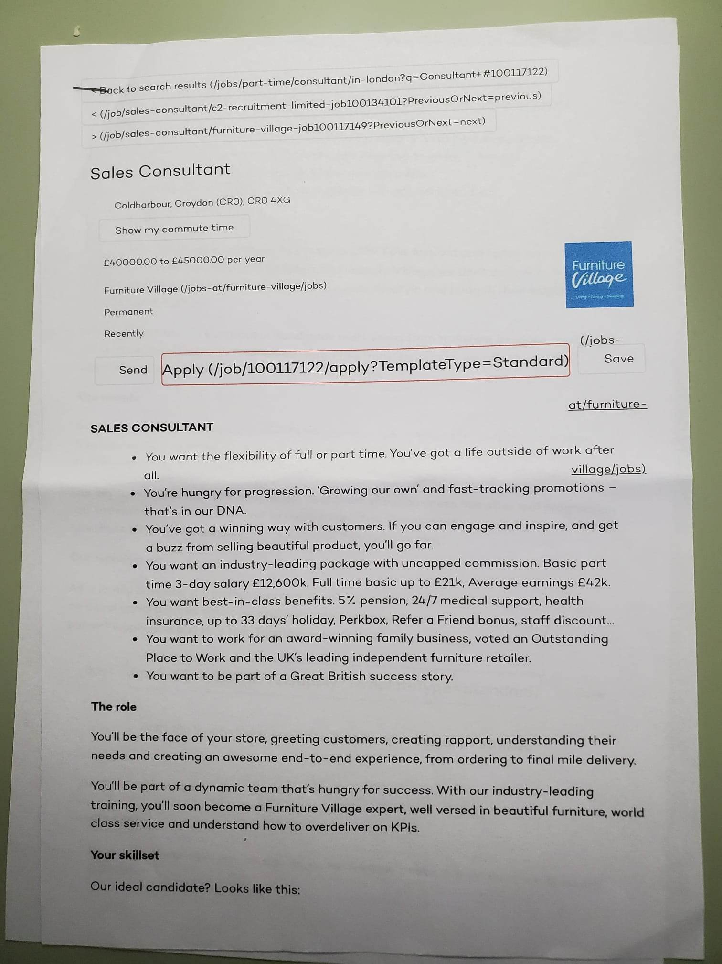

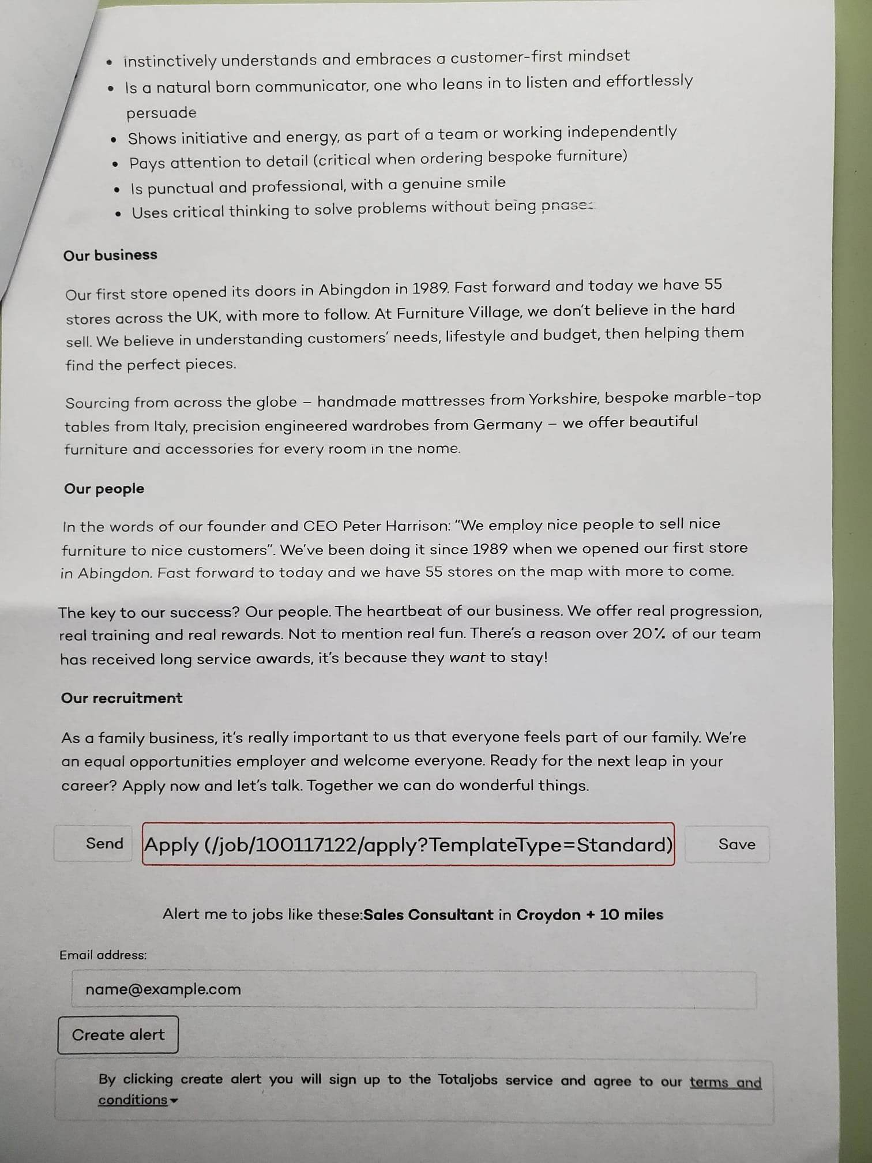

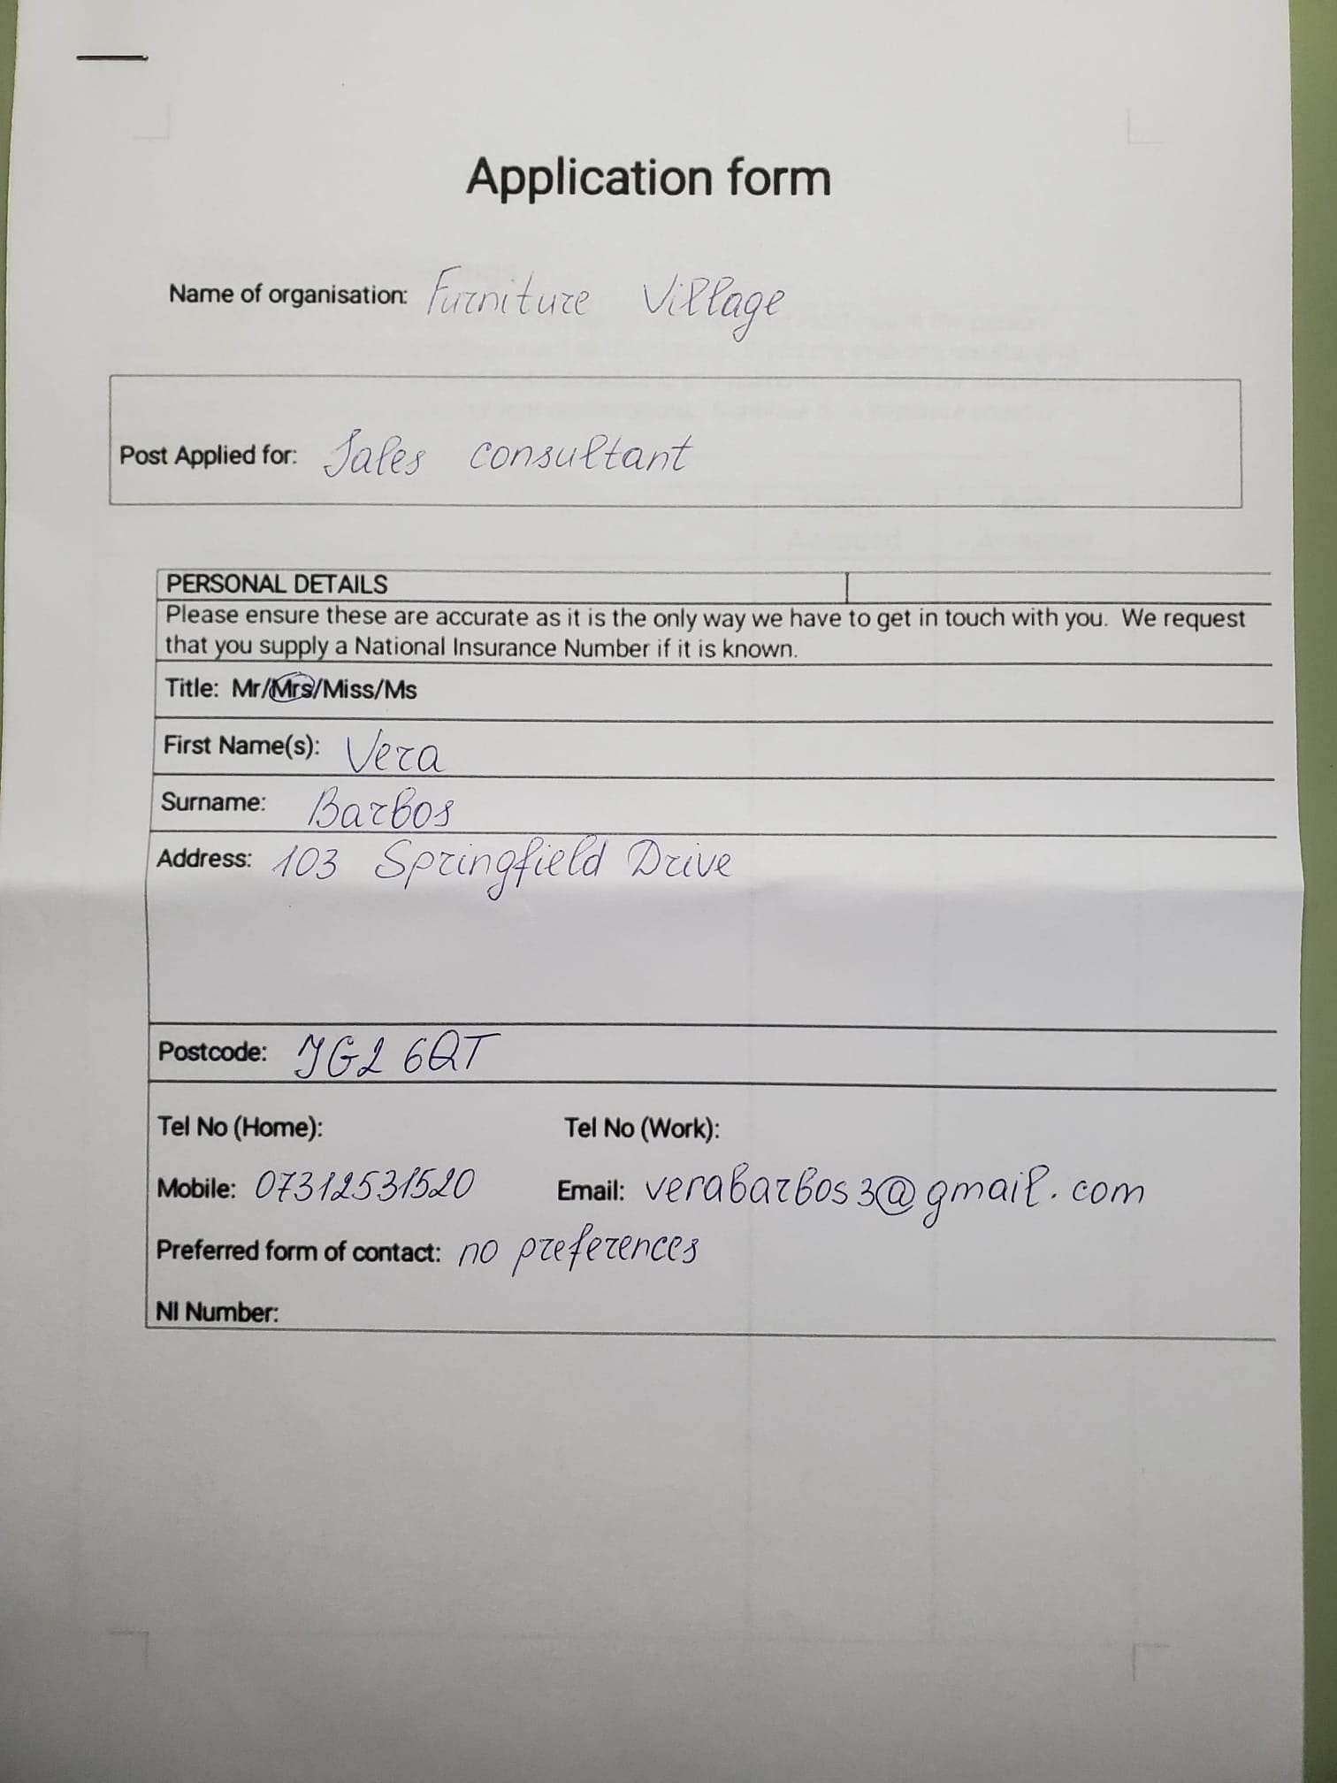

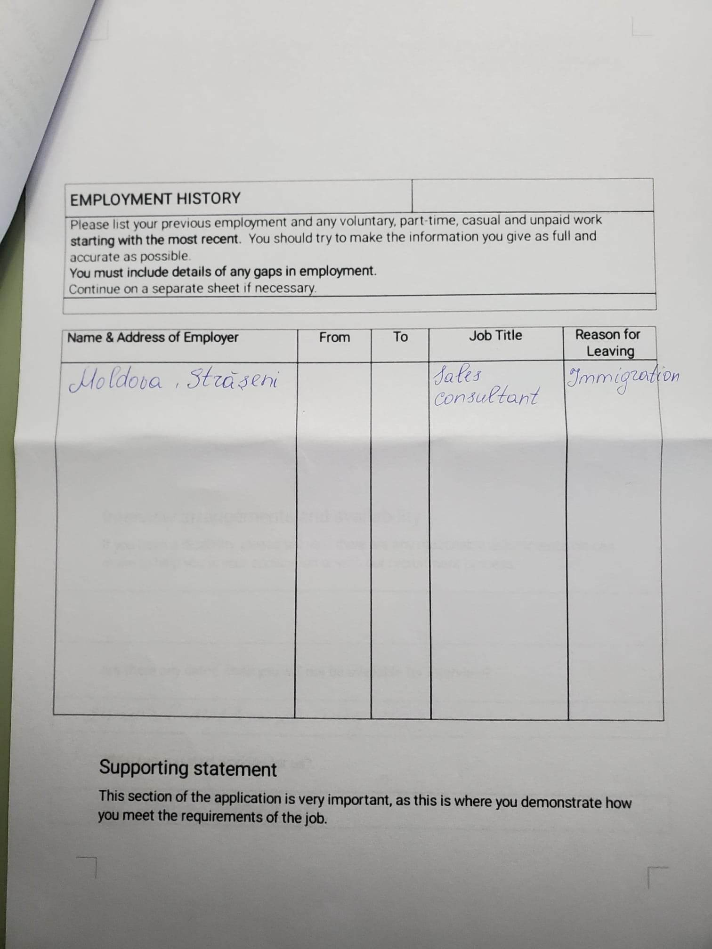

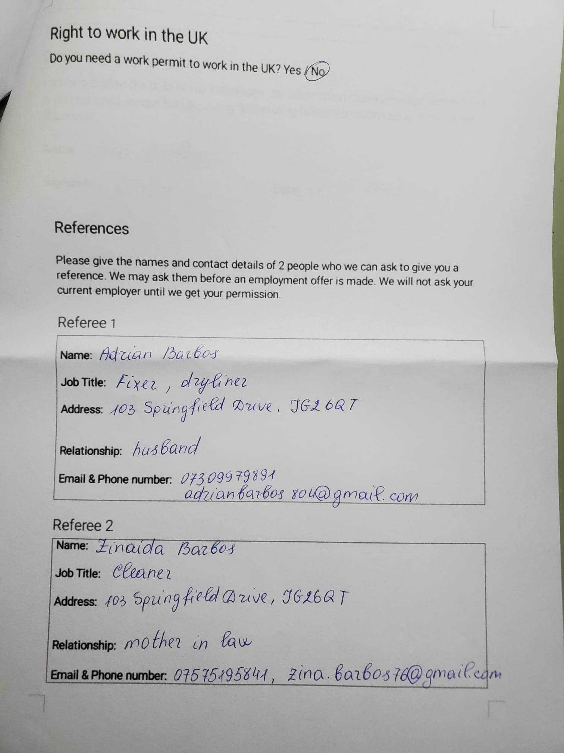

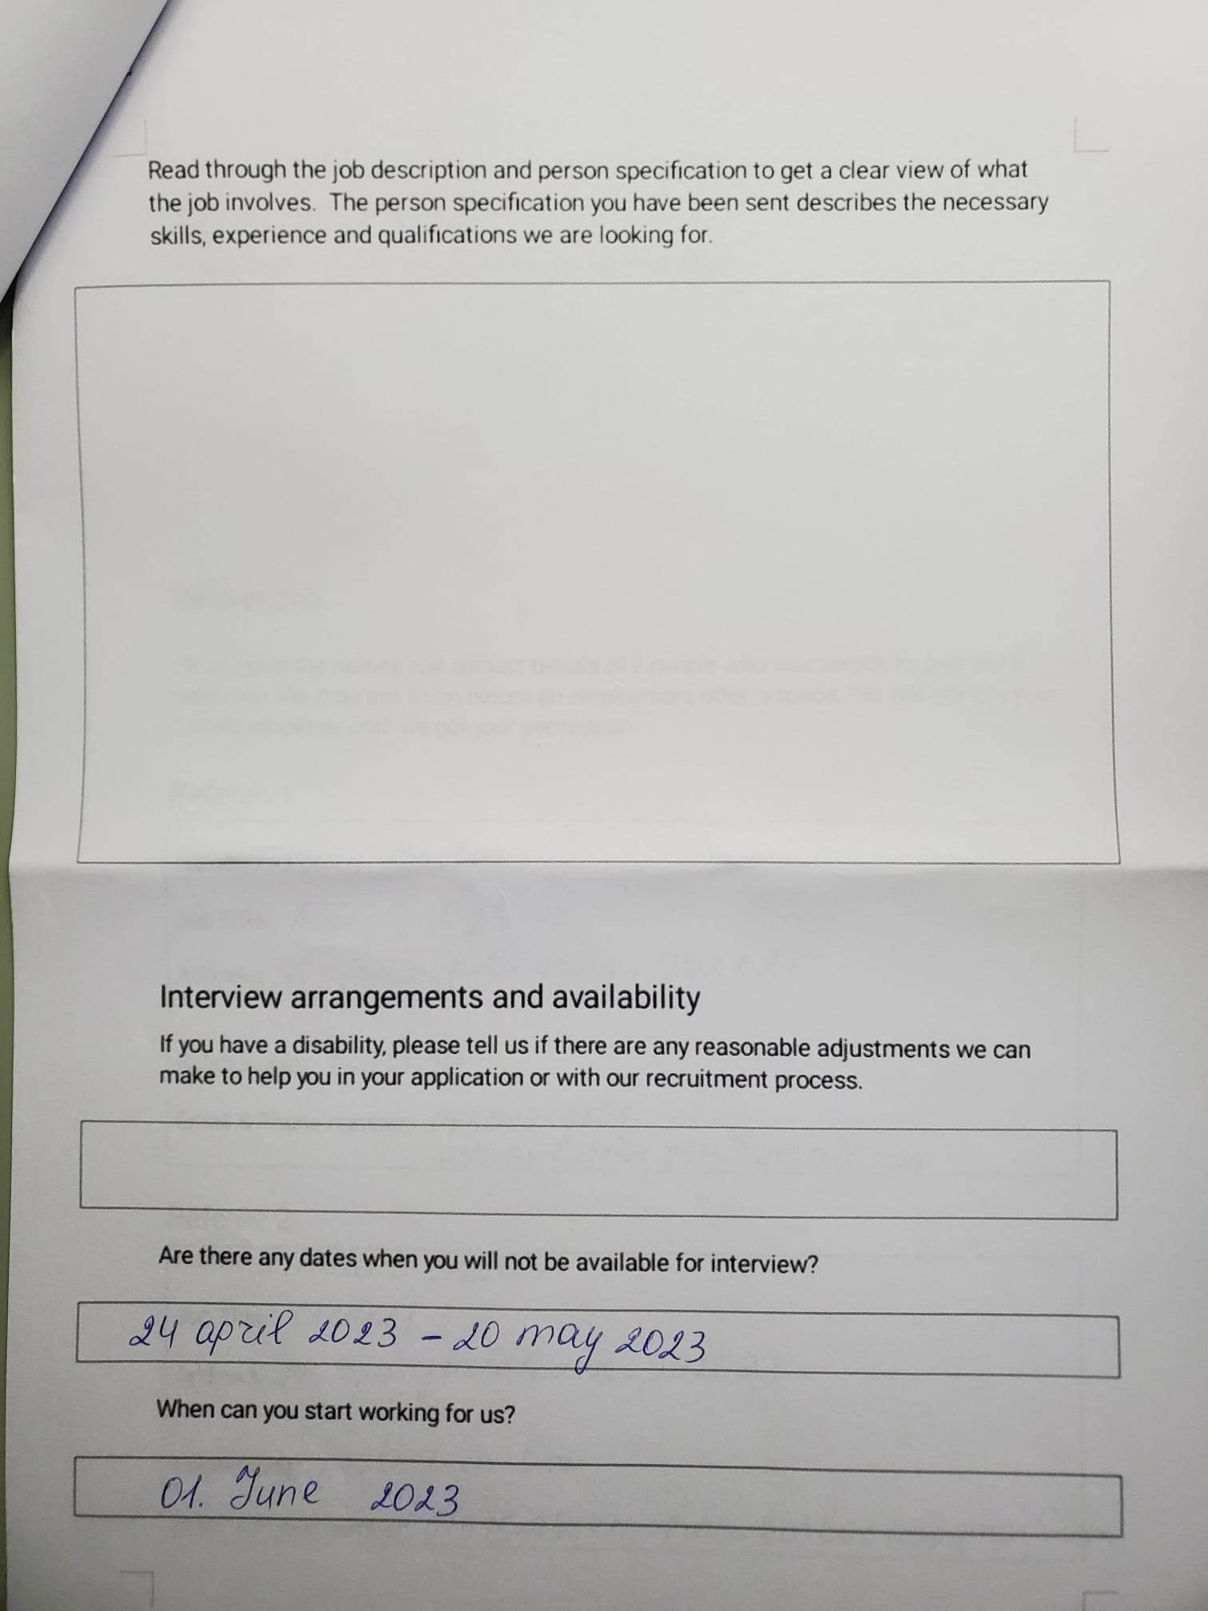

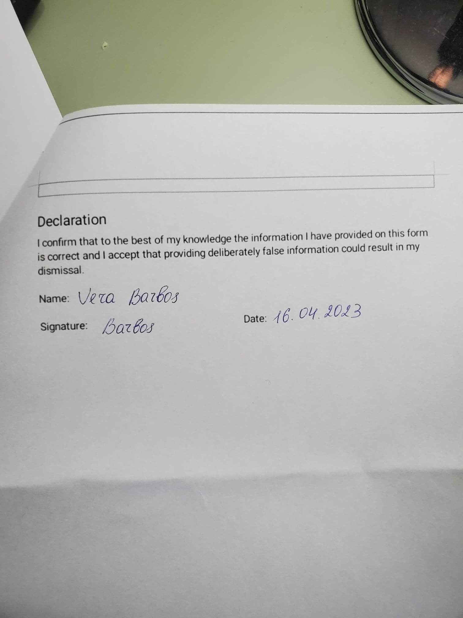

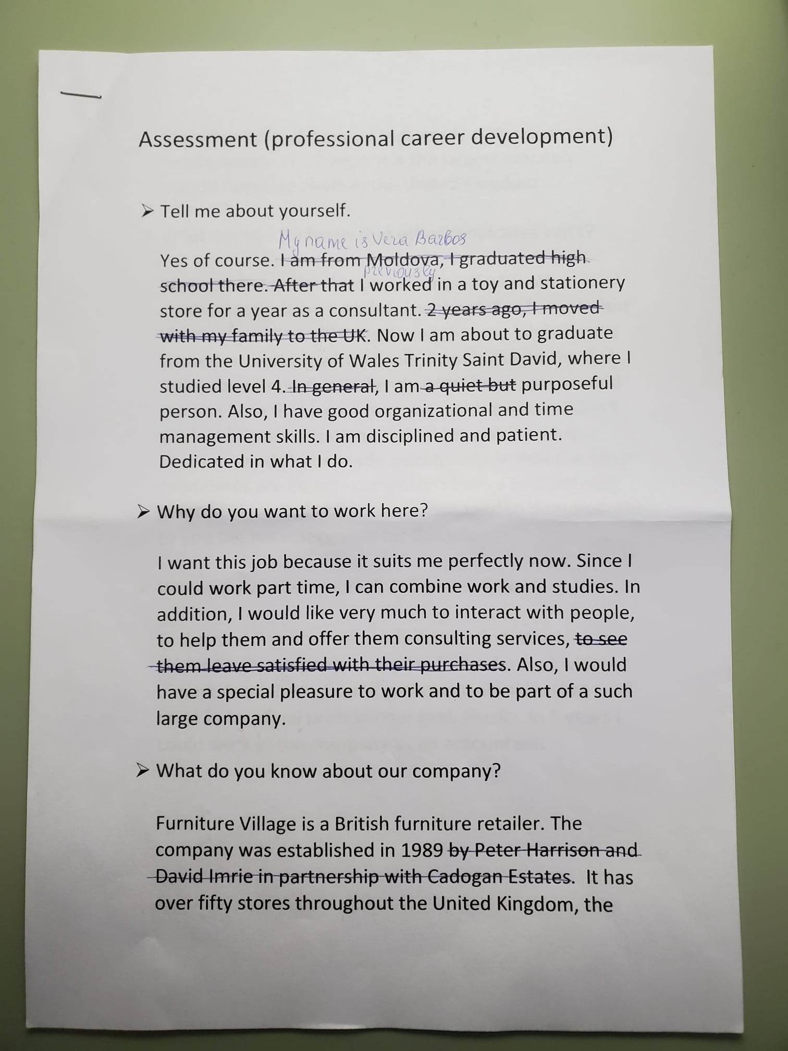

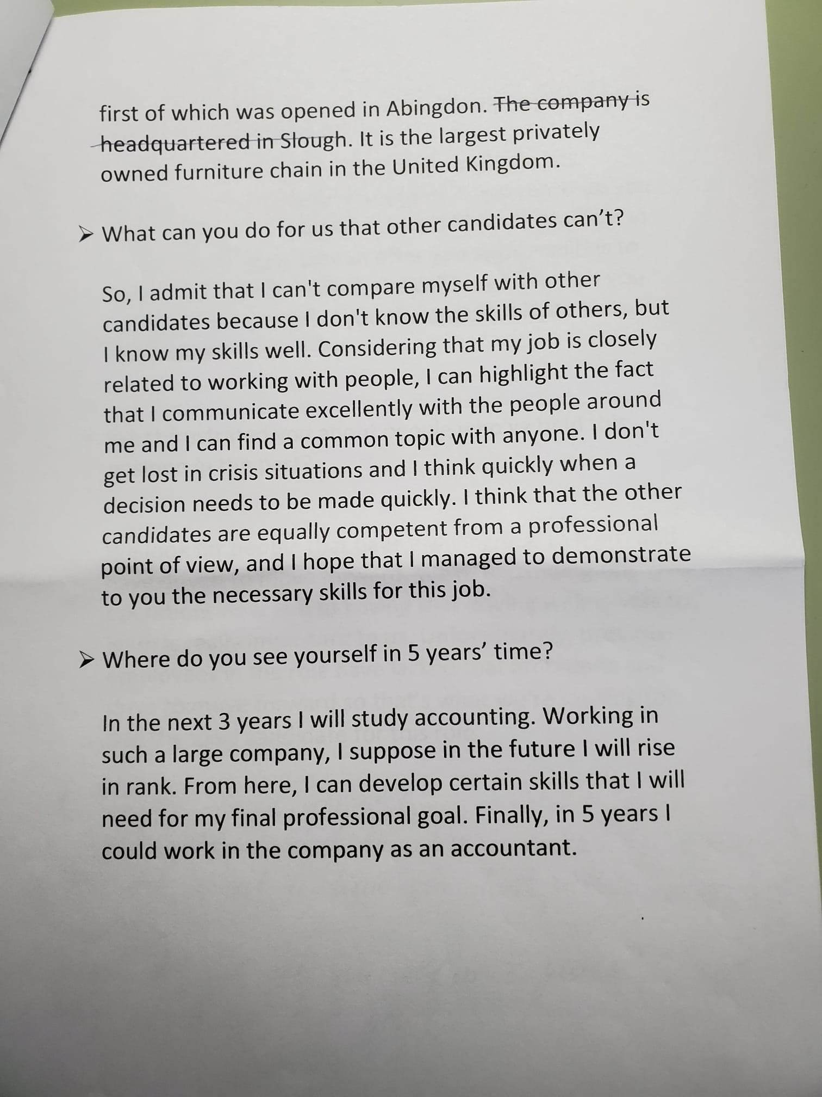
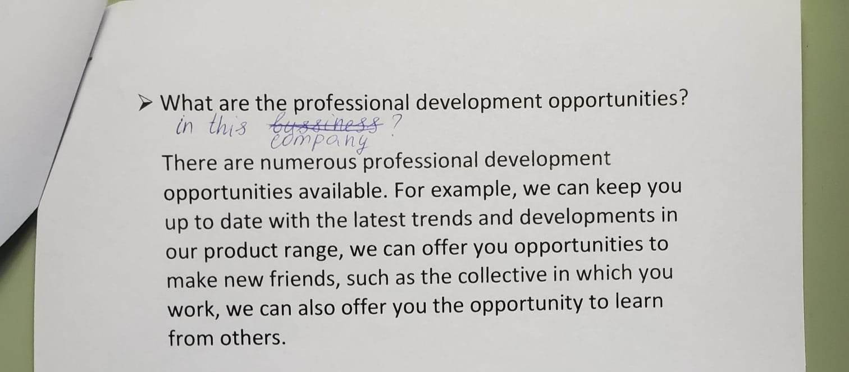
References:

- https://www.indeed.com/hire/job-description/sales-consultant
- https://uk.indeed.com/jobs?q=furniture+village&l=Work+from+Home&vjk=0f3bba0445080db2
- https://my.cumbria.ac.uk/media/MyCumbria/Documents/ReflectiveCycleGibbs.pdf
- https://www.indeed.com/career-advice/resumes-cover-letters/skills-employers-look-for
- https://www.talentlyft.com/en/resources/sales-consultant-job-description
- https://www.optimizely.com/optimization-glossary/marketing-strategy/
- https://coschedule.com/marketing-strategy
- https://www.thebalancemoney.com/list-of-teamwork-skills-2063773
- https://libguides.wigan-leigh.ac.uk/c.php?g=667800&p=4736457
- https://www.careers.govt.nz/job-hunting/cvs-and-cover-letters/how-to-describe-skills-in-your-cv/

