The Parentified Child in the Pottery:
How Can I Become My‘Self’?
A Heuristic Inquiry

This little girl is losing her‘self’.
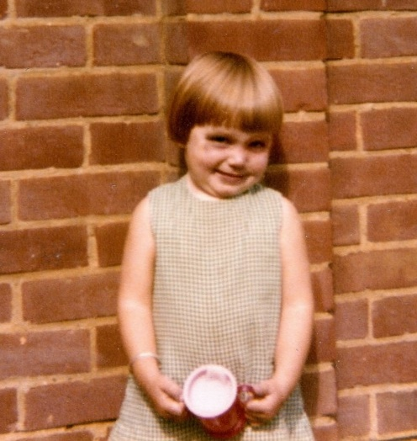
The woman she has become hopes this research journey will not only introduce new insights and approaches to working therapeutically with the legacy of Adverse Childhood Experiences in adulthood but will also offer comfort and reassurance.

Introduction

The introduction will begin by setting the scene, with a brief account of my childhood experience which has led me to where I am today and informed this research topic. The aims and objectives of the research will be stated, followed by a background to the area of research, its application and relevance to psychotherapeutic practice and a wider societal and public health context. Finally, a brief explanation of the research methodology, why it has been chosen, and its limitations will then lead onto a description of the chapters to come.

Personally significant pictures will be interspersed throughout to support the expression of what is an emotionally challenging process. I am finding that words can feel as though they are not always enough. Wall Kimmerer (2013), an environmental and forest biologist, ancestor and member of the Potawatomi Nation, shares a reassuring conversation with a Cheyenne elder when trying to learn her native language;

‘I spoke to him with a heavy heart, lamenting that I had no native language with which to speak to the plants and the places that I love. “They love to hear the old language” he said, “it’s true”. “But,” he said, with fingers on his lips, “You don’t have to speak it here.” “If you speak it here,” he said, patting his chest, “They will hear you.” ‘
Wall Kimmerer (2013, p.59)

It is with a hand on my chest, a gentle listening to my internal native language and a wish to express whole heartedly that I begin writing.

Before stepping fully into the body of the introduction it is important to firstly acknowledge that this dissertation has been conceived, researched, nurtured and written during the Covid-19 pandemic. Living in a period of personal and global uncertainty, with an awakening to a new sense of impermanence and change, will no doubt be reflected within this work. The grief, anxiety, longing, coming together and moving apart will be shadows within the words, analysis and meaning making. Perhaps this research is timely and as relevant as it has ever been, as the Welsh Government (2021a) proposes that, although Adverse Childhood Experiences should not be seen as deterministic, it is already becoming apparent that childhood adversity has increased as a result of the pandemic. It feels important, therefore, to bear in mind the heart of hermeneutic philosophy and research when reading what is to follow. The cultural context of this research is profound and unique. As McCaffrey et al (2012, p.215) states, when reappraising the hermeneutic research approach, ‘I have become aware of the sands of history shifting under my feet – the insight of impermanence’. I too have this experience.

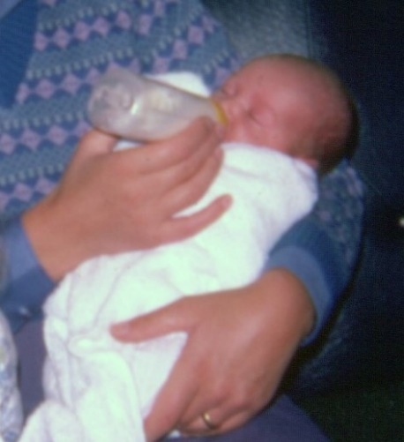

I was born in the mid 1970’s. Growing up with my Mum, Dad and older sister, it was a time of concrete playgrounds, mud pies and lemon sherbet bought by the quarter from the corner shop. It was also a time of despair, uncertainty, fear and loss. Things were different then, but not so different!

Mum lived for many years with depression and psychosis, and as a child I don’t remember a time when this was not the case. When I was 21 a psychiatrist appeared, the saviour, dishevelled, dressed in a brown suit jacket and clutching a leather bag. Here was the possibility of light and to breath. As he left, he took Mums tormentors with him in his leather bag, the dark, shadowy visitors that had stayed far too long. He couldn’t take it all though. Their presence in my childhood left a mark, a sense of having lost my’self’. This legacy continues to exist in my adult life and it is with curiosity toward this phenomena that this research is based. How can I become my’self’?

It feels important to post a loving disclaimer for Mum here. It was never Mum’s intention to cause harm to me or my sister. In fact, I often felt as though Mum was trying to protect us from what she perceived to be threats from outside our magical group of three. She did the best she could in the situation she found herself. Mum has a kind and gentle soul, with many beautiful gifts still waiting to be realised.
Thank you Mum.

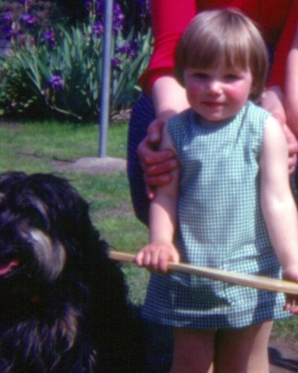

This research aims to explore how the legacy of an adverse childhood experience in adulthood, such as parental mental illness, can cause parentification and the potential impact of this on the development of the ‘self’. Working with clay as a creative therapeutic approach to support the healing of this burden in adulthood will also be studied. It is my hope and intention that this research may add to a growing field of psychotherapeutic research which holds at its heart the aim of better understanding and easing human suffering.

To achieve the aims, the objectives are firstly to explore and review research related to adverse childhood experiences, parental mental illness, parentification and loss of ‘self’, theories on the development of the ‘self’, neuroscience and the potential therapeutic benefits of using clay as a creative, body-based, non-verbal approach to psychotherapeutic practice. Secondly, as this research is not purely a literature review, it is guided by a heuristic inquiry methodology, my living experience of the phenomena will be included, plus the data collected from my personal use of clay in a therapeutic context. In collating, analysing and synthesizing all the data, conclusions and recommendations will be drawn, relevant to psychotherapeutic practice and a current public health issue.

Adverse Childhood Experiences (ACE’s) is a term that originates from the seminal research of Felitti et al (1998). ACE’s are traumatic events that happen in childhood, such as physical and emotional abuse or neglect, plus experiences like domestic abuse, parental separation, substance misuse, parental incarceration and parental mental illness (Welsh Government, 2021a).

The research conducted by Felitti et al (1998), which was undertaken in San Diego and included more than 9000 participants, found that ACE’s have a negative impact on physical and mental health outcomes in adulthood, this impact increased as the number of ACE’s increased, and that the impact can be cumulative. A diagram was produced (Figure 1) illustrating the potentiality of ACE’s over the lifespan.

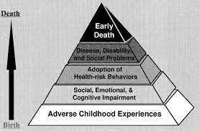
Figure 1. Felitti et al (1998)

The Welsh Government (2021a) have taken this research on board and conducted their own, more recent study (Public Health Wales, 2015), which relates to the work of many others (Herzog and Schmahl, 2018; Navalta et al, 2018; Hughes et al, 2017; Mackes et al, 2020; Iob et al, 2021), finding that ACE’s can affect how a child’s brain develops, along with the hormonal, immunological and nervous system development. As a result, Felitti et al’s (1998) diagram has been updated (Figure 2) with the introduction of an extra layer, that of disrupted neurodevelopment and allostatic load.

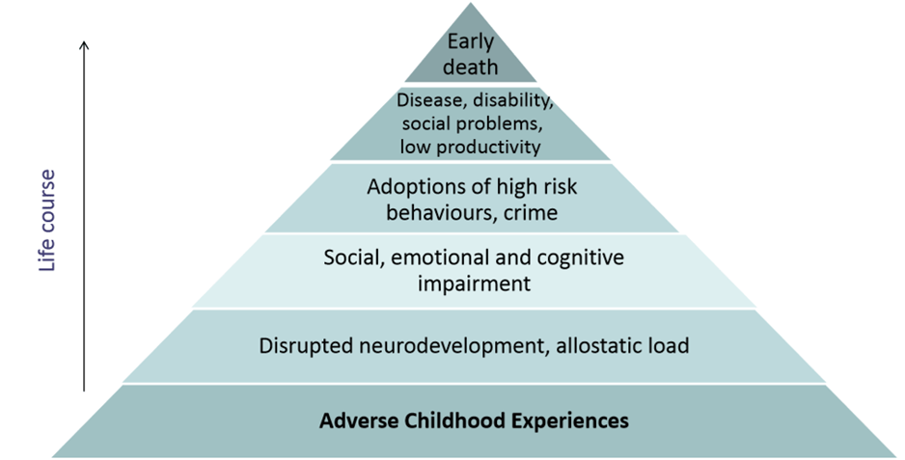
Legacy Zone
Figure 2. Public Health Wales, 2015.

There is an understandable acknowledgement of the need to prevent ACE’s (Welsh Government, 2021; Hughes, 2017, p.365; Centers for Disease Control and Prevention, 2021a), with research and interventions focusing heavily on the bottom layer. There is, however, recognition of a need for more research into the upper layers, the legacy (Murphy et al, 2011, p.3430; Hooper et al, 2011, p. 1028; Murphy et al, 2016, p.668; Simpson-Adkins and Daiches, 2018, p.2706; Metz and Jungbauer, 2021, p.64). This research will sit very much within the legacy zone, particularly the layers of disrupted neurodevelopment, allostatic load and social, emotional and cognitive ‘adaptation’. I have deliberately changed the term ‘impairment’ to ‘adaptation’ as it feels less pathologising, less likely to unhelpfully suggest abnormality within me and people with similar living experiences to me. I believe the legacies of ACE’s in adulthood, although painful and confusing, could be described as intricate, natural adaptations. Sar’s (2017, p.2) research suggests that developmental trauma, which can be caused by ACE’s, can lead to a protective internal division to save the psychological self from annihilation. Therefore, the adaptation could be seen as a means to survive, not an impairment or abnormality at all.

The phenomena that can occur from experiencing the ACE of growing up with a parent with mental illness is ‘parentification’. This is clearly recognised within research, as Murphy et al (2011, p.3433) and latterly, Simpson-Adkins and Daiches (2018, p.2712) and Kallquist and Salzmann-Erikson (2019, p.2062) found in their meta-synthesis’. Parentification is a term coined by Boszormenyi-Nagy (1965 cited in Jurkovic, 1997, p.17) and can describe the overburdening of children within a family dynamic. Jurkovic (1997, p.19) suggests ‘the net result is that the childhood of destructively parentified children is lost.’ Murphy et al’s (2016, p.668) research testifies that adult children experience this sense of loss too, the ‘loss of self’. It is this deep relationship between an ACE, parentification and the loss of self that is at the core of this research, and invites the question ‘How can I become my’self’?

It is recognised that there is the need for further research into psychotherapeutic practices that may support the healing of this phenomena. Within the three meta-synthesis already mentioned (Murphy et al, 2011, p.3433; Simpson-Adkins and Daiches, 2018, p.2712; Kallquist and Salzmann-Erikson, 2019, p.2062) it was found that adult children could experience anxiety, depression and relational issues and it is proposed that a cognitive behavioural model be used, and that reduction of the stigma of mental illness by educating clinicians would be helpful. Hughes et al (2017, p.364) report from their systematic review and meta-analysis on the effects of multiple ACE’s on health, that there is a need for collaborative, trauma-informed services available across the life course, and ACE-informed practice could be developed in multiple settings. When considering the need for ACE and trauma-informed practice, and the impact ACE’s can have on our neurodevelopment and nervous systems, it seems reasonable to turn to contemporary research in the fields of trauma, neuroscience, somatic and sensorimotor psychotherapy, haptics, metaphor use and art therapies to explore new possibilities. This will be explored in depth within the literature review chapter, but it is apparent that there is a convergence of these theories and practices within therapeutic clay work. It is my immersion into and experiencing of the research question that I hope will offer new insights and approaches into psychotherapeutic practice when in the presence of an adult living with the experience of an ACE legacy, that of having lost them’selves’.

To guide this process heuristic inquiry has been chosen as the research methodology for this Masters dissertation. It offers a rigorous and robust qualitative research approach that explores and gives voice to a living experience, such as the feeling of losing one’self’. Emerging from a humanistic background, heuristic inquiry focuses on what it means to be human. It is autobiographical, uniquely placing me as researcher and participant, it weaves a rich tapestry through engaging with seven processes within six distinct research phases. All of which will be explored in depth within the methodology chapter. The processes and phases of the research flow between introspection and relationality, therefore inviting a connection between the personal and societal, and perhaps even universal. A profound, enlightening approach to researching human experiencing, it sits closely with the foundations of my humanistic psychotherapeutic training and practice, and with my aim of researching the possibility of healing emotional burden in adulthood and to better understanding and easing human suffering.

Curiously, there is a mutual symbiotic relationship between the chosen research methodology and the research topic. Heuristic research is an exploration of the self, and the focus of this research is on a sense of losing and becoming my’self’. Heuristic inquiry is creative and based on tacit knowledge, which begins with non-verbal, body-based experiences (Sela-Smith, 2002, p.61). This research is studying the therapeutic use of clay as a body-based, creative, non-verbal approach to becoming my’self’. This relationship between methodology and topic creates an opportunity to deepen the experience and process, inviting profound and significant meaning making.

Heuristic inquiry as a research method is not without critique and limitations. Moustakas published his original work on heuristic research in 1990. This was later reviewed by Sela-Smith (2002) who felt Moustakas had not acknowledged the possibility of resistance to experiencing ‘unbearable pain’. Therefore, the potential for the research focus to shift from the self’s experience to the idea of experiencing could result in a model of ambivalence. This became apparent when Sela-Smith (2002, p.70) reviewed 28 research papers that followed Moustakas’ research method and found only 3 had successfully used the method. In recognising the issues, Sela-Smith (2002, p.83) went on to propose a research method called Heuristic Self-Search Inquiry (HSSI). The focus of which was to clearly address ambivalence and resistance and focus on the ‘I-who-feels’. Sela-Smith (2002, p.85) drew three conclusions, firstly a need for recognition of HSSI and returning to the internal perspective. Secondly, recognition of resistance to feeling and thirdly, an acceptance of surrender to the process.

Sultan (2019) has produced a contemporary revision and revitalisation of Moustakas’ original work. The aim being to ‘more efficiently meet the needs of the 21st century researcher’ (Sultan, 2019, p.xiv). Interestingly, Sultan (2019) makes no reference to Sela-Smith’s (2002) work. But similarly discusses the experiencing of ‘roadblocks’ when refining research questions and becoming saturated and fully immersed (Sultan,2019, p.19). This suggests a similarity to Sela-Smith, albeit implicit, in surrendering to the process and the opportunity for resistance. Sultan (2019) offers a clear, concise, thorough, vibrant and guided approach to undertaking heuristic inquiry in the present day. She acknowledges contemporary qualitative research ‘resides at the highly complex intersection of human experience, perception, memory, language, history, culture and other social systems, relational interactions, and social justice’ (Sultan, 2019, p.xiv).

With this knowledge and depth of information about the process, and the acknowledged critique and limitations, it is suggested that a hybrid approach be utilised, incorporating the work of Moustakas, Sela-Smith and Sultan. In so doing, the relevance, credibility and application of this research to the present will be significant.

To Follow – explanation of chapters to come.

Literature Review

Before stepping into the body of this literature review, it feels important to firstly describe the approach that has guided this process. Sultan (2019, p.109) notes that for a heuristic research literature review it can be wise to explore the literature at different phases of the research journey; ‘Before formulating your research question’, ‘After identifying a research question’ and ‘After analysing your data and identifying themes’. I have attempted to follow the guidance for this literature review, however, the process has had moments of challenge, overwhelm and emotional pain. Reading articles and books related to a deep, profound, personal experience has, at times, felt like scratching at a raw wound and this feels unacknowledged within Sultan’s (2019) writing on this area. Moustakas (1990, p.37) does, however, reassuringly acknowledge, ‘Heurisitic research is an extremely demanding process.’

Gilroy (2006, p.104), when exploring qualitative research in art therapy, describes a literature review as intrinsically being about identifying and analysing research, drawing data from literature, but goes on to state that data can also be in the form of any ‘physical object that bears the traces of human activity’. This proposition sits comfortably with the theme of this research and has, therefore, inspired this literature review. It also speaks to the part of me that is terrified of being exposed through this process and finds reassurance in imagery and non-verbal expression. Is this the part of my’self’ that feels lost? Is it here? Letting its presence be known, as it did when I discovered it at the beginning of this research journey. The calling to non-verbal communication is silent but undeniable. Not speaking enters my dreams; the peace and the safety.
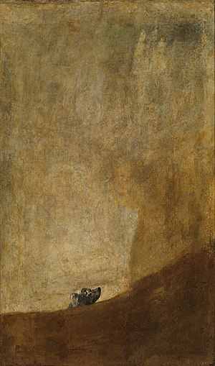
The written word will continue to be given precedence here, to uphold what feels like a traditional belief of credence. However, pictures and artworks will be included to enhance what is being discovered and to acknowledge and offer comfort to the part of me that craves this.
What is sought in this literature review is a depth of understanding, but also depth of feeling. To engage the reader in exploring the living experience of parentification and the almost unbearable pain of having lost one’self’. Like Goya’s El Perro/The Dog, the parentified soul is afraid, stuck, lost, and silent, looking toward a dark, shadowy place.

‘A picture is worth a thousand words’ (Barnard, 1921).

El Perro, Francisco Goya, 1819-1823.

As I write, the sun is low in the sky, golden leaves are falling from the oak and beech trees outside my window, autumn has arrived. When I began it was spring and green shoots were emerging. The changing of the seasons is an embodiment of the liminal space I find myself whilst undertaking this work.
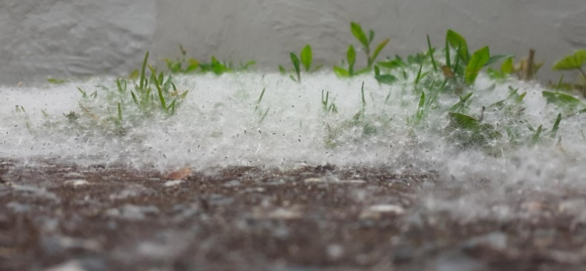

In order to undertake this literature review books and articles were accessed using the University of Wales Trinity Saint David library database. In particular texts were accessed using SAGE Books, SAGE Knowledge, ProQuest Ebook Central, Taylor & Francis Group eBooks, EBSCOhost Academic Search Premier, ( STILL MORE TO ADD TO THIS LIST).

This literature review will begin by exploring the definition of parentification. Research on growing up with a parent with mental illness and the connection to parentification will then be examined followed by a review of the potential impact this can have on the development of the self. This will lead into an analysis of the concept of the self, drawing on the foundational work of Donald Winnicott, John Bowlby and Daniel Stern, whilst incorporating contemporary research in the field of neuroscience. In bringing together the old and new, deeper insights into the ‘self’ and the phenomena of losing one’self’ is possible, and the question, ‘How can I become my’self?’, emerges. In endeavouring to explore this question, in light of what has already been examined, a review of trauma, sensorimotor, haptic, metaphor and art psychotherapeutic research follows. In drawing together these areas of research and studying the work of Souter-Anderson and Elbrecht, the therapeutic potentiality of clay is considered.

In the 1960’s, when Minuchin and colleagues were working with families living in the ghettos of New York, they noticed that some children were taking on parental responsibilities. They referred to these youngsters as ‘parental children’ (1967 cited in Jurkovic, 1997, p.16). But it was Boszormenyi-Nagy (1965 cited in Jurkovic, 1997, p.17), also a key figure in family therapy at the time, that coined the term parentification. Within psychotherapeutic research, the term parentification most often refers to children, or adult children, who have experienced an overburdening of parental responsibility, beyond what is developmentally appropriate. The parent-child relationship boundary is distorted and the family dynamic becomes confusing. The child takes on the functional and/or emotional role of the parent, sacrificing their own needs in response to what the parent needs, this is considered damagingly exploitative (Chase, 1999, p.5; Boszormenyi-Nagy and Spark, 1984, p.164). It is a heavy burden that involves invisible loyalties and symbiotic relationships between parent and child. A sense of obligation is created, an internalisation of the expectations to care for the parent.

It is alarming that parentification was being recognised in the 1960’s, with acknowledgement in the late 1990’s that ‘there is an epidemic of parentified children’ (Chase, 1999, p.143). Yet, even as research on ACE’s in general has been thriving over the last few years (Struck et al, 2021, p.1), research on the impact of parentification on both children and adults is still desperately needed (Chase, 1999, p26.; Engelhardt, 2012, p.45; Abraham and Stein, 2013, p.600; Van Loon et al ,2017 p.142; O’Connell, 2008, p.89).

Perhaps it is the ubiquitous nature of parentification that makes it unappealing to researchers. Boszormenyi-Nagy and Spark (1984, p.151) believed that parentification is applicable to most human relationships, not always inherently damaging or problematic. They propose that a level of parentification can enable a child to prepare for and identify with responsible roles in the future. The reciprocity in the relationship being helpful to a child’s sense of belonging and usefulness. In recognising the dichotomy in parentification, two definitions are offered, ‘adaptive’ and ‘destructive’ (Byng-Hall, 2002, p.376). Jurkovic (1997, p.19) identified adaptive parentification as generally transient, the child is not captive to the role and their identity is not formed around it, whereas destructive parentification is diametrically opposite to this. I wonder if these two definitions capture the entirety of the living experience. Chase (1999, p.144) suggests, ‘there is no one parentified child, any more than there is one form of parenting’. Defining parentification in a way that fits all individual experiences is nigh on impossible, as can be the case when offering one or two words to describe a complex phenomenon. If reaching for classifications, perhaps the term parentification would better serve the people it is applied to if considered a three dimensional, interrelated continuum.

When using the term parentification within this research, it will be referring to the overburdening, exploitative aspects, the ‘destructive’ form. It is hoped that more research will be undertaken in this area and that, in some small way, this piece of research may help in filling some of the void.

There is a growing body of research on the experience of growing up with a parent with a mental illness and the impact this can have. However, it has been acknowledged for some time that there is a need for further research and understanding in this area, particularly in relation to adult children (Foster, 2010, p.3144; Petrowski and Stein, 2016, p.2873; Murphy et al, 2018, p.1016; Metz and Jungbauer, 2019, p.74). The division between researching the experience of the child and the experience of the adult child is apparent within the research. Within the three meta-synthesis identified as key pieces of research for this literature review, one captures data from under 18’s, whilst the other two explore the adult child perspective (Simpson-Adkins and Daiches,2018; Murphy et al, 2010; Kallquist and Salzmann-Erikson, 2019). This dissertation research focus is on the adult child experience, however, the qualitative data, so generously shared by the young participants, feels like a courageous, heartfelt expression of personal experiences, that is rich and insightful. As Murphy et al (2018, p.1016) describes, ‘Whilst there is a paucity of qualitative studies with a focus on adults who experienced childhood parental mental illness, current knowledge suggests there might be similarities with study findings involving children.’ It is prudent, therefore, to include the findings of Simpson-Adkins and Daiches (2018) here.

The three meta-synthesis’ aimed to identify and bring together the available, applicable, published, qualitative research on the experience of having a parent with a mental illness and offer new interpretations and insights within this field. They identified, or defined parental mental illness as either having depression, psychosis, bipolar disorder, schizophrenia, obsessive compulsive disorder, a diagnosed personality disorder or being in contact with a psychiatrist or mental health service. It feels imperative, at this point, to highlight that we are so much more than a diagnosis.

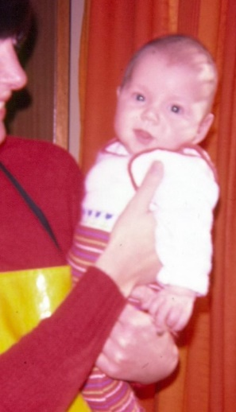
It is acknowledged that a diagnosis can be helpful, but that medicalisation within qualitative research runs the risk of dehumanisation. It may be considered a requirement for robustness, to define and achieve the aims, and perhaps to achieve a word limit, but it feels a rudimentary aspect of qualitative research. Categorising ourselves and others, inside and outside of research, seems popular but at what cost. Does it offer some comfort by creating a framework for our experiences? Is it helpful to us to define and therefore know where we fit in the world? If we realise the existential unknowns, can we then value the individual more, perhaps value having a small number of participants in qualitative research without questioning applicability? Within this piece of research, I am the lone participant. Does this make what you are reading less significant? It feels significant to me. For continuity and to avoid confusion, the term mental illness will continue to be used throughout, to align with the adopted terminology used within this field of research.

Simpson-Adkins and Daiches (2018, p.2707) identified 14 papers related to under 18’s for their meta-synthesis. Murphy et al (2010, p.3432) included 7 articles exploring adult experiences and interestingly, 9 years later, Kallquist and Salzmann-Erikson (2019, p.2058) identified 14 articles. It is hoped that this increase in available research on adults suggests increased attention and interest in this area. Simpson-Adkins and Daiches (2018, p.2710), both holding Doctorates in Clinical Psychology from the University of Lancaster, in their up-to-date, significant study on the experiences of 5 to 18 year olds, discovered amongst the heart-wrenching accounts of these young people that they, ‘Subjugate own needs for the parent’s: “Sometimes it’s more like I’m the one who’s the parent” (Simpson-Adkins and Daise, 2018, p.2711). There was a clear recognition of the changing role within the family, the sense of parentification (Simpson-Adkins and Daiches, 2018, p.2712).

Murphy, a mental health nurse and lecturer, appears to be a prolific contemporary researcher on adult experiences of growing up with a parent with a mental illness (Murphy et al, 2010; Murphy et al, 2016; Murphy et al, 2018a; Murphy et al 2018b). Kallquist and Salzmann-Erikson (2019, p.2061), both associated with the University of Gavle in Sweden, incorporate three of Murphy’s research papers in their very recent meta-synthesis. It is perhaps not surprising that the findings of both their meta-analyses are similar. Murphy et al (2010, p.3433) and Kallquist and Salzmann-Erikson (2019, p.2062) identified that adults who grew up with a parent with mental illness experienced ‘reversed roles and responsibilities’. This corroborates with Simpson-Adkins and Daiches’ (2018) findings. However, there is curiosity and concern towards the intertwined nature of the two research articles. The potential for Murphy and her colleagues work to flood the research is a possibility. Their work appears highly significant and is peer reviewed, but it is ultimately conducted through their eyes, their minds, their emotions. Surely inviting the potential of bias within the interpretations of the data.

In an attempt to address this, three pieces of additional research, not included within the meta-analyses, have been identified. Metz and Jungbauer (2021), Abraham and Stein (2013) and Reupert and Maybery (2007). Metz and Jungbauer’s (2021, p.66) very recent qualitative research in Germany included eighteen adult participants, all had grown up with at least one parent with a mental illness. They found that 72% of the participants disclosed experiencing parentification (Metz and Jungbauer, 2021, p.74). Abraham and Stein’s (2013, p.604) research, affiliated to the University of Michigan and recruiting 116 participants, specifically focused on the experiences of emerging adults who have a mother with a mental illness. From responses to an online self-report questionnaire, they claim that having a mother with mental illness resulted in experiencing higher levels of role reversal. Reupert and Maybery’s (2007, p.362) research, based on a review of literature, also found that children can assume parental responsibilities when a parent has a mental illness. It is noticed that Reupert and Maybery’s (2007) research fails to highlight how many articles were included, and the criteria for inclusion and exclusion. It is also slightly dated. Metz and Jungbauer (2021, p.74) and Abraham and Stein (2013, p.611) both state that a low number of participants is a limitation to the generalizability of their results. Both had predominantly female participants, which does bring into question the applicability to men. Abraham and Stein’s (2013) research was concentrated on having a mother with a mental illness. This fails to address the possibility that parentification may not be exclusive to the mother-child relationship, much like when the terms ‘role reversal’ and ‘parentification’ are used interchangeably. Role reversal implies exclusivity in the relational dynamic between parent and child, when parentification could in fact involve multiple familial relationships.

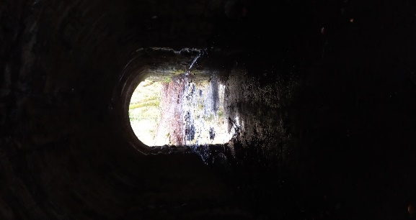
When examining the available research, taking into account the limitations, it seems reasonable to suggest that the relationship between the Adverse Childhood Experience (ACE) of growing up with a parent with a mental illness and parentification is supported.
Light at the end of the tunnel. Helen Evans 2021.
There is strong evidence within the research that, once established in childhood, the legacy of parentification can be carried into adulthood creating psychological symptoms (O’Connell, 2008, p.96; Jurkovic, 1997, p.19). Hooper et al (2011, p.1037) support this claim in their extensive meta-analysis that includes 2472 participants from 12 studies. Adults can experience isolation, confusion, grief, worry, fear, alienation, lack of trust, shame and crippling guilt (Engelhardt, 2012, p.47; Byng-Hall, 2002, p.377; DiCaccavo, 2006, p.469). It is also noted that the devastating effects can include being held emotionally captive, losing our autonomy, our freedom and, importantly for this research, losing a sense of our’self’ (Boszormenyi-Nagy and Spark, 1984, p.160; Foster, 2010, p.3148; Murphy et al, 2016, p.670; Foster, 2010, p.3146; Earley and Cushway, 2002, p.165; Engelhardt, 2012, p.47). Chase (1999) writes with such poetic expression about parentification that it touches the soul;

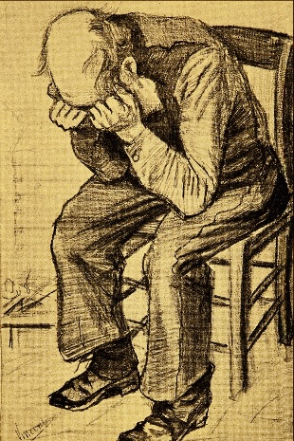
“Parentified children swim in a sea of internal, drowning objects, too many to save easily, yet too precious to be abandoned. To where can the true self swim? Does the true self even deserve to stay afloat, hearing the cries for help, the distress, of the other parts who carry the burden of overwhelming experience? How can the true self justify accepting help for itself, knowing that these related parts have, at times, served to aid in its very survival, and are equally deserving of rescue? The powerful undertow of loyalty to even those desperate parts makes the prospect of individuation a terrible dilemma. Psychic life comes to resemble the interminable, hellish waiting for the drowning.” (Chase, 1999, p.147)
At Eternity’s gate/ Worn Out. van Gogh, 1890.

Chase (1999, p.147) writes ‘children’, but what she so eloquently describes is an experience that continues into adulthood. The losing of a place for one’s true ‘self’. Sars (2017, p.2) agrees, as referenced in the introduction, stating that internal division occurs as a result of developmental trauma, to protect one’self’ from annihilation. Interestingly, Chase (1999, p.145) suggests that parentification and dissociation contain similarities, in the sense of invisibility being employed as a means to survival, stating ‘much of the inner world of the parentified child is invisible and rarely seen in its purest form’. It is my lost self, the invisible part of me that is so afraid of writing this dissertation. The exposure feels too much.
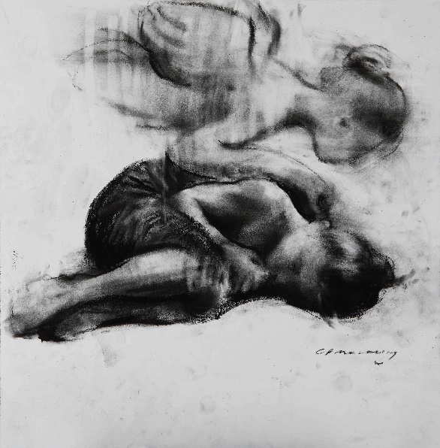
Girl and Angel. Mackesy, 2020.

Childhood is packed full of developmental milestones and if this process is interrupted the consequences can be felt for years to come.
*Going on to discuss theories on the development of the self through attachment theory and Sterns the four senses of self. Looking also at Winnicott and his writing on the true self and false self. Incorporating neuroscientific work which shows how the brain and nervous system can be altered in children through adversity.
*Move into trauma theory, Bessel van der kolk, Janina fishes, Pat ogden – sensorimotor theory. How this sits with the theory on using clay therapeutically – Cornelia Elbrecht and Lynne Souter-Anderson.

Methodology

Heuristic inquiry has been chosen as the research methodology for this Masters dissertation because it gives voice to a living experience. The fact that the experience may not have had a means to express itself before, or may have wished to remain invisible, made the process feel even more important. Heuristic inquiry offers a systematic, organised, reflexive, robust qualitative research approach, which is autobiographical and will uniquely place me as both participant and researcher. Its roots are humanistic and from here grows the exploration of an aspect of what it means to be human. It is a deeply personal research process but with application to a much wider societal and cultural context, and in the case of this research focus, an important current public health issue within Wales. As Moustakas (1990, p.15), the originator of heuristic inquiry, states ‘with virtually every question that matters personally there is also a social – and perhaps universal – significance.’ In a more recent explanation, Sultan (2019, p.2) states it can be ‘a multicultural, contextual, intersubjective, and embodied act.’
The word heuristic is derived from the Greek heuriskein, which means ‘to discover or to find’ (Moustakas, 1990, p.9) and it first came to light with the publication of ‘loneliness’ by Moustakas (1961 cited in Moustakas, 1990, p.9). The research approach Moustakas developed was influenced by Maslow’s work on self-actualisation, Gendlin’s writing on focusing and the felt sense, Husserl’s foundational work on phenomenology and Polanyi’s proposals on tacit knowing (Moustakas, 1990, p.9; Sultan, 2019, p.4).
*Explain more here about Moustaka*
*Introduce sela-smith and sultan. Dicussing limitations and approaches of all three. Discussing how bringing all three together, to create a strong ‘Hybrid Heuristic Methodology’ which is in touch with its original self, but incorporates the critique of Slea-smith and the contemporary research approach of Sultan. This will offer opportunity for a more thorough research process.
*I will describe each process and phase below
It has been reviewed twice since this time, firstly by Sela-Smith (2002), and secondly by Sultan (2019).

Talk about 7 processes and 6 phases
The seven processes of heuristic inquiry;
Identifying with the focus of inquiry
Self-Dialogue
Tacit Knowing
Intuition
Indwelling
Focusing
The Internal Frame of Reference
The six phases:

Initial Engagement
What in your life is calling you,
When all the noise is silenced,
The meetings adjourned,
The lists laid aside,
And the wild iris blooms
By itself
In the dark forest …
What still pulls on your soul?
~ Jalaluddin Rumi

Immersion
Incubation
Illumination
Explication
Creative Synthesis

Explain each phase and what I did in each. Timings etc Approx 6 months data capture. The process naturally occurred in 2 phases.

Ethical approval given for the research from the University of Wales Trinity Saint David

Data Analysis/Findings
Photos and journal entries in appendices??

Phase 1 - Holding, Supporting, Exploring
a)
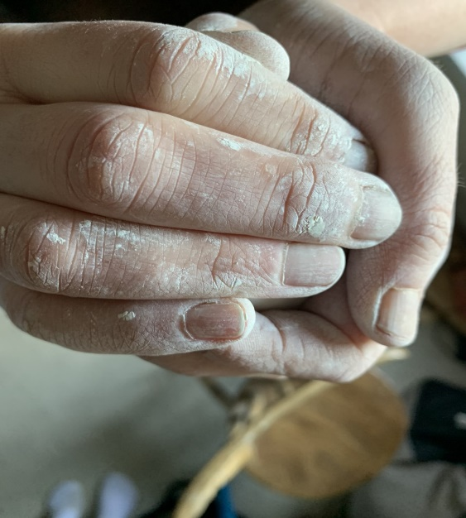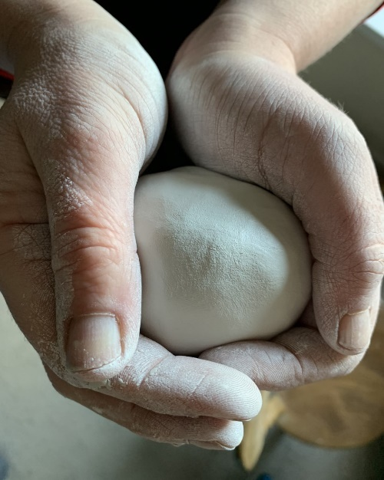
Holding 1 Holding 2
b)
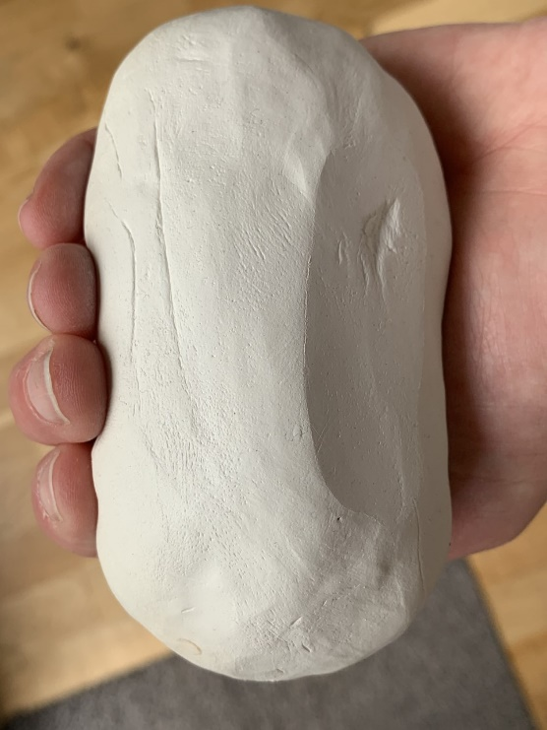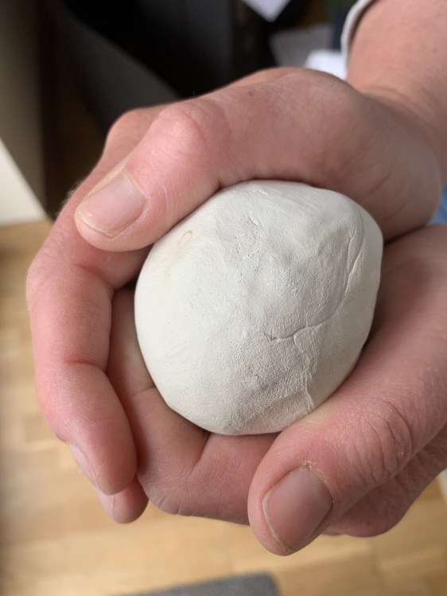
Stillness 1 Stillness 2

c)
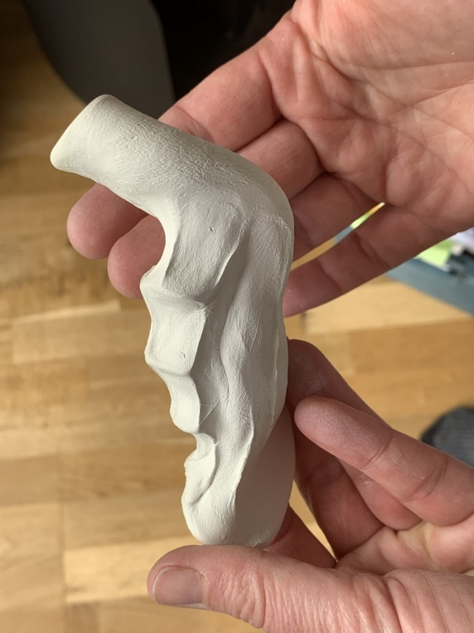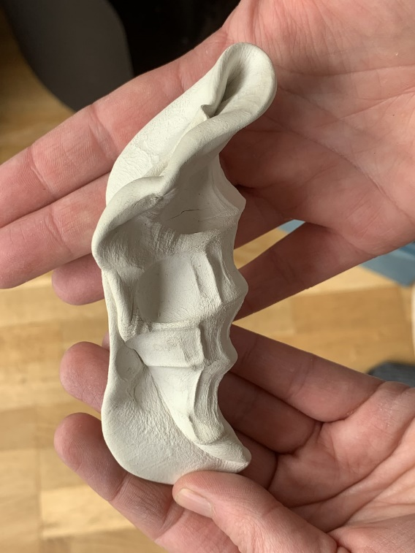
Energy 1 Energy 2
d)
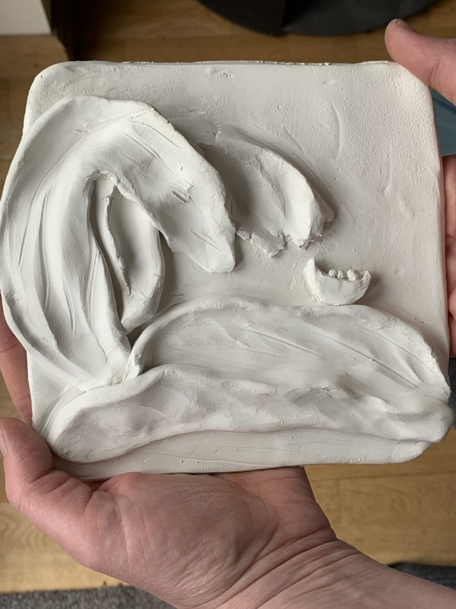
Fear for the three of us

e) f)
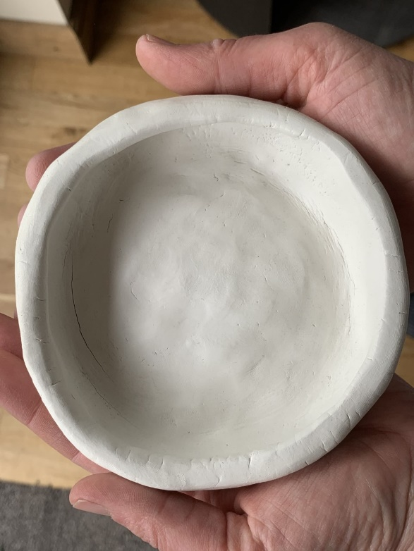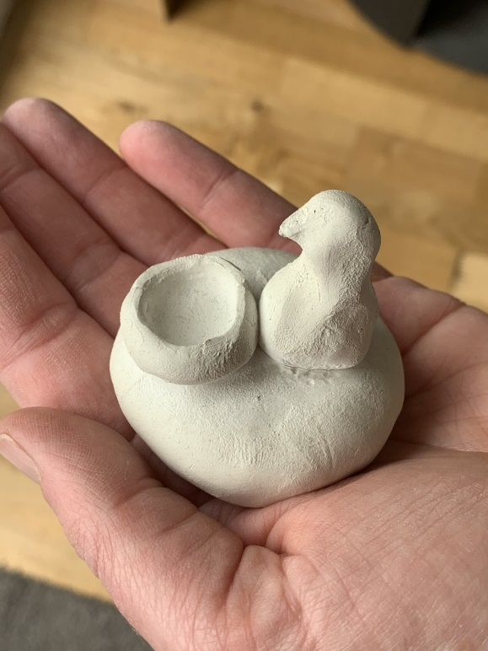
Container Grandad/Safety/Comfort
g)
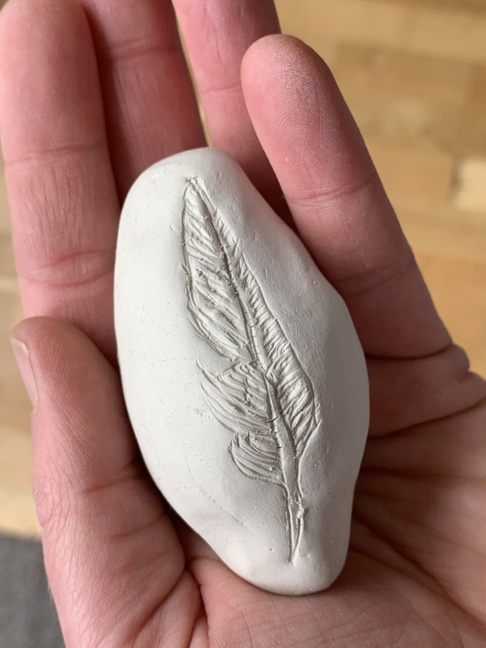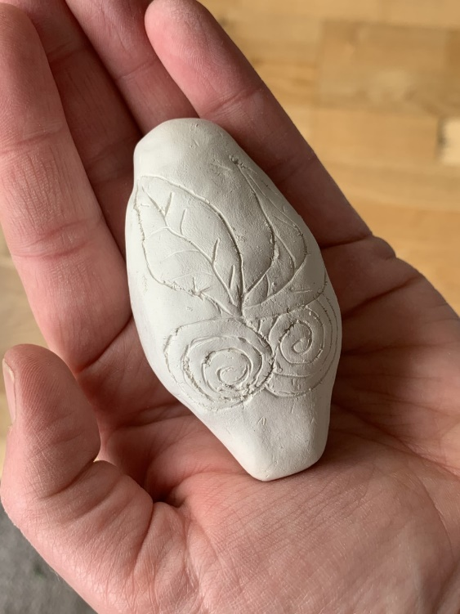
The Gem The Gem

h)
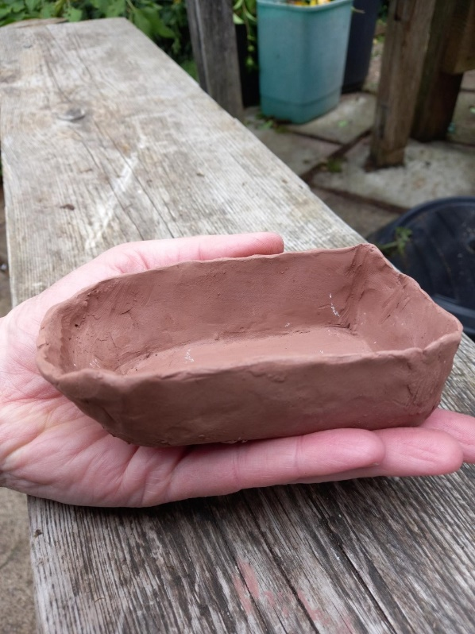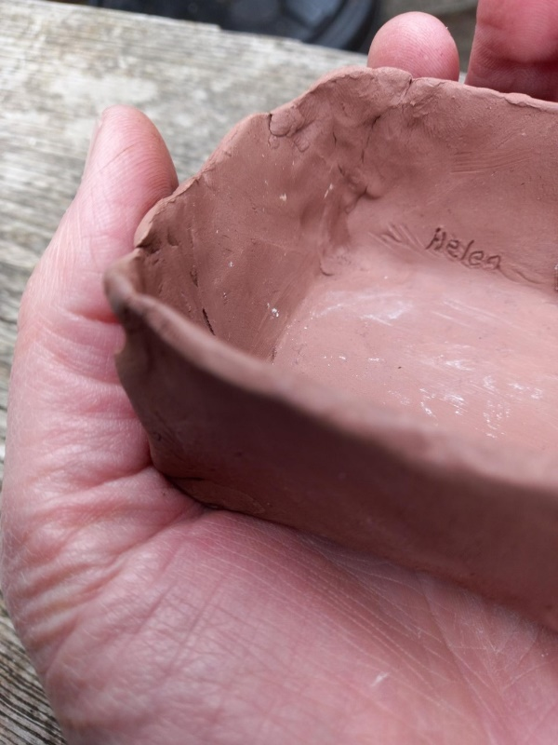
Empty Boat Empty Boat Name Etching

i)
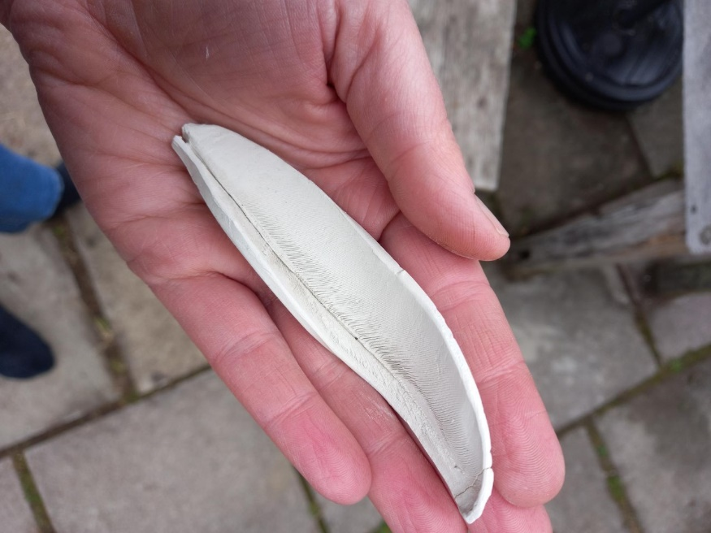
Feather

j)
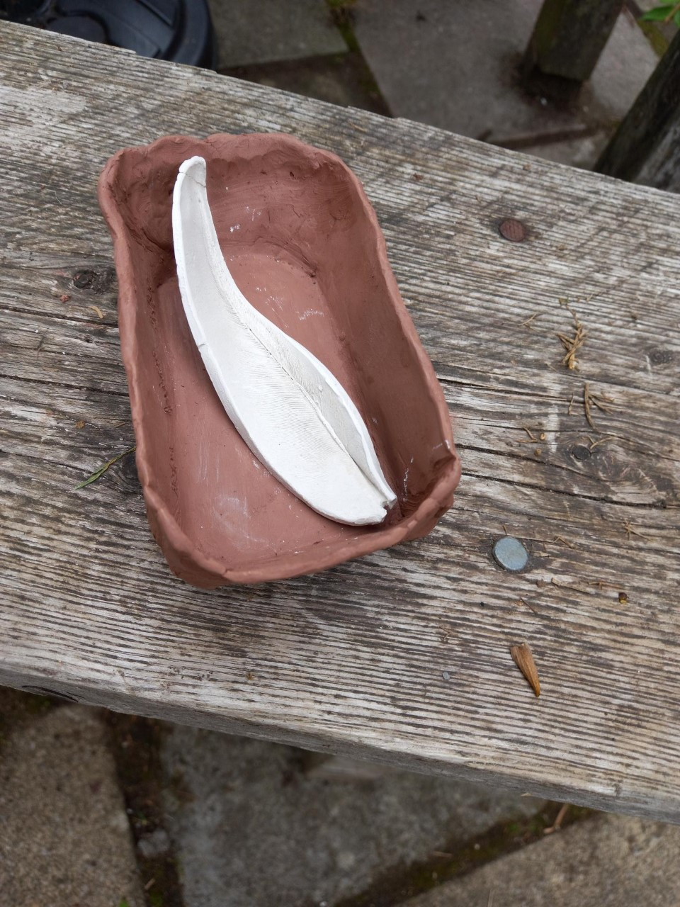
Free

Phase 2 – Realising, Consolidating, The Birth, My’Self’
k) l)
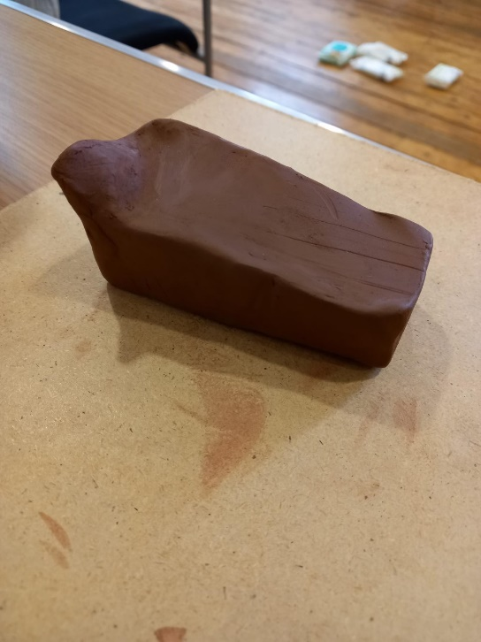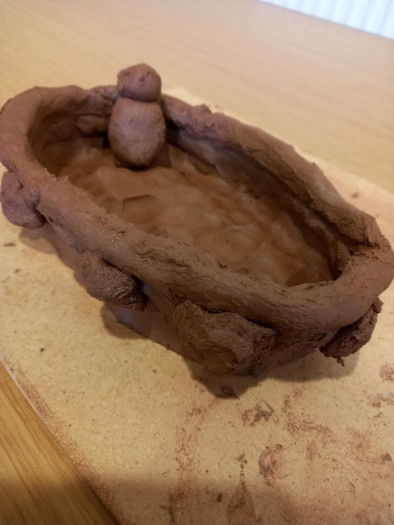
Emptiness Alone
‘Shul’
m)
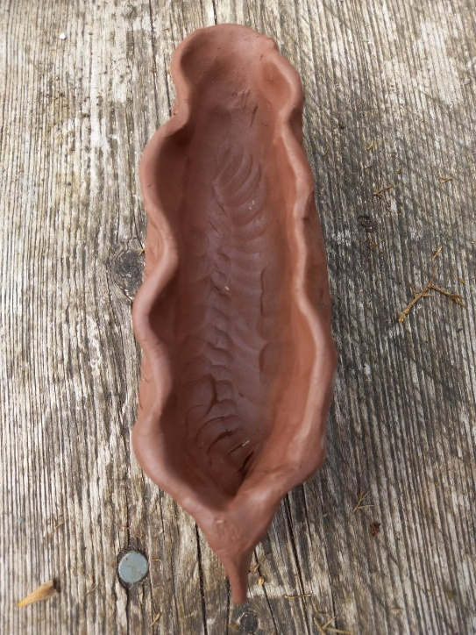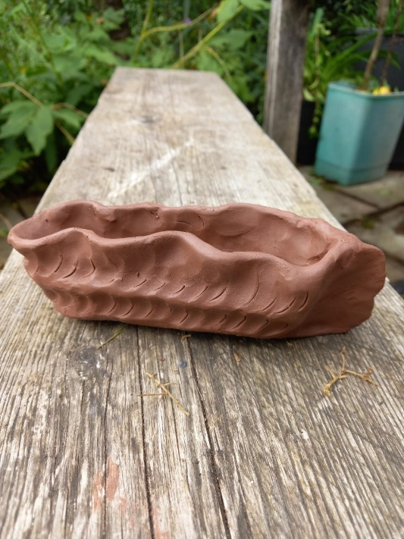
The Oak Leaf Ammonite Boat

n)
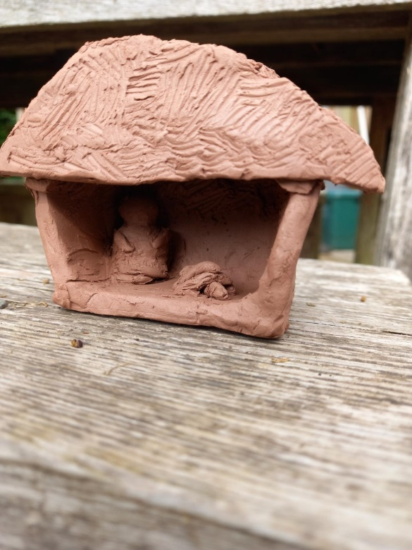
Shelter

o)
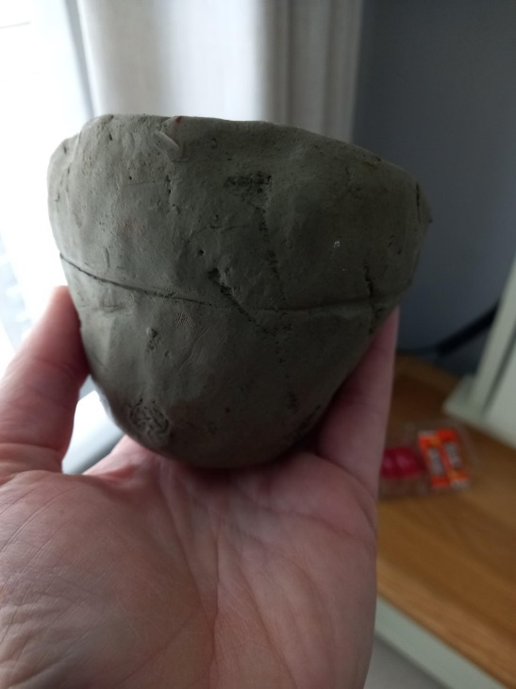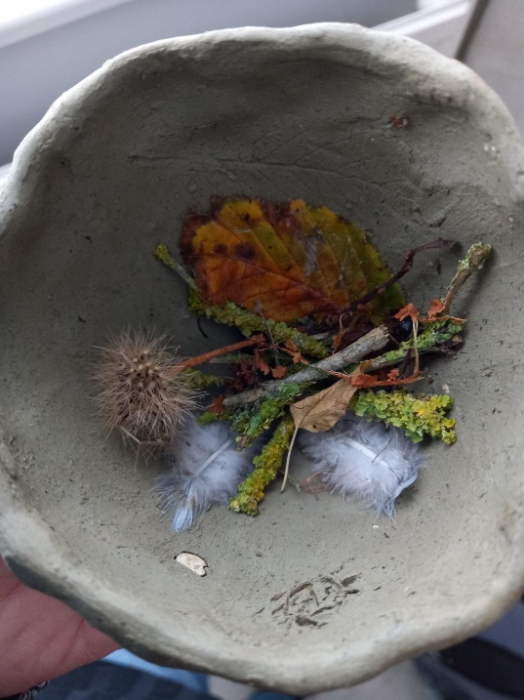
Outside and Inside the Nest

p)
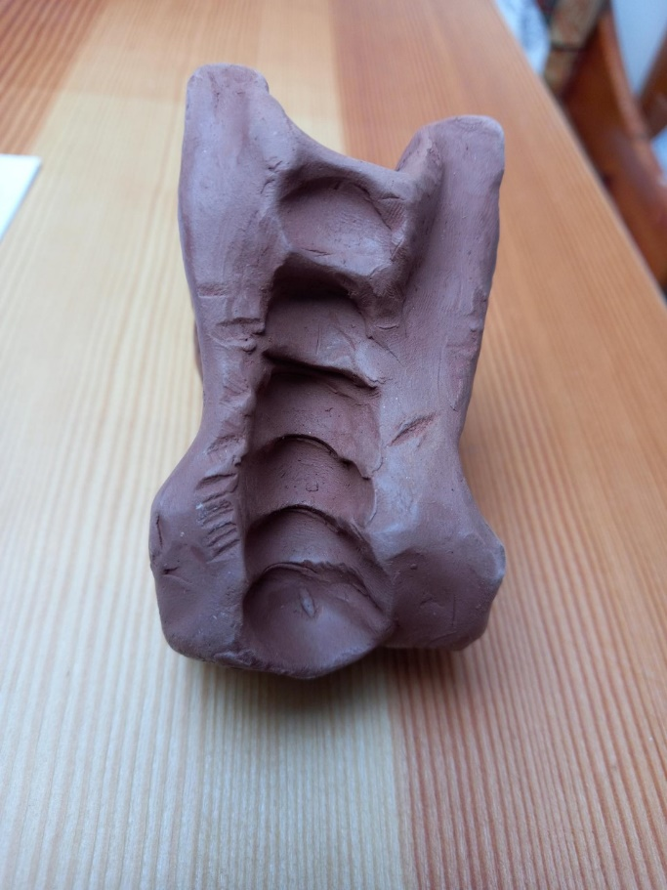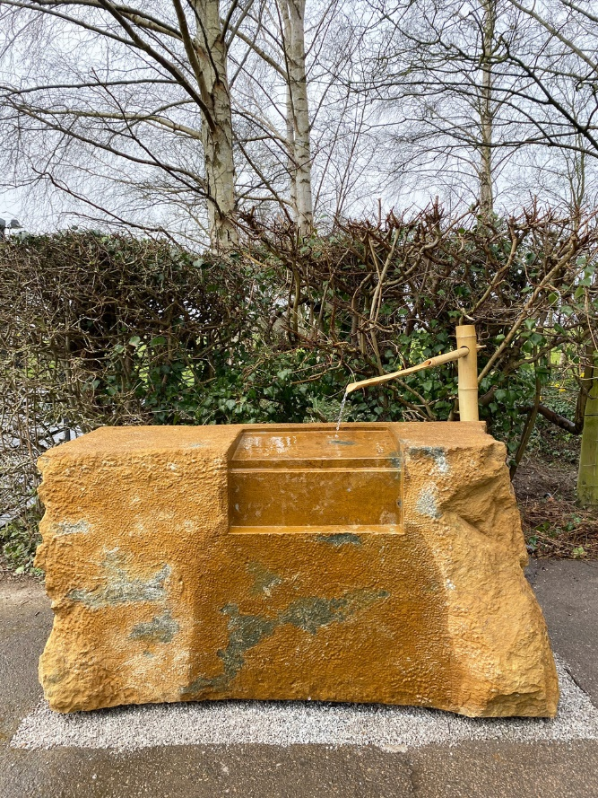
Edmund de Waal (2021) Stone for Two Hands and Water

Cleansing the Hands/Space for contemplation

q)
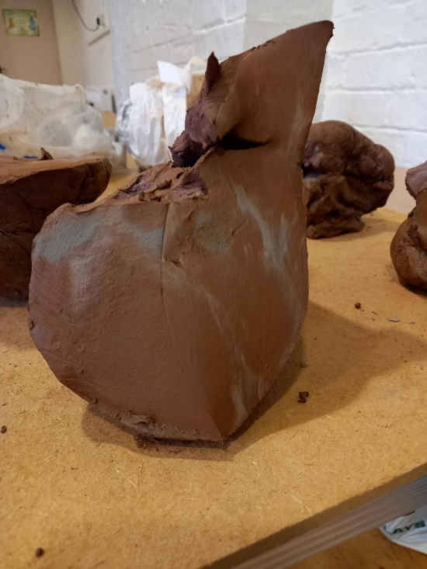
Pregnancy
r)
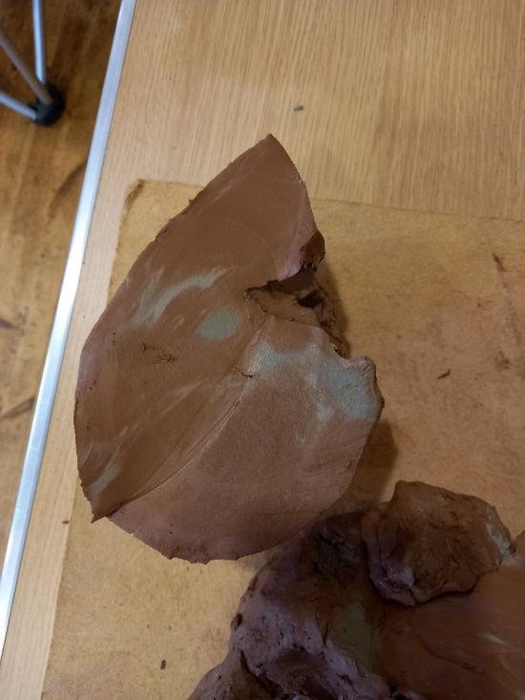
The Foetus

s)
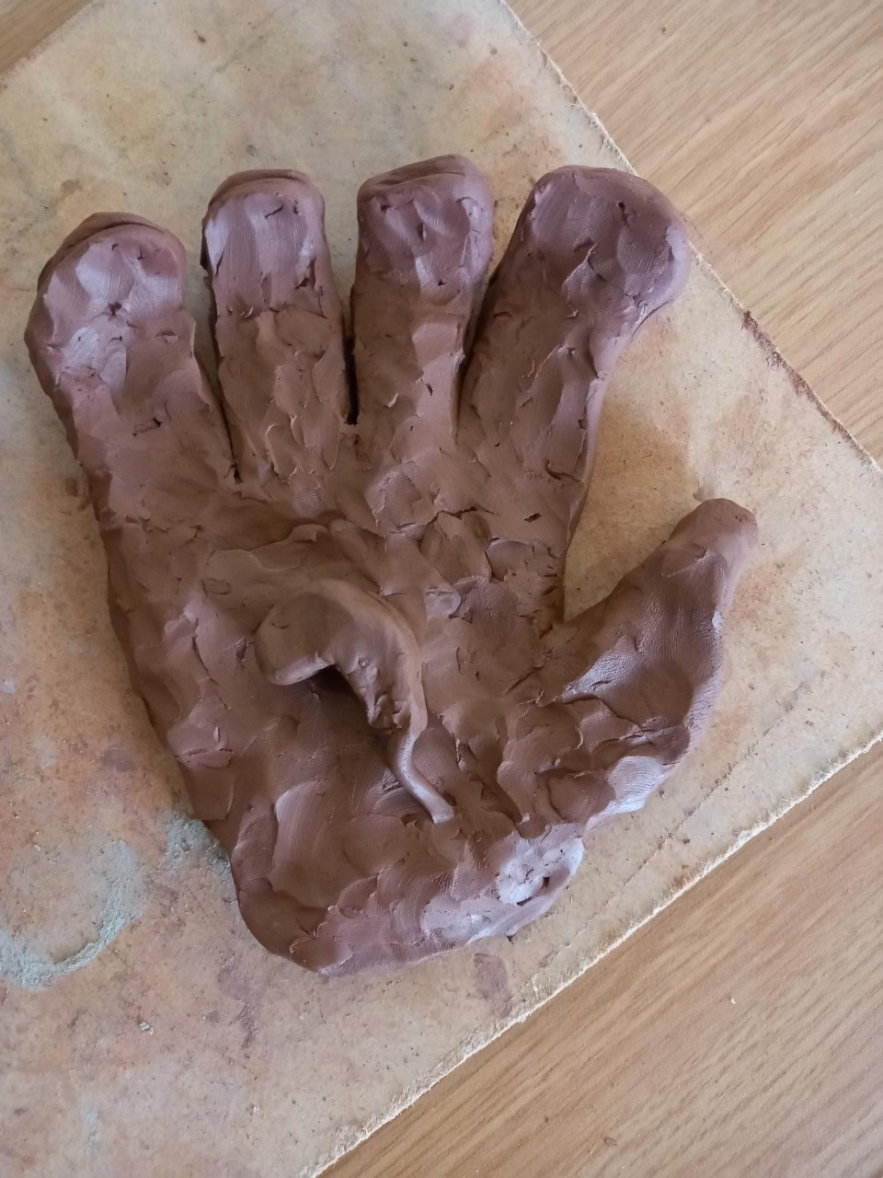
Holding the Seed

t)
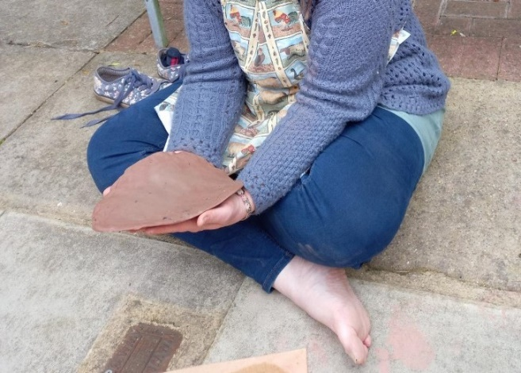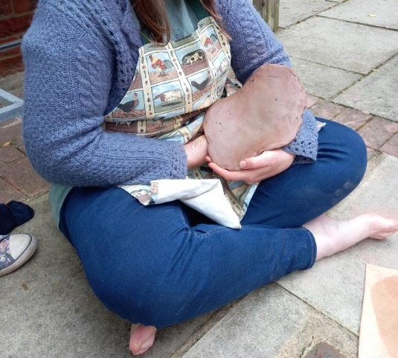
The Birth of My’Self’
Moksha?

u)
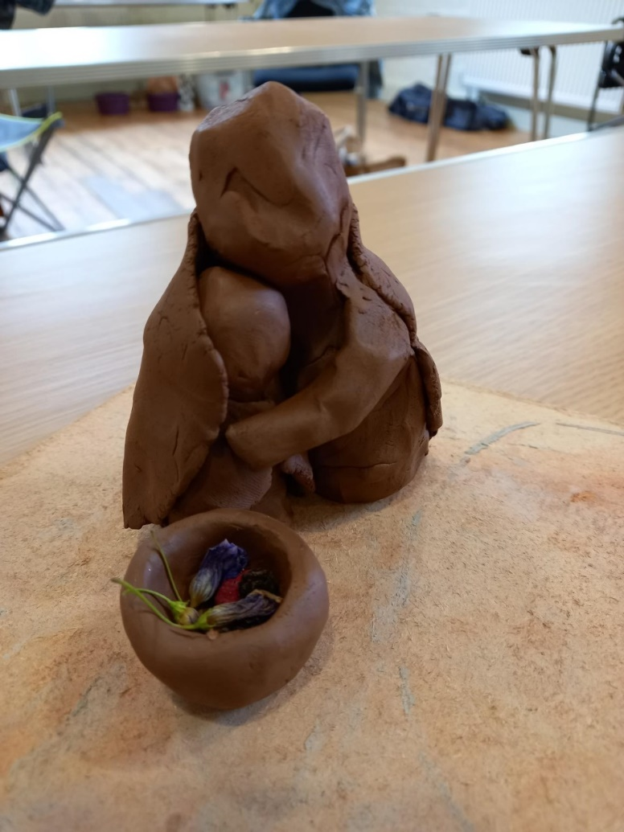
Loving Tenderness
v)
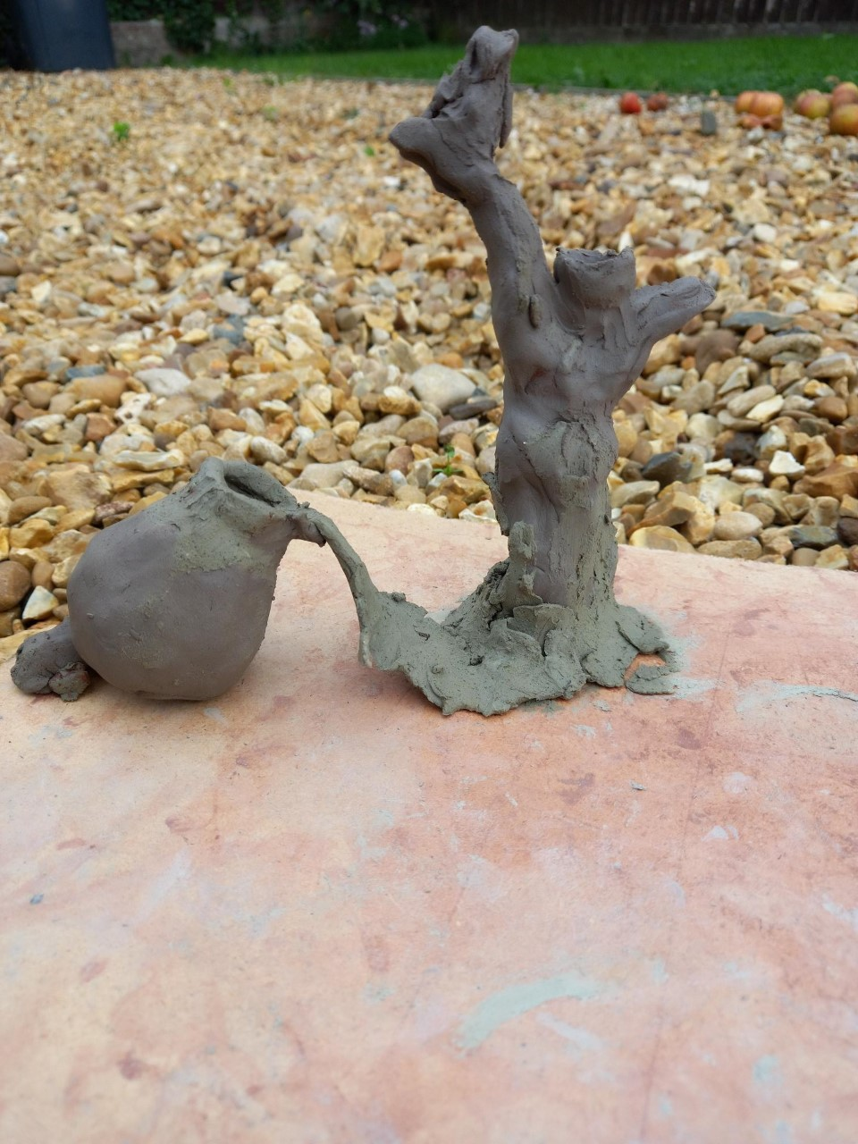
The Revelation/Liberation
Nourishing the Self

Discussion

Conclusion
Things to include/ideas..
Mackesy (2019), ‘I need pictures, they are like islands, places to get to in a sea of words.’
Chase (1999, Chap 6) states authentic working alliance essential when working with parentified adult clients, so clients can feel they can be their real selves, as parentified adult clients are prone to shame related to true-self expression. The authentic working alliance is vital for clients to feel they can express their real selves. However, when working with clay sometimes images appear that hadn’t been planned. Is there a place within clay work for a shame or trauma informed approach when working with someone that is a parentified adult? It can be an exposing process, people may reject it as a possible way of working as it may feel too exposing of the self, and against the survival parts. Lynne mentioned that it is important to know if clients are in a place where they can work with clay, if they are resourced enough. How is this known?

Article 5 Laptop – Parentification – p.3431 no 4 – one specific close relationship can be protective – Grandad in clay!

Article 16 no 18 – noted 4 places for further research in this area. This heuristic study has gone some way to address one, that of researching needs and effective services – in light of therapeutic approaches/methodologies it seems that, when appropriate and the therapist is appropriately trained and experienced, that clay as a medium could be introduced in therapeutic sessions, to offer a way of differentiating self, seeing and finding the self amongst the turmoil of insecure and entangled attachment. Mixed up identity with the parent. To offer a place for the indissoluble relationship to begin to feel soluble.

Article 17, no 7, Article 29, no 4 and no 6 (wounded healer) and Article 25, p.469 – says many therapists may be parentified children. This is something to be aware of , the perpetual caretaking/caregiving role. I am a parentified therapist. Article 25, see discussion – research into counselling psychologists found high number had insecure attachment and parentification. Importance of self care and burnout. Impact of this on practice – suggests allows dealing with own distress vicariously through clients (pg 469)

Critique – how well does a heuristic piece of research fit into the formalness of a masters dissertation. Taxing to meet deadlines, creates unnatural bookmark in a personal process that needs flow.

Article 23, p.165 and Article 9*Researching this and focusing on the impact on me, I wonder about the intergenerational aspect of this phenomena, as stated in research. I wonder what influence my experience has had on my children, ‘a debt of guilt can feel as though it is being repaid when giving all attention to children’. Is this me? With all my heart and soul, all my being, I hope not. But I feel I need to remain open to the possibility that secondary effects of parentification have played a role in me as a mother. This deeply touches my heart and I try to sit again with the guilt of it all!! My process of living my life continues…

Article 26, no 4 – calls for development of parentification measure. How is this possible, and why needed? Perhaps as a qualitative requirement, but how will this help people living with this legacy burden? Adding numbers to something may not be as helpful as listening, and witnessing each individual’s experience, and not through the spoken word, but by creating a representation of the experiences and emotions that are here because of that childhood.

Inclusion of pictures, reflections and journal – noticed a hesitancy not only in touching clay for the first time, but also in beginning this work. There is a pattern hesitancy with beginning, starting, entering into a relationship with something, and it doesn’t need to be with another human. I have noticed through this process a part of me that is terrified of the exposing nature this piece of research holds. To this young part of me, it feels like telling a secret and the consequences of this are to be falling, not held by the family I grew up with. Chase (1999, p.145) parentified children are ‘negotiating a landscape devoid of protective hands.’ I have been conscious of holding this part, offering comfort through images, as ways of expression. As this work comes to completion, it is not finished personally. My journey continues beyond these pages. But, in some way this process feels cathartic. I am imagining submitting this work to feel like I am releasing a beautiful dove from my hands. Be free, Fly high sweet bird! You no longer need to hold onto the burden of caring, of being responsible for another.

