
Student Name: | Md Asif Hosen | Student Number: | 2506161
Programme: | Master of Business Administration
Module: | Strategic Management
Module code: | LCMB7003
Lecturer: | Amare Desta and Ghulam Mujtaba
Assignment Title: | Report | Word count (or  equivalent): | 5390

“Strategic Management Consultancy Report:
Apple iPhone in the UK Smartphone Market”

RESEARCH | For this assessment, you can use Generative AI to support you in research and data analysis. | Yes ☐  No ☒
STRUCTURE | For this assessment, you can use Generative AI to support you in structuring your submission, including creating a draft argument structure, identifying parts  and headings, etc. | Yes ☐  No ☒
PROOFREADING | For this assessment, you can use Generative AI to check your own text/creation for grammatical and syntactical mistakes, including getting suggestions to  rephrase your work. | Yes ☐  No ☒
WRITING | For this assessment, you can use Generative AI to create text for submission. | Yes ☐  No ☒
CREATIVE | For this assessment, you can use Generative AI to create creative materials, such as images. | Yes ☐  No ☒
PROGRAMING | For this assessment, you can use Generative AI to create and check code. | Yes ☐  No ☒
NONE | For this assessment, you are not allowed to use any type of Generative AI support. This includes research support, structure support, writing/proofreading  support and creative support. | ☐

Executive Summary
This report focuses on the analysis of the iPhone product line for the United Kingdom telecom market to further quell iPhone's competitors and to develop a strategy which could give the Company a future competitive edge to market. The iPhone remains much of a financial powerhouse for Apple: From Apple's reported iPhone sales of $209.586 billion, 50.4% of its total net sales were attributable to the iPhone. The UK market is attractive, but mature: Ofcom has found that 54% of UK smartphone users aged 16+ use an iPhone as their main device in 2025, compared to 69% of 16–24-year-olds. The big issue is the need to maintain premium demand for products in the face of growing competition from AI, regulatory oversight, affordability pressure, re-servicing expectations and sustainability issues. The strategies are responsible intelligent differentiation: useful on-device AI, privacy, ecosystem integration, longer device life, transparent repair support, trade-in value and credible sustainability. This is better than being purely price competitive or offering a different product at a premium.

Table of Contents
Executive Summary 2
Section 1: Strategic Management Consultancy Report 5
1. Organisational Context and Product Overview 5
1.1 Apple Inc. and the iPhone 5
1.2 Scope and justification 5
1.3 Market position and strategic problem 6
2. External and Internal Strategic Analysis 6
2.1 PESTEL analysis 6
2.2 Porter’s Five Forces 9
2.3 VRIO analysis 10
2.4 SWOT synthesis 12
3. Comprehensive and Holistic View of the Organisation 12
3.1 CSR and sustainability strategy 12
3.2 Balanced Scorecard 13
4. Strategic Choices and Implementation 15
4.1 Strategic alternatives 15
4.2 Ansoff Matrix application 16
4.3 SAFe evaluation 16
4.4 Implementation roadmap 17
4.5 Expected Strategic and Financial Outcomes 18
Conclusion 19
Section 2: Reflective Account Using Gibbs’ Reflective Cycle 20
2.1 Description 20
2.2 Feelings 20
2.3 Evaluation 20
2.4 Analysis 21
2.5 Conclusion 21
2.6 Action Plan 21
References 23

Section 1: Strategic Management Consultancy Report

1. Organisational Context and Product Overview

1.1 Apple Inc. and the iPhone
Incorporated in 1977 and founded in 1976, Apple Inc. began as a maker of personal computers to become a technology firm of integrated hardware, software and services. Apple's vision is to provide the very best user experience with groundbreaking hardware, software and services (Apple Inc., 2025). Its strategic vision could mean premium integration: product development which keeps customers loyal and sustains value for the longer term in the Customer Ecosystem. The iPhone, which debuted in 2007, plays an important role in this vision, as it links customers with iOS, the App Store, Apple Pay, iCloud, AppleCare, AirPods and Apple Watch. Competitive advantage is enhanced when complementary resources are used as a system, instead of as separate assets (Grant, 2021).
The iPhone's commercial value is still pretty big. iPhone net sales in FY2025 amounted to $209.586 billion, accounting for 50.4% of Apple's total net sales. The interdependence between hardware and recurring digital revenues is reflected in iPhone sales growth of 4% and a 14% rise in Services revenue, which now accounts for $109.2 billion of total revenue (Apple Inc., 2025). Apple's business model is premium margins on devices, software control, services, direct retailing, and carrier partnerships and installed base retention. 40% of sales for FY2025 have been driven by direct channels, while 60% comes from indirect channels, which means that telecom operators and resellers continue to play a strategic role.

1.2 Scope and justification
This report is a benchmark of the Apple iPhone towards the United Kingdom smartphone market. The discussion of MacBook, iPad, Apple Watch, AirPods and services comes only in the context that they form part of iPhone's competitiveness. This limited scope is suitable, as strategy analysis involves a clear define product, market and competitive environment (Whittington et al., 2023). Strong regulatory, market and consumer evidence is also provided in the UK. A significant amount of switching barriers and ecosystem complementarity are shown in that 83% of the iPhone users surveyed across the UK had at least one other Apple device (Competition and Markets Authority, 2022).

1.3 Market position and strategic problem
Apple's position in the United Kingdom is quite strong but rather vulnerable. According to Ofcom, in 2025, 54% of the overall population of UK smartphone users aged 16+ used an iPhone as their main device, while 45% were Android users. Among users aged 16–24, iPhone usage reached 69% (Ofcom, 2025). Samsung Galaxy will, however, compete on platform openness, financing, camera and AI, with the cheaper Android phones. At the heart of it, the central strategic challenge is how Apple can maintain its premium standing as replacement cycles get longer, consumers' willingness to pay comes under increasing strain, regulatory pressure grows, and AI, repairability and sustainability change customer expectations.
The strategic challenge is: How will Apple maintain its competitive edge in the mature UK iPhone market as replacement cycles grow, premium pricing is decreasing, mobile AI is reshaping the landscape and sustainability and repairability demands rise? This calls for discriminating understanding and not description. While margins may be insulated from competition by pure premium differentiation, it may feel like an incremental cost to those with able smartphones. Pure price competition could drive up investment in improvement but might erode Apple's margins and brand. The rest of the report then examines the possibility of a more balanced way, responsible intelligent differentiation.

2. External and Internal Strategic Analysis

2.1 PESTEL analysis
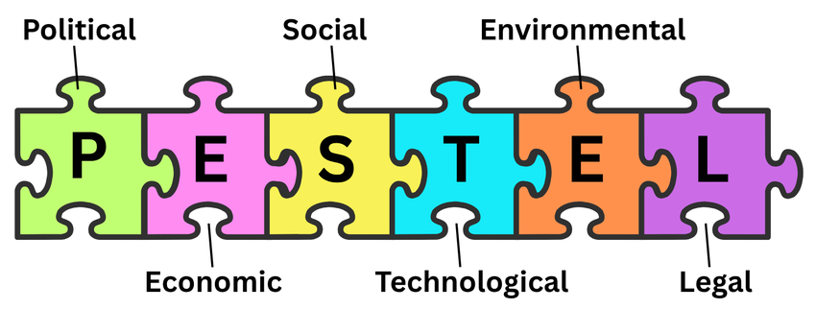
Figure 1: PESTEL Analysis Framework (Karadzhov and Patarchanova, 2025)
Political
In a political sense, the iPhone runs in a context where digital markets are increasingly being regulated in the UK. The Digital Markets, Competition and Consumers Act 2024 provides the UK with a strategy to tackle firms with strategic market status, and the CMA has already started to investigate Apple's mobile platform and mobile browsers (Great Britain, 2024). This poses a direct strategic threat as regulators are increasingly seeing the ability to control Apple's ecosystem as a potential limitation on competition, whereas before it was more of a quality and security play. While handset competition continues to impact iPhone strategy, the Competition and Markets Authority's (2025) report on the mobile browsers and cloud gaming market also raised concerns about the regulatory environment affecting the distribution of software.
Economical
Apple has a business advantage based on premium pricing, but struggles with consumer affordability. Based on the iPhone category net-sales table (which does not account for the revenue contribution from Services and other categories) and the total net-sales growth of 6.4%, the growth in Apple's net sales in FY2025 was balanced more by its other categories of business than by iPhone growth alone. But the evidence shows that primary device awareness isn't a big issue for Apple; the iPhone already establishes a good primary device lead in the UK. The strategic calculus is twofold: Apple needs to maintain high-end premium margins, but consumers in the UK, under financial strain, could withhold a new upgrade, opt for a refurbished iPhone, switch back to an old model or weigh up the terms and conditions of the Android financing schemes. Because of how consumers usually switch out electronic devices when they don't perform as they'd like, or when they are not what they desire, or they are not convenient, Apple needs to get upgrades to look like it is helping them rather than just a new device (Magnier and Mugge, 2022).
Social
Socially, the use of smartphones is deep and every day, but the meaning of value has shifted. Consumers are looking for camera quality, privacy, safety, convenience and status, and are paying more attention to device life, device repair and sustainability. Ofcom's (2025) data that younger adults are more likely to use iPhones helps Apple's brand image, but also adds to the issue of relevance for those using the smartphone for social media, payments, health, entertainment and productivity (Ofcom, 2025). But it's not just product design that influences repair practices, as Jaeger-Erben, Frick and Hipp demonstrate in the UK, where access to repair and trade-in services is affected by both motivation and knowledge, as well as by the costs involved. (Jaeger-Erben, Frick and Hipp, 2021).
Technological
Mobile AI is the most disruptive opportunity and threat in terms of technology. Goggin claims that mobile AI is turning the smartphone into a larger, general-purpose AI personal interface (Goggin, 2025). The good news for Apple is that bringing the processing, privacy positioning, and built-in chips together will enable the company to offer very different AI experiences, while AI in the cloud and the use of Google's tools and Android collaborations can help other companies catch up. However, it is Apple's competitor analysis that Google must consider as a service provider and competitor, as the emphasis of Alphabet's 2025 annual report on AI extends to Apple's services and products (Alphabet Inc., 2026). The downside is that in the premium market, AI capabilities will become the next benchmark; the upside is that AI can be useful, private and energy-efficient, potentially lending to a better next iPhone experience.
Environmental
Smartphones have relatively high life cycle impacts when considering their materials extraction, components and manufacture, transportation, energy use, and disposal. Cordella, Alfieri and Sanfelix (2021) estimate that their life-cycle costs go down by 4-10% and their carbon footprints go down by 23-30% when extending the replacement cycle from 2 years to 3 years for smartphones, along with repairs. Apple advances in recycled materials, renewable electricity and packaging enhancements, but there's an inherent dichotomy between annual iPhone changes and lifecycle extension (Apple Inc., 2026a). Legally, privacy, consumer protection, repairability, governance of apps in app stores, and product claims are all important. In this regard, van Hoboken and Ó Fathaigh believe that smartphone platforms are "privacy regulators" that give Apple a lot of power, but also raise expectations for transparency and accountability (van Hoboken and Ó Fathaigh, 2021).
Table 1: Prioritised PESTEL analysis of Apple iPhone in the UK
Factor | Evidence | Opportunity or threat | Strategic importance | Required response
Political/legal | DMCCA and CMA scrutiny (Great Britain, 2024; Competition and Markets Authority, 2025). | Threat/opportunity | High | Prepare transparent platform governance.
Economic | FY2025 iPhone sales $209.6bn; 50.4% of Apple sales (Apple Inc., 2025). | Threat | High | Use trade-in, financing and service bundles.
Social | iPhone primary-device share: 54% aged 16+; 69% aged 16-24 (Ofcom, 2025). | Opportunity | High | Convert loyalty into meaningful upgrades.
Technological | Mobile AI is reshaping smartphones (Goggin, 2025). | Both | High | Build useful private on-device AI.
Environmental | Longer lifetimes can lower smartphone footprints (Cordella, Alfieri and Sanfelix, 2021). | Both | Medium-high | Integrate repair, trade-in and carbon data.
These are the top material factors: UK digital regulation, affordability, mobile AI and lifecycle sustainability. This prioritisation is based on Rumelt's reasoning that "strategy must come before action: it must be a statement of the problem and then a statement of the solution" (2022).

2.2 Porter’s Five Forces
There is a lot of competition in the UK Smartphone market. Competition from Apple products includes Samsung Galaxy, the Android competitors, AI assistant, camera, display technology, battery, device financing, data privacy and convenience of ecosystem. But the competition isn't just device to device - it's ecosystem to ecosystem. Competition is the CMA's term for the competition between operating systems, app stores, browsers, payment services and developer access of mobile ecosystems, which both Apple and Google are part of (Competition and Markets Authority, 2022). According to Whittington et al., much value is captured after the sale of smartphones through Apps, services and subscriptions and industry analysis must determine the value creation and capture.
Buyer power is moderate-high, with customers in the UK being able to readily compare handsets, contracts, and monthly payments; however, Apple curtails switching with iOS familiarity, iMessage/FaceTime, app purchases, passwords, iCloud, Apple Watch and AirPods integration. Supplier power is moderate: Apple has massive purchasing power, but relies on specialist semiconductors, displays, camera modules, materials and global assembly capacity. Moderate risk of substitutes: customers can extend the use of the existing phones and purchase refurbished phones as well as lower-cost Android phones or use tablets and wearables for certain functions. Bieser et al. demonstrate that “not upgrading” is a viable alternative to new-device sales and a strategy for extending smartphone service lifecycle by engaging consumer interventions (Bieser et al., 2022). Low, as there are substantial barriers as far as new-entry threat is concerned R&D intensity, development of an operating system, brand trust, patents, distribution and ecosystem scale.
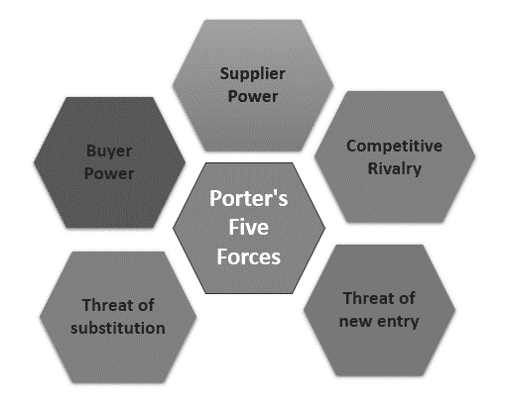
Figure 2: Porter’s Five Forces (Hessing, 2021)
It needs to maintain its high-end position by actively engaging in the ecosystem, private AI, service and customer trust and increasing lifetime value. This aligns with Grant's concept of sustainable advantage being dependent on a system of resources and capabilities that it is difficult to replicate (Grant, 2021).

2.3 VRIO analysis
Well, Apple doesn't have just the features of its iPhones to back them up. The one that's harder to copy is the embedded bundle of brand, iOS, chips, services, installed base, distribution and trust. The CMA's analysis of its survey of UK iPhone users also showed a genuine ecosystem behaviour; 83% of respondents to the survey reported having other Apple products and devices (Competition and Markets Authority, 2022). Apple's iPhone is effective because users also have an Air Pods, Apple Watch or use iCloud, but that might only be possible through some level of ecosystem towards enabling lock-in (Haftor, Climent and Kallmuenzer, 2025).
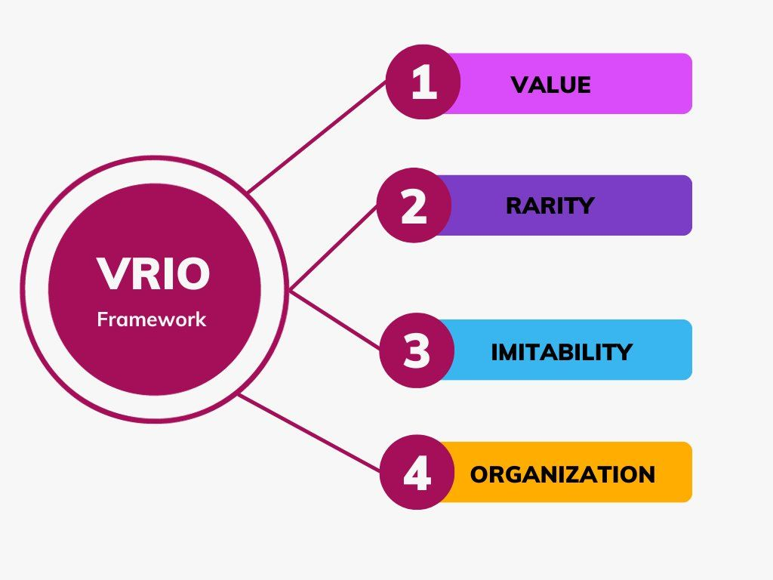
Figure 3: VRIO Analysis Framework (Solutions Hub, 2023)
Table 2: VRIO assessment of Apple iPhone resources
Resource or capability | Valuable | Rare | Difficult to imitate | Organised | Competitive implication
Apple brand and premium reputation | Yes | Yes | Difficult | Yes | Sustained advantage if quality and trust are maintained.
iOS and integrated ecosystem | Yes | Yes | Very difficult | Yes | Sustained advantage through switching costs and complements (Haftor, Climent and Kallmuenzer, 2025).
Apple-designed processors | Yes | Partly | Difficult | Yes | Temporary to sustained advantage, especially for on-device AI.
Installed customer base and user data capabilities | Yes | Yes | Difficult | Yes | Sustained advantage if used transparently and privately.
Retail, online and telecom distribution | Yes | No | Imitable | Yes | Competitive parity to temporary advantage.
Privacy-oriented positioning | Yes | Partly | Moderate | Yes | Advantage, but must withstand regulatory and transparency scrutiny (van Hoboken and Ó Fathaigh, 2021).

The VRIO judgement is: Apple's assets can be imitated one at a time, but when aggregated, they are more difficult to imitate. The importance of the Apple-designed processor is that on-device AI is dependent on hardware-software integration, and the positioning of on-device privacy is important because consumers view their smartphones as both communication devices and "data containers" (van Hoboken and Ó Fathaigh, 2021). Apple's structure is geared towards extracting value from these resources via product teams, retail control, software development and services but they also generate regulatory risk as tight control can be seen as a form of gatekeeping.

2.4 SWOT synthesis
Table 3: SWOT synthesis for Apple iPhone in the UK
Dimension | Strategic evidence and judgement
Strengths | Premium brand; iOS integration; customer loyalty; Apple-designed processors; privacy positioning; ecosystem switching costs (Apple Inc., 2025).
Weaknesses | Premium pricing; dependence on replacement purchases; limited compatibility outside Apple; repairability criticism; global manufacturing dependence (Cordella et al., 2021a).
Opportunities | On-device AI; trade-in and refurbished growth; sustainability-led differentiation; accessibility and health integration; service bundling (Goggin, 2025).
Threats | Android AI competition; UK platform regulation; affordability pressure; longer upgrade cycles; supply-chain disruption; privacy incidents (Competition and Markets Authority, 2025).
The SWOT synthesis validates that Apple should not have a one-sided approach. The strategic fit is to leverage ecosystem, privacy, design and processor capacities to ensure differentiated AI value and solve affordability, device sustainability and longevity issues. Material, functional, psychological and economic obsolescence was discussed by Corrocher and Paganuzzi, and this aspect is relevant because Apple's question is whether they have any valid reasons to upgrade the device without being accused of trying to make it look like a need to replace it prematurely (Corrocher and Paganuzzi, 2025).

3. Comprehensive and Holistic View of the Organisation

3.1 CSR and sustainability strategy
As reported by Apple, recycled materials, renewable electricity, packaging, water, supplier energy, carbon reduction and the percentage of materials from recycled sources have all progressed. Additionally, Apple has reported progress toward recycled materials, including 30% of materials in products shipped in 2025 being from recycled sources, and a goal of 50% by 2025, and toward renewable electricity, packaging and water (Apple Inc., 2026a). The strategic driver is easy to see: sustainability can add a premium element to trust, limit the risk of materials and appeal to those increasingly conscious of e-waste in the UK. But a crucial judgment should be made, as there can be a clash of annual iPhone releases with the concept of extending the life cycle. Cordella and her colleagues demonstrate that durability and the potential to be repaired are key factors in the reduction of impacts associated with smartphones, and thus play a crucial role in Apple's sustainability credibility, beyond carbon language (Cordella et al., 2021a).
Repairability is a very sensitive area. While perceived self-repairability and repair experience can be better achieved using cues of modular design and repair, customer behaviour remains a function of confidence and service design (Amend et al., 2022). Similarly, Jaeger-Erben, Frick and Hipp (2021) demonstrate that users are not repairing devices 'automatically' and that factors like cost, knowledge, convenience and social norms have an impact on repair practice. This implies not only that self-service repair and trade-in initiatives by Apple must be simple and accessible, but that they must also be trusted, or they are not an example of successful CSR. Additionally, Manwaring's right-to-repair analysis shows repair policy is also evolving into a legal and consumer rights challenge, meaning a poor repair experience can become a strategic liability. Furthermore, Manwaring's right-to-repair analysis suggests repair policy is turning into a legal and consumer rights issue, making a poor repair experience a strategic risk.
Financial aspects of circularity also exist. For end-of-use scenarios, Pamminger, Glaser and Wimmer model what refurbishment, reuse and recycling can achieve and demonstrate that the environmental effects can vary in accordance with the collection and processing. Bieser et al. suggest that interventions for life extension need to be at various consumer decision points, including purchase, use, repair, and recirculation (Bieser et al., 2022). For Apple, the verdict is that trade-in must go beyond just boosting new device sales and become a viable circularity model that includes clear refurbishment and material recovery. Apple has introduced a social component by introducing supplier standards, training workers, and environmental programmes in its supply chain, but the company will need to prove supplier improvements are real or symbolic changes, not just general statements (Apple Inc., 2026b).

3.2 Balanced Scorecard
The Balanced Scorecard is suitable because the strategy of the iPhone can’t simply be measured by revenues. There are four perspectives in the Balanced Scorecard framework: financial, customer, internal processes and learning and growth (Kaplan and Norton, 1992). When used for Apple's iPhone product in the UK, the scorecard turns responsible intelligent differentiation into measurable priorities: safeguard premium economics, reinforce perceived value, enhance the iPhone lifecycle processes, and create AI and sustainability capability. The targets in Table 4 are not official Apple targets but proposed strategic targets, as there is no baseline publicly reported.
Table 4: Balanced Scorecard for Apple iPhone in the UK
Perspective | Strategic objective | KPI | Proposed target | Initiative
Financial | Protect premium profitability and upgrades. | iPhone share of Apple sales; trade-in conversion; service attachment. | Keep iPhone above 48%; FY2025 baseline 50.4% (Apple Inc., 2025). | Tiered offers, trade-in and bundles.
Customer | Strengthen loyalty and perceived value. | Retention; satisfaction; switching intention; privacy trust. | mprove trade-in conversion by 10% within 12 months; baseline 54% (Ofcom, 2025). | AI features, privacy and after-sales service.
Internal processes | Improve availability and lifecycle performance. | Repair time; refurbished flow; recycled-material share. | reduce average UK repair turnaround by 15% within 18 months; | Repair access and supplier resilience.
Learning and growth | Build AI, sustainability and retail capability. | Training; AI milestones; responsible-AI governance. | achieve 95% employee training completion before major AI releases; | Cross-functional development.
Table 4 is significant in terms of the finances involved. Apple’s iPhone net sales were $200.583 billion in FY2023, $201.183 billion in FY2024 and $209.586 billion in FY2025; total net sales were $383.285 billion, $391.035 billion and $416.161 billion respectively, giving iPhone shares of 52.3%, 51.4% and 50.4% (Apple Inc., 2025). As per these calculations, the revenue from iPhone has risen, but its net sales contribution and percentages of Apple's net sales have dropped to 50.4% and 52.3%, respectively, in FY2025 from the prior fiscal year, FY2023, when it contributed 52.3% and 52.4% to the company's net sales. This reinforces the recommended strategy, which is to still keep the iPhone the "core product" in the ecosystem, but to make money on the back of attached services and customer lifetime value (LTV), instead of hardware price increases.
The scorecard perspectives are causally connected. With learning and growth, better AI, repair and retail capability is achieved. Improved internal processes result in increased availability, confidence in repairs and environmental credibility. Customer value is improving, which benefits customer retention and upgrade demand. Loyalty, service attachment and premium trust are then followed by financial performance. This is a balanced logic, in that it doesn't rely upon a purely financial strategy, and does adhere to the logic of Kaplan and Norton, who suggest that non-financial drivers may be leading indicators of future performance (Kaplan and Norton, 1992).

4. Strategic Choices and Implementation

4.1 Strategic alternatives
There are three options for strategy. Option 1 - aggressive price-based market penetration. Apple might be able to lower the price of its iPhone, or more aggressive pushes the older, lower-priced models. The benefit would be greater access for and potential for volume growth with price-sensitive UK customers. But the danger of doing so would be that it would mar Apple's high-end image and deplete the company's margins relative to cheaper producers of Android. If the firm does not have a cost advantage, as Apple is absent when the target market is the low-price segment, then competing on what others can offer for lower prices is a poor strategy Grant (2021).
Apple can highlight design, exclusivity, photographic capabilities and top-of-the-line Pro photography models. This reinforces the brand and helps to protect margins, as well as the sales boost in Apple's Pro-model products in FY2025 (Apple Inc., 2025). But if they perceive the annual hardware changes as incremental, pure premium differentiation is not enough. Magnier and Mugge (2022) study of replacement behaviour suggests that appeal to new features is not even a foregone conclusion, but rather consumers are also interested in usefulness, condition and replacement triggers (Magnier and Mugge, 2022). This thin-pick approach can then only work to defend current loyal customers, while not being able to deliver larger upgrade uptake.
The recommended strategy is option 3: responsible intelligent differentiation. This encompasses device durability, trade-in value, access for repairs, environment, ecosystem integration and customer service. It covers a higher number of risks as compared to other alternatives as it integrates product innovation with affordability and CSR. The value of AI as a new smartphone logic is reinforced in Goggin's analysis of mobile AI, as is the economic and ecological materiality of lifecycle extension in Cordella, Alfieri and Sanfelix's discussion (Goggin, 2025; Cordella et al., 2021a). The tactic is not to lower the cost of the iPhone itself, but rather to enhance the overall cost of ownership and provide greater defence.

4.2 Ansoff Matrix application
Table 5: Ansoff Matrix for Apple iPhone in the UK
Ansoff direction | Application to iPhone UK | Strategic judgement
Market penetration | Encourage upgrades among current UK iPhone users; improve trade-in conversion; strengthen telecom and retail partnerships. | Primary route because Apple already has a strong UK user base (Ofcom, 2025).
Product development | Develop useful AI, camera, battery, accessibility, security and repair-related features. | Second priority because product improvements justify premium replacement.
Market development | Reach underpenetrated value-sensitive segments through financing, certified refurbished options and accessibility. | Selective route, without damaging premium positioning.
Diversification | Avoid unrelated diversification in this report. | Low priority because it would weaken the product focus required for iPhone strategy.
Based on the information in Table 5, Apple should focus on market penetration and product development, not diversification in unrelated businesses. In this case, Whittington et al. argue that Ansoff's Matrix disciplines growth logic, in this instance, by committing to further growth for iPhone in the home UK market before taking up product diversifications. Responsible intelligent differentiation is also in line with Rumelt's principle that strategy needs to concentrate effort and not a list of appealing but disconnected actions (Rumelt, 2022).

4.3 SAFe evaluation
Table 6: SAFe evaluation of responsible intelligent differentiation
Criterion | Evaluation | Evidence and judgement
Suitability | High. Addresses AI, affordability, privacy, sustainability and replacement cycles. | Supported by Ofcom usage and mobile AI/repairability evidence (Ofcom, 2025; Goggin, 2025).
Acceptability | Medium-high. Customers gain value; shareholders keep premium logic; regulators may scrutinise control. | Depends on transparent privacy, repair and platform governance (Competition and Markets Authority, 2026; Manwaring, 2024).
Feasibility | High but demanding. Apple has resources, chips, software, retail and suppliers. | Supported by Apple scale but limited by supply-chain and regulatory complexity (Apple Inc., 2025; Apple Inc., 2026b).

The SAFe judgement is good but not definite. The strategy is very suitable, as it tackles the most prevalent external and internal issues. The case with acceptability is more complicated, as what makes a customer feel good might also worry the regulators. One of the conditions noted above is that strategic market status can influence the conduct of an Apple mobile-platform in the UK, meaning that the recommended course of action should take this into account and should not be seen as an unlimited right of control (Competition and Markets Authority, 2026). Feasibility is high as Apple has the financial resources, design ability and distribution, but will have to manage the supplier standards, AI reliability and repair service quality.

4.4 Implementation roadmap
Table 7: Implementation roadmap for the recommended UK iPhone strategy
Timeframe | Priority | Action | Responsible function | KPI | Main risk | Mitigation
0-6m | Validation | Test AI, privacy, repair and sustainability priorities. | UK Strategy / Product Marketing | Research done | Weak fit | User testing
6-12m | Value communication | Improve trade-in, privacy and lifecycle messages. | Marketing / Retail | Conversion; satisfaction | Greenwashing | Verified data
6-18m | Delivery | Improve AI, diagnostics and repair support. | Product / Software / Services | Adoption; repair time | Technical delay | Phased rollout
12-24m | Ecosystem growth | Deepen services while preserving user choice. | Product / Services | Retention | Lock-in criticism | Transparent settings
Ongoing | Governance | Review Balanced Scorecard performance. | Senior management | KPI review | KPI overload | Limit indicators

The potential risks in implementation include: regulation, problems with AI reliability, privacy concerns, brand pricing incentive resistance, and supply-chain dependency, as well as sustainability credibility and internal coordination. For every risk, there is a practical mitigation. The DMCCA provides for transparency and preparation for compliance with regulation. Tracking and communicating capabilities and hardware rolling out in phases helps reduce risk associated with AI reliability. No blunt discounting reduces premium price resistance; it's about trade-in value and service packaging. Credibility is compromised by measurable life-cycle reporting and repair access. From the evidence given by Corrocher and Paganuzzi (2025), it is clear that having an "obsolescence" strategy is important to avoid a situation where customers feel compelled to replace the products too soon. Manwaring's right-to-repair analysis reiterates the importance of considering repair as a strategic, not defensive, legal decision (Manwaring, 2024).

4.5 Expected Strategic and Financial Outcomes
Revenue Protection and Customer-Lifetime Value should be used to evaluate the recommended strategy. The revenue from iPhone hardware grew by about 4.2% in FY2025 while the revenue from Services grew by 14%, highlighting how much more financial logic is attached to services rather than hardware growth as a result of the iPhone's installed base (Apple Inc., 2025). Better retention, trade-up conversions and service take-up may buffer premium revenue in the UK, where 54% of adult smartphone users cite the iPhone as their main device (Ofcom, 2025).
Quarterly scenario analysis should be done by management. A base case should keep more than 50% of customers using the UK iPhone, double the rate of sales to the trade-up channel within 12 months and cut down repair turnaround time by 15% within 18 months. The upside test should include higher usage of AI and higher attachment to services, and the downside test should include higher regulatory restrictions and cost of suppliers, and weaker upgrade demand. With regard to the gains, the CMA's findings on ecosystem power mean that they must not rely on restrictive customer lock-in (Competition and Markets Authority, 2022). Extended device life may lower environmental impact, but potentially have a negative impact on replacement financial benefits; the value can be recovered through refitting, services and retention instead of premature device replacement (Cordella, Alfieri and Sanfelix, 2021b). This yields a more robust performance model.

Conclusion
While Apple's iPhone is well-positioned for success in the UK, its competition is not assured. The best evidence is that iPhone commands a dominant share of the UK primary device market; that iPhone accounts for half of Apple's UK net sales; and that it enjoys a highly circular ecosystem of high switching costs (Ofcom, 2025; Apple Inc., 2025; Competition and Markets Authority, 2022). But risk is also shown iPhone addiction, high-end “affordability” squeeze, maturing replacement cycles, mobile AI market competition, regulatory review and sustainability demands. The S.O.S. is responsible intelligent differentiation. Better than hostile rivalry, it has none of the low-cost alternatives that Apple has, and better than narrow premium differentiation, where there is a need to demonstrate value to the owner. Incorporating these valuable features alongside privacy, ecosystem integration, trade-in value and repairability alongside measurable sustainability, Apple can remain competitive with premium pricing in UK smartphone sales.

Section 2: Reflective Account Using Gibbs’ Reflective Cycle
Gibbs's reflective cycle is a theoretical framework comprised of six stages and can be used during structured debriefing to guide reflection (Grant, 2021).
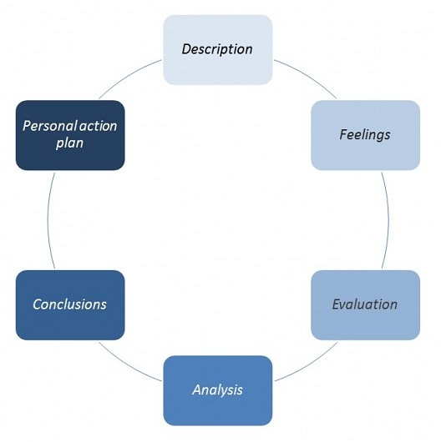
Figure 4: Gibbs Reflective Cycle (Grant, 2021)

2.1 Description
This report was compiled following a clarification that an overall organisational or market analysis was not required, but instead a specific product was requested. I chose to analyse the UK market for smartphones at Apple's iPhone as this was not a general idea. The research methodology employed was secondary research based on company reports, regulatory documents of the UK, market information and peer-reviewed publications in journals. I went on to use PESTEL, Five Forces, VRIO, SWOT analysis, the Balanced Scorecard, Ansoff's Matrix and SAFe. Saunders, Lewis and Thornhill (2023) highlight the importance of scope and evidence being suitable for credible research, heavily influencing the approach taken and the changes that were required.

2.2 Feelings
I had some doubts since restricting the topic required me to reword the majority of the previous work. I had worried that you would not be able to find enough data on a product-level report, but the iPhone turned out to be a solid bet as Apple publishes plenty of detailed financial and sustainability reports and Ofcom and the CMA have provided data specific to the UK. I also got more confidence as the point of the product focused on the analysis. I could assess a company's performance in one product market rather than all of the company's markets. The lessons for me from the process were why Rumelt's core strategic challenge concept is relevant in practice (Rumelt, 2022).

2.3 Evaluation
Reliable evidence was the most positive aspect of the process. Apple's annual report enabled calculations of dependence and sales growth of the iPhone and its revenue; Ofcom lined up the UK usage data, and CMA sources were used to explain the power in the ecosystem and regulatory risk. The patterns were also more effective if applied to a specific product. But the first error was picking a scope that's overly wide. If it's a very broad topic matter, then it may be descriptive since it is possible that each and every simple problem is seen to have relevance. The overhauling of focus was going to bring up the standard of judgement, as each paragraph would be able to say whether the evidence was relevant to the iPhone or not. I found the importance of sources in relation to the material discussed in the work very useful since it allowed me to identify useful information from the background (Saunders, Lewis and Thornhill, 2023).

2.4 Analysis
The bottom line is that scope is a key determinant of quality in analysis. PESTEL was used to identify external factors including digital regulation in the UK, affordability, AI and sustainability. The Five Forces suggested that competition is not only among handsets, but also at the ecosystem level. With Apple's advantage being split between brand, iOS, processors, services and customer data, VRIO then assisted me in making the determination that Apple's advantage is difficult to imitate. However, SWOT proved useful only for summarising these, but not for repeating them. To transform the recommendation into financial, customer, internal process, and learning objectives, the Balanced Scorecard was used. Lastly, a test was conducted to check that the proposed plan was appropriate, acceptable and feasible. This approach honed my critical thinking skills as evidence was used to make a recommendation rather than a simple description. For Whittington et al., frameworks are useful when they help to make strategic decisions, so the improvement with the updated report was that (Whittington et al., 2023).

2.5 Conclusion
I picked up an important point that in strategic management the choice of the unit of analysis is important. The new report is more robust as it examines one product, one market and one strategic issue. Another thing I learned was that a combination of theory and evidence, and calculation and judgement, is required at high-level writing. The most significant change was from a general description of the company to the consultant-style recommendation. I will not start the full writing until the product and geography are confirmed and the strategic problem and the industry boundary are decided.

2.6 Action Plan
As with all future assignments, I will seek the approval of my tutor and the assessment brief first. I will develop an evidence matrix for each source to a section, framework and judgement. Will add more numerical benchmarks in planning so that claims can be supported by calculations rather than assertions. I will also differentiate facts of the company and independent facts and evidence and my proposed targets. I will pre-read each paragraph before submission, answering three questions: what is the evidence, what does the evidence imply strategically, and how does the evidence support the recommendation? This Action Plan is intended to enhance clarity, critical analysis and professional judgement in further post-graduate study.

References
Alphabet Inc. (2026) Annual Report 2025. Mountain View, CA: Alphabet Inc. Available at: https://abc.xyz/investor/ (Accessed: 5 August 2026).
Amend, C., Revellio, F., Tenner, I. and Schaltegger, S. (2022) ‘The potential of modular product design on repair behavior and user experience: Evidence from the smartphone industry’, Journal of Cleaner Production, 367, 132770. doi: 10.1016/j.jclepro.2022.132770.
Apple Inc. (2025) Form 10-K: Annual Report for the fiscal year ended 27 September 2025. Cupertino, CA: Apple Inc. Available at: https://investor.apple.com/ (Accessed: 2 August 2026).
Apple Inc. (2026a) Environmental Progress Report 2026. Cupertino, CA: Apple Inc. Available at: https://www.apple.com/environment/ (Accessed: 5 August 2026).
Apple Inc. (2026b) People and Environment in Our Supply Chain: 2026 Annual Update. Cupertino, CA: Apple Inc. Available at: https://www.apple.com/supply-chain/ (Accessed: 1 August 2026).
Bieser, J.C.T., Blumer, Y., Burkhalter, L., Itten, R., Jobin, M. and Hilty, L.M. (2022) ‘Consumer-oriented interventions to extend smartphones’ service lifetime’, Cleaner and Responsible Consumption, 7, 100074. doi: 10.1016/j.clrc.2022.100074.
Competition and Markets Authority (2022) Mobile Ecosystems Market Study: Final Report. London: Competition and Markets Authority. Available at: https://www.gov.uk/cma-cases/mobile-ecosystems-market-study (Accessed: 2 August 2026).
Competition and Markets Authority (2025) Mobile Browsers and Cloud Gaming Market Investigation: Final Decision Report. London: Competition and Markets Authority. Available at: https://www.gov.uk/cma-cases/mobile-browsers-and-cloud-gaming (Accessed: 3 August 2026).
Competition and Markets Authority (2026) Apple’s mobile platform. London: Competition and Markets Authority. Available at: https://www.gov.uk/cma-cases/apples-mobile-platform (Accessed: 25 July 2026).
Cordella, M., Alfieri, F. and Sanfelix, J. (2021b) ‘Reducing the carbon footprint of ICT products through material efficiency strategies: A life cycle analysis of smartphones’, Journal of Industrial Ecology, 25(2), pp. 448-464. doi:10.1111/jiec.13119.
Cordella, M., Alfieri, F., Clemm, C. and Berwald, A. (2021a) ‘Durability of smartphones: A technical analysis of reliability and repairability aspects’, Journal of Cleaner Production, 286, 125388. doi: 10.1016/j.jclepro.2020.125388.
Corrocher, N. and Paganuzzi, S. (2025) ‘Planned obsolescence and smartphone replacement: Empirical evidence on the Italian market’, Telecommunications Policy, 49(8), 103022. doi: 10.1016/j.telpol.2025.103022.
Goggin, G. (2025) ‘Mobile AI: Communication and mobility after the smartphone’, Communication and Change, 1, article 5. doi:10.1007/s44382-025-00002-3.
Grant, R.M. (2021) Contemporary Strategy Analysis. 11th edn. Hoboken, NJ: Wiley.
Haftor, D.M., Climent, R.C. and Kallmuenzer, A. (2025) ‘Business ecosystems as a way to activate lock-in in business models: A theoretical integration’, International Entrepreneurship and Management Journal, 21, article 77. doi:10.1007/s11365-025-01078-5.
Hessing, T. (2021). Porter’s Five Forces. [online] Six Sigma Study Guide. Available at: https://sixsigmastudyguide.com/porters-five-forces/.
Jaeger-Erben, M., Frick, V. and Hipp, T. (2021) ‘Why do users (not) repair their devices? A study of the predictors of repair practices’, Journal of Cleaner Production, 286, 125382. doi:10.1016/j.jclepro.2020.125382.
Kaplan, R.S. and Norton, D.P. (1992) ‘The balanced scorecard: Measures that drive performance’, Harvard Business Review, 70(1), pp. 71-79.
Karadzhov, V. and Patarchanova, E. (2025). How to create the best PESTEL analysis. International Journal of Digital Research, 1(3), pp.8–20. doi:10.63711/ijdr.net20250301.
Magnier, L. and Mugge, R. (2022) ‘Replaced too soon? An exploration of Western European consumers’ replacement of electronic products’, Resources, Conservation and Recycling, 185, 106448. doi:10.1016/j.resconrec.2022.106448.
Manwaring, K. (2024) ‘Slowing down the loop: Smart devices and the right to repair’, International Review of Law, Computers & Technology, 38(3), pp. 268-296. doi:10.1080/13600869.2024.2324535.
Ofcom (2025) Online Nation 2025. London: Ofcom. Available at: https://www.ofcom.org.uk/ (Accessed: 5 August 2026).
Pamminger, R., Glaser, S. and Wimmer, W. (2021) ‘Modelling of different circular end-of-use scenarios for smartphones’, International Journal of Life Cycle Assessment, 26(3), pp. 470-482. doi:10.1007/s11367-021-01869-2.
Rumelt, R.P. (2022) The Crux: How Leaders Become Strategists. London: Profile Books.
Saunders, M.N.K., Lewis, P. and Thornhill, A. (2023) Research Methods for Business Students. 9th edn. Harlow: Pearson.
Solutions Hub (2023). EPAM SolutionsHub | Software Solutions for Digital Business. [online] Solutionshub.epam.com. Available at: https://solutionshub.epam.com/blog/post/vrio-analysis.
Great Britain (2024) Digital Markets, Competition and Consumers Act 2024. London: The Stationery Office. Available at: https://www.legislation.gov.uk/ukpga/2024/13/contents (Accessed: 5 August 2026).
van Hoboken, J. and Ó Fathaigh, R. (2021) ‘Smartphone platforms as privacy regulators’, Computer Law & Security Review, 41, 105557. doi:10.1016/j.clsr.2021.105557.
Whittington, R., Regnér, P., Angwin, D., Johnson, G. and Scholes, K. (2023) Exploring Strategy. 13th edn. Harlow: Pearson.

