

Student name: Emilia Milewska
Student ID:2245525
Module name: Independent Project
Module code: BMHP6020
Supervisor’s name: Bianca Sanfilippo

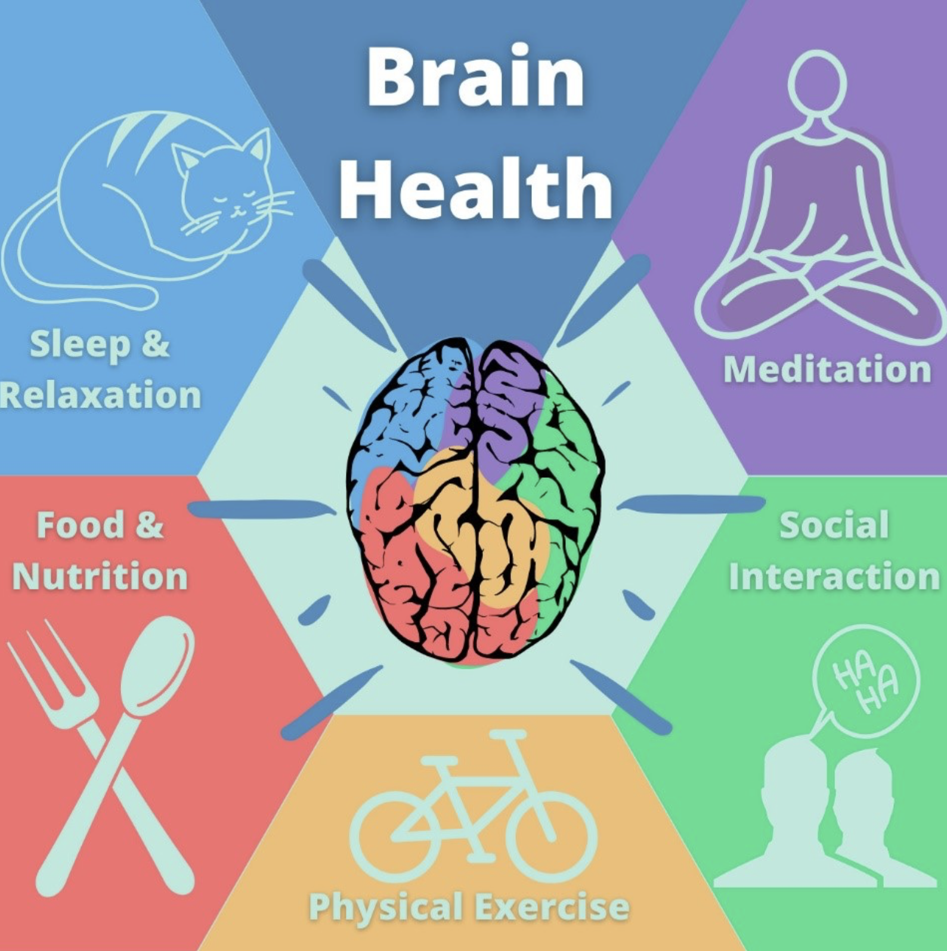  You (2020) |  | Exploring how lifestyle choices impact the brain in UK adults  Aim  To explore how various lifestyle choices, such as diet, physical activity, sleep, substance use, and screen time, affect brain health and cognitive function in UK adults aged 18-65 (UK Biobank, 2025).  Objectives  - Discuss daily lifestyle choices, such as diet, physical activity, sleep, substance use, and screen time, among UK adults.  - Explain the factors that influence UK adults’ lifestyle choices.  - Analyse how lifestyle choices, such as diet, physical activity, sleep, substance use, and screen time, influence the brain in UK adults.  - To offer suggestions for encouraging healthy lifestyle choices and brain health among UK adults. |  | 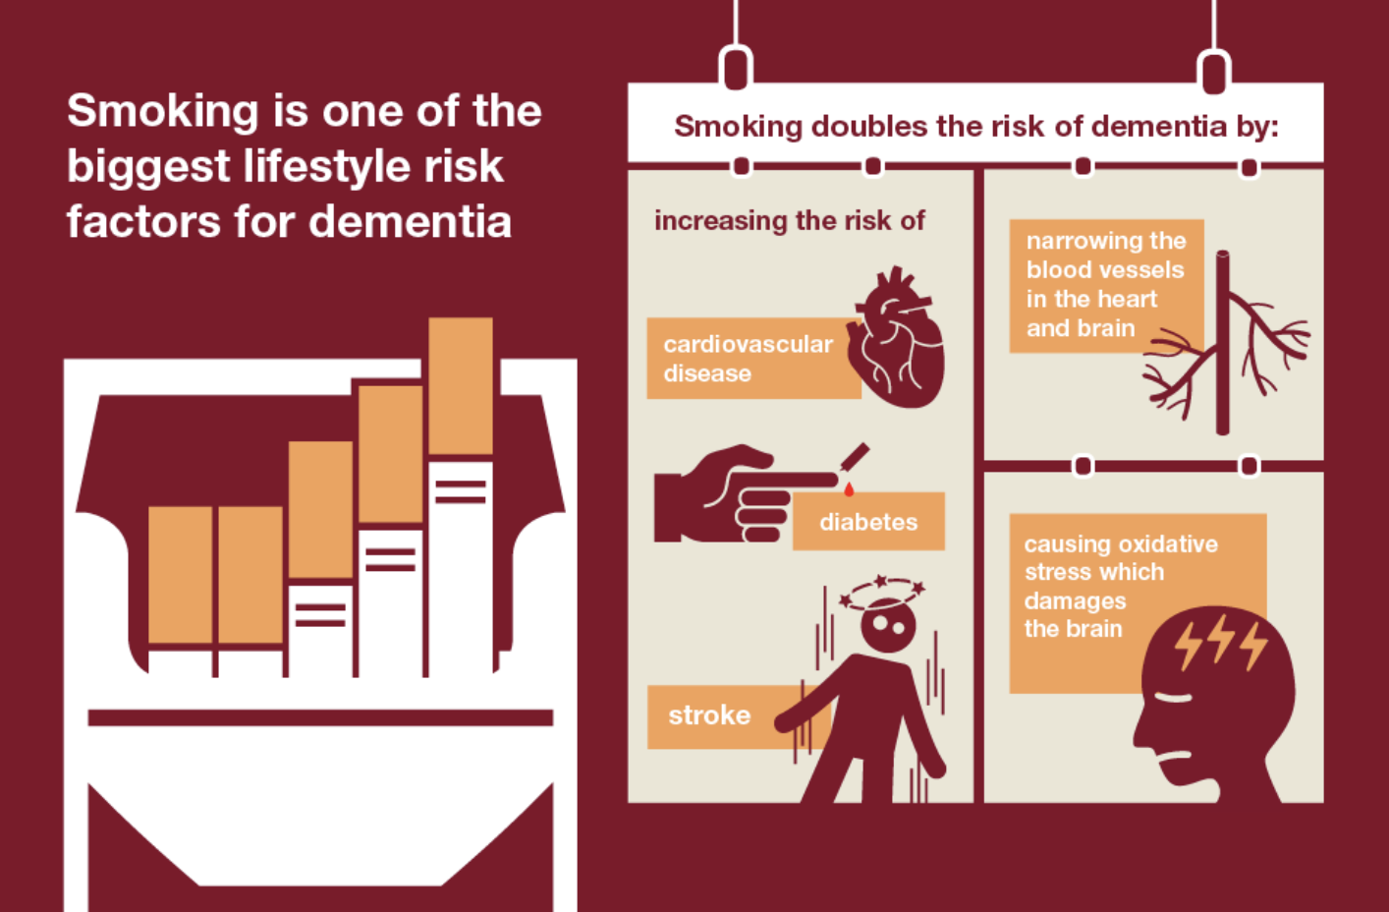  PHE (2021)
Methodology  Using a secondary research approach, this study analyses previous scholarly research to investigate the effects of lifestyle choices on cognitive function and brain health.  The strategy will entail a thorough analysis of 10 peer-reviewed research articles based on primary research.  Keywords  Lifestyle choices, impact on the brain, UK adults, brain health, diet, exercise, sleep, smoking, and alcohol will be used to conduct research in relevant databases  Databases  PubMed, ProQuest, and the UWTSD library. |  |  |  | Data analysis  The data analysis will be conducted using thematic analysis, which requires the following steps:  - Familiarisation with the data  - Generating initial codes  - Searching for themes  - Reviewing themes  - Defining and naming themes  (Braun and Clarke, 2021)  Ethical considerations  The UWTSD ethics form was submitted and approved before the research began, and ethical principles were followed in accordance with it.  In secondary research, ethical considerations include:  Using reliable sources, such as peer-reviewed journals, and reporting accurate information, and providing appropriate citations using the Harvard Cite Them Right style (BHBIA, 2020).

Inclusion and exclusion criteria

Inclusion criteria:
- Primary research studies are published in peer-reviewed journals.
- Studies published after 2015.
- Studies focused on adults aged 18-65 living in the UK.
- Examining lifestyle factors (diet, exercise, sleep, screen time, substance use) and brain health or cognition.
- Research articles written in English

Exclusion criteria:
- Secondary research, reports, books, websites and studies not in peer-reviewed journals
- Studies published before 2015.
- Studies focusing on non-UK populations
- Studies focusing on individuals diagnosed with neurological or severe psychiatric conditions.
- Participants under 18 or over 65 years old.
- Studies written in languages other than English.

References
BHBIA - British Healthcare Business Intelligence Association (2020) BHBIA Data Analytics Guidelines Secondary Data – Ethical Principles. Available at: https://www.bhbia.org.uk/assets/Downloads/Guidelines/4_secondary_data_ethical_principles_aug2020_fv.PDF (Accessed: 5 February 2026).
Braun, V. and Clarke, V. (2021) Thematic Analysis: A Practical Guide. SAGE Publications Ltd
PHE, Public Health England (2021) Guidance Health matters: midlife approaches to reduce dementia risk. Available at: https://www.gov.uk/government/publications/health-matters-midlife-approaches-to-reduce-dementia-risk/health-matters-midlife-approaches-to-reduce-dementia-risk (Accessed: 5 February 2026).
UK Biobank (2025) The impact of modifiable risk factors on cognition and dementia. Available at: https://www.ukbiobank.ac.uk/projects/the-impact-of-modifiable-risk-factors-on-cognition-and-dementia/ (Accessed: 9 February 2026).
You, X. (2020) HeJu Mental Health Awareness Month (Oct 2020) – Brain health. Available at: https://blogs.helmholtz.de/hejus/2020/10/heju-mental-health-awareness-month-oct-2020-brain-health/ (Accessed: 5 February 2026).

