4.1 Chapter Overview

This chapter of the thesis is an analysis of the researcher’s primary data that was collected through an online questionnaire and interviews, concentrating on holiday makers decision-making process and their views on all-inclusive holidays with specific focus on the difference between packaged and all-inclusive. There was a sample of 80 online respondents and a total of 5 interviews.
Primary data will be presented in the form of percentages, along with responses sighted throughout this chapter.
Section 1 – Understands the demographics of the respondents;
Section 2 – Holidaymakers understanding of the all-inclusive concept,
Section 3– Respondents decision-making process and motivations,
Section 4– Holiday makers awareness of the impacts of all-inclusive resorts on host communities.

Please see Appendix B for the copy of the questionnaire and interview questions.

4.2 Section 1 – Demographics

4.2.1 Gender

Question 1 asked the respondents to confirm their gender. The results were as following; 36% identified as male which was closely followed by 64% of female respondents.

Figure 4 - Gender

4.2.2 Age
Following on from gender, question 2 asked the respondents to specify the age group they belong in. The smallest sample was 6% of respondents aged 50 +. This was followed by 9% of 16-21-year olds and 40% of 22-29 -year olds. The largest group was represented by 45% of 30-49-year olds.

Figure 4.1 - Age

4.2.3 Income

Question 3 asked for the respondent’s household income which was optional. The largest sample group was represented by 55% of respondents who have an household income of £10 - £19,000. This was followed by less than £10,000 at 18 % and over £30,000 at 16%. The smallest sample was represented by 11% of respondents who have a household income of £20,000 - £30,000

Figure 4.2 - Income

4.2.4 Visitor Profile

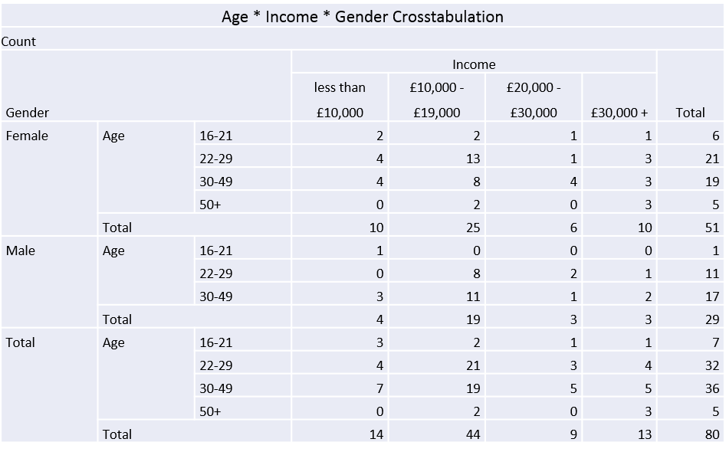
Predominantly, the highest visitor profile who pick all-inclusive as their type of holidays from the sample were 38% males aged 30-49 with an income of £10,000 - £19,000. It was no surprise to find that this was closely followed by 28% of males aged 22-29 with an income of less than £10,000, aged 22-29. Similarly, when we compare this against females, it appears that there is a trend in visitor profile as 25% of females of this sample were aged 22-29 with an income of £10,000 - £19,000 and 16% of females were aged 30-49 with an income of also £10,000 - £19,000.
Figure 4.4 – Crosstabulation of Age, Gender and Income

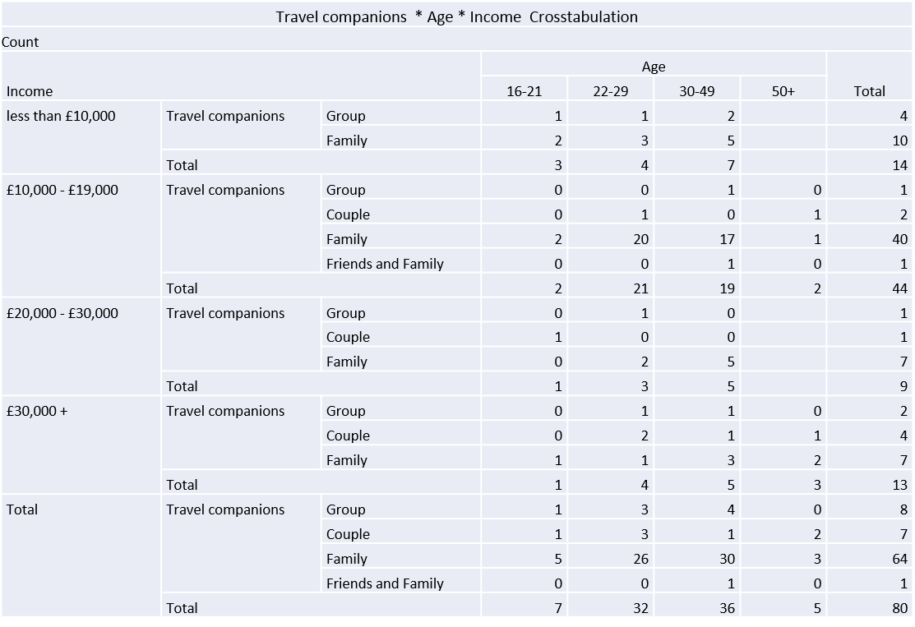
If we group these figures together it shows that the visitor profile of all-inclusive holidays is 64% of visitors aged between 22 and 49 with an income of less than £20,000. When we compare these figures to the type of visitor profiles, it is clear that 80% of all respondents were families with 70% of these respondents fitting the age bracket of 22-49. Therefore, it can be said that 70% of holidaymakers who participate in all-inclusive holidays are families aged between 22 and 49. Furthermore, when we compare against income, 56% of all families aged between 22 and 49 have an income of less than £20,000.
Figure 4.5 – Crosstabulation of Travel Companions, Age and Income

4.3 Section 2 – Holidaymakers understanding of the all-inclusive concept

4.3.1 All-inclusive vs Package
An issue raised through this thesis was ‘are holidaymakers aware of the difference between all-inclusive and packaged holiday’. The results for question 5 show that only 21% of respondents knew the difference, compared to 79% of respondents who did not know the difference. This supports the finding from the national opinion poll cited in Swarbrooke and Horner (2016) research which showed that 40% of people did not understand the all-inclusive concept and this data further suggests that double of the respondents agree.
Figure 5 – Tourists awareness of the difference between all-inclusive and packaged

Q5a allowed respondents who answered yes to elaborate further and explain their awareness of the difference between all-inclusive and packaged. 42% of respondents referred to all-inclusive holidays as including food and drink within the price. While 58% of respondents also agreed that a package holiday can be as basic as transport and hotels. Participant number 10 stated:

“A packaged holiday is combined of transport and accommodation that is put together by a tour operator and sold as a holiday. An all-inclusive holiday means that all meals including food and drinks will be included in your holiday”.

Respondent 30 also agrees that all-inclusive includes food and drink, however, the respondent also argues that an all-inclusive holiday can also be referred to as a packaged holiday. Participant number 30 stated:
“All-inclusive typically includes everything such as; accommodation, transport, food, drinks and entertainment etc. Whereas, packaged can be as simple as accommodation and transportation. However, all-inclusive can be referred to as a packaged holiday”

Participant 50 raises the question that a package holiday will include transport and accommodation and a selection of holiday boards such as self - catering etc. But for it to be ‘all-inclusive’ the hotel must provide “food and drinks all day/night. From this it can be said a package holiday can still include; self-catering, half board, full board (not including drinks), whereas the drinks aspect makes it all-inclusive – includes food, drinks and snacks all day.

Question 18 allowed the respondents to elaborate further for the researcher of this thesis to gain a better of what tourists expect to be included in their holiday package as 79% are unaware of the difference between all-inclusive and packaged. The most frequent trend was that 70% of respondents mentioned that food and drinks would be included in a packaged holiday. Figure (5.1) shows interview responses which also show that for it to be an all-inclusive holiday, tourists expect to receive food and drinks for the duration of their holiday included in the single payment they paid prior to their holiday.

Figure 5.1 - Interview Matrix – Table 1 Defining an all-inclusive holiday
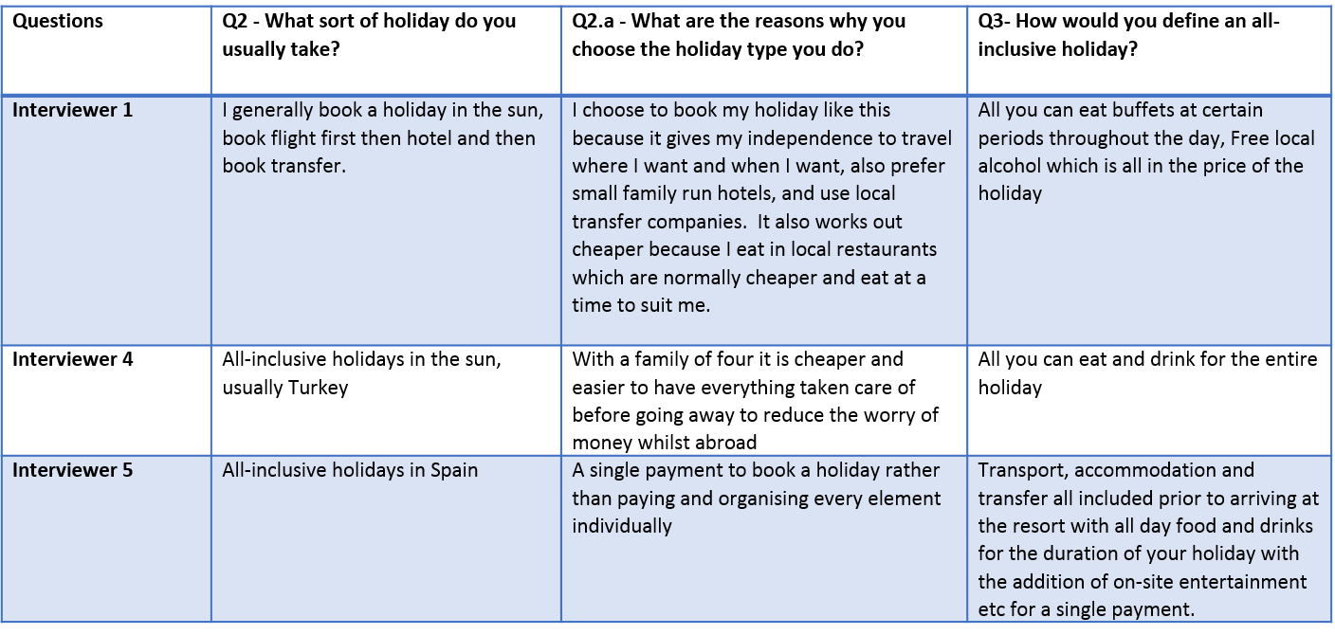

4.3.2 Stakeholders who Benefit

Figure 6 – Tourists views of which stakeholders benefit the most

Question 7 asked respondents to rank stakeholders who benefit the most from all-inclusive resorts to who benefits the least. The results show that tourists believe that the benefit the most from these holidays. The state that travel operators then benefit, followed by 34% who suggest that local community’s benefit. As we look further down the scale, they suggest that other countries do not benefit as much and that 24% believe local businesses do not benefit at all. The study by UNEP (2002) would disagree with the respondents as other countries benefit significantly from all-inclusive as resorts import good and supplies to fulfil the needs of international tourists that cannot be sourced locally which increases leakage.

4.3.2.1 Tourists awareness of negative impacts, who benefits and whether they left the resort to support local businesses with this knowledge

Figure 6.1 suggest that 46% of respondents who left the resort were aware of the negative impacts of the local community and also stated that local businesses benefit the least which suggest because they are aware of these impacts, they went to support such businesses. Although, 30% of respondents did not leave the resort while they were aware of the negative impacts. Nevertheless, 84% of respondents who were not aware of these impacts also did not leave the resort. Therefore, like the 46% who did leave, a greater awareness of the negative impacts all-inclusive resorts has on local businesses may encourage tourists to leave their resort at least once during their holiday to support such businesses.

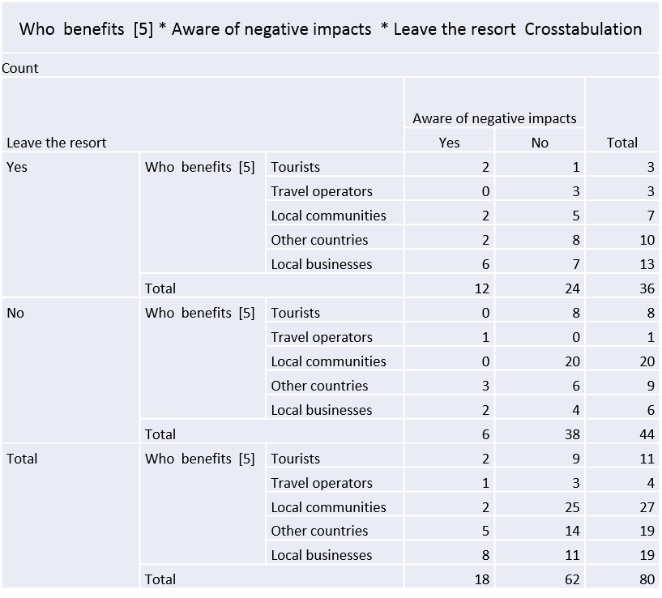
Figure 6.1 shows a crosstabulation to see if tourists who are aware of the negative impacts left the resort to support the local business that they ranked ‘benefits the least’

4.4 Section 3 – Respondents decision-making process and motivations

4.4.1 Factors that Influence Tourists Choice of Holiday

Question 8 asked the respondents to choose which four influence them to book an all-inclusive holiday. The results show that the number one factor that is the most important to individuals who book an all-inclusive holiday is the cost which accounts for 84% of respondents. 61% of respondents said that weather was the second most important factor for booking all-inclusive holiday, suggesting hotter countries than others. The third most frequent factor was safety accounting for 50% of respondents which Issa and Jayawardena(2003) suggests that they contribute to social issues as it reduces interaction with the locals, however, it also supports Schmidt(1979) and Wickens(2000) who suggests that tourists will avoid any unpleasant locals and staying in the resorts will allow them to stay safe and enjoy their holiday. Armstrong and Mok (1995) also support the theory that tourist will feel safer with a larger group of people with a similar background. Wong and Kwong (2004) suggested that booking an all-inclusive holiday will avoid unreliable transport and ensure safer travel which 44% of respondents agreed which is why accessibility was a contributing factor.

Figure 7 – Factor that influence holidaymakers’ choice to book an all-inclusive holiday

4.4.2 Age, Income and Factors (Cost)

Figure () shows that the 30% of respondents aged 22-29 with an income of £10,000 - £19,000 first choice of factors that influence them was the cost of the holiday. This was closely followed by 27% of respondents aged 30-49 with an income also of £10,000 - £19,000. This would suggest that cost is the most important factor that influences the ‘family’ profile to book an all-inclusive holiday.

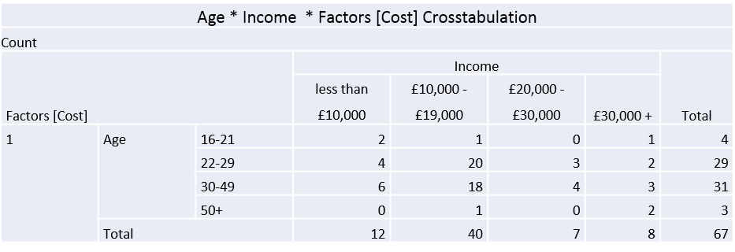
Figure 7.1 – Crosstabulation of Age, Income and Factors that Influence holidaymakers to book an all-inclusive holiday (Cost)

4.4.3 Holiday Location and Income
Figure 7.1 shows a trend between holiday location and cost. There is no surprise that the leading all-inclusive destinations welcome the most visitors with 55% of respondents visiting Spain and 70% of these respondents earning less an £20,000 and 28% of respondents visiting Turkey with 77% of these respondents earning less than £20,000. With cost being the number one factor and considering the holiday location and average cost per holiday according to Tui (2020) these destinations are relatively cheaper to visit which is the result of a higher volume of tourists visiting these European country to stretch their money further, compared to an all-inclusive destination which is evidently more expensive such as Jamaica with an average of £1500pp where only 4% of respondents visited with 34% of these respondents who earns more than £30,000, therefore, their choice of holiday may not be influenced by cost. From this data, it can be concluded that income and location has a link.Cost of the most popular all-inclusive destinations…. Support that location and income links

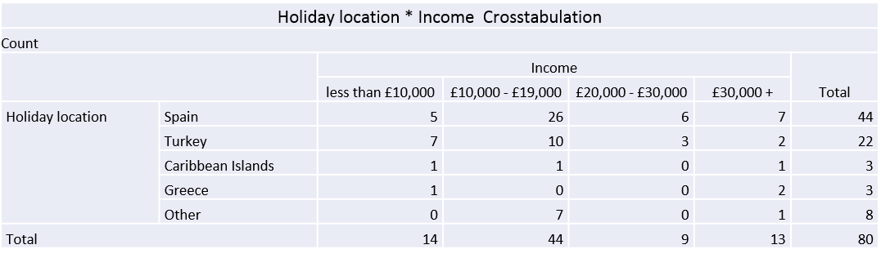

Figure 8 – Crosstabulation between Holiday Location and Income

4.4.4 Age, Gender and Factors (Safety)
From cross referencing the factor of safety against age and gender, It is clear from figure () that from the male participants only males aged between 22 and 49 chose safety as a factor with 9% saying it was the most important and 91% stating it was the third most important factor. As these ages fit the ‘family’ profile, it can be said that only males with families answered as safety is an important factor for the protection and welfare of the family and younger children. Furthermore, 82% of females who said safety of all-inclusive resorts influences them to book that type of holiday fit the ‘family’ profile of ages 22-49.

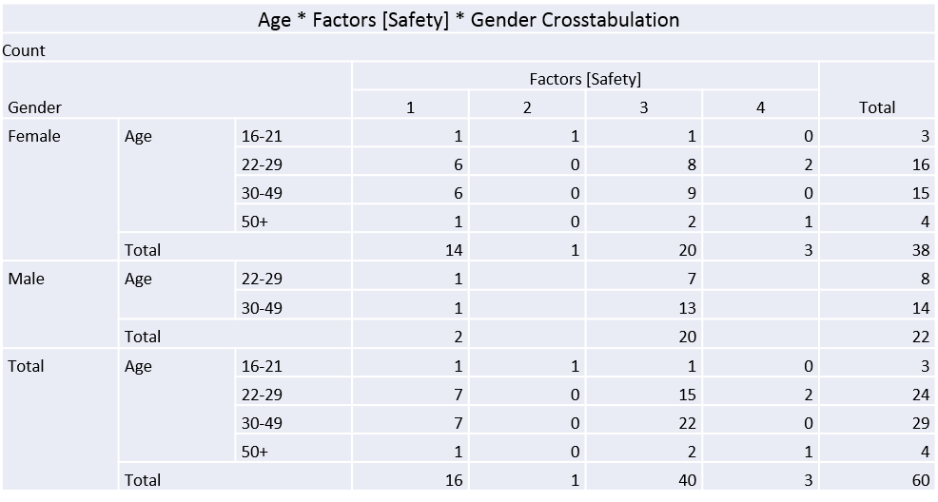

Figure 9 – Crosstabulation of Age, Gender and Factors that Influence holidaymakers to book an all-inclusive holiday (Safety)

4.5 Section 4 – Holiday makers awareness of the impacts of all-inclusive resorts on host communities

4.5.1 Negative Impacts
Question 6 asked if respondents were aware of the negative impacts of all-inclusive resorts on host communities. The results show that only 22% said they were and 78% stated that they were unaware. Question 19 then asked respondents to state why such resorts have a negative impact. The data shows a trend that 65% of respondents agree that the main negative impact that all-inclusive resorts cause is loss of business within the local community, followed by 24% of negative economic impacts directly relating to the loss of local business. This supports the statement made by Kondo (2015), who suggests that local communities receive minimal economic benefits from all-inclusive resorts, which results in the closure of many businesses.

Figure 10 – Respondent awareness of the negative impacts of all-inclusive holiday

Figure 11 - Interview Matrix – Table 2 – Impacts on the local community
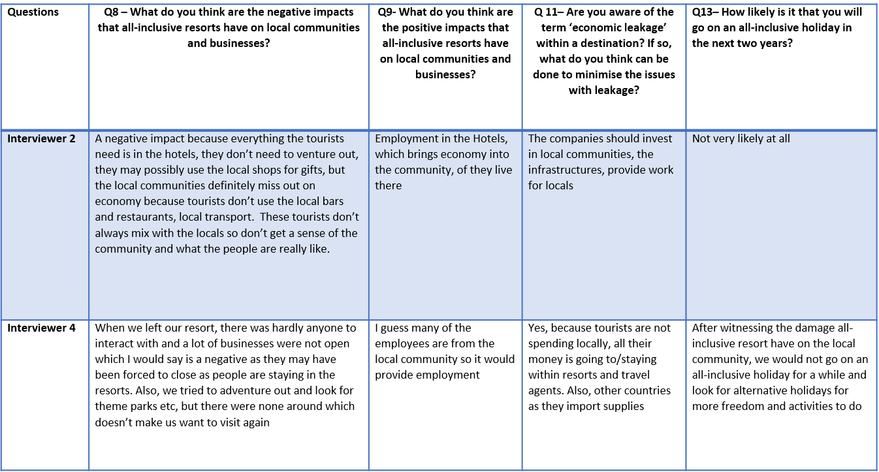

After answering the interview questions, 80% of respondents said that they are not likely to go on an all-inclusive holiday within the next two years. Interviewer 4 answer to question 13 supports the statement made by Saayman (2013:311) that environmental protection has become a globalised concept which is further supported by Haarhoff (2015) who suggests that conservation has dramatically influenced consumer behaviour which has seen the rise in alternative tourism and decrease in packaged holidays

4.5.2 Leaving the Resort
Question 11 asked respondents if they left the resort during their holiday. The results show that 45% of visitors did leave their resort, while 55% of holidaymakers did not leave the resort. 86% of respondents did not encounter any environmental issues whilst on holiday, however, 86% of respondents also stated that they did not leave their resort which suggests because they did not leave their resort, they would not have witnessed any environmental issues if there were any, furthermore, it is also evident that private investors and travel operators only invest in the tourism environment of a destination; resorts, beaches, bars, clubs, however, if you travel a few streets behind these resorts and tourism products you would witness the negative environmental issues of a destination. 33% of respondents who did leave the resort reported that they encountered environmental issues whilst on holiday

It is interesting that 45% said that did use the off-site facilities compared to 55% who said they did not use these facilities and stayed within the resort they booked into which suggests that they go on an all-inclusive holiday and stay inside the resort which associates to the reasons behind the development of Butlins, the reason cruise ships are so popular and all-inclusive resorts are very popular because they do not use local facilities.

These figures support the reasons for why an all-inclusive holiday were developed in the first place. For example, if you want to visit a destination but you want someone to book your accommodation, flights and your transfers, that would be a packaged holiday which suggests there would be no need for an all-inclusive holiday if all tourists are happy to make their own arrangement and eat in local restaurants and bars. However, it seems that the all-inclusive model was created as tourists want to go on holiday with everything taken care of so they can do nothing and not have to worry for the duration of their holiday.
Figure 12 – Tourists decisions whether to leave their resort or not

4.5.2.1 Correlation between Negative Impacts/ Environmental issues and Tourists who left the Resort
It is clear that there is a relationship between tourists’ awareness of environmental issues and tourist awareness of negative impacts. The 33% of respondents who said they encountered environmental issues also stated that they are aware of the negative impacts within the local community. Whereas, the remaining 66% who left the resort but did not encounter any environmental issues which also stated that they are not aware of the negative impacts on local communities.
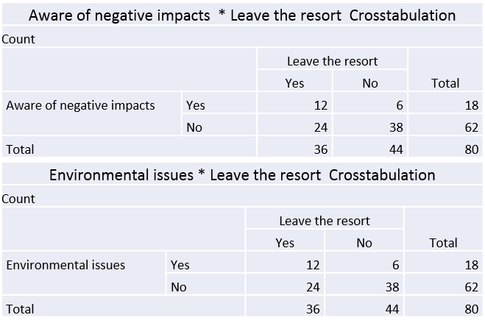
Figure 12.1 – Crosstabulation of Tourists awareness of negative impacts and Environmental awareness and their decisions whether to leave their resort or not

4.5.2.2 Age, Income and Tourists who left the Resort
55% of respondents show that they did not leave the resort whilst on holiday, compared to 45% which did. It can be assumed that 45% spent money within the local community when they left the resort. 67% of respondents aged 16 – 21 with an income of less than £10,000 left the resort, compared to 71% of respondents aged 30-49 with an income of less than £10,000. Whereas, 92% of respondents aged 16+ with an income of over £30,000 left the resort whilst on holiday.

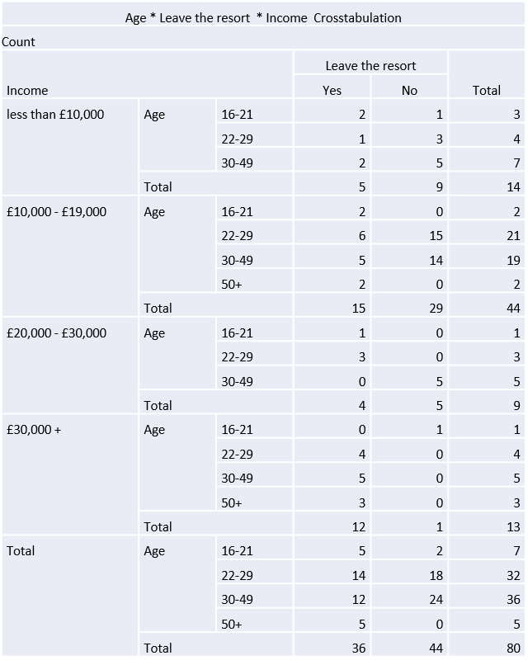
Figure 12.2 – Crosstabulation of Age, Income and tourists’ decisions whether to leave their resort or not

4.5.3 Negative Impacts and Tourists who used service that were not provided within their package
Participants were asked how often they use services that are not included in their all-inclusive package such as off-site; bars, restaurants, transport and activities. There was a clear pattern within respondents’ awareness of the negative impacts and off-site bars and off-site restaurants and the impact on the community. 58% of respondents who are not aware of the negative impacts of all-inclusive on local communities did not use off-site bars whilst on holiday. Whereas, 67% of respondents who are aware of these impacts, did use off-site bars at some point during their holiday. Furthermore, 63% of the respondents who are not aware of the impacts that all-inclusive resorts have on the local did not use off-site restaurants whilst on holiday, whereas, 61% of

respondents who are aware of the impacts stated that they used off-site restaurants during their all-inclusive holiday. This shows that there is a clear link between tourist awareness of these impacts and their decision-making whist on holiday which supports Haarhoff (2015) theory of increased conservation within tourists and their consumer behaviour whilst on holiday.
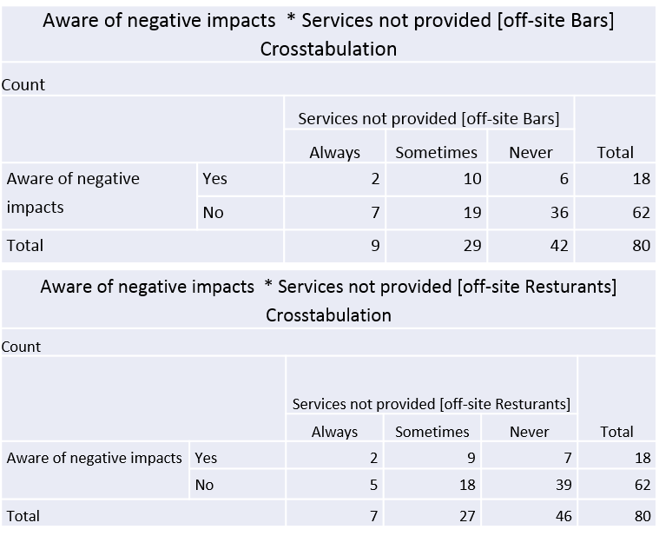
Figure 13 – Tourist awareness of negative impacts and the use of services not provided (off-site bars and Restaurants)

4.5.3.1 Age, Income and Services not provided within their package
The 44% of respondents who always use off-site bars are aged 22-29, with 41% of these stating that they sometimes use off-site bars. However, when we look into the income, only 21% of respondents who earn less than £10,000 sometimes left the resort or used off site bars and restaurants but 79% never left the resort. Whereas, respondents who earn over £30,000 shows that 100% of respondents left the resort at some point of their holiday to visit a local bar and 77% of respondents left their resort to visit a restaurant. The results show that less visitors leave their resort based on their financial income, whereas, 100% of visitors with the highest income bracket left the resort. Nevertheless, 50% of respondents aged 16-21 always use off site bars which could suggest that their main purpose for holidaying was to party and make use of these bar and not because they are aware of the negative impacts. These figures also suggest that younger respondents like to go out to local bars which links to the club 18-30 holidays which always involves excursions in the evenings. Although they would be onsite throughout the day, they would utilise local facilities in the evenings when going out clubbing.

Furthermore, 50% of respondents who never use off-site bars and restaurants fall into the family category and therefore, have younger children who may not be suitable for bar as they supply alcohol or that simply they cannot afford to leave the resort and that is why they chose this type of holiday and cost was the main influence.
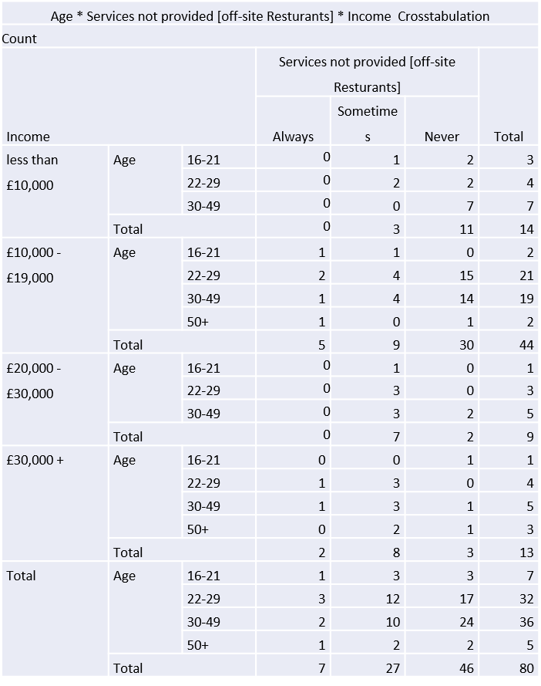
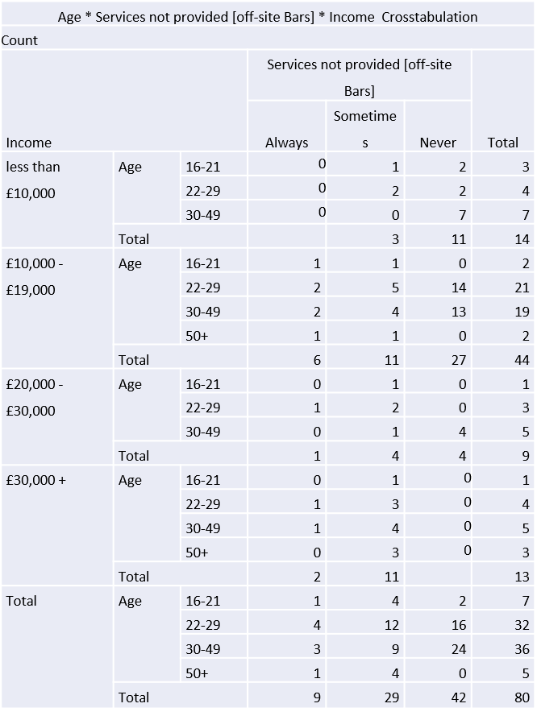

Figure 14 –Crosstabulation between Age, Income and the use of services not provided (off-site bars and Restaurants)

4.5.4 Multiplier effect
Question 9 asked the respondents if they were aware of the term ‘multiplier effect’. 94% of respondents said that they were unaware of the multiplier effect and only 6% were aware of the term.

Figure 15 – Tourists awareness of the multiplier effect

4.5.4.1 Tourists awareness of the term multiplier effect and their choices of using service not provided by their all-inclusive holiday

55% of respondents who were not aware of the term multiplier effect also did not use bars and 60% did not use restaurants outside their resort, therefore, not contributing to the local economy. Whereas, 80% of respondents who are aware of the term did use off site bars and restaurants at some point during their holiday, therefore, contributing to the local economy which was a key negative impact highlighted by respondents. Therefore, the results show that, if tourists had more knowledge of their action and the impacts, they are more likely to use facilities and services outside their resort so local communities also benefit.

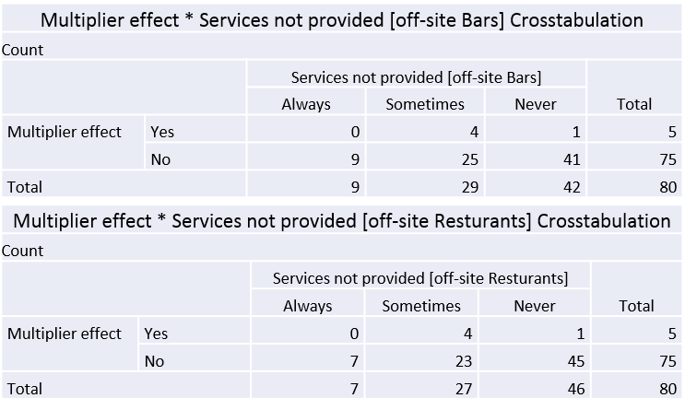
Figure 15.1 – Tourists awareness of the multiplier effect and the use of services not provided within their all-inclusive holiday (off-site bars and restaurants)

4.6 Summary

All quantitative data questions used spss to sort, run tests and cross tabulate for a more comprehensive analysis which was supported by the qualitive matrix of the interviews.

