Case study report
Psychology for Health and Social Care

Student Name: Vimi Naiko
Student ID: 2120212
Module : BMHP 4003
Lecturer Name : Joanne Davies

Table of Contents
Introduction 3
Discussion 3
Social identity Theory 3
Theory of Planned Behaviour 5
Frustration Aggression Hypothesis 7
Conclusion 7

Introduction
This paper is based on a case study that is based on a case study that is based on YOT in Carmarthen, West Wales. The case study deals with the case of Gareth, who is 17 years old and has been in Parc Youth Offenders Institute for 18 months before he was released on the ground to have shown significant improvement in behaviour. For a better understanding of the case, the theories related to lifespan development have been added to the paper along with the social identity theory and theory of planned behaviour. The writer in the paper has further explained about Frustration Aggression Hypothesis in light of Gareth's behaviour towards the institute members at the time of interrogation.

Discussion
After having asserted all the details from the case study it can be found that the paper is solely based on the core aspects of health and social care. The fact that individual gets to associate with the anti-social company only when they get to face issues in their personal life; in this aspect, several theories have been explained in the points which would further help society to under about the nature of human and identify the reasons and the gaps that remain in making Gareth behave socially.

Social identity Theory
This particular theory was introduced by Henri Tajdel to put emphasis on the psychological aspects of the human. He defined social identity to be the sense of a person having associated it with their company and the group of members they are associated with. By groups, Tajfel explains family, social class, football team etc to which a person belongs (Edwards et al., 2019). He further explains that the group to which a person belongs helps them to have a sense of social identity which further makes them a sense of being a part of the social world. This theory of social identity can be further exaggerated into two different parts, the first part explains it to show the difference between the groups and the second part elaborates on the similarities of things in the same group the person belongs.
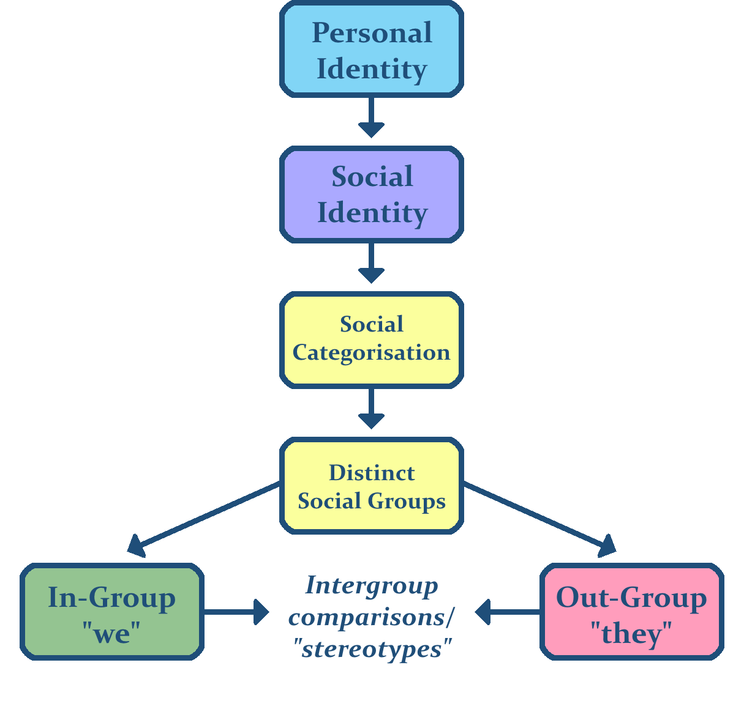
Figure 1: Social identity Theory
(Source: Perry et al., 2022)
In order to define the social identity theory Tajfel and Turner proposed three stages so that people can understand the theory in a better manner. The first part consists of social categorisation, the second part includes social identification and the third part involves social comparison (Ahmad et al., 2022). In order to understand the factors of social identity of Gareth the members of the institute must ensure that they get to analyse this theory as per the steps.
Categorization: The institute members must try to categorize the objects of the case of Gareth so that they can understand his nature and can identify the reasons that made him have the same. The institute must try to be aware of the social environment of Gareth including the caste, community, creed, and race they belong. As the institute will assign the category of Gareth they will be able to know about the inner aspects of this behavioural change and be able to understand his nature in a better manner.
Social Identification: This is the second stage of the social identity theory, and in this stage, the institute must try to adopt the identity of the group to which Gareth belong. Having considered their age group of Gareth, the most suitable group for him happens to be school, yet he was found to have been involved in anti-social activities. A person must have the sense to be able to distinguish the difference that they have based on their social identification. Had Gareth been placed amongst a group of students, he would have learned to behave and act like that of the students which would have been a confirmation of the norms of the group he would have belonged.
Social Comparison: This is the final stage of the social identity theory which can be considered by the institute to categorise Gareth as a part of a group by having identified his characteristic with that group and with the group that would have been a better place for him. Having identified two groups the institute will be able to the difference that lies in both places and further will be able to identify the differences effectively.

Theory of Planned Behaviour
This is one such theory that is entirely based on reasoned actions which enable a person to predict the intentions of another person to get them engaged in an activity at a given point in time and place. This particular theory comprises all the actions on which a person can have self-control (Huang, Dai and Xu, 2020). The primary factor of this theory continues to be their behavioural intentions which can be influenced by the attitude displayed by another person. The theory of planned behaviour has always proven to be successful in predicting as well as explaining the range of intentions and health behaviours like drinking, breastfeeding, substance, smoking and health service utilization and many others.
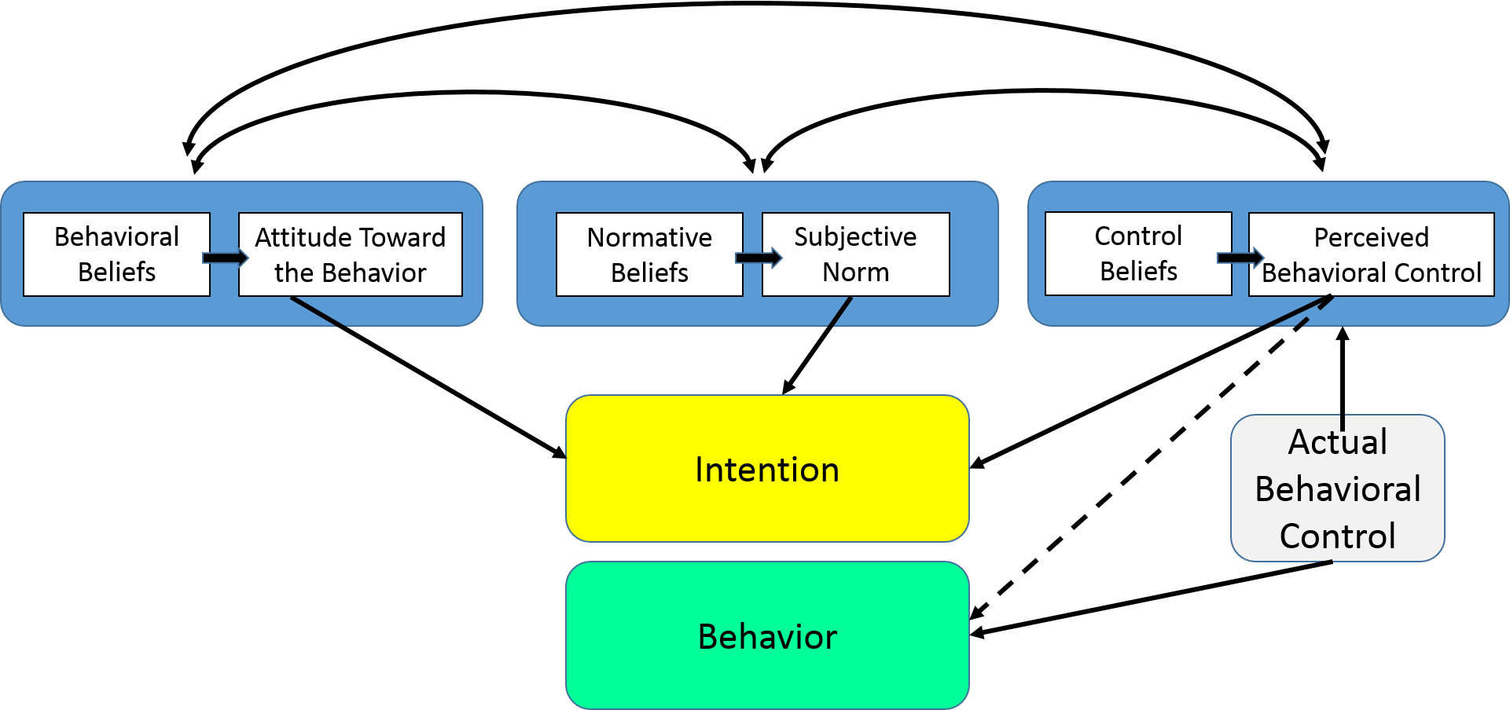
Figure 2: Theory of Planned Behaviour
(Source: Tornikoski and Maalaoui, 2019)
In the process of achieving of healthy lifestyle of a person, they must ensure that they get to be constantly motivated and grow the ability to control the urge that occurs within them (Razali et al., 2020). However, there are six basic constructs that have been put forward in the points below that can be further linked with Gareth's case to explain a person's control over their behaviour.
Attitude: After having been in the institute for a period of 18 months Gareth's change in attitude defined his approach towards life. As his interests changed towards his career his attitude too was found to have changed to a considerable level.
Behavioural intention: The institute members constantly motivated and encouraged Gareth to keep up high spirits having strengthened his intentions so that they can perform based on his behaviour.
Subjective norms: Subjective norms explain the belief that a person gets to have about the behaviour they are required to adopt. The institute thus must apply this theory to be in this change within Gareth.
Social norms: The customary codes enable a person to think about society as a whole. Thus the institute must try to inculcate this change in its social norms.
Perceived power: As Gareth was released from the institute he was found to have gotten involved in the same activities in order to perceive the power that he previously had. However, this can be changed by the institute as they get to do proper counselling of Gareth in terms of perceived power.
Perceived behavioural control: The most important factor in this aspect is the control over their perceived power. Since Gareth was found to have been involved in the same activity, he can be stated to have poor perceived behavioural power that could not make him resist to be getting himself involved in the activities all over again.

Frustration Aggression Hypothesis
This is one such hypothesis that is based on the psychodynamic approach. This hypothesis puts forward the fact that when a person happens to be frustrated with their personal life they deem to have the experience a drive which will encourage them to be aggressive towards the object on which they have been frustrated. This hypothesis can be further supported by the concepts highlighted by Catharsis. According to this concept, the frustration and aggression of a person are signs of relieving emotional tensions and displacement (Killgore et al., 2021). This further makes them grow a mechanism that enables them to defend themselves on having been pointed out the actions that they have committed or have been involved in. The psychological facts further explain it to be the process when a person's level of tension is showcased.
In this context, Gareth’s aggression towards the institute members on having been interrogated about his whereabouts shows the tension he had. Thus it can be asserted that Gareth has definitely been connected with his previous acts which is why he felt tension when he was asked about it (Battigalli, Dufwenberg and Smith, 2019). He was also found to have not been attending college and his involvement with his previous associates was also proven. Thus a fact of the case links it effectively with the frustration and aggression hypothesis.

Conclusion
The fact that individual gets to associate with the anti-social company only when they get to face issues in their personal life; in this aspect, several theories have been explained in the points under which would further help society to under about the nature of human and identify the reasons and the gaps that remain in making Gareth behave socially. In order to understand the factors of social identity of Gareth the members of the institute must ensure that they get to analyse this theory as per the steps. The Theory of planned behaviour comprises all the actions on which a person can have self-control. The hypothesis that has been added to the paper can be found to have supported the concepts highlighted by Catharsis.

Reference
Ahmad, N., Ullah, Z., AlDhaen, E., Han, H., Araya-Castillo, L. and Ariza-Montes, A. (2022) Fostering hotel-employee creativity through micro-level corporate social responsibility: a social identity theory perspective. Frontiers in Psychology, 13.
Battigalli, P., Dufwenberg, M. and Smith, A. (2019) Frustration, aggression, and anger in leader-follower games. Games and Economic Behavior, 117, pp.15-39.
Edwards, C., Edwards, A., Stoll, B., Lin, X. and Massey, N. (2019) Evaluations of an artificial intelligence instructor's voice: Social Identity Theory in human-robot interactions. Computers in Human Behavior, 90, pp.357-362.
Huang, X., Dai, S. and Xu, H. (2020) Predicting tourists' health risk preventative behaviour and travelling satisfaction in Tibet: Combining the theory of planned behaviour and health belief model. Tourism Management Perspectives, 33, p.100589.
Killgore, W.D., Cloonan, S.A., Taylor, E.C., Anlap, I. and Dailey, N.S. (2021) Increasing aggression during the COVID-19 lockdowns. Journal of affective disorders reports, 5, p.100163.
Perry, E., Mandy, W., Hull, L. and Cage, E. (2022) Understanding camouflaging as a response to autism-related stigma: A social identity theory approach. Journal of Autism and Developmental Disorders, 52(2), pp.800-810.
Razali, F., Daud, D., Weng-Wai, C. and Jiram, W.R.A. (2020) Waste separation at source behaviour among Malaysian households: The Theory of Planned Behaviour with moral norm. Journal of Cleaner Production, 271, p.122025.
Tornikoski, E. and Maalaoui, A. (2019) Critical reflections–The Theory of Planned Behaviour: An interview with Icek Ajzen with implications for entrepreneurship research. International Small Business Journal, 37(5), pp.536-550.

