Problem Solving And Decision Making

TITLE OF REPORT :- MANAGEMANT REPORT.

NUMBER OF AUTHOR :- 1705027.
NAME OF HOST ORGANIGETION :- UNIVERSITY OF WALES TRINITY SAINT DAVID.
NAME OF LECTURER: LIANNE CUKE.
DATE OF REPORT PUBLICATION :- 21 JANUARY 2018.
SUBMISSION DEADLINE : 20 APRIL 2018.

An executive summary:
The National Health Service (NHS) is the publicly funded national healthcare system in the United Kingdom. In the history of health and social care of people, it is contributing for since its launch in 1948. In the health and social care, people think the NHS to be one of our society’s most precious resources. Instead, historically the NHS has been under a lot of pressure, and that pressure is increasing for several causes. In this report, the writer will discuss different aspects of NHS with critical evaluation of its recent situation and problems. Solutions to the problems will also be planned, monitored and evaluated. Here proper recommendations are also added for ensuring the effectiveness of the implementation of planning for resolving different problems in NHS.

Contents
An executive summary: 2
An introduction which defines the current situation of the NHS and the impact that this is having on its stakeholders 4
A PESTEL framework to explain the causes of the NHS’s problems and use statistics as supportive evidence; 7
Options to resolve these problems 14
Evaluation of these options 15
Conclusion 16
Recommendations regarding the implementation of the chosen option/s; 17
References 18

An introduction which defines the current situation of the NHS and the impact that this is having on its stakeholders
The National Health Service is world famous and largest publicly funded health service in the UK for providing required health related services all over the UK. In this regards, Morrison (2013), “the NHS is providing its services among 51m and employing more than 1.3m people with new and innovative technologies and approaches.”
To define the stakeholders of the NHS, we can use a popular stakeholder defining tool Mendelow's Matrix. Mendelow's Matrix is a tool that may be used by an organisation to consider the attitude of their stakeholders at the start of a project or when they are setting out strategic objectives.
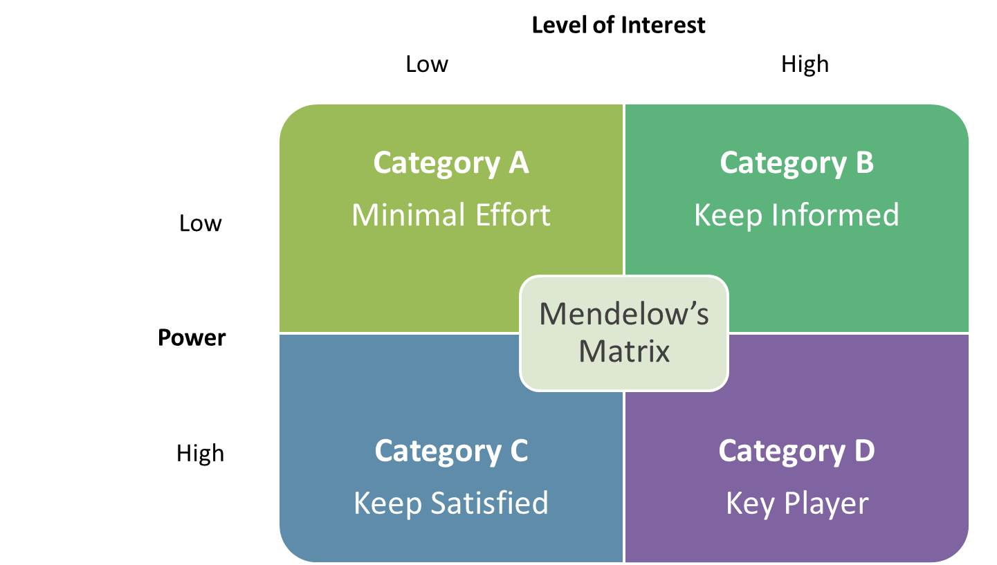
Figure 1: Mendelow's Matrix Source: (Thompson and Wright, 2003)
Mendelow matrix has divided the stakeholders in Four Grids ABCD. A is low impacting or interested stakeholders who has limited power to influence the organization's activities. Secondly, Grid B stakeholder is highly interested and influencing stakeholders without any power to change the strategy of an organization. Thirdly, grid C stakeholders have the authority to influence strategy but they have low levels of interest in organizational activities. The last level stakeholder is the Grid D possesses highest level of interest in organizational activities and a high degree of power to influence operations of a business. They are also considered as the key players of an organization.
It has a huge budget from very beginning like £437million and that has been increased £100 billion and more in 2017(Debt and reserves management report 2012-13, 2012). The NHS is paying its stakeholders with its massive budget. It is reported by the authority of the NHS about 60% of the NHS budget has been paid to staff of the NHS. In general, healthcare service being provided within England to every particular citizen is a difficult commission to undertake and therefore the system needs effective health personnel to assist the operative system carefully. According to Selbig (2015), “The NHS services of the UK are prominently ensuring proper health and social care of people of all classes in the country.” It is also creating an opportunity to build a better relationship with foreign patients from all countries of the world (Blackstone's employment law practice 2011, 2011). Activities of the NHS are operated by following a basic structure that should be followed. In the structure of the NHS, the activities are operated from the Secretary of state and Department of Health controlling the overall NHS in England. It is the responsibility of the secretary of state for health has the responsibility of reporting to the Prime Minister regarding the advancement and needs of the NHS (Crisp, 2011). The activities of NHS are monitored by 10 different Strategic Health Authorities (SHAs) in England. Mutual co-operation ensures better services and health to its service receivers. Different types of primary cares are increasing the chances to develop the public health with community healthcare and central NHS of the UK. Different organization in health and social care services like Mental Health services, Hospitals, Ambulances and Learning disability services are ensuring immediate health services for people all overall the UK (Klein, 2010).
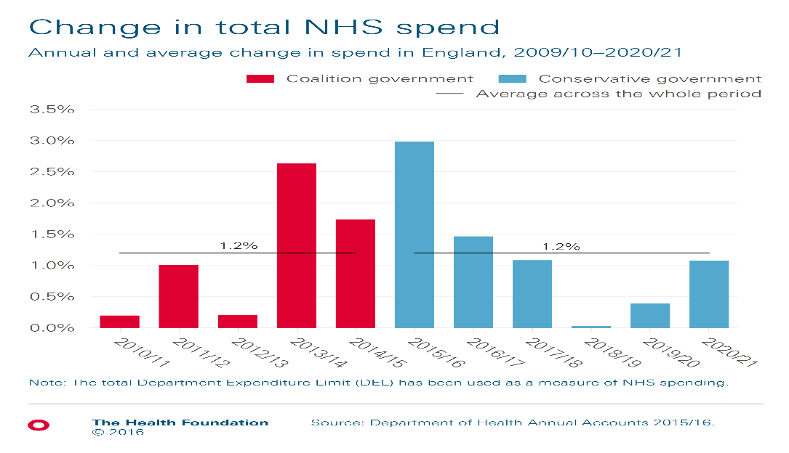
Figure 2: Spending in NHS Source: (Debt and reserves management report 2012-13, 2012).
Rest 40% of total budget is used in two portions including 20% for drugs and other supplies and another 20% split between buildings, equipment and training costs of the NHS.
Stakeholders: In the context of the NHS there are different types of stakeholders who are related to the activities from different perspective (Thompson and Wright, 2003). To define the term Stakeholders, Thornbory (2016) has reported “A stakeholder indicates to a party that has an interest in a company, and can either affect or be affected by the business.” In the context of NHS, there are many stake holders who are impacted with the activities or initiatives of the NHS. Here, the government, employees in NHS, co-operating organizations and customers (Wills and Naidoo, 2015).

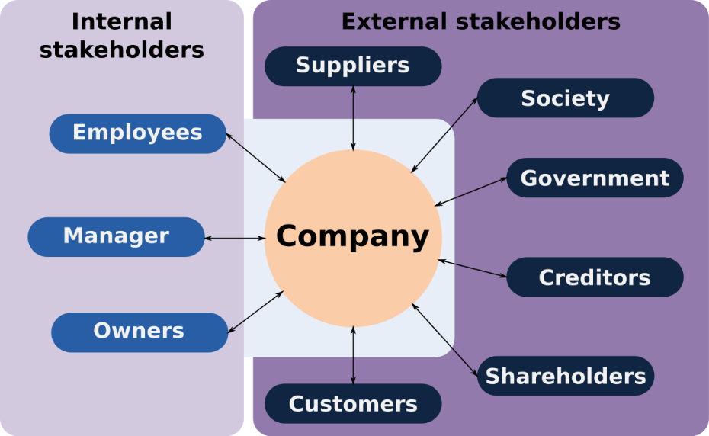
Figure 3: Different types of stakeholders Source: (Selbig, 2015).
Impacts of recent condition of NHS on Stake holders:
Patients: The impact of recent situation of the NHS has greatly impacted on the services to the patients or service receivers of the NHS (Coles and Porter, 2011). An overall development has been occurred in patient handling and taking care of their health and including patients, staffs, suppliers, doctors, nurses, technical experts to operate the activities. The stakeholders are getting benefited with the activities of the NHS.

Figure 4: A Patient under service Source: Google
For instance, the Patients are getting different types of medicines, equipment, services and training for overcoming their situations for leading a better life and get cured(Mansfield and Bowers, 2011). Barr and Dowding (2016) has noted “The staffs of the NHS are getting paid with handsome salaries with proper payments.” It is also offering different types of trainings and supporting for the staffs. They are provided with required essential commodities and medicines for ensuring required treatments.
Government: Government is another most important stakeholder of the NHS who is providing required funding and finance. Different financial aids are provided to the NHS. The government is always interested to ensure proper management of money and aids in the context of the NHS. It is impacted with the needs of other stakeholders of the NHS. Selbig (2015) has said, “The government has the most important responsibility for proper development of the NHS.”
Staffs: Staff is another the most important stakeholders of the NHS. 60% of total budget of the NHS in last years have been spent for ensuring better livelihood of the staffs of the NHS (Barr and Dowding, 2016). There are different types of staffs in NHS including doctors, care workers, pharmacists, technical specialists, physio therapists, etc. Different types of staffs are working together in many organization in different health caring sectors (Mansfield and Bowers, 2011).
Co-operating organizations of the NHS: Different medical services, local and international organizations are helping in the activities of NHS (Debt and reserves management report 2012-13, 2012). They are working together and ensuring better health services for the patients. Such organizations have directly impacts and are being impacted in operating their activities and performing their duties from different aspects (Morrison, 2013).

A PESTEL framework to explain the causes of the NHS’s problems and use statistics as supportive evidence;
In NHS, there are different problems which are causing different types of problems by getting impacted by different factors from different perspectives. There are many problems are coming before us from different viewpoints in the NHS sector of the UK like-
- An ageing population with increasing number of population
- Different types of healthcare needs are increasing like obesity and diabetes, or antibiotic resistance and many other diseases.
- Increasing demands of medical services and equipment’s are creating lack of proper services (Mansfield and Bowers, 2011).
- Lack of due budget is also a very important problem in the NHS from different perspective.
BRAINSTORMING:

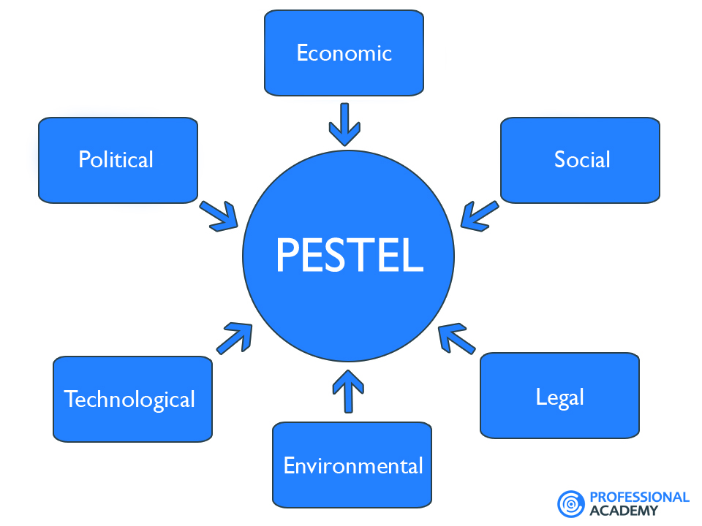
Figure 5: PESTLE framework source: (Debt and reserves management report 2012-13, 2012).
Because it is alone hampering many development and services to patients and service holders (Selbig, 2015). The increasing number of Medical advancements and progress in medical technology increases the costs at least an extra £10bn a year in the medical sector of the UK. Lack of political decision and change of government and their policies are impacting on the NHS of the UK. Due to centralization drives, the closure of local services. And dependency on privatized services for NHS is also very big problems because such dependency hampers rights of poor and general people (Barr and Dowding, 2016). To explain the causes of problems very effectively, the writer has used different evidences with a PESTLE framework (Mansfield and Bowers, 2011).
PESTLE framework:
PESTLE is a term that is consisted with political, economic, social technological, legal and environment. It is used for analyzing and monitoring different aspects the macro-environmental (external marketing environment) factors that have an impact on an organization (Mansfield and Bowers, 2011). Here in this report, the writer has analyzed the problems in NHS with this effective tool. According to Barr and Dowding (2016), “PESTLE means "Political, Economic, Social, Technological, Legal and Environmental" and is used for business and premeditated planning, organizational change, business, research reports and marketing planning.”
The Political causes
Politics is the first element of the PSETLE analysis. Politics has direct impact on the activities and development of the NHS of the UK. Different types of politics are directly or indirectly impacting on the services to people. The government and its policies are changing day by day (Debt and reserves management report 2012-13, 2012). As a result, the NHS managers or care providers are getting failed to take long term and effective initiatives for developing the health care of people. Now in the UK, we are experiencing a coalition Government that has a commitment to cut public spending.
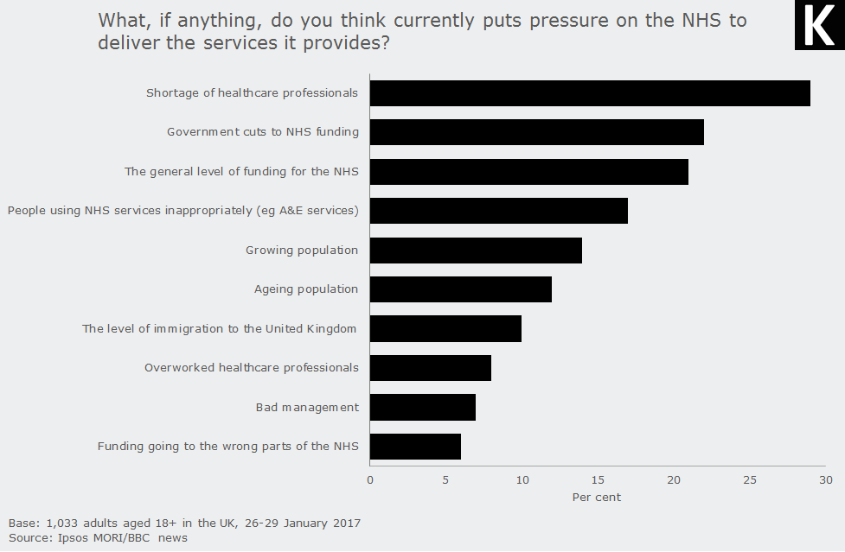
Figure 6: NHS and its Link with Politics Source: (Morrison, 2013).
Because of such political initiatives, the problems of lack of budget and want of good willing for developing this sector transparently become clear to us (Morrison, 2013). Lack of different large scale contracts with neighboring governments of that are also affecting the NHS negatively. Cost reduction policy of the government of the UK is directly impacting on the enhancement of problems (Blackstone's employment law practice 2011, 2011). Because of a political decision to reduce the cost in health care services, the problems are getting increased form different aspects. The value-for-money of public expenditure is also very effective and important with the group of MPs who are responsible for the decision making of the NHS. Monitoring of CCG and other organizations by the government is also responsible for rising problems in NHS (Thompson and Wright, 2003). While the government tries to defined the targeted customers like the Department of Health/new ‘clusters’ of Clinical Commissioning Groups (CCG’s) or Commissioning Support Organizations (CSO’s) or individual Trusts. Then the problem becomes more acute in the NHS (Davies, 2008). Different types of policies that are taken by the government for providing political benefits to own or political people. Services become faint and problems are raised. While the government fails to ensure a proper collaboration in existing health service providers, it becomes critical to solve any kind of problem and the scenario become more complex and vigorous (Klein, 2010). Passing many bills and providing different opportunities to doctors in political point of view, hampers the possibilities of solving any problem.
The Economic
The economy has direct impacts on the activities and performances of the NHS. The movement of money from or to the organization causes changes in the NHS. The quality of services depends on the economic capacity of the NHS. How much government is providing in this fields (Klein, 2010). In very recent, qualified staff are very costly. The market of medicine and medical equipment are going higher and higher day by day. Increasing labor cost is drastically enhancing the budget of the NHS. But the government is failing to collect such huge money and provide (Davies, 2008). As a result, the NHS is getting compelled to work without qualified staffs and limited equipment for providing services among people.
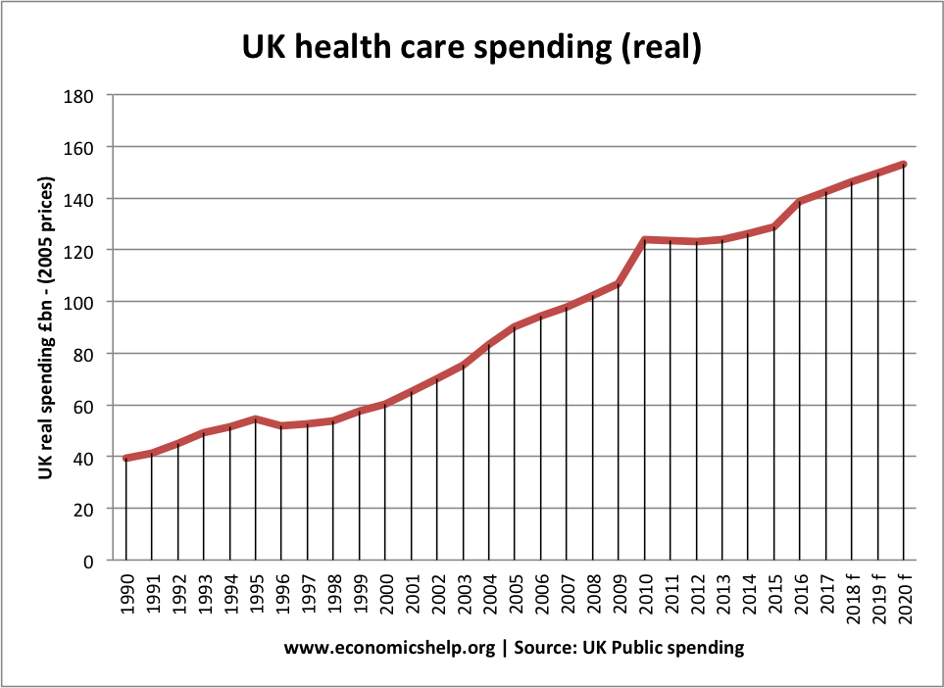
Figure 7:Health Care Spending in UK under NHS Source: (Debt and reserves management report 2012-13, 2012).
For managing proper development and reaching to customer, procurement and service delivery of the NHS is also very important that is also impacted by the economic foundation of the NHS. Since the NHS has not enough budgets, advance management and business operations are becoming impossible for them (Folmer, 2014). With the help of trusts in UK, the government is operating the activities of NHS. The budget of the NHS had reached £3 billion by 2016, a 12% increase from 2010 levels and the government was trembling to handle the situation (Thornbory, 2016). As a result, cost reduction policy was taken to ensure proper services with less cost.
Sociological Causes
In the UK, social causes are mostly important for increasing problems in NHS. Here a huge number of aging people are getting increased in last decades (Coles and Porter, 2011).
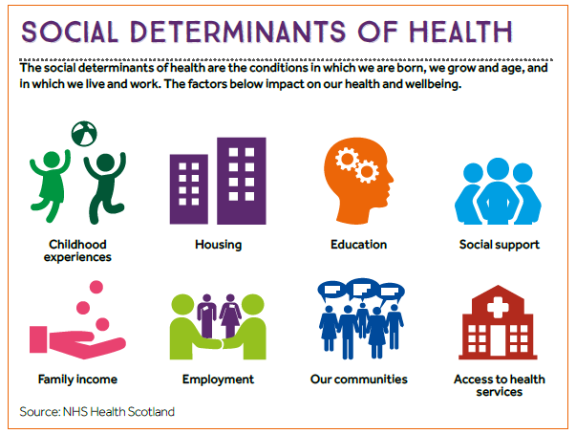
Figure 8: Social factors of problems in NHS Source: (Klein, 2010).
The advancement of treatment and medication have directly impacted on the longevity of people and making their aged. As a result, diseases in old age are increasing from different aspects. On the other hand, in social environment of the UK, the number of patients of diabetes, obesity, and overlap are getting increased (Mansfield and Bowers, 2011). They are required with special attention and increasing the burden of NHS and creating huge problem. The over growing population is hampering services by increasing the number of patients.
Here, thousands of hospitals, clinics and many other NHS organizations have been created and built their infrastructure for ensuring their profit (Blackstone's employment law practice 2011, 2011). Now health care is a huge profitable business and they are not afraid of taking any kind of deceiving initiatives for earning money. Another cause of increasing problem in NHS is lack of proper education (Morrison, 2013). Patients are not well educated regarding different diseases. As a result, they are always trying to take services from an organization under NHS and creating overcrowding. Lack of community care and integrated care are also responsible for enhancing the problems in NHS.
The Technology context:
According to Selbig (2015), “Technology has made our life easier and ensured comfortless.” It’s true, but the important aspect of technology is increasing stress, obesity and making people idle. As a result, in recent times, people are getting fat.

Figure 9: Technology in its NHS Source: (Thornbory, 2016).
They are suffering from much more different obesity based diseases. The NHS has become dynamic, federated and potentially rapid for making a solution by using a technology (Selbig, 2015). But the cost has been increased enormously. The success of the organizations under the NHS is creating aging generation.
Because of using technologies sometimes, people are provided with misleading information and causing death. Proper use of technology is increasing the number of population and leading the whole NHS to a gigantic condition (Selbig, 2015).

Legal causes
The NHS is very importantly facing different problems because of many legal reasons. For instance, health and safety is one of the most important reasons. An organization under the NHS should ensure health and safety of patients and staffs (Wills and Naidoo, 2015). The organization should ensure equal opportunities for all patients and staffs too. While the organization under the NHS fails to ensure such things problems are created and remained in the working environment of the NHS (Folmer, 2014).
Environmental causes
It is a responsibility of the NHS to ensure a better natural environment in clinical area and reaching the patients with proper services with natural remedies. As a result, the government is creating ‘Green’ IT agenda that includes, political imperatives (Klein, 2010). The NHS is also obligated to ensure a proper green service policy by reducing harmful dumping of wastes. As a result, the problems are increasing to manage such measures (Davies, 2008).

Options to resolve these problems
The problems that have been discussed before have been discussed in the following with proper solution here-
Providing supports: In the NHS, the aging population is increasing greatly with different types of diseases. Aged people should be provided with required guidelines for keeping good health and mental condition (Folmer, 2014). They should be kept physically fit and advice to keep themselves aloof from different risk factors like smoking, high blood pressure, high cholesterol, alcohol, infections, etc.

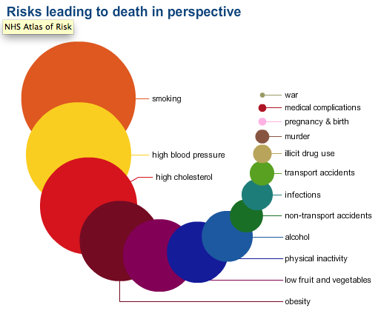
Figure 10:Risk Factors for a patients Source: (Folmer, 2014).
Proper medication: To ensure proper care among the children and people from all age, the government should raise awareness among people against obesity, diabetes or antibiotic resistance and many other diseases. Proper advertisement against such diseases are influencing on proper protest (Thornbory, 2016). Providing proper medication in time and regular screening are also very effective in these situations (Morrison, 2013).

Providing training: For ensuring proper and updated services, gradually the demands of different medical equipment and trained staffs are increasing. That’s why the government should provide more fund for the NHS. The NHS can collect funds from different trusts and charity organizations for buying this equipment (Selbig, 2015).

Community engagement: To solve this problem, the NHS should inspire community engagement and privet health services. People who are capable to afford the services of privet organization under NHS will be capable to ensure their health services from such organizations (Debt and reserves management report 2012-13, 2012). Poor people will get proper support from different trusts and aids.
Ensuring proper funding: The services of the NHS will be developed with proper funding or budget. The government of the UK should ensure proper financial aids for providing training to the staffs, medication to patients; create awareness among common people with proper funding and financial monitoring (Morse, 2012). The government should inspire privet investments, trust’s donations, charitable assistance and local community engagement for ensuring huge investments solving these problems.
Create effective planning: Effective planning is another solution for solving these problems. With proper planning and effective strategies will help the NHS will help easily solve problems. After completing market analysis, proper documentation, evaluation and assessment, a planning helps to resolve all these problems effectively (Davies, 2008).

Evaluation of these options
Providing training: To eliminate the weaknesses of the employees or staffs of the NHS in their workplace proper training will develop their skills effectively. Since a training program allows an individual to strengthen existing skills with proper guidelines and instructions (Folmer, 2014). The staffs have opportunities to improve their lacking. A simple person can be fit for operating the activities of an organization under NHS and reach to a higher level. For ensuring proper and updated services, gradually the demands of different medical equipment and trained staffs are increasing (Thornbory, 2016). That’s why the government should provide more fund for the NHS. The NHS can collect funds from different trusts and charity organizations for buying these equipment.

Ensuring proper funding: While the management of the NHS will ensure proper funding with required budget, all organizations related to the NHS will ensure proper implementation of projects and activities will be easier for the organization to secure required services for people. The government should inspire privet investments, trust’s donations, charitable assistance and local community engagement for ensuring huge investments solving these problems (Mansfield and Bowers, 2011). Proper monitoring of these funding will increase the possibility of increasing the quality of services and management.
Creating effective planning: While the management of the NHS will make effective plans, it will be capable to go ahead to solve the problems effectively. Because, a Planning encourages innovations and planning provides competitive edge (Barr and Dowding, 2016). Additionally planning is another solution for solving these problems. Moreover, Planning improves employee’s moral and Planning minimizes uncertainties (Morse, 2012). So making effective planning will secure the success of the NHS.
Ensuring proper funding: Benefits of proper funding cannot be denied for ensuring the success of the NHS (Debt and reserves management report 2012-13, 2012). The services of the NHS will be developed with proper funding or budget. The government of the UK should ensure proper financial aids for providing training to the staffs, medication to patients, create awareness among common people with proper funding and financial monitoring. Proper inspiration to privet investments will make services available for people (Selbig, 2015). Engagement of different trusts and charitable organizations in local or remote area will help the NHS to get released from the burden colleting huge amount of money.

Conclusion:
In any organization or field, problems are very common. But resolving such problems can be effectively ensured with proper supports and mutual co-operations. Raising awareness among people regarding different problems to prevent them can be a good solution from different aspects. Supply and preservation of equipment and medication are also very effective to ensure proper care people in NHS. The government should provide required funding, assistance and monitor every activities of the NHS with skilled and experienced human resources. Creating and implementing proper planning will help the NHS to ensure proper and updated services. Community engagement with different organizations, trusts and charities can be also beneficial for solving all kinds of problems in the NHS.

Recommendations regarding the implementation of the chosen option/s;
To implement the chosen options, here some recommendations have been recommended in the following-
- Initially, finding out causes related to the problems
- Finding out impacts of different factors on the problems
- Finding out all solutions related to the problems
- Completing a research for understanding full perspective of problems
- Creating a time based effective plan with SMART objectives.
- Responsibilities should be divided among personnel and management of the NHS
- Informing all related organizations and stakeholders of the NHS about plans
- Taking actions for adapting with changes after implementing the changes.

References
Barr, J. and Dowding, L. (2016). Leadership in health care. 2nd ed.
Blackstone's employment law practice 2011. (2011). Oxford: Oxford University Press.
Coles, L. and Porter, E. (2011). Policy and strategy for improving health and wellbeing. Exeter [England]: Learning Matters.
Crisp, N. (2011). 24 hours to save the NHS. Oxford: Oxford Univ.y Press.
Davies, P. (2008). NHS handbook 2008/2009. London: NHS Confederation.
Debt and reserves management report 2012-13. (2012). London: The Stationery Office.
Folmer, M. (2014). The Aramaic language in the Achaemenid period. Leuven: Peeters.
Klein, R. (2010). The new politics of the NHS. Oxford: Radcliffe.
Mansfield, G. and Bowers, J. (2011). Blackstone's employment law practice 2011. Oxford: Oxford University Press.
Morrison, M. (2013). Strategic business diagnostric tools. [Place of publication not identified]: Createspace.
Morse, A. (2012). Department for Business, Innovation and Skills. London: The Stationery Office.
Selbig, W. (2015). Aerial application of antimycin. 3rd ed. [Madison, Wis.]: Dept. of Natural Resources, Division of Forestry, Wildlife and Recreation, Southern District, Bureau of Fish and Wildlife Management.
Thompson, D. and Wright, K. (2003). Developing a unified patient-record. Abingdon, U.K.: Radcliffe Medical Press.
Thornbory, G. (2016). Contemporary occupational health nursing.
Wills, J. and Naidoo, J. (2015). Health studies.

