

Assessment Component 2

Written Essay

Student name: Michael Abak
Student ID: 1917009
Module name: Children, Young People and Families
Module code: (BMHP5004_LON)
Lecturer name: Bianca Sanfilippo
Word count: 2459

This essay will be discussing the significance of the social construction of childhood. It will be providing an overview of various changes that take place from historical to present times. The family as a socially constructed concept and various changes within the family unit in the UK will be included. The contributory factors in changing the lives of children and reduction of inequalities that existed from historical periods to present times, including the rationale relating to how these factors enhanced the lives of children will also be discussed. Finally, a discussion of present interventions in the UK to support children that are vulnerable and how this can lead to a reduction in inequalities between privileged and disadvantaged children will be analysed.

A child can be defined legally as “every human being below the age of 18 years unless under the law applicable to the child, majority is attained earlier” (Office of The High Commissioner for Human Rights, 2021). Biologically a child can be defined as a person that has not attained puberty and reached sexual maturity (Dictionary.com, 2019) and any child that is conceived and not adopted by a particular parent and therefore having the genes of the parent (Collins Dictionary, 2021). Sociologically a child can be described as someone that is vulnerable and immature (Thompson, 2016) and must be protected (Kehily, 2013). There is no universally accepted definition of childhood because socio economic factors influence the construction of childhood. The social construction of childhood relates to the idea that childhood is decided by the society and the society also decides when a child is a child and when a child reaches adulthood, in other words it is not a natural process. It involves a group of interpretations, expectations, social beliefs, and social meanings that differ through time and circumstances (Ali Norozi and Moen, 2016). Childhood relates to the actual experience of growing as a child, the period in life when human beings are children. Socio -economic factors and cultures influence the experience of being a child, childhood is not a universal concept (Cherry, 2011).

The family has an influence on the experiences and needs of children. The concept of the family is ongoing because it involves continuous changes for example mothers now take up employment, divorce rates have increased, more single mothers are taking care of children (Meier et al., 2016). The family is a socially constructed concept, and it varies according to sociological, cultural, and religious concepts and there are different kinds of families. Diverse families exist for example in the UK. You have nuclear family which is a social unit of two parents and their children (Cambridge Dictionary, 2019) This is the dominant family model in western societies (McDowall Clark, 2013)., same sex couple which is a family relationship or marriage involving two people of the same sex (Cambridge Dictionary, 2021) single parent family involves either a mother or a father but not the two of them (Cambridge Dictionary, 2021a), families with Adopted children and foster care family, children can also live with their extended family and other carers like the child’s grandparents. Ethnically diverse families are also common in the UK.

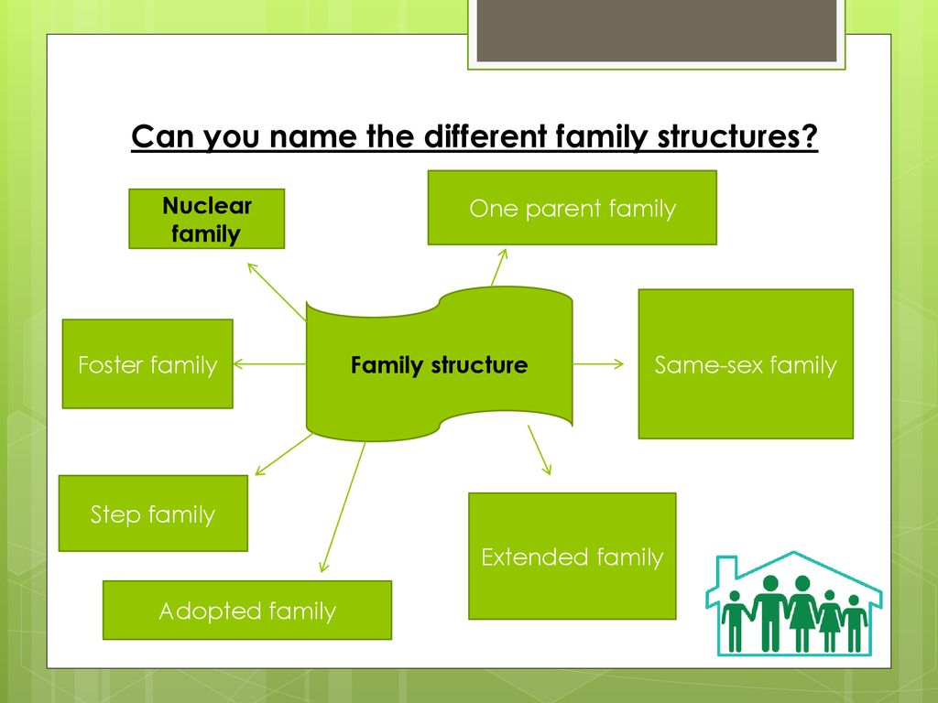
Image 1: (Knight, 2021)
Childhood experiences is different in various countries for example female genital mutilation is still being practiced in some countries like Gambia, Egypt and in the middle East, in comparison it is against the law in the United Kingdom, the practice is being carried out even if it has been described as a violation of the human rights of women and girls by the World health organisation (World Health Organization, 2020). Child prostitution and child sex tourism is prevalent in Thailand (Favre, 2020). The differences between this countries proves that childhood is a socially constructed concept, furthermore, comparing Yemen and the UK, the experiences of children are different, since children work from an early age, in Yemen 70% of children between the ages of 5 to 14 years work in agriculture. (US Department of Labour, 2018), are exposed to unsafe working conditions and recruited by armed groups (Lakrichi, 2020). In comparison to UK, school attendance of children is compulsory until the age of 16 years and children are expected to be in education or being trained until they turn 18 (GOV.UK, 2021). This demonstrates the differences and expectations of childhood in these two countries. Children getting married is a common phenomenon in some countries but in England and Wales marriage is legally possible from 16 years (Children's Commissioner, 2019) child sexual exploitation is prevalent in Thailand while it is against the law in the UK and is punishable by imprisonment (Crown Prosecution Service, 2017). Child marriage is also carried out in Cameroun (UNICEF, 2020)

The social construction of childhood has developed and passed through significant changes from historical times in comparison to the present day, for example the middle class multiplied during industrialisation and created a lasting system of class conflict (Muskato, 2019). For example, historically it is possible to isolate three different ways that children were viewed and treated in Europe. Theb16th and 17th century puritans believed that childhood was a time full of evil and wildness (Moran and Vinovskis, 1985), the idea of childhood being viewed as a blank slate was shaped by the ideas of John Locke between 1632 to 1704 (Duschinsky, 2012), the environment and education shaped children they are not good or evil. Childhood as a time of innocence was a rather romantic view that was guided by Jean-Jacques Rousseau’s ideas (1712-1778), children were viewed as innately good until they are corrupted by adults (Pranjal et al., 2021).

Differences in the lives of children in Greek and Roman times, medieval, Industrial revolution, and Victorian time.
During the Greek and Roman times, the mortality rate of infants was very high, being physically perfect was important and unwanted infants were left to die, children below seven stayed at home, the rich employed wet nurses, girls had to stay at home until they were about 15 years old to get married, male children were allowed to socialise with adult men and to learn trades like carpentry and building and rich boys from the age of 7 were educated (Dasen and Späth, 2010)
In the period of the industrial revolution of 1760-1830 factories and Mills employed children to work as cleaners, repairers, and waste cleaning especially because they were small and could fit in tight, small spaces. They were paid low wages, worked long hours, and were punished ruthlessly for mistakes made.
During the Victorian period (1837 – 1901), the population in Britain grew during this period and there was a gap between the rich and the poor, class distinction developed and the middle- and upper-class children led privileged lives with nannies and governesses caring for them. In contrast the poor children were exploited heavily, worked in factories, and became pickpockets and street scavengers. The population growth and deterioration in living conditions in the cities led to the introduction of health policies and legislation that set limits on age, working hours and education hours.

The major changes since Victorian times were changes in legislation, policy, also changes in sociological factors and the coming of child development and neuroscience. Some of the policies in England include legislation in connection with education, work, the health and safety of children and the UN convention on the rights of a child (UNCRC, 1991).
- The principal legislation that is associated to child labour and work that caused changes in the lives of children is the Factories Act of 1833 during the 19th century (The National Archives, 2019) The Act was responsible for abolishing the labour of children before their 9th birthday, currently the legislation in England states that children can take up part time employment from 13 years full employment from 16 years of age (GOV.UK, 2012)
This legislation that has an association with child labour protects children from abuse, harm and exploitation and ensures their education (UNICEF, 2021)

- Another important legislative contribution was the 1880 Education Act, through the Act, education became compulsory for children between 5 to 11years old. Currently in the UK, it is compulsory that children be in education up to their 16th birthday and in training until they turn 18 years (GOV.UK, 2021b). Education being made compulsory has positively improved the lives of children by taking them out of factories.
- The enactment of legislation that protects children from being harmed and abused for example the age of sexual consent fixed at 16 and the restriction of the sale of alcohol to children under 18 years. This has contributed to the improvement of the lives of children studies have found out that alcohol usage by teenagers can be harmful and can negatively affect their development according to the NHS (2021). The law aims to protect children from sexual abuse because according to ChildLine (2021) children under 16 have no capacity to give consent because it is against the law.
- The United Nations Convention on the Rights of the Child (UNCRC, 1991) has had a positive impact on children’s lives. This convention stipulates that every child Has the right to life, non-discrimination, education, to be protected from harm and all kinds of abuse and for a healthy development (Save the Children 2021)
- The advent of child development and neuroscience was also significant in the improvement of the lives of children. the advent of the discipline of child development promoted the significance of the provision of a good childhood to every child also by bringing to light the effect of negative childhood experiences on future development of children. Damage caused in the first five years of life can also affect the development of the child, studies through neuroscience have stated (Centre on the Developing Child at Harvard University) The disciplines of child development and neuroscience significantly contributed to the lives of children positively because it stated the importance of the provision of a good childhood to all children, coupled with a good environment and experiences.
- As a result of sociological factors parents now spend more time with their children because neuroscience and child development disciplines have stated the importance of a stimulating environment for child development. The effect of child development studies can be acknowledged in various services designed for children in the society, furthermore governments invest more financially on children than in the past and the NHS provides free care health care services.

A major theory that influenced child development was Bronfenbrenner’s ecological theory which stated that children were influenced by various factors that were external to their family. The five different systems in this theory are the micro system representing the child, the mesosystem relating to the family, teachers, nursery, play areas and the interconnectivity between them. The next system is the ecosystems which are people in the community, health services, friends, extended family members or relatives etc.

The theory of Abraham Maslow also had a major influence in the development of services for children and the family.


Image: 3 (Mcleod, 2020)

Maslow stated that for human beings to arrive at the stage of self-actualisation or full potential they had to pass through several stages in a hierarchical order, the theory is often depicted as a pyramid and the needs are:
- Physiological needs like food, water, warmth, clothing. Sexual reproduction was also included because of the necessity for the propagation of the human species.
- Safety and security needs such as protection from harm.
- Love and belonging needs such as having friends and relationships
- Esteem needs such as confidence in oneself, self-esteem, and respect from others.
- Self-actualisation relates to reaching one’s full potential and creativity (McLeod, 2020)

In the UK there are several welfare services that act in the interest of children such as child benefit, child tax credit, universal credit, free school meals, free childcare etc. Child benefit helps parents with the cost of raising children. The wages that most low-income families receive is not sufficient to cover the costs associated with raising children, therefore child benefit helps to bridge the gap (Citizens Advice Bureau, 2019). The provision of free school meals (GOV.UK, 2021a) has positive impact on the health, diet, and behaviour of children, it improves their concentration at school (Kitchen et al., 2010)
Other legislations and policies also assist in safeguarding and protecting children from abuse for example ‘Working Together to Safeguard Children A guide to inter-agency working to safeguard and promote the welfare of children’ (2018) this policy allows for a multiagency approach in intervening to protect children that are vulnerable and in need.
There are several interventions and policies to assist families and to support children. Some of the services available to children and families include universal services: these are services within the reach of everyone without the need for a referral, they include health visiting, GP, school nurse, community pharmacy, opticians, dentists, and sexual health services. Sexual health clinics for example give free and confidential sexual health advice for teenagers between the ages of 13-16 without the consent of parents some of the services are the treatment and testing of sexually transmitted diseases, free condoms, advice, contraception, and emergency contraception pills and pregnancy testing. (NHS, 2018)
Specific services are directed at children who at risk and children who are deemed to be at risk according to the Children Act 1989. Intervention is necessary for these children because they have specific and individual elements of vulnerability. For example, some of these children have parents that misuse substances like drugs or alcohol, suffer from mental health issues and have disabilities. Another targeted service also for children is the free school meals The free school meals is important to the development of the child because it supports the right of the child to food, furthermore the acquisition of this right supports the holistic development of the child, for example the physical or body function, emotionally it includes self-esteem and feelings and socially like interactions and relations with others and intellectually like the brain, memory, problem solving and concentration (Gloucestershire County Council, 2021). The model used to illustrate the different levels of children and young people's needs in Gloucestershire is referred as the windscreen of needs for children and young people (see Diagram 1: The Windscreen). It recognises that children, young people, and their families will have different levels of needs and that a family's needs may change over time.

Irrespective of the vast improvements in the lives of children over the years, the scourge of poverty and deprivation is still manifested in the daily lives of children in the UK, about 2.8 million children are believed to be living in poverty in the UK (Joseph Rowntree Foundation, 2018). There should be free school meals for all children (Perez, 2021) and free summer childcare for parents (Topping, 2021) the application of this recommendations will positively improve the lives and social construction of children.

.

