

University of Wales Trinity Saint David
School of Engineering

Plant Flow Diagrams and Pipe and Instrument Diagrams
Written by Joshua Hadden
Student Number: 2206081
Engineering Management
Date Written: 10/07/2024
Module Name: Plant Operations & Performance
Module Code: ACMA4007

Table of Contents
Table of Acronyms 1
Table of Figures 1
Introduction 2
Understanding P&ID’s 3
P&ID of a Sprayer Process 5
Commissioning 7
Health and Safety 8
Bibliography 10
Appendices 11
Appendix 1 – P&ID Sprayer Machine 11
Appendix 2 – Full A0 Poster 12

Table of Acronyms
Acronym | Definition
P&ID | Piping and Instrumentation Diagram
PCB | Printed Circuit Board
UV | Ultraviolet
CPU | Central Processing Unit
HMI | Human Machine Interface
SPC | Statistical Process Control
KPI | Key Performance Indicator
SOP | Standard Operating Procedure
COSHH | Control of Substances Hazardous to Health
PPE | Personal Protective Equipment

Table of Figures
Figure 1 - Table Defining P&ID Component Markings 3
Figure 2 - Piping / Resource Transport Symbols 4
Figure 3 - P&ID of a Sprayer Process 5
Figure 4 - COSHH Symbols 8

Introduction
Piping and instrumentation diagrams (P&ID’s) are a brilliant tool adopted by manufacturing and other types of plants internationally. They are diagrams designed to provide a layout of a process, and detail the components used to manipulate resources from the input stage to the desired output stage.
Throughout this report, a sprayer process will be used to describe the intricacies of P&ID’s. The sprayer process inputs a sprayer liquid (undefined for confidentiality purposes), which is used to coat printed circuit boards (PCB’s), the liquid material is placed into an ultraviolet (UV) oven which triggers a chemical reaction, solidifying the material. The coating is applied to mask the components used in the development of the PCB boards, thus rendering the products redundant in the event a competitor attempts to dissect the technology.
The sprayer process is an ideal manufacturing process to demonstrate a P&ID, the system uses a central processing unit (CPU) to control a closed loop system, which regulates the inputted material and airflow to achieve the desired references inputted to a human machine interface (HMI).
Additionally, a pneumatic line is fitted to the process, and used to atomise the sprayer material. This ensures the material is separated to a particular level and encourages a consistent coating of the material onto the desired PCB.
After the above process is designed, a plan to have it officially commissioned and integrated to replace the redundant manual process of censoring PCB’s will be highlighted below. The purpose of an efficient commissioning process is to minimize risk regarding safety, efficiency, cost and quality, each of these aspects will be further addressed.
After the process has been installed and implemented, a mature plant ensures the process is standardized, well documented, and controlled. This is achieved via tools such as statistical process control (SPC), key performance indicators (KPI’s) and standard operating procedures (SOP’s). The machinery will degrade over time due to the laws of entropy, therefore planned preventative maintenance (PPM’s) will be developed on a router to ensure all machinery is kept safe and up to date (Accurate Mechanical Services, 2021).

Understanding P&ID’s
A P&ID is derived from several symbols and annotations which follow a standardized structure to ensure consistency from company to company. ISO14617-6 is the standard of graphical diagrams which classifies the symbols that should be used to depicts the symbols used to describe things such as piping / connections, actuators, valves, pumps and other mechanical components that are required in a P&ID (Wikipedia, 2022). ISA S5.1 is a derivative of the ISO standard of graphical diagrams and is a more user-friendly reference for P&ID engineers.
(ISO 14617-1:2005(E), 2005)
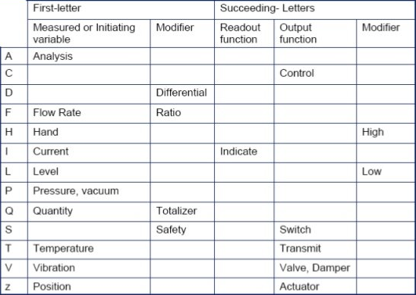
Figure 1 - Table Defining P&ID Component Markings
Figure 1 is an extract of data from ISA S5.1, which supports in the analysis of the components listed in a P&ID diagram. Most Components will have two or three letters, the first letter is denoted with the first two columns, the second and third letter is derived from the remaining columns. For example, a component listed as FT would stand for ‘Flow Rate Transmit’, this would be a device that transmits the rate of flow of a resource being transported through a pipe.
(Wikipedia, 2024)
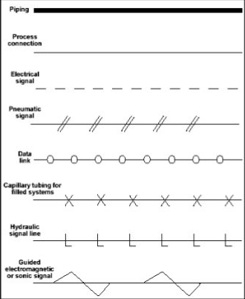
Figure 2 - Piping / Resource Transport Symbols
Figure 2 describes the resources that can be transported around P&ID systems. Most factories have resources such as electricity, pneumatic lines and hydraulic lines; some processes may also utilise the flow of data, radio waves and ultrasonic connections.

P&ID of a Sprayer Process
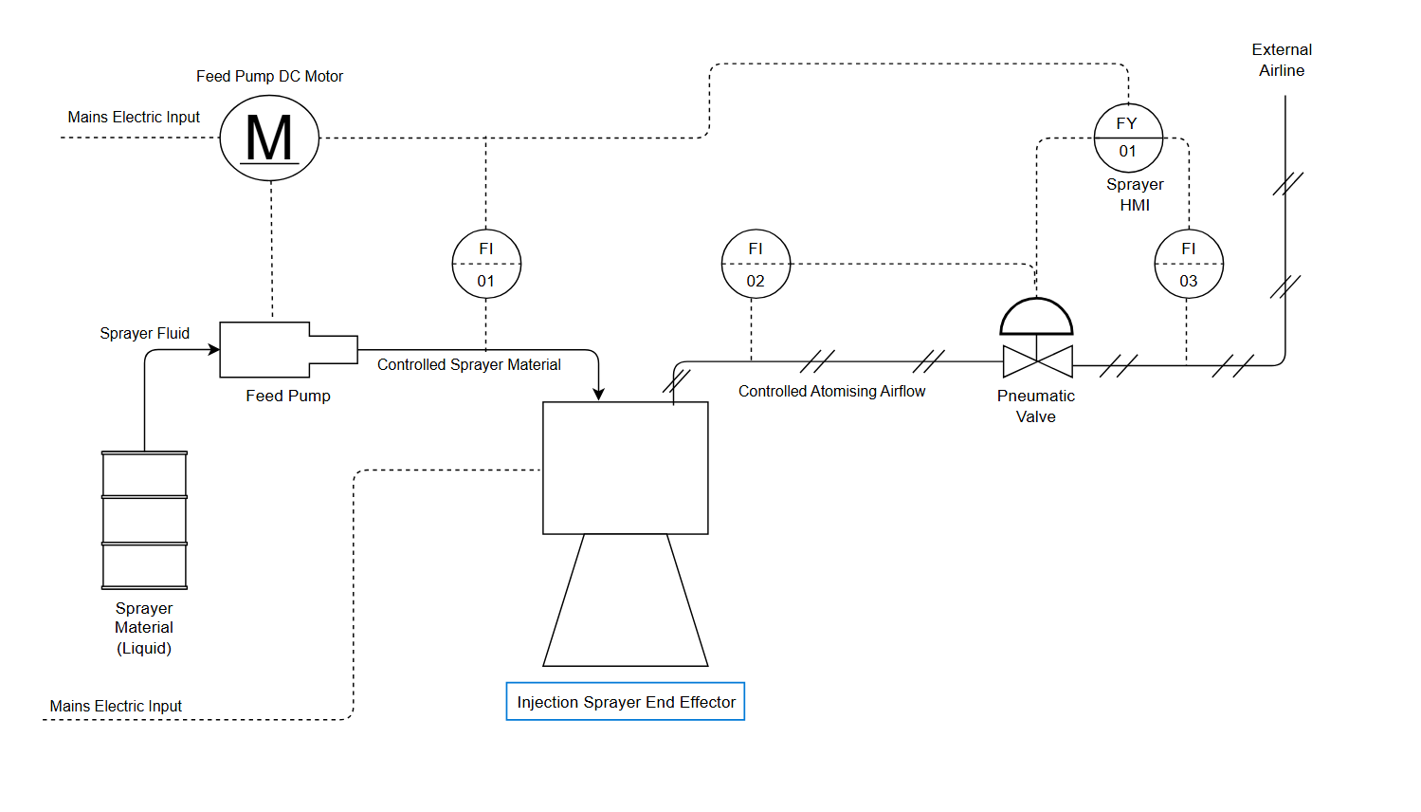
Figure 3 - P&ID of a Sprayer Process
Figure 3 is a P&ID of a Viasat process, in which a liquid (undefined for confidentiality) in a liquid form is atomised and sprayed onto PCB boards, with the purpose of censoring the mechanical circuits on the PCB boards to protect the technology from competitors. This process is delicate and requires a defined quantity of fluid to be sprayed onto each product.
There are two inputs into this process, electricity and pneumatics. The electricity is used to power the electrical components, such as the DC motor and the sprayer end effector tool. The pneumatic line is inputted directly into the sprayer end effector tool, and the function is to atomise the material, this is achieved by providing a positive pressure to the material as it is injected from the end effector, that separates the particles and results in an even spread of the material.
The electrical mains enter the circuit in two locations, the first is executed into a DC motor. This motor is powered by a 215V power supply and operates the rotation of a ‘feed pump’. The feed pump channels the fluid passing through it, and the fluid must pass through a thread, the thread rotates and transports the material through it, by controlling the number of rotations, and understanding the area of the internal thread space, it is possible to accurately define the amount of fluid passing through the feed pump accurately.
There are two variables that must be accounted regarding the fluid, the quantity and the rate of flow. The rate of flow defined in the internal procedure for this process is 0.5ml per second. After feed pump, there is a symbol connected to the sprayer material pipe via an electrical connection denoted as ‘FI-1’. When comparing this symbol to figure 1, FI is defined as ‘flow rate indicator’; the ‘1’ is traceability for which element this is referring to. The purpose of this component is to measure the rate of flow passing from the pump to the injector sprayer end effector. Note that the symbol has a dashed line through the centre of it, this means the device is not accessible via normal means. The reason for this, is that the element that detects the flow rate is inside a robot.
The FI-1 element that measures the flow rate of the sprayer material is connected via an electrical signal to the motor that controls the feed pump. If the flow rate is too high, the speed of the pump is reduced, if the flow rate is too low the opposite effect takes place. Note that in addition to a connection to the motor, there is also an electrical connection FY-1. FY-1 is a HMI that controls the input variables for the flow rate, and fluid quantities. It also controls the flow rate of the pneumatic line and ensures the result is as it should be, there are therefore data bus lines interconnecting all the gauges which are controlled from a localised CPU within the robot.
The second input resource into this P&ID is the pneumatic line referenced above, denoted by the checkered line entering the right of the diagram. FI-3 is connected to the pipe via an electrical signal, the indicator gauge is connected to the logic program which compares the data to a reference inputted by the operator, and the electrical signal is connected to a pneumatic gauge. The gauge is opened or closed to regulate the pressure passing that point. Note there is an additional check for the pressure via FI-2, this data feeds back to the same circuit and control the previous valve, in the event of a misreading through FI-2, FY-1 is programmed to notify the operator of this process and warn them there is an issue with the pneumatic line, with the root cause likely being related to the pneumatic valve.
The injector sprayer end effector is a tool attached to a robotic arm and is powered directly from the electrical mains. This process is simplistic and is a part of a larger system.

Commissioning
Commissioning is process defined in plants and factories to ensure new processes work as intended, but also work safely. There are often many variables at play, and approaching this task in a methodical way can ensure minimum risk is encountered.
For this purpose, the first stage in any commissioning project is planning. This would involve consulting any standards / regulations related to the project being commissioning, designing any drawing for processes and P&ID’s etc, defining budgets, deadlines, teams etc.
After the planning stage has been completed, the materials defined in the previous process is purchased, and contractors will install these materials in accordance with the drawings developed in the planning stage. Once the mechanical completion phase of the commissioning project has been completed, the factory should look like a factory.
The third process can be defined as P&ID checking, and essentially involves a full quality check to ensure the P&ID’s have been followed through to completion, the components ordered are correct, and executed to the correct locations, and the theory matches the practical.
Once the inspections have been completed, the processes can undergo their first functional check. All the processes are powered on, and the transportation of resources are monitored, the gauges are inspected, and any issues with the process are defined and resolved.
A pre-commissioning phase is undertaken once the functional checks have been completed. Resources are fed into the process in a very small quantity, and very slowly fed through the process one stage at a time with experts from all departments monitoring each stage closely.
Once it has been confirmed that the plant can achieve its desired goal, the commissioning state is undertaken. The plant becomes fully operational, but targets and high efficiency goals are not yet set. The processes will operate as intended when the factory is in full swing, processes are developed, process operators are trained, potential failure modes are identified and countermeasures are put in place, and final products are vigorously inspected to ensure they are in accordance with customer specifications and regulatory requirements.
After the commissioning stage the factory is officially ‘started-up’. Continuous improvement truly begins, targets are set in accordance with trials run during the commissioning stage, all processes operate in parallel with each other, and full accountability is taken for each process owner.
After the start up stage, continuous performance testing is undertaken to ensure the plant is working as intended and processes are not failing. The plant enters a ‘post-commissioning’ state which perpetuates the never-ending entropy of continuous improvement and preventive maintenance. Potential improvements are identified, the processes are intermittently inspected to ensure they are working as intended etc.
(Banyards, 2024)

Health and Safety
It is essential the health and safety of employees is put before anything else. Figure 3 outlines a process developed, there are several standards and regulations to consider regarding this process.
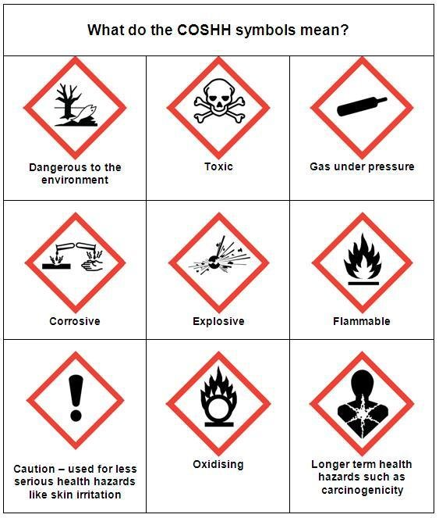
Figure 4 - COSHH Symbols
Control of substances hazardous to health (COSHH) is the first standard to consider. The sprayer fluid has been identified as a hazardous material. Regarding figure 4, the symbols for ‘dangerous to the environment’, ‘toxic’ and ‘flammable’ have been highlighted. A risk assessment has been completed by Viasat’s health and safety engineer; the risk assessment proactively considers the potential ways in which an employee may be harmed when completing a process and measures the likelihood of the accident with the severity of the occurrence.
The ’dangerous to the environment’ warning is considered a low likelihood because there is no material entering any kind of drainage system from the plant. The only potential for the material to access the environment is via the disposal of the empty containers, however Viasat has a contract with an environmental waste management company that collects high risk materials and disposes of them professionally.
The material can be toxic if consumed. This is a high severity as high consumption can result in death; however, this is mitigated with personal protective equipment (PPE). Employees are instructed to wear a mask and disposable gloves when operating this process to reduce the risk of accidental consumption.
The material is also labelled as flammable. A fire extinguisher is always kept in the room, and when not in use the material is kept is a locked COSHH cupboard. There are no processes involving open flames around the material, to the likelihood of the material catching fire is very low. The room in which the material is kept is fitted with sprinklers and fire alarms, and the material is feed from a fireproof bottle directly into the pipes of the process it is involved in.
(British Safety Council, 2024)

Bibliography
Accurate Mechanical Services. (2021). What is Planned Preventative Maintenance (PPM)? Accurate Mechanical Services. https://ams.limited/what-is-planned-preventative-maintenance-ppm/
Banyards. (2024). Commissioning Management. Banyards.
British Safety Council. (2024). What is COSHH? Everything you need to know. British Safety Council.
ISO 14617-1:2005(E) (2005). https://cdn.standards.iteh.ai/samples/41838/3bdf620c00c841c5bb0628e97e4b8592/ISO-14617-1-2005.pdf
Wikipedia. (2022, May 20). ISO 14617. Wikipedia. https://en.wikipedia.org/wiki/ISO_14617
Wikipedia. (2024, July 11). Piping and instrumentation diagram. Wikipedia. https://en.wikipedia.org/wiki/Piping_and_instrumentation_diagram

Appendices

Appendix 1 – P&ID Sprayer Machine

Appendix 2 – Full A0 Poster
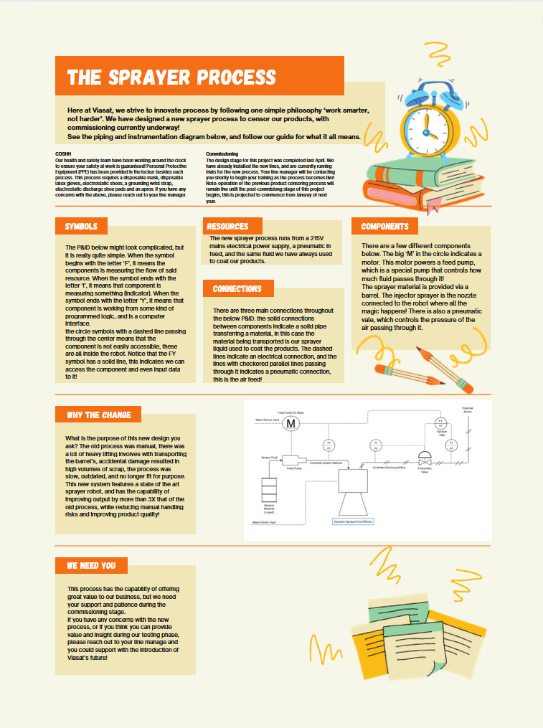
Note: The poster has been downsized for legibility within this report.

