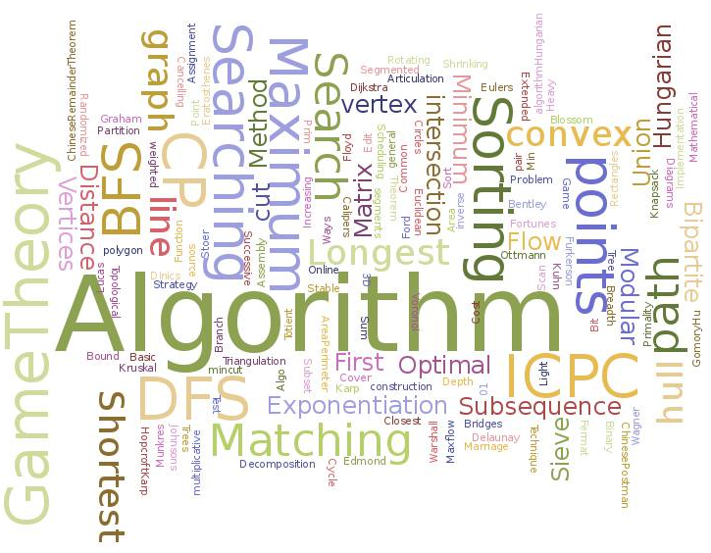

Assignment Title – Algorithms and Data Structures
Module – OOP and Advanced Software Development (Algorithms)
Module Code – ACCA5032
Student Name - Michelle Chalmers
Student Number - 1809316

Contents
PART A 2
1. Arrays vs. Linked Lists 2
1.1 Arrays 2
1.2 Linked Lists 2
1.3 How they compare 3
1.4 Which to Use 4
2. The Hybrid 4
2.1 If the lists are not equal 5
3. Binary Search Tree (BST) 6
3.1 The Balanced Tree 7
PART B 8
1. Djkstra’s Algorithm 8
PART C 12
The Minimax algorithm 12
Table of Figures 13

PART A

1. Arrays vs. Linked Lists

1.1 Arrays
An array stores elements in fixed memory locations. These are associated, or next to each other (contiguous), so are easily located with no need for further referencing. Arrays are a rigid structure as the indices are fixed. There has to be enough memory locations reserved when creating the array to allow for all anticipated data. But you cannot create an over large array ‘just in case’, as this would allocate memory without necessarily making actual use of the memory.
Adding or deleting data if you want to keep the array in an order, requires changing the whole array as elements will need to be moved. This is costly as you need to create space for the new element by moving the other elements. For instance if you wanted to add number 300 into list containing:
100, 150, 200, 250, 350, 400, 450…….up to 10,000 in steps of 50
You would need to move all of the elements after 250.
The same problem is encountered when removing an element. If you removed number 200 from the above list you would have to move all elements from 250.
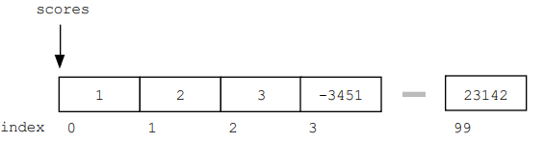 [1]
Figure 1 100 element array has fixed points in memory

1.2 Linked Lists
These are not a rigid structure but dynamic, containing nodes which are linked and are in no set order. This does mean though that in order to locate elements each one needs to have an address, so each element has a tag pointing to the next element. This uses memory above what an array would require.
The size of a linked list is not fixed and elements can be added and removed with ease.
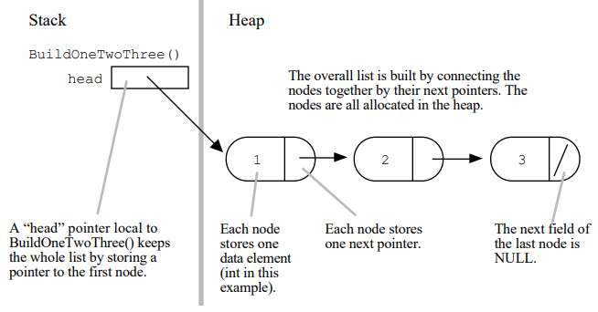 [1]
Figure 2 A linked list creation – elements contain a pointer to the next

1.3 How they compare

SIZE
Array is a fixed size so creation needs to be well planned, considering potential future changes in requirements.
Linked lists are dynamic, but will need more memory due to the tags/pointers on each element.
MEMORY
A well designed array will use minimal memory as the elements do not need to be located. However, an array built with room for expansion will be using memory for elements that do not exist yet.
As the linked list requires pointers on each element it will be, in theory, larger than the well designed array. However, where the actual amount of elements is not definite the dynamic linked list may be more efficient as extra memory does not need to be allocated to accommodate possible changes.
ACCESSING DATA
As elements in an array are indexed, accessing the data is fast as you go direct.
Data in a linked list has to be accessed in a series – you have to move to each element to find the location of the next – so data retrieval is slower.
ADDING/REMOVING ELEMENTS
Changing an array size is time consuming.
Dynamic linked lists grow and shrink easily.

1.4 Which to Use
If the number of elements is not going to change much, an array is better suited as it is faster than a linked list.
The down side is the rigid structure.
Where there is likely to be a frequent need to add or remove elements, a linked list is more suitable.
The downside is the need for more memory and slower data retrieval.

2. The Hybrid
In a situation where 1,000s of new entries are being added every day, which is more suitable?
The linked list is more suitable than an array:
- Arrays are not well suited to data being added/removed
- Arrays are not ideal when the amount of data will expand or contract
- A linked list is dynamic and easily handles data being added/removed
If the list was not being amended often, an array would be better as it indexes the entries allowing for faster searches, uses less memory than a list, and utilises local caching to further improve performance.
However a better option is the hybrid data structure as it uses the best of both:
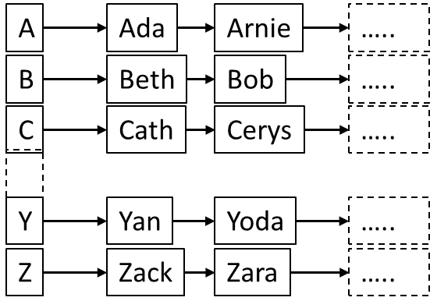
The array has an element for each letter of the alphabet.
The element contains the linked list of the names starting with that letter.
When adding/removing/searching the initial search is for the first letter of the name, which passes into the linked list for that letter.
If this was just an array the search would be fast and memory usage low, but the maintenance of the data would be costly.
If it was just a linked list the search would be very slow, having to step through 1,000s of nodes to locate the correct one.
In the hybrid structure the search, assuming that each element of the array contains an equal number of names, would be searching just 1/26th of the data as the linked list search.

2.1 If the lists are not equal
The above assumes that the list in each element contains the same number of names. But this will not be true as some letters are more commonly seen in names, and some are rare – there aren’t many names starting with X or Z in the UK for instance. There are also some names that were or are common:
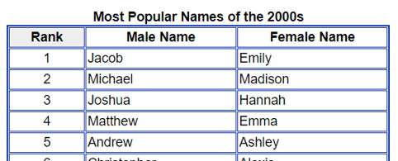
Figure 3 Common Names (http://www.baby2see.com/names/2000s.html)
There are reports indicating that the most common name in the world is Mohammed and there are many global name lists that back this up, so it’s fair to assume that it will appear in our list frequently. It will not be the only name seen frequently though.
How will the hybrid structure perform if it’s only divided into 26 array elements?
Taking the letter M as the example and assuming all other elements are balanced, searches that are not for M will be normal, but searches on M will be slower. This could be further compounded if other popular names also start with M – Michael and Maria are still popular in the UK for example.
We could restructure the array to better reflect the balance of data. If we initially consider what data we may expect we could create more suitable array elements:
- Combine rarely used letters, such as Q X Y and Z, into one element
- Research the most common names and give these their own array element
- If one letter is equally popular across genders we could separate the letter into genders
- Where a letter has a lot of entries, use the second letter of the name. The letter M could be in 2 elements where the second factor is A to M or N to Z as the second letter of the name.
How you can create a better structure depends on what actual data is being presented, and in what volume. But if this structure does not age well (over decades the popularity of names change), you can restructure the array over the 20 to 30 elements at significantly less cost than trying to run this as one big array.

3. Binary Search Tree (BST)
Tree construction for 34, 6, 7, 18, 45, 23, 3, 26 (using 34 as the top node).
㉞
⑥ ㊺
③ ⑦
⑱
⑫ ㉖
Figure 4 Binary Tree

BST attributes:
- Each node has a parent and/or child relationship
- The top node is the main or top-level node
- A parent node does not have to have a child node but can have a maximum of two
- Nodes on the left of the subtree have a lower value than their parent
- Nodes on the right of the subtree have a higher value than their parent
- There are no duplicate nodes

3.1 The Balanced Tree
A balanced BST speeds up a search. For instance a search for the value 12 in the above tree:
- Top-level node is >12, so you will be searching only the left of the tree
- Next node is 6 which is < 12 , so you will be looking to the right of 6
- Next node is 18 which is > 12 so you will look to the left of 18
- Node = 12 so the search ends after 4 steps
By having these simple conditions the search only needs to run through 4 steps rather than trying to search all the data.
In a balanced tree there should be only one level of difference between the left and right sub trees, both of which must also be balanced. The tree above is therefore not balanced.
In a large tree with many nodes it needs to be balanced as a tree that has an approximate 50/50 split left to right will be faster to search. If the tree has an 80/20 split left to right any searches on the larger side will take longer to return a value than a search on the smaller side.
This is a balanced tree using the same values as above. In this case the maximum number of steps to complete a search is 3 steps (searching for value 7).

This is the correct tree for these values.

⑱
⑫ ㉞
⑥ ㉖ ㊺
③ ⑦
Figure 5 Balanced Binary Tree
If you have an unbalanced tree there are algorithms that can help. Commonly used are ‘red black trees’ and ‘AVL trees’, which will force the tree to balance.

PART B

1. Djkstra’s Algorithm
Created by Edsger Dijkstra this is an iterative graph search algorithm. The graph vertices are nodes, and the edge path is the value between the two nodes (such as miles between point A and point B).
The algorithm looks at every option and point in order to find the shortest route between the start and end nodes. It’s therefore regarded as a greedy search and is processor heavy.

In this scenario you have item A and wish to trade and pay in order to get item F:
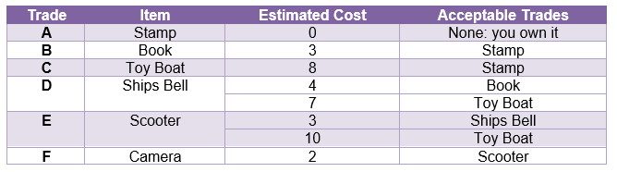
It is not immediately obvious which is going to the cheapest way to do this – the shortest path to complete the transaction. There is more than one route to the end point as there are several swap options.
We can start with a directed graph in order to visualize all the options:

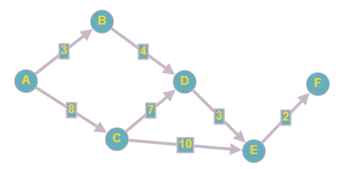
Figure 6 The directed graph

From here we can create an adjacency matrix:
Now calculate the costs, one vertex at a time:
Start by setting all vertices to ∞ (infinity).
A is adjacent to B and C.
A = 0, B = 3, C = 8.
B is looked at next as it is the lower cost.
B is adjacent to A and D – we are looking to see if the cost through B is smaller than the previous known cost.
D was previously ∞ so the new cost is lower @ 7 (4+3).
D is looked at next as the cost is less than C.
D is adjacent to E (C does not count due to direction) - we are looking to see if the cost through D is smaller than the previous known cost.
E was previously ∞ so the new cost is 10 (3+7).
C is now the lowest cost.
C is adjacent to D and E - we are looking to see if the cost through C is smaller than the previous known cost.
D was previously 7 – this new route costs 15 (7+8) so does not replace 7.
E was previously 10 – this new route costs 18 (10+8) so does not replace 10.
E is the last node to calculate.
E is adjacent to F which has a value of ∞
Therefore the shortest path from A to F = 12 (2 + 10 (the previous calculation of E))

This can be more easily seen in a distance matrix:
Figure 7 Distance Matrix

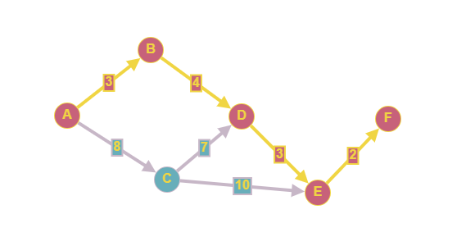
Figure 8 Shortest path length is 12: A⇒B⇒D⇒E⇒F
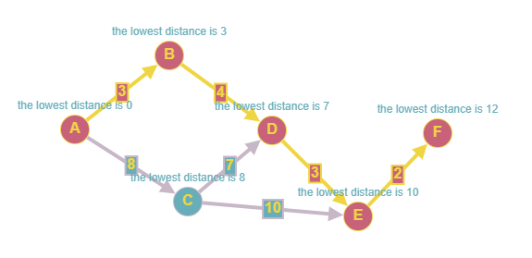
Figure 9 Directed graph showing costs

PART C

The Minimax algorithm
The minimax algorithm is used in 2 player games with a computer/AI. In order for the AI to calculate how to win, it evaluates the possible moves.
It looks at all of the possible moves that can be made in order to calculate the next best move, using a game tree. The tree will contain 1,000s of potential moves and outcomes as the AI does not look at the next 2 or 3 potential moves, as a person would, it looks at every potential move until the game end.
It always assumes that both players are playing optimally.
Using tic-tac-toe as an example, the game tree will include:
- Board state – where are the current O’s and X’s
- The player to make the next move
- The next possible moves
- The game state – a combination of all the above

AI uses a scoring system to evaluate its next move:
- Win = 1 any move with a positive outcome
- Draw = 0 any move that does not impact the outcome
- Lose = -1 any move that has a negative outcome
These scores are for the move, not the whole game. Each move is calculated to have one of these three outcomes.
It uses the tree to calculate the outcomes of all of the next possible moves, moving backwards from the desirable outcome to choose the best route to get there.
Final game states are ranked as a win, draw or loss.
Ongoing game states are classed as:
If its X’s turn to move, take the move with the MAXimum score
If it’s O’s turn to move the aim should be the MINImum score and X should avoid it
This is only suitable for ‘games of perfect information’. That is games such as chess or tic-tac-toe where the moves are predictable. It cannot be used for unpredictable games such as scrabble.

Table of Figures
Figure 1 100 element array has fixed points in memory 2
Figure 2 A linked list creation – elements contain a pointer to the next 3
Figure 3 Common Names (http://www.baby2see.com/names/2000s.html) 5
Figure 4 Binary Tree 6
Figure 5 Balanced Binary Tree 8
Figure 6 The directed graph 9
Figure 7 Distance Matrix 11
Figure 8 Shortest path length is 12: A⇒B⇒D⇒E⇒F 11
Figure 9 Directed graph showing costs 12

