Concrete and steel frame Buildings -Compare and contrast The Jade and NO1 Deansgate
Elliott Lewis

Table of Contents
Introduction 3
The Jade 3
Design and planning 4
Site Area 4
MRT Line 5
Design conclusion 5
Construction 6
Social Impact 7
Environmental Impact 7
NO 1 Deansgate 8
Design and planning 9
Construction conclusion 9
Social Impact 10
Environmental impact 10
Framing material analysis 11
Durability and climatic resistance 11
Production Process 12
Assembly 13
Adaptation 13
Life cycle 13
Conclusion 14
References 14

Introduction

This report will study two habitable building and evaluate research on their construction method, framing material, sustainability factors and site-specific considerations relevant to two chosen case studies

The Jade

Project Data
Site Area | 8705.5 mᶟ
Building Area | 1735 mᶟ
Total Floor Area | 30489.25 mᶟ
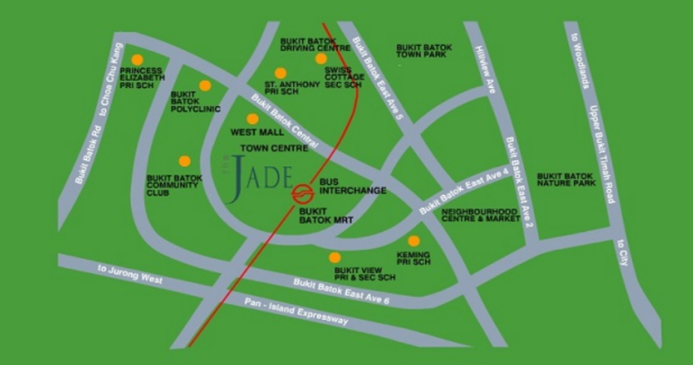
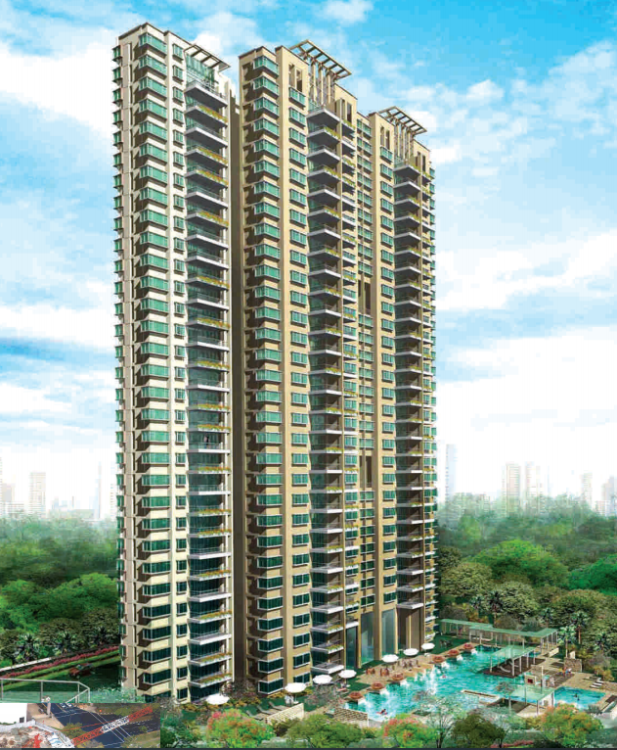
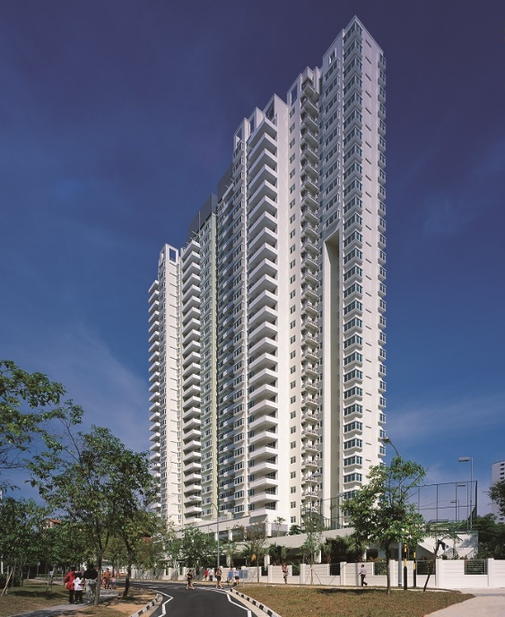
The Jade is located in the heart of Bukit Batok Central in Singapore (see figure?) The residential building consists of 31stories with one basement and houses 280 units (Sim Lian Group Limited, no date) The project was completed in 2002 and took 29 months to construct by Sim Lian Construction. The structure is concrete framed and 120m in height costing $43.4 million.

Design and planning

During the pre-construction phase there were several site-specific constraints that needed to be consider in the final design. Due to the site area being small this restricted the amount of available working space. Also, the site being in proximity of the MRT line was another significant factor to account for. The ground investigation revealed the earth below the site was mostly made up of bedrock and as a result the basement design was to be a flat concrete slab supported on piles in the same way as the residential blocks were all to be founded on piles.

Site Area

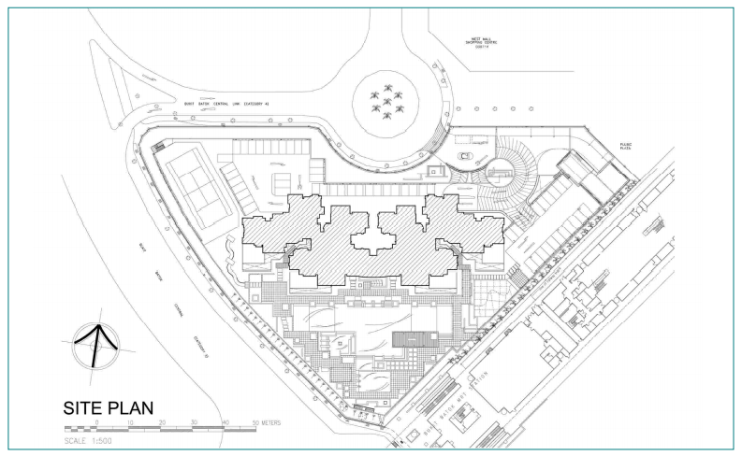
Due to the site constraints regarding limited working space, there are several importuning considerations before progressing on the construction stage. Plant and vehicle size may be compromised and balancing that with site safety as do not want a larger number of smaller vehicles moving around the site constantly. The maximum amount of material that can physically be delivered or removed from the site also needs to be understood in detail so the programme and design can accurately reflect the sites specific constraints (Mace Group, 2016). The design and planning stage also needed to consider things like where the 2 tower cranes were going to be positioned and how were they going to utilise the use of prefabricated components. Offsite preassembly not only saves times it reduces the number of deliveries needed to site. Also, from health and safety perspective production in a controlled factory environment is saver than being on site especially one with limited working space and at significant height.

MRT Line

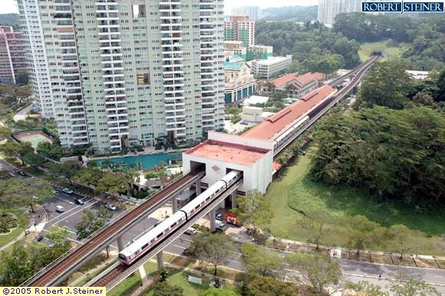
The site is extremely close to the MRT station which meant the design had to accommodate strict restrictions and criteria set by the Land transport authority (LTA). The tower cranes that would be needed for the construction of the building were not allowed to tower over the MRT station for obvious safety reasons which resulted in several restrictions regarding crane usage and boom length during the works. As piles were used to support the structure during installation of the piles and the construction process monitoring devices were installed to ensure that the MRT structures were not affected by vibrations. The MRT line is regularly used and therefore public safety was also an important factor to account for.

Design conclusion

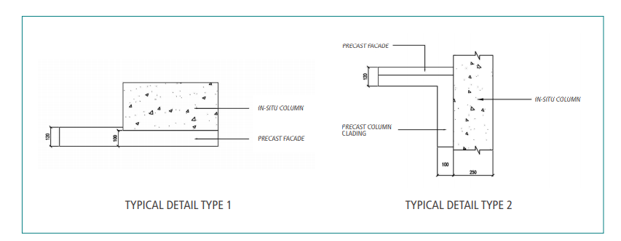
Due to the sites specific needs the decision was made that the combined use of cast in-situ columns with non-load-bearing precast facades as the external envelope of the building would the chosen construction method. This was analysed and found to be the best method as the precast facades could help achieve a better-quality wall finish (see figure?). Precast concrete facades can incorporate a variety of colours textures and finish making them a very flexible material and popular design choice (Architectural precast innovations, INC. 2021) The facades were non load bearing and designed not only to act the final finish but also as forms for cast in situ columns eliminating the need for framework.

Construction

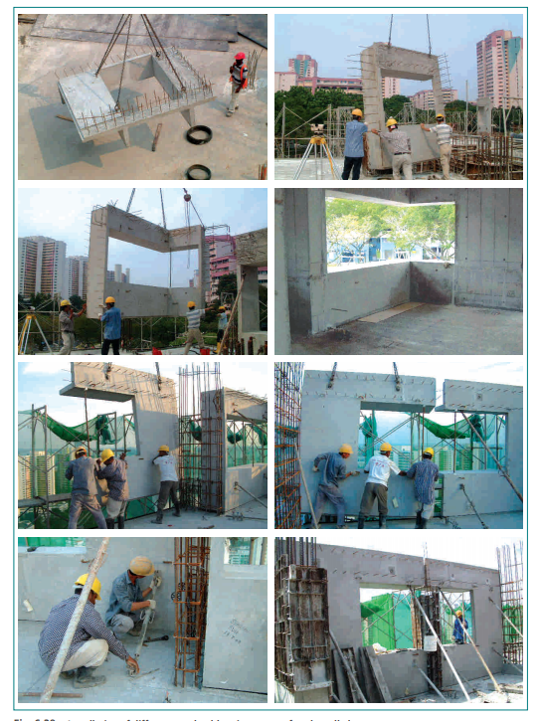
Metal shuttering was used for the in-situ casting of the simpler component such as the flat wall panels and columns. The prefabricated façade panels that were cast off-site and delivered to site when required. The precast facades weighed around 4.5 tonnes and the build required 2 tower cranes which due to being in proximity of the MRT line could only be above the completed structure by two floors.

Social Impact

Due to its location a quick timescale is very important to reduce the impact to a busy area especially being in the proximity it is to the MRT line which is frequently used by the public. The use of precast facades as integrated formwork for cast in-situ columns had also reduced the construction time thereby achieving higher productivity and quality for the project. The layout plan was kept simple and floor heights were repeated to facilitate the use of precast elements. Prefabricated components such as precast refuse chutes and precast staircases were also used. This also helped limit the noise and speed up the construction process.

Environmental Impact

Singapore’s green space plan sumps up their environmental conscience and how they plan to reduce emissions and be a more sustainable. Singapore has ambitions to have 80% of its buildings achieve Green Mark Certification by 2030. Green mark certification is a certification that represents sustainable development and quality living for its residents. One of Singapore’s most recognisable structure, Marina Bay Sands, embodies this vision and is a testament and true monument to environmental sustainability (Visit Singapore, 2021)
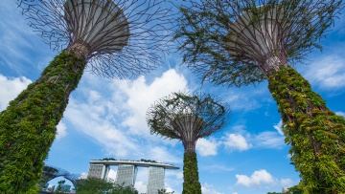

NO 1 Deansgate

No1 Deansgate is in Central Manchester (see figure?). The steel residential building was completed in 2002 and designed by Simpsonhaugh and Partners. The development was part of the areas redevelopment after the IRA bombing in 1996. The 60 metres high building has 14 floors which consists of 84 apartments also containing 8 penthouses. The apartments are above a retail level 16 metres high.
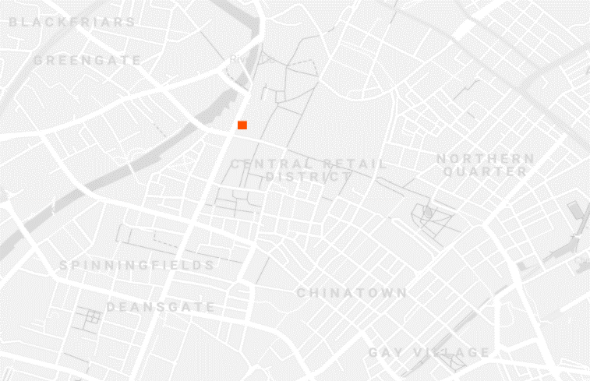
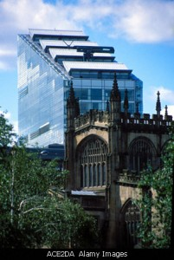
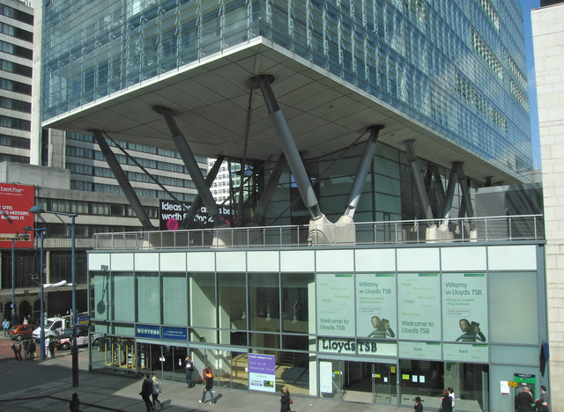
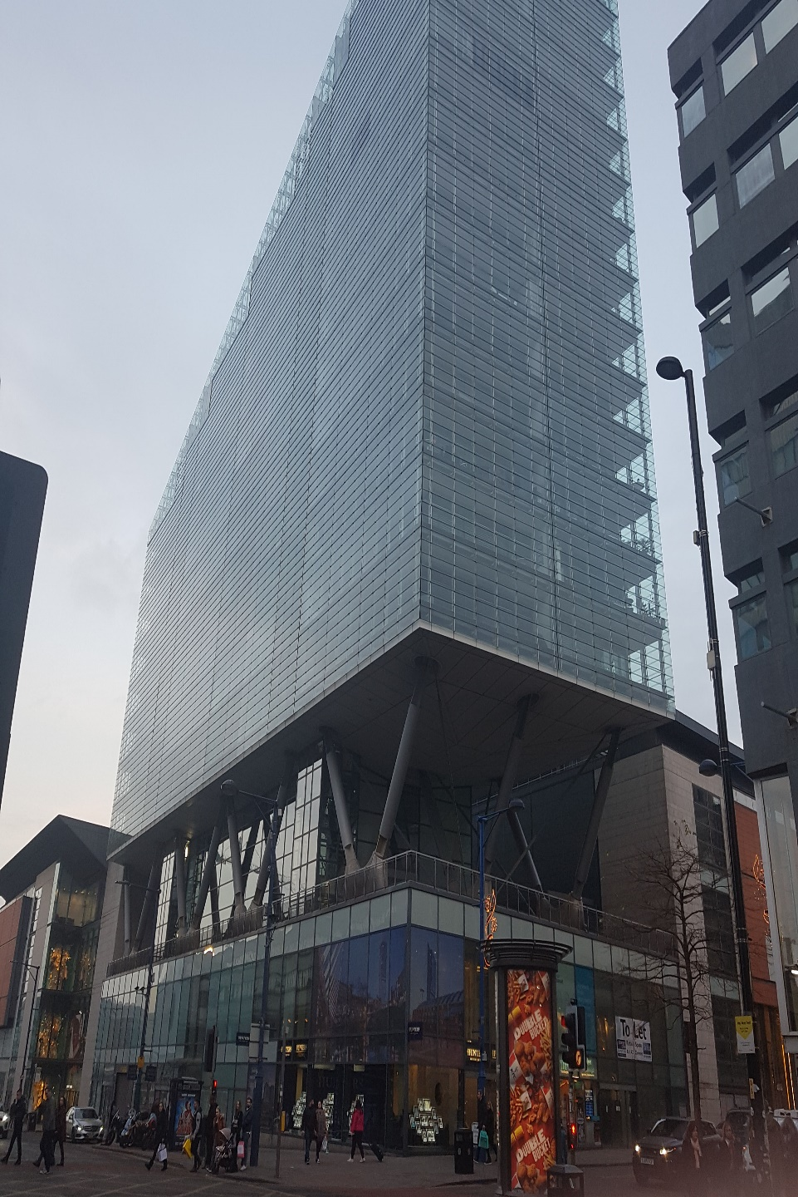

Project Data
Total Floor Area | 18700 mᶟ

Design and planning

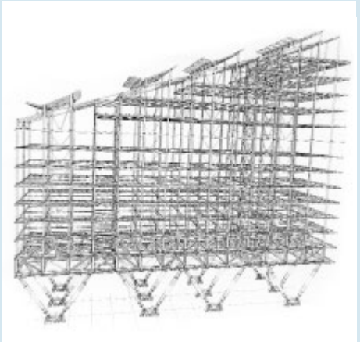
The main constraint with this project was the location as it is in the city centre and therefore minimal impact and a quick programme is vital to limit the amount of disruption caused. This project took full advantages of the design opportunities steel construction can provide and subsequently were able to construct in initiative lightweight mixed commercial and residential building. The Building uses existing foundations where possible again reducing the need for further groundworks. The open podium structure allows for pedestrian circulation below the residential block. The building is an iconic and instantly recognisable building within the city and achieved this by its unique crystalline prismatic form of the residential floors supported on a series of dramatic inclined steel columns (Simpsonhaugh 2021) A innovative temporary platform was developed to allow for the floor beams to be erected quickly and safely and was raised each time the build progressed.

Construction conclusion

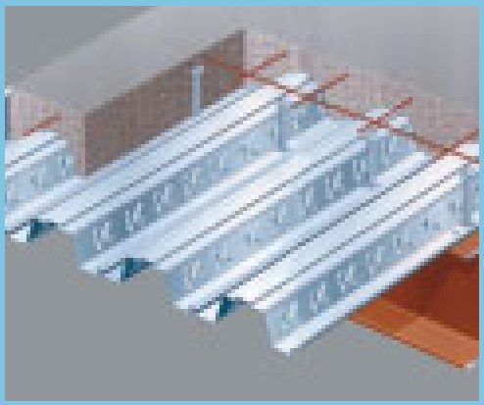
The uppers floors were roughly 60 meters by 17 meters and were formed using a regular steel structure in which a 4.1 meter span composite slab was supported by a 6.8 meter span composite beams using 203 mm UC sections that were perforated for services installation. The 165mm thick composite slab used Ribdek 80 decking finished with 40mm of screed (see figure?). At 16 Metre above ground level the upper residential block sits on a 1 storey steel transfers structure which reduces the wider grid of the retail area below to the sensible residential grid. This is achieved by two directional trusses supported by incline tubular legs. The longitudinal transfer structure was erected as large, braced sections fabricated from UC sections and cruciform from 40mm steel plate. The structure used 800 tonnes of steel to construct

Social Impact

The aesthetic of the simple form the residential tower resembles relates in scale to the surround tall buildings in the area strengthening the dramatic long views down this major route through the city and framing the view of the Cathedral further north along Deansgate. The height of the residential tower steps down from its highest point on St Mary’s Gate to relate to the Cathedral and to acknowledge and respect the variety of the building heights in the surrounding context. The buildings orientation helps fill it with light and the sloping roof provides penthouses with open terraces.
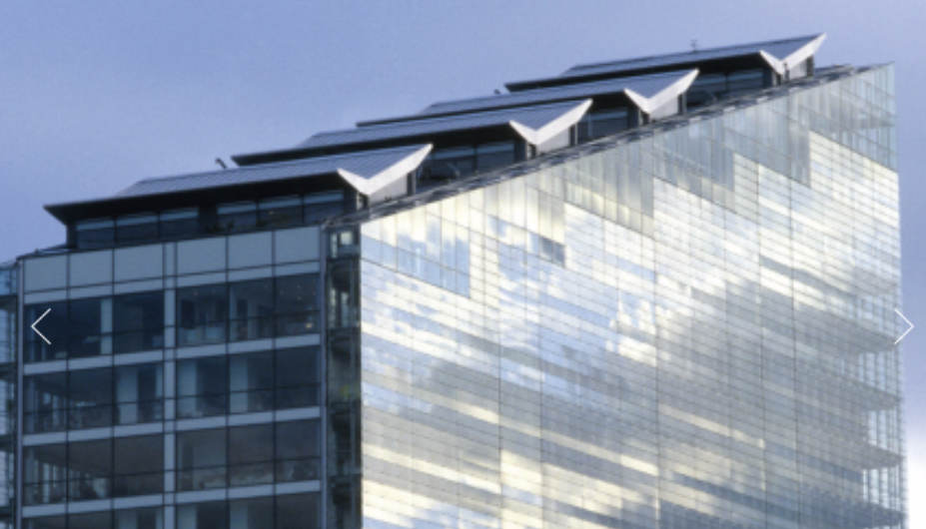

Environmental impact
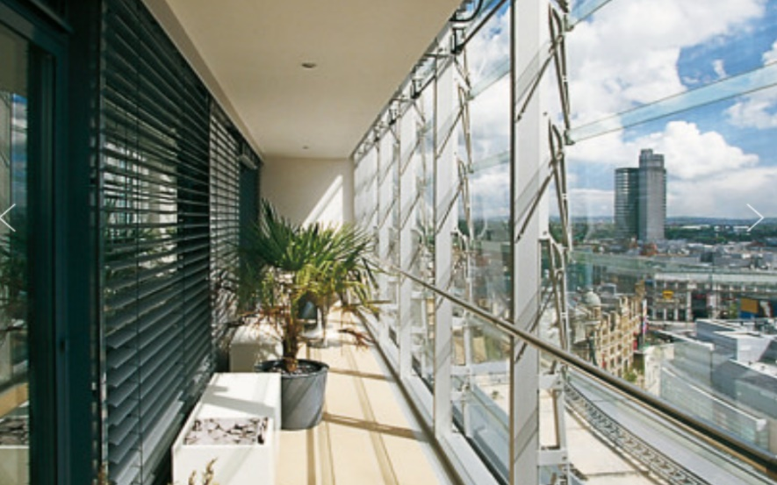
The structure is fully glazed and incorporates a variable twin skin louvre system to the balcony outer edge. This allows for a highly usable and unique semi-outdoor space to the living accommodation but also at the same time assisting with acoustic, solar, and thermal gains.

Framing material analysis

The following section of this report will analyse the framing material and compare and contrast them in the following areas:
Durability and climatic resistance
Production process
Ease of assembly
Adaptation potential
Life cycle

Durability and climatic resistance

One factor that can lead to deterioration of concrete as a framing material is freezing and thawing however as the lowest temperature average in Singapore from data recorded 2005-2015 was 24ᵒc (time and date, 2015) this is not an issue in its environment. Differently to this Manchester climate is a lot colder and the average annual low temperature is 2ᵒc and below 0ᵒ are common over winter periods (time and date, 2015). Freezing and thawing effect faster on surfaces most likely to retain water (Civil Engineering Web, 2021) and therefore in Manchester the concrete facade method the Jade has would be considerably less suitable unless preventive measures were put in place.
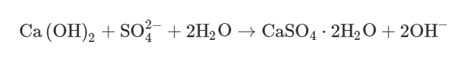
Another factor that is chemical attacks such as acid rain. Although Singapore is making great effort as a country to reduce emissions acid rain is worldwide issue. When concrete frame structures suffer sulphate attacks, hydration products of cement react with acid rain to produce gypsum, which will expand 1.5–2.2 times in volume (see formula below) (Oxford Academic, 2021). Acid rain can lead to cracking in the concrete due to inside tensile stress which can compromise the structures condition and could lead to further works required at a later date and higher maintenance costs.
The optimum conditions for corrosion is a relative humidity of 70%-80% and can occur during carbonation which is the reaction between the carbon dioxide in the air and the alkalis in the concrete. Carbonation indirectly effects the durability of the concrete by reducing the alkalinity of the concrete which long term results in de-passivation of the steel reinforcement leading to corrosion (The University of Hong Kong, No date). Similarly, Manchester and Singapore have an average annual relative humidity of 80% (time and date, 2015)

Steel is prone to corrosion and requires frequent treatment to ensure they are protected from the weather and rusting. For corrosion to occur moisture and oxygen is required resulting in the iron in the steel to oxidise producing rust (see equation below). Unlike concrete the durability of steel can be greatly compromised if not correctly maintained (Steel construction, 2021)
Fe + 3O₂ + 2H₂O = 2Fe₂O₃H₂O
(Steel) + (Oxygen) + (Water) = Hydrated ferric oxide (Rust)
Specifically referring NO1 Deansgate the buildings athletics having the structural steel visible at parts would also be greatly compromised if it was to rust and they have incorporated the elegant treated structural steel into the design combining aesthetic and practicality.
As both building are for residential purpose their performance and durability during a fire is vital. Steel does not have the same fire resistance as concrete but there are a number of solutions to improve the steels fire resistance. In the Manchester building a suspended ceiling comprising of two layers of 15mm plasterboard is in place to help improve fire resistance and protect the steel.

Production Process

The production process of Steel can have a negative effect on the environment. The main ingredient in the production of steel is iron ore. Iron ore is mined from the earth at a rate of 2,000 million tonnes a year and 95% of the iron ore mined goes towards the production steel (The world counts, 2021). The mining of iron ore is extremely energy intensive and can cause air pollution in the form of carbon dioxide, carbon monoxide nitrous oxide and sulphur dioxide from plant and equipment. Acid drainage is another long-term effect of mining and can stay present for thousands of years after the mining has stopped. Acid drainage is the term given to water polluted by heavy metals and acid that drains away from the mine. The actual steels production can also be extremely damaging to the environment. A negative effect in consequence of using steel is that on average 1.83 tons of CO2 is emitted for every ton of steel produced making it a key contributor to global warming. On the other hand, some countries are working on developing a steel production method that are less harmful. For example, Hyundai Steel’s Dangjin plant recycles 100 percent of the bi products which supply 80% of the operation energy at the plant. This is achieved as the bi product gas contains carbon monoxide, hydrogen and methane which can be utilized to heat up the furnaces in the plant (CNN,2011) Although the production of concrete is not a harmful to the environment as steel production due to concretes properties steel reinforcement is required to improve its tensile strength. During concrete production, the embodied energy consumed from the mining and processing of natural resources up to the manufacturing stage is believed to be between 0.86 mj/kg and 1.4 Mj/kg. Moreover, the embodied energy when reinforcement is added increases to 63% as the calculation is also accounting for the production of the steel rebars (Science direct, 2021)

Assembly

The construction cycle achieved by the concrete frame building was about 10 days per floor. Differently to this the Construction of NO1 Deansgate took an averaged 14 days per floor but still proving that both materials can be erected quickly. Due to both The Jade and NO1 Deansgate being in very urban areas operating quickly and effectively is vital. When the materials arrived on site there is no space to store materials and both materials need to be delivered just in time.
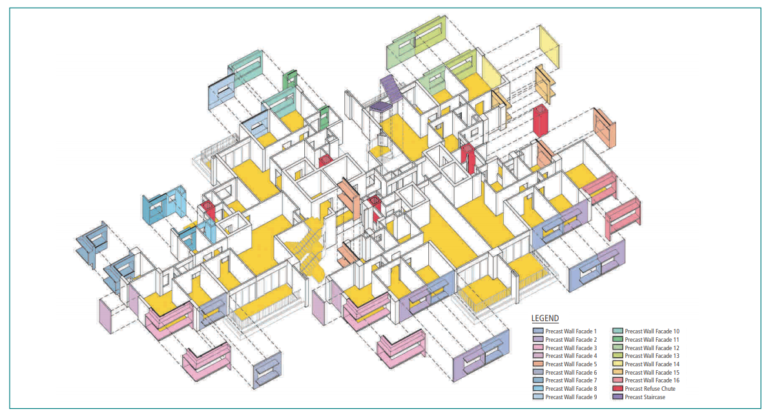

Adaptation

Steel’s ability to be extremely flexible means that future changes or extensions including even vertically can be carried out with minimal disruption and cost. After Covid-19 adaptability will be key in the construction sector with working from home taking people out of the cites and also overseas students potentially decreasing. The truth is 2021 is still a very unpredictable time and the opportunity to adapt buildings into field hospitals or isolation units has been a great benefit to the country. Concrete does not offer the same flexibility achieved with steel without greater cost implications

Life cycle

Steel can be assembled and dissembled unlike concrete and recycled to be reused again. Concrete is not as easy to recycle and reuse and has no scarp value unlike steel.

Conclusion

The analysis of both building and framing materials helps demonstrate how materials work in different climates and how their properties can eb utilized to function at their best
Function | Concrete frame | Steel frame
Load bearing capacity | Compared with steel load bearing capacity of unreinforced concrete is low and it requires reinforcement to increase its tensile strength | The load carrying capacity of steel structural frame is good
Lifecyle | Concrete has no scrap | Steel has good scrap value
Weight | Concrete weighs significantly more than steel | Steel has a much better weight to strength ratio and is considerably lighter than concrete
Assembly and disassembly | Concrete requires less skilled labour and more work to demolish | Steel requires more skilled labour to assemble but can be disassembled and taken off site just like it was taken on site
Cost | The cost of using concrete is usually less | Construction cost suing steel is more

References

Sim Lian Group Limited (No date) Our Portfolio. Available at: https://www.simlian.com.sg/portfolio/residential/our-portfolio/the-jade/ (Accessed: 7th February 2021)
Mace group (2016) 6 things you need to know when working on constrained sites. Available at: https://www.macegroup.com/perspectives/161001-6-things-you-need-to-know-when-working-in-constrained-sites (Accessed: 7th February 2021)
Architectural precast innovations, INC (2021) Facades. Available at: Precast Concrete Facades- Architectural Precast Innovations - Default (api-precast.com) (Accessed: 7th February 2021)
Simpsonhaugh (2021) No1 Deansgate. Available at: No.1 Deansgate | SimpsonHaugh (Accessed: 7th February 2021)

Visit Singapore (2021) Leading the way: Singapore sustainable future. Available at: Leading the Way: Singapore’s Sustainable Future – MICE Singapore (visitsingapore.com) (Accessed: 7th February 2021)
Time and date (2015) Annual weather averages near Singapore. Available at: Climate & Weather Averages in Singapore, Singapore (timeanddate.com) (Accessed 9th February)
Time and date (2015) Climate & Weather Averages in Manchester, England, United Kingdom. Available at: Climate & Weather Averages in Manchester, England, United Kingdom (timeanddate.com) (Accessed 9th February)
Civil Engineering Web (2021) Freezing and Thawing effect on durability of concrete-preventive measures. Available at: Freezing And Thawing Effect On Durability Of Concrete-Preventive Measures (civilengineeringweb.com) (Accessed 9th February)
Oxford Academic (2021) Effect of acid rain on economic loss of concrete structures in Hangzhou, China. Available at: Effect of acid rain on economic loss of concrete structures in Hangzhou, China | International Journal of Low-Carbon Technologies | Oxford Academic (oup.com) (Accessed 9th February)
The University of Hong Kong (no date) Durability of reinforced concrete structures, theory vs practice. Available at: Durability of Reinforced Concrete Structures (devb.gov.hk) (Accessed 9th February)
Steel Construction Info (2021) Corrosion of structural steel. Available at: Corrosion of structural steel - SteelConstruction.info (Accessed 9th February)
The World Counts (2021) Impact of steel production. Available at: Environmental Impact of Steel - TheWorldCounts (Accessed 14th February)
CNN (2011) Hyundai steels itself for a cleaner future. Available at: Hyundai steels itself for a cleaner future - CNN (Accessed 14th February)
Science Direct (2021) Concrete production. Available at: Concrete Production - an overview | ScienceDirect Topics (Accessed 14th February)

