MODULE: FOREIGN LANGUAGES AND CULTURAL AWARENESS
INTERCULTURAL COMPETENCE REPORT
MODULE CODE: BMIH5003
STUDENT NAME: Rufsana Begum
STUDENT ID: 2208636
LECTURER: Giulia Chifari
WORD COUNT: 1039

Executive Summary
This report is based on a well-known five-star hotel chain from the United Kingdom. called The Diversity Hotel & Spa. It is about to open a branch in India, a country known for its diverse cultural heritage. Drawing on findings from the GLOBE Project's study on culture and leadership, this paper provides an extensive overview of Indian customs, values, and culture. Comprehending the collective and hierarchical culture of India is crucial for the hotel's successful entry and operation in this heterogeneous market. Apart from offering cultural insights, this report also offers actionable recommendations to help the Diversity Hotel & Spa navigate the complex nuances of Indian culture and establish a peaceful and well-respected presence in this exciting new market. These recommendations include language proficiency, cultural training, and customized service offerings.

Table of Contents

Introduction 3
Main Body 3
The Cultural Landscape of India 3
Insights into the GLOBE Project 4
Cultural Sensitivity and Intelligence 5
Conclusion 7
Recommendations 7
References 8

Introduction
The need for distinctive travel experiences and locations is fuelling the ongoing growth and expansion of the global hospitality sector. It is an honour for me to travel on an exciting adventure with the General Manager to grow the company’s operations to a new and culturally varied destination as the Assistant General Manager of Diversity Hotel & Spa, a prestigious 5-star hotel brand with headquarters in the United Kingdom. India is the nation selected for this worldwide project; it is renowned for its many cultures, customs, and traditions (Fernández Gutiérrez et al. 2022).
India is a tempting market for the company’s business because of its large and diverse geography, which presents an enthralling tapestry of languages, faiths, cuisines, and cultures. But India's great cultural variety also makes it difficult to navigate its complex social and commercial environment.
The team at Diversity Hotel & Spa shall conduct a thorough investigation of India's cultural dynamics in this report, drawing on knowledge from the GLOBE Project's study on culture and leadership (Vu, 2019). The report will explore the importance of comprehending Indian traditions and values and evaluating the need for cultural awareness and intelligence in a corporate setting. The study will present a collection of useful suggestions to give the team the tools and knowledge they need to establish the brand as a peaceful and profitable presence in this booming and dynamic industry.

Main Body

The Cultural Landscape of India
India has been chosen as the General Manager's destination as it has rich cultural diversity. This nation is renowned for having a rich and varied cultural environment with widely disparate regional cultures and traditions (Ozlem, 2020). Some motifs are present across Indian culture despite its diversity. Family is important, and there is a deep-rooted respect for senior citizens. There is a long history of spirituality and its effect on daily living.
In increasingly globalized societies, greetings and salutations may vary from a straightforward handshake to the traditional "Namaste" signified by a hand motion (Afsar et al. 2019). Compared to some Westerners, Indians see time more fluidly and place a greater focus on the value of connections in both personal and professional contexts. India is a fascinating but complicated market for the general manager to visit because of these cultural contrasts (Otoo, 2019).

Insights into the GLOBE Project
The GLOBE Project provides useful details on the cultural aspects of India. India has a unique set of cultural norms that impact business interactions significantly. It is noteworthy for having a high-Power Distance, which demonstrates a strong regard for authority and hierarchy (Zhang et al. 2020). This focuses on the need of maintaining a sense of hierarchy in business dealings and identifying and honouring those in positions of authority. India also does highly around in-group collectivism, which emphasizes the value of close social and family ties. The connection between personal and professional life is emphasized by this.
Indian culture also places a strong focus on tolerance, perseverance, and respect for customs (Christou et al. 2020). It is also high context, meaning that relationship building, and communication depend heavily on nonverbal cues and contextual awareness. These cultural characteristics have an impact on how business is done in India and must be considered during the General Manager's visit.

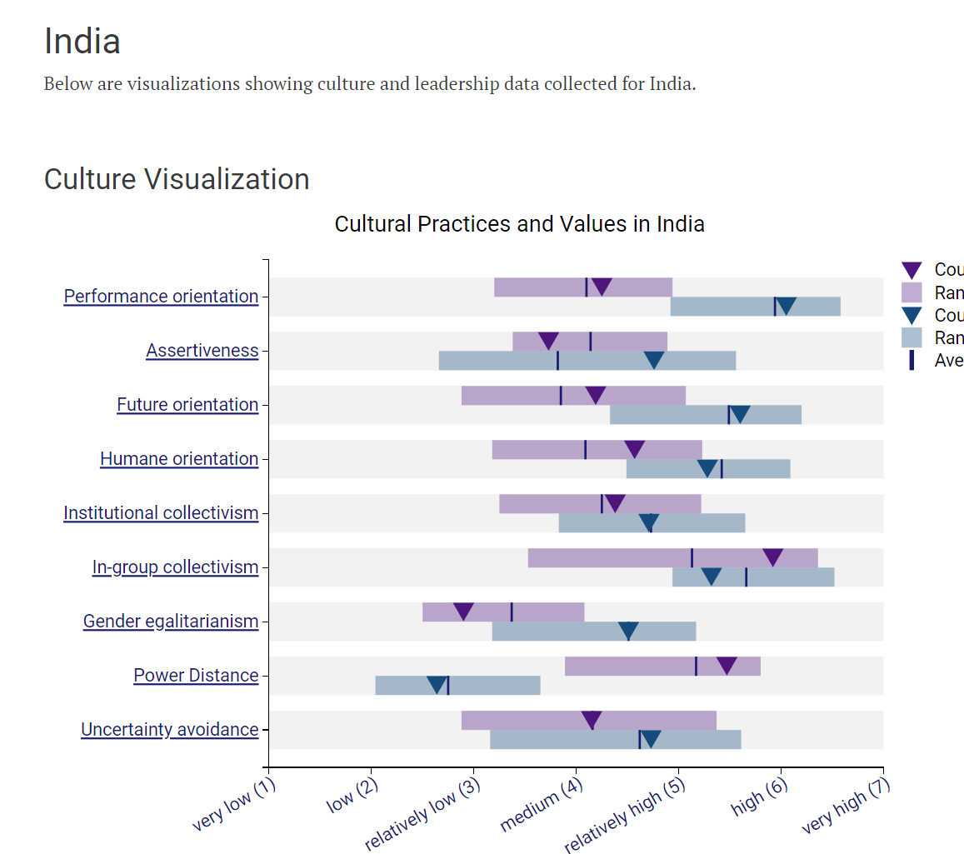
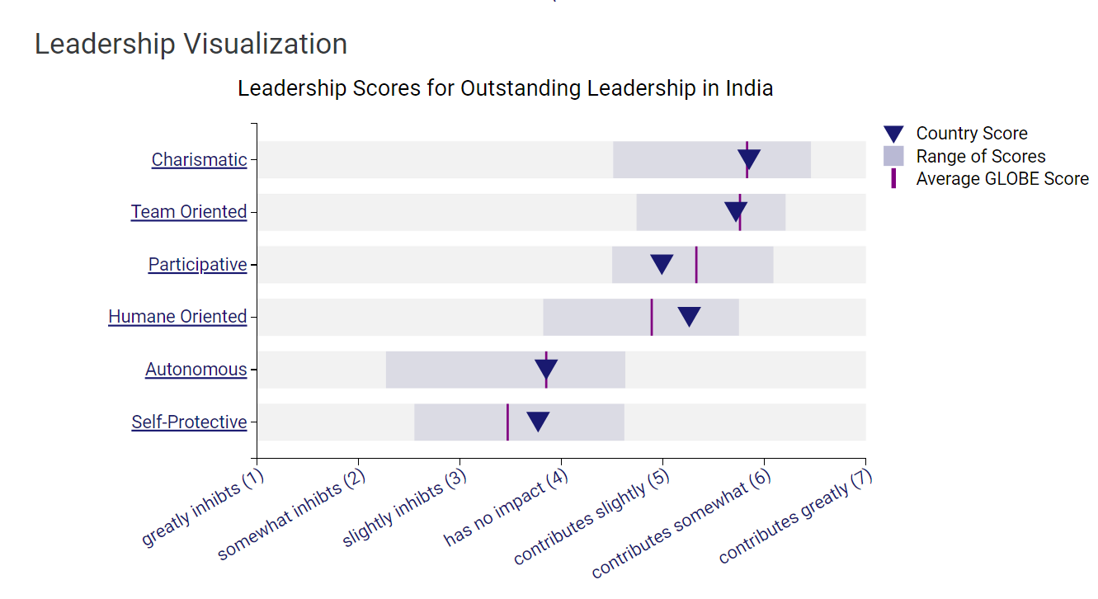
According to the analysis these are some of the figures of cultural practices and values as well as leadership visualization. It gives an insight and background on India’s performance. (Results - India GLOBE Project) accessed 06.11.2023

Cultural Sensitivity and Intelligence
To work successfully in this culturally varied setting, hotel personnel must not only recognise these cultural characteristics but also have the cultural intelligence and sensitivity to traverse them effectively (Goh and Baum, 2021). The development of cultural intelligence is critical for developing strong guest relationships, avoiding cultural misunderstandings, and providing a better experience for visitors from varied backgrounds.
Miscommunications, cultural insensitivity, and unsatisfied visitors may occur from a failure to establish cultural intelligence and sensitivity. To flourish in India's dynamic and varied market, hotel workers must embrace these cultural values, respect local customs, and prioritize relationship building that aligns with the GLOBE Project's cultural insights (Etehadi and Karatepe, 2019). By doing so, companies may improve visitor pleasure, build solid business relationships, and ensure the success of their endeavour in India's colourful and varied cultural scene.

Parameter | Value
Population (2022) | 1.366 billion
Official Languages | 22 recognized languages
Gross Domestic Product (GDP) | $3.2 trillion USD (2022)
Foreign Direct Investment (FDI) | $81.72 billion USD (2021)
Major Religions | Hinduism, Islam, Christianity, Sikhism, Buddhism, Jainism
Major Festivals | Diwali, Holi, Eid, Christmas, Navratri, Durga Puja
Business Hierarchy | Strong emphasis on hierarchy and respect for authority
Business Etiquette | Namaste (traditional greeting), hierarchical decision-making
Work Hours | Vary by region, typically 9 am to 5 pm
Business Dress Code | Formal attire with emphasis on modesty and cultural sensitivity

Table 1. Key Cultural and Economic Figures in India
(Source: Self-constructed)

Conclusion
The Diversity Hotel & Spa is moving into India, a nation rich in cultural diversity. With its many languages, beliefs, and cultures, India's distinctive environment gives a great chance for the hotel's expansion. The GLOBE Project emphasises India's strong family relationships and respect for authority, both of which are essential to its culture. To be successful, hotel employees must be culturally sensitive, comprehend Indian communication subtleties, accept local peculiarities, and recognize the relevance of religion and festivals in everyday life.
Success requires embracing personal relationships, customizing services, and respecting Indian culture. In this diversified market, the hotel's commitment to creating a truly Indian experience will generate goodwill, strong ties with guests, and profitability.

Recommendations
- Cultural Sensitivity Training: Provide thorough cultural sensitivity training to all employees to guarantee that they have a thorough awareness of Indian traditions, manners, and communication techniques.
- Tailored Service Provisions: Motivate employees to provide individualized services that take into account dietary restrictions, geographical variances, and religious observances to meet the various demands of visitors (Nair-Venugopal, 2018).
- Language Fluency: To ensure successful communication with visitors who might not speak English well, give priority to language fluency in important Indian languages like Hindi (Shen et al. 2020).
- Cultural Ambassadors: Designate cultural ambassadors to help personnel and visitors comprehend the subtleties of Indian culture, so that cultural sensitivity is ingrained in day-to-day operations.

References
Afsar, B., Shahjehan, A., Shah, S.I. and Wajid, A., 2019. The mediating role of transformational leadership in the relationship between cultural intelligence and employee voice behavior: A case of hotel employees. International Journal of Intercultural Relations, 69, pp.66-75.
Christou, P., Simillidou, A. and Stylianou, M.C., 2020. Tourists’ perceptions regarding the use of anthropomorphic robots in tourism and hospitality. International Journal of Contemporary Hospitality Management, 32(11), pp.3665-3683.
Etehadi, B. and Karatepe, O.M., 2019. The impact of job insecurity on critical hotel employee outcomes: The mediating role of self-efficacy. Journal of Hospitality Marketing & Management, 28(6), pp.665-689.
Fernández Gutiérrez, B., Reljanovic Glimäng, M., Sauro, S. and O'Dowd, R., 2022. Preparing Students for Successful Online Intercultural Communication and Collaboration in Virtual Exchange. Journal of International Students, 12, pp.149-167.
Goh, E. and Baum, T., 2021. Job perceptions of Generation Z hotel employees towards working in Covid-19 quarantine hotels: the role of meaningful work. International Journal of Contemporary Hospitality Management, 33(5), pp.1688-1710.
Nair-Venugopal, S., 2018. Issues of language and competence in intercultural business contexts. In Language and Intercultural Communication in the Workplace (pp. 41-57). Routledge.
Otoo, F.N.K., 2019. Human resource management (HRM) practices and organizational performance: The mediating role of employee competencies. Employee Relations: The International Journal, 41(5), pp.949-970.
Ozlem, Y., 2020. Enhancing the development of intercultural communicative competence in business and study environments. Training, Language and Culture, 4(1), pp.44-54.
Shen, L., Qian, J. and Chen, S.C., 2020. Effective communication strategies of sustainable hospitality: A qualitative exploration. Sustainability, 12(17), p.6920.
Vu, T.N., 2019. Theoretical constructs and practical strategies for intercultural communication. Journal of Curriculum Studies Research, 1(1), pp.43-53.
Zhang, T., Shaikh, Z.A., Yumashev, A.V. and Chłąd, M., 2020. Applied model of E-learning in the framework of education for sustainable development. Sustainability, 12(16), p.6420.

