Component 2- Individual Report

Contemporary Human Resource Challenges and Practices at BT Group plc

Muhammad Abdul Jalil
Student No. 2026580
Lecturer’s Name:

Contents
Introduction 2
Organisational Background 2
Section 1 – Key HR Challenges at BT Group 2
1.1 Technological advancement 2
1.2 Talent acquisition and retention 3
1.3 Diversity, equity and inclusion 4
Section 2 – Evaluation of Contemporary HR Practices 4
2.1 Digital learning, HR analytics and AI-supported HR 4
2.2 Employer branding, flexible working and career development 5
2.3 Inclusive recruitment and employee development 6
Section 3 – Critical Evaluation of Managers' Role in Implementing HR Practices 6
Recommendations 8
Conclusion 8
Refrences: 9

Introduction
This report evaluates the contemporary human resource (HR) challenges faced by BT Group plc, one of the UK's leading telecommunications organisations. The report focuses on three key issues: technological advancement, talent acquisition and retention, and diversity, equity and inclusion (DEI), as identified in the assessment brief. It critically evaluates contemporary HR practices that can address these challenges and examines how departmental managers can ensure their effective implementation to support sustainable organisational performance. The discussion applies relevant HR and motivation theories where appropriate and uses recent academic literature, professional reports and company evidence to develop balanced, evidence-based arguments (CIPD, 2024; BT Group, 2026a).
Table 1: HR and motivation theories applied in the analysis of BT Group
Theory | Application in BT
Herzberg | Employee motivation and retention
Adams' Equity Theory | Fairness and flexible working
Goal-setting Theory | Feedback and performance management

Organisational Background
BT Group plc is a major UK telecommunications company providing broadband, mobile, television, cybersecurity, networking and managed digital services to more than 30 million customers. Its main businesses include BT, EE and Openreach (BT Group, 2026a). The company is investing in full-fibre broadband, 5G and digital technologies while simplifying its operations and concentrating more strongly on the UK market (BT Group, 2026e). These developments make effective HR management essential because employees must continuously develop new technical and customer-service skills. However, rapid transformation may also create job insecurity, resistance to change and difficulties retaining skilled employees. Therefore, BT must balance technological efficiency with employee development, motivation, fair career opportunities and inclusion to achieve sustainable performance.
Table 2: Summary of BT Group's key HR challenges, organisational impacts and contemporary HR practices
HR Challenge | Impact on BT | Contemporary HR Practice
Technological advancement | Skills gaps, employee resistance to change | Digital learning, AI-supported HR, reskilling
Talent acquisition and retention | Difficulty recruiting and retaining digital talent | Employer branding, career development, flexible working
Diversity, Equity and Inclusion | Under-representation and unequal progression | Inclusive recruitment, mentoring, leadership development

Section 1 – Key HR Challenges at BT Group

1.1 Technological advancement
BT operates in a rapidly changing industry shaped by artificial intelligence, automation, cybersecurity, cloud computing, 5G and full-fibre broadband. Its current strategy aims to create a smaller and simpler organisation in which data and AI provide a competitive advantage (BT Group, 2026e). Although these technologies can improve efficiency, service quality and decision-making, they also change job roles and increase the demand for advanced digital skills. Employees whose skills become outdated may experience anxiety, reduced confidence or fear of redundancy.
Technology is therefore not only an operational issue but also a motivational challenge. The module materials explain that motivation influences employees’ enthusiasm, persistence and willingness to support organisational goals (UWTSD, 2026a). The Xerox case similarly shows that technological and organisational change is more likely to succeed when leaders communicate clear priorities, involve employees and create opportunities for contribution (Lumen Learning, n.d.). However, employee involvement may slow decision-making, particularly when BT must respond quickly to competitors. BT must therefore balance urgent technological investment with training, communication and meaningful consultation.

1.2 Talent acquisition and retention
BT must attract and retain employees with specialist capabilities in areas such as software engineering, network management, cybersecurity, data analytics and AI. This is difficult because many UK employers compete for the same limited talent. CIPD research found that 56% of organisations were experiencing increasing retention difficulties, showing that recruitment alone cannot resolve workforce shortages (CIPD, 2024).
BT offers graduate schemes, apprenticeships and career-development opportunities, including programmes in engineering, cybersecurity and AI (BT Group, 2026c). These routes can create a long-term skills pipeline and widen access beyond traditional graduate recruitment. Career case studies also show that mentoring, professional learning, feedback and leadership opportunities can support employee progression (Ealing Grid for Learning, 2021). Nevertheless, development programmes may fail to improve retention when employees cannot see realistic opportunities for promotion or when restructuring creates uncertainty.
Motivation theories suggest that pay is important but is not sufficient by itself. Herzberg distinguishes between hygiene factors, such as salary and job security, and motivators, including achievement, recognition, responsibility and growth (UWTSD, 2026b). Therefore, BT needs a balanced employee-value proposition that combines competitive rewards with flexibility, recognition and transparent career pathways.

1.3 Diversity, equity and inclusion
BT also faces the challenge of building a workforce that reflects its customers. The company recognises that a diverse workforce can help it design more accessible and inclusive products and services (BT Group, 2026d). However, diversity is not achieved simply by publishing policies or recruitment targets. Structural factors such as education, social class, gender, ethnicity, family background and professional networks can shape access to employment and progression before an individual applies for a role (UWTSD, 2026c).
Inclusive recruitment may broaden BT’s talent pool and improve decision-making, but targets can become symbolic when under-represented employees continue to face unequal promotion, limited influence or exclusion from professional networks. BT must therefore examine recruitment, pay, development, retention and leadership representation together. Overall, the three challenges are closely connected: technological change increases demand for talent, career development supports retention, and genuine inclusion enables BT to access skills from a wider section of society.
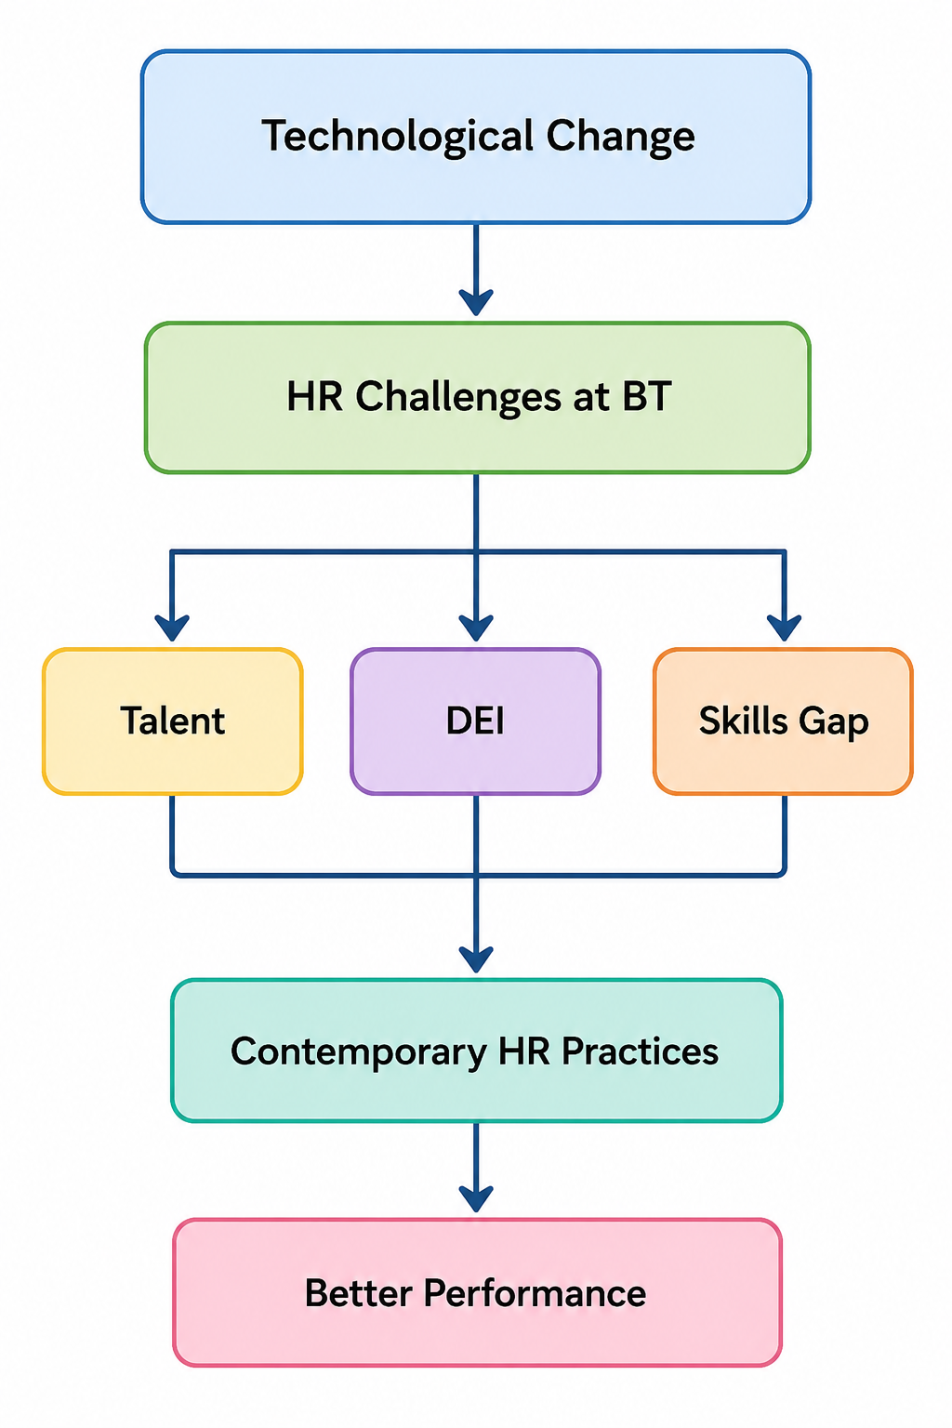
Figure 1: Relationship between technological change, HR challenges and contemporary HR practices at BT Group (created using Canva)

Section 2 – Evaluation of Contemporary HR Practices

2.1 Digital learning, HR analytics and AI-supported HR
BT can respond to technological change through continuous digital learning, reskilling and skills-based workforce planning. Learning management systems allow employees to access training consistently and can help BT measure participation. BT has also introduced AI and data apprenticeships for existing employees, which may reduce dependence on expensive external recruitment (BT Group, 2026g). However, completing an online course does not necessarily demonstrate that an employee can apply the skill effectively. BT should therefore combine digital learning with mentoring, practical projects and assessed workplace performance.
Digital HR systems and workforce analytics can also identify skills shortages, training needs and possible causes of employee turnover. Recent research found that digital HRM systems can improve HR efficiency, particularly when organisations are sufficiently agile to respond to the information produced (Mahmoud, Al-Sharafi and Al-Emran, 2025). Nevertheless, inaccurate data may lead to poor decisions, while excessive monitoring can reduce employee trust. BT should therefore explain what employee data is collected and maintain human oversight.
AI-supported recruitment can reduce administrative work, improve application processing and potentially increase accessibility. CIPD reports that the use of AI and machine learning in recruitment has increased considerably (CIPD, 2024a). However, AI can reproduce discrimination contained in historical recruitment data. BT’s responsible-AI approach is therefore relevant, but recruitment algorithms should also be independently audited and should support rather than replace human judgement (BT Group, 2026f).

2.2 Employer branding, flexible working and career development
A strong employer brand can help BT attract digital and technical specialists by presenting the organisation as innovative, inclusive and socially responsible. However, employer branding is effective only when the promises made during recruitment match employees’ actual experiences. The Xerox case demonstrates that organisational reputation and motivation can improve when leaders communicate clearly, involve employees and encourage contribution during change (Lumen Learning, n.d.). Nevertheless, attractive advertising cannot compensate for poor management, limited progression or insecurity.
Flexible and hybrid working may improve wellbeing, widen BT’s recruitment area and support retention. Recent CIPD research identifies links between flexible working, engagement and employee wellbeing (CIPD, 2025). However, remote working is not equally available to field engineers, retail employees and contact-centre workers. This may create unfairness between occupational groups. In line with Adams’ equity theory, perceived unfairness between employees’ contributions and rewards can reduce motivation (UWTSD, 2026a). BT should therefore provide different but equivalent forms of flexibility, including predictable rotas, compressed hours and shift choice.
Career development and internal recruitment can improve retention because employees are more likely to remain when they can see realistic progression opportunities. Career case studies show that mentoring, feedback, professional development and leadership responsibilities can support progression (Ealing Grid for Learning, 2021). However, internal recruitment may reproduce existing inequalities when opportunities are communicated informally or influenced by personal networks. BT should therefore publish clear career pathways and use transparent selection criteria.

2.3 Inclusive recruitment and employee development
BT can strengthen DEI through accessible job advertisements, structured interviews, diverse recruitment panels and skills-based selection. These practices may reduce subjective decision-making and widen the talent pool. Nevertheless, blind recruitment alone cannot remove wider structural inequalities linked to education, class, gender, ethnicity and professional networks, as highlighted by the structural approach to career choice (UWTSD, 2026b).
Employee networks, mentoring and inclusive-leadership training can improve belonging and provide under-represented employees with greater voice. However, one-off unconscious-bias training often has limited value when promotion systems, organisational culture and managerial accountability remain unchanged. BT should therefore evaluate DEI through recruitment, promotion, pay, retention and employee-feedback data rather than relying only on workforce targets. Overall, contemporary HR practices are most effective when they are combined, continuously evaluated and supported by managers rather than introduced as isolated policies.

Section 3 – Critical Evaluation of Managers' Role in Implementing HR Practices
Departmental managers play a vital role in ensuring that HR policies are translated into everyday workplace practices. While the HR department develops organisational policies and strategies, managers are responsible for implementing them, supporting employees and monitoring performance. Therefore, the success of BT's HR practices depends not only on well-designed policies but also on the capability of managers to apply them consistently across different departments (Armstrong and Taylor, 2023).
One of managers' most important responsibilities is leading employees through technological change. As BT continues to invest in AI, automation and digital networks, managers must help employees understand why these changes are necessary and how they will benefit both the organisation and individual careers. Clear communication can reduce uncertainty and resistance to change, while regular feedback encourages employees to develop new skills. The Xerox case demonstrates that organisational change is more successful when leaders communicate a clear vision, involve employees in decision-making and recognise their contributions (Lumen Learning, n.d.). However, involving employees in every decision may delay implementation, particularly in a fast-moving industry such as telecommunications. Managers therefore need to balance employee participation with timely decision-making.
Managers also have a significant responsibility for motivating employees and improving performance. According to Goal-Setting Theory, employees are more motivated when they receive clear objectives, constructive feedback and opportunities to monitor their progress (Locke and Latham, 2002). The Week 8 and Week 9 lecture materials similarly highlight that effective feedback improves employee engagement, learning and continuous performance improvement (UWTSD, 2026a; UWTSD, 2026b). Nevertheless, feedback is only effective when it is timely, specific and focused on development rather than criticism. Managers who provide inconsistent or unclear feedback may reduce employee confidence and motivation.
Another important responsibility is supporting career development and employee retention. Managers should identify employees' strengths, discuss career aspirations and provide access to mentoring, coaching and professional development opportunities. Career progression case studies show that supportive leadership, continuous learning and mentoring can increase employee confidence and career progression (Ealing Grid for Learning, 2021). However, development opportunities should be allocated fairly. If managers favour certain employees or rely on informal relationships, perceptions of unfairness may arise, reducing trust and engagement. Transparent promotion criteria and regular development reviews can reduce this risk.
Managers are also responsible for creating an inclusive working environment where employees feel respected and valued regardless of their background. Inclusive leadership encourages collaboration, innovation and employee wellbeing. However, diversity policies alone do not automatically create inclusion. Managers must actively challenge bias, ensure equal access to opportunities and respond appropriately to discrimination or exclusion. Recent research suggests that inclusive leadership is positively associated with employee engagement, innovation and organisational performance (Shore et al., 2023). Nevertheless, managers require appropriate training and organisational support because inclusion cannot depend solely on individual commitment.
Overall, departmental managers act as the link between organisational HR strategy and employee experience. Their leadership, communication, coaching and decision-making determine whether HR practices achieve their intended outcomes. While HR policies provide the framework, successful implementation ultimately depends on managers applying them fairly, consistently and in ways that motivate employees, support career development and encourage continuous improvement.

Recommendations
BT Group should introduce a company-wide digital skills programme linked to practical projects, mentoring and measurable performance outcomes. Managers should hold quarterly career-development discussions and publish transparent internal promotion criteria to improve retention and reduce unfair access to progression. Recruitment systems using AI should be regularly audited for bias and supported by human decision-making. BT should also measure inclusion through promotion, pay, retention and employee-feedback data rather than relying only on diversity targets. Finally, managers should receive training in constructive feedback, inclusive leadership and change communication, because HR policies are effective only when they are applied consistently and fairly (Armstrong and Taylor, 2023; CIPD, 2025).

Conclusion
This report has shown that BT Group faces significant HR challenges arising from technological advancement, talent acquisition and retention, and diversity, equity and inclusion. These challenges are interconnected and require strategic HR practices supported by effective managerial leadership. While digital learning, career development, flexible working and inclusive recruitment can improve organisational performance, their success depends on consistent implementation, employee engagement and continuous evaluation. Departmental managers play a key role in motivating employees, providing constructive feedback and supporting career progression. By combining innovative HR practices with strong leadership, BT can develop a skilled, motivated and inclusive workforce that supports long-term organisational success and sustainable competitive advantage (Armstrong and Taylor, 2023; CIPD, 2024).

Refrences:
Armstrong, M. and Taylor, S. (2023) Armstrong’s Handbook of Human Resource Management Practice. 16th edn. London: Kogan Page.
BT Group (2026a) About BT. Available at: https://www.bt.com/about/bt (Accessed: 21 July 2026).
BT Group (2026b) BT Annual Report 2026. Available at: https://www.bt.com/about/annual-reports/2026summary/ (Accessed: 21 July 2026).
BT Group (2026c) Graduates & Apprentices – Early careers. Available at: https://jobs.bt.com/content/Students-and-Graduates/ (Accessed: 21 July 2026).
BT Group (2026d) Inclusion. Available at: https://www.bt.com/about/bt/our-people/diversity-and-inclusion (Accessed: 21 July 2026).
BT Group (2026e) Our strategy. Available at: https://www.bt.com/content/bt-plc/en/about/bt/our-company/our-strategy (Accessed: 21 July 2026).
BT Group (2026f) Responsible AI. Available at: https://www.bt.com/about/digital-impact-and-sustainability/championing-human-rights/responsible-ai (Accessed: 21 July 2026).
BT Group (2026g) Upskilling business for an AI future. Available at: https://newsroom.bt.com/upskilling-business-for-an-ai-future/ (Accessed: 21 July 2026).
Chartered Institute of Personnel and Development (CIPD) (2024) Resourcing and talent planning report 2024. Available at: https://www.cipd.org/uk/knowledge/reports/resourcing-surveys/ (Accessed: 21 July 2026).
Ealing Grid for Learning (2026) Career development for teachers. Available at: https://www.egfl.org.uk/elp-services/career-and-professional-development (Accessed: 21 July 2026).
Locke, E.A. and Latham, G.P. (2002) 'Building a practically useful theory of goal setting and task motivation: A 35-year odyssey', American Psychologist, 57(9), pp. 705–717.
Lumen Learning (n.d.) 6.7 Motivation: Key for Success – The Case of Xerox. Available at: https://courses.lumenlearning.com/suny-orgbehavior/chapter/6-7-motivation-key-for-success-the-case-of-xerox/ (Accessed: 21 July 2026).
Mahmoud, M.H., Al-Sharafi, M.A. and Al-Emran, M. (2025) ‘The impact of digital HRM systems and digital transformation on HR efficiency: The moderating role of organisational agility’, Discover Sustainability, 6(1). Available at: https://link.springer.com/article/10.1007/s43621-025-01713-9 (Accessed: 21 July 2026).
Shore, L.M., Cleveland, J.N. and Sanchez, D. (2023) 'Inclusive leadership and workplace inclusion: Recent developments and future directions', Annual Review of Organizational Psychology and Organizational Behavior, 10, pp. 109–135.
University of Wales Trinity Saint David (UWTSD) (2026a) Week 8 lecture: Motivation and feedback. LCLM5002 Developing and Managing Individuals and Teams. Unpublished teaching material.
University of Wales Trinity Saint David (UWTSD) (2026b) Week 9 lecture: Understanding motivation and feedback. LCLM5002 Developing and Managing Individuals and Teams. Unpublished teaching material.
University of Wales Trinity Saint David (UWTSD) (2026c) Week 4 lecture: Developing career choice—structural approach. LCLM5002 Developing and Managing Individuals and Teams. Unpublished teaching material.

