

Learning in the digital era
Module code - BMPS4009
Lecturer - Mike Durke
Student: Olivia Saunders
Student number: 2115551

Contents page

3 …..................................................................................................... Summary
4 …....................................................................................................... Mind Map
5…........................................................................................................ Video
6…........................................................................................................ Reflection
7…........................................................................................................ References

Preparing for higher education

Preparing for higher education is a very important part of being a student. Learning also how to study effectively is a key step to preparing for higher education. Creating a secure, quiet place to study such as a coffee shop, bedroom, libraries to stay focused during study sessions. (Boston University Education Resource Center 2011). As well of this it is important to organise effectively for a piece of work to ensure you cover all the key points. Organising can consist of creating a list of important tops that need to be covered, or creating a mind map, and researching the topic beforehand effectively. Prioritising work into two categories urgent task and important task, will help get the important things finished first. (Mind Tools, no date). Managing time is a crucial step for preparing for higher education. Starting assignments and giving yourself time to complete these assignments will help with the mark of your work. Students must manage the time they have free to study (Cottrell,2019). Producing authentic work and understanding the task description, and how to reference and use citations correctly. Referencing is necessary in work, and students must understand the correct way to do so, (UWTSD, Library and Learning resources, no date). Lastly, preparing for higher education's consists of understanding the assignment and what is being expected from you as a student. Knowing how to write at a higher standard with correct punctuation and spelling. Knowing how to lay out your work effectively. Understanding how to use Turnitin, and where your work is being submitted.

Mind map

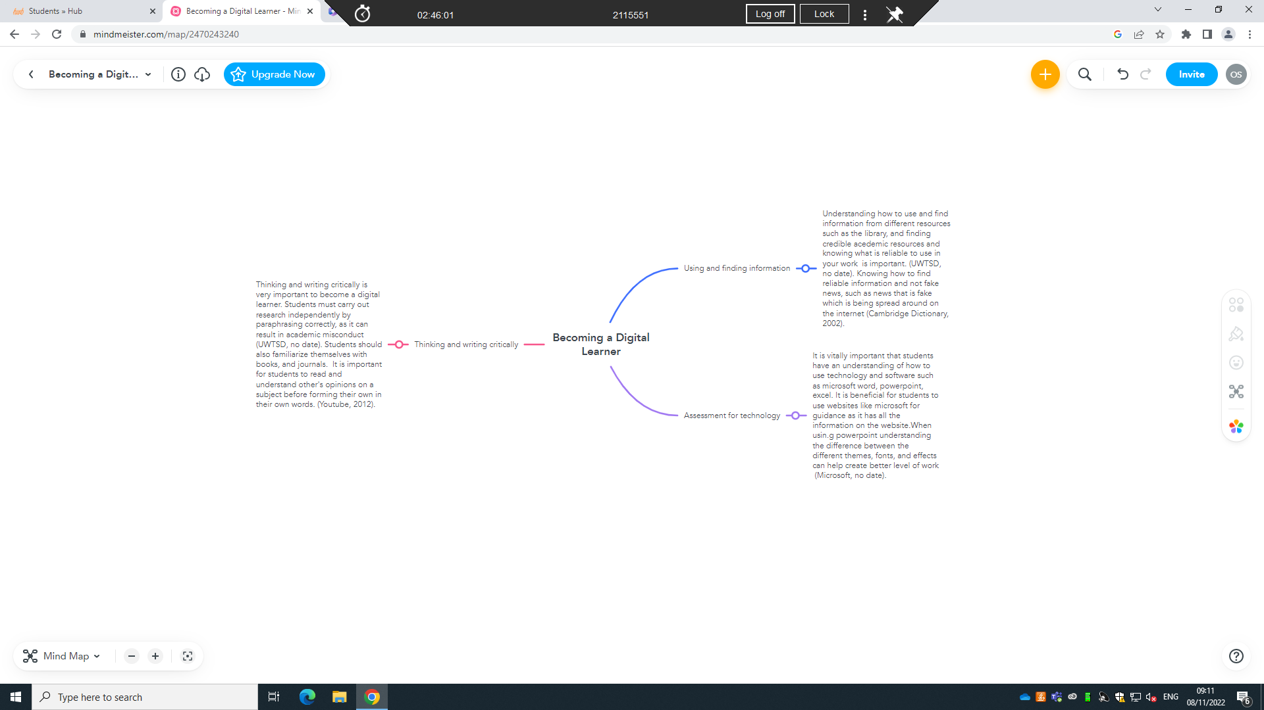

Reflection

Beginning university was quite intimidating for me as it was something so new and different. I felt a lot of pressure with presenting work of a higher standard and learning how to reference and research correctly. Correct referencing is a crucial ability for a student as it is mandatory to reference in every piece of work and composing a task (UWTSD, no date). Understanding how the online resources work and where to find online learning sources, and how to use them effectively and correctly. I have learnt how to use the university’s app’s correctly as this is something I use every day and lesson. Using apps such as moodle, online library, teams etc. Understanding how to use them correctly has benefited me with my experience at university as they have positively contributed to the quality of my work. As well as this, it was important for me to learn how to use Microsoft apps such as, word, power point, excel, as I would need to use these for my work. Being taught how to use them to a further extent to how I normally do have been eye opening as well as I have learned so much new skills. Learning new skills and understanding online resources is exciting and will benefit me in my future as this is a massive aspect of being a detective and doing police work. When given my assignments I started straight away, I began by organising my work, and creating a list of what I would write about. Starting the essays straight away helped me with time and deadlines. I used moodle, online books, and credible online resources. In an academic research paper, it's critical to cite reliable sources because your audience will expect you to have provided reliable evidence to support your claims (Finding credible sources, no date). I believe starting my assignments early has helped me massively with writing better essays and I have been less stressed.

Video Presentation link

https://uowtsd-my.sharepoint.com/:p:/r/personal/2115551_student_uwtsd_ac_uk/Documents/Digital%20Era%20-%20Assignment%201.pptx?d=w000b730ab7434eccbd4296a88785aef5&csf=1&web=1&e=5nVCst

Reference list

Boston University Education Resource Center (2011) Study environment analysis. Available at: https://blogs.bu.edu/erc/2011/03/07/is-this-a-good-place-to-study-take-the-quiz/ (Accessed : 05/10/22).

Cambridge Dictionary (2022) definition of ‘fake news’. Available at:https://dictionary.cambridge.org/dictionary/english/fake-news (Accessed: 07/11/22)

Cottrell,S. (2019) The Study Skills handbook. 5th edn. London: Macmillan Education UK.
Coursera, 2022,. What is Effective Communication? Skills for Work, School, and Life. Available at: https://www.coursera.org/articles/communication-effectiveness (Accessed:11/11/22)

Finding credible sources, no date, what does credibility mean? Available at:https://sites.google.com/site/evaluatingsourcecredibility/for-students/what-does-credibility-mean. (Accessed:08/11/22)

Keates, no date, The 5 C’s of Effective Communication. Available at:https://www.forbes.com/sites/forbescoachescouncil/2018/09/10/the-five-cs-of-effective-communication/?sh=3123267820c8. (Accessed: 11/11/22).

Microsoft, no date, Insert a table of content : Available at : https://support.microsoft.com/en-us/office/insert-a-table-of-contents-882e8564-0edb-435e-84b5-1d8552ccf0c0 (Accessed 07/11/22).

Microsoft, no date, understanding the difference between power point templates and themes. Available at :https://support.microsoft.com/en-us/office/understand-the-difference-between-powerpoint-templates-and-themes-e2408e10-e015-43b3-8b29-b99d128ae448. Accessed : 07/11/22).

Mind Tools (no date) Eisenhower’s Urgent/important Principle. Available at:https://www.mindtools.com/pages/article/newHTE_91.htm (Accessed: 17/10/22)

UWTSD Library and Learning Resources (no date) Referencing handbook: Harvard. Available at :https://uwtsd.ac.uk/media/uwtsd-website/content-assets/documents/library-and-learning-resources/infoskills/Harvard-eng_v.1.2.pdf (Accessed 17/10/22)

UWTSD, no date, referencing handbook. Available at: https://www.uwtsd.ac.uk/library/student-essentials/referencing-handbooks/ (Accessed on: 08/11/22)

