Craig Oldham
0501251
Network Operating Systems and Services
ACCA5023

Table of Contents
Task 1: Research 3
Research on Hypervisor 3
Research on IP Addressing 4
Research on Routing 5
Research on Network Services 6
Task 2: Technical Documentation 7
Installation 7
Testing Connectivity 11
Task 3: Reflection 14
References 15
Table of Figures 16

Task 1: Research

Research on Hypervisor
A hypervisor is a form of software that can be installed on a machine that enables the running of multiple virtual machines [1]. Each machine can be set up to have it’s own operating systems and applications, utilising the machine’s hardware as dictated by the setup as required. This technology is highly beneficial in enterprise environments, allowing for efficient use of infrastructure.
There are two types of hypervisor available. A type one hypervisor is installed on to the hardware of the machine, with no operating system or other software between it. These types of systems have very basic operating systems [2].
A type two hypervisor will run in addition to the installed operating system and uses that systems drivers to access the hardware of the machine it is installed on. This type of hypervisor is designed to be run on a single machine, often used when a user requires access to multiple operating systems.
There are many hypervisor options available on the market, from open-source KVM, which allows users to run most common Linux, Solaris and Windows operating systems [3] to enterprise scale solutions such as VMware. When looking for a type 2 hypervisor, Oracle Virtualbox is a go-to application for many as an open-source system.
Hardware requirements for hypervisors vary depending on the type and the usage. The KVM type one system recommends a minimum hardware of [4]:
- Intel Xeon processor with at least 6 cores and should support hyper threading
- 24 GB RAM
- 500 GB Hard Disk Storage
- 4 Network Interface Cards
It is more common for these types of hypervisors to be deployed on server hardware, where the scalability of hardware is greater. They are also much more secure as they run from the hardware directly and are less likely to be subject to cyber attack [2].
Type two hypervisors require less than their type one counterparts, with the Oracle Virtualbox system requiring a minimum:
- x86 hardware, such as a recent AMD or Intel Processor
- 512MB RAM, but the more you can install, the better it will perform
- 30MB Hard Disk Storage for installation, but considerably more for the Virtual Machine
In addition to the hardware, they require compatible host operating systems such as macOS, Windows, Linux or Solaris. As these types of hypervisor use less resources, a machine can run many more virtual machines.

Research on IP Addressing
An IP address is a unique identifier assigned to a network device [5]. These identifiers allow communication data between connected devices to occur efficiently and accurately. An IP address is not random but are produced mathematically by the Internet Assigned Numbers Authority [6].
There are two forms of IP addressing used. The most common of these being IPv4 [7]. IPv4 addresses are displayed in 4 sets of numbers separated by a period, ranging from 0 to 255. These are known as 32-bit addresses.
This number is split into two sections: a host address and a network address. There are 5 different classes of addressing, labelled from A to E.
A typical example of an IPv4 address would be:
192.168.0.1
An IPv6 address is formed using hexadecimal numbering concepts, and is split into 8 groups, separated by colons. This is a 128-bit address and allows for a much larger number of devices to be connected to one network. Unlike IPv4, there are no separate classes for address.
A typical example of an IPv6 address could be:
3fcb:91d4:bb60:6b0f:7b8a:9f2e:2c47:5d81
Most networks utilise the IPv4 address system, but for larger networks, allowing all the devices through one branch can have serious impacts on the network performance. Subnetting, allows a 32-bit network to be split into smaller networks, each with their own IP address range to allow communication between a set number of devices to happen more efficiently [8].
Using classes A to C, a Subnet utilises between 1 and 3 of the IP address octets to determine how much of the address is allocated between the network and the host.
Class A networks allow a small number of networks to be assigned many hosts while Class C allow for large numbers of networks, with a small number of hosts.
The below image displays a potential application of a Class A IPv4 network (Figure 1)
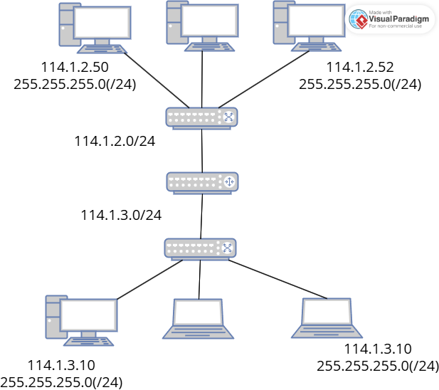
Figure 1: Class A IPv4 Network Topology

Research on Routing
Routing operates at Level 3 of the Open Systems Interconnection (OSI) model, often referred to as the Network Layer [9] it directs data packets through different networks making sure that information reaches the users desired destination.
There are two main types of routing protocol, static and dynamic.
Static routing protocols are programmed by the system administrator and do not change unless they are modified manually [10]. This type of protocol is more secure than dynamic routing and can be a more cost-effective solution, however for larger networks, the task of administration becomes extremely difficult with every route having to be manually configured and can be difficult for a new administrator to pick up.
Dynamic routing is much easier to configure and is a more effective method for routing data more efficiently and finding remote networks. This is because, unlike static routing, a dynamic protocol utilises complex algorithms to alter the routing table when a network’s topology changes. The dynamic protocols however are less secure than a static one and will use much more bandwidth.
The two most common routing protocols are Border Gateway Protocol (BGP) and Open Shortest Path First (OSPF) [11]. BGP is usually deployed in large networks for dynamically routing data between networks operated by separate organizations, usually towards the point that the network would connect with the internet.
OSPF protocols are usually deployed within an organization’s Local Area Network (LAN) as it is usually easier to deploy and maintain as it stores the information of local and learned networks. By storing this information, routers can determine the most efficient route to transmit data by calculating a reference bandwidth to quantify the speed of a link.
However, due to the amount of resource required for OSPF protocols, they are not recommended for large scale networks and administrators have to control their usage much more than they would with a BGP.

Research on Network Services
Used as a virtual security tool, a VPN, or Virtual Private Network, can be used to make a secure and private connection to another network which is essential when it needs to be accessed remotely via a shared or public network [12]. Some of the recommended best practices for a VPN are to keep all connected devices up to date, implement multi-factor authentication or strong password policies, test limitations and, if possible, utilise rate limiting.
DHCP servers assign IP addresses to devices without static assignments and are commonly used in modern business networks [13]. To be effective, DHCP servers should have enough IP addresses to accommodate current and future device needs. It's also important to be aware of the static IP address range to avoid overlap. For security, business and guest networks should be separated, unused switch ports disabled, and administrators alerted when unknown devices send DHCP requests.
Active Directory Domain Services (AD) enable network administrators to manage domains, devices, and user accounts [14]. Recommended best practices include understanding permission inheritance, modifying default settings, removing unused accounts, enforcing password policies, minimizing privileges, and standardizing group names.
Certificate Authorities (CAs) issue digital certificates to verify the identity of individuals accessing a network [15]. There are public CAs, used for website trust, and private CAs, used for secure private communications. Administrators should stay updated on certificate management, protect the Root CA, prepare onboarding strategies, customize policies (e.g., Zero Trust), maintain an effective Certificate Revocation List and stayed on top of Certificate Expiration.

Task 2: Technical Documentation
For this task, I chose to use the Oracle Virtualbox type 2 hypervisor to build my network. My reasoning behind this is that the Oracle Virtualbox is an open source software which is an industry standard tool used for the creation and management of virtual machines.
It also has good cross-compatibility, something that needed to be considered as there is a need to build both Windows and Linux operating systems.
There was no need for me to download the hypervisor as it was already installed on the machine I was using.

Installation
Figures 2 to 9 document me downloading the operating system to set up the Windows server and installing it as a virtual machine on the Hypervisor.
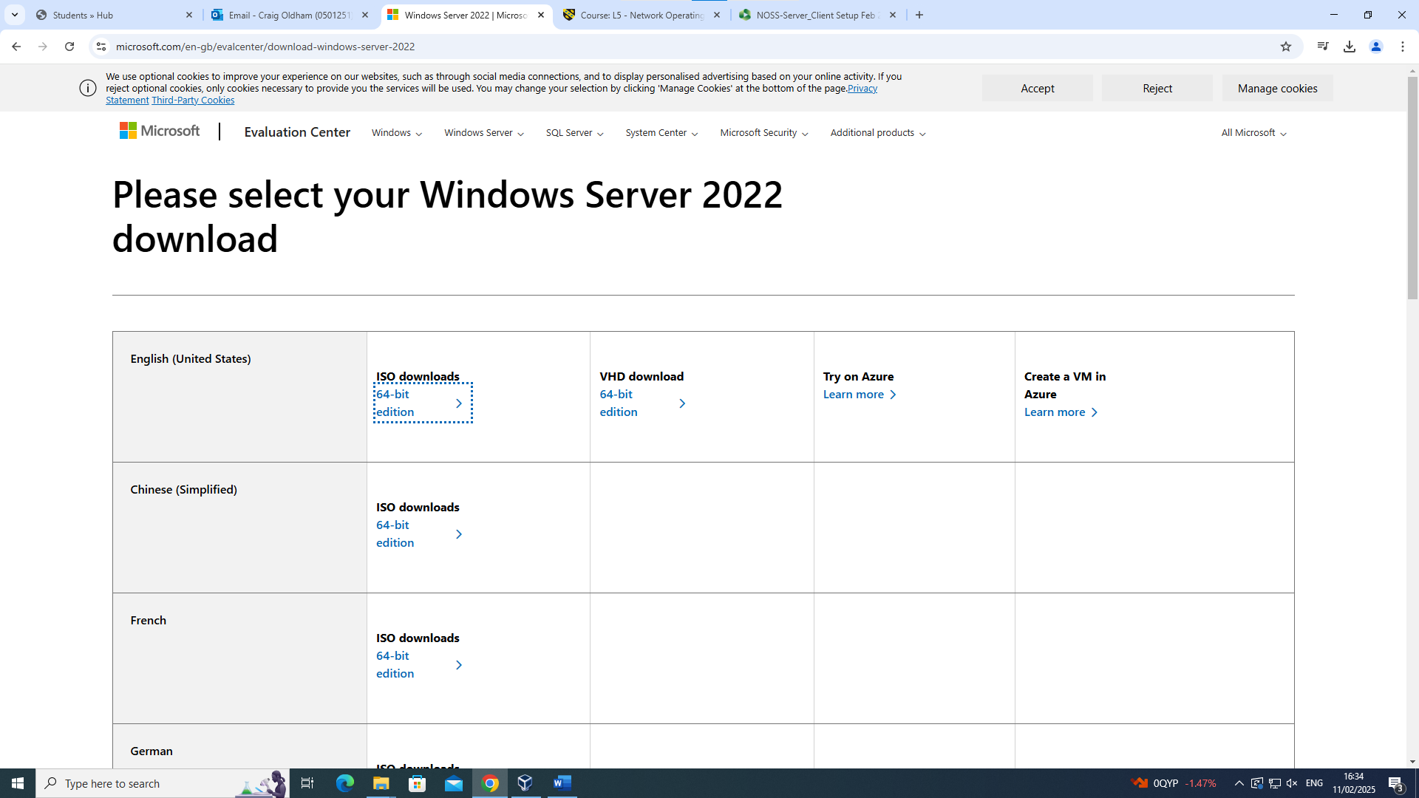
Figure 2: Downloading the image required to set up the Swansea Windows Server
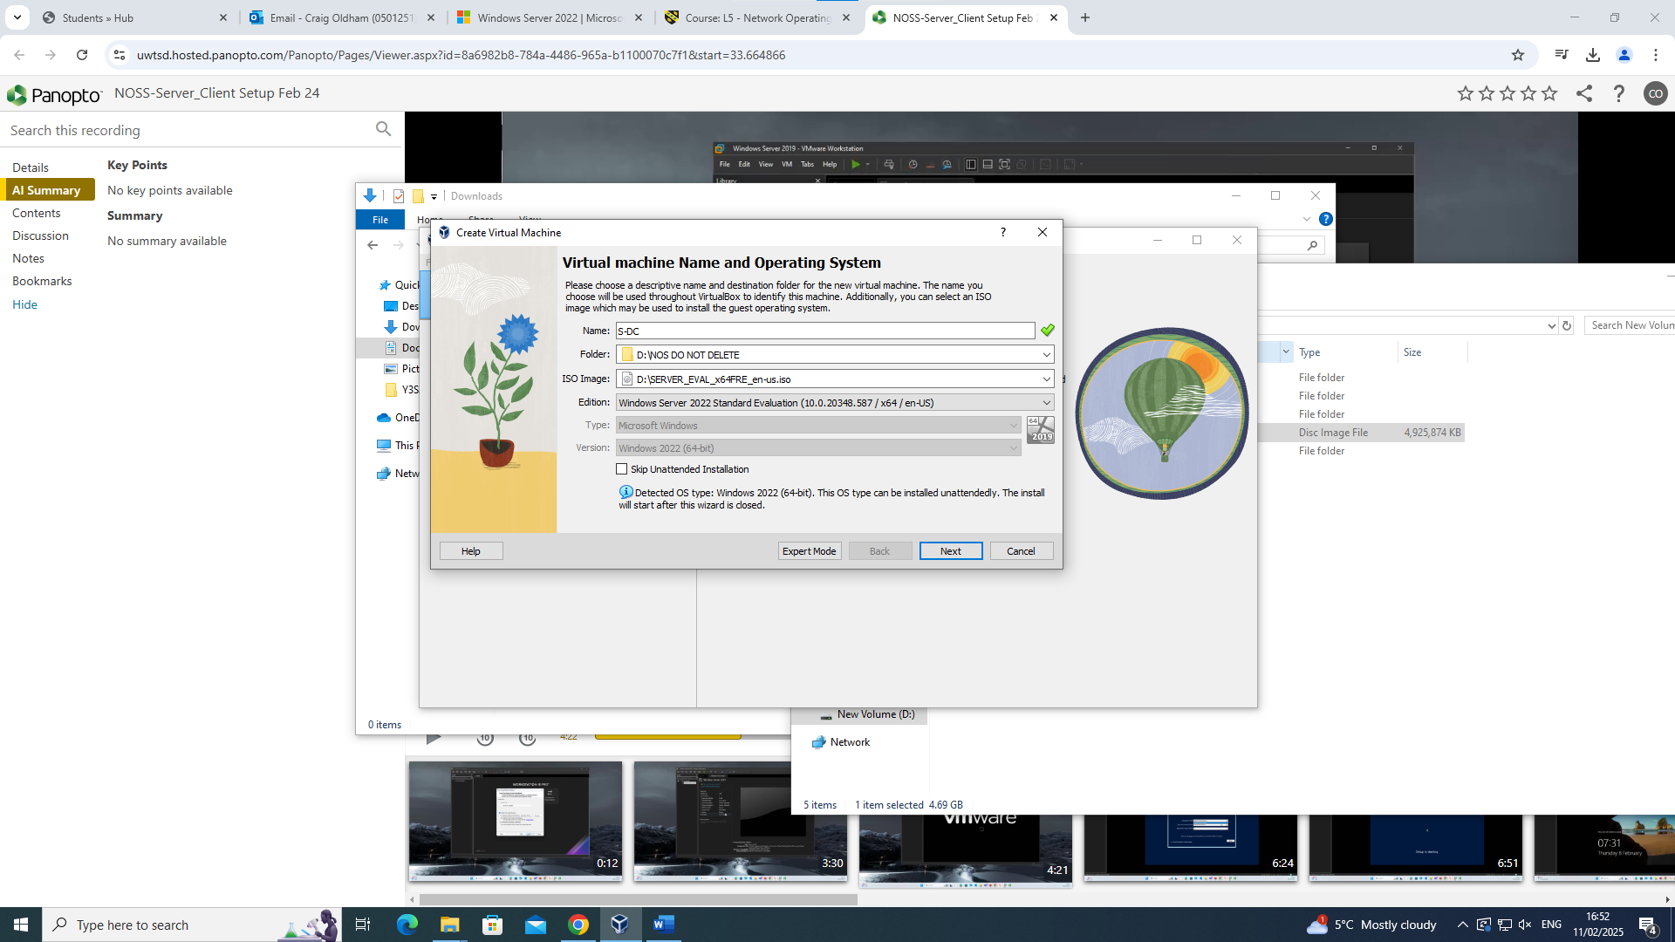
Figure 3: Setting the location on the PC for the S-DC Virtual Machine to be stored

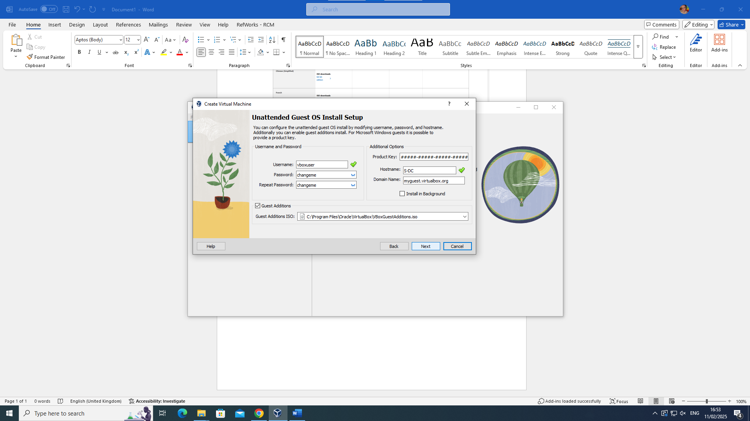
Figure 4: Configuring the credentials for the S-DC server
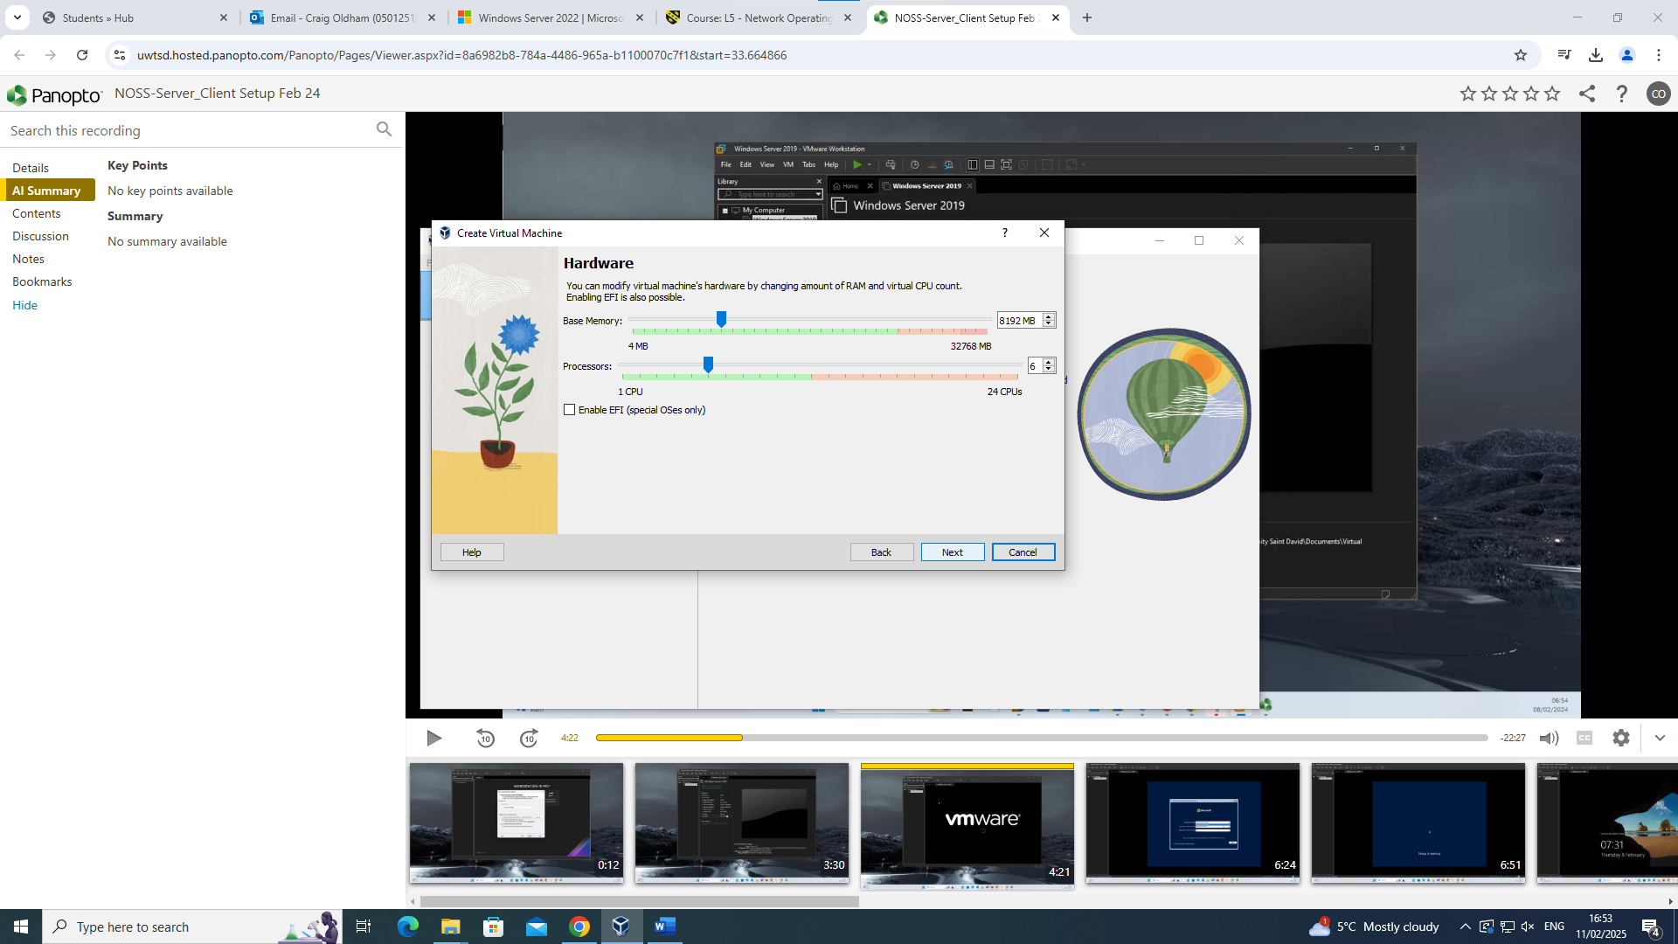
Figure 5: Allocation of Hardware RAM and CPU resources to run the S-DC Virtual Machine
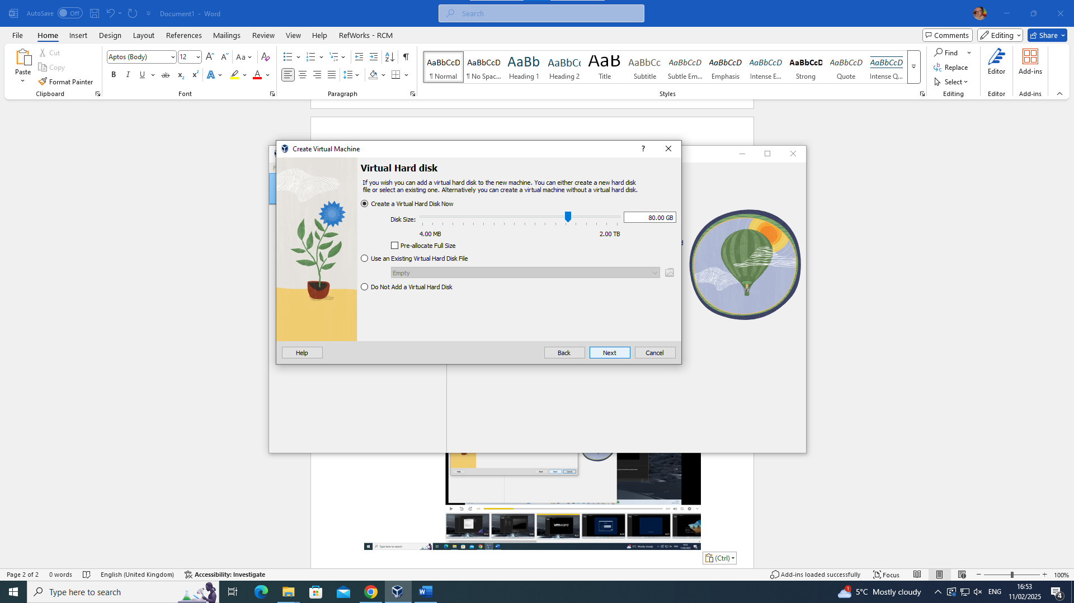
Figure 6: Allocation of Hard-Disk Space for the S-DC Virtual Machine
My initial installation failed, so I did have to start again, making sure I didn’t miss any steps in the setup
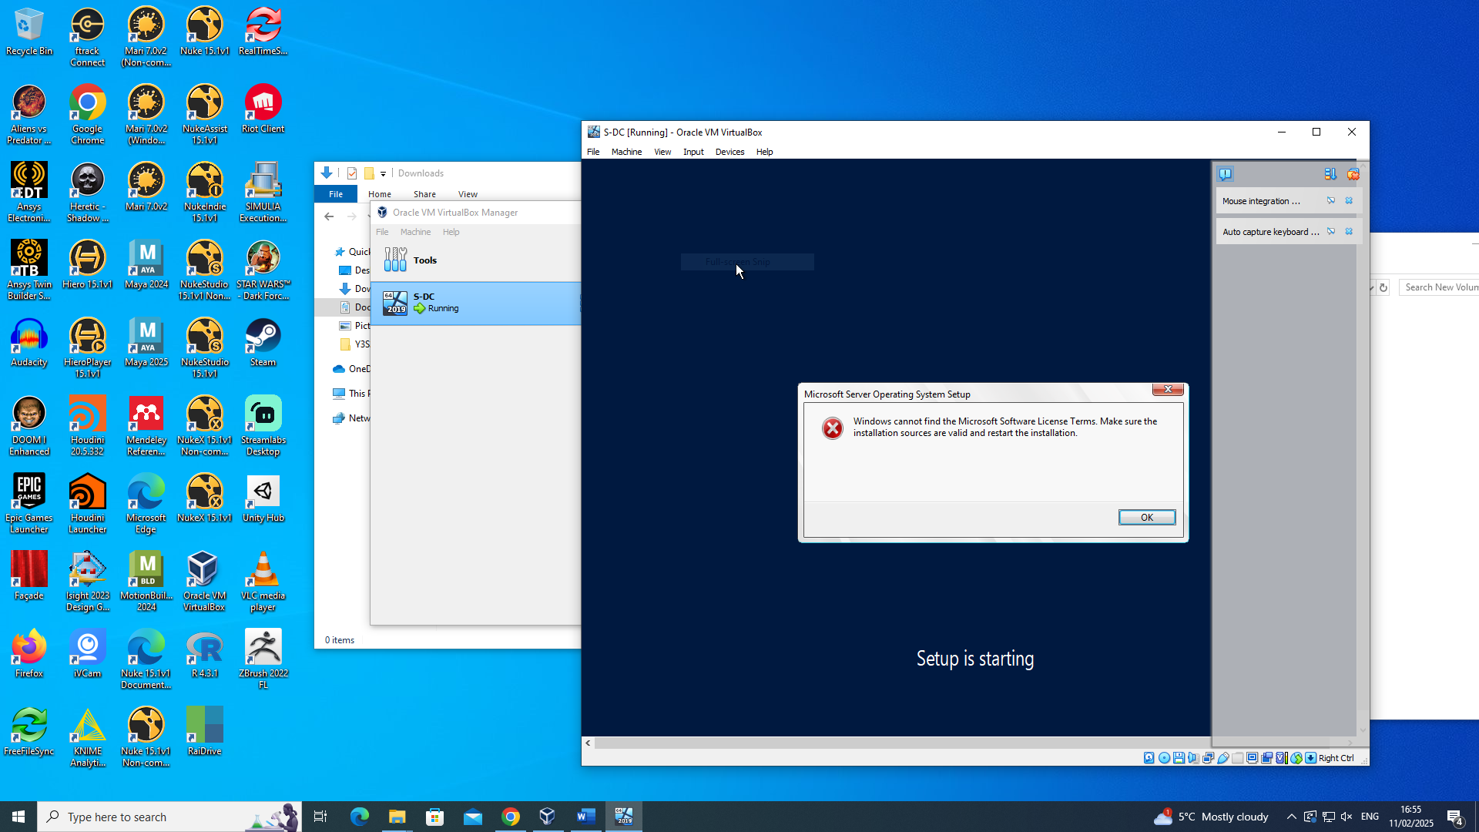
Figure 7: Failed installation of S-DC Windows Server
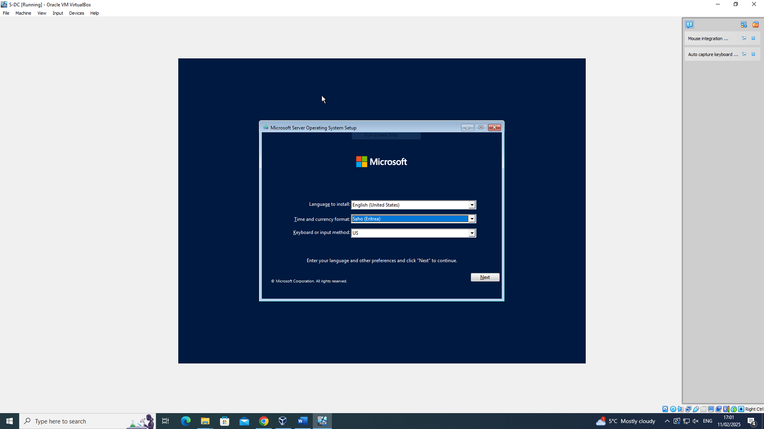
Figure 8: Configuring the Language and Timezone settings of the S-DC Server
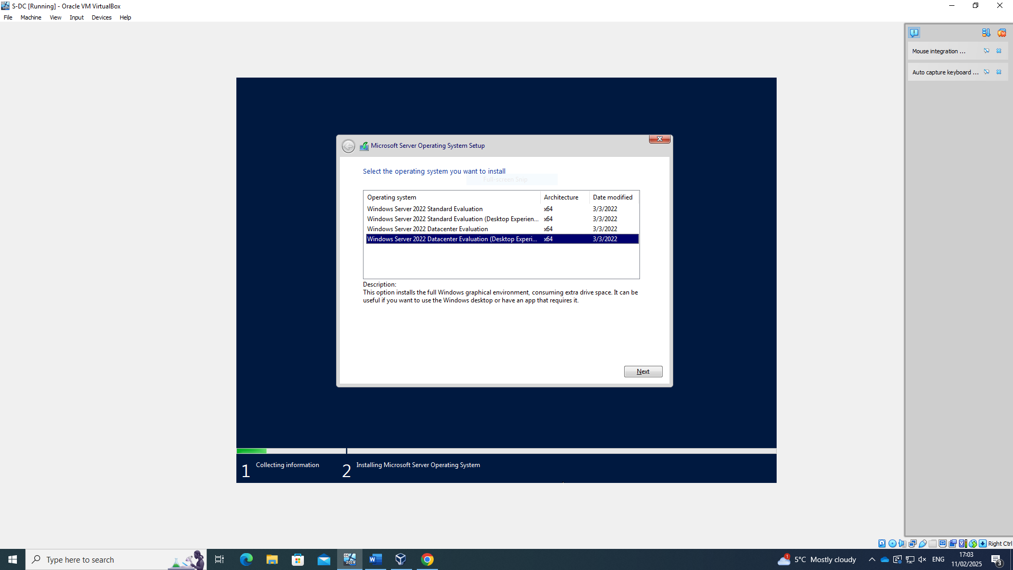
Figure 9: Choosing the right build of Server to use for the S-DC
Identical steps were followed for installing the Windows Client and Linux Servers and clients

Testing Connectivity
Once the Windows Server and Client had been successfully installed, I needed to see if they could communicate with each other by running ping commands in each virtual machine’s command line interface. As figure10 shows, my first attempt was unsuccessful.
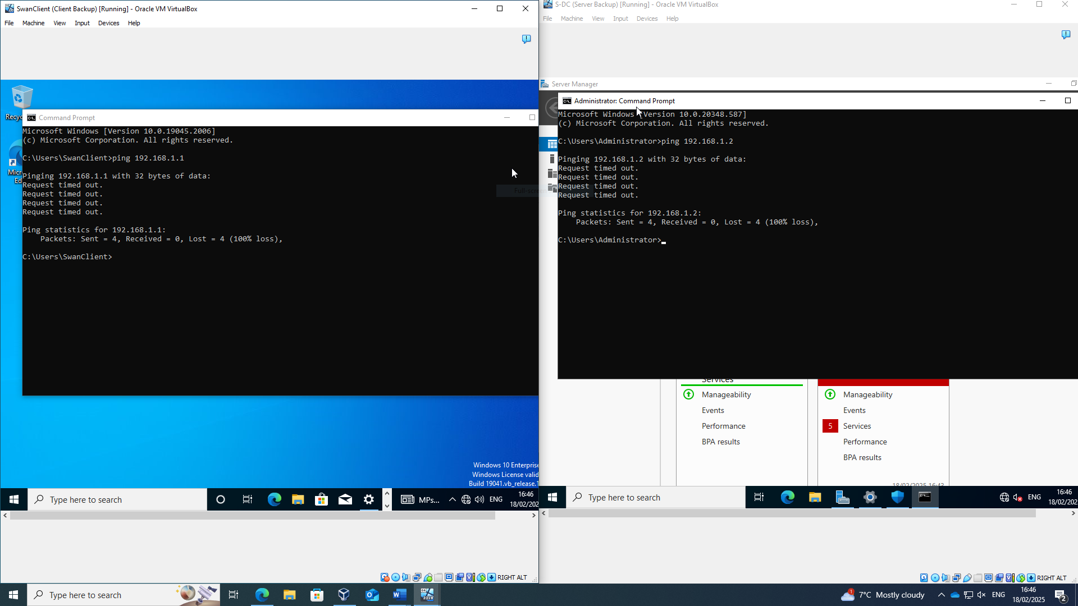
Figure 10: Unsuccessful pings between the Swansea (Windows) Server and Client Virtual Machines
To resolve this, all firewall settings were disabled on both the Server and Client Virtual Machines. In a real-world environment, this is not something that would normally be done, but for demonstration purposes, this was the only way to let the traffic through. Figure 11 shows that removing the firewalls worked and the pings were successfully sent from Server to Client and vice versa.
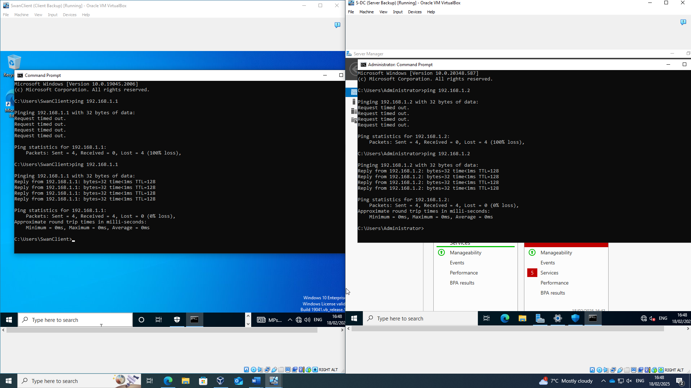
Figure 11: Successful Pings from Swansea (Windows) Server and Client Virtual Machines
Figure 12 shows the IP Configuration of all 4 virtual machines, with the Windows Server in the top left, Windows Client in the bottom left, Linux Server in the top right and Linux Client in the bottom right.
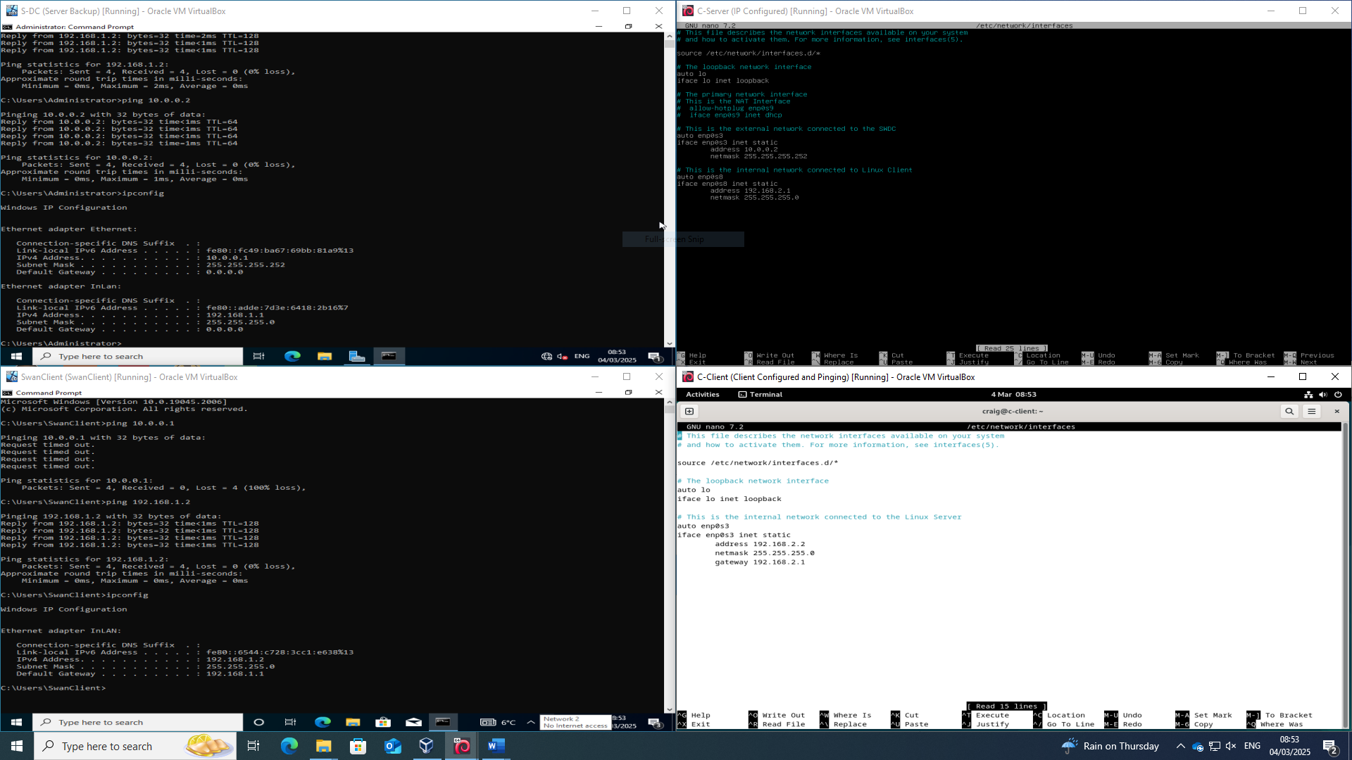
Figure 12: IP Configuration for Windows and Linux Servers and Clients
Figure 13 demonstrates successful pings between both Windows and Linux machines within their own networks and a successful connection between the Windows and Linux Servers with each other.
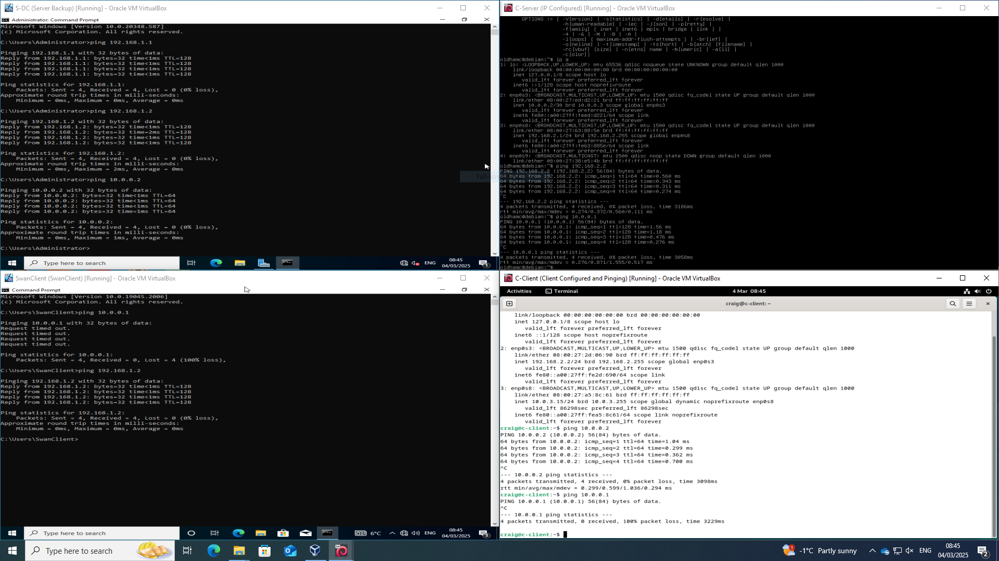
Figure 13: Successful pings between Windows Server & Client, Linux Server & Client and Windows & Linux Servers
To demonstrate an unsuccessful connection between the Windows Server and the Linux Server, I altered the names of the networks on the Windows Server Virtual Machine and attempted to ping each server from their respective machines. As Figure 14 shows, they were unable to connect to each other.
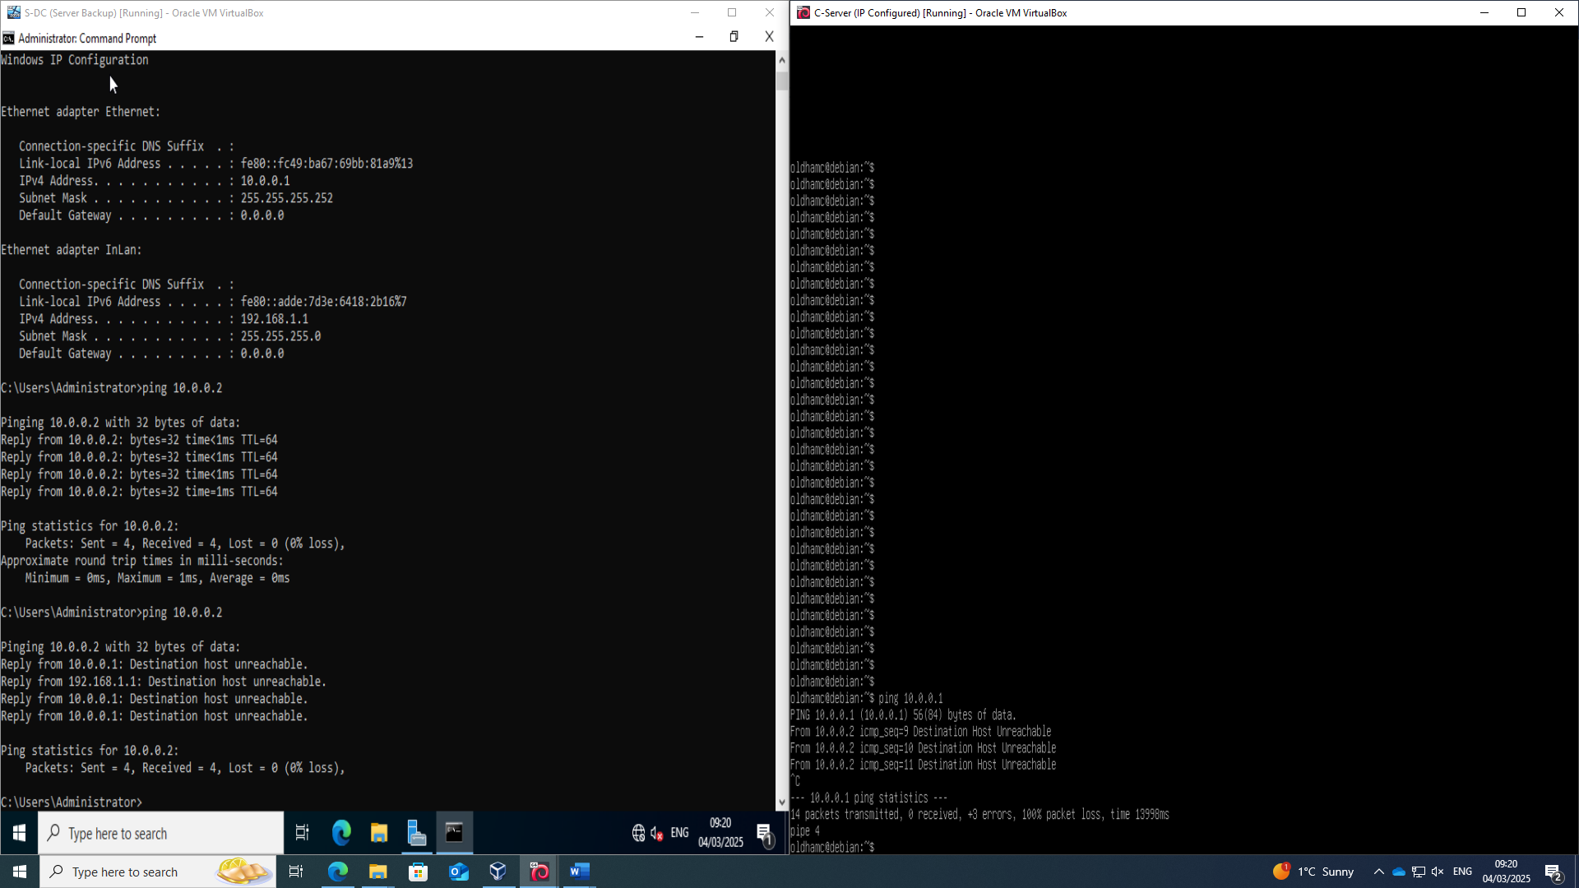
Figure 14: Unsuccessful Ping test between Windows and Linux Servers
One of the requirements of Oracle Virtualbox is that the network adaptors must use the same naming convention across all virtual machines if they are going to connect with each other. By changing the name on the Windows machine, the Linux machine was unable to connect to it through the internal network connection.

Task 3: Reflection
Network Operating Systems and Services, Hypervisors and Virtual Machines deployment are all concepts that are new to me as is the use of command line scripts. As such, there were instances during the deployment and testing where I thought I had connection issue but in fact had entered invalid IP addresses for the ping tests. I was aware that there could be connection issues with the Windows Firewalls and by removing them was able to quickly get my Windows machines talking to each other.

References
[1] Anonymous (-04-20). Type-1 and Type-2 Hypervisors Explained. Available: https://www.bdrsuite.com/blog/type-1-and-type-2-hypervisor/.
[2] O. Pankevych. O. Pankevych. Type 1 vs. type 2 hypervisor: What is the difference? Type 1 vs. type 2 hypervisor: What is the difference? 2023. Available: https://www.starwindsoftware.com/blog/type-1-vs-type-2-hypervisor-what-is-the-difference/.
[3] K. Ward. (-04-12). The Top 5 Enterprise Type 1 Hypervisors You Must Know. Available: https://www.actualtechmedia.com/io/top-5-enterprise-type-1-hypervisors/.
[4] Anonymous Anonymous KVM hypervisor hardware and software requirements - SBC core 12.1.x documentation - ribbon public documentation center. KVM hypervisor hardware and software requirements - SBC core 12.1.x documentation - ribbon public documentation center. Available: https://publicdoc.rbbn.com/display/SBXDOC121/KVM+Hypervisor+Hardware+and+Software+Requirements.
[5] C. Team. C. Team. The importance of network addressing and how it works. The importance of network addressing and how it works. 2023. Available: https://www.cachefly.com/news/understand-network-addressing-its-importance-and-how-it-works/.
[6] Anonymous (-11-07). What is an IP Address? Types and How to Protect your IP Address. Available: https://www.kaspersky.com/resource-center/definitions/what-is-an-ip-address.
[7] Anonymous . Understanding IPv4 vs IPv6: Key Features and Differences. Available: https://www.simplilearn.com/tutorials/cyber-security-tutorial/difference-between-ipv4-and-ipv6.
[8] R. Nyarko. (, 17 May). What are subnets and subnetting, and how do they work?. Available: https://gcore.com/learning/what-is-a-subnet-how-subnetting-works/.
[9] R. T. Kambhampati. R. T. Kambhampati. Routing and switching: Foundations of modern network design and implementation. Routing and switching: Foundations of modern network design and implementation. International Journal of Computer Engineering and Technology (Ijcet) International Journal of Computer Engineering and Technology (Ijcet) 1515(4), pp. 610–621. pp. 610–621. 2024. Available: https://lib-index.com/index.php/IJCET/article/view/IJCET_15_04_054.
[10] Anonymous (-05-20). Difference between Static and Dynamic Routing. Available: https://www.geeksforgeeks.org/difference-between-static-and-dynamic-routing/.
[11] A. Shaikh, C. Isett, A. Greenberg, M. Roughan and J. Gottlieb. A. Shaikh, C. Isett, A. Greenberg, M. Roughan and J. Gottlieb. A case study of OSPF behavior in a large enterprise network. A case study of OSPF behavior in a large enterprise network. 2002, . DOI: 10.1145/637201.637236.
[12] C. Craven. . Virtual Private Network (VPN) Best Practices. Available: https://www.sdxcentral.com/security/definitions/what-is-encryption-definition/what-is-virtual-private-network-vpn/what-are-vpn-best-practices/.
[13] Anonymous Anonymous DHCP best practices and DNS overview: Sysadmin’s guide. DHCP best practices and DNS overview: Sysadmin’s guide. 2019. Available: https://www.msp360.com/resources/blog/sysadmins-guide-to-network-services/.
[14] S. Contributor. (-05-29). The Ultimate Guide to Active Directory Best Practices - DNSstuff. Available: https://www.dnsstuff.com/active-directory-best-practices.
[15] E. Raphaely. E. Raphaely. 5 best practices for certificate authority management. 5 best practices for certificate authority management. 2024. Available: https://www.securew2.com/blog/best-practices-certificate-authority-management.

Table of Figures
Figure 1: Class A IPv4 Network Topology 4
Figure 2: Downloading the image required to set up the Swansea Windows Server 7
Figure 3: Setting the location on the PC for the S-DC Virtual Machine to be stored 7
Figure 4: Configuring the credentials for the S-DC server 8
Figure 5: Allocation of Hardware RAM and CPU resources to run the S-DC Virtual Machine 8
Figure 6: Allocation of Hard-Disk Space for the S-DC Virtual Machine 9
Figure 7: Failed installation of S-DC Windows Server 9
Figure 8: Configuring the Language and Timezone settings of the S-DC Server 10
Figure 9: Choosing the right build of Server to use for the S-DC 10
Figure 10: Unsuccessful pings between the Swansea (Windows) Server and Client Virtual Machines 11
Figure 11: Successful Pings from Swansea (Windows) Server and Client Virtual Machines 11
Figure 12: IP Configuration for Windows and Linux Servers and Clients 12
Figure 13: Successful pings between Windows Server & Client, Linux Server & Client and Windows & Linux Servers 12
Figure 14: Unsuccessful Ping test between Windows and Linux Servers 13

