Contents Page

Contents Page 1
Introduction 2
Aims and Objectives 2
Who’s involved? 3
Sessions 4
Funding 5
Advertisement and Marketing 6
Other support groups 6
Barriers 7
Overcoming the barriers 8
Conclusion 8
Appendices 9
References 11

Introduction

Referring back to the needs analysis, the data collected shows that there desperately needs to be something done. I am going to open up a support group for children and young people with mental health and it will be called ‘Let’s Talk’. This will be available for people up until the age of 21 as there are adult mental health services available when they reach that age. Support groups can play an important role in coping with and overcoming problems. Organising and maintaining a strong support group does take time and a lot of effort.

Aim and Objectives

The aim of this unit will be to help young people and children with any problems that they are having but most importantly this unit can be a listening ear from someone who gets it. This support group is going to be somewhere for young people and children to come anytime of the day, everyday. Let’s Talk will be somewhere where young people and children can come to talk openly about their mental health in a safe environment so they will not rejected from less than empathetic ears. It will be somewhere for them to have one to one sessions with a trained specialist where they can talk about any problems that they are having or if they just simply want a chat and some company. It can also be a place where young people and children come to hang out, play games and socialise with one another which you would not get anywhere else. Let’s Talk will take many forms depending on the needs of the group members. There will be many groups, some can be for the carers only which will give the carers options and advice on what to do for their children and different ways they can help. Mostly, the groups will consist of people who have experienced or are still experiencing mental health illness. It gives children and young people a chance to get out of the house if they are being isolated, and it gives them a chance to socialise with others who are in the same boat. This support group will aim to have a focus on self-help, massive amount of information for everyone who attends, peer support, campaigning and fundraising. The main aim of this support group is to help fellow suffers take some control over their problems.
Let’s Talk will support and empower people with mental health illnesses. We would do this by providing information that people need so they know what their rights are, getting them to control their own lives and make a difference and by assisting people to take part in what we do within the support group. The support group will work towards good practice in mental health services based on the needs and rights of the individuals who come to Let’s talk. We would do this by working closely with the individuals campaigning locally, providing information and training on mental health issues to other organisations. Let’s Talk will raise public awareness of mental health issues. We would do this by providing useful information produced by other mental health organisations and by working with the media to highlight the importance of mental health issue. The support group will work towards a more sustainable organisation. We would do this by attracting volunteers, staff and trustees with the skills and experience required, by raising the profile Let’s Talk and by reviewing service user involvement.

Who’s involved?

Everyone is welcome to Let’s Talk, anytime of the day and any day of the week. Many people will be involved within this support group, and each and every one who is involved will be equally important. There will be a few leaders of the support group where they are responsible for maintaining the structure of the group and keeping the group on topic. Leaders will also set up sessions and meetings and organise one to one meetings with the peers that attend. They must also make arrangements for speakers, and be assertive. There needs to be specialist trainers and professionals within the mental health industry. A professional in the support group can answer any questions with expertise. This is very important as someone might have a certain question where the support workers may not be able to answer. The specialists can also help someone who is in obvious distress by taking that person to a private room and maybe contact a family member, therapist or a counsellor.
There will also be doctors available for assessments, for example, if a parent or a teacher referred you to Let’s Talk we can carry out an assessment on someone to see what help they can get and a develop plan will be available for what happens next. All people that are involved in this support group will need to have 100% commitment to the group as it will be open 24/7 for anyone who needs the help. All specialists and those who are involved will have to have monthly meetings as they are sufficient. In general, a meeting can include both a discussion and goal-planning so it should take around two hours long so dedication is everything.
There will also be volunteers that can take part and be involved in this support group as they can be studying mental health in university, or just have an interest in helping others with a mental health illness. The volunteers will have a dedication and passion for empowering those with mental health problems and they will also have a highly approachable and professional manner. Volunteers can be in the one to one sessions, talk to the members, be in the office or the technical support side and just provide emotional support for all the people who will use this service activities and the support sessions.

Sessions

There will be numerous sessions available within the support group. In some sessions, a profession will be invited in to give a presentation at the start of the session as this way the speaker provides perspective on a particular issue. Some examples of the sessions that will take place are peer support sessions, self harm support, bipolar support group, depression and anxiety self help support group, managing anger courses, counselling sessions and many more. Many sessions will have decided on a topic before it starts, for example, on a Monday there might be a self-harm topic and a discussion. Whereas on a Tuesday there may be a drug and alcohol abuse session. Topics of the sessions can be directly or indirectly related to the group’s core problems and each and every member should have a chance to share their thoughts about it. However, many may not want to share their ideas within a group, they may want to have a one to one discussion at the end and that is perfectly fine. It is acceptable for someone to decline to respond. There will be more than one session running at a time, depending on how many people turn up to the sessions, The children or young people who attend just to have a chat or play some games are perfectly fine to do it, others who want to come and have a discussion on a certain topic are welcome to at any time. There will not just be one session per day. Socialising is a massive part of the sessions. There will be refreshments through each session and many breaks available. Socialising within sessions can include friends catching up, making new friends, informal discussions of the chosen topic and asking for additional advice from the leaders or other members of the support group.
There will be goal planning for each member. Members should also choose a specific goal to work on that can be accomplished by the next week. By doing goal planning it gives the support workers a chance to know what the individual wants to achieve and accomplish and it also gives the individual a chance to reflect on their goals and see how much they are developing and overcoming their problems which will only lead to further success. Each person’s success helps the whole group as some individuals who may be having difficulties to view their success, may have inspiration off others. Goals must be simple and easy to achieve for them to see a difference. If people pick impossible goals then it can have a negative affect on their self-esteem and they may think that the sessions are a waste of time and then they will not carry on to attend. The goals should be active or for them to think in a new way. There will be no failures when it comes to this. When a member simply does not reach their goal then it is not a failure. Let’s Talk will never call someone a failure, or tell something that their goal is not reachable because every goal is achievable. This is where we come in and they to help that person find a different way to accomplish the same goal. Medication is not going to be discussed with the support group. This support group is trying to provide support and help members learn how to regain control of their behaviour.

Funding

The Welsh Government want mental health services in Wales to meed the needs of the whole population. They want services as close to people’s homes as possible, people to be assessed and treated in a timely manner, mental health and social services to work together, emotional health and wellbeing to be promoted among the wider population and for mental health discrimination to be ended. The Welsh Government are inviting applications for grant funding from national Third Sector organisations in Wales, to run a mental health focused social pilot scheme. The total amount of funding available each year between 2018 and 2021 is up to £500,000. (See Appendix 1 and 2). Applications are now open. I will complete an application form for my mental health support group Let’s Talk and hopefully will be accepted to have a loan off themselves. In Wales, more than £600m a year is invested in mental health services which is more than any other service in the NHS. There is also an additional £16m a year which is being invested in mental health services which is already helping to develop more effective perinatal services which is improving access to psychological therapies and child and adolescent mental health services. Professor Drakeford (2016) said:
One in four adults experience mental health problems or illness at some point during their lifetime, while one in six of us will be experiencing symptoms at any one time. One in 10 children between the ages of five and 16 has a mental health problem and many more have behavioural issues.
I intend to raise money for this support group from the public by fundraising. I will register with the Fundraising Regulator to demonstrate my commitment to good fundraising practice. The BBC award grants for projects working with children and young people aged under 18. The small grants are under £10,000 for one to three years. Mental Health Foundation also helps to try and improve the lives of those with mental health problems or learning difficulties. There are many organisations that can help me run this support group.

Advertisement & Marketing

The advertisement and marketing effort will provide success to the support group. There will be flyers and posters that will have a brief description of what Let’s Talk is all about. It will have information on the flyer about where it is, what meetings take place, what time it is open and contact information. (See appendix 3). I will ask other mental health organisations to post the flyers in their offices or get them to send an announcement to their members or patients to let them know about our support group we are opening. I will see if local mental health organisations will let me set up a stall in their sessions to recruit members and get them aware of what Let’s Talk is all about. I will contact the local newspapers and local radio stations to inquire if they will broadcast the information for our support group. I will attend schools in the areas and talk to them about what the support groups offer and leave posters with the school to be put up around the school so any pupil can contact us or turn up to our sessions. I will go to colleges, churches and community centres and also ask them to put posters up around the place, hopefully this would catch peoples attention. I will make a website so people can contact us through our emails and the website will also have all the information members need to know, like what sessions are what days and what times. I will also market my support group to social media sites such as Twitter, Instagram, Facebook and other social networking sites as most young people use social media so it will spread the word fast.

Other support groups

There is a support group in Swansea called Mind. They are a mental health charity where they aim to work towards a mental health service that is based on the wishes, needs and rights of those who use their service. Support and empower people with mental health problems. Assist in developing a good practice in mental health services and provides information and services for people with mental health problems. Swansea Mind tries to uphold the following values in all areas of work such as equal opportunities, user empowerment and involvement, choice, working together and being confident.
Another support group in Swansea is called Bipolar UK. They are a mental health organisation which focuses on people with bipolar only. They are the national charity dedicated to supporting individuals with the much misunderstood and devastating condition of bipolar. They reach out to over 80,000 individuals through their range of services. Their free support groups are free to attend and are open to anyone affected by bipolar, including friends, family and carers. They are open 6 pm - 8 pm and meetings are held every first Monday of every month.
Although these two mental health organisations are good and are making a difference in Swansea. I think Let’s Talk has something special which is different to these support groups. Firstly, Let’s Talk is open 24/7. So if a person is feeling very isolated late at night or is having thoughts to do something like suicide because of for example depression, we will be here for them any time of the day. I think that is vitally important as it gives each member the relief that someone is also there waiting. The Bipolar UK only focuses on one mental health so therefore people with other mental health conditions such as an eating disorder would be restricted to attend that support group. Whereas Let’s Talk has sessions and experienced specialist who know everything about every mental health, so there is never a moment we will not be able to help a person suffering. The main point of the difference is that Let’s Talk is aimed at children and young people whereas the other support groups I have mentioned focus on adult mental health issues.

Barriers

Although it is clear that I can not help everyone, this support group will be a start. If the group was too narrowly focused, for example, focusing on one mental health then it is very likely that there will be a difficulty finding enough members to attend the sessions. Family members are encouraged to come with their children to be involved in what is going on, but I understand that not all family members are understanding so they may be disruptive or use selective hearing in the support group, which can result in the children attending to avoid coming back. Another barrier may be that the individual is isolated and on their own, so they may have a problem travelling down to our support group. Many children are embarrassed to talk about their mental health problems so attending a support group would be the last thing they would want to do. Because public, perceived and self-stigmatising attitudes to mental health illness can create embarrassment and it is the fear of identifying themselves with a mental health illness. Some young people simply do not know how to identify when the difficulties they are facing are beyond the normal things such as stress so they are not aware that it is a mental health illness so they just continue to identify themselves as no mental health illness. Trust and having confidence in someone is very difficult for young people to do, especially if they do not know the people they are going to confide in as there is a lack of familiarity.

Overcoming the barriers

There are many ways Let’s Talk can overcome these barriers. This support group will be very broad. The broader the group, the greater effort I will make to help others understand the similarities they have amongst each other. Family members can come to the support groups, and there will also be a session for the parents and the carers where it will be focused on how they can support and help their child and guide them along the right path of recovery. People that have a problem travelling down to the support group, they will have the option to call us and one of us can go and pick them up from their house. So there will never be a time where a child or young person has to keep their thoughts and feelings to themselves as we will always be here. Embarrassment is very high amongst young people who have a mental health issue, they do not want to talk about things as they feel as if they are not ‘normal’. This support group will take that away from each member and get them to see that embarrassment is not the answer and it never will be something to be embarrassed about. A lot of young people have trust issues when it comes to issues like these. That is why we will build a relationship with each and every member and create a strong bond so they will know that they can talk to us about anything.

Conclusion

Overall, in conclusion, I think Let’s Talk will be a great success. The number of children and young people who are suffering in silence because there is not a place like this around is terrifying. This is why this support group will be the next step to children and young people suffering to take control of their own life and to help make a difference. Let’s Talk will be open 24/7 so there is never a time that someone cannot come and talk to us and I think that is what makes it so special. It is special because all the staff and members involved will be one big family. As I explained earlier, this unit will be a listening ear from someone who gets it.There is nothing like this support group around and it definitely needs to be the first one and I can guarantee it will not be the last one.

Appendices

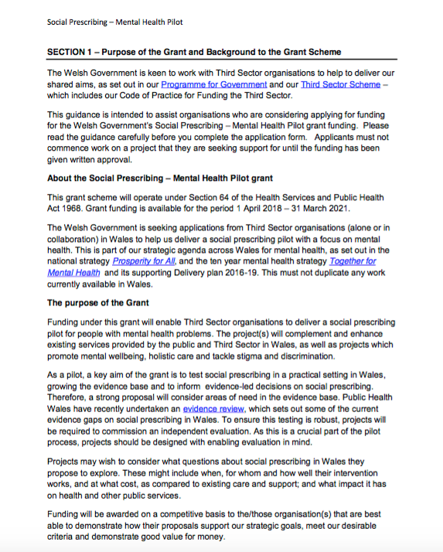
Appendix 1 (http://gov.wales/topics/health/nhswales/mental-health-services/?lang=en)


Appendix 2 (http://gov.wales/topics/health/nhswales/mental-health-services/?lang=en)

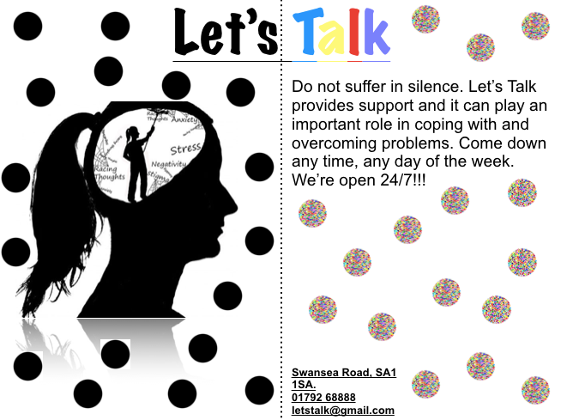
Appendix 3
References

Welsh Government (2017). Mental Health: Good Mental Health and Well-being is Essential.
(Last accessed 7th December 2017).
http://gov.wales/topics/health/nhswales/mental-health-services/?lang=en

Drakeford, P. (2016). New three-year plan to improve mental health services in Wales.
(Last accessed 18th January 2016).
http://gov.wales/newsroom/health-and-social-services/2016/mental-health/?lang=en

Swansea Mind
http://www.swanseamind.org.uk

Bipolar UK
https://www.bipolaruk.org

