Student Name: Evangelos James Manolikas
P Number: 1902155
Programme of Study: Automotive Design
Module: Ways of Thinking

Task in the order I received them:
Task One: Manifesto (Julia’s Task) =500 words
Task Two: Semiotic Analysis (Ryan’s Task =500 words
Task Three: (Jon’s Task) =500 words

Task 1: Julia Lockheart-Manifesto Writing:
“What do I believe in?”

- Automotive Designers need to be skilled in multiple areas.

- Teamwork plays an important role in Automotive Design.

- Innovation is key to competing in the Automotive Design Industry.

- Designers need to be able to keep up with the modern world.

- Creativity should not be limited

- Designers need to know the demographic their car will appeal to.

- New car designs should be creative without eliminating the heritage of the previous models.

- The car design should typically portray the trademark of the company it derives from.

Keywords and Images
Skill
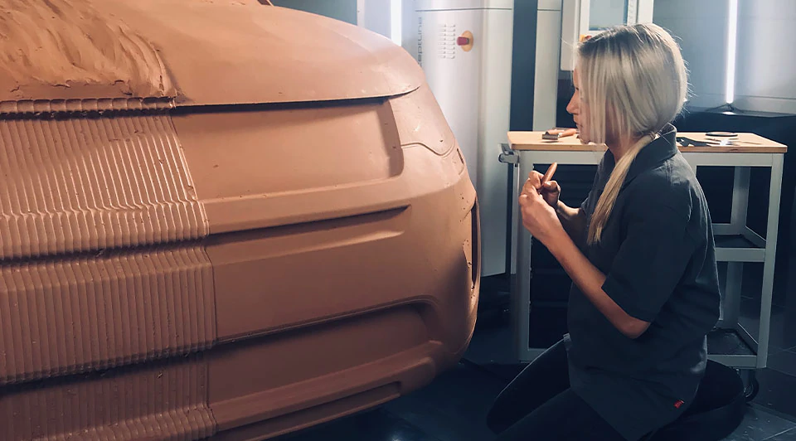
Figure 1: Automating artistry

- Automotive Designers need to be skilled in multiple areas.
Automotive Design is a sophisticated industry in which there are multiple different disciplines. These disciplines can be exterior, interior, wheels and aerodynamics. For each of these disciplines, designers must possess the necessary skill and the knowledge in order to produce their product. Skills such as sketching, sculpting, modeling and digital design are essential for creating a car. As Thom Taylor and Lisa Hallet quote “Having the equipment without knowing drawing basics won’t help you a bit” (How to draw cars like a pro. 1997. Page 14). The starting point of every new design is to transfer your ideas on to paper. With good drawing skills a designer is able to clearly project his ideas. Clay models and 3d renders help emphasize the design and expand the vision of the initial design. Creativity, patience, delicacy and an eye for detail are all prerequisites for every automotive designer. With all skills combined, Automotive designers can produce stunning result.
Keywords and Images
Time
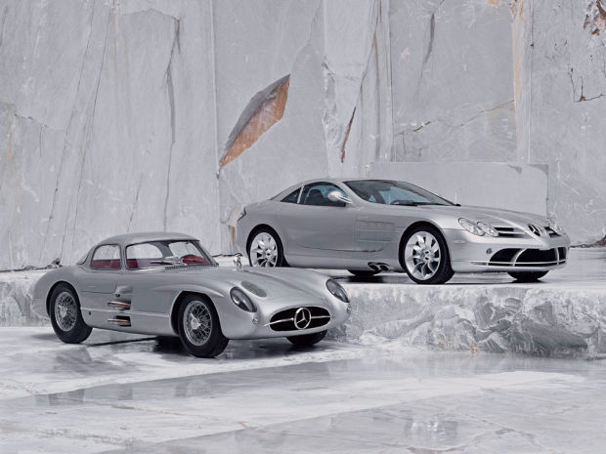
Figure 2: Mercedes Benz
- Designers need to be able to keep up with the modern world.
Time is an important issue regarding automotive design. As time passes, the environment together with trends, styles and interests change. The style of the design is the biggest selling point of the vehicle. An unpopular design can ruin the company’s reputation. In general, automotive designers find that designing the exterior concept of a vehicle is the most enjoyable process of automotive design, as stated from Neil Burtley (in the book An Introduction to Modern Vehicle Design. 2002. Page 93). In order for a car design to be successful, it needs to intigrate modern day standards. The design of a vehicle must be timeless. Time can be an automotive designer’s ‘worst enemy’ as stated from Paul Bracq in the video Paul Bracq, a BMW designer of the 70s (2014). Designers must take into consideration the past and the essence of an automotive company in order to create a modern piece of artwork. People will not buy something that is outdated and uninteresting.

Keywords and Images
Demographic
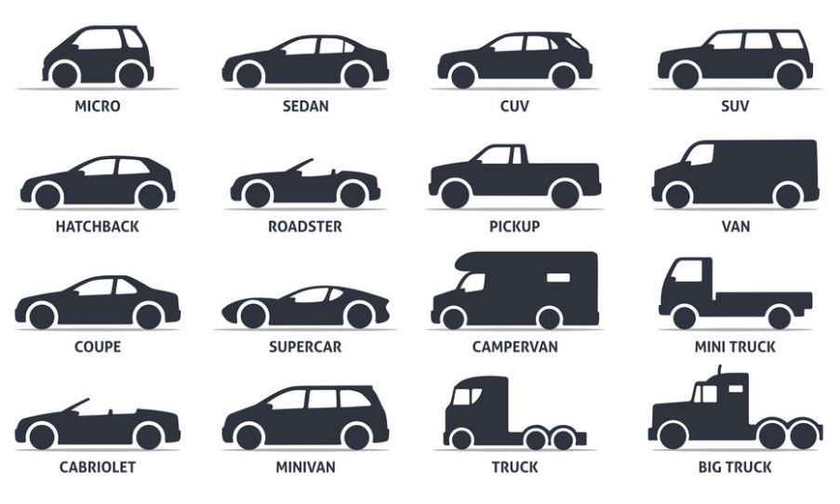
Figure 3: 9 Types of Cars: Which is Right for You?
- Designers need to know the demographic their car will appeal to.
The consumer is by far the most important factor regarding automotive design as this determines whether the design is sellable and therefore successful. Modern times have seen an increase in car categories ranging from hatchback cars to large trucks which attract a wider range of consumers The category of car is usually determined at the beginning of the project in order to help navigate designers in a more specific direction. (Stuart Macey and Geoff Wardle. H Point. The Fundamentals of Car Design and Packaging. 2009. Page 25). Once the type of vehicle that needs to be produced has been decided, the designer must then take into consideration the consumer and adapt to their requirements and fulfill specific needs such as luggage space, passenger capacity and car size. Age groups are an important factor in the design process as well as economic, environmental factors and the vehicles power source.

Bibliography:
- Burtley, N. (2002) An Introduction to Modern Vehicle Design (Edited by Julian Happian-Smith). Oxford, Butterworth-Heinemann
- Stuart Macey and Geoff Wardle. H Point. The Fundamentals of Car Design and Packaging (Forewords by Ralph Gilles, and Freeman Thomas and Professor Gordon Murray.). 2009. Page 25. Vehicle types and market segments.
- Thom Taylor and Lisa Hallet. How to draw a Car like a Pro, 1997, Page 14, Tools and Equipment.

Figures:
- Figure 1: Automating artistry
Accessed from Autodesk
https://www.autodesk.com/customer-stories/kolb-clay-milling?linkId=68840826
Accessed on 01/12/2019
- Figure 2: Mercedes Benz
Accessed from InfotainWorld
https://infotainworld.com/21-photos-of-classic-cars-vs-their-modern-version/
Accessed on 01/12/2019
- Figure 3: 9 Types of Cars: Which is Right for You?
Accessed from Smart Motorist
https://www.smartmotorist.com/car-types
Accessed on 01/12/2019

Video Reference:
Paul Bracq. Paul Bracq, a BMW designer of the 70s. 2014
Accessed from YouTube
https://www.youtube.com/watch?v=Popc1kRM6JA

Task 2: Ryan Moule-Observational Writing:
Identify an image and write a semiotic analysis.

Photography has greatly impacted our world and continues to do so. It is something that influences our everyday lives. We use photography to create memories or be creative. Photographs are used in Professional fields such as medicine, science, education cinematography as well as trade advertisement. Advertising is everywhere and at times, we cannot escape it! The reason that images or photographs are used for commercials is because they are particularly powerful. As quoted from Vicki Goldberg (in her book The Power of Photography: How Photographs Changed Our Lives. 1993. Page 7) “Photographs have a swifter and more succinct impact than words, an impact that is instantaneous, visceral and intense”. Usually there are two types of images used in advertising. The one type of image usually portrays the product in a colorful energetic environment, often accompanied with lengthy bold statements in an attempt to try to manipulate the viewer to purchase the product. The other type of image seen is more simple and subtle with far less wording on the image itself promoting the product. These types of photos do not “scream out” at you in order to buy the product. They instead charm you with their simplicity. An excellent example of simplistic commercialism can be seen in Aston Martin’s new car model promotional image, The Aston Martin D11. The image consists of a plain dark background broken only by the the Aston Martin badge with the quote in small letters “The new Aston Martin DB11 has arrived”. The car itself is displayed subtlety on the righthand side of the image. The viewers’ attention is immediately drawn to the car itself which is only partly displayed leaving the consumer with the desire to witness its entire beauty. The subtle understated view of the car highlights the epitome of Aston Martin style, line, beauty and elegance whilst retaining the traditional Aston Martin heritage. In contrary too Laurence E. Keefe and Dennis Inch’s beliefs (in their book The Life of a Photograph, Archival, Processing, Matting, Framing, Storage. 1984. Page 5) “the essence of conservation is conservatism”, the Aston Martin image portrays conservation of traditional Aston Martin design whilst at the same time portraying modern innovation. Modern day standards are kept whilst maintaining the essence of the previous models. The Aston Martin grill, and bodyline curves are reminiscent of past models and accentuated in the image. Nothing distracts the viewer’s attention from the beauty of the car itself. The simplistic image promotes a feeling of elitism and fuels the consumers desire to own something truly special. The company aims to attract wealthy buyers of exclusive cars and gain general admiration from all who see the image. (Stuart Macey and with Geoff Wardle. H Point The fundamentals of Car Design and Packaging 2nd Edition Page 63). As technology advances, so does photography. Commercialism also continues to grow with new and creative ways in which to present certain products and the freedom with which these products are presented leads to endless possibilities of creativity and innovation.

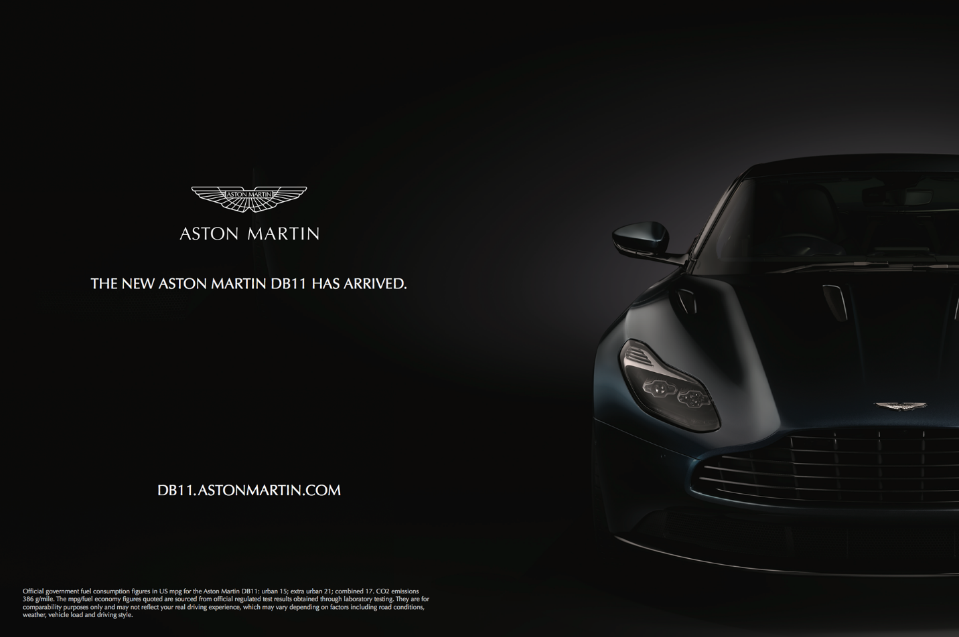
Figure 1: Aston Martin DB11 Marketing Banner
Bibliography:
- Laurence E. Keefe and Dennis Inch. The Life of a Photograph, Archival, Processing, Matting, Framing, Storage. 1984. Page 5. The essence of conservation.
- Stuart Macey and Geoff Wardle. H Point The Fundamentals of Car Design and Packaging 2nd Edition. (Forewords by Ralph Gilles, and Freeman Thomas and Professor Gordon Murray). 2014. Page 63. Setting Clear Objectives
- Vicki Goldberg. The Power of Photography: How Photographs Changed Our Lives. 1993. Page 7. Under the Influence of Photography.
Figures
- Figure 1: Aston Martin DB11 Marketing Banner
Accessed from NO. 19
https://no19.co/template-test/aston-martin/
Accessed on 06/12/19

Task 3: Jonathan Pugh - Reflective Writing:
A reflective process driven piece of writing.
Throughout the Automotive Design industry, it is a commonly known fact that it is important to design a car that serves a purpose in order for it to be profitable to the manufacturers. As quoted by Stuart Macey and Geoff Wardle (in their book H Point. The Fundamentals of Car Design and Packaging. 2009. Page 48) “Every product must serve a purpose for its customer and manufacturer”. Hatchbacks and SUV’s appeal to a larger demographic group and have a significantly larger amount of profit when compared to other car categories. However not all Automotive designers wish to design cars that serve a purpose. Franco Scaglione was an automotive designer born on the 26th of September 1916, who diverged from the mainstream idea that products needed to serve a certain purpose. He was known for creating car designs that were extremely bold and highly imaginative. Before World War 2, Scaglione studied at the University of Aeronautical Engineering. Hence, his designs were aerodynamically efficient. He was a strong believer in aerodynamics as he understood the importance of allowing the vehicle to travel through the air as efficiently as possible. (Stuart Macey and Geoff Wardle. H Point. The Fundamentals of Car Design and Packaging 2nd Edition. 2014. Page 244). One of his most memorable designs was an Italian mid-engine car, the Alfa Romeo 33 Stradale. This car was considered by many to be one of the most beautiful cars ever made. Whilst being an extremely aesthetic vehicle it still retained classic Alfa Romeo Design elements such as the triangular front grill and body curvature. Scaglione is most remembered for designing the Alfa Romeo BAT cars (Larry Edsall, Masters of Car Design, 2008. Page 48). The BAT (Berlinetta Aerodinamica Technica) cars were notorious for their organically curved rear tail wings. The first car, named the BAT 5 was unveiled at the Turin Motor show in 1953. It was based on a study of aerodynamics. Scaglione’s knowledge gained on wing profiles in the Aeronautical Industry enabled him to improve his previous design by creating the BAT 7, which resulted in the creation of large curved rear tail fins. Both the BAT 5 and BAT 7 were extreme and did not resemble previous classic Alfa Romeo designs. Their only purpose served was to create attention and be aerodynamically efficient. Following this, in 1955 at the Turin Motor show, Scaglione revealed the BAT 9. The final BAT car was a toned-down version of its predecessor’s. The body lines were cleaner and more sober than the previous models. It was designed to resemble the more current Alfa Romeo models of the day. Franco Scaglione’s goals were quite unique. In comparison to other Automotive Designers at that time who combined interesting designs with practicality and purpose, Scaglione preferred to create unique and aesthetically beautiful designs without the practical element and gained worldwide recognition for this. I admire Scaglione’s designs and I too believe that aesthetic beauty is one of the main principals to be considered when designing a car.

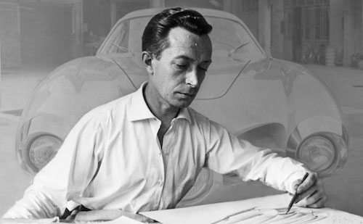
Figure 1: Franco Scaglione
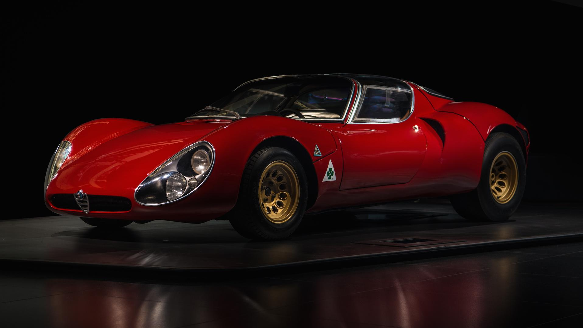
Figure 2: Alfa Romeo 33 Stradale
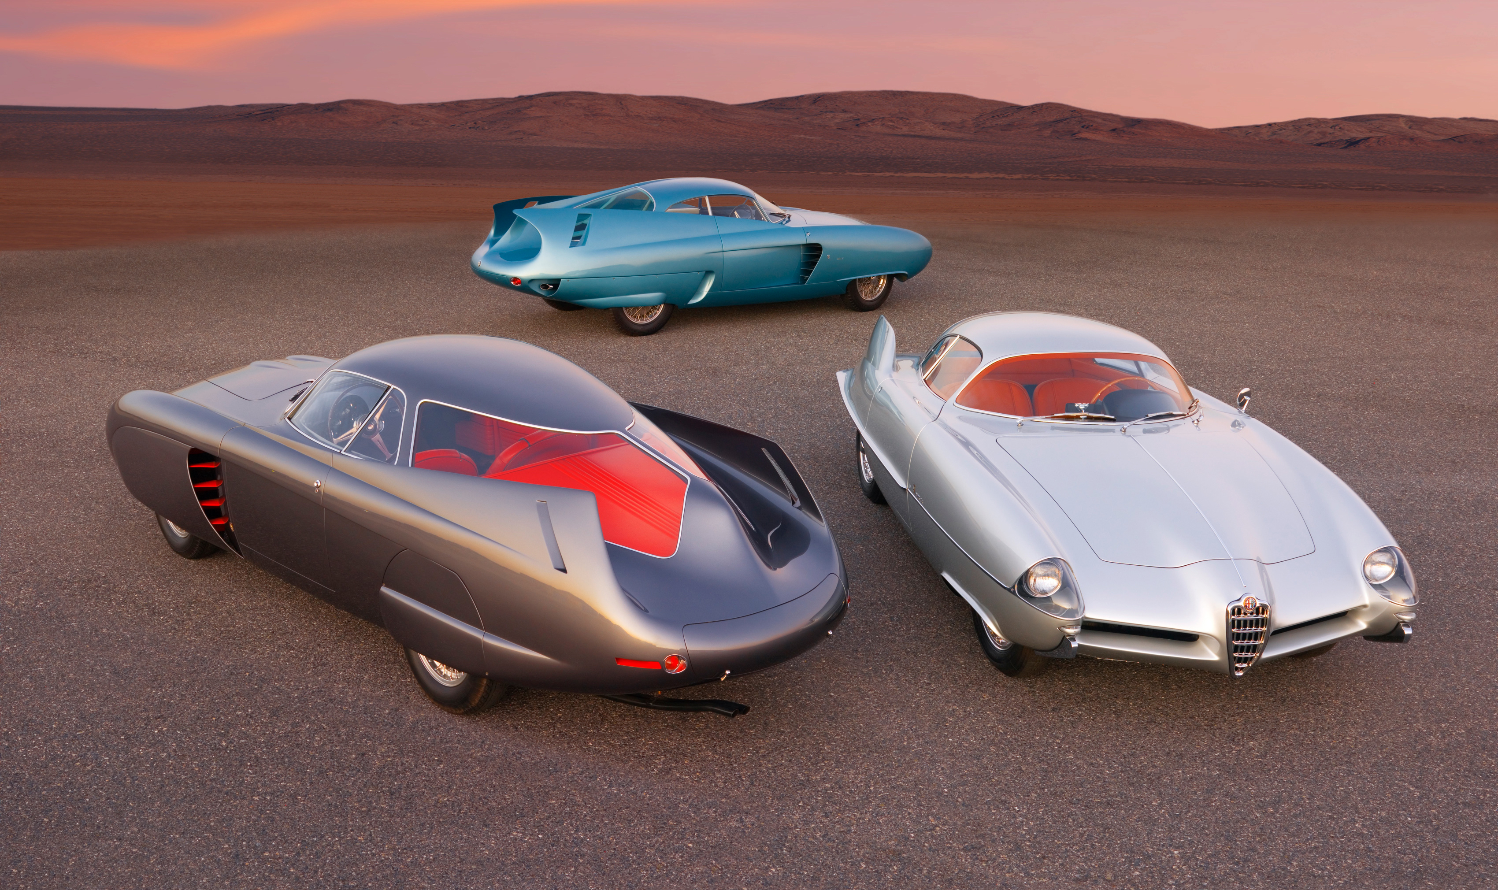
Figure 3: Alfa Romeo B.A.T. '1953–2008’
Bibliography:
- Daniel Simon. (foreword by Syd Mead) Cosmic Motors, Spaceships, Cars and Pilots of another galaxy. 2007
- Edsall L. 2008. Masters of Car Design. Page 48. Franco Scaglione
- Stuart Macey and Geoff Wardle. H Point. The Fundamentals of Car Design and Packaging. (Forewords by Ralph Gilles, and Freeman Thomas and Professor Gordon Murray.). 2009, Page 48. Introduction to Functional Objectives
- Stuart Macey and Geoff Wardle. H Point. The Fundamentals of Car Design and Packaging 2nd Edition. (Forewords by Ralph Gilles, and Freeman Thomas and Professor Gordon Murray.). 2014, Page 244.
Figures:
- Figure 1: Franco Scaglione
Accessed from Coachbuild
https://www.coachbuild.com/2/index.php/encyclopedia/designers/item/scaglione-franco
Accessed on 08/12/2019
- Figure 2: Alfa Romeo 33 Stradale
Accessed from Epitrohon
https://epitrohon.gr/alfa-romeo-tipo-33-stradale/
Accessed on 08/12/2019
- Figure 3: Alfa Romeo B.A.T. '1953–2008’
Accessed from Wheels Age
https://en.wheelsage.org/alfa_romeo/b.a.t./exact/pictures/m9q2et/
Accessed on 08/12/2019

