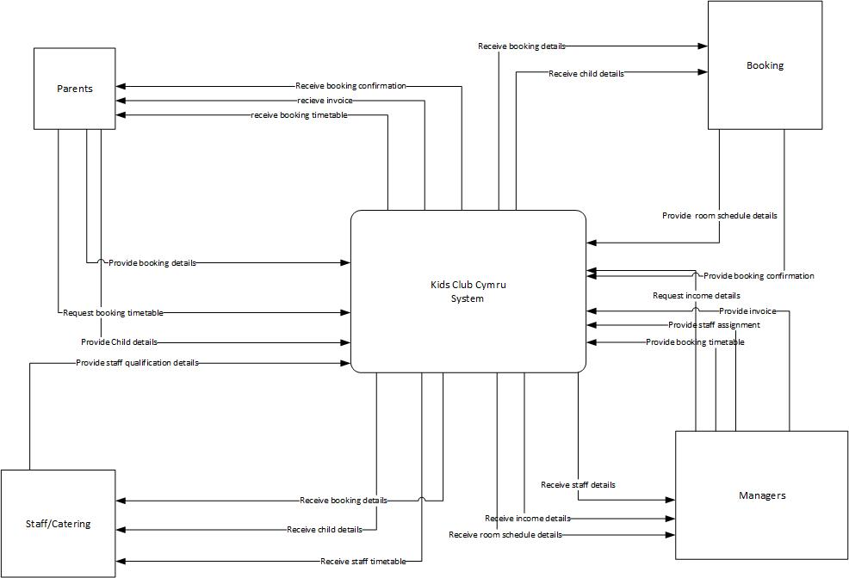
Information Engineering
Practical test
Analysis of Systems requirement

Thomas Davies
14/01/20

Context Diagram

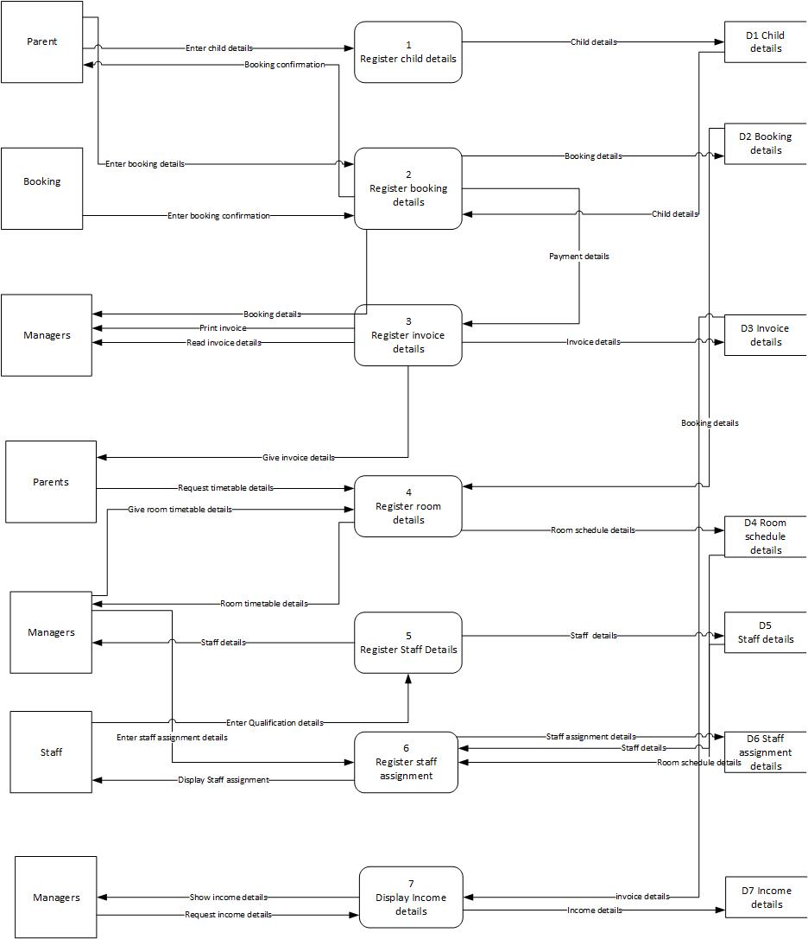

Level 0
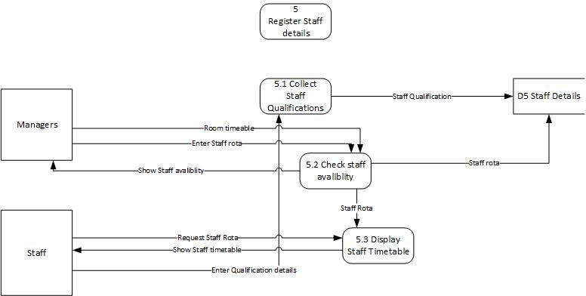

Level 1

ERD


