Enhancing User Acceptance of VR Museum Guide Systems: A Hypothetical Study Using the Technology Acceptance Model for Experience Design and Optimization

Abstract
In the era of digital transformation, the widespread adoption of information technology, virtual reality (VR), and generative artificial intelligence has unlocked new creative and practical possibilities for virtual reality museums. Unlike traditional museums that focus on physical collections, virtual museums prioritize the symbolic meaning and dissemination of cultural artifacts. By leveraging unrestricted spatial layouts, they offer enhanced accessibility and convenience for visitors’ appreciation and engagement. However, despite the evident potential of virtual museums, little attention has been paid to integrating guide systems to meet users’ experiential needs, particularly in how users process information and adapt to the virtual environment to enhance interaction comfort and overall satisfaction upon entering the virtual space. This study extends the Technology Acceptance Model (TAM) by incorporating immersion, emotional response, and technology trust as external variables, constructing a research model with six hypotheses to examine users’ behavioral intention (BI) toward VR museum guides. Due to time constraints, simulated data for 300 (n=300) participants were analyzed using Structural Equation Modeling (SEM). The simulated results indicate that immersion significantly influences perceived usefulness (PU) (β=0.35, p<0.01), while emotional response impacts perceived ease of use (PEOU) (β=0.28, p<0.05). Technology trust also enhances both PU and PEOU. These findings suggest practical design improvements, such as enhancing 3D interactions and adopting emotionally engaging narration. This study aims to address the gap in design research and provide actionable insights for future museum curators and designers to optimize user experiences in virtual museums.
Keywords
Virtual museum, intelligent guide system, user experience optimization, immersion, emotional response, technology trust

Introduction
Museums are increasingly positioning themselves as platforms for delivering enriched visitor experiences, moving beyond their traditional roles as mere repositories of artifacts (Falk & Sheppard, 2006; Kirchberg & Tröndle, 2012). From this perspective, museums are evolving into active producers of culture (Smith, 2011), shaping a sense of place and cultural identity, and establishing themselves as significant tourism destinations (Kirshenblatt-Gimblett, 1998). With the advent of the information technology era, there has been growing interest in leveraging new technologies to create more experiential, interactive, and engaging spaces. However, as with any novel technology, the rapid and seamless adoption of these innovations requires clear guidance and user-friendly support to ensure accessibility and effectiveness.
In recent years, the proliferation of virtual environments in industries such as entertainment and heritage preservation has drawn significant attention to their potential in museum development (Lepouras, 2001). Virtual museums, particularly those utilizing Virtual Reality (VR), offer unique opportunities to enhance visitor engagement. However, compared to the well-established service systems of traditional museums—such as guided tours, information desks, and visitor notifications—virtual museums face challenges due to factors like underdeveloped VR hardware, non-standardized platform designs, and external limitations (Schofield et al., 2018). These constraints position virtual museums as an emerging field with considerable room for growth.
A critical question arises: does the absence of robust hardware fully account for the challenges faced by virtual museums, or are there underlying software-related issues that persist? In other words, even if hardware limitations are resolved, will new problems emerge? Furthermore, are there theoretical frameworks capable of evaluating users’ experiences with intelligent guidance systems in virtual museums and quantifying their satisfaction levels? (Lee & Jung, 2020). This study seeks to address these questions by exploring the experiential dynamics of virtual museum visitors interacting with intelligent guidance systems, particularly those powered by advanced technologies such as large language models (LLMs).
Generally, a complete visitor experience can be conceptualized in three stages: intention (motivation-driven), engagement (interaction occurrence), and reflection (outcome evaluation). These stages reflect a dynamic process from initial intent to active experience and subsequent reflection. In the intention stage, visitors’ motivations can be conscious (e.g., seeking knowledge) or unconscious (e.g., leisure and entertainment) (Yan, 2018). Self-Determination Theory (SDT) provides a robust framework for understanding these motivations, positing that behavior is driven by intrinsic factors (e.g., interest-driven exploration via Augmented Reality [AR]) and extrinsic factors (e.g., rewards or social expectations) (Deci, 1971). This stage determines whether visitors will engage deeply with a VR museum experience. Intelligent guidance systems, powered by LLMs embedded in museum applications, can enhance this phase by offering personalized recommendations, tailoring guided routes, and curating content based on individual motivations, thus laying the foundation for a meaningful experience.
In the engagement stage, the visitor experience is conceptualized as a “dialogue” between the individual and the environment (McCarthy & Ciolfi, 2008). Embodied Cognition Theory underscores the pivotal role of the body not only as a medium for information but also as a central component in cognitive processes (Foglia, 2013). Cognition emerges through bodily interactions with the environment, suggesting that applications must incorporate contextualized interactions—such as AR-guided tours or voice-activated narrations—to deepen visitors’ understanding of exhibitions. Additionally, Flow Theory highlights that immersive experiences arise from pleasurable interactions and a state of “oneness” where users lose track of time (Csikszentmihalyi, 1990). Early conversational agents, such as chatbots, have already demonstrated a shift toward interactivity, transforming users from passive recipients to active participants (Toumanidis et al., 2019). However, the potential for technology-induced anxiety should not be underestimated, as it may negatively impact the user experience, particularly in complex VR interfaces.
After that, visitors’ evaluations of their interactions with intelligent guidance systems in virtual environments will directly influence their satisfaction. The Technology Acceptance Model (TAM) provides a framework for assessing technology adoption based on perceived usefulness (PU) and perceived ease of use (PEOU) (Davis, 1989). For instance, an intuitive and practical guidance system can enhance immersion and engagement, thereby increasing acceptance of the service. Compared to traditional museum guided tours, intelligent systems supported by advanced technology enable more natural and seamless interactions. Well-designed navigation planning and efficient question-answering systems further optimize the user experience by providing responsive and context-aware support.
Building on the integration of these theoretical frameworks, this study aims to empirically analyze users’ experiences and states when interacting with intelligent guidance systems in virtual reality museums, employing TAM, SDT, and Flow Theory as foundational models (YiFei, 2024). Specifically, the study investigates how variables such as immersion, trust in technology, and emotional responses influence user behavior through perceived usefulness (PU) and perceived ease of use (PEOU). Additionally, it examines the roles of intrinsic motivation and flow experience in shaping the overall interaction process. By constructing a comprehensive theoretical model, this research seeks to uncover the multidimensional factors affecting user experiences in VR guidance systems.
To expand the scope, this study also considers the role of cultural context and individual differences (e.g., technological literacy, cultural background, and prior museum experience) in shaping user interactions with virtual museum systems. For example, users from different cultural backgrounds may exhibit varying levels of comfort with VR interfaces or differing expectations for content delivery. Furthermore, the study explores the potential of adaptive learning algorithms within LLMs to dynamically adjust guidance based on real-time user feedback, enhancing personalization and engagement. By providing theoretical insights and practical recommendations, this research aims to inform the optimization of VR museum system designs, ensuring they are intuitive, immersive, and culturally responsive, ultimately contributing to the broader adoption and success of virtual museums as innovative cultural and educational platforms.

Literature Review
Development and Challenges of Virtual Museum Guidance Design
The concept of the virtual museum was first formalized by Geoffrey Lewis in the 1996 Encyclopaedia Britannica, where he defined it as a digital repository of images, sounds, texts, and other data of historical, scientific, or cultural significance, accessible through electronic media (Lewis, 1996; Lepouras, 2001). Unlike physical museums, virtual museums lack tangible artifacts, which strips them of the permanence and uniqueness inherent in traditional institutions. This distinction initially led developers to undervalue the importance of immersive spatial design and user experience in virtual environments (Wang et al., 2024). Early virtual museums were often relegated to supplementary roles for physical museums, receiving minimal attention. However, as technology has advanced, there is growing recognition that robust guidance systems are essential in virtual settings, particularly in Virtual Reality (VR), to deliver high-quality user experiences (Delgado & West, 2024). The absence of such systems has become a critical barrier, prompting a shift toward more user-centric design approaches.
Current online virtual museums frequently lack integrated guidance systems, relying instead on passive visual browsing of digital exhibits, which limits interactivity and engagement (Xia, 2023). This reflects a broader neglect of guidance in virtual museums, akin to overlooking the role of guided tours in physical museums, where visitor satisfaction depends on cultural significance, unique exhibits, and professional narration. Similarly, in virtual museums, adaptive guidance systems can significantly enhance cognitive and entertainment value, fostering deeper connections with content (Delgado & West, 2024). The challenge lies in designing systems that not only present information but also respond dynamically to user needs, paving the way for AI-driven solutions to bridge this gap.
The rise of artificial intelligence (AI), particularly large language models (LLMs), has transformed information processing and user interaction, excelling in knowledge storage, reasoning, and responsive communication (Ivanov & Webster, 2019). Yet, technological sophistication alone is insufficient; success hinges on user-centric design. AI technologies, such as natural language processing (NLP)-based systems like ChatGPT, enable dynamic narration and personalized interactions, creating natural connections between users and exhibits (Wang & Cai, 2022; Toumanidis et al., 2019). As human-centered systems, virtual museum guidance relies on understanding user needs and preferences, underscoring the need for theoretical frameworks to support design. For instance, researchers at Beijing Information Science and Technology University developed a virtual guide system that aggregates online museum data, converts text to audio using text-to-speech (TTS) technology, and integrates visuals via Unity plugins (Guo, 2023). While technically impressive, such systems often fall short of delivering holistic user experiences, highlighting a persistent gap between technical implementation and user satisfaction that requires further exploration.
Despite these advancements, research on user experiences with cutting-edge technologies in museums remains limited (Han & Jung, 2018). Han and Jung’s study on virtual urban heritage tourism revealed that users favor intuitive interfaces with minimal learning curves, a preference that extends to virtual museum guidance systems. As this field is still in its infancy, many questions remain unanswered, particularly regarding how to design guidance systems that align with user expectations. These challenges set the stage for examining key factors influencing technology adoption, such as perceived usefulness and ease of use, which are central to understanding user interactions in virtual environments.
Perceived Usefulness (PU) and Perceived Ease of Use (PEOU)
The Technology Acceptance Model (TAM), introduced by Fred Davis in 1989, offers a robust framework for predicting technology adoption. Its core constructs—Perceived Usefulness (PU), Perceived Ease of Use (PEOU), Attitude (ATT), and Behavioral Intention (BI)—explain how users evaluate new technologies. PU captures the extent to which users believe a technology enhances their performance, such as improving learning outcomes or efficiency (Davis, 1989). Research has used PU to study adoption behaviors for technologies like personal computers (Al-Khaldi & Wallace, 1999) and virtual stores (Oh et al., 2009), showing that higher PU fosters positive attitudes and increases usage. Huang et al. (2013) found that user and system characteristics amplify PU, enhancing attitudes toward digital museum platforms. In virtual museum guidance systems, PU is critical, as users are more likely to engage with systems they perceive as valuable for their cultural or educational goals.
PEOU measures how intuitive and user-friendly a technology is perceived to be (Davis, 1989). Studies demonstrate that PEOU indirectly drives adoption by enhancing PU (Cheng, 2012; Kashive et al., 2020). For example, in e-learning, systems deemed easy to use are perceived as more functional and engaging. In VR museum guidance systems, intuitive interfaces and seamless interactions boost perceptions of usefulness and engagement, encouraging adoption. Thus, this study proposes:
H1: Perceived Usefulness positively influences users’ intentions to use VR museum guidance systems.
H2: Perceived Ease of Use positively influences users’ intentions to use VR museum guidance systems.
By shaping users’ perceptions of utility and usability, PU and PEOU lay the groundwork for deeper engagement, setting the stage for exploring psychological factors like immersion, which further enhance the user experience.
Immersion (IM)
Introduced by Mihaly Csikszentmihalyi in 1975, immersion is a psychological state defined by nine dimensions, including balanced challenge and skill, clear goals, and immediate feedback. Fully immersed users experience sustained cognitive engagement, losing track of time and self-consciousness. In VR, immersion aligns with presence, where users feel “present” in a virtual environment through vivid visual, auditory, and tactile stimuli (Slater & Wilbur, 1997). For VR museum guidance systems, fostering focused attention and seamless action-awareness integration enables users to engage deeply with exhibits, unlocking the experiential value of immersion. Systems that create such immersive experiences are likely to be perceived as more useful and user-friendly, enhancing overall adoption. Therefore, this study proposes:
H3: Immersion positively influences Perceived Usefulness in VR museum guidance systems.
H4: Immersion positively influences Perceived Ease of Use in VR museum guidance systems.
The immersive quality of VR guidance systems not only enhances usability but also builds user confidence in the technology, leading to the exploration of technology trust as a critical factor.
Technology Trust (TT)
Technology trust, rooted in social psychology and information systems, reflects a user’s willingness to accept risks based on perceived competence, benevolence, and integrity (Mayer, Davis, & Schoorman, 1995). With technological advancements, trust has evolved to encompass performance, reliability, and security (McKnight, Choudhury, & Kacmar, 2002). Amid growing data privacy concerns, trust in privacy protection is pivotal, directly influencing technology acceptance. In AI-driven VR museum guidance systems, reliable navigation, seamless interactions, and robust data security foster user confidence, facilitating effortless engagement. Systems that inspire trust are perceived as more valuable, enhancing their utility for users. Thus, this study proposes:
H5: Technology Trust positively influences Perceived Usefulness in VR museum guidance systems.
Trust in technology shapes users’ willingness to engage, which in turn influences their attitudes and intentions, key drivers of sustained interaction with virtual museum systems.
Behavioral Intention and Attitude (BI)
Attitude refers to the positive or negative emotions associated with a behavior (Pallud & Straub, 2014), while Behavioral Intention (BI) reflects the strength of user-organization connections (García-Madariaga et al., 2017). In information systems research, understanding adoption intentions is paramount (Hsu & Lu, 2004; Shin, 2021). Studies show that attitudes toward products or services strongly predict behavioral intentions. In virtual museums, positive attitudes toward museum websites drive revisit intentions (Castaneda et al., 2007). Pallud and Straub (2014) note that VR guidance system design shapes attitudes, influencing users’ likelihood of returning to virtual spaces. This study defines attitude as users’ evaluative responses to VR guidance systems and proposes:
H6: Attitude positively influences Behavioral Intention to use VR museum guidance systems.
H7: Behavioral Intention positively influences the actual use of VR museum guidance systems.
Users’ attitudes and intentions are closely tied to their emotional experiences, as emotional responses play a pivotal role in shaping how they perceive and interact with guidance systems.
Emotional Response (ER)
Rosalind Picard’s (1997) concept of affective computing posits that positive emotional responses enhance user interactions, while negative ones hinder them. Norman’s (2004) Emotional Design framework identifies three experiential levels: visceral (visual aesthetics), behavioral (interaction fluency), and reflective (cultural resonance). In VR guidance systems, these translate to appealing visuals, smooth interactions, and meaningful cultural connections. Although the TAM does not explicitly include emotional variables, researchers have integrated them as external factors influencing PU and PEOU (Venkatesh & Davis, 2000). Positive emotional responses, such as delight from an engaging virtual tour, enhance perceptions of a system’s usefulness and ease of use, driving adoption. Thus, this study proposes:
H8: Emotional Response positively influences Perceived Usefulness in VR museum guidance systems.
H9: Emotional Response positively influences Perceived Ease of Use in VR museum guidance systems.
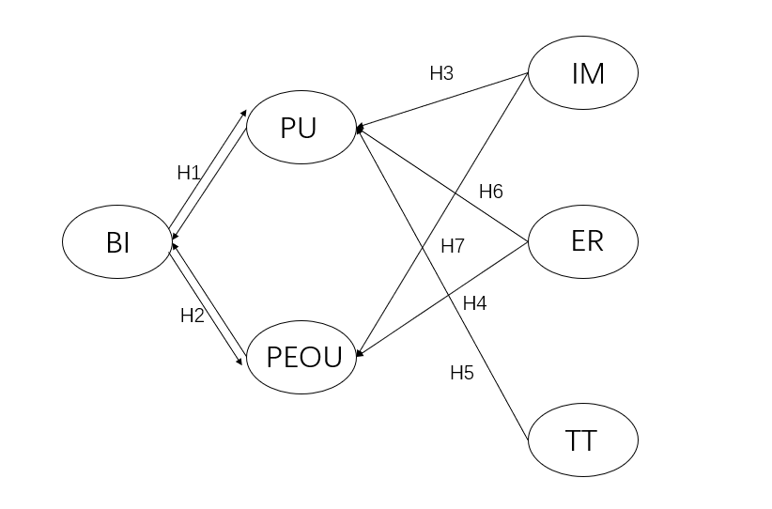 Figure 1. Proposed research model(for showing)
Methodology
This study employs a virtual museum developed by the researcher as the experimental platform, created using the Unity game development engine. Unity’s extensive SDK plugins make it more than just a game development tool; it is also well-suited for building VR environments. Components such as the XR Interaction Toolkit and Interaction System effectively support the needs of virtual reality platform development. For the guidance system, this study utilizes the generative AI system developed by Convai, which enables NPCs in games and virtual worlds to engage in dialogue. Convai’s system addresses issues like information hallucination through knowledge bases, ensuring accurate real-time responses, and allows characters to perform contextually appropriate actions based on environmental states and instructions. This functionality is critical for constructing an effective guidance system within a VR virtual museum.
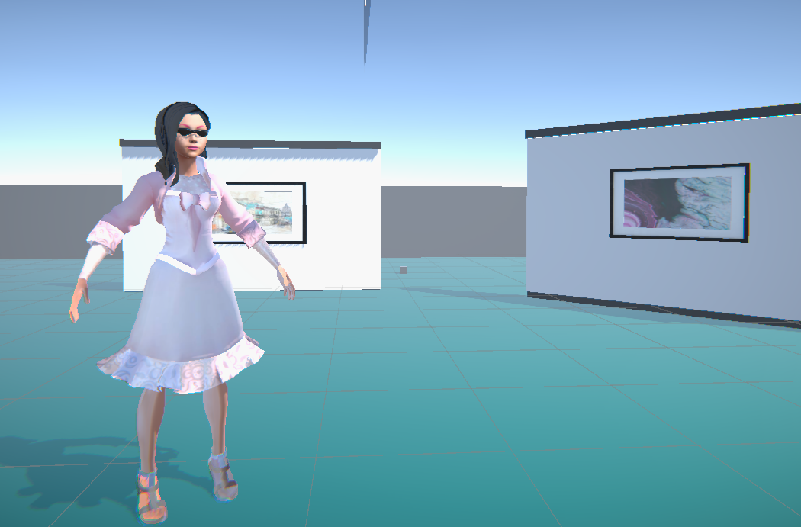
Figure 2. The Environment of the virtual museum I
The research methodology primarily centers on quantitative analysis, employing Structural Equation Modeling (SEM) for data analysis (Baum, 1973). SEM integrates confirmatory factor analysis and path analysis, comprising measurement and structural models. This approach enables the validation of relationships among selected latent variables—immersion, emotional response, technology trust, perceived usefulness (PU), perceived ease of use (PEOU), and usage intention—and their corresponding observed items. Factor loading coefficients are used to confirm whether each item significantly correlates with its respective latent variable, ensuring statistical significance. Beyond examining variable relationships, the study aims to verify the scientific validity of the proposed model by assessing fit indices such as X², CFI, TLI, and RMSEA. It should be noted that the data used in this study are simulated to demonstrate the feasibility and rationality of the research process.
For data collection, the study adopts a questionnaire survey method, with items adapted from relevant literature to measure the constructs in the proposed research model, aiming to explore user behavior and perceptions in virtual museum experiences. All items are measured using a 5-point Likert scale (1 = strongly dissatisfied, 5 = strongly satisfied). The questionnaire items and their reference sources are detailed in Table I.
As this study is a simulation to investigate user experiences with VR museum guidance systems, it requires a sample size of n=300 to ensure reliable conclusions. Due to constraints such as time, environment, and other factors, simulated data representing 300 potential VR museum guidance system users (including museum visitors, students, and design professionals) are used. The simulated dataset is generated using Python to produce normally distributed data aligned with theoretical assumptions (e.g., immersion has a mean of 4.0 on a 5-point Likert scale). In total, 18 observed variables (RQ1–RQ18) are created to measure the six latent variables, with each latent variable comprising three measurement items. The sample size of 300 exceeds the minimum requirement for SEM, which typically recommends a participant-to-item ratio of 10:1 (Jackson, 2003). The simulated data are analyzed using R language for Confirmatory Factor Analysis (CFA) and SEM to ensure the reliability and validity of the measurement model. This approach provides a preliminary test of the proposed model, laying the foundation for future empirical studies with real user data.
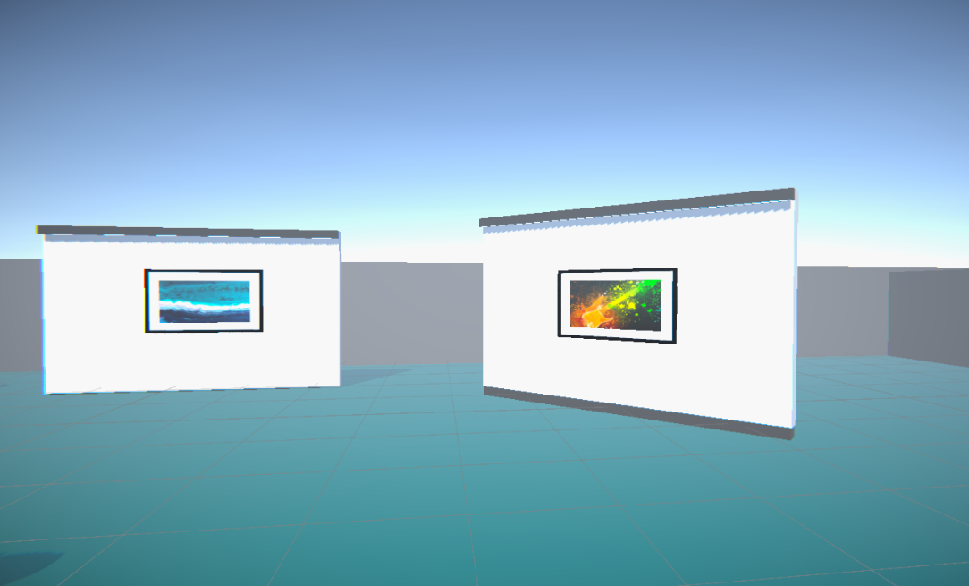
Figure 3. The Environment of the virtual museum II
For future questionnaire design, a pre-test will be conducted with ten randomly selected participants, and feedback from two domain experts will be solicited. Based on this feedback, the number of questions and the questionnaire layout will be adjusted. After these steps, the finalized scale will be distributed on a larger scale. The questionnaire will include the three following key sections:
The first is the pre-test Section, This section assesses users’ expectations and anticipation before interacting with the system. To enhance response quality and reliability, the first question is designed as: “Have you previously experienced a VR virtual reality museum?” If respondents select “No,” this response will be recorded and statistically analyzed. the second is Variable Questions, The questionnaire includes 18 questions targeting the six variables in the model. The third is about demographic Information: Respondents’ basic personal information, such as gender, age, education level, and occupation, will be collected and securely protected.
When studying user acceptance of intelligent guidance systems in VR environments,
Table I. Measurement Model and Sources
Construct | Indicator | Description |  | References
Immersive(IM) | RQ1 | I feel like I am physically present in the virtual art museum. | Y Yang（2024）
Emotional  Reflection(ER) | RQ2  RQ3  RQ4  RQ5 | The visual effects of the virtual scene make me feel it is real.  When using the VR guide, I feel isolated from the real world.  The explanations from the AI guide make me feel pleased.  When using the AI guide, I feel excited or curious. | George（2021）  Dimitrios（2021）  Y Yang（2024）  Krishna（2024）
 | RQ6 | The response speed of the AI guide makes me feel satisfied. | de Mello（2024）
Tech trust(TT) | RQ10 | I believe the information provided by the AI guide is accurate. | ZhanWan（2024）
 | RQ11 | I feel reassured about the privacy protection of the AI guide. | ZhanWan（2024）
 | RQ12 | I think the AI guide system is reliable. | W Peng（2010）
Perceived  Usefulness(PU)  Perceived ease  Of use(PEOU)  Behavioral  Intention(BI) | RQ13  RQ14  RQ15  RQ16  RQ17  RQ18  RQ19  RQ20  RQ21 | The AI guide helps me better understand the artworks.  The AI guide improves my visiting efficiency.  The AI guide helps me learn more about art knowledge.  I think the AI guide system is easy to operate.  I can quickly learn how to use the AI guide.  Interacting with the AI guide feels effortless to me.  I am willing to use this AI guide again.  I would recommend this AI guide to others.  I plan to use similar VR guides in the future. | ZhanWan（2024）  Y Lu（2024）  ZhanWan（2024）  Giuliano(2014)  Y Yang（2024）  ZhanWan（2024）  Dong Jining2023  Y Yang（2024）  Costas(2001)
data collection and cleaning pose greater challenges than data analysis. Collecting and converting 270–300 high-quality responses via Likert scales requires significant effort. Additionally, ensuring a smooth experimental process and enabling users to accurately translate their experiences into numerical ratings is inherently challenging.
But the key difficulties in the experimental process and data analysis relate to ethical considerations and data quality. In scenario-based experiments, an informed consent form is essential to ensure participants fully understand the study’s purpose, legal assurances, and intended use, empowering museum users to accept or decline participation. Additionally, protecting the anonymity of participants’ data during the experiment is critical to prevent information leaks.
Regarding data collection, sampling bias is a significant challenge, as it is difficult to balance participant demographics. Not all participants will have prior VR experience, so the n=300 sample must carefully account for user backgrounds, covering diverse age groups, educational and professional backgrounds, and related demographics to minimize external influences on the study’s outcomes.
In terms of data quality, ensuring participants respond thoughtfully is crucial. Empirical research indicates that many post-experiment online questionnaires suffer from invalid or careless responses. To address this, the study incorporates attention-check questions (e.g., requiring participants to select “3” in specific instances) to filter out non-serious responses.
After data collection, proper data processing is critical to the model’s functionality, as SEM assumes normally distributed data. Significant skewness or kurtosis in the dataset could undermine the reliability and accuracy of model evaluations. To address this, the study will assess data normality through skewness and kurtosis tests. If the data deviate from normality, non-parametric methods (e.g., Bootstrap) will be employed for robustness checks, followed by necessary transformations to ensure compliance with SEM assumptions.

Discussion and Analysis
Analysis of Reliability and Convergent Validity
In this section, the results of the quantitative experiment are evaluated and analyzed using simulated data to clarify the implications and value of the research findings. The data and analyses presented are intended to demonstrate the research methodology and do not carry precise empirical significance.
The reliability of the collected data was analyzed using SPSS 27.0 software. As shown in Table 3, the Cronbach’s α values for each factor range from 0.790 to 0.905, exceeding the threshold of 0.7 proposed by Nunnally (1967). Furthermore, removing any item results in lower Cronbach’s α values, indicating that the measurement items exhibit strong reliability and are suitable for further analysis.To assess the internal consistency of each item, Exploratory Factor Analysis (EFA) was conducted. Principal Component Analysis was used to extract new factors with eigenvalues greater than 1 for each construct. The results show that the Kaiser-Meyer-Olkin (KMO) values for all items exceed 0.50, and the Bartlett’s Test of Sphericity yields significance levels below 0.05, confirming significant correlations among measurement items and their suitability for EFA (Kaiser, 1974; Norusis, 1992). All items within each dimension contributed to the extraction of a single new factor with an eigenvalue greater than 1 (Harman, 1976), demonstrating strong internal consistency within each construct (Kohli et al., 1998). As shown in Table 4, the KMO values for all variables exceed 0.700, and the significance probability of Bartlett’s Test is less than 0.001, further confirming significant correlations among measurement items.
To evaluate convergent validity and discriminant validity, Confirmatory Factor Analysis (CFA) was performed using R programming. Factor loading coefficients indicate the correlation between factors and their measurement items. In general, standardized factor loadings of 0.5 or higher are considered practically significant (Hair et al., 1998). Additionally, all constructs exhibit Composite Reliability (CR) values greater than 0.7 (Chin, 1998) and Average Variance Extracted (AVE) values greater than 0.5 (Fornell & Larcker, 1981), indicating strong convergent validity. As shown in Table 3, all measurement items achieve a significance level of 0.001 (p < 0.001), and the standardized factor loadings, CR, and AVE values fall within standard thresholds, confirming robust convergent validity. As shown in Table 5, the square roots of all AVE values exceed the correlations between other constructs in the matrix, further validating the discriminant validity of the research data (Fornell & Larcker, 1981).
Table 2. Reliablity and Convergent Validity
Construct | Item | Unstd | SE | Unstd./SE | p-Value | SD | Cronbach’α | AVE | CR
IM | RQ1 | 1.000 | - | - | - | 0.861 | 0.898 | 0.745 | 0.898
 | RQ2 | 0.982 | 0.054 | 18.169 | *** | 0.957
 | RQ3 | 0.992 | 0.054 | 18.524 | *** | 0.871
ER  TT  PU  PEOU  BI | RQ4  RQ5  RQ6  RQ10  RQ11  RQ12  RQ13  RQ14  RQ15  RQ16  RQ17  RQ18  RQ19  RQ20  RQ21 | 1.000  0.986  1.002  1.000  0.996  0.992  1.000  0.990  0.966  1.056  1.197  1.000  0.947  1.104  1.000 | -  0.058  0.057  -  0.052  0.052  -  0.068  0.067  0.096  0.107  -  0.084  0.090  - | -  17.038  17.703  -  19.305  18.972  -  14.597  14.413  10.972  11.236  -  11.215  12.259  - | -  ***  ***  -  ***  ***  -  ***  ***  ***  ***  -  ***  ***  - | 0.837  0.847  0.878  0.870  0.880  0.867  0.805  0.806  0.797  0.753  0.785  0.753  0.715 | 0.891  0.905  0.840  0.790  0.800 | 0.730  0.761  0.644  0.562  0.571 | 0.890  0.905  0.845  0.794  0.799
Structural Model Assessment
To ensure consistency between the data and the theoretical model, the model’s goodness-of-fit must meet established standards. (The following analysis evaluates simulated data to illustrate the research process.) The proposed model was tested using R programming. As shown in Table 5, the overall model fit indices are as follows: CMIN/DF = 2.093 < 3, RMSEA = 0.038 < 0.10, CFI = 0.982 > 0.9, GFI = 0.939 > 0.9, TLI = 0.978 > 0.9, and IFI = 0.982 > 0.9, all of which meet the criteria for acceptable model fit. Overall, the model demonstrates satisfactory statistical significance and meets the research requirements.
Table 3. Results of KMO and Bartlett Sphere Test
Construct | KMO | Bartlett  Sphere Test | Item | Communality | Factor  Loadings | Eigenvalue | Total Variation Explained%
IM | 0.753 | <0.01 | RQ1 | 0.787 | 0.898 | 2.493 |  | 83.091
 |  |  | RQ2 | 0.783 | 0.905
 |  |  | RQ3 | 0.785 | 0.906
ER  TT  PU  PEOU  BI | 0.748  0.756  0.727  0.703  0.702 | <0.01  <0.01  <0.01  <0.01  <0.01 | RQ4  RQ5  RQ6  RQ10  RQ11  RQ12  RQ13  RQ14  RQ15  RQ16  RQ17  RQ18  RQ19  RQ20  RQ21 | 0.742  0.749  0.801  0.804  0.835  0.809  0.622  0.590  0.589  0.501  0.570  0.503  0.594  0.696  0.675 | 0.927  0.881  0.877  0.904  0.889  0.937  0.747  0.873  0.852  0.874  0.805  0.767  0.757  0.843  0.870 | 2.463  2.522  2.275  2.114  2.144 |  | 82.100  84.050  75.826  70.454  71.482

Table 4: Main Test Indicators for Model Fitting：
Common indices X^2/df RMSEA CFI TLI IFI GFI
Judgement criteria Value <3 <0. 1 <0.9 >0.9 >0.9 >0.9
2.093 0.038 0.982 0.978 0.982 0.939
The path coefficients of the structural equation model reflect the relationships and effect sizes among the model’s paths. Standardized effect sizes are presented in Table 7, and the relationships among variables in the structural model are illustrated in Figure 3. The results indicate issues with certain paths, including TT to BI, ER to TT, and TT to IM, as well as the path from PEOU to BI, which exhibits a low variance proportion (SD = 0.19). Although the p-value for this path (0.004 < 0.005) is statistically significant, the risk of Type I error is relatively high, highlighting a significant issue in this simulated model.
IM significantly affects PU and PEOU (p = 0.000 < 0.01), supporting H3 and H4. PEOU positively influenced by ER (p = 0.000 < 0.01) and IM (p = 0.000 < 0.01), supporting H6 and H7. PC significantly affects PU (p = 0.001 < 0.01), supporting H5. Additionally, BI are positively be influenced by PU(p = 0.000 < 0.01) and PEOU (p = 0.000 < 0.01), supporting H1 and H2. PU positively be affected by ER (p = 0.000 < 0.01) and IM (p = 0.014 < 0.05), supporting H3 and H4.
furthermore, PEOU, ER, and TT explain 52.8% of the total variance in PU for VR museum guidance system usage. TT accounts for 53.7% of the variance in BI.
 | IM | ER | TT | PU | PEOU | BI
IM | 0.863
ER | 0.033 | 0.854
TT | 0.076 | 0.107 | 0.872
PU | 0.408 | 0.433 | 0.384 | 0.799
PEOU | 0.478 | 0.462 | 0.014 | 0.408 | 0.748
BI | 0.359 | 0.372 | 0.252 | 0.738 | 0.456 | 0.753
Table 5. Correlation Matrix and AVE
Table 6. Hypothesis Test Results
IV → DV Unstd SE Unstd/SE p-value SD R^2 Result
TT → BI - - - - 0.535 0.537 H8 is valid
PEOU → PU 0.688 0.131 5.257 0.000 0.629 0.528 H9 is valid
ER → PU 0.327 0.039 8.372 0.000 0.480 0.528 H6 is valid
ER → PEOU - - - - - - H6 is valid
TT → PU 0.261 0.036 7.305 0.000 0.400 0.528 H5 is valid
TT → IM - - - - - -
PU → BI 0.684 0.079 8.630 0.000 0.580 0.573 H1 is valid
PEOU → BI 0.189 0.066 2.846 0.004 0.190 0.573 H2 is valid
IM → PU 0.265 0.037 7.097 0.000 0.390 0.528 H3 is valid
IM → PEOU 0.337 0.045 7.521 0.000 0.490 0.457 H7 is valid
The above analysis demonstrates that Structural Equation Modeling (SEM) effectively measures the reliability and validity of observed variables, assessing the significance of relationships among latent variables. The measurement and evaluation of the path model further confirm whether reasonable connections exist among latent variables, directly validating the effectiveness of the proposed model.

Conclusion
The value of virtual reality (VR) museum guidance systems lies in their ability to provide users with convenient access to cultural experiences despite external constraints. In contemporary society, factors such as fast-paced lifestyles, demanding work schedules, and geographic or economic limitations have made technology-enabled virtual museums increasingly appealing. However, the successful implementation of advanced
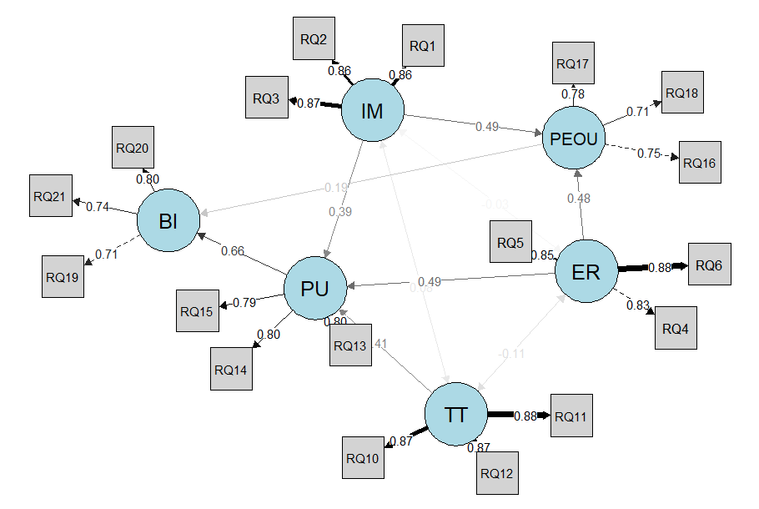
Figure 4. Proposed research model (hypothetical for showing)
technologies hinges on the human element. Compared to traditional physical museums, modern virtual museums integrate new narrative and dissemination methods enabled by digital technologies, such as the internet, cloud computing, and VR interactions. Yet, current research primarily focuses on the technical implementation and application of virtual museums, with limited attention given to user-centric guidance systems. This study shifts the focus to measuring the diverse experiences and perceptions users exhibit when interacting with such technologies.
Most visitors voluntarily and purposefully use VR devices to access virtual museums, transitioning from passive recipients of information to active co-creators of the exhibition experience. Therefore, it is crucial to help future virtual museum developers, designers, researchers, and professionals recognize the importance of enhancing user perceptions and understanding. At the theoretical level, this study clarifies previously ambiguous causal relationships among variables and provides technical insights into improving the adoption rate of guidance systems in VR museums.
First, this study explores users’behavioral intentions through the **Technology Acceptance Model (TAM) and system characteristic factors. It proposes 11 hypotheses, of which 8 are statistically significant. The results indicate that Perceived Ease of Use (PEOU), Perceived Usefulness (PU), and Behavioral Intention (BI) determine whether users and visitors ultimately adopt intelligent guidance systems in VR museums, consistent with prior research. Second, the study extends four key literature domains, revealing that for users to experience positive feedback in virtual museum spaces, the guidance system’s ability to provide immersion, technology trust, and emotional engagement significantly enhances usage intentions. By improving immersion and experiential richness, guidance systems can help users enhance their perceptions, fulfilling both knowledge and emotional needs.
However, one hypothesized path in this study encountered issues, primarily due to the study’s reliance on simulated data generated under a normal distribution, which may have led to suboptimal model fit for certain latent variables. This simulation experiment highlights a critical insight: even when using the TAM framework, data issues or the pursuit of higher statistical significance may require consideration of **mediating or moderating variables** between certain latent constructs. This is an area to address in future research.
Moreover, well-designed VR museum guidance systems have the potential to address challenges faced by traditional virtual museums, such as accommodating growing visitor numbers, alleviating physical space constraints, and mitigating funding shortages. However, while virtual museums, especially those equipped with intelligent guidance systems, offer numerous advantages, they cannot fully replace physical museums. A content analysis study suggests that virtual museums inspire many users to visit physical museums to experience authentic artifacts (Saiki & Robbins, 2008). In the future, virtual and physical museums are likely to coexist, catering to users and visitors with different needs. People will choose between virtual and physical museums based on their circumstances and contextual suitability.
This study serves as a supplementary exploration for future doctoral research, aiming to empirically identify the factors influencing users’ optimal use of guidance technologies in virtual environments. It primarily demonstrates the validation process of the TAM framework by examining the impact of perceived usefulness, perceived ease of use, immersion, emotional response, and technology trust on usage intention, thereby establishing the rationality of the proposed model. However, future research must acknowledge that relying solely on quantitative analysis may limit the depth of inquiry, particularly in user experience (UX) research. As humans are inherently emotional beings, their experiences are difficult to fully quantify through data alone. Quantitative research excels at addressing questions like “what is it?” or “how much?” but often falls short in exploring “why?” Traditional UX research methods, such as interviews, focus groups, or A/B testing, can provide valuable qualitative insights to complement and enrich findings.
In conclusion, achieving a robust research outcome for VR museum guidance system design requires meticulous attention to detail across all aspects. By addressing both quantitative and qualitative dimensions, future studies can offer a more comprehensive understanding of user experiences, paving the way for optimized and user-centric virtual museum platforms.

Reference（To The question
1. Richter, N.F. and Tudoran, A.A., 2024. Elevating theoretical insight and predictive accuracy in business research: Combining PLS-SEM and selected machine learning algorithms. Journal of Business Research, 173, p.114453.
2. Yildiz Durak, H. and Onan, A., 2024. Predicting the use of chatbot systems in education: a comparative approach using PLS-SEM and machine learning algorithms. Current Psychology, 43(28), pp.23656-23674.
3. Tcha-Tokey, K., Christmann, O., Loup-Escande, E., Loup, G. and Richir, S., 2018. Towards a model of user experience in immersive virtual environments. Advances in Human‐Computer Interaction, 2018(1), p.7827286.
4. Zheng, F., Wu, S., Liu, R. and Bai, Y., 2024. What influences user continuous intention of digital museum: integrating task-technology fit (TTF) and unified theory of acceptance and usage of technology (UTAUT) models. Heritage Science, 12(1), p.253.
5. Yan, B., Chu, X.N. and Zhang, L., 2019. User perception modeling by combining structural equation model and artificial neural network. J. Shanghai Jiaotong Univ, 53, pp.830-837.
6. Wu, Y., Jiang, Q., Liang, H.E. and Ni, S., 2022. What drives users to adopt a digital museum? A case of virtual exhibition hall of National Costume Museum. Sage Open, 12(1), p.21582440221082105.
7. Lepouras, G., Charitos, D., Vassilakis, C., Charissi, A. and Halatsi, L., 2001, May. Building a VR-Museum in a Museum. In Proc. of VRIC Virtual Reality International Conference.
8. Carignani, F., Laura, C., Iodice, G. and Bifulco, F., 2023. How management uses AI in the museum field: From chatbots towards chatGTP. In Sinergie-SIMA Management Conference Proceedings Rediscovering local roots and interactions in management (pp. 407-413).
9. Li, Y., Yang, R., Zou, J., Xu, H. and Tian, F., 2024. Human-Centric Virtual Museum: Redefining the Museum Experience Through Immersive and Interactive Environments. International Journal of Human–Computer Interaction, pp.1-12.
10. Zhao, J. and Yezhova, O., 2024. Strategy of design online museum exhibition contents from the perspective of artificial intelligence. Art and Design, (2), pp.80-89.
11. Schweibenz, W., 2019. The virtual museum: an overview of its origins, concepts, and terminology. The Museum Review, 4(1), pp.1-29.
12. Derda, I. and Predescu, D., 2025. Towards human-centric AI in museums: practitioners’ perspectives and technology acceptance of visitor-centered AI for value (co-) creation. Museum Management and Curatorship, pp.1-23.
13. Wang, Z., Yuan, L.P., Wang, L., Jiang, B. and Zeng, W., 2024, May. Virtuwander: Enhancing multi-modal interaction for virtual tour guidance through large language models. In Proceedings of the 2024 CHI Conference on Human Factors in Computing Systems (pp. 1-20).
14. Yamada, N., Yoshino, A. and Wilson, J., 2017. Why do you go to a museum and why don’t?–A case study of motivations to visiting Antalya Museum, Turkey. In Proceedings of the IAFOR International Conference on the Social Sciences (pp. 77-89).
15. Lu, Y., Yang, Y., Zhao, Q., Zhang, C. and Li, T.J.J., 2024. AI assistance for UX: A literature review through human-centered AI. arXiv preprint arXiv:2402.06089.
16. Chromik, M., Lachner, F. and Butz, A., 2020, October. Ml for ux?-an inventory and predictions on the use of machine learning techniques for UX research. In Proceedings of the 11th Nordic Conference on Human-Computer Interaction: Shaping Experiences, Shaping Society (pp. 1-11).
17. Pérez Cortés, L.E., Ha, J., Su, M., Nelson, B., Bowman, C. and Bowman, J., 2023. Gleaning museum visitors’ behaviors by analyzing questions asked in a mobile app. Educational technology research and development, 71(3), pp.1209-1231.
18. Walczak, K., Cellary, W. and White, M., 2006. Virtual museum exbibitions. Computer, 39(3), pp.93-95.
19. Huhtamo, E., 2013. On the origins of the virtual museum. In Museums in a digital age (pp. 121-135). Routledge.
20. Tsichritzis, D. and Gibbs, S.J., 1991, October. Virtual Museums and Virtual Realities. In ICHIM (pp. 17-25).
21. Sylaiou, S., Mania, K., Karoulis, A. and White, M., 2010. Exploring the relationship between presence and enjoyment in a virtual museum. International journal of human-computer studies, 68(5), pp.243-253.

