
- Introduction
The reason for building automation systems (B.A.S) is to make management of the building centralized. This works by using network protocols and encapsulation to link everything in the building for example: safety alarms, intrusion alarms, access control, Lighting and much more.
It is easier to have two secure control rooms, one for security only, one for all other services managing the entire building, thus increasing security compared to having security spread all over the place.
Aims and Objectives
To analyze if adding B.A.S.S increases security?
The aim of the experiment is to determine the effects of automation on increasing security in buildings.
- To research the basics of B.A.S and the world wide web then how to develop a sensor network on Cisco packet tracer and study crime statistics from around the UK.
3. Research design choices
- Literature Review
The goal of social engineering is the same as hacking, getting access to information, systems and locations, that hackers are not authorised to be in or have access to.

- Statistics that helped with conclusion

- Implementation shown below
The project was implemented and tested on Cisco Packet Tracer this was due to the circumstances of the year, the design of the project was all about security and in ways to alert security when something was wrong for example doors opened without valid RFID card being used. Laser trip wires hit without the doors/ windows being opened. Motion detectors picking up motion when no one should be in the room and windows open when they should be shut.

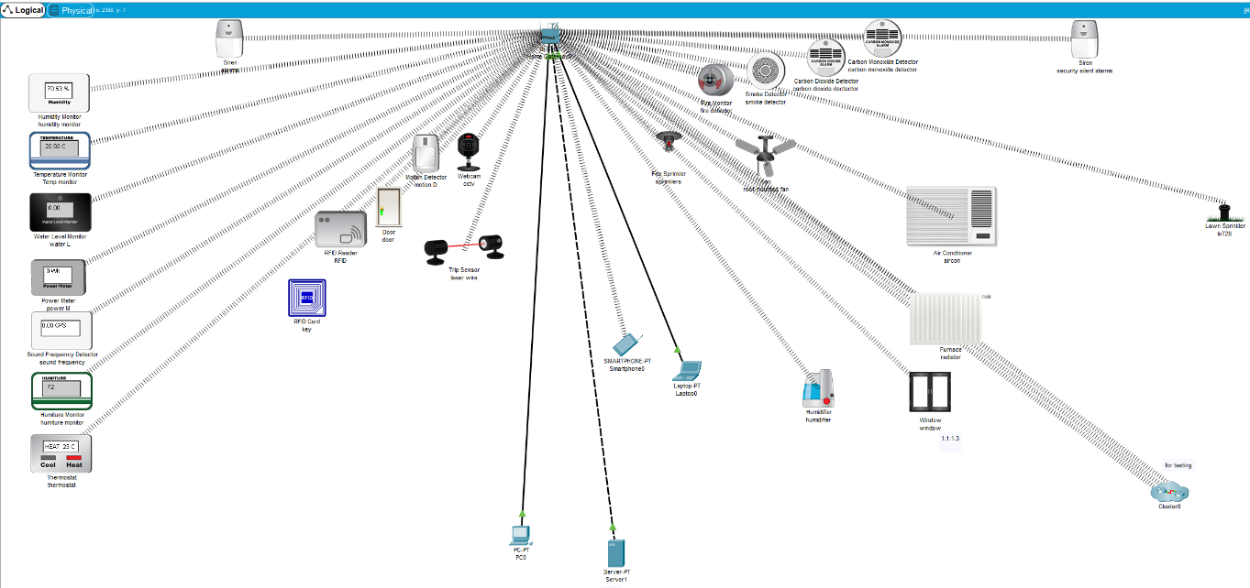
- Conclusion
In conclusion to the project the final result is a 2-8% increase in security for well-off and rich areas, a decrease in security of roughly -1-10% if installed in poor areas due to it making criminals think there is something worth having , finally an increase of security for business’s/ universities of 2-15%, this depends on the number of burglaries a business’s/ universities goes through a year.

- References
C. Hadnagy, Social Enginering: the Art of Human Hacking, Indianapolis: Wiley Publishing Inc., 2011.

Azquotes, “War is 90% information: Azquotes,” 2020. [Online].

gov.uk, “crime against businesses: findings from the 2018 Commercial Victimisation Survey,” statistics at home office, [Online]. Available: https://assets.publishing.service.gov.uk/government/uploads/system/uploads/attachment_data/file/829399/crime-against-businesses-2018-hosb1719.pdf. [Accessed 26 04 2020].
ons gov uk, “crime in england and wales year ending december 2019,” ons gov uk, [Online]. Available: https://www.ons.gov.uk/peoplepopulationandcommunity/crimeandjustice/bulletins/crimeinenglandandwales/yearendingdecember2019. [Accessed 26 04 2020].

- Future additions to the work
Better security systems overall – ones were humans will not always be the biggest weakness.
Better security management systems for both staff and the computers the security software runs on.
A way to lockdown a corridor/ entrance and trap criminals inside.

