Title page

Student name: Maria Doday
Student number: 2133010
Module code: LCHS4004
Title: Polio Disease
Lecturer name: Laila Surani
Module name: Introduction to public
Health

Introduction
Polio also known as poliomyelitis is an infectious disease that can be life threating and disabling as it affects various parts of the body such as the spinal cord and brain where it causes paralysis (Adelaidean, Kalkaska, Thompson 2022). This assessment aims to demonstrate that there are many approaches and strategies used to measure, monitor, and control the incidence of diseases includes surveillance, screening, early detection, prevention, and control. Surveillance involves monitoring the occurrence of diseases, screening involves the use of diagnostic tests to find and detect diseases in the population, early detection allows for early treatment of the disease, prevention involves measures to reduce the risk of disease, and control involves strategies to reduce the spread of the disease. These strategies may involve a combination of education, policy and law enforcement, public health interventions, and access to health services (Tebbens 2010).

Surveillance is an important tool in public health that can be used to monitor and control the spread of diseases. Surveillance systems collect data on disease trends, allowing public health authorities to track, analyse and respond to the spread of illness. By monitoring current and past trends, public health officials can better predict and prevent outbreaks of infectious diseases (Barton 2021). Surveillance can take many forms, including active and passive. Active surveillance includes collecting data on diseases from hospitals, labs, and physicians. Passive surveillance involves collecting data from sources like media reports, school records, and surveys (Aturaliya 2021). This data can help public health officials identify emerging trends and target areas of concern, surveillance can be used to detect outbreaks of infectious diseases, by monitoring the spread of diseases, public health authorities can identify areas that are at risk for outbreaks and take action to prevent them. The Centers for Disease Control and Prevention (CDC) uses a variety of disease surveillance techniques, including the National Notifiable Disease Surveillance System, to monitor the spread of diseases. Surveillance can also be used to track and monitor vaccine-preventable diseases. By monitoring the rates of vaccine-preventable diseases in a population, public health officials can identify areas where vaccination coverage is insufficient and take action to increase rates of vaccination (Public Health 2020).

Screening is an important tool in controlling and monitoring diseases, screening is a process of testing for diseases or other medical conditions in people who do not have any symptoms. The aim of screening is to detect diseases early, before they cause symptoms, so that treatment can be started before any damage to the body has occurred (Public Health 2020). Screening can also help identify those at risk of developing a disease, allowing preventive measures to be taken, screening for common diseases such as cancer and heart disease is widely available in many countries. Screening for these diseases involves tests such as mammograms for breast cancer, Pap smears for cervical cancer and cholesterol tests for heart disease. Screening for these diseases can help detect diseases early when they are more treatable, increasing the chances of successful treatment screening can additionally help identify those at risk of developing a disease. For example, genetic tests can be used to identify people who are at increased risk of developing cancers such as breast and colon cancer. People who are identified as being at increased risk can then be monitored more closely, allowing any changes in the disease to be detected earlier and treated more effectively. Screening can also be used to identify those who are at risk of developing certain infectious diseases (Leon 2021). For example, screening for HIV can help identify those who are infected with the virus and can then be offered treatment to reduce the risk of them developing AIDS. Similarly, screening for hepatitis C can help identify those who are infected and can then be offered treatment to reduce their risk of developing liver disease (Gonzalez 2017).
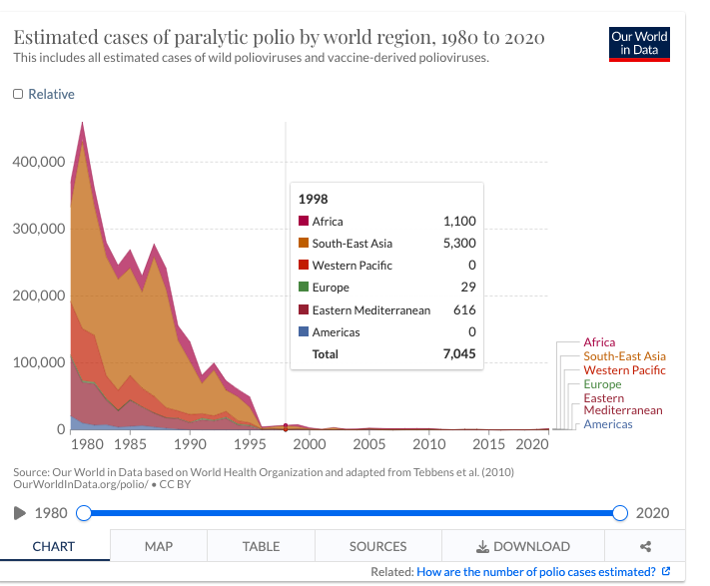
Exhibit A Source: Our world in Data based on World Health Organization and adapted from Tebbens et al. (2010)OurWorldInData.org/polio/CC BY

Preventive measures have long been recognized as an important part of controlling and monitoring diseases. For one thing, prevention often reduces and decrease the severity of a disease and can even prevent it altogether, this is especially true for communicable diseases, which can be spread from person to person (Kadakia 2021). By taking preventive measures, such as vaccination and good hygiene, it is possible to reduce the spread of these diseases, including those caused by bacteria and viruses. In addition to preventing the spread of disease, preventive measures can also help to monitor and control the disease. For example, regular health screenings can help to detect diseases in the early stages when they are more treatable. Screening tests may include blood tests, imaging tests, and physical exams. Early detection can also lead to better treatment outcomes. Finally, preventive measures can also help to reduce the economic burden of a disease. For example, by preventing the spread of a disease, it is possible to reduce the amount of money spent on medical treatment. Additionally, preventive measures can reduce the amount of time that people must take off work due to illness, which can help to maintain productivity. In conclusion, preventive measures are an important component of controlling and monitoring diseases. These measures can help to reduce the severity of a disease and prevent its spread, as well as detect it in the early stages and reduce its economic burden. By removing the necessary steps to prevent and monitor diseases, it is possible to reduce the overall burden of the disease and improve public health Dastvar 2021).
Conclusion
The main approaches and strategies used to measure, monitor and control the incidence of diseases vary depending on the disease and context. Generally, these approaches include surveillance and epidemiological studies, health education, case management, and health promotion and prevention strategies. Surveillance is the most common approach used to measure, monitor, and control the incidence of diseases, as it provides data on the size and distribution of a disease within a population. Epidemiological studies help us to understand the cause of a disease, while health education and prevention strategies are used to reduce the risk of acquiring a disease. Finally, case management involves identifying and treating those already affected by a disease. A combination of these approaches is often used to effectively measure, monitor, and control the incidence of diseases.

References

Armooh, T., Barton, T., Castillo, G., Cinnick, S., Clark, S., Giles-Cantrell, B., Gorenflo, G., Hoagland, G. W., Horneffer, K., Pardal, A., Parekh, A., Pham, T., Resnick, B., Rice, S., Sellers, K., Shirley, L., & Wu, K. (2021, December). Public Health Forward: Modernizing the U.S. Public Health System. The Bipartisan Policy Center.
Aturaliya, R., Espinosa, O., Lafronza, V., Ransom, M., & Bleser, J. (2021). Challenges and Opportunities for Strengthening the US Public Health Infrastructure: Findings from the Scan of the Literature
Badizadegan, K., Kalkowska, D. A., & Thompson, K. M. (2022). Polio by the Numbers–A Global Perspective. The Journal of Infectious Diseases.
Centers for Disease Control and Prevention. (2019). Surveillance. Retrieved from https://www.cdc.gov/surveillance/
Centers for Disease Control and Prevention. (2020). Prevention & Treatment. Retrieved from https://www.cdc.gov/prevention/index.html
Centers for Disease Control and Prevention. (2020). Public Health Data Modernization: Listening Session on Real-World Testing of 21st Century Cures Act Requirements
Classification and reporting of vaccine-derived polioviruses (VDPV). (2016). Global Polio Eradication Initiative. https://polioeradication.org/wp-content/uploads/2016/09/Reporting-and-Classification-of-VDPVs_Aug2016_EN.pdf
Dastvar, D., & Averill, D. (2021). The National Public Health Data System: The case for an aggregated national healthcare database
Exhibit A: Our world in Data based on World Health Organization and adapted from Tebbens et al. (2010)OurWorldInData.org/polio/CC BY
Kadakia, K. T., Howell, M. D., & DeSalvo, K. B. (2021). Modernizing Public Health Data Systems: Lessons from the Health Information Technology for Economic and Clinical Health (HITECH) Act. JAMA: The Journal of the American Medical Association, 326(5), 385-386. DOI: 10.1001/jama.2021.12000
National Cancer Institute. (2020). What is Genetic Testing? Retrieved from https://www.cancer.gov/about-cancer/causes-prevention/genetics/genetic-testing-fact-sheet
Ramirez Gonzalez, A., Farrell, M., Menning, L., Garon, J., Everts, H., Hampton, L. M., … & Patel, M. (2017). Implementing the synchronized global switch from trivalent to bivalent oral polio vaccines—lessons learned from the global perspective. The journal of infectious diseases, 216(suppl_1), S183-S192.
Sáez-Llorens, X., Bandyopadhyay, A. S., Gast, C., Leon, T., DeAntonio, R., Jimeno, J., Caballero, M. I., Aguirre, G., Oberste, M. S., Weldon, W. C., Konopka-Anstadt, J. L., Modlin, J., Bachtiar, N. S., Fix, A., Konz, J., Clemens, R., Costa Clemens, S. A., & Rüttimann, R. (2021). Safety and immunogenicity of two novel type 2 oral poliovirus vaccine candidates compared with a monovalent type 2 oral poliovirus vaccine in children and infants: two clinical trials. Lancet (London, England), 397(10268), 27–38. https://doi.org/10.1016/S0140-6736(20)32540-X
Source: Our world in Data based on World Health Organization and adapted from Tebbens et al. (2010)OurWorldInData.org/polio/CC BY
Tebbens, R., Pallansch, M., Cochi, S., Wassilak, S., Linkins, J., & Sutter, R. et al. (2010). Economic analysis of the global polio eradication initiative. Vaccine, 29(2), 334-343.

