

Student name: Naney Hyara Quaresma C D Pinto
Student ID: 2132446
Module name: Independent Project
Module code: BMHP6020
Supervisor’s name: Jolly Nwankwo

Acknowledgement of the use of AI tools
I declare that I have not made use of any AI resources in the research and production of this assignment. I declare that I have not included any materials generated by an AI resource and passed them off as my work.

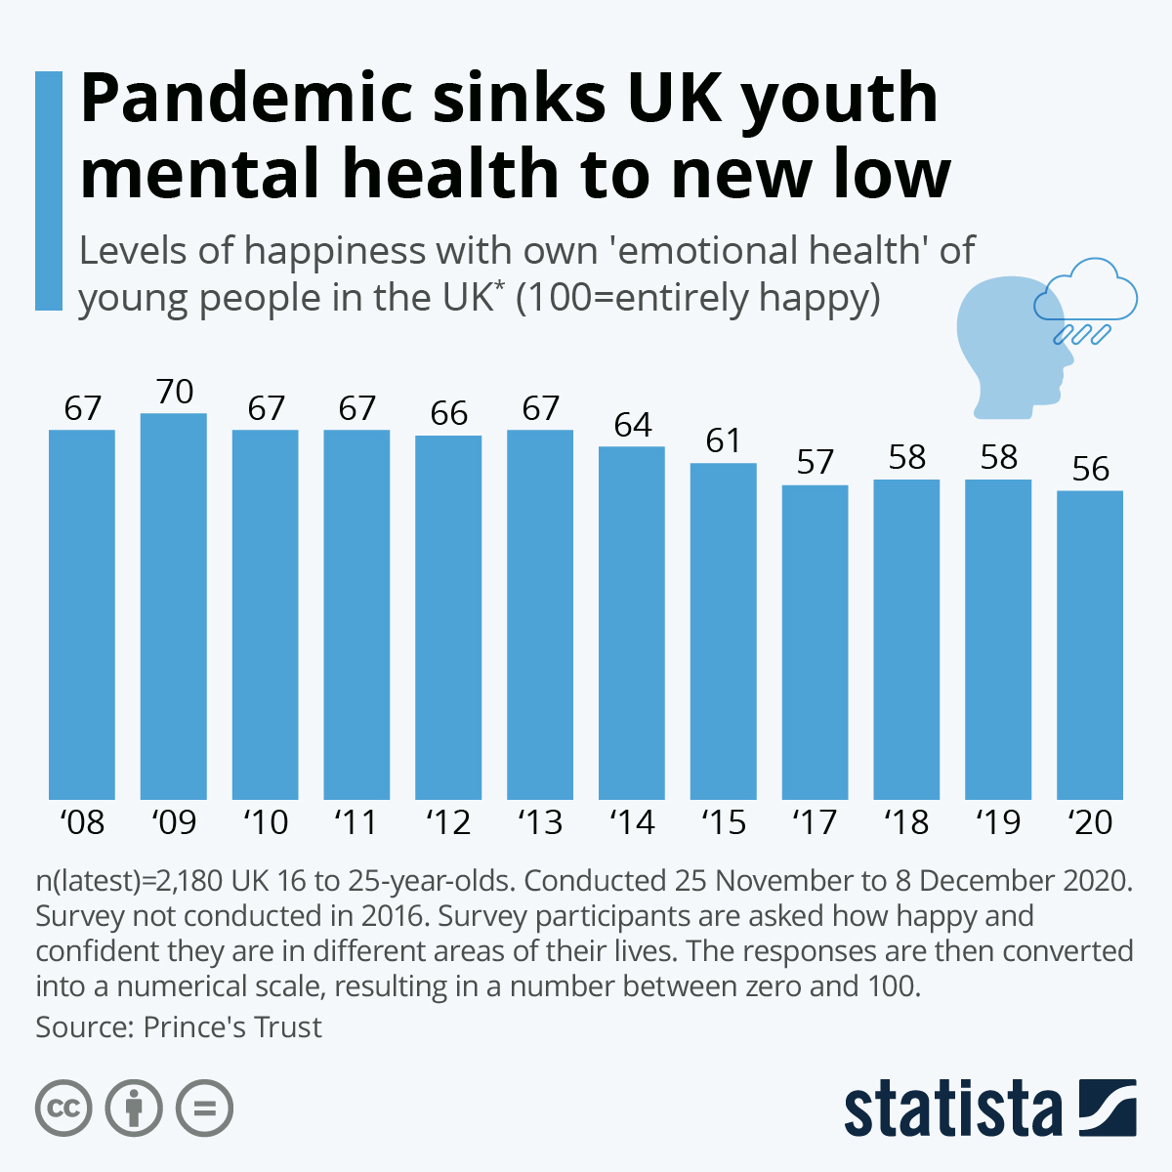  For instance, in the UK, mental health problems are on the increase among young people, particularly after the COVID-19 pandemic. Anxiety and depression have been identified as two of the major diagnosed mental health ailments among the youth between the ages of 18-25 years. From recent statistics, it has shown that one in four young people suffers from mental health problems at least once a year (Mental Health Foundation, 2023). Since there are health care systems such as the NHS, university wellbeing team, and volunteers, young people still encounter problems. |  | Exploring Mental Health Supports for Young Adults in the UK  Aim: The aim of this research is to explore the availability, accessibility, and perceived effectiveness of mental health support services for young adults aged 18–25 in the UK.  Objectives  - Identify formal and informal mental health supports available to young adults.  - Examine awareness and utilisation of services.  - Explore barriers and facilitators influencing engagement.  - Provide recommendations to improve access and service delivery. |  | 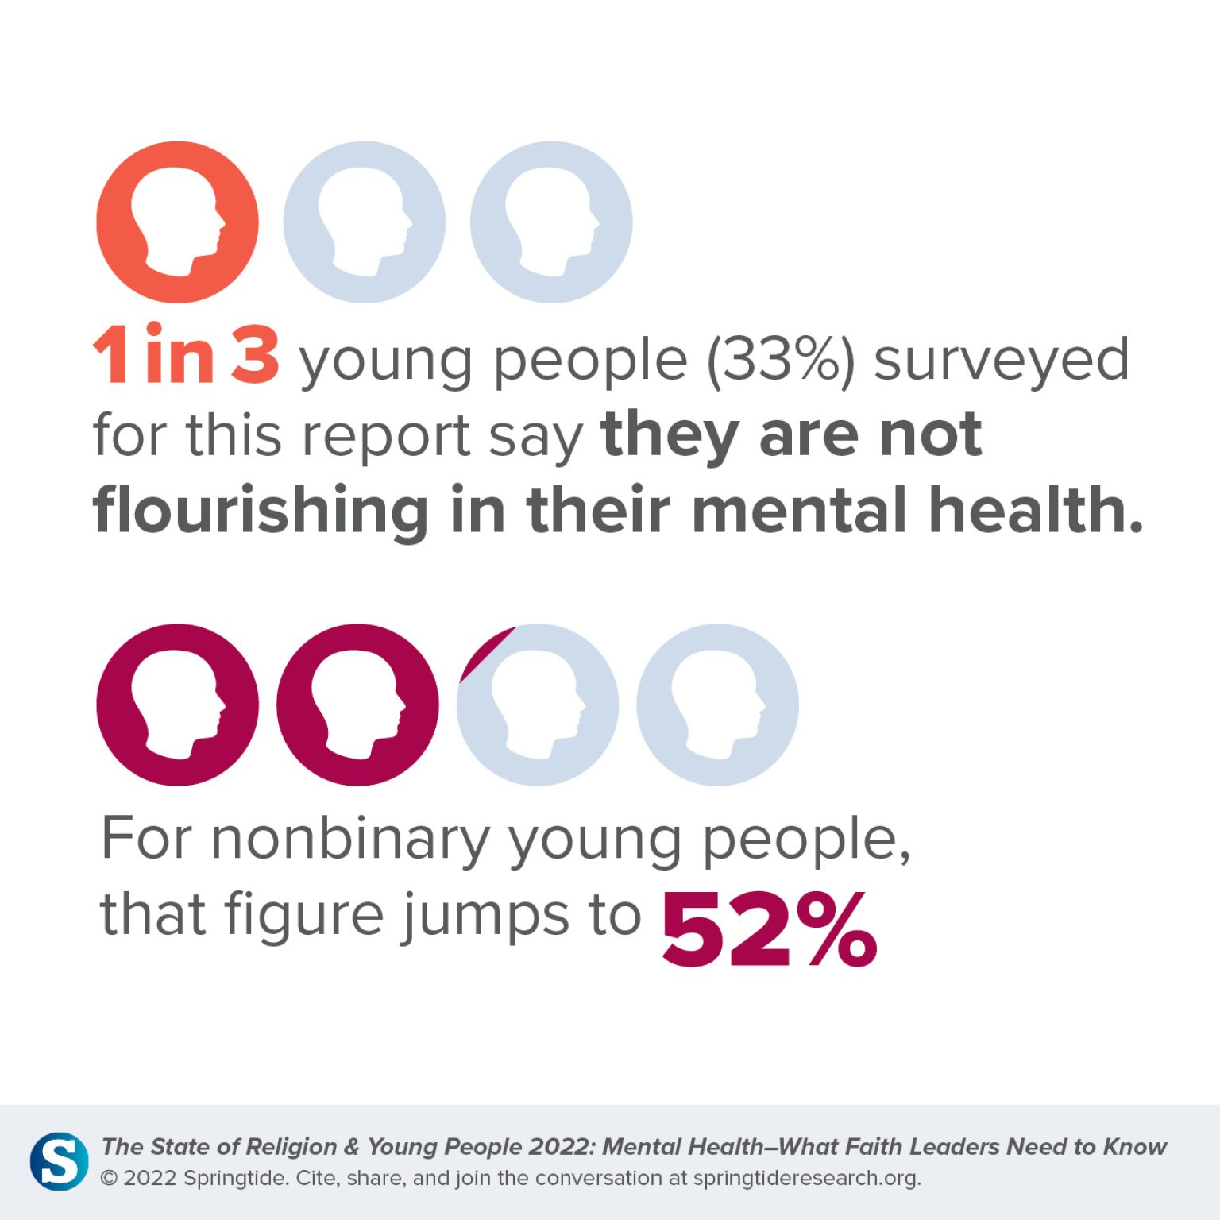
Methodology:  to provide a comprehensive understanding of the research problem.  Sample  Quantitative studies contain between 50 to 70 young adults aged between 18 and 25 years old, who are currently residing in the UK.  A smaller subgroup of 6–8 members will also be selected and incorporated via semi-structured interviews to explore personal experiences.  Data Collection  This data will be collected through an online survey, constructed using Google Forms, and disseminated via university social media groups and youth networks.  The semi-structured interviews will be done using Microsoft Teams.  Convenience and purposive sampling techniques will be employed. |  |  |  | Data Analysis  The quantitative data will be analysed using descriptive statistics techniques with the help of Microsoft Excel towards the identification of trends regarding awareness, usage, and satisfaction.  Qualitative data will be analysed following a thematic analysis approach as proposed by Braun & Clarke (2006). This will enable us to identify various recurring themes, barriers, and facilitators for engagement within mental health services.  Ethical Considerations  Ethics are central in any given study. Ethics have been described as "the moral principles invoked by responsible data collection and reporting" (Largan & Morris, 2019). Ethical approval would be granted by the UWTSD. This would be done as per the Research Ethics and Integrity Code of Practice Policy (UWTSD, 2022). The respondents would be provided with information and would be required to give consent before the study begins. The study would also be carried out following ethical regulations as stated by the British Psychological Society (2021).
Inclusion Criteria:
- Aged 18–25
- Currently living in the UK
- Have used or considered using mental health services within the past two years
Exclusion Criteria:
- Individuals outside the specified age range
- Individuals not residing in the UK

References
Braun, V. and Clarke, V. (2021) Thematic Analysis: A Practical Guide. London: Sage
British Healthcare Business Intelligence Association, BHBIA (2020) BHBIA Data Analytics Guidelines Secondary Data – Ethical Principles. Available at: https://www.bhbia.org.uk/assets/Downloads/Guidelines/4_secondary_data_ethical_principles_aug2020_fv.PDF (Accessed: 18 June 2025).
Jacobsen, K.H. (2020) Introduction to Health Research Methods: A Practical Guide. 3rd edition. Burlington: Jones & Bartlett Learning, LLC.
Largan, C. and Morris, T. (2019) ‘Ethics in Qualitative Secondary Research’, In: Qualitative Secondary Research: A Step-By-Step Guide. London: SAGE Publications Ltd. pp. Available at: https://doi.org/10.4135/9781529682816.n6
Maternal Mental Health Leadership Alliance (MMHLA) (2024) Maternal Mental Health Conditions and Statistics. Available at: https://www.mmhla.org/articles/maternal-mental-health-conditions-and-statistics
Mental Health Foundation (2023) Children and young people: statistics. Available at: https://www.mentalhealth.org.uk/explore-mental-health/statistics/children-young-people-statistics
University of Wales Trinity Saint David (UWTSD) (2022) Research Ethics and Integrity Code of Practice. Available at: https://www.uwtsd.ac.uk

