
Introduction to Web and Database Concepts
ACCA4023

Component one
Fatema Bandali
Student ID:2514792

Table of contents
Introduction………..
Normalization………………….
Entity Relationship Diagram (ERD)……………..
Designs Decsions and Reflection………………..
Conclusion………………………….
References…………………….

Introduction

Auto Park system operated in many parking locations, currently records are done manually, which than results in:
- Displaced records
- Very slow customer service,
- Unable to monitor parking spaces,
- Many mistakes

The company has multiple parking spots. Each parking spot is divided into different spaces, including standard, disabled, and electric parking spots. The public registers and adds details about their vehicles. When a customer books a particular slot, their entry and exit times are recorded, and each booking is confirmed with a payment. All this information is stored in the database. There are rules that must be followed, such as a booking cannot refer to an existing customer, a booked slot, or a non-existent slot. The system includes six related tables: Parking Site, Parking Slot, Customer, Vehicle, Booking, and Payment. The relationships between these tables allow the company to answer important questions, such as which slots are available at a site, what vehicles a customer owns, and how much income a booking generates. The purpose of this database is to consolidate all information, ensuring that each fact is stored clearly and only once/ The main aim is to create a Microsoft Access that automated the data for parking management.(Omar 2021)

The Database will include:

- Tracked Parking Slots
- Customer Information
- Vehicle information
- Records of booking
- Records of Payment

Customer Information-Attributes:
Customer ID
Customer Name
Phone
Email

Vehicle information -Includes:
Vehicle Number
Vehicle Registration
Vehicle Colour
Vehicle ID

Relationship: One customer can own many different Vehicles
Parking Allocations
Parking Attributes

Site ID
Site Name
Sie Management (How many cars each site can take)
Site Address

Parking Slots
Booking ID
Vehicle Details
Slot ID
Time of Entry
Time of Exit

Relationship-One vehicle can have many different bookings.

Payment Attributes

Payment ID
Payment ID
Amount
Date of Payment

Relationship-Each booking has one payment

Normalization

First Normal Form (1NF)

- No repeating groups.- Each field contains one value only.

Second Normal Form (2NF)

- Any non-key attribute is wholly dependent on the primary key.

Example:
Vehicle Colour depends on Vehicle ID. This is not the case for CustomerID.

Third Normal Form (3NF)
There are no transitive dependencies.
Example

A customer email is only in the Customer table, and a Booking does not include a customer phone number, and a Payment does not include a registration number. Hence, the database is in 3NF.

Entity Relationship Diagram (ERD)

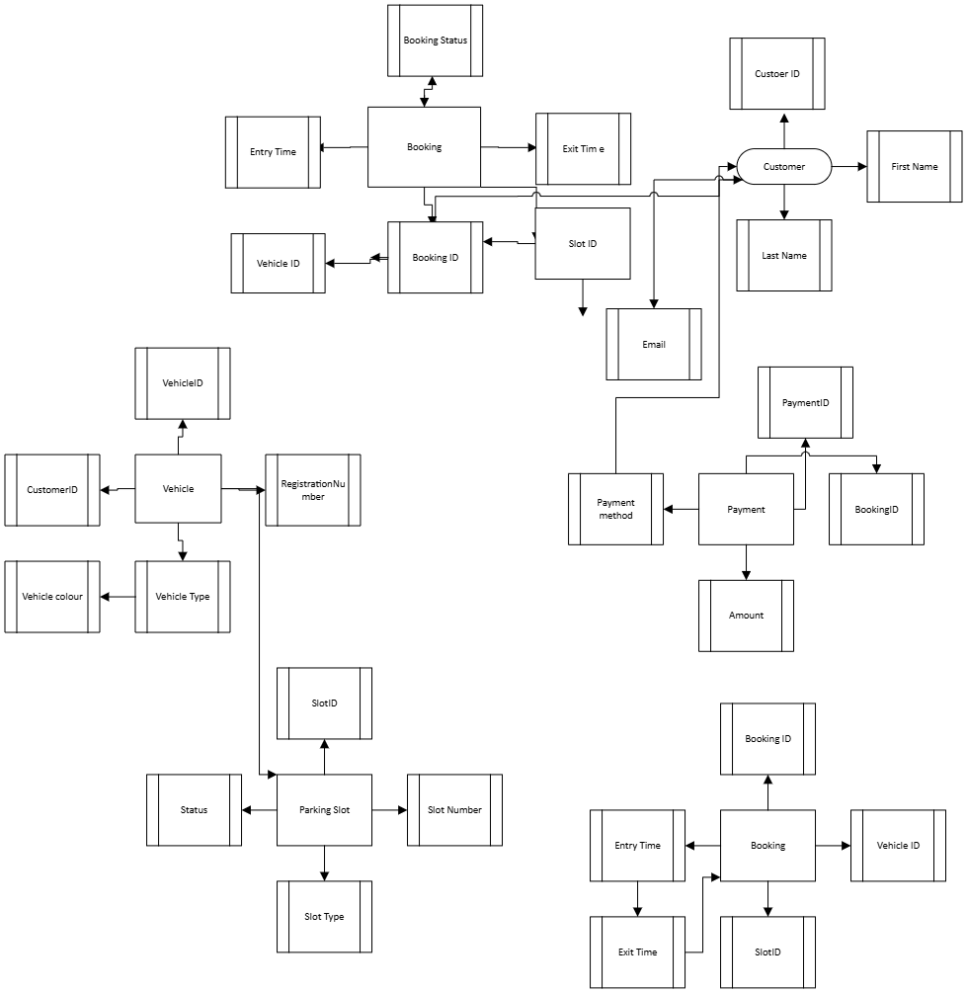

Designs Descsions and Reflection

This database was designed to improve consistency and tables were created such as customers, parking sites, vehicles, bookings, parking slots, payments and bookings. The primary keys ensured proper relationships between records designs with 3NF to minimise duplication.
One problem was deciding the relationships between bookings, vehicles and parking slots this was a challenge to make sure the past bookings were intact. An improvement in the future would be introducing online reservations, better parking rates, good staff management, reserved spots for particular vehicle types. Introducing monthly subscriptions could also be an idea for future.It was challenging connecting relationships

Conclusion
The Auto park Management database is created to automatically handle parking management rather than manually recording. This database manages everything from Vehicles, customer, parking- slots, payments, parking sites etc. Payments are done swiftly and efficiently through the database system. The database allows accuracy providing manged information and revenue.

Screenshots
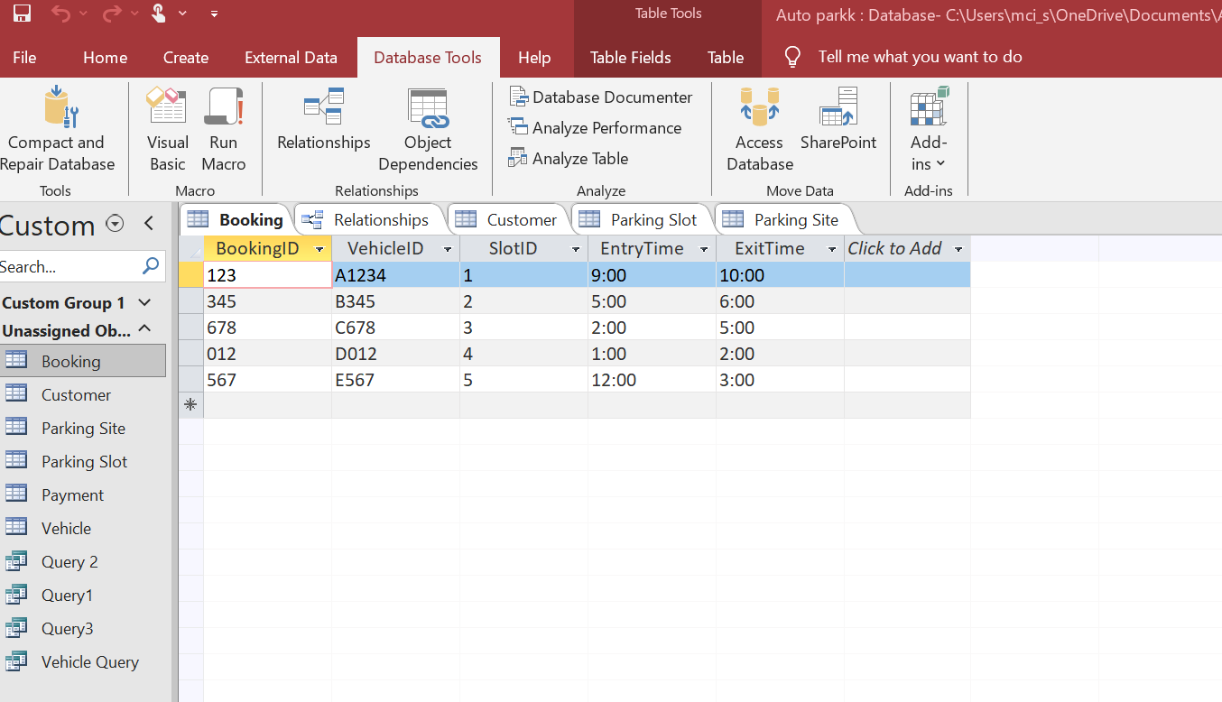
Figure 1:

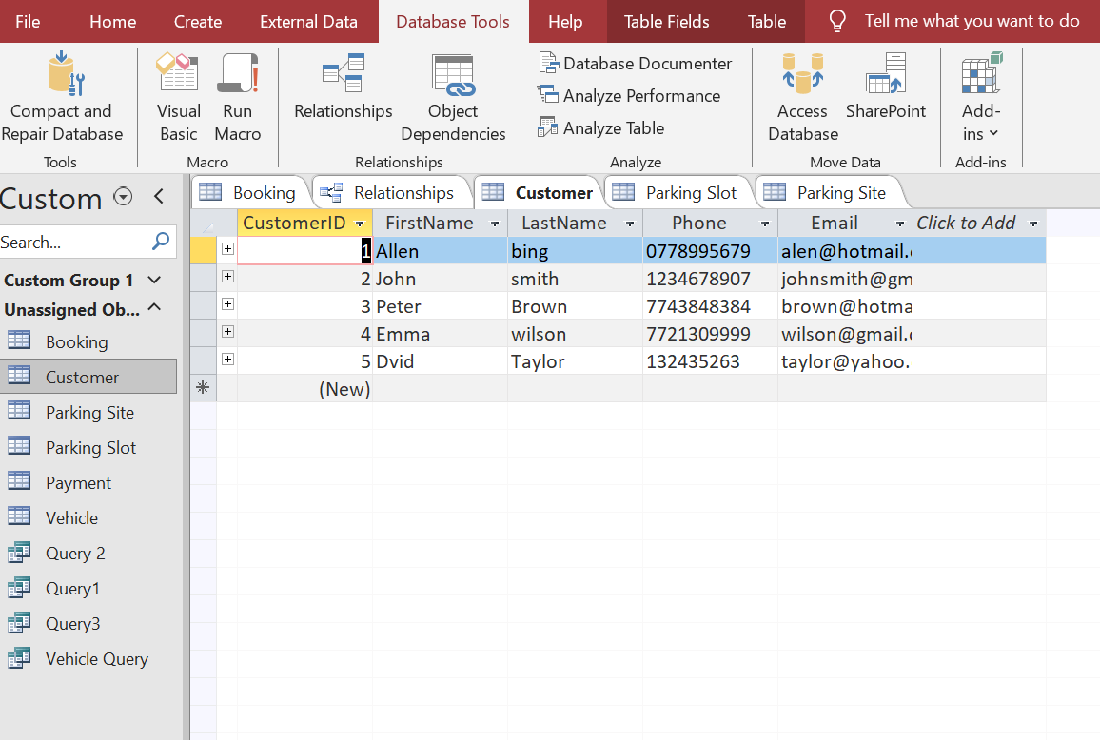

Figure 2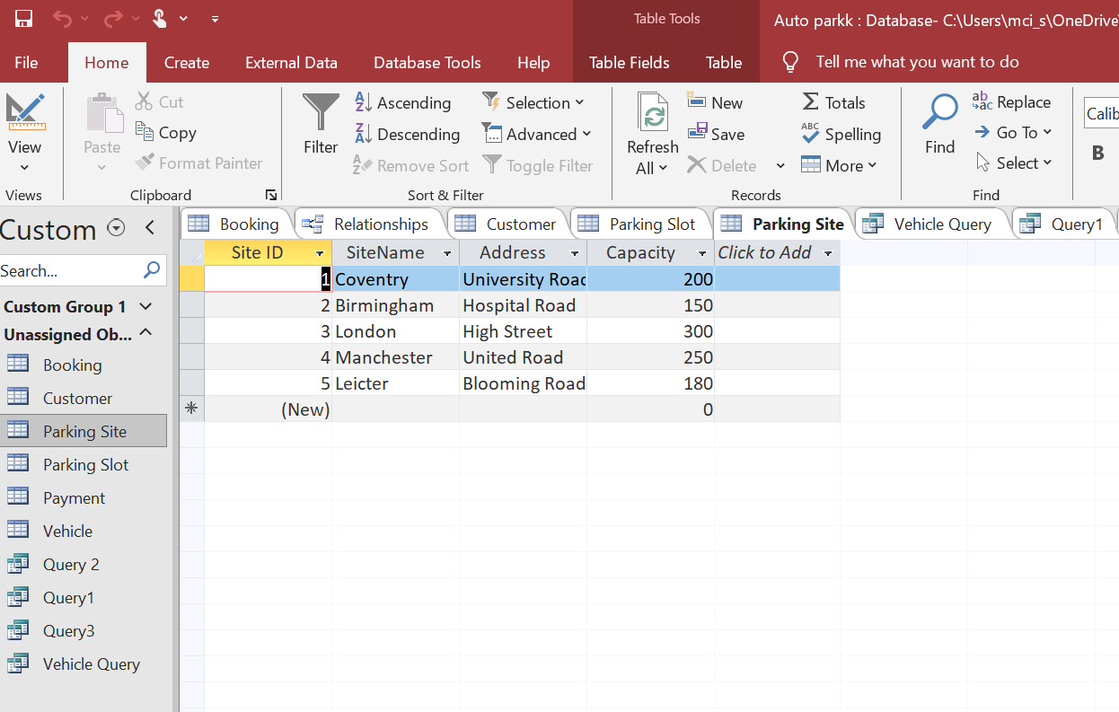
Figure 3

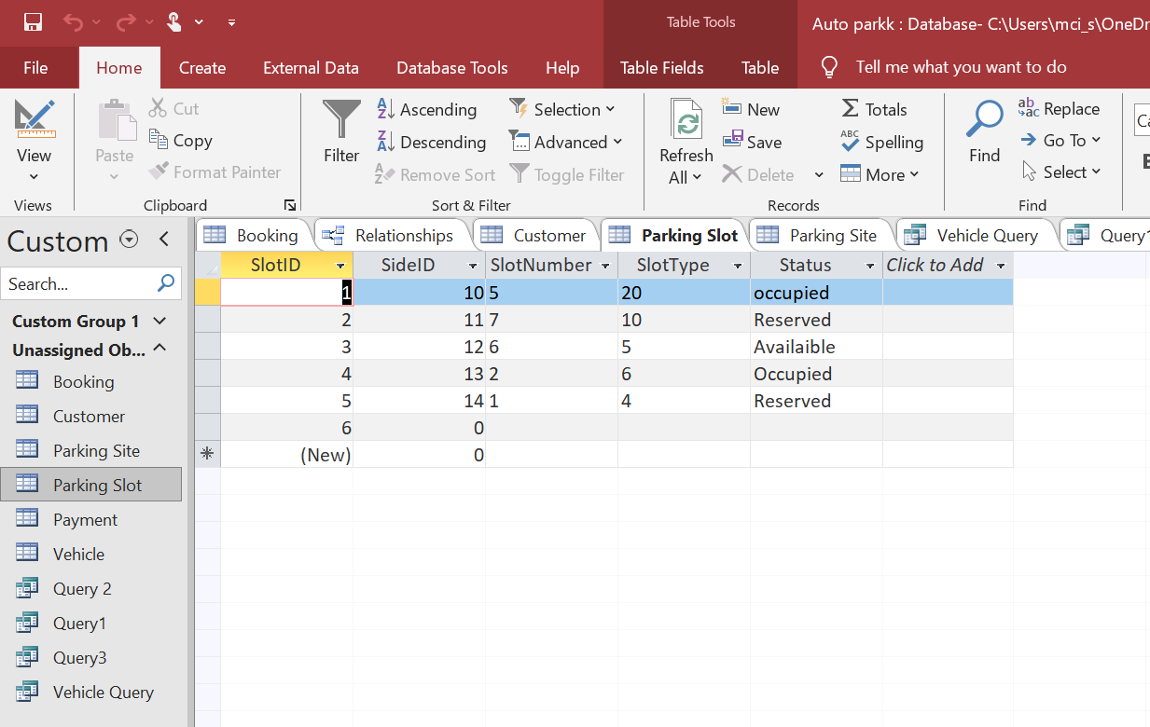
Figure 4
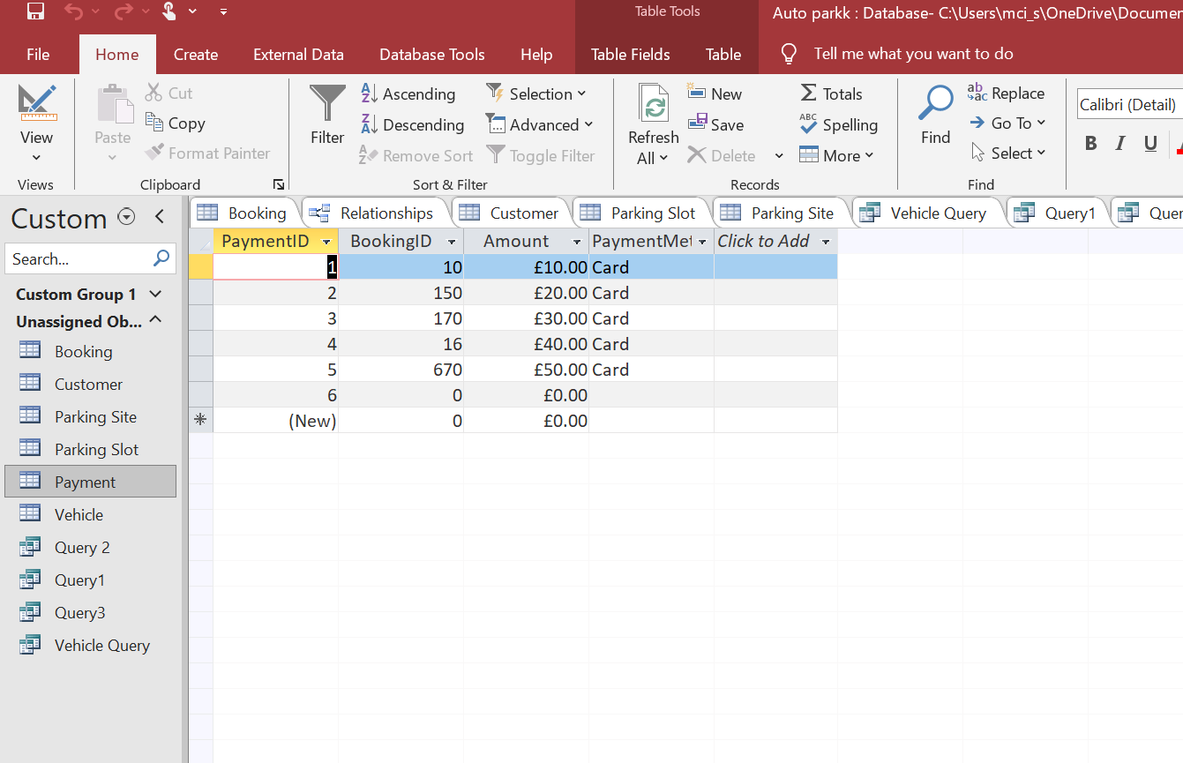
Figure 5
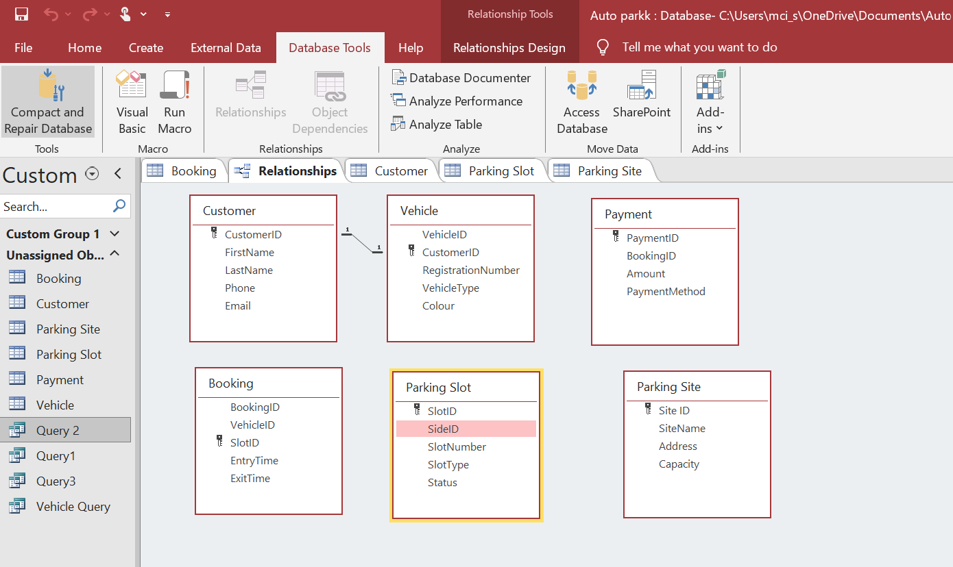
Figure 6
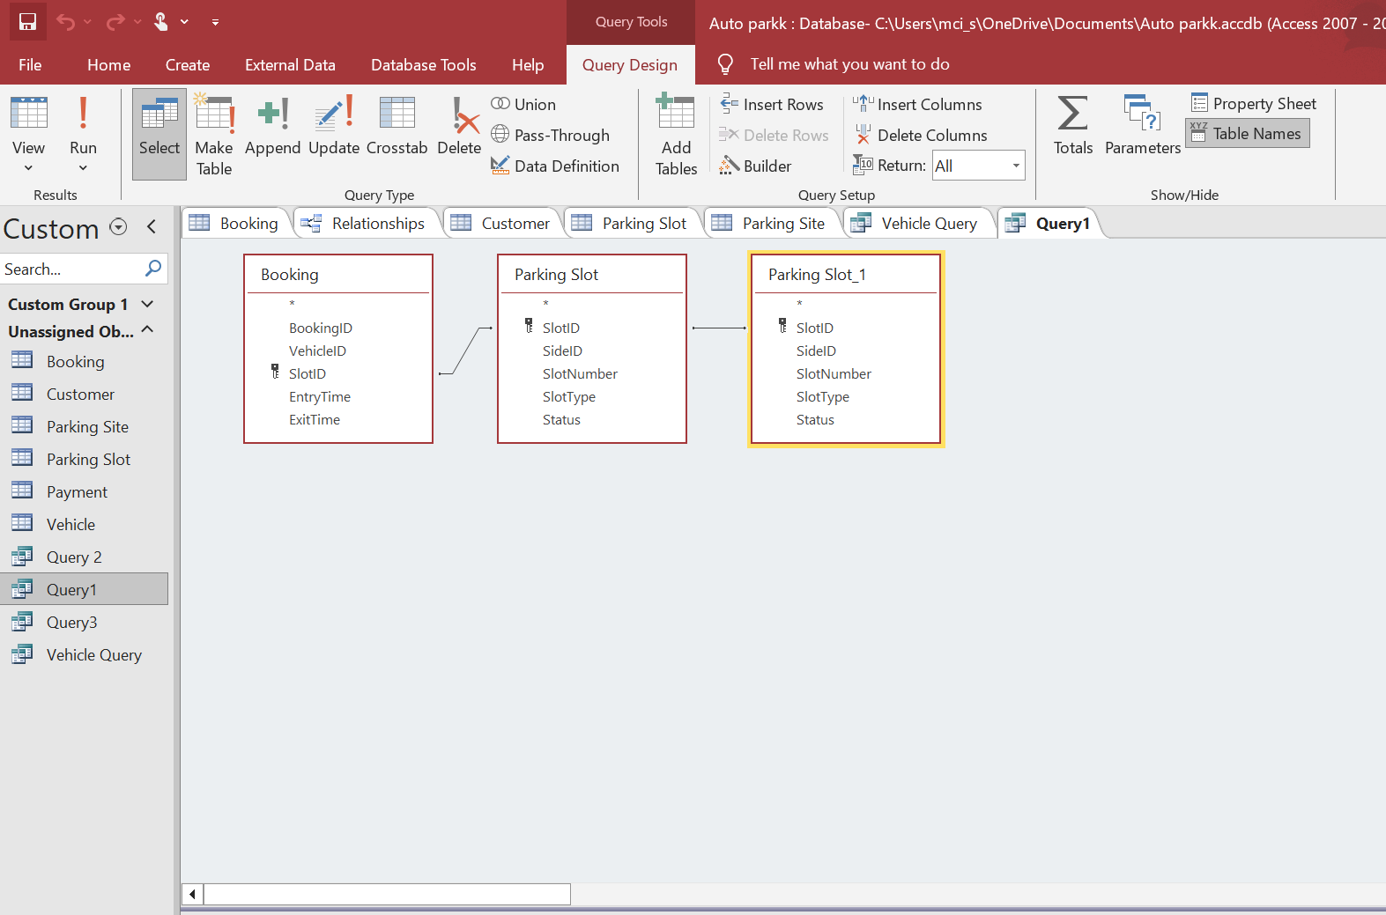
Figure 7

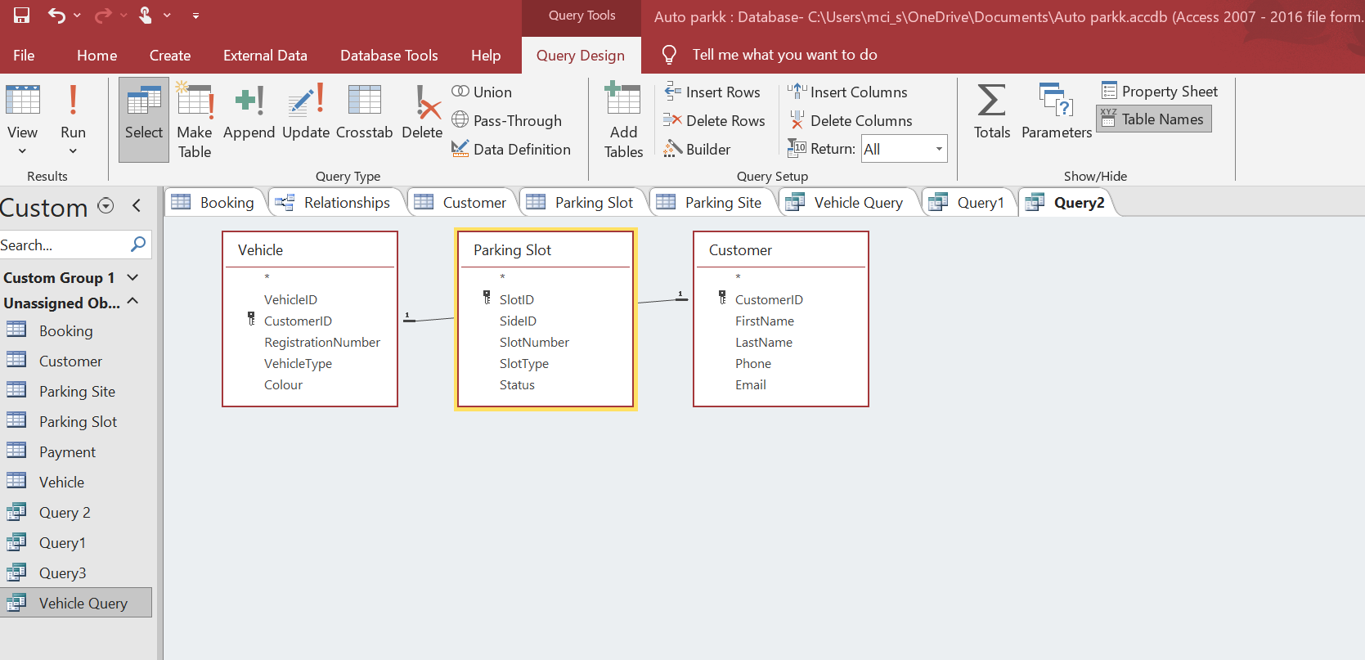

Figure 8

References
[1] R. Elmasri and S. B. Navathe, Fundamentals of Database Systems. Pearson Education, 2015.
[2] Microsoft, “Video: What is Access? | Microsoft Support.” Accessed: Jul. 09, 2026. [Online].
Available: https://support.microsoft.com/en-us/access/training/video-what-is-access
[3] A. Silberschatz, H. F. Korth, and S. Sudarshan, Database System Concepts. McGraw-Hill
Education, 2020. [Online]. Available:
https://books.google.com.pk/books?id=5xbQuwEACAAJ
[4] Microsoft, "Create a database in Access,"Available: https://support.microsoft.com/access

