- Lesson Plan
Name of Trainee: | Leanne Dawney |  |  | Session ref: |  | 06/CROSSCUR |  | Date: |  | 06/01/20 |  |  | Class: | Year 1 |  |  | Foundation Phase
 |  |  |  |  |  |  |  | Number of learners: |  |  |  | 30 | Age: | 5 years old |  |  | Foundation Phase
Learning objectives/intentions: |  | A cross curricular lesson; a science experiment with the use of literacy and numeracy skills – making Winnie the Witch’s hat fly |  |  |  |  | Success Criteria |  | - Be able to make a list (class activity)  - Predict what will happen  - Use new vocabulary in context to lesson  - Measure and select correct quantities of ingredients  - Give an account of what happened  - Reflection |  |  |  |  | Meeting learners’ needs: |  | Teaching assistants to support children when practicing making their potion. E.g, instead of using jug to measure 1L of water, suggest equivalence in cups worth. Help children to pour in.
Introduction/plenary tasks |  |  |  |  | Main activities |  |  |  |  |  | Resources/  Key Vocabulary |  |  |  | Assessment for Learning (strategies and opportunities)
Introduction  Class has previously been reading Winnie the Witch books.  Class come in to discover a letter left by Winnie. Read letter with class and show them the two ingredients left by Winnie – baking soda and white vinegar (clearly labelled).  Watch the video on YouTube as written in Winnie’s letter.  Class are to discuss with a partner (talking partners) what they have seen on the video and how they could adapt what they have seen to make Winnie the Witch’s hat fly (they will need to place the hat over the bottle). |  |  |  |  | Once the children have established that they need to place the hat over the bottle, move on to list the ingredients that they will need. This will be done as a class, teacher to write list on the whiteboard. All resources are to be on hand ready to show the class.  If children cannot think of what they need, refer back to video.  Each pair of children are to be given a whiteboard and pen to write a word/draw a picture of what they predict will happen. TA’s to note down/take picture of whiteboards.  TA supported activity – children to practice making the potion that will make the hat fly in small groups. Children will be given ingredient list to use but will use water instead of the white wine vinegar, just for the practice.  Children to go outside and perform the experiment as a whole class, explaining to the teacher what steps they should take, and the measurements needed.  Experiment to be recorded on the class iPad.  Watch the video of the experiment taken on iPad with class on the whiteboard.  Discuss.  Encourage children to use new vocabulary which was introduced during the lesson. |  |  |  |  |  | Key vocab  High/higher  Low/lower  Fly  Fall over  Explode  Move  Shoot up  Quickly  Slowly  Glide  Rocket  Resources  Winnie’s letter  Winnie’s hat  Whiteboard and pens  iPad  Classroom whiteboard  Ingredients:  Bottles  Pencils  Tape  Corks  Tissues  White vinegar  Baking soda |  |  |  | Asking the children what they think will happen –  Will it stay in the sky?  How high will it go?  How we do measure how high? (higher than the swings?)  Talking partners and group work.  Thumbs up/thumbs down if children are feeling confident to help make the hat fly.  Lollipop sticks with children’s names on to select individuals to explain to class their account of what happened.  Reflecting on experiment.

Plenary

Ask children to describe what happened. Record results by asking children to write words/draw a picture to describe what happened on mini whiteboards.
TA’s to take note/pictures of the whiteboards.
Curriculum coverage (range and skills)
Knowledge and Understanding of the World – exploring and experimenting, thinking about questions and then asking them and listening to the answers, listening to others ideas’, thinking creatively and imaginatively, communicating observations and measurements, describing what they have found out and offering simple explanations, reflecting on and evaluating their own and others’ work
Literacy (LNF)  Include some detail and relevant vocabulary to extend their ideas or accounts.  Listen to others, with growing attention, usually responding appropriately, e.g. carrying out instructions.  Show understanding of what they have heard by asking questions to find out more information.  Take part in activities with others and talk about what they are doing.  Write words, phrases and simple sentences and read back own attempts. |  |  |  |  |  |  |  |  |  |  | Numeracy (LNF)  Transfer mathematical skills to play and classroom activities.  Identify steps to complete the task.  Use knowledge and practical experience to inform estimations.  Use non-standard units to measure length, height and distance.  Collect information.
DCF – Observe others online |  |  |  |  | Thinking |  |  |  |  |  | ESDGC |  |  |  | YCC

- Resources – Winnie’s letter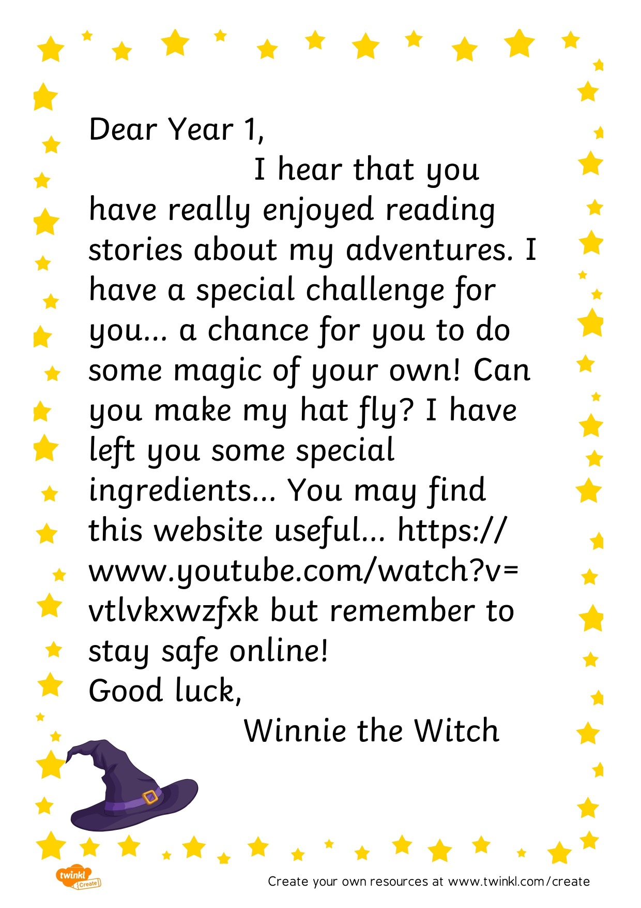
2, Resources – Ingredient List 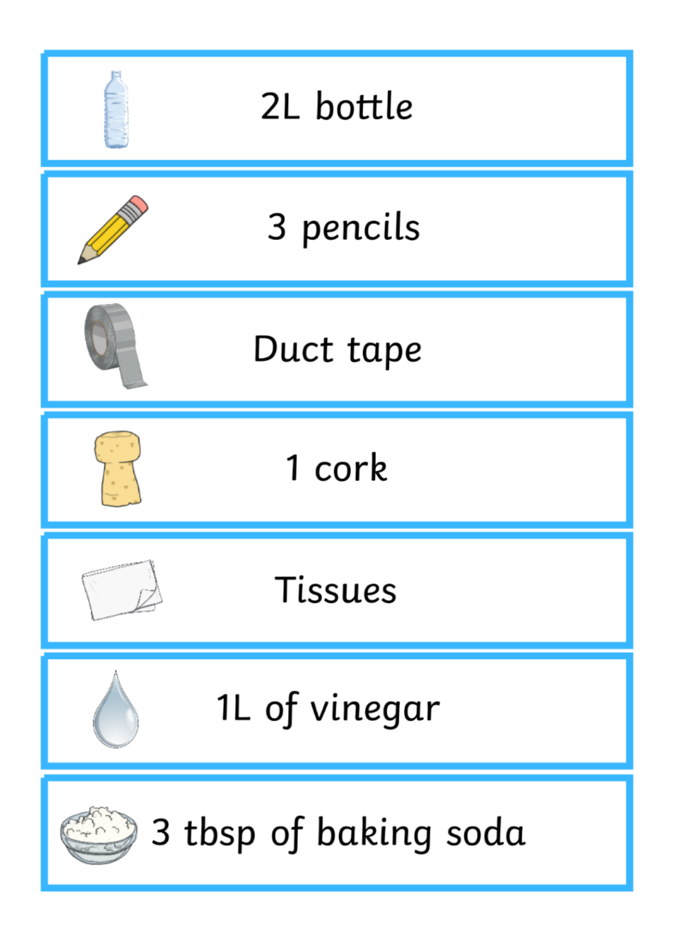

- Justification

All lessons need a starter activity. This class has previously been reading the Winnie the Witch story books (Thomas, 2016). To excite the class and engage the children as soon as they walk in, there is a letter to be found for the children from Winnie. Williams (2016) states starters should be exciting and activate children’s interest in the topic. It should get the children thinking straight away. Therefore, starter activities should be set out ready for when the learners walk in so that they can begin as soon as they enter the class (Williams, 2016). The children then watch the video and are to discuss with a talking partner what they have seen on the video and how they could adapt it to make the hat fly, which they will need to do by placing the hat over the bottle. By discussing, asking and answering questions about the letter and video, it prepares children and links into the following activities. Williams (2016) supports this by explaining that the starter activity needs to connect the learning between the activities.

This session is a cross-curricular lesson. Dewey (1902) believed that there was no benefit in creating a false opposition between ‘subjects’ (Rowley and Cooper, 2009, p.1). The new curriculum Successful Futures proposed by Professor Graham Donaldson (Welsh Government, 2015) has a focus on cross-curricular teaching and learning. This lesson is essentially a science experiment but shared with the essential areas of learning, numeracy and literacy. It also has elements of digital competency skills with the use of finding the video that Winnie left a link to and using the class iPad to record the actual experiment. The Welsh Government have said:

The cross-curricular responsibilities of literacy, numeracy and digital competence support almost all learning and are essential for learners to be able to participate successfully and confidently in the modern world. Literacy, numeracy and digital competence need to be considered as part of school-level curriculum design across all areas of learning and experience (Welsh Government, 2019, p.11).

By engaging the use of these three areas of learning, children are able to use them in conjunction with other subjects in the curriculum. Instead of just using literacy skills in English lessons, numeracy in math lessons and digital competency skills in ICT, children are able to apply them to a science experiment and use them in different contexts and experiences. According to Donaldson’s report, literacy, numeracy and digital competency should be the focus for all teachers and literacy and numeracy should be used as more than just a basic skill (Welsh Government, 2015).

The main philosophy of the Foundation Phase is the key main reasoning behind elements of this lesson plan. Outdoor learning is a key feature of the Foundation Phase (Welsh Government, 2015). By simply taking the children outside to perform the experiment provides many benefits. This can be called using the ‘outdoor classroom’. It is known as using an outdoor area as an environment for learning for either a whole class of children or groups for adult-led activities such as for reading stories, or in this case a cross-curricular lesson. It can also be used for child-initiated activities (Bilton, 2010). In 2006, a Learning Outside the Classroom Manifesto was created. The term ‘learning outside the classroom’ has been defined as ‘the use of places other than the classroom for teaching and learning’ (DfES 2006:1, quoted in, Bilton, 2010, p. 4). This refers to a lesson/activity being taken outside, not to specifically use the outdoor features, but just to be outside (Bilton, 2010). Specifically, in this lesson, the outdoor area has been facilitated as the hat needs room to ‘fly’ and can be slightly messy when the mixture explodes and fizzes. However, by being outside, children are able to have a more enhanced experience. Studies have shown that there has been a decline in young children’s engagement with the outdoors (Macquarrie, 2018, p. 345). Therefore, there has been an importance on ensuring that children have as much access to the outdoor environment as possible.

There are a range of skills included from the numeracy element of the National Literacy and Numeracy Framework. There is a difference between literacy and numeracy. Numeracy is the ‘actual application of the skills learned in mathematics in a cross-curricular, real-world way and not purely about the skills themselves’ (Welsh Government, 2013, p. 20). A new area of learning which will be implemented in 2022 will be ‘mathematics and numeracy’ (Welsh Government, 2015). In this lesson, within the ‘developing numerical reasoning’ strand is the element ‘transfer mathematical skills to play and classroom activities’ (Welsh Government 2015). In this activity before the experiment, the children are to practice making their own potion. For this, they must use their numerical skills to count out what they will need and measure the white vinegar and baking soda. On the list given to the children, it says they will need one litre of vinegar. Teaching assistants can help differentiate this for different mixed abilities. Some children will be able to use a measuring jug to measure one litre, whereas others may do ‘cups worth’ of water. The ingredient list also says the children will need three tablespoons of baking soda. In order to extend this for higher abilities, the teaching assistant could measure how many grams of baking soda that would be equivalent to and ask the children to measure the ingredient out in grams instead of spoons worth. Haylock and Thangta (2007) have said when practitioners are considering introducing numeracy elements to lessons that there should be connections with other curricular areas, be in a purposeful context, include concrete experiences and have good use of mathematical language (Haylock and Thangta, 2007).

Successful lessons are aided with good, effective resources. In this lesson, two original resources have been included in order to help the children’s learning and prompt effective teaching. The first resource is a letter. The children come into the classroom to find a letter has been left by the witch along with two ingredients that are needed to make her hat fly. This gives children a concrete experience and the opportunity to use their imagination. The second original resource is a sheet with the ingredient list on. This is in the form of seven labels with a picture of the ingredient, the amount and the ingredient itself. With the use of this, children are able to refer back to what they need to make the potion. Glazzard et al. (2015) has highlighted the importance of having a picture of an item alongside the word in order to help children with their learning. This is done as having the picture with the word helps children familiarize themselves with the item. The ingredients also consist of everyday items which children may be familiar with. In the resource list is also whiteboards and pens. Using whiteboards instead of sitting at the table with paper and pencil gives a more relaxed, inclusive approach to the children. The focus is also more on what the children think rather than the actual spelling of a word and their handwriting which is why they can also draw a picture to help depict and visualize their predictions and observations.

This activity involves a lot of social interaction. After reading the letter, the children work in pairs to predict what they think will happen to the hat. Such as, will the hat fly? How high will the hat go? They are able to do this by writing down some words or draw a picture together depicting what they think will happen. The children then must work in groups to practice making the potion together, before they have to do the real experiment with the teacher and assist the teacher in how to make it. After practicing, the children help the teacher do the actual experiment by working together to tell the teacher what they need and how much of it. After the experiment is done, the children are then to discuss together their accounts. Vygotsky placed a huge importance on children’s social interactions. Vygotsky developed the theory of ‘the zone of proximal development’ otherwise known as ‘ZPD’. This is where there ‘is a gap of what a child can do alone and what they can do with the help of someone more skilled or experienced, who could be an adult or another child’ (Pound, 2006). This can also be known as ‘scaffolding’. The social interactions within this activity allow the children to scaffold each other. They are able to share ideas, predictions and help each other in creating the potion. This can also be seen again when the children work as a class to help the teacher make the hat fly.

There a few theories that support learning through doing and concrete experiences. Froebel first introduced the sentiment (Pound, 2006). Dewey believed that children should learn through doing and that their education should be based on real-life experiences (Pound, 2006). Kolb looked at the process of experiential learning and drew from Piaget, Lewin and Dewey (Beard and Wilson, 2006). This is hugely reflected in the Foundation Phase as it places an emphasis on children having experiences that will help develop their learning. Kolb explained ‘Learning is the process whereby knowledge is created through the transformation of experience’ (Kolb, 1984, quoted in, Beard and Wilson, 2006, p. 19). Kolb’s learning process begins with a concrete experience, reflective observation, abstract conceptualization and active experimentation. In this activity children are given a concrete experience. The children come into the classroom to find the letter and ingredients left by Winnie. The children are able to take part in the experiment which gives them the opportunity to learn through doing. After the activity has been carried out, the children watch the video of the activity that was taken on the iPad on the classroom interactive whiteboard. The children are then able to reflect on what happened. They are able to discuss together their accounts and think about what their first prediction was. The overall style of this lesson is to learn through doing.

Assessment for learning is an essential feature of lesson planning and is needed for effective teaching. It is all about involving children in their own learning. Teachers are able to share learning goals with their pupils. This helps the children in their class to know and recognize what they are aiming for. It also allows pupils to take part in self-assessment. In 2005 to 2008, the Assembly Government ran a pilot of a programme which included developing thinking and assessment for learning (Welsh Government, 2010). It was a success and saw improvements in pupils’ performance which led to higher quality outcomes, all learners engaged in their own learning and the children’s ability to transfer generic skills. It also contributed to the enjoyment of both the teacher and the children (Welsh Government, 2010). Questioning is a key principle of assessment for learning. In this lesson children are asked what they think will happen when they try to make the hat fly. They are then later asked to give an account of what they saw happen which reinforces the aims of assessment for learning, the children are also selected by using lollipop sticks with the children’s names on so that all the selections are by random. The children are also asked during the lesson to give a thumbs up or thumbs down in regard to whether they are confident in assisting the teacher with helping to make the hat fly. The thumbs up or thumbs down system is commonly used to check whether learners are confident in what they are doing. Ysgol Y Foryd has been praised by Estyn for their good practice. The school have been trialing different methods to see which works best for learners. All classes use ‘talking partners’ (Estyn, 2019). In this lesson plan, talking partners is a method used when discussing at the beginning of the lesson and during the plenary. The talking partners are used to encourage confidence in speaking and listening. By being able to discuss with each other, children are able to identify some misconceptions early (Estyn, 2019).

Reference List

Beard, C. and Wilson, J. (2006) Experiential learning: a best practice handbook for educators and trainers. London: Kogan Page.

Bilton, H. (2010). Outdoor learning in the early years: management and innovation. London: Routeledge.

Cartoonium (2014) DIY Baking Soda & Vinegar Rocket! – Meet Me at the Reck [video]. Available at: https://www.youtube.com/watch?v=vTlvkXWzfXk (Accessed: 23/12/19).

Estyn (2019) Giving pupils the power to learn. Available at: https://uwtsd.ac.uk/media/uwtsd-website/content-assets/documents/library-and-learning-resources/infoskills/Harvard-eng_v.1.2.pdf (Accessed 30/12/19).

Glazzard, J. (2010) Teaching primary special educational needs. Exeter: Learning Matters.

Haylock, D. and Thangta, F. (2007) Key Concepts in Primary Mathematics London: SAGE

Macquarrie, S. (2018) ‘Everyday Teaching and Outdoor Learning: Developing an Integrated

Approach to Support School-Based Provision’, Education 3-13, 46(3), pp. 345-361.

Pound, L. (2006) How Children Learn. London: Practical Pre-School Books.

Rowley, C. and Cooper, H. (2009) ‘cross-curricular learning and the development of learning’, in Rowley, C. and Cooper, H. (eds.) Cross-curricular Approaches to Teaching and Learning. SAGE: London.

Thomas, V. (2016) Winnie and Wilbur: Winnie the Witch. Oxford: Oxford University Press.

Welsh Government (2010) Why develop thinking and assessment for learning in the classroom? Available at: https://hwb.gov.wales/storage/2d2b99cd-5431-421e-ac8b-8608fe0edf05/why-develop-thinking-and-assessment-for-learning-in-the-classroom.pdf (Accessed 30/12/19).

Welsh Government (2013) National Literacy and Numeracy Framework. Available at: https://hwb.gov.wales/storage/64812b0e-3d20-4d10-94e8-68221e47a38d/to-support-schools-in-introducing-the-national-literacy-and-numeracy-framework.pdf (Accessed 23/12/19).

Welsh Government (2015) Foundation Phrase Framework. Available at: https://hwb.gov.wales/storage/d5d8e39c-b534-40cb-a3f5-7e2e126d8077/foundation-phase-framework.pdf (Accessed 23/12/19).

Welsh Government (2015) Successful Futures: A summary of Professor Graham Donaldson’s report. Available at: https://gov.wales/sites/default/files/publications/2018-03/succesful-futures-a-summary-of-professor-graham-donaldsons-report.pdf (Accessed 23/12/19).

Welsh Government (2019) Digital Competence Framework: draft Curriculum for Wales 2022 version. Available at: https://hwb.gov.wales/draft-curriculum-for-wales-2022/digital-competence-framework-draft-curriculum-for-wales-2022-version#overview (Accessed 30/12/19)

Welsh Government (2019) Draft Curriculum for Wales 2022: A guide to Curriculum for Wales. Available at: https://s3-eu-west-1.amazonaws.com/hwb-live-storage/cd/b4/f8/7c/b7d34ffb968d9a09de4d460c/a-guide-to-curriculum-for-wales-2022.pdf (Accessed 23/12/19).

Williams, S. (2016) Sharon Williams Educational. Available at: http://www.sharonwilliamseducational.co.uk/blog/lesson-planning-2-starters-and-plenaries-and-why-they-are-so-important-to-the-learning-process (Accessed: 30/12/19).

