5/5/2024
Assessment
Portfolio Report on Contemporary Software Applications for Business

Student Name:
STUDENT ID:
Eduardo Ismael Erazo Lopez
2518857

MODULE NAME: SOFTWARE SOLUTIONS FOR BUSINESS
MODULE CODE: ACCA 4026
LECTURER: KOUSHIK MODAK
TRINITY SAINT DAVID UNIVERSITY OF WALES (LONDON CAMPUS)

Table of Contents
Introduction 2
Main Body 2
Task 1 2
e-Commerce Website builders/software solutions 2
Task 2 2
Mind-map of Contemporary Software Applications 2
Task 3 3
Office Applications for Creating, Storing, Presenting, and Analysing Data 3
a. 3
b. 3
Task 4 3
Communication and Collaboration applications 3
a. 3
b. 4
Conclusion 4
References 4
Appendices 4

Introduction
This portfolio has been produced for the module Software Solutions for Business (ACCA4026) and demonstrates my understanding of how contemporary software applications are used to support day-to-day business operations. The work combines research, critical analysis and practical activities to show both theoretical knowledge and hands-on competence with a range of digital tools commonly used in modern workplaces.
In Task 1, I analyse contemporary e-commerce website builders, comparing their main features, benefits and limitations for businesses that trade online. Task 2 introduces mind mapping as a technique for organising information and presents a visual mind map of current software applications used in organisations. Task 3 focuses on core office applications—Microsoft Word, Excel, PowerPoint and Access—exploring how they are used to create, store, present and analyse data, and providing practical evidence of selected features in use. Finally, Task 4 examines one communication tool and one collaboration tool, analysing their role in modern business communication and illustrating how they support file sharing and teamwork.

Main Body

Task 1
(10 marks)

e-Commerce Website builders/software solutions
(Approx. 500 words)
Name several e-Commerce website builders/software solutions most popularly used and give a description of 2 contemporary e-Commerce website builders/software solutions based on their major features, benefits and limitations (approx. 2/3 sources).
Shopify, Wix, Squarespace, and WooCommerce are among the most widely used e-commerce website builders for both established businesses and small entrepreneurs. They offer a wide range of features that make them attractive options for creating and managing online stores [1].
Shopify is particularly user-friendly for individuals with little or no coding experience. Its drag-and-drop graphical user interface (GUI) allows users to design and structure their websites quickly and efficiently. One of Shopify’s main advantages is its integrated payment system, which eliminates the need for third-party transaction services [1].Features such as Shop Pay, an accelerated one-tap checkout option, enhance the user experience by providing faster transactions and greater convenience [2]—factors that can lead to higher customer satisfaction and increased sales.
Furthermore, Shopify bundles essential tools into a single platform, including hosting, payment processing, security, and social-media marketing integrations. This significantly simplifies the process of launching and managing an e-commerce site.However, Shopify has certain limitations. Its content-management capabilities are relatively limited compared to more flexible platforms, as its primary focus is on online retail rather than content marketing. Additionally, because Shopify operates on a fully hosted infrastructure, businesses are dependent on its environment, making migration to another platform more complex and restrictive[1].
BigCommerce, on the other hand, supports both Business-to-Consumer (B2C) and Business-to-Business (B2B) models within a single platform [3]. This multi-functional structure allows users to manage multiple storefronts from one BigCommerce account, enabling businesses to reach diverse customer segments across different regions.
Another key strength of BigCommerce is its multi-channel selling capability. It integrates seamlessly with major online marketplaces such as Amazon, eBay, Walmart, and social media platforms like Instagram and TikTok [4]. This feature allows sellers to manage all their sales channels from one place, increasing efficiency and market reach.
BigCommerce also includes strong SEO (Search Engine Optimisation) tools — such as customisable URLs, meta descriptions, and automatic image optimisation — all built into the platform [3]. These tools help businesses improve their online visibility without relying on external applications.
One of its most attractive advantages is the absence of transaction fees. BigCommerce does not charge extra fees beyond those set by the chosen payment gateway, giving small businesses and entrepreneurs a competitive financial advantage over platforms that impose such charges [3].
However, BigCommerce can feel complex and overwhelming for beginners because of its wide range of features [4]. Some users may prefer a simpler and more intuitive interface, such as Shopify’s. Additionally, its pricing plans include annual sales limits, meaning that small businesses may need to upgrade to higher plans as their revenue grows [3]. The platform also offers a limited number of free design themes, which can make stores appear visually repetitive.
Overall, while Shopify provides a more user-friendly and visually intuitive experience, BigCommerce excels in flexibility and cost-effectiveness. Each platform has its own strengths: Shopify suits small businesses and entrepreneurs seeking simplicity, whereas BigCommerce is better for growing companies that require advanced multi-channel capabilities.
[1]What is Shopify and how does it work? (2025). (2025, September 8). Shopify. https://www.shopify.com/uk/blog/what-is-shopify
[2]Nguyen, R. (2024, December 30). Shopify Pros and Cons – Is it worth using? PageFly. https://pagefly.io/blogs/shopify/shopify-pros-and-cons
[3]Ecommerce Solutions through Open-Platform Flexibility | BigCommerce. (n.d.). BigCommerce. https://www.bigcommerce.com/product/
[4]BigCommerce Help Center. (n.d.). https://support.bigcommerce.com/s/article/Multi-Storefront?language=en_US#:~:text=Multi%2DStorefront%20(MSF)%20allows,specific%20product%20or%20campaign%20launch.

Task 2
(15 marks)

Mind-map of Contemporary Software Applications
(Approx. 500 words)

a. Describe mind mapping and explain the benefits of using mind mapping in business operations (approx. 2/3 sources). 5 marks
Mind mapping helps businesses to hold and organise information, and learning does need repetition ,as a mind map collects and organizes information quicker and easier for businesses to manage and plan any future tasks [1].
Information already known , gets connected to new and extended information e.g., knowing many businesses names , could potentially be connected with , when did they started, how did that exact business grew along the years , and what made it successful , all that information may be connected with the mind map , allowing business to share and analyze their current information, take action according to what they have [1].
Mind mapping also helps to dismantle complex information, making it easier for businesses to understand and analyze the information , eliminating the stress and tension [2].
As mind maps provide shared ideas , groups and teams can collaborate more , as the ideas are more clear and smaller, which makes it easier to pick and work on each idea.This could potentially boost the problem identification , and structure problem [2].
This increases efficiency and productivity. simpler topics → fast pick of ideas→ process information → fast productivity. [3]
Business can set their goals on a mindmap , the information gets tracked and keep to continue developing the ideas and which objectives are to be prioritized and which ones are not, this to throw light on the path, that helps business to be motivated and be exact to what they need to do [1].

[1] Guthrie, G. (2025, February 13). 13 science-backed benefits of mind mapping - Nulab. Nulab. https://nulab.com/learn/strategy-and-planning/8-science-backed-benefits-of-mind-mapping/#:~:text=Mind%20mapping%20makes%20it%20easier,an%20average%20of%2023%20percent.
[2] Atlassian. (n.d.). What is a mind map? Learn its benefits and how to create one | The Workstream. https://www.atlassian.com/work-management/project-management/mind-mapping#:~:text=A%20mind%20map%20visualizes%20ideas,and%20understand%20how%20information%20works.
[3] Mind mapping in the workplace - Business use | MindMapping.com. (n.d.). MindMapping. https://www.mindmapping.com/mind-mapping-in-business#:~:text=Over%20the%20last%20few%20years,Mind%20Mapping%20Productivity%20Boost

b. Create a mind map of contemporary software applications that are used to support day-today business/Organisation operations. 10 marks

MindMap Link:https://mm.tt/map/3847906048?t=e3T3mvMUTd

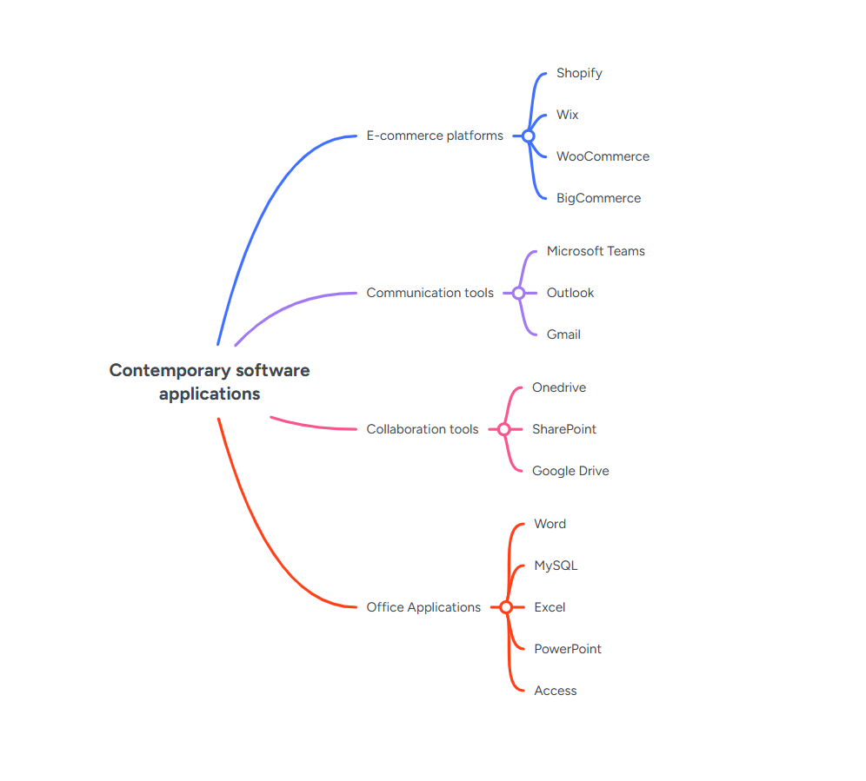

Task 3
(50 marks)

Office Applications for Creating, Storing, Presenting, and Analysing Data
(Approx. 2000 words)

a.
30 marks
Explain four office software solutions for business operations (MS Word, MS PowerPoint, MS Excel, and MS Access), highlighting their major features, benefits, and limitations (if there are any). You can use some images in addition to text (approx. 4/5 sources).
- Please try to avoid using bullet points. Rather, describe them in separate paragraphs.

Microsoft Word
Microsoft Word contains a variety of tools that are intuitive and easy to use because of its friendly user interface. This makes Microsoft Word one of the most widely used word-processing software solutions in business environments. Users can track work and collaborate on the same document, which enhances team productivity. They can also add many different elements, similar to working on a physical sheet of paper, such as photos, charts, tables, shapes, 3D models and SmartArt graphics [1]. These capabilities allow businesses to create professional reports, letters, proposals and other formal documents in a consistent and efficient way.
The core functionality of Microsoft Word focuses on text editing and formatting. Users can type, cut, copy, paste, delete and move text easily within a document. They can change fonts, sizes and colours, apply formatting such as bold, italics and underline, and use predefined styles for headings and body text. Word also enables users to control layout and structure by adjusting page size and margins, setting indentations, and adding columns, headers, footers and page numbers. In addition, built-in tools such as spell check, grammar suggestions, auto-correction and automatic table of contents generation help users produce accurate and professional work more quickly [1]
In business settings, Microsoft Word offers several important benefits. It is a standard tool that many employees already know, which reduces training time and supports consistent document formatting across an organisation. Word makes it straightforward to create templates for recurring documents such as invoices, contracts or company policies, saving time and ensuring that branding and layout remain uniform. Integration with other Microsoft 365 services, such as OneDrive and SharePoint, allows documents to be stored in the cloud and shared with colleagues, supporting real-time collaboration and remote working.
However, Microsoft Word also has some limitations. It is not designed to manage large volumes of numerical data or perform complex calculations, so it is less suitable for tasks that are better handled in spreadsheet software such as Microsoft Excel. Very long documents with many images and complex formatting can become slow or difficult to manage, and formatting may change when files are opened on different devices or in different versions of Word. In addition, although collaboration features such as comments and track changes are powerful, they can become confusing when many people are editing the same document at the same time [1].
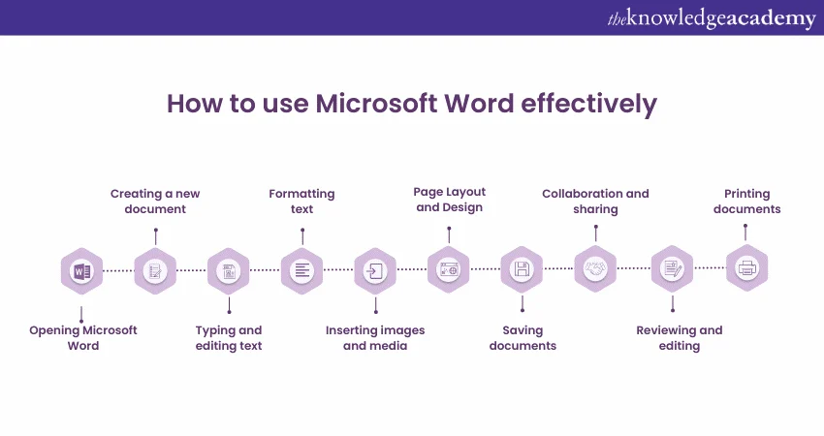[1]

Microsoft PowerPoint
Microsoft PowerPoint is one of the most widely used tools for creating professional slideshows. It allows users to combine text, graphs, images, audio and video to build presentations that communicate information in a more organised and visually engaging way [2]. In modern businesses, it is commonly used for meetings, training sessions, sales pitches and project updates, helping presenters structure their ideas and deliver them clearly to different audiences.
PowerPoint offers a range of features that support this process. Users can choose from predefined slide layouts and design templates, which simplify the process of creating consistent, visually appealing presentations. They can customise themes, colours and fonts to match corporate branding, and insert charts, diagrams and SmartArt to represent data and relationships visually. Animations and slide transitions can be applied to highlight key points or control the flow of information across slides. Presenter View and slideshow tools also support presenters by showing notes and upcoming slides on their screen while the audience only sees the current slide [2]
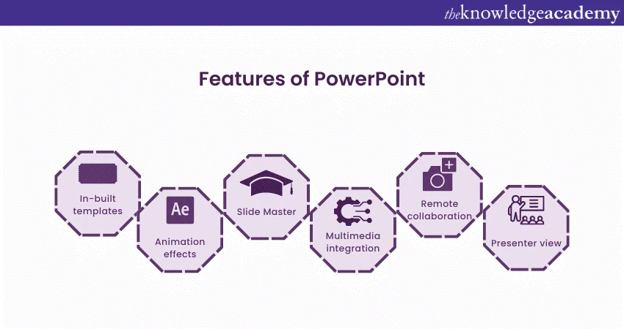[2]
These features provide several benefits for business communication. PowerPoint helps to break down complex topics into manageable segments and supports a logical sequence of ideas. Visual elements such as charts and diagrams make numerical data easier to understand for non-specialist audiences, which is important in meetings with mixed roles. Presentations can be reused and adapted for different clients or internal meetings, which saves time compared with creating new material from scratch. Integration with Microsoft 365 also means that PowerPoint files can be shared via OneDrive or Teams, allowing colleagues to collaborate on slides and present remotely.
At the same time, PowerPoint has some notable limitations. Many users tend to overload slides with text, which can reduce audience engagement and make the presentation harder to follow. Overuse of animations and transitions can distract from the main message rather than supporting it. PowerPoint is also primarily a one-way communication tool, so interaction with the audience is limited unless the presenter deliberately includes questions or discussion [2]. Finally, PowerPoint is not suitable for storing detailed documentation or complex datasets; it works best as a visual summary of information that is stored and managed elsewhere, for example in Word or Excel.

Microsoft Excel
Microsoft Excel is a spreadsheet application that is widely used to organise, analyse and visualise data in both personal and professional contexts. It allows users to work with data arranged in rows and columns, perform calculations and present results using tables and charts [3]. In business environments, Excel is commonly used for financial modelling, budgeting, forecasting, sales reporting and other forms of data analysis.
A key strength of Excel is its combination of basic and advanced features. At a basic level, users can enter numbers and text, sort and filter data, and apply formatting to make tables easier to read. More advanced functionality includes formulas and functions for performing calculations, such as SUM, AVERAGE, IF and VLOOKUP, as well as tools for conditional formatting, which can highlight important values automatically. Excel also provides charts and graphs to visualise trends and comparisons, and PivotTables and PivotCharts, which enable users to summarise large datasets and explore them from different perspectives without changing the underlying data [3] .
These features offer significant benefits for business operations. Excel supports data-driven decision making by allowing users to test scenarios, compare results and identify patterns in large volumes of information. It is flexible enough to be used in many different departments, including finance, human resources, operations and marketing. Because Excel is part of the Microsoft 365 suite and widely taught in education, many employees arrive in the workplace with at least some familiarity with it, which reduces training effort for employers. Files can also be shared through OneDrive or SharePoint, enabling multiple colleagues to collaborate on the same workbook when creating reports or forecasts.
However, Excel also has limitations that businesses must consider. Complex spreadsheets that rely on many formulas and cross-references can be difficult to understand and maintain, especially when several people have edited them over time. Human error in formulas or data entry can lead to inaccurate results, which may affect important business decisions. Excel is also not the best solution for very large or highly relational datasets, where a database management system such as Microsoft Access or SQL Server would be more appropriate [3]. In addition, although Excel offers collaboration features, simultaneous editing by many users can sometimes cause version-control issues or performance problems.

Microsoft Access
Microsoft Access is a database management system that is part of the Microsoft 365 office suite. It combines a relational database engine with a graphical user interface and a set of development tools, allowing users to create and manage databases without needing to write extensive code [4]. Access is often used by small and medium-sized organisations to store and manage structured data, such as customer records, inventory information or internal tracking systems.
Access is built around several core components: tables, queries, forms and reports. Tables store data in a structured way, with rows and columns representing individual records and fields. Relationships can be defined between tables, which supports a relational database design and helps to avoid duplication of data. Queries allow users to retrieve and filter information based on specific criteria, while forms provide a user-friendly interface for entering and editing records. Reports can be designed to present data in a formatted layout suitable for printing or distribution, such as invoices, summaries or performance dashboards [4]. Access also includes features such as macros and wizards that help automate common tasks and simplify application development.
For businesses, Microsoft Access offers several advantages. It provides an affordable and relatively simple way to build custom database solutions compared with larger enterprise systems. Non-programmers can create useful applications by using the graphical tools, templates and wizards that Access provides. Because it integrates with other Microsoft 365 applications, data from Access can be exported to Excel for analysis or linked to Word for generating letters and documents. This makes Access a practical option for small teams or departments that need more structure than Excel can reliably provide, but do not require a full-scale corporate database solution.
Despite these benefits, Access also has important limitations. It is primarily a desktop application that runs on Windows, which limits its use in cross-platform or cloud-native environments. Access databases are not designed to scale to extremely large datasets or very high numbers of simultaneous users, so performance can degrade as the database grows or as more people connect to it. Managing relationships, queries and security settings can be challenging for users without a technical background, which may increase the risk of design errors or data integrity problems [4]. As a result, Access is best suited to small-scale business applications rather than mission-critical systems.

[1] The Knowledge Academy, “What is Microsoft Word? Definition, Uses and Features,”
The Knowledge Academy, 2025. [Online]. Available:
https://www.theknowledgeacademy.com/blog/what-is-microsoft-word/

[2] The Knowledge Academy, “What is PowerPoint? Introduction, Features & Uses,”
The Knowledge Academy, 2025. [Online]. Available:
https://www.theknowledgeacademy.com/blog/what-is-powerpoint/

[3] Coursera Staff, “What Is Excel? Formulas, Functions, and More,”
Coursera, Feb. 25, 2025. [Online]. Available:
https://www.coursera.org/articles/what-is-excel

[4] J. Terra, “What Is Microsoft Access? An Introductory Guide,”
Simplilearn, Jun. 19, 2025. [Online]. Available:
https://www.simplilearn.com/what-is-microsoft-access-article

b.
20 marks
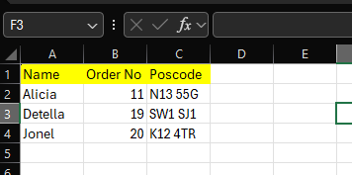
Test some (Two different functions/tools from two different software applications. Show the process step by step through screenshots) business-related features of Office Applications (e.g., Mail merge, IF Function, VLOOKUP, Pivot Table, Goal Seek, Database concept using MS Access) and document several screenshots with accompanying description to provide evidence of practical use.
-Note: This task is based on your own practical activity.
Mail Merge
(This exercise is done within an excel document , to make it work as i am using the labels option form mail merge:
)
- In a Word Black document select mailings > then start a Mail merge > Step by step mail merge wizard
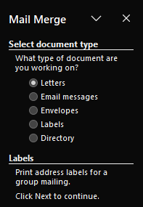
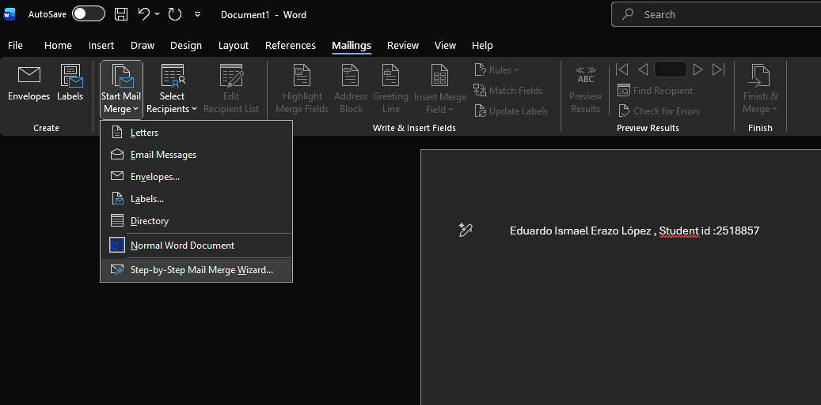

This will show the list of the type of mail merge that you can do :
In this case we will choose Labels

Next we click on starting a document
- 
- Click on select document and label options 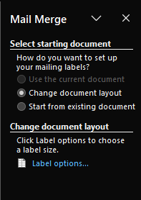
- Now Choose your vendors and your product number
- 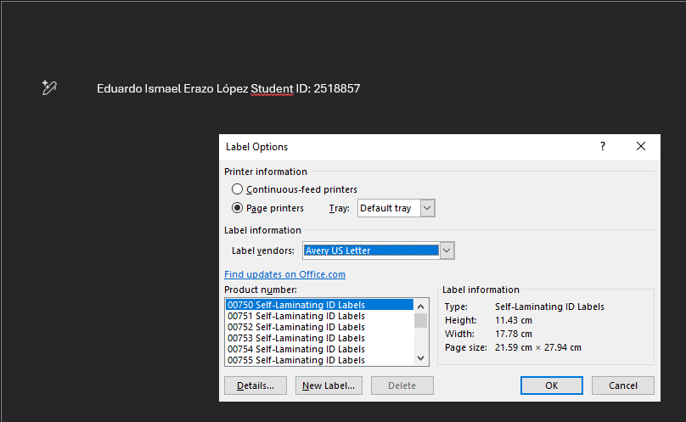


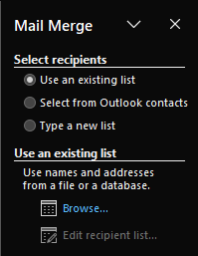
- Now click on select recipients and browse.( In this case am using my own list)


Once you find your recipients , in this case an excel sheet , select the sheet and click ok.
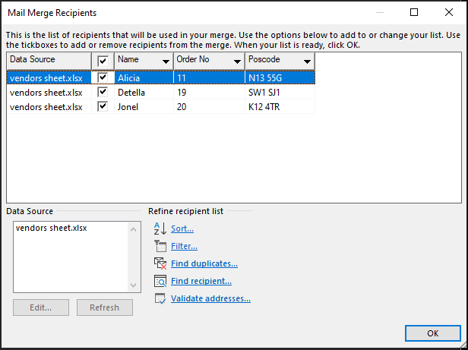
It will then show you the column and all the data, click ok.

- Now click on next step > arrange you labels then address block
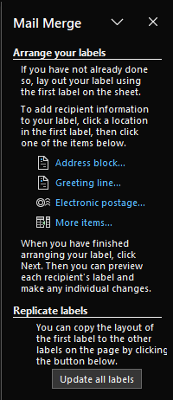
-  >

- Select you address elements and click ok
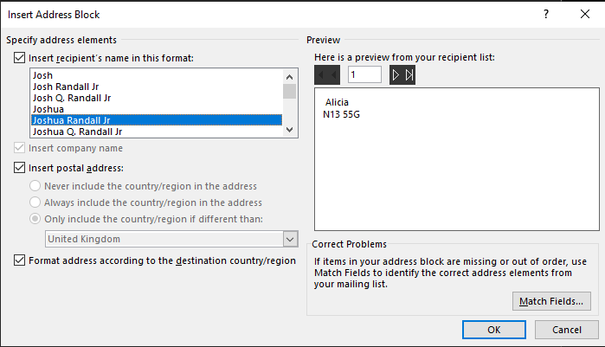
- Now to replicate the first label > select update all labels
- Then to preview your labels click on next and preview your labels

And you will see you label preview

You can also change which label you want to preview by clicking on the recipient No
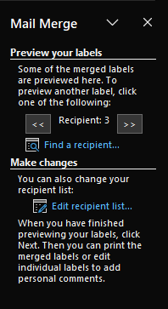
To finish click on complete the merge


Task 4
(25 marks)

Communication and Collaboration applications
(Approx. 1000 words)

a. 13 marks
Analyse one contemporary Communication (Email, MS Teams etc.) and one Collaboration (SharePoint, One Drive etc.) applications/tools used frequently in the modern business world and document a summary of their key features, benefits and limitations using written text with some images and relevant citations. (approx. 2/3 sources)
Communication tools:
- Outlook
- Microsoft Outlook can offer an interesting user interface which matches with the modern aesthetic from MS , this new interface is easier to understand and use which improves email management and efficiency.
- It also has an enhanced integration with Microsoft services, such as Microsoft teams, OneDrive , Bing, etc. this also improves collaboration as a team and business
- Microsoft Teams
- Gmail
- slack

Analysis of One Communication Tool and One Collaboration Tool
Digital communication and collaboration platforms are essential in modern organisations, especially with the growth of hybrid and remote working. Communication tools enable users to exchange information quickly through email and other messaging channels, while collaboration tools focus on storing, sharing and co-authoring files. This section analyses Microsoft Outlook as a contemporary communication application and OneDrive for Business as a collaboration and cloud-storage platform, highlighting their key features, benefits and limitations in a business context.

Microsoft Outlook – Communication Application
Microsoft Outlook is an email and personal information management application that forms part of the Microsoft 365 suite. It allows users to manage email, calendar appointments, contacts and tasks within a single interface, making it a central tool for day-to-day communication in many organisations [1][2]. Employees can use Outlook to send and receive emails, schedule meetings, store contact details and keep track of to-do lists, which helps them coordinate work and maintain professional communication with colleagues and clients.
Outlook offers a range of features designed to support efficient email management. The inbox includes folder structures, categories, flags and rules that help users organise messages and highlight important items [1][3]. A “focused inbox” view can automatically prioritise messages that are likely to be more relevant, while less important ones are moved to a separate view [1]. The built-in search function allows users to quickly locate specific emails, even in large mailboxes, which is particularly useful for staff handling high volumes of correspondence [3]. Outlook also integrates calendar and scheduling tools, enabling users to create appointments, invite participants to meetings, check availability and reserve meeting rooms directly from the application [4]. These elements make Outlook more than just an email client; it becomes a central hub for planning and communication.
For businesses, Outlook provides several clear benefits. Because email, calendar, contacts and tasks are combined in one place, users can manage their day from a single application, reducing the need to switch constantly between different tools [1]. Integration with other Microsoft 365 services, such as Teams and OneDrive, allows users to attach cloud-stored files, create online meetings and share calendars easily, which supports collaboration and hybrid work [1][4]. Outlook is also available on desktop, web and mobile, so staff can access their email and calendar from different devices, helping them stay responsive when working remotely or travelling [2]. In addition, Outlook is widely used across industries, meaning that many new employees already have some familiarity with it, which can lower training requirements.
However, Outlook also has limitations. New or less experienced users may find the interface complex, with many folders, options and configuration settings that can be confusing at first [5]. Large mailboxes with thousands of messages can become difficult to manage, and important emails may still be missed if users rely too heavily on the focused inbox. Like other cloud-based tools, Outlook depends on network connectivity and server availability, so technical problems or outages can temporarily disrupt access to email and calendars. Finally, organisations must manage security and compliance settings carefully, as email remains a common channel for phishing and other cyber-attacks [5]. These issues show that, while Outlook is powerful, it needs good configuration and user training to be used effectively.

OneDrive for Business – Collaboration and Cloud-Storage Application
OneDrive for Business is Microsoft’s cloud-storage and file-sharing service for organisations. Each user is given personal online storage space where they can save work documents and access them from multiple devices [3]. When used with a work or school account, OneDrive for Business is tightly integrated into the Microsoft 365 ecosystem, connecting to applications such as Word, Excel, PowerPoint, Teams and SharePoint [3][6]. It is often described as the main storage system within Microsoft 365, bringing company documents into the cloud and making them available wherever employees are working [6].
OneDrive for Business provides several core features that support collaboration. First, it offers cloud-based file storage, allowing users to save documents, images and other files in a secure online location instead of only on their local computer [3]. Second, it includes synchronisation tools so that files stored in OneDrive can be synced to a user’s device, enabling offline access and automatic updates when the device reconnects to the internet [8]. Third, OneDrive supports file sharing with internal colleagues or external partners through permission-controlled links, where users can specify whether others can view or edit a file [3][7]. A key collaborative feature is real-time co-authoring, which allows multiple people to work on the same document simultaneously in Office applications, with each user’s changes visible as they are made [1][3]. OneDrive also keeps a version history for files, so earlier versions can be restored if necessary.
For organisations, these features offer important benefits. OneDrive for Business enables secure, centralised storage of work documents, helping to protect data against device loss, theft or hardware failure [7]. Because files can be accessed from any device with an internet connection, employees can work from home, the office or while travelling without needing to copy files manually [3][8]. The ability to share files via links and collaborate in real time supports more efficient teamwork and reduces the need to send multiple email attachments, which often leads to version-control problems. Integration with Microsoft 365 security and compliance tools also means that businesses can apply policies for data protection, retention and access control across OneDrive as part of their wider governance strategy [6][7].
Despite these advantages, OneDrive for Business has some limitations. Its effectiveness depends on reliable internet connectivity; users with poor connections may experience delays when uploading, downloading or synchronising files [8]. Synchronisation conflicts can occur if files are edited simultaneously in different locations or if offline changes are not uploaded correctly, which can create duplicate versions or confusion for users [7]. Managing sharing links and permissions can also be challenging, and if configured incorrectly, they may either block legitimate access or expose documents more widely than intended. Furthermore, while OneDrive is suitable for personal and small-team storage, organisations still need platforms such as SharePoint for more complex, structured document libraries and intranet sites [6]. These limitations highlight the importance of user training and clear organisation policies when adopting OneDrive for Business.

Comparative Comment
Microsoft Outlook and OneDrive for Business support different but complementary aspects of digital work. Outlook focuses on communication through email and scheduling, helping users manage messages, appointments and tasks in one interface. OneDrive for Business focuses on file storage and collaboration, ensuring that documents are securely stored in the cloud and can be accessed and edited from multiple devices. When used together, these tools allow employees to share links to OneDrive files directly from Outlook, schedule meetings where those files are discussed and maintain a more efficient, connected workflow. However, to gain the full benefits, organisations must address issues such as information overload in Outlook and permission management in OneDrive through appropriate training and governance.
[1] Microsoft, “Outlook for everyday email and calendars,” Microsoft 365, 2025.
[2] “Microsoft Outlook,” Wikipedia, 2025.
[3] Microsoft, “Overview of OneDrive in Microsoft 365,” Microsoft Learn, Mar. 2025. Microsoft Learn+1
[4] Microsoft, “Basic tasks in Outlook,” Microsoft Support, 2025. Soporte de Microsoft+1
[5] LuxHosting, “Pros and Cons of Microsoft Outlook for Business,” 2021.
[6] intranet.ai, “OneDrive: How Microsoft’s Cloud Storage Works,” 2024. intranet.ai
[7] Windward Studios, “What is OneDrive – The Complete Guide,” 2023. windwardstudios.com
[8] Ramsac, “An Introduction to OneDrive,” 2023. ramsac Ltd

b. 12 marks
Test some features of a freely available Communication (1) and Collaboration (1) application and document several screenshots with brief accompanying description to provide evidence of practical use.
-First you need to consider one communication and one collaboration application. Then discuss one use (How they are getting used in the business world) of each application showing the process step by step through screenshots.
-Note: This task is based on your own practical activity.
In this part of the task, I demonstrate practical use of Microsoft Outlook and OneDrive for Business in typical business scenarios. The evidence for this section is provided through screenshots and short descriptions.
First, I use Microsoft Outlook to compose and send a professional email to a colleague.

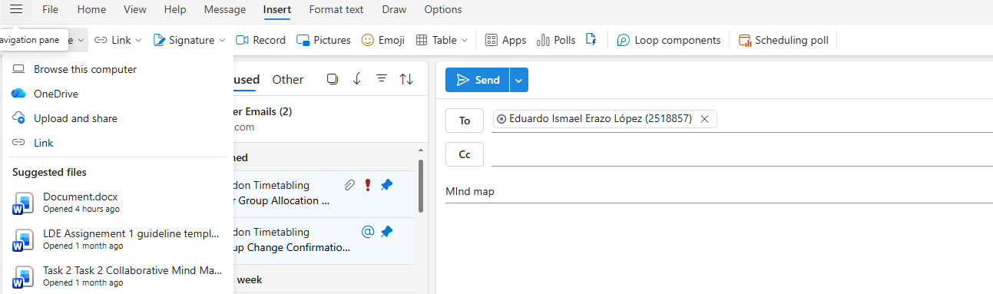

The screenshots show the Outlook inbox, the “New Email” window and a completed message with a clear subject line, structured content and a file attached from my OneDrive storage. This illustrates how Outlook is used to send formal messages and share documents within an organisation.
Additional screenshots show the Outlook calendar being used to schedule a meeting, invite participants and set a reminder, which demonstrates how employees coordinate appointments and manage their time using the integrated calendar [1][4].
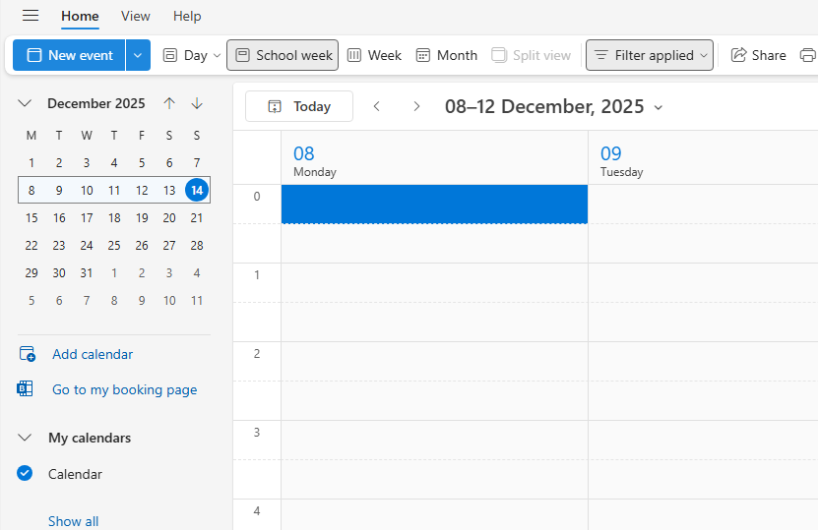
Second, I use OneDrive for Business to upload and share a document.
The screenshots show the OneDrive web interface or desktop client with a project folder created for the activity. I then upload a Word document into this folder and use the Share option to generate an editable link for a colleague.

The final screenshot shows the sharing pane with the colleague’s name listed as having access. This sequence provides evidence that I can store files in OneDrive, manage their location in the cloud and share them with specific users for collaboration [3][7][9].
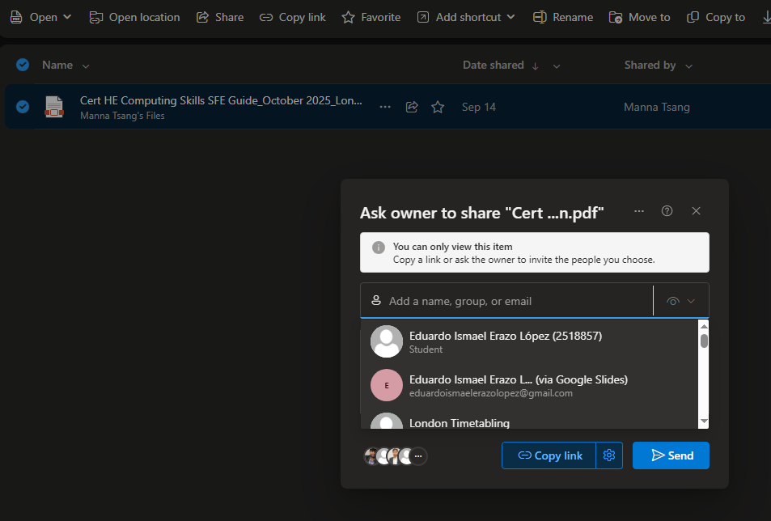

Together, these practical activities show how Outlook and OneDrive for Business can be combined to support everyday digital work. Outlook is used to send messages, schedule meetings and notify colleagues, while OneDrive is used to store and share the files that are discussed and edited. This combination reflects the way many organisations use Microsoft 365 to streamline communication and collaboration.

Conclusion
Microsoft Outlook and OneDrive for Business are widely used communication and collaboration tools that play a central role in modern digital workplaces. Outlook helps users organise email, calendars, contacts and tasks in a single application, improving the coordination of communication and scheduling. OneDrive for Business provides secure, cloud-based file storage and sharing, supporting flexible working and real-time co-authoring of documents. When used together, these tools enable employees to access information from multiple devices, share documents efficiently and maintain more effective workflows. Although both applications present challenges—such as information overload in Outlook and synchronisation or permission issues in OneDrive—these can be managed through appropriate training, careful configuration and clear organisational policies.

References
Present 10-15 sources. Please use IEEE referencing style. Do not forget to use in-text citations all the way through out this portfolio report.

Appendices
-Supplementary information (Optional)
An appendix page/section can be used to include relevant supplementary information such as indirect supporting information to task answers, tutorial activity answers, any other evidence.
NB: Also, look at your assessment brief to see the guidance for students in completion of the tasks section, students’ feedback form for overall marking criteria and assessment criteria to understand your level of work for grading.
Thanks, and good luck.

