

Evaluation the performance and implementation of sustainability in the construction industry in the UAE

XXXXXX XXXXXXXXX
1804502
BMSP7005D (Dissertation)
Submitted for the degree of MBA Sustainability Leadership
University of Wales Trinity Saint David (UWTSD)
Carmarthen Business School
2022

Abstract
The civil engineering and construction industry is usually highlighted as primary contributing factors for resource consumption and scarcity. Many researchers perceive that as a normal event with the respect to the high demand for construction that comes concerning the growing world population. As a consequence of this demand, a need for resources and energy efficiency becomes extremely critical and vital. The circular economy could be presented as one of the potential factors to regulate the construction industry with a circular business model. The reason that the professionals highly suggest this mechanism is due to its suitability with the vibrant and dynamic nature of the construction industry that usually causes a communication gap between the main stakeholders. The literature shows that this could be a result of a lack of collaboration and creating unnecessary complex steps that affect the productivity and durability of the business. Hence, a need for a holistic and integrated framework is necessary to regulate and manage the flow work of resources and energy efficiency process. In this study, the Sustainability Development Goals (SDGs) will be highlighted as major key performance indicators to ensure the accuracy and feasibility of the circular economy. Through this study, the survey and the interviews showed that three areas could be considered as challenging to be applied to circular economy in construction in The United Arab Emirates (UAE): regulatory factors, economic factors, and technological factors.
Keywords: Circular economy (CE), Sustainability, Policy, Evaluation.

Acknowledgement

I would like to acknowledge my advisor, Dr Alex Bell, Senior Lecturer, for his peerless supervision, motivation, attention, and guidance throughout the MBA program. I would like to thank my committee members for their encouragement, perseverance, and continuous support in this research program. This work is dedicated to, my wife, XXXXX XXXXXXXX, my daughter, XXXXXX XXXXXXXX, my son, XXXXXXXX XXXXXXXX, and my brother, XXXXXX XXXXXXXX, for their boundless support in my MBA study. I would also like to thank my friends and colleagues, XXX XXXXX, XXXXXX XX XXXXXXX, and XXXXXX XXXXX, for their honest feedback and encouragement during the entire MBA program. Finally, this research work is dedicated to all workers who involved daily in the fight against the poor sustainability performance of the construction industry

Table of Contents

Chapter 1: Background Study 8
1.1. Introduction 8
1.2. Aim and Objectives 10
1.3. Contribution to knowledge 10
1.4. Significance of the study 10
Chapter 2: Literature Review 12
2.1. Sustainability as Concept 12
2.2. The Four Unsustainability Concepts 16
2.3. Planetary boundaries 18
2.4. Resilience 19
2.5. Circular economy 21
2.6. Global initiatives in the sustainability of the built environment 30
2.6.1. Smart cities 30
2.6.2. Waste management 31
2.6.3. Public-Private Partnership (PPP) 33
2.7. Sustainability Challenges in UAE Construction Industry 35
Chapter: 3 Research Methodology 38
3.1. Research Design 38
3.2. Questionnaire 39
3.3. Data Analysis Approach 39
Chapter 4: Presentation of the results 41
4.1. Introduction 41
4.2. Statistical significance: Cross-tabulation and chi-square 41
4.3. Presentation of questionnaire results 42
Chapter 5: Discussion and Conclusion 55
5.1. Discussion of results 55
5.2. Conclusion 57
5.3. Limitations 59
5.4. Recommendations 60
References 62
Appendixes 74
Appendix A: Participant Information Form: 74
Appendix B: Questionnaire Form 76

List of Figures
Figure 1: Purvis et al. (2019). 15
Figure 2: Sustainable business Model Hierarchy Bocken, N. M., & Short, S. W. (2021). 17
Figure 3: Steffen et al. (2015). 18
Figure 5: Marchese et al. (2018). 20
Figure 6: Sustainable Construction (CIB, 2002). 21
Figure 7: LCA Framework (Singh et al., 2011). 24
Figure 8: Circular Economy policies development from 2000-2020 (Milios, 2018). 26
Figure 9: Product Life Cycle (Milios, 2018). 27
Figure 10: Regulatory framework for Type III environmental declaration of building products (Bovea et al., 2014). 30
Figure 11: Lingard et al. (2001). 32
Figure 12: Wang and Ma (2021). 34

List of tables

Table 1: Definitions of Sustainability. 12
Table 2: Type of the construction company. 42
Table 3: The gender. 42
Table 4: The age. 43
Table 5: The Education Level. 43
Table 6: Job Location. 44
Table 7: Dose your company has weak sustainability system. 44
Table 8: You are familiar with Sustainability assessment bases methods. 45
Table 9: Sustainability KPIs are always reported in your company. 45
Table 10: Your company provides enough training to ensure sustainability competencies level between its employees. 46
Table 11: You are familiar with the sustainability elements of your company. 46
Table 12: There are efficient communication channels between the management and the labourers. 47
Table 13: Top Management conducts regular sustainability tours to construction fields. 48
Table 14: You understand your role and responsibilities towards Sustainability in your job. 48
Table 15: You understand your line supervisors’ role and responsibilities towards Sustainability in his job. 49
Table 16: Sustainability policies and procedures are up to date in your company. 49
Table 17: You always attended the Sustainability meeting in your department. 50
Table 18: Interviewees Theming analysis. 50

List of Abbreviation:

CE: Circular Economy
EMF: Ellen MacArthur Foundation
EU European Union
FSSD Framework for Strategic Sustainable Development
IEA International Energy Agency
IAEA: International Atomic Energy Agency
MNC: Multinational Company/Corporation
MSLS: Master’s in strategic leadership towards Sustainability
PSS: Product Service System
SME: Small Medium Enterprise
SSD: Strategic Sustainable Development
ROI: Return on Investment
IABSE : International Association for Bridge and Structural Engineering
Fib : The International Federation for Structural Concrete
CIB : International Council for Research and Innovation in Building and Construction

Chapter 1: Background Study

Introduction
Sustainability is a keyword and a popular topic in many industrial sectors due to its robust effect in the long term. There are multiple definitions of sustainability, and all these convey the importance of sustaining and maintaining the current resources to satisfy the needs of tomorrow. According to many of the scholars who promote sustainability (Huovila & Koskela, 1998), construction could be one of the toughest industries to apply this concept although there is huge potential. This is due to the evident scattered nature of the construction sector, where external and internal factors could affect the communication in the chain of command. For example, according to Glass et al. (2012), one of the major challenges for the execution of sustainability in the construction industry is scarce social and industry awareness on the true concept of sustainability. For more illustration, numerous shareholders, investors, and stakeholders in construction manufacturing do not possess adequate basic knowledge on sustainability. This could be due to many reasons but, according to the author, the fear of extra cost is an additional burden that is not allowing people to take sustainability more seriously and incorporate it into construction businesses strategy.
The terminology of sustainability was presented to deliver the means for handling the type of difficulties regarding the weakening association between our global ecology and constant economic development in which sustainability as a concept shows that ways in economic development could be comprehended while taking supposed environmental and social parameters into consideration. As stated by different scholars, sustainability (Rogers, 2012) as a concept is ill-defined, undefined or contradictorily defined. When the word sustainability is used, the first issue that appears is “what sustainability was applied to”, for determining the link between global ecology and economic development. Sustainability explicitly highlights artificial or human-made structures and systems. These systems are commonly labelled in terms of purpose, objective and adjustment, and can mimic natural practices without being natural elements (Zsoka et al., 2013). According to authors (Brulle, 2010; Brown, 2009; Nurse, 2008), the latest studies and increased understanding of sustainable development have improved the significance of sustainable development terminology, which has earned status over the past decade. It supports the terms such as cleaner manufacture, pollution avoidance, pollution management, and minimization of resource usage, eco-design, and zero waste. These words are in frequent use in scientific studies, articles, workbooks, sustainability reports of organizations, governmental policy frameworks, and the public media streams (Haugh and Talwar, 2010; Roseland, 2012; Catellani and Sala, 2010). The application of these terminologies is highly dependent on their description and acknowledgement, rather than on the domain of concept. However, some of these terminologies are, enabling diversity from the others. In addition, differences amongst the term usage, based on the geographic location, exist that often lead to vague definitions of the terms and their practice.
The accessibility of numerous data sources enhances the propagation of sustainability terms and their definitions, as utilized by various sources and associations. Consequently, several innovative conditions are evolving, or the current ones are being expanded in the sustainability field. However, it is not enough attention to the descriptions and their semantic values. For instance, on their technical and operational aspects. The variety of explanations trigger much uncertainty about their management since the meaning of some terminologies is either disordered or misleading and is only marginally distinct from one another such as the definition that mainly focuses on resources management. One more crucial challenge is that most of the terms are wordy, consequently, the definitions are unavailable in scientific dictionaries. Until now, this subject has not been analysed holistically, yet. As a result, communications within the scientific community, corporations, societies, and investors can be enhanced. A classification and association of the terms need to be established to accomplish a healthier and more holistic understanding of sustainability.

Aim and Objectives
The main aim of this study is to evaluation the performance and implementation of sustainability in the construction industry in the UAE
The main objectives of this research paper are as follows:
Objective 1: Evaluating critically the present and future challenges of sustainability implementation in the construction industry.
Objective 2: Providing a holistic understanding of circular economy policy in the construction industry.

Contribution to knowledge
In The Gulf Cooperation Council (GCC) area, there is a lack of published work that explains and illustrates a clear mechanism on how one should implement and design policies concerning the circular economic goals. In addition, as shown in different studies, were to have an effective implementation in the circular economy, we need a holistic approach that covers all the aspects such as technical, managerial, and industrial (Sturm et al., 2008).

Significance of the study
The importance of this study is that it shows the existing challenges in implementing the circular economy in UAE and how it is associated with various internal and external factors. As such, this would give a chance to many stakeholders to participate and be a part of an effective mechanism to establish a clear policymaking approach. Also, this study has the potential to help the sustainability and economic future through the prediction of the upcoming trends and patterns that may impact the industries and markets (Lawn,2000).
Another challenge is that countries with exceedingly high HDI such as Saudi Arabia, the UAE and Qatar are faced with, is trying to impact overconsumption patterns. Even though these countries have their green building rating systems and relatively higher levels of awareness than in other countries, they are notorious for their overconsumption patterns.

Chapter 2: Literature Review

Sustainability as Concept
Sustainability is a complicated and puzzling hypothesis where its definition can have many forms. For example, according to the literature review (Moore et al., 2017, Alwan et al., 2017), there are more than 60 classifications that explain sustainability to its operational role. For more illustration, environmentalists, economic experts, and demographics, all had their preferred personal view of sustainability. Yet mostly they did not consider other industrial viewpoints. Therefore, there is a need for a more tangible and clearer concept for sustainability through a different approach. As a result, it can be said that that the essence of “sustainability” cannot be easily determined or defined. Therefore, the dynamics of the concept, its direction and its evolution are the topic of this investigation until now as shown in Table 1 and Figure 1.
Table 1: Definitions of Sustainability.
 | Definition of Sustainability | The Main Theme | Source
1 | “Development that meets the needs of the present without compromising the ability of future generations to meet their own needs.” | Economic | 1987 by the Brundtland Commission (formally known as the World Commission on Environment and Development (WCED)
2 | The continued satisfaction of basic human needs-- food, water, shelter--as well as higher-level social and cultural necessities such as security, freedom, education, employment, and recreation [that is, as suggested by Maslow (1970 | Social | Maslow, A. 1970. Motivation and personality, 2nd and.  Harper and Row, New York.
3 | Integration of environmental, social, human, and economic goals in policies and activities. | Social/ Economic/Environmental (Holistic) | Eggenberger, M., & Partidário, R. (2000)
4 | Sustainability simply is all about thinking about others in all aspects. | Social/ Economic/Environmental (Holistic) | Dr Alex Bell,  Carmarthen Business School
5 | Ensuring inter-generational equity | Social
6 | Sustainability demands the ways of living, working and being that enables people all over the world to lead healthy, fulfilling, and economically secure lives without destroying the environment and without endangering the future welfare of people and the planet | Social/ Economic/Environmental (Holistic) | Reclaiming the definition of Sustainability  Paul Johnston
7 | Capacity to monitor the state of natural systems. | Economic | Carpenter, S. R., & Gunderson, L. H. (2001).
8 | The economic system was currently dependent on growth in material consumption within a world of finite resources. | Economic | Dietz, R., & O'Neill, D. (2013).
9 | "Sustainability demands turning and charting a new course that will improve the quality of our lives and the lives of our children while restoring the gift of natural systems upon which our lives depend. | Social/ Economic/Environmental  (Holistic) | National Research Council. (1999).
10 | People are not subject to conditions that systematically undermine their capacity to meet their needs. | Social | Missimer, M., Robèrt, K. H., Broman, G., & Sverdrup, H. (2010).

Sustainability as a concept has been accepted by the United Nations as an administrative value for economic, environmental, and social growth that hopes to achieve the needs of the present without compromising the ability of future generations. According to many authors (Berkes and Folke, 1994), sustainability involves the safety and security of the ecosystem and ecological resources as well as delivering social and economic prosperity to the current and successive generations. From the social aspect, sustainability is seen as a major guideline basis for the modern society which includes a durable and moral connection of present generations and the next one. These three scopes of sustainability as shown in Fig.1 have been signified as pillars of the sustainability concept that show the requirement of responsible development concerning the holistic ecosystem. For example, sustainable construction encourages a decrease in the utilization of non-renewable energy supplies thereby reducing economic investments. At the same time, it supports the development of high-tech for generating power from renewable energy sources such as wind and solar which supports economic growth and reduces greenhouses emissions.
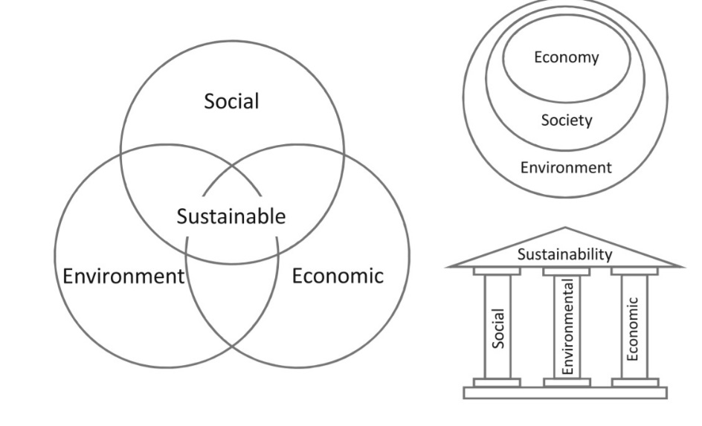
Figure 1: Purvis et al. (2019).

An attractive understanding regarding the combination of the three aspects was that it often corresponded with the occurrence of conflicts between them. This could be a result of the differences between the three aspects leading to methodical attempts for their incorporation. Also, it can be observed from the opposite side in which the disagreements could occur when attempts to balance environmental, economic, and social aspects of sustainability are produced. Yet many researchers think that an ideal holistic approach is the one that takes care of the economic aspect For instance, attaining environmental objectives in the present may have a positive impact on the economic status of the next generations, with a potential for short-term economic growth.
In addition, enhancing human capital investment can holistically foster sustainability. However, to fulfil this possibility the development of such capital requirements is to be connected to sustainability education for all stakeholders.

The Four Unsustainability Concepts
Many sustainability scholars (Bocken, and Short, 2021), agree that as there are main themes or pillars for sustainability. Additionally, there is also a theme for the “unsustainability concept”. For example, the root causes of unsustainability can be divided into four areas:
- Extracting a large number of materials from earth’s curst
- The huge volume of chemical substances created by society
- Physical inhabit nature’s ability to run cycles
- Social barriers to people in meeting their basic needs

As such, different scholars suggest that governments can play a critical role in solving these four root cases via clear and strict policies. For instance, governments should be anticipated to put policies to reduce excessive demand for the limited natural resources and introduce incentives for sustainability for greener commercial projects. By doing this our government will be an inclusive one that helps all the stakeholders to not abuse the four root causes of sustainability. And the result would be both in the economic scale and social aspects to reach the optimum of the sustainable business model as shown in Fig2.
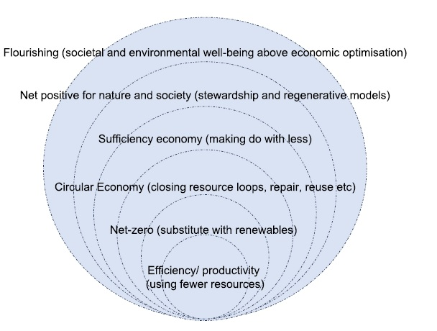
Figure 2: Sustainable business Model Hierarchy Bocken, N. M., & Short, S. W. (2021).

Many scholars (Kirveennummi et al., 2013), believe that the government can reach this level of maturity in sustainability if they use inclusive governance systems. For more illustration, this system can motivate all stakeholders to deliver through access to economic mechanisms and post which, this can be a major positive encouragement towards better sustainability on all three aspects. It is important to know that there may be some losses in the short term on the economic dimension of sustainability during the transition in the process. An inclusive progression and methodology have the potential to be an active apparatus for getting the real transition from the unsustainability root causes to a healthy sustainability concept.

Planetary boundaries

The notion of planetary boundaries recognizes a reliable outer space for humankind. For more illustration, present energy schemes are primarily intended with an emphasis on total cost-cutting on CO₂ emissions which heavily affect climate change as shown in Fig3.
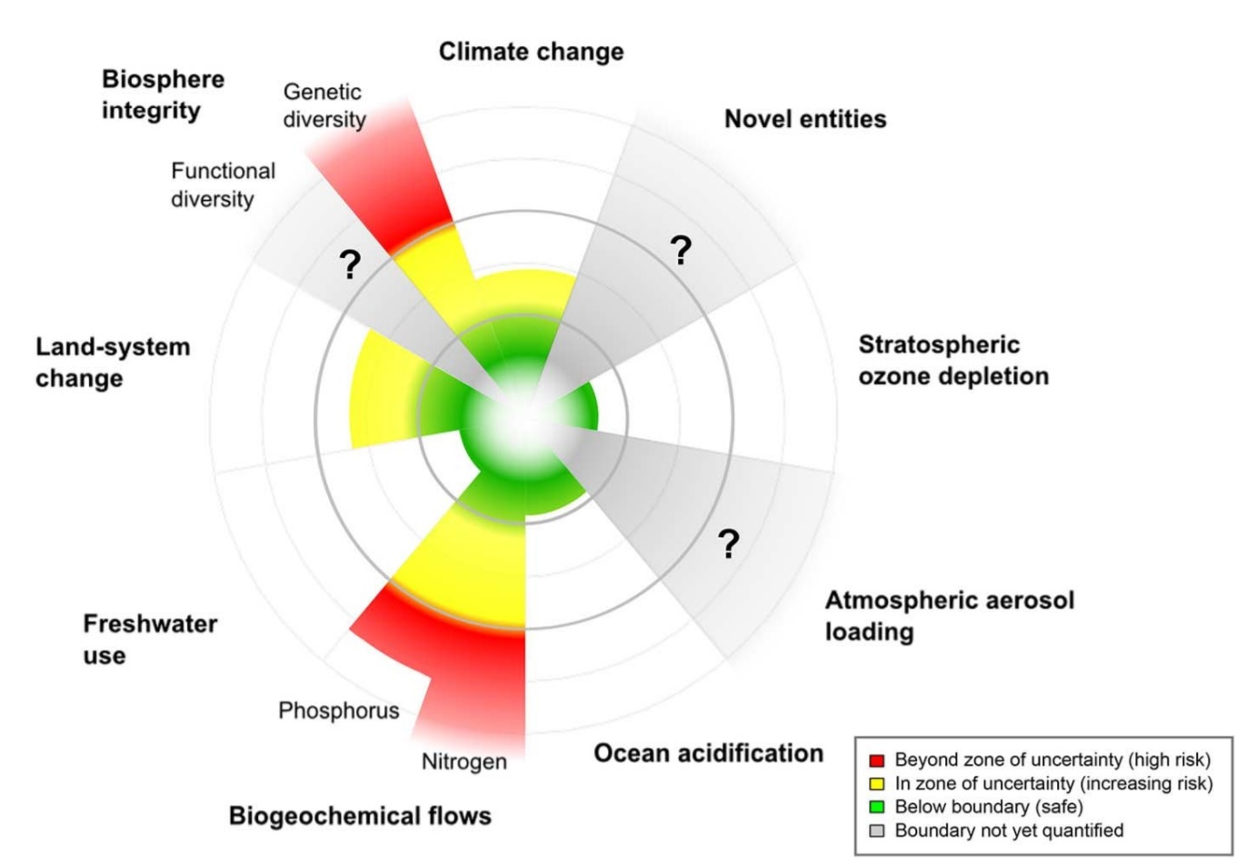
Figure 3: Steffen et al. (2015).

From Fig 3 the planetary boundaries could be classified into eight categories:

- Climate change
- Biosphere integrity
- Land-system Change
- Freshwater use
- Biogeochemical flows
- Ocean acidification
- Atmospheric aerosol loading
- Stratospheric ozone depletion

Many scholars (Whiteman et al., 2013), believe that neglecting planetary boundaries in energy systems is a real challenge. For example, this neglect could act as a roadblock for sustainable power development which is highly needed in many developing countries. For that, there is a need to highlight the link between ecological resources and energy systems commercial models. As a result, one may observe many energy industries’ leaders start investing in novel energy models such as hydrogen energy which eventually open to a newer economy like hydrogen economy. As such, meeting planetary boundaries is possible from a commercial aspect to boost sustainability if there was a holistic collaboration between all the stakeholders and support for future researches in this area.

Resilience
Parallel to sustainability definitions, there are numerous definitions of resilience in the literature review from different fields such as psychology, engineering, and construction (Collier et al., 2013). Yet, most of them share the element of absorbing, recovering and bouncing back as fast as the system can. Marchese et al. (2018), give a very holistic and niche of resilience as shown in Fig.5, where it explains resilience from many aspects e.g. dimensions, properties and results. However, according to the authors, the real challenge of resilience adoption is how to implement it appropriately and not mix it with sustainability. For example, distinct applications of sustainability and resilience should be predominant in construction in many aspects; construction guidelines, building codes, policy protocols, financial enticements, industry drill programs, and community campaigns.

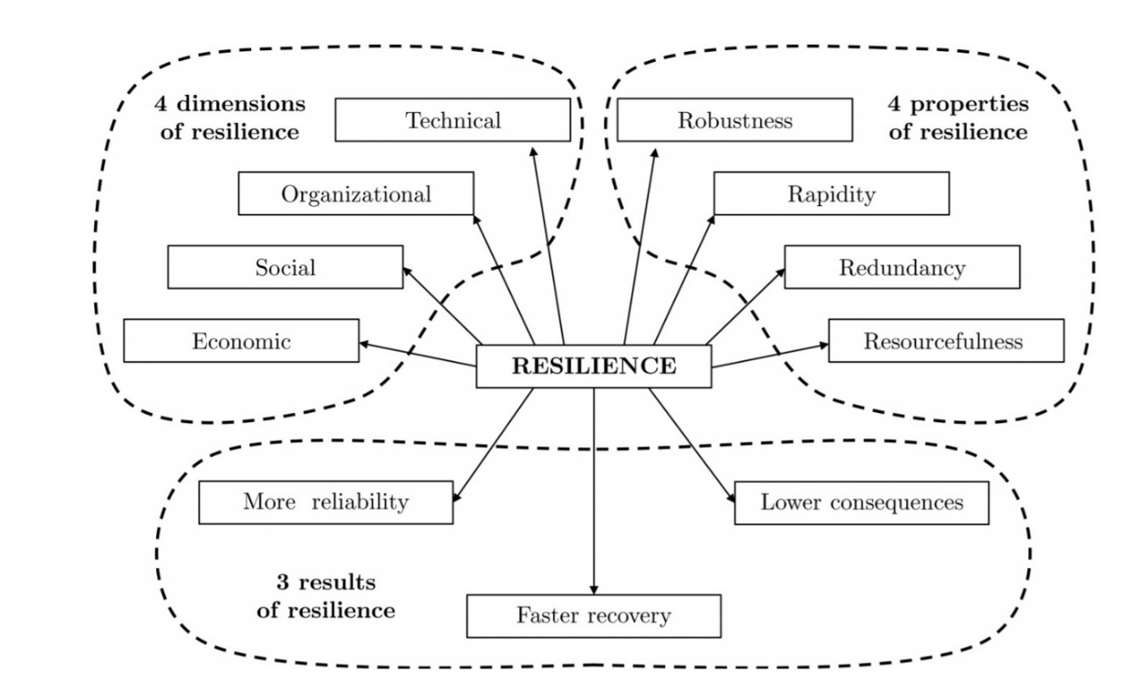
Figure 5: Marchese et al. (2018).

Due to that, in the infrastructure, resilience should be addressed as a distinct concept from sustainability while delivering construction projects. These separate methods in the construction sector possibly led to enhance sustainability holistically. Yet, that does not mean we cannot use a synergistic method between resilience and sustainability. For instance, Bocchini et al. (2014), recommend a numerical structure for this type of approach using the notions of risk and likelihood of an event. This scheme describes resilience as a comeback to low possibility, high influence occasions, on another hand, it defines sustainability as a response to high chance occasions for which the effects are spread into the life cycle system. As such, it can be said that the authors, view sustainability and its pillars, through economic, environmental, and social, from a life-cycle point of view. However, resilience is viewed more as a function of resistance and reliability of the infrastructure.
Correspondingly, Lizarralde et al. (2015), initiate that sustainability and resilience models and goals are best sought via a joint scheme, mentioning the difficulty of the outlines as the key cause.

Circular economy

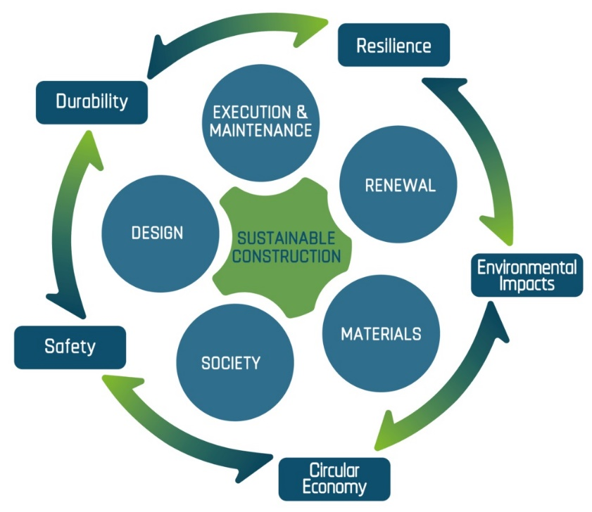
Figure 6: Sustainable Construction (CIB, 2002).
Sustainability in the construction industry should highlight three main scopes; social, economic and environmental to the conventional viewpoint, in which the main challenge could be the economical aspect. For example, the social aspect usually highlights the matters that are associated with the improvement of people’s quality of life. On another side, the economic aspect shows the economic issues such as employment rate, Market supply-demand dynamic, life costing cyclic, production rate, etc. For the environmental part, it includes the following phases in the construction project’s life:
- Design stage
- Construction stage
- Operation sate
- Maintenance stage
- End life stage
- Deconstruction and waste management
Many scholars consider that the influence of the construction industry towards sustainability as a concept is a global demand and challenge at the same time. This applies to both developed and developing countries. For example, it could be more challenging for the construction industry in the developed countries due to the lack of resources and the efficiency of the supply chain systems. To illustrate that, conventional challenges of developing countries are; poor finical power, water scarcity, unhealthy sanitation systems, corruption and inefficient infrastructure system. However, from a positive point of view that many sustainability scientists believe, in developing countries, there is more potential to build a green system from scratch that can last for a long time for the construction industry (Hendiani & Bagherpour, 2019). These systems could signify the accountability of the infrastructure towards development with sustainable patterns. Construction industry phases such as designing the construction, operation, etc., have substantial influences on society and its surrounding environment. For instance, the over usage of natural capital and energy resources, and water supplies are some illustrations of these applications. There are several risks and opportunities for growth related to sustainability execution in the construction landscape.
One of the key sustainability challenges in construction is the financial power within environmental management. As such, according to many sustainable scholars, stable financial capital is a challenging process, where the adoption of formal environmental management schemes within these construction companies could be expensive if it is applied in the wrong manner. Broadly speaking, experimental indication displays that the most substantial dangers related to environmental management include an increase in expenses, lack of ecological awareness and education. In addition, from a management perspective, other factors such as inefficient supply chain system that includes green materials and clean technologies can play a significant role in enhancing the sustainability implementation in the construction industry in addition to poor environmental legislation knowledge, poor communication, and lack of commitment.
The notion of extra costs of fulfilling sustainable orientated construction could be observed as more luxurious than conservative construction due to the escalation in consultancy payment. Naik, (2008), mentioned that it is hard for senior management to have a holistic understanding of the long-term benefits of implementing sustainability, especially from the financial and profitability aspects. For that, the author suggests forming governments that support and play the role of an educator for the different stakeholders that can result in better collective awareness among society. As the first step, it is highly suggested to start with putting generic road maps and legislations in which it can nourish the corporate sustainability cultures within the construction industry. The first step of building high cultural awareness towards sustainability implementation is to understand and explore the existing economic challenges of sustainable construction and to launch its business profits in which it can stimulate policies authorities to apply more sustainable exercises that can create a durable green market for long gain benefits in the construction industry. According to Zhou, & Lowe (2003), it is highly recommended to use the life costing method as an integrated approach to evaluate economic concerns of sustainable construction via different aspects such as changing the business model pattern from linear to cyclic process, and stakeholders’ involvement.
On the other hand, many scholars believe that the stakeholder’s involvement should not only be about the financial aspects but can include the sustainability performance itself. For example, using Life Cycle Assessment (LCA) could be considered as an efficient tool and method in which it can examine the sustainability performance of construction materials from its different phases, extraction, processing, installation, and disposal or recycling. As a result of this holistic approach, the number of the stakeholders in the construction companies nowadays are suggested to have The International Organization for Standardization (ISO) 1400 as the main requirement of the organization business profile.
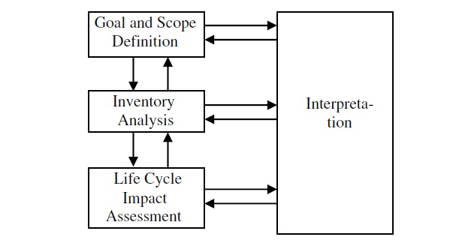
Figure 7: LCA Framework (Singh et al., 2011).
The simplicity and clarity of the (ISO) 1400 could be the main advantage of the LCA that makes analysing and the data, a simpler step in which helps the organization to be agile and adjustable against any external or internal challenges. For more illustration according to Wallbaum et al., 2012, LCA not only becomes an environment indicator but starts to be used as economic input and output. For instance, the economic input-output LCA (EIO-LCA) technique has been utilized as a method to deliver some of the financial Key performance indicators (KPIs) in major construction organizations. In addition, The EIO-LCA technique utilizes a geographic district, typically a nationwide financial system, as the boundary of analysis and incorporates economy via using input-output patterns. After that, the usage of hybrid method between LCA and EIO-LCA has been used in the construction industry (Opoku, & Ahmed, 2014). Professional I construction industry, starts using this hybrid prototype as resource data for typical manufactured goods and processes that are characterized via input-output systems, while the specific goods are developed from procedure analysis,
According to Nahmens, & Ikuma, (2012), That methods such as LCA or life costing method, are highly effective in the construction industry and yet not enough to have the full impact on the real circular economy impact. The authors believe in non-technical and non-engineering solutions. For example, Primarily, in the construction industry in Europe, waste management strategies were familiarized to highlight environmental and health difficulties associated with landfills. With time, the policy emphasis shifted towards encouraging recycling as an ecological approach of handling wastes as by products. Construction materials management policies are originally intensive on the energy effectiveness of the construction materials and the classification of them with lower ecological impacts. With the policy emphasis now being on the evolution to a circularity and sustainability scheme in which the value of products is upheld for their durability, a new stage in policy structuring has been introduced. Yet, the change that is desirable today needs more than a shift in focus. According to Linder (2017), too many scholars, young commercial organizations for recycling are the significant players in this policy shift, but the inner loops of circularity concept e.g., re-use, repair and remanufacture would be equally impacted. For example, In the European Union, design for durability disassembly and reliance become the new features of the Eco Design concept for the main heavy industries such as construction and energy sectors.

To have more depth in the circular economy policy in EU, guidelines for supply efficiency, integrating elements of Circular Economy, can be dated back to the 1980s and 1990s in German structured policymaking, essentially prejudiced by the captivating then-new notion of the closed-loop economy (Shibieka et al., 2019). For example, as a result of that, during the last 20 years, the strategic resource plan track of EU progressively moved towards the sustainable usage of natural capital, increasing supply effectiveness in the business economy, and encouraging the recovering and prevention of industrial by products, while at the same time it supports the economic growth movement as shown in Figure 2.

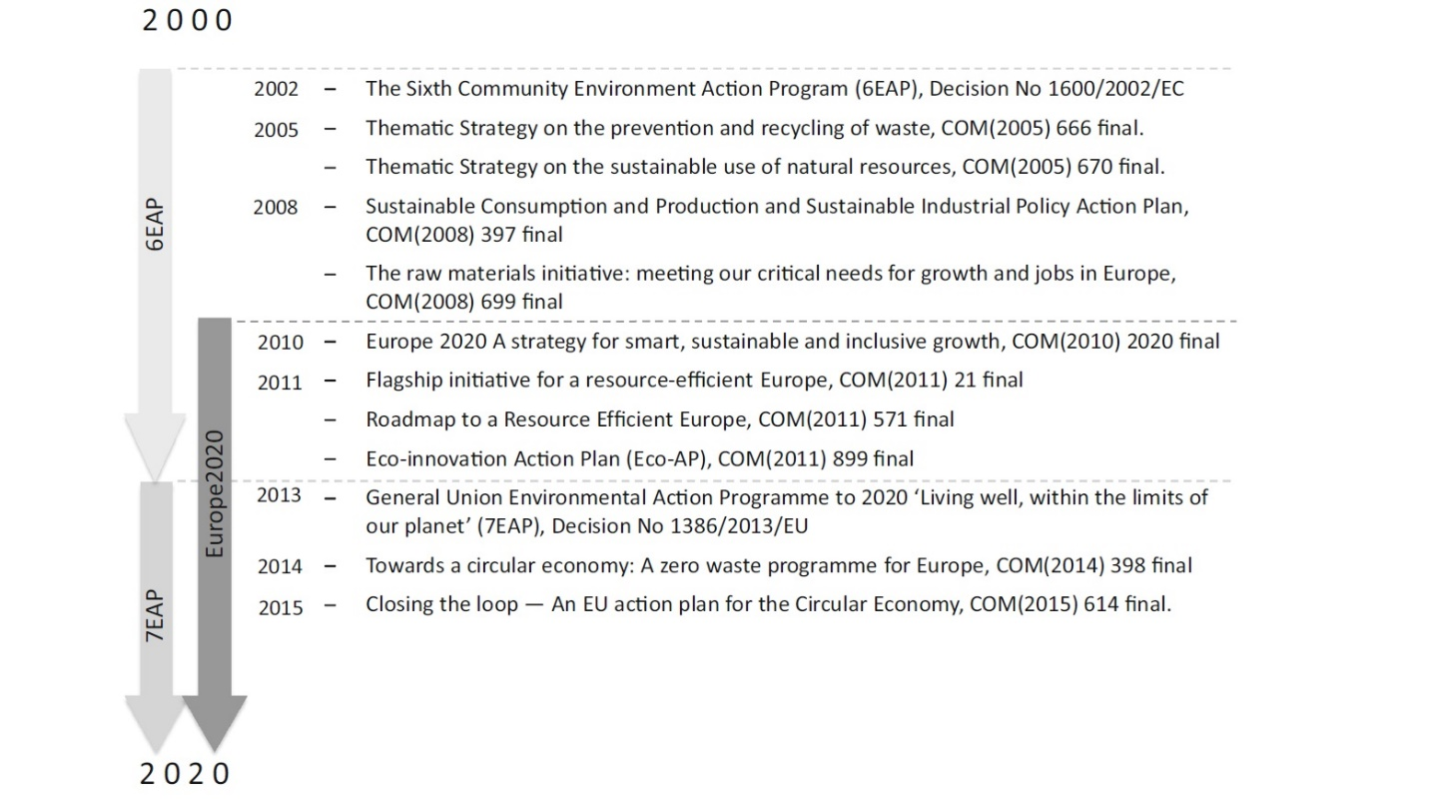
Figure 8: Circular Economy policies development from 2000-2020 (Milios, 2018).

Moreover, the examination of current policies in the EU in which it highlights the three pillars or areas of the circular economy policies that could drastically rise resource effectiveness and smooth the path for implementing a Circular Economy in Europe. The three pillars are:
- Production design
- Consumption
- End life of the product

For the production design phase, many scholars such as Tecchio et al., (2017), believe that there is a major lack of clear guidelines which drive the resource effectiveness in the production phase and at individual product details as shown in Fig 3.
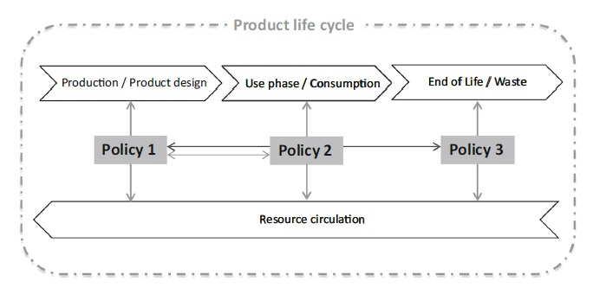
Figure 9: Product Life Cycle (Milios, 2018).
Yet, on other hand, the sustainability policies experts such as Singh et al. (2019) believe that the most challenging part faced by the policymakers is in the second phase, consumption, simply because the government authorities do not highlight and benchmark specific targets in the consumption mechanism either as product or service in the favour for all the stakeholders.
The last phase, End life of the product, according to literature (Murray et al., 2017, Mendoza et al, 2019) the challenge here is not about the existence of the policies but in the implementation of them, since there is currently a considerable growth of recycling policy requirement trend. For instance, in the construction industry, even if one has a recyclable scheme in their organization, while construction materials have low quality for recyclability, this would be a technical barrier against all the incentive policies designed for better and more circular end of life of the product. As such, policymakers in this stage should be extremely careful and have the essential knowledge either technical or managerial so that they can evaluate this critical phase holistically.
On the other hand, the policy scholars see that the circular economy policy could have another classification than the one illustrated in Fig.3, which is associated with the product life cycle. For example, scholars such as Damato et al., (2020), suggest having clear policies for reuse, repair, and remanufacturing, which significantly enhanced the public procurement, product durability and circulation in short loops. For illustration, in the structure of the Circular Economy, the definitive aim is to preserve the essential value of the products by employing high-quality items during the circulation phase. As a result, according to many experts such as De Abreu et al. (2018), this is the required mindset that the construction organization should have as the backbone of its circular economy policy scheme to increase the material circulation in short loops. Authors such as Ferronato et al. (2019), highlight the importance of considering the durability and reparability of the product in the design stage. For example, in the construction industry, durable construction materials should be designed to last long and to function in their maximum capacity for resource efficiency by preserving their operational effectiveness as long as possible and simultaneously promoting their users by saving the organization capital and investments. Yet, to have a holistic policy around the durability concept in the construction industry, it is highly vital to associate it with the reparability concept. For instance, from a circular economy view, durability is inseparably associated with the reparability concept of the construction product and it is critical to have an integrated design, where companies use these two elements together as design features. This would help to sustain, improve, and recycle a product. In this regard, durability and reparability concepts are measured and seen as a uniting factor to serve the sustainable development in the construction industry (Taušová et al., 2019).
Additionally, to durability and reparability design factors, two other critical points should be considered (Malinauskaite et al., 2017, Lesising et al., 2018):
- Accessibility
- Affordability
For more illustration, extra cost and effort are usually the main obstacles for implementing the durability design in the construction industry and this is the reason why many of the senior management executives tend to deal with them as waste materials. It is easier for them and it has a shorter procedure and low process cost. On the availability of an accessible and affordable approach, then they will be more receptive to change and novel design. For example, there are several methods to increase and reduce the reparability of the construction products, like manufacture spare parts that are flexible and changeable for different purposes i.e., steel plates’ connection and joints.

In the construction industry, there is a diversity of strategies and methods to boost durability and reparability policies as direct implementation schemes. Scholars such as Di Maio and Rem, (2015), highly advised having the main and key durability and reparability policies in the design stage. This would enable to have better control on the environmental and ecological impacts that are associated with the construction material. For example, this can be approached via placing visible and compulsory requirements in the construction industry on the materials’ lifespan, reusability, and recyclability. Another critical point that is highlighted by the author is that there is a major lack in the holistic Standards of Procedures (SOP) towards designing concerning durability and reparability elements where using energy efficiency could be a great initiative. Due to that, it can be founded that many construction organizations start using the labelling approach. To explain this, establishing durability conditions in the construction procurement chain such as Environmental product declaration (EPD) as voluntary mutual deals within the industry are shown in Figure 4.

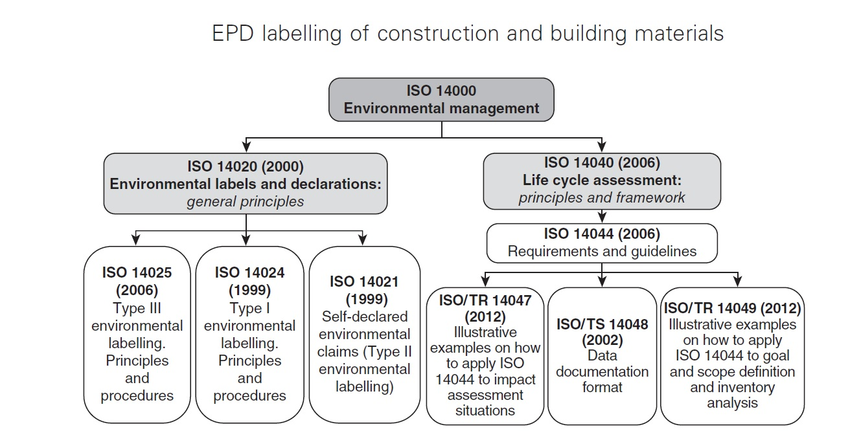
Figure 10: Regulatory framework for Type III environmental declaration of building products (Bovea et al., 2014).

The general description of the switch towards a circular economy indicates that strategies focus on the waste stage are inadequate to attain circular inventions in construction. For that, two elements are essential; the emphasis on the policies and strategies ought to involve more than zero waste elimination scheme and the measures through the product's life cycle need to be monitored to avoid any disruption that affects the harmony of the cycle.

Global initiatives in the sustainability of the built environment

Smart cities

There are several definitions of the smart city concept in the literature review, where sustainability can be highlighted into this concept as the main categories: physical infrastructure and social services. Many scholars (Bifulco et al., 2016, Saidani, et al, 2019 ), believe that for many people the true integration between soft and social capitals is the key to have a smart and sustainable city. To explain this, having a highly interconnected city with advanced Information and Communications Technology (ICT), does not mean it is a sustainable one. A city where human well-being is considered would be a live-able city and that is the basis of sustainability. For more explanation, the complete methodologies enclosed all scopes of sustainability, the environmental, the social and the economic one, and showed in a well-adjusted theme on what a smart city would be. This will help the ecological and social-oriented characterizations emphasise how smart cities incorporate technology with proper management schemes to advance excellence in life and diminish the ecological impact of urbanism.
On the other hand, a few economic-oriented schemes projected the mixture of physical infrastructure and soft services intending to form economical cities to promote sustainable economic growth. The intent to moderate the importance of financial sustainability in the application of the smart city concept can be witnessed in the concept. This is conflicting with the present implementation strategies and the extraordinary progression rate of the smart city marketplace.
In general, different from most sustainability-associated and defined concepts, the societal (human well-being) aspect of sustainability appeared to be the most needed one in smart city concepts. This characterization is vital to highlight some of the substantial challenges raised previously and presents the significant points that the smart city themes should reflect, with a focus on general sustainability, comprehensiveness and consideration to local occupants.

Waste management

The definition of waste has been improved throughout history. For example, Building Research Establishment (BRE) defined waste as the variance between materials ordered and those used for fixing on construction developments. After that, BRE defines that waste as ‘any material separately from earth recourse that needs to be transported away from the construction site. Moving forward more holistic definitions appear such as the one that the Hong Kong government where it defines waste as any products made and removed from the construction industry, restoration and destruction sites of construction structures as shown in Fig.11.

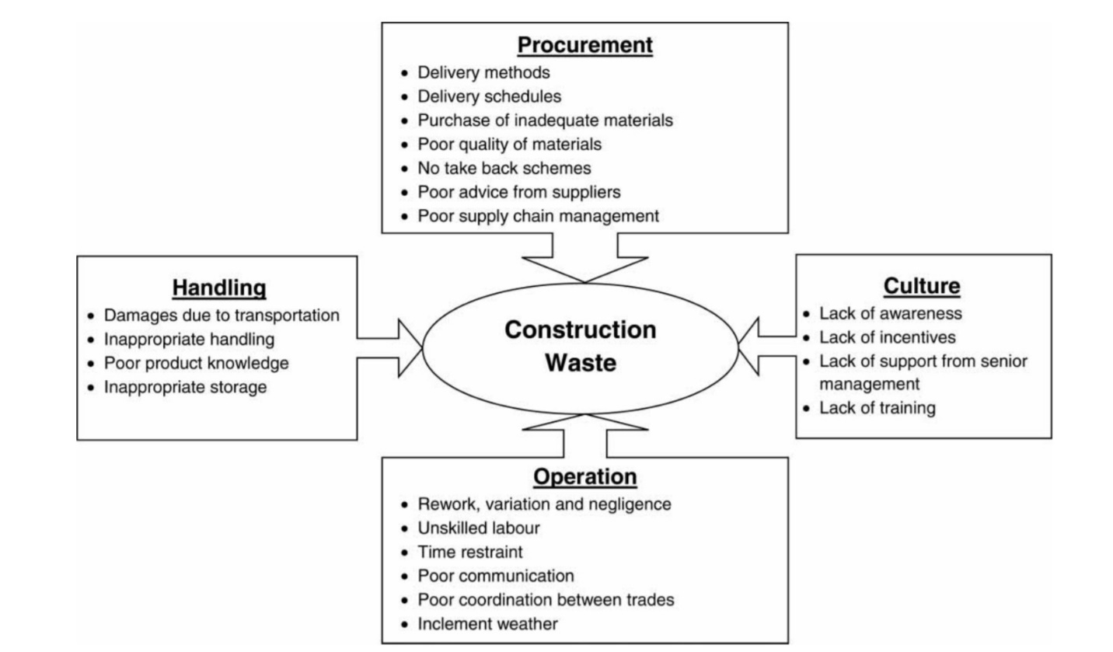
Figure 11: Lingard et al. (2001).

From this figure, it can be said that there are four main stages that construction wastes are generated:
- Procurement
- Culture
- Handling
- Operation
According to many scholars (Lingard et al., 2001), the concept of lean construction is one of the vital concepts to reduce waste at the construction site. For example, the authors believe that wastes that are of value or needed activities are hard to be eliminated. As such, the focus should be directed towards the “Not needed” activities because they hold higher potential for sustainability. To explain this, the extra construction activities and the approaches to reduce the waste they produce are the foundation of lean construction thinking and this can help with having a healthy concept of waste management. Most of the waste management methods usually depend on two factors; the total amount of construction waste, and the financial cost. Furthermore, the fact that calculating waste is a requirement for its management, knowing how much waste is produced could be used as a benchmarking scheme.

Public-Private Partnership (PPP)

Recently, the sustainability concept has become the most favoured theme in PPP-related readings in which many references show an association among these studies. For illustration, the number of studies highlighting the social aspect significantly exceeded those of ecological and economic scopes (Wang, & Ma, 2021, Sverko et al., 2020). There have been many suggestions displaying that PPP has employed a dominant role in contributing to social and health services such as insurance, vaccine development, and biomedical devices targeting better well-being of the community. This shows the importance of the PPP and infrastructure. For instance, PPP was considered as the leading apparatus for several countries in their infrastructure logistics, as the benefits of PPP over financial sustainability and support for long-term green growth have become extensively recognized. For instance, the largest segment in infrastructure PPP is transportation as shown in Fig. 12 that has been considered as a green elucidation in terms of charge and effluence consequences. Because of the raise via the United Nations, PPP has been recognized by several administrations and scholars as a possible tool for Sustainable Development Goals (SDG). Previous studies lack a strong description of sustainability from a PPP perspective and the holistic view of PPP as a green methodology.
The implementation of PPP in educating social sustainability will be further expanded due to the emerging needs in the infrastructure. As PPP remains to grow from the social sustainability aspect, some developing examples as connected cities, critical infrastructure, human factors and well-being are drawing more consideration. The influence of PPP as an apparatus for social sustainability and the implementation of PPP in these vital areas will entice more scholars to discover this substantial joint point. As these areas frequently include innovative technologies, the involvement of an integrated framework of PPP will be needed.
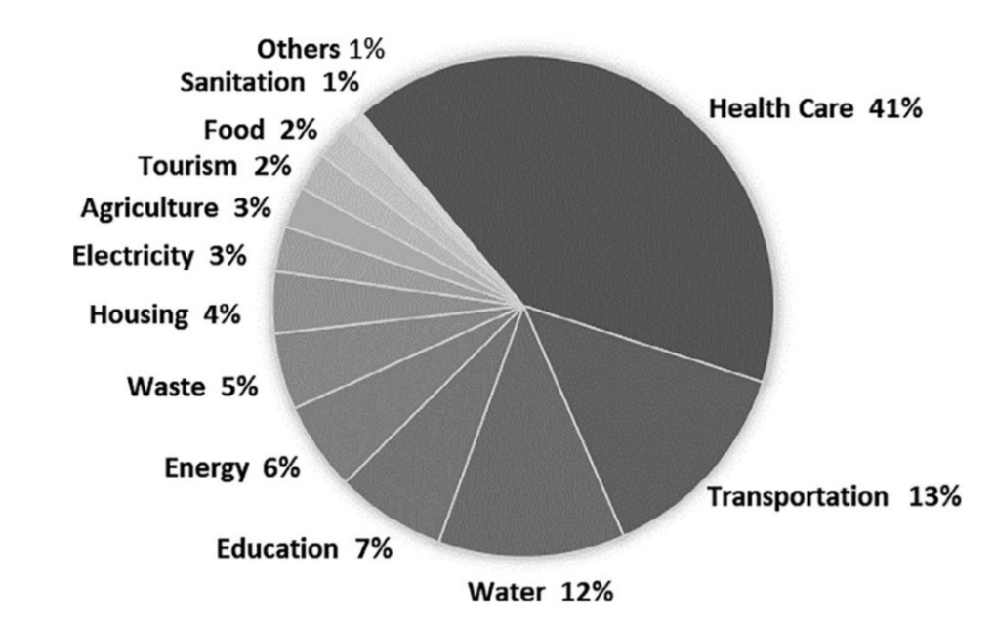
Figure 12: Wang and Ma (2021).

Sustainability Challenges in UAE Construction Industry
Regardless Of the enormous volume of green changes in the Middle East to enable the sustainability concept in the industrial sector, still, there are serious challenges for adequate implementation of sustainability. For example, in addition to financial consequences, time, effort, and planning should be considered. From ecological limitations to man-made difficulties, Middle Eastern nations have tried to find the assets to recognize and execute the concept of sustainability. A key ecological dilemma in the Middle East is the scarcity and security of water. According to the studies, (Saleh & Alalouch, 2015), the Middle East region only has 1% of the world’s available freshwater, concerning the elevated hot and dry climate. Under such tough environmental conditions, it is evident that excessive population expansion, poverty and the subsequent deprivation of natural resources do not assist in guiding governments’ advances towards a ‘greener’ portfolio(Siew, 2015) .
Additionally, the Middle East area is confronted with several varieties of encounters when it comes to attaining substantial sustainability purposes such as lack of cultural awareness. To its advantage, the Middle East region has a higher rate of literacy among its population, in which a large number of provincial residents chasing secondary and higher education (Salama and Hana, 2010). For example, the United Nation Development Program (UNDB) has classified countries besides the Human Development Indexes (HDIs) where these indexes include different aspects of sustainability, well-being, quality of life, education level and life expectancy. These indexes show that Gulf Cooperation Council (GCC) countries, Bahrain, Kuwait, Oman, Qatar, Saudi Arabia, and the United Arab Emirates, have high (HDIs). To illustrate that, GCC countries are rich with hydrocarbon resources, yet, according to (Al Naqbi. 2018) that human development and natural wealth are not necessarily correlated with high interest and awareness levels in sustainability. For instance, many countries have high HDIs but their chief emphasis is on the leisure industry, which directly subsidizes their GDPs and may have negatively impacted sustainable development.
From a different perspective, after the year 2010, the Middle East region has witnessed some dogmatic instability that results in consequent economic weights to solve. As such, the public seems to tend towards the belief that they would accept the suffering of the environmental pollution and lack of sustainable resources than be suffered due to a civil war. To illustrate more, this is a pattern faced by some of the Middle East governments in the area when executing sustainable development goals (SDGs).
An additional obstacle is that countries with extremely high HDI, such as The Kingdom of Saudi Arabia (KSA) and the UAE are confronted with, is trying to impact overconsumption attitudes. Although these developed countries have a strong green building rating system, and sustainability infrastructure system levels seem too high compared with other middle east countries, other countries, do have a challenge with for overconsumption economic behaviour (Elchalakani et al., 2014, Moshood, 2020).
For better illustration, UAE’s water consumption has reached 265,550 litres per capita per day (Kazim, 2010) in which substantially surpasses the world’s average consumption. This is especially challenging. For example, the countries that consume more water in general than people staying in countries that are abundant in surface water and have other alternatives such as groundwater and aquifers that may be refilled. In this point, it is important to highlight that there have been significant accomplishments in the region with the execution of sustainability concept via green building construction codes, yet there is still a key test in handling the existing construction units that were built before the rise of the awareness towards sustainability in the infrastructure.
The construction industry is a chief contributor to the UAE’s Gross Domestic Product (GDP) after the oil and gas industry. Consequently, rising cities such as Dubai have to plan along with a sustainability vision to reduce the ecological impacts and the earth resource reduction. The sustainable construction industry in the UAE is growing with amplified awareness in adapting green structures concerning ecological aspects (Al-Hajj& Hamani, 2011). Nevertheless, it has been recognized that the efficiency of employing structure ecological sustainability evaluation approaches differs considerably with numerous aspects. For example, the most two famous building sustainability assessments are Pearl Building Rating (PBR) and Al Safat Rating methods. However, even with these systems in place, many scholars and experts in UAE construction see that there are many challenges towards implementing sustainability in the industry. For instance, starting with organization challenges, a key challenge to senior management within the construction industry was observed as the actual or perceived financial associated with sustainability (Al-Hyari, 2017). It is hard for the senior management to see implementing sustainability is good for the construction business also. Due to that, the real change should start with the policy, law and regulations of the organization in which emphasises the importance of sustainability as a way of function so that it can be integrated as a core element in the culture.
In addition to that, there are market challenges towards sustainability implementation in the construction industry. To illustrate, the construction industry is a very fragmented industry where this nature of work makes implementing sustainability hard, as such many governments recommended having holistic sustainability governance in the construction industry (Hamani and Al-Hajj, 2015). This mentality will help the profession in the construction industry to understand that construction is not only about “build” yet it has a social and environmental aspect.

Chapter: 3 Research Methodology

Research Design
The aim of this study is to evaluate the performance and implementation of sustainability in the construction industry in the UAE. To do so, two objectives should be studied; evaluating critically the present and future challenges of sustainability implementation in the construction industry and providing a holistic understanding of circular economy policy in the construction industry. These objectives contain variety of aspects; managerial, engineering and social in which each objective has unique approach to be attained. For the first objective, Knowing the current and future challenges, many sustainability scholars (Asif, 2016, Sim et al., 2015) used the questionnaire as methodology to determine the sustainability challenges in the construction industry in the UAE.
In this study, the similar method will be utilized and a survey will be employed to explore the difference factors that can play major and minor roles to effect of the implementation of the sustainability in the construction industry in the UAE. Additionally, this survey will try to provide a comprehensive understanding via descriptive questions that have exploratory attributes to have more accurate insights. For example, this investigation highlights and includes the behavioral characteristics of the individual employee in the construction industry such as the assessment and compliance of the sustainability systems.
For more illustration, According to many sustainability scholars such as Brochner et al., (1999), that compliance to sustainability via assessments approaches is a vigorous indicator of the green performance in the construction industry. The authors highlight that in heavy industries such construction, studying the sustainability compliance process through assessment methods should aid to show technical and managerial defects that have a straight influence on the green decision-making mechanism in the construction industry.

Questionnaire
The questionnaire was designed for all the staffs who working on the major construction projects in the industry at the UAE development plans. Mainly, there are three main groupings for the construction companies in the UAE industry:
- Owners (mostly are public sectors),
- Contractors, ( shared between public and private sectors)
- Vendors ( mostly from the private sectors)
Most of construction development projects are located in two Emirates; Abu Dhabi and Dubai especially in the free zones areas. As such, most of the questionnaires in this study where circulated towards the construction companies in the both Emirates that have accessible communications tools in their offices and construction sites. In-person appointments were obligatory (with some restrictions due COVID-19) to confirm that the wanted employees from senior management, middle management and site workers level receive and understand the questionnaires. In this research, 12 personal trips to different construction companies, including 5 in Abu Dhabi and 7 Dubai were conducted to distribute the questionnaires either in the offices and sites.

Data Analysis Approach
The interview structure will be highlighted different areas: generic individual information, sustainability understanding, procedural and managerial challenges, culture and behavioural challenges towards sustainability. The beginning questions aims to expose the general interviewee’s background in sustainability in construction and how he/she is engaged in the construction activities through various undertaken responsibilities. Following this, generic questions about sustainability performance and implementation, other questions will be asked to determine the employee view about the present sustainability procedures alongside all the possible threats in the construction industry for green performance. Additionally, in this questionnaire, the emphasis will be about why many major construction companies do not pay the essential attention towards the sustainability principles and measures e.g. not informing the procedures and lack of implementing the sustainability values.
The interview will also examine the interviewee’s opinion about the government’s role in ensuring the effectiveness of the organization sustainability procedural systems in the ongoing construction projects. 10 main interviews will be conducted in this study in which the goal of having these interviews is to identify the root causes for the practical influences that are affecting the implementation sustainability performance in the construction industry. Many sustainability scholars use the interview approach as a technique at the investigational stage in the construction industry. For instance, Abidin (2010) used the interview methodology to expose the significant aspects that increase the gap between the site workers and senior managers with respect to the sustainability performance.

Chapter 4: Presentation of the results

Introduction
The survey in this study starts with demographic enquiries e.g. age and gender position in which these types of questions will deliver a holistic idea in the outcome of results in the discussion phase. The mainstream of the replies in this questionnaire came from construction organizations that are located in Abu Dhabi and Dubai.
In this questionnaire we have distributed the questionnaires to 60 employees in which:

- S: 20 of them are holding senior management role in the construction organization (project manager and higher)
- M: 20 of them are holding middle management role construction organization (Site Engineer and equivalent)
- W: 20 of them are site workers and end-users.
- Alpha value of 0.05

Statistical significance: Cross-tabulation and chi-square
There are several social and sustainability scholars in the construction prefer to use the Cross-tabulation and chi-square approach due to its benefits and accuracy in the construction area (Wildemuth, 2016, Kjaer et al., 2019):
- One important benefit of utilizing Cross-tabulation and chi-square method in a review is, it’s easy to calculate and comprehend.

- It excludes misperception as primary statistics that can sometimes be difficult to comprehend and understand.
- It is direct and easy to comprehend the ideas even from a complex data.
- It delivers capable statistics on two or more variables across numerous landscapes with simplicity.
- The most central benefit of employing Cross-tabulation and chi-square approach for survey examination is the simplicity of using any statistics e.g. nominal, ratio, etc.

Presentation of questionnaire results
- Demographic questions

Table 2: Type of the construction company.
Type/Employee | S | M | W
Owner | 12 | 5 | 5
Vendor | 2 | 2 | 1
Contractors | 6 | 13 | 14

The chi-square statistic is 13.7045. The p-value is .0083. The result is significant at p < .05.
As shown in Table 2, Most of the senior management come from the owner companies and end-user from the contractors companies in this study. This will give nice and two different perspective about the implementation of sustainability in construction.
Table 3: The gender.
Gender/Employee | S | M | W
Male | 12 | 5 | 17
Female | 8 | 15 | 3

As shown in Table 3, it was expected that the number of male will overcome the female since it is a construction industry. Yet, it was surprising that the number of women in the middle management was than men in this study.

The chi-square statistic is 14.7964. The p-value is .000612. The result is significant at p < .05.
Table 4: The age.
Age/Employee | S | M | W
Under 20 | 1 | 2 | 6
20-30 | 3 | 2 | 3
30-40 | 3 | 6 | 3
40-50 | 5 | 8 | 4
Above 50 | 8 | 2 | 4

As shown in Table 4, that, the senior management in the construction companies usually are above 50 years old and this is a very interesting point, because on the another hand, most of the workers are between 20-30 years old. This difference in the generation era can play critical role in the sustainability implementation.
The chi-square statistic is 15.1242. The p-value is .000625. The result is significant at p < .05.
Table 5: The Education Level.
Education/Employee | S | M | W
Basic education | 1 | 1 | 12
Diploma degree | 1 | 5 | 6
Bachelor degree | 10 | 12 | 2
Master degree | 6 | 1 | 0
PhD degree | 2 | 1 | 0

The chi-square statistic is 16.2415. The p-value is .000865. The result is significant at p < .05.
As shown in Table 5, most of the workers in the site have a basic education as many parts in the world at the construction industry and the dominate degree in the office jobs either in the middle management or senior management is the bachelor degree.

Table 6: Job Location.
Position/Employee | S | M | W
Sites | 2 | 6 | 15
Offices | 16 | 6 | 1
Both | 2 | 8 | 4

The chi-square statistic is 12.2415. The p-value is .000715. The result is significant at p < .05.

As shown in Table 6, the senior management spend most of their time in the office and the workers in the site, and the middle management (e.g., site engineers).

Table 7: Dose your company has weak sustainability system.
Employee | S | M | W
Strongly Disagree | 6 | 6 | 7
Disagree | 4 | 5 | 3
Agree | 8 | 7 | 2
Strongly Agree | 2 | 3 | 8

The chi-square statistic is 14.1012. The p-value is .000665. The result is significant at p < .05.

As shown in Table 7, it was interesting that to see there are good number of the workers do not believe that they have a good system in the sustainability although most of them have a basic education. Yet, in the other hand most of senior management believe they do have good system that support the sustainability implementation.

Table 8: You are familiar with Sustainability assessment bases methods.
Employee | S | M | W
Strongly Disagree | 2 | 3 | 6
Disagree | 2 | 7 | 6
Agree | 8 | 4 | 4
Strongly Agree | 8 | 6 | 4

The chi-square statistic is 12.315. The p-value is .000765. The result is significant at p < .05.
As shown in Table 8, most of the workers are not familiar with the sustainability assessment methods and mechanism in the organization and could be due their level of education or the poor illustration from the organization to their workers in the site.

Table 9: Sustainability KPIs are always reported in your company.
Employee | S | M | W
Strongly Disagree | 1 | 4 | 6
Disagree | 2 | 5 | 9
Agree | 9 | 6 | 2
Strongly Agree | 8 | 5 | 3

The chi-square statistic is 13.266. The p-value is .000694. The result is significant at p < .05.
As shown in Table 9, most of the workers in the site believe that there are no proper monitoring and recording for the sustainability KPIs and that may be related to the green bonus that are associated with the green performance. To explain, if sustainability performance was recorded the whole team members will lose the bonus even the higher management who has usually a big bonus if they achieve the required green perforce.
Table 10: Your company provides enough training to ensure sustainability competencies level between its employees.
Employee | S | M | W
Strongly Disagree | 5 | 2 | 12
Disagree | 4 | 2 | 5
Agree | 6 | 7 | 1
Strongly Agree | 5 | 9 | 2

The chi-square statistic is 17.2965. The p-value is .000988. The result is significant at p < .05.
As shown in Table 10, that both of the senior and middle management believe that they do provide an enough sustainability training for their workers. Yet this is not what shows when the workers respond to this question. This difference in believe could affect the sustainability culture in the organization.

Table 11: You are familiar with the sustainability elements of your company.
Employee | S | M | W
Strongly Disagree | 1 | 2 | 8
Disagree | 1 | 6 | 6
Agree | 14 | 6 | 3
Strongly Agree | 4 | 6 | 3

The chi-square statistic is 14.2415. The p-value is .000917. The result is significant at p < .05.
As shown in Table 11, the majority who has a good familiarity with the sustainability elements are the senior management.

Table 12: There are efficient communication channels between the management and the labourers.
Employee | S | M | W
Strongly Disagree | 2 | 1 | 6
Disagree | 1 | 8 | 7
Agree | 16 | 9 | 4
Strongly Agree | 1 | 2 | 3

The chi-square statistic is 11.6275. The p-value is .000765. The result is significant at p < .05.

As shown in Table 12, the quality of the communication is not efficient from the workers perceptive and if that true, that could cause a serious gap in the sustainability implementation and other critical aspects such as safety.

Table 13: Top Management conducts regular sustainability tours to construction fields.
Employee | S | M | W
Strongly Disagree | 2 | 4 | 9
Disagree | 4 | 3 | 9
Agree | 10 | 6 | 1
Strongly Agree | 4 | 7 | 1

As shown in Table 13, senior management believe that they usually do enough site visit to shoe enough visibility and leadership to the other joiner employees in the organizations.

The chi-square statistic is 12.2415. The p-value is .000597. The result is significant at p < .05.

Table 14: You understand your role and responsibilities towards Sustainability in your job.
Employee | S | M | W
Strongly Disagree | 3 | 4 | 5
Disagree | 2 | 6 | 11
Agree | 8 | 7 | 2
Strongly Agree | 7 | 3 | 2

The chi-square statistic is 13.221. The p-value is .001479. The result is significant at p < .05.

As shown in Table 14, Most of the employee in the organization who has difficulty to understand their role towards sustainability are the workers in the site although they are who are doing the execution work in the field.

Table 15: You understand your line supervisors’ role and responsibilities towards Sustainability in his job.
Employee | S | M | W
Strongly Disagree | 1 | 2 | 6
Disagree | 4 | 2 | 8
Agree | 6 | 8 | 4
Strongly Agree | 9 | 8 | 2

The chi-square statistic is 11.782. The p-value is .000971. The result is significant at p < .05.
As shown in Table 15, there is a poor communication between site workers and senior management in terms understanding the expectation. For instance, to have an effective implementation in sustainability workers should have a holistic idea about their supervisor role in this mission.

Table 16: Sustainability policies and procedures are up to date in your company.
Employee | S | M | W
Strongly Disagree | 1 | 7 | 6
Disagree | 3 | 3 | 8
Agree | 7 | 9 | 2
Strongly Agree | 9 | 1 | 4

The chi-square statistic is 13.2415. The p-value is .000952. The result is significant at p < .05.
As shown in Table 16, here that both of the middle management and site workers believe that the sustainability policies and procedures are not updated and that has and direct impact in the implementation plan for the sustainability in the organization.
Table 17: You always attended the Sustainability meeting in your department.
Employee | S | M | W
Strongly Disagree | 2 | 4 | 7
Disagree | 1 | 6 | 10
Agree | 12 | 7 | 1
Strongly Agree | 5 | 3 | 2

The chi-square statistic is 14.2415. The p-value is .000721. The result is significant at p < .05.
As shown in Table 17, it is a very surprising that most of the middle management and sites workers are not attending the meeting which indicates poor involvement from the senior management to other employees to implement sustainability in the organization.
Table 18: Interviewees Theming analysis.
Theme 1: Construction industry has Strong Sustainability governance and leadership Challenges
Interviewee | Highlights | Meaning units
Interviewee (2) | - There is need for holistic governance | “ Sustainability starts from clear policy and governance”
Interviewee (7) | - Sustainability shows from the leaders in the organization | “ Sustainability should be a value not a KPI by senior management”
Interviewee (9) | - Construction industry needs green initiatives to move on | “ All stakeholders should provide green initiatives for this industry to be more sustainable”
Theme 2: Construction industry has communication and development organizational challenges
Interviewee | Highlights | Meaning units
Interviewee (1) | - Sustainability needs clear communication | “Sustainability likes Safety , can’t happen without clear columniation”
Interviewee (4) | - Employees need more training in sustainability | “ Sustainability is a skill that needs consistent training”
Interviewee (8) | - Construction a very fragmented industry | “ You always feel lost in communication in the construction industry”
Interviewee (5) | - Construction needs a specific development scheme | “ holistic approach are needed for implementing sustainability”
Theme 3: Construction industry has cultural and behavioral organizational challenges
Interviewee | Highlights | Meaning units
Interviewee (6) | - Culture are powerful more than procedures | “ Culture eats procedures for breakfast”
Interviewee (10) | - Sustainability is a cultural aspect more than anything. | “Green construction starts from Green culture.
Interviewee (3) | - Behavioral change starts from management | “ I follow my boss when it comes to the sustainability”

The mainstream of the survey respondents’ range between 26-52 years old, and work with owners and contractors’ organizations at the construction field in the UAE between Abu Dhabi and Dubai Emirates. Most respondents hold a basic education, but this depends mostly on the position they hold at the organization. The yields of the study clarify several optimistic and undesirable features regarding the implementation process of sustainability system that are experienced at the construction sites. For example, several replies specify that the existence negative exercise, such as un-evident leadership in construction site and week theoretical Sustainability process that is in the place among the organization producers.
For instance, the result of the survey depicts how most senior management believe that they have strong sustainability procedures. Yet, instantaneously, as can be shown from the results, many of the sustainability practical procedures need to be updated to aid workers into implementing the safety practices. Furthermore, the results of this questionnaire shed a key challenge in implementation of sustainability examination that raises many queries: How can construction organizations improve the application of examination and assessment to enhance the implementation of sustainability? Avoiding these questions will impact the sustainability decision-making mechanism and shows on the critical role of having a robust monitoring mechanism to guarantee the sustainability in the workplace.
Apart from the sustainability procedural challenges exposed in the survey results, there are some machinal challenges in implementing sustainability towards the equipment safety at the construction sites. For instance, many workers do not believe that their equipment or operation methodology are designed with respect to sustainability and this explains why construction waste has a very high rate in the UAE. This could be the first obvious gap between the point views about sustainability between the management and end-users. These gaps become even more pronounced when the questionnaire examines the behavioural safety aspect at the construction activities. This is vital because even if all technical aspects of sustainability are evaluated without considering the behavioural aspects and attributes, it will not be operative to assure the implementation of sustainability at the construction sites.
This questionnaire exposes several areas that directly influence the sustainability implementation systems, especially the sustainability assessment, varying from engineering to managerial features. Yet, additional examination is essential to comprehend the factors behind why these challenges occur inside the construction companies, predominantly between senior management. Such a study will aid achieve the goal of this study i.e. providing an integrated outline to enhance sustainability implementation systems such as circular economy in the construction industry. This can be approached via interviewing construction specialists who hold a holistic view relating to the current challenges against sustainability implementation systems.
For the interviews, it is noticeable how some interviewees have more information regarding sustainability and its implementation application from the theory perspective than others. For instance, some interviewee elucidates that the major weakness in sustainability assessment is that most construction organizations deal with it as a procedure which requires to be finalized and recognized without proper monitoring of its applications. However, in comparison to other interviewee, the justify the difficulty of applying the sustainability examination due to the multifaceted language of the procedures that most construction labors cannot comprehend because of their education background. At the same time, almost all interviewees approve on the vital role of the participation of the construction labors in the sustainability discussion as a pair of new eyes that can aid regulate all the possible threats towards sustainability in the construction process. Interviewees showed different systematic views concerning the procedural challenges of sustainability implementation in the construction companies. To illustrate, one of the interviewees (5) believes most senior administrations work very hard in the sustainability procedures especially at the early stage of the construction company to get the international green credentials in order to improve the branding standing only to abandon it later on.
This statement can be related to the interviewee (7) view regarding the lack of training for the construction end users towards the understanding sustainability procedures and how to apply them in the site. For instance, constant emphasis and consideration towards procedural assistances is obligatory for the construction labors as the technical competency. As result, when a lack of procedural familiarity between construction labors occurs it specifies a weak sustainability administration. This can be observed from numerous acts at the construction site such as the struggle of construction labors to have full access to the sustainability procedures. These undesirable applications can be replaced by healthier ones via noticeable communication between the senior management and the employees in the organization. As recommended by numbers of interviewees, having an explicit focus group ensures the implementation of the sustainability requirements. In addition, this focus group can also manage the sustainability polices training courses that should be offered out on a for the construction labors.
For the behavioral aspect, there were numerous reasons elucidated by both interviewees. For instance, many interviewees hold that the senior management has a limited comprehension about the implementation of sustainability nation where actions such as poor planning and lack of green awareness can disturb the behavioral sustainability of the employees, especially construction labors. According to Dietz and Neill (2017) such a vulnerable sustainability mentality is associated to the organization’s sustainability procedures being mistranslated by senior management. Due to that, such, Dietz and Neill suggest conducting examinations frequently to know the worker fulfilment with the sustainability implementation at the construction site and how it can be enhanced. This common interaction between end-users and management would aid create a philosophy with open channels for communication to enhance the sustainability. As a consequence, proper monitoring for the behavioral aspect can be functional to deliver an efficient sustainability values and principles at the construction site to organizations office. Most of the interviewees approve the idea about the vital role of the employee behavioral in creating the sustainability culture in which interviewee (7) highlights that poor wellbeing strategy can interrupt the sustainability presentation of the worker. This can be improved, if the senior management provides self-esteem and a sense of belonging for the workers inside the construction organization.
The main goal for these interviews is to determine the top risk factors that affect the sustainability implementation in the construction industry in the UAE. The interviews show numerous areas and issues that impact the implementation of sustainability. For instance, lack of interpretation, weak communication and workers green skills, seems as a root sources for many sustainability tasks. Most of the challenges highlight to an absence of the joined view as mentioned in the literature review. Both the interviews and the questionnaires aid form a holistic and complete idea in what is needed it to enhance the application and implementation of sustainability. Having a complete solution such as using circular economy in the construction industry could be one of the most efficient solution that suits the market in the UAE. The question was here about the suitability of using circular economy to enhance the construction industry in the UAE or not? In the literature review, many authors presented different challenges that may face the circular economy such as the complex logistic process. Yet, many interviews acknowledge this challenge, but they refer to the new technology in the construction such as BIM and digital twin in which it can solve this challenge especially if it was involved in the early stages such as the designing stage.

Chapter 5: Discussion and Conclusion

Discussion of results
This study tried to answer the question about why the construction industry is suffering from lack of implementation in the construction industry. Looking back at the literature reviews, there were several theories in which each one of them had its own principles and reasons to explain the delay and challenges of having an effective sustainable construction industry. For example, many theories in the technical aspect suggest that there is a need for adapting new technologies such as new raw construction materials especially in the main two construction materials: concrete and steel. However, after conducting the questionnaire and the interviews, it appears having healthy green materials cannot give any push for sustainability if there is no commercial value behind it. This explains why many of the answers both in the questionnaire and interviews, were highlighting the need to conduct life costing analysis and life assessment analysis when we use any new materials in the construction process. In addition, for clean technology such as carbon capture, there is a need to provide a proper and updated training for workers in the site, simply because they are the one who is in the front line to implement and monitor the Carbon emission as a key sustainability indicator.
However, as the data shown from results shows, there is a lack of proper training that covers sustainability as concept and application in most construction companies. As such, having a sustainable culture in the construction organization from offices to the site will be a challenge. For that, we found many of the interviewee's emphasis on the idea or notion of the difference between looking sustainable and being sustainable in the construction industry. This shows that using advanced technology alone is not enough for the construction industry challenges in the UAE.
Due to that, having the required leadership role is very critical to support the implementation sustainability in the construction industry which was shown in both: the litterer review and result data. It was very interesting that that data shows most of the workers in the site believe in the “lead by example” concept and it will really help them to believe that sustainability is not only a KPI to achieve, but a value within the organization itself. As such, we can understand why there are many comments from the construction workers to have a direct meeting with the senior management to share their inputs which will give them the feeling of contribution and belonging. As a result, when there are construction workers who have been trained and educated about sustainability and at the same time they are participating with senior management in the decisions that are associated with sustainability implementation, then using advanced technology will be an adding value to enhance sustainability performance of the construction organization.
In addition, in terms of regulations, both the senior management and construction workers highlight the need to have clear and robust sustainability policies and regulations that would be presented as a clear path for everyone in the industry. One of the interesting points is that many of these regulations are so complex to be illustrated to the construction workers due to their limited education and here, the senior management should interfere to make sure this sustainability is simple and can be understood via their end-users to ensure the healthy sustainability culture inside the organization. As such, the need of having a holistic solution that combines all the different aspects, such as managerial, technical and procedural, is a key solution to have effective implementation of the sustainability in the construction. In the literature review, using circular economy was one of the holistic approaches that can help the construction industry to have better implementation regarding the sustainability challenges. In addition, the interviewees mentioned that there is another misunderstood idea about using the “extra cost” of using the circular business model in construction. As shown in the literature review, the circular economy usually costs more than the usual or linear capital investment, yet as many of the engineers and workers highlight that, in the long run the maintenance cost will be less which will reduce the total cost significantly. As such, many responses either in the interviews or questionnaires suggest using life costing analysis as a tool with the circular economy business model.

Conclusion
Through this research attempts to enhance the sustainability performance at construction industry in the UAE via exposing the current challenges and provide potential solutions such as circular economy. As can be seen from the literature review, many construction scholars explicate their sustainability struggles with current implementation applications in the industry and the needs for a holistic method. The purpose of this investigation is to include all dynamic attributes that can cause and impact the implementation of the sustainability in the construction sites. Practical, Managerial, and social features were examined with respect to the different factors that play a critical role in the oil and gas industry. Several global sustainability initiatives could not deliver a holistic viewpoint to recognize the complete opportunity of implementing sustainability the construction industry in the UAE. To have a unified interpretation for better sustainability implementation, an integrated investigation should be conducted such circular economy approach. To regulate the potential sustainability threats at the construction organization, all the staffs in the organization have been examined via a questionnaire that was circulated as a part of the methodology work in this study.
Revealing the current sustainability challenges in the construction organization’ sustainability culture was a vibrant phase towards identifying the significant essentials that had to be reinforced in order to enhance the sustainability implementation. There were unanticipated points raised up via both senior management and site workers, providing a sight at the several challenges towards the sustainability implementation strategy. For example, both senior management and site workers specify some defects in the practical skills, due to the lack of sustainability exercise or communication between construction organizations. Additionally, this phase of the study elucidates the variance mindset between senior employees and site workers in how the sustainability and organizational measures should be applied. A chief encounter arose in the social feature especially from the senior management side. For more illustration, most executives who participated in the survey, lacked sustainability vision when it came to how sustainability culture and climate are associated with site workers behavioral and mindset.
The practical work in this research; survey, and interviews helped to expose critical essentials, as demonstrated in analysis (Chapter 5). The results provide the need of conceptual plans that satisfy industrial concerns such construction industry to implement sustainability. Simultaneously, through this study, sustainability scholars specify the importance of linking other features such as people behavioral and organization culture as part of sustainability integrity. Additionally, in depth, the results show new features of behavioral safety during the sustainability assessment, confirming the behavioral communication between the seniors and juniors’ employees. Thus is, an open channel for both managers and workers will be established to enhance the sustainability implementation.
As the in the interview stage, it highlighted that when the behavioral examination is used in the sustainability assessment, the senior employs green performance awareness towards their construction industry fundamentals is amplified. This, in turn, it has the potential to improve the profitability in the long run for construction organizations. As shown in the Framework, these comprehensive features of sustainability implementation provide a better strategy for sustainability implementation in the construction industry. Due to the practicality of the civil engineering and construction field, especially in the infrastructure, there is a necessity to study how these results of this study will be implemented and employed with the current markets. The participants explained that the potential positive impact of circular economy in playing a holistic role in implementing sustainability in the construction industry. For instance, the participants highlighted that the construction firms should have a sustainability strategy that includes all employee groups from senior to site workers. Additionally, according to the participants in this study that they suggested continuous actions to the site workers feedbacks towards sustainability which advances the implementation process. Furthermore, to enhance the green performance, the participants recommended numerous healthy practices under the circular economy umbrella that must be applied laterally with regular construction actives.

Limitations
This research delivers a new standpoint towards optimizing the implementation of sustainability in the construction industry. Sustainability and green construction professionals suggest using a cohesive apparatus to improve the sustainability implementation at the site. The critical suggestion was provided in this via explaining circular economy in which it illustrates how to fill current sustainability implementation defects. Yet, as with any study, there were constraints have some impact on the investigation approaches.
According to Sierra et al., (2016), limited timing constraint is a collective aspect that effects the mixture of a proper method to attain any construction research goals. For instance, in this research, the mainstream of the construction sites inspected were from Abu Dhabi and Dubai Emirates, since over 85% of UAE development construction projects are positioned there (UAE Government Report ,2018).
Regardless the resemblance of the construction measures between all difference projects in all Emirates, an emphasis research at other Emirates such as Sharjah and Ajman may uncover specific sustainability implementation challenges. Due to that, there are verity external influences such as financial and regulation aspects. That is, application of the holistic sustainability assessment should be taken seriously and their impact on the construction firm culture and site workers mindset towards green performance.

Recommendations
This research observes the sustainability presentation and implementation at the construction industry in the UAE. The participants of this study highlight the need of a cohesive method that encloses vigorous features to improve the sustainability system execution. As was displayed in literature review stage, sustainability in construction is a very vibrant arena that needs a sequential development. For instance, according to many construction scholars (Carpenter, et al., 2001), that to have a significant construction development, the sustainability occurrence in construction should be restructured regularly with respect to other factors e.g. technology and policies. As result, this research suggest the next recommendations that can deliver the potential for other scholars to employ the conceptual results of this study.
- Creating proper governess system that suits the circular economy in the construction industry
Having dynamic governess system for the circular economy in the construction industry will help the construction organization to have a clear road map and reference that help them to implement sustainability regardless to the changing variables in the construction industry.
- Studying in depth the role of human factor in the circular economy
As shown in research that the behavioral aspect plays a critical role in the implementation the sustainability as healthy culture in the construction organization. For that, studying human factors with respect the circular economy system will be a good start and coloration for better sustainability implementation via the circular economy in the construction industry.

References

- Abidin, N. Z. (2010). Investigating the awareness and application of sustainable construction concept by Malaysian developers. Habitat international, 34(4), 421-426.

- Al-Hajj, A., & Hamani, K. (2011). Material waste in the UAE construction industry: Main causes and minimization practices. Architectural engineering and design management, 7(4), 221-235.
- AL-Hyari, A. M. (2017). The Integration of Sustainability in Project Management and Its Impact on UAE Construction Projects Performance (Doctoral dissertation, The British University in Dubai (BUiD)).
- Al-Naqbi, A. K., & Alshannag, Q. (2018). The status of education for sustainable development and sustainability knowledge, attitudes, and behaviors of UAE University students. International Journal of Sustainability in Higher Education.
- Alwan, Z., Jones, P., & Holgate, P. (2017). Strategic sustainable development in the UK construction industry, through the framework for strategic sustainable development, using Building Information Modelling. Journal of Cleaner Production, 140, 349-358.
- Asif, M. (2016). Growth and sustainability trends in the buildings sector in the GCC region with particular reference to the KSA and UAE. Renewable and Sustainable Energy Reviews, 55, 1267-1273.
- Baloi, D. (2003, September). Sustainable construction: challenges and opportunities. In 19th Annual ARCOM Conference, University of Brighton, United Kingdom (pp. 289-297).

- Berkes, F., & Folke, C. (1994). Linking social and ecological systems for resilience and sustainability. Beijer International Institute of Ecological Economics, The Royal Swedish Academy of Sciences.

- Bifulco, F., Tregua, M., Amitrano, C. C., & D'Auria, A. (2016). ICT and sustainability in smart cities management. International Journal of Public Sector Management.

- Bocchini, P., Frangopol, D. M., Ummenhofer, T., & Zinke, T. (2014). Resilience and sustainability of civil infrastructure: Toward a unified approach. Journal of Infrastructure Systems, 20(2), 04014004.
- Bocken, N. M., & Short, S. W. (2021). Unsustainable business models–Recognising and resolving institutionalised social and environmental harm. Journal of Cleaner Production, 127828.

- Bocken, N. M., Olivetti, E. A., Cullen, J. M., Potting, J., & Lifset, R. (2017). Taking the circularity to the next level: a special issue on the circular economy. Journal of Industrial Ecology, 21(3), 476-482.

- Bovea, M. D., Ibáñez-Forés, V., & Agustí-Juan, I. (2014). Environmental product declaration (EPD) labelling of construction and building materials. In Eco-efficient Construction and Building Materials (pp. 125-150). Woodhead Publishing.

- Brown, J. (2009). Democracy, sustainability and dialogic accounting technologies: Taking pluralism seriously. Critical Perspectives on Accounting, 20(3), 313-342.

- Brochner, J., Ang, G. K., & Fredriksson, G. (1999). Sustainability and the performance concept: encouraging innovative environmental technology in construction. Building Research & Information, 27(6), 367-372.

- Brulle, R. J. (2010). From environmental campaigns to advancing the public dialog: Environmental communication for civic engagement. Environmental Communication, 4(1), 82-98.

- Carpenter, S. R., & Gunderson, L. H. (2001). Coping with Collapse: Ecological and Social Dynamics in Ecosystem Management: Like flight simulators that train would-be aviators, simple models can be used to evoke people's adaptive, forward-thinking behavior, aimed in this instance at sustainability of human–natural systems. BioScience, 51(6), 451-457.

- Carvajal-Arango, D., Bahamón-Jaramillo, S., Aristizábal-Monsalve, P., Vásquez-Hernández, A., & Botero, L. F. B. (2019). Relationships between lean and sustainable construction: Positive impacts of lean practices over sustainability during construction phase. Journal of cleaner Production, 234, 1322-1337.

- Castellani, V., & Sala, S. (2010). Sustainable performance index for tourism policy development. Tourism management, 31(6), 871-880.

- CIB (2002), Agenda 21 for Sustainable Construction in Developing Countries, UNEP‐ITEC, Discussion Document, International Council for Research and Innovation in Building and Construction, Cape Town.

- Collier, M. J., Nedović-Budić, Z., Aerts, J., Connop, S., Foley, D., Foley, K., & Verburg, P. (2013). Transitioning to resilience and sustainability in urban communities. Cities, 32, S21-S28.

- DAmato, D., Veijonaho, S., & Toppinen, A. (2020). Towards sustainability? Forest-based circular bioeconomy business models in Finnish SMEs. Forest policy and economics, 110, 101848.

- De Abreu, M. C. S., & Ceglia, D. (2018). On the implementation of a circular economy: The role of institutional capacity-building through industrial symbiosis. Resources, Conservation and Recycling, 138, 99-109.

- Doppelt, B. (2012). The power of sustainable thinking: How to create a positive future for the climate, the planet, your organization and your life. Routledge.

- Dietz, R., & O'Neill, D. (2013). Enough is enough: Building a sustainable economy in a world of finite resources. Routledge.

- Di Maio, F., & Rem, P. C. (2015). A robust indicator for promoting circular economy through recycling. Journal of Environmental Protection, 6(10), 1095.

- Eggenberger, M., & Partidário, M. R. (2000). Development of a framework to assist the integration of environmental, social and economic issues in spatial planning. Impact assessment and project appraisal, 18(3), 201-207.

- Elchalakani, M., Aly, T., & Abu-Aisheh, E. (2014). Sustainable concrete with high volume GGBFS to build Masdar City in the UAE. Case Studies in Construction Materials, 1, 10-24.

- Ferronato, N., Rada, E. C., Portillo, M. A. G., Cioca, L. I., Ragazzi, M., & Torretta, V. (2019). Introduction of the circular economy within developing regions: A comparative analysis of advantages and opportunities for waste valorization. Journal of environmental management, 230, 366-378.

- Glass, J. (2012). The state of sustainability reporting in the construction sector. Smart and sustainable built environment.

- Hamani, K., & Al-Hajj, A. (2015, July). A conceptual framework towards evaluating construction contractors for sustainability. In The construction, building and real estate research conference of the Royal Institution of Chartered Surveyors RICS COBRA AUBEA (pp. 8-10).

- Haugh, H. M., & Talwar, A. (2010). How do corporations embed sustainability across the organization?. Academy of Management learning & education, 9(3), 384-396.
- Hendiani, S., & Bagherpour, M. (2019). Developing an integrated index to assess social sustainability in construction industry using fuzzy logic. Journal of cleaner production, 230, 647-662.

- Huovila, P., & Koskela, L. (1998, August). Contribution of the principles of lean construction to meet the challenges of sustainable development. In 6th Annual Conference of the International Group for Lean Construction. Guaruja, São Paulo, Brazil (pp. 13-15).

- Kazim, A. (2010). Strategy for a sustainable development in the UAE through hydrogen energy. Renewable Energy, 35(10), 2257-2269.

- Kirveennummi, A., Mäkelä, J., & Saarimaa, R. (2013). Beating unsustainability with eating: four alternative food-consumption scenarios. Sustainability: Science, Practice and Policy, 9(2), 83-91.

- Kjaer, L. L., Pigosso, D. C., Niero, M., Bech, N. M., & McAloone, T. C. (2019). Product/service‐systems for a circular economy: The route to decoupling economic growth from resource consumption?. Journal of Industrial Ecology, 23(1), 22-35.

- Lawn, P. A. (2000). Toward sustainable development: an ecological economics approach. CRC Press.

- Lizarralde, G., Chmutina, K., Bosher, L., & Dainty, A. (2015). Sustainability and resilience in the built environment: The challenges of establishing a turquoise agenda in the UK. Sustainable Cities and Society, 15, 96-104.

- Malinauskaite, J., Jouhara, H., Czajczyńska, D., Stanchev, P., Katsou, E., Rostkowski, P., ... & Anguilano, L. (2017). Municipal solid waste management and waste-to-energy in the context of a circular economy and energy recycling in Europe. Energy, 141, 2013-2044.

- Marchese, D., Reynolds, E., Bates, M. E., Morgan, H., Clark, S. S., & Linkov, I. (2018). Resilience and sustainability: Similarities and differences in environmental management applications. Science of the total environment, 613, 1275-1283.

- Mendoza, J. M. F., Gallego-Schmid, A., & Azapagic, A. (2019). Building a business case for implementation of a circular economy in higher education institutions. Journal of Cleaner Production, 220, 553-567.

- Milios, L. (2018). Advancing to a Circular Economy: three essential ingredients for a comprehensive policy mix. Sustainability Science, 13(3), 861-878.

- Moshood, T. D. (2020). Emerging challenges and sustainability of industry 4.0 era in the Malaysian construction industry. TD Moshood, AQ Adeleke, G. Nawanir, WA Ajibike, RA Shittu, Emerging Challenges and Sustainability of Industry, 4, 1627-1634.

- Moore, J. E., Mascarenhas, A., Bain, J., & Straus, S. E. (2017). Developing a comprehensive definition of sustainability. Implementation Science, 12(1), 1-8.

- Missimer, M., Robèrt, K. H., Broman, G., & Sverdrup, H. (2010). Exploring the possibility of a systematic and generic approach to social sustainability. Journal of Cleaner Production, 18(10-11), 1107-1112.

- Murray, A., Skene, K., & Haynes, K. (2017). The circular economy: an interdisciplinary exploration of the concept and application in a global context. Journal of business ethics, 140(3), 369-380.

- Nahmens, I., & Ikuma, L. H. (2012). Effects of lean construction on sustainability of modular homebuilding. Journal of architectural engineering, 18(2), 155-163.

- National Research Council. (1999). Our common journey: a transition toward sustainability. National Academies Press.

- Naik, T. R. (2008). Sustainability of concrete construction. Practice Periodical on Structural Design and Construction, 13(2), 98-103.

- Nurse, K. (2006). Culture as the fourth pillar of sustainable development. Small states: economic review and basic statistics, 11, 28-40.

- Opoku, A., & Ahmed, V. (2014). Embracing sustainability practices in UK construction organizations. Built Environment Project and Asset Management.

- Purvis, B., Mao, Y., & Robinson, D. (2019). Three pillars of sustainability: in search of conceptual origins. Sustainability science, 14(3), 681-695.

- Leising, E., Quist, J., & Bocken, N. (2018). Circular Economy in the building sector: Three cases and a collaboration tool. Journal of Cleaner production, 176, 976-989.

- Linder, M., Sarasini, S., & van Loon, P. (2017). A metric for quantifying product‐level circularity. Journal of Industrial Ecology, 21(3), 545-558.

- Lingard, H., Gilbert, G., & Graham, P. (2001). Improving solid waste reduction and recycling performance using goal setting and feedback. Construction Management and Economics, 19(8), 809-817.

- Rogers, P. P., Jalal, K. F., & Boyd, J. A. (2012). An introduction to sustainable development. Earthscan.
- Roseland, M. (2012). Toward sustainable communities: Solutions for citizens and their governments. New Society Publishers.

- Salama, M., & Hana, A. R. (2010, September). Green buildings and sustainable construction in the United Arab Emirates. In Proc. 26th Annual ARCOM Conference (pp. 1397-1405).

- Saleh, M. S., & Alalouch, C. (2015). Towards sustainable construction in Oman: Challenges & opportunities. Procedia Engineering, 118, 177-184.

- Saidani, M., Yannou, B., Leroy, Y., Cluzel, F., & Kendall, A. (2019). A taxonomy of circular economy indicators. Journal of Cleaner Production, 207, 542-559.

- Shibieka, A. I., Raheem, T. B. A., & Hittini, B. Y. (2019). Exploring Challenges of Adopting Sustainability Assessment Methods in UAE-Perspectives of Project Professionals.

- Sierra, L. A., Pellicer, E., & Yepes, V. (2016). Social sustainability in the lifecycle of chilean public infrastructure. Journal of Construction engineering and management, 142(5), 05015020.

- Sim, Y. L., & Putuhena, F. J. (2015). Green building technology initiatives to achieve construction quality and environmental sustainability in the construction industry in Malaysia. Management of Environmental Quality: An International Journal.

- Siew, R. Y. (2015). Briefing: Integrated reporting–challenges in the construction industry. In Proceedings of the Institution of Civil Engineers-Engineering Sustainability,168(1), 3-6.

- Singh, A., Berghorn, G., Joshi, S., & Syal, M. (2011). Review of life-cycle assessment applications in building construction. Journal of Architectural Engineering, 17(1), 15-23.

- Singh, S. K., & Singh, A. P. (2019). Interplay of organizational justice, psychological empowerment, organizational citizenship behavior, and job satisfaction in the context of circular economy. Management Decision.

- Steffen, W., Richardson, K., Rockström, J., Cornell, S. E., Fetzer, I., Bennett, E. M., ... & Sörlin, S. (2015). Planetary boundaries: Guiding human development on a changing planet. Science, 347(6223).

- Sturm, M., Strasky, J., Adolf, P., & Peschel, D. (2008). The Gulf Cooperation Council countries-economic structures, recent developments and role in the global economy. ECB occasional paper, (92).

- Sverko Grdic, Z., Krstinic Nizic, M., & Rudan, E. (2020). Circular economy concept in the context of economic development in EU countries. Sustainability, 12(7), 3060.

- Tecchio, P., McAlister, C., Mathieux, F., & Ardente, F. (2017). In search of standards to support circularity in product policies: A systematic approach. Journal of cleaner production, 168, 1533-1546.

- Taušová, M., Mihaliková, E., Čulková, K., Stehlíková, B., Tauš, P., Kudelas, D., & Štrba, Ľ. (2019). Recycling of Communal Waste: Current State and Future Potential for Sustainable Development in the EU. Sustainability, 11(10), 2904.

- UAE Government Report (2018): The Annual Economic Report, 2018

- Wallbaum, H., Ostermeyer, Y., Salzer, C., & Escamilla, E. Z. (2012). Indicator based sustainability assessment tool for affordable housing construction technologies. Ecological Indicators, 18, 353-364.

- Wang, N., & Ma, M. (2021). Public–private partnership as a tool for sustainable development–What literatures say?. Sustainable Development, 29(1), 243-258.

- Whiteman, G., Walker, B., & Perego, P. (2013). Planetary boundaries: Ecological foundations for corporate sustainability. Journal of management studies, 50(2), 307-336.

- Wildemuth, B. M. (Ed.). (2016). Applications of social research methods to questions in information and library science. ABC-CLIO.

- Zhou, L., & Lowe, D. J. (2003, September). Economic challenges of sustainable construction. In Proceedings of RICS COBRA foundation construction and building research conference (pp. 1-2).
- Zsóka, Á., Szerényi, Z. M., Széchy, A., & Kocsis, T. (2013). Greening due to environmental education? Environmental knowledge, attitudes, consumer behavior and everyday pro-environmental activities of Hungarian high school and university students. Journal of Cleaner Production, 48, 126-138.

Appendixes

Appendix A: Participant Information Form:

Participant Name __________________________________
Interviewer Name _________________________________
Interviewer Programme of Study ______________________________________
Research Overseeing Tutor ________ Dr Alex Bell, UWTSD _______________
Participation Agreement to be interviewed:
I agree to participate in the research concerning “your study title here”. I understand that the purpose of this study is to examine my experiences of “e.g. the nature of the experience that they have had or the thoughts that they have”. I understand that this will involve me in a short 30-45 minute interview.
I understand that my participation in this interview will be recorded and transcribed for use only in interviewer’s full name Masters Research Dissertation at the University of Wales Trinity Saint David, and that I will be asked for permission for any use beyond this

I understand that my name or any reference that could identify me will be anonymised in this study. I understand that use, storage of the recordings and transcriptions relating to this interview will be both anonymous and held securely and that it will be subsequently destroyed after the use intended here.

I understand that I may withdraw from the study at any point with all records of my contribution removed without having to provide a reason.

Interviewee Signature:

Interviewer Signature:

Date of Interview:

A copy of this agreement should be retained by both interviewer and interviewee.

Appendix B: Questionnaire Form
Designed Survey for the sustainability implementation level in construction industry in the UAE

The main purpose is to identify the current defects in the risk assessment system of the oil industry, Please tick (✓) near the appropriate answer:
- Demographic questions
Q1- What is your construction company type?
⃝ Owners
⃝ Vendors
⃝ Contractors

Q2- What is your gender?
⃝ Male
⃝ Female
Q3- What is your age?
⃝ Under 20
⃝ 20-30
⃝ 30-40
⃝ 40-50
⃝ Above 50

Q4- Please describes your education level:
⃝Basic education level
⃝Hold a Diploma degree
⃝Hold a bachelor degree
⃝Hold a Master degree
⃝Hold a PhD degree

Q5- Where is your job location?
⃝ Sites
⃝ Office
⃝ Both
- Technical/Procedural/behavioral questions
Q6- Dose your company has weak sustainability system?
⃝ Strongly Disagree
⃝ Disagree
⃝ Agree
⃝ Strongly agree

Q 7– You are familiar with Sustainability assessment bases methods.
⃝ Strongly Disagree
⃝ Disagree
⃝ Agree
⃝ Strongly agree
Q8- Sustainability KPIs are always reported in your company.
⃝ Strongly Disagree
⃝ Disagree
⃝ Agree
⃝ Strongly agree
Q9- Your company provides enough training to ensure sustainability competencies level between its employees.
⃝ Strongly Disagree
⃝ Disagree
⃝ Agree
⃝ Strongly agree

Q10- You are familiar with the sustainability elements of your company.

⃝ Strongly Disagree
⃝ Disagree
⃝ Agree
⃝ Strongly agree

Q11- There are efficient communication channels between the management and the labourers.
⃝ Strongly Disagree
⃝ Disagree
⃝ Agree
⃝ Strongly agree

Q12- Top Management conducts regular sustainability tours to construction fields.
⃝ Strongly Disagree
⃝ Disagree
⃝ Agree
⃝ Strongly agree
Q13- You understand your role and responsibilities towards Sustainability in your job.

⃝ Strongly Disagree
⃝ Disagree
⃝ Agree
⃝ Strongly agree

Q14- You understand your line supervisors’ role and responsibilities towards Sustainability in his job.
⃝ Strongly Disagree
⃝ Disagree
⃝ Agree
⃝ Strongly agree

Q15- Sustainability policies and procedures are up to date in your company.

⃝ Strongly Disagree
⃝ Disagree
⃝ Agree
⃝ Strongly agree

Q16- Sustainability policies and procedures are well understood by employees.

⃝ Strongly Disagree
⃝ Disagree
⃝ Agree
⃝ Strongly agree

Q17- You always attended the Sustainability meeting in your department.
⃝ Strongly Disagree
⃝ Disagree
⃝ Agree
⃝ Strongly agree

The End

