Material Science / Structural Appreciation, Science and Materials
M4X01314 / M4X01349
Construction Materials

Jamie Davies
1703062

Content Page
Leadenhall Building (Steel) Design Page 2
Leadenhall Building (Steel) Construction Pages 3 - 4
Leadenhall Building (Steel) Sustainability Page 4
Steel Durability and Climate Resistance Page 5
Steel Environmental Impact Page 5
Steel Ease of Assemble Page 5

Trump Towers (Concrete) Design Page 6
Trump Towers (Concrete) Construction Page 7
Trump Towers (Concrete) Sustainability Pages 7 - 8
Concrete Durability and Climate Resistance Page 8
Concrete Environmental Impact Page 8
Concrete Ease of Assemble Page 8

Comparison Page 9

Leadenhall Building – London

Design
The Leadenhall building situated in London began construction in 2011 and was the world’s first prefabricated skyscraper. The building stands at 224m high with a unique shape. The local nickname for the Leadenhall building was the ‘Cheese Grater’. The reason for this was because of its tapering shape. The Architect who designed the building designed it this way because of a specific planning condition to protect the views of London’s landmarks, specifically, St Paul’s Cathedral. The client also benefited from the shape of the building as they could now offer a variety of office spaces to rent out to suit all types of businesses. The design of this building was revolutionary, a 3D model of the whole building was made to save time. The building was made 37 times in a virtual world, and the model was accurate to the last bolt.
The building design had a steel exoskeleton instead of a concrete core because of the lack of room to pour. The steel had to be sandblasted, primed and fire proofed to withstand all the possible outcomes. The steel is also prepressed to withstand and transfer the load to the foundations. The building was also planned to lean, and the designers called it ‘Active Alignment’ to allow for the weight of the building. The contractor had to remove the correct number of packers to shift the top of the building 25mm back to the south. All services, WC’s and lifts are placed into an external spine called the north core which is a separate structure. Each floor of the north core was delivered with pipework, plumbing, electrics and floor plates.

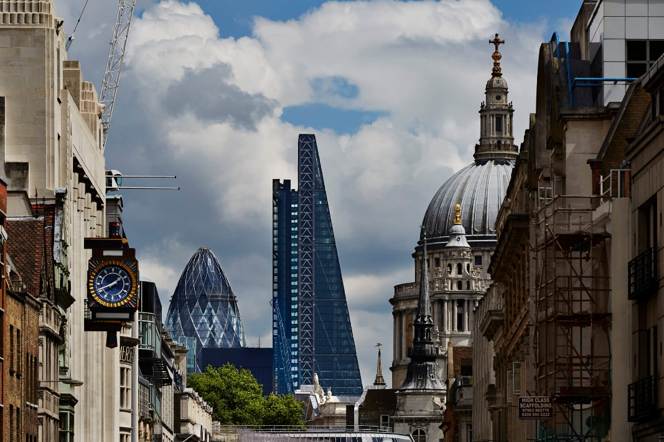
Image 1 – The Leadenhall Building (Rogers Stirk Harbour and Partners - Unknown)

Construction
The construction cost was £340000000. The Leadenhall had more than 80% of prefabricated components due to the tight site boundary, logistics and location. All the 20000 tonnes of steel were made 200 miles away from the site and the glass was made in China with a six week lead time for any replacements for breakages. With all materials being made off site, the main contractor’s (Laing O’Rourke) main issue was that the building was in Central London and the logistics all had to be prearranged and was worked to a ‘Just in Time’ system, meaning everything had its designated timeslot. All deliveries were planned to be after hours to avoid disrupting London traffic. Any small delay would have a major knock on effect to the construction as Laing O’Rourke aimed to have 2 storeys built within 24 hours. If they failed to meet their targets the liquidated damages for the project was in the hundreds of thousands per week. The two cranes used to install all the steelwork were bespoke cranes made in Italy. The cranes would need to fit 72 concrete floor planks a day, which was the only concrete that was in the building’s structure. The innovating window installation method used was called ‘Cerberus’. This was a self-raising platform with a monorail which can be moved from floor to floor. In a week they should have had 2 floors cladded.

Image 2 – Constructing the Leadenhall Building (The Leadenhall Building - Unknown)
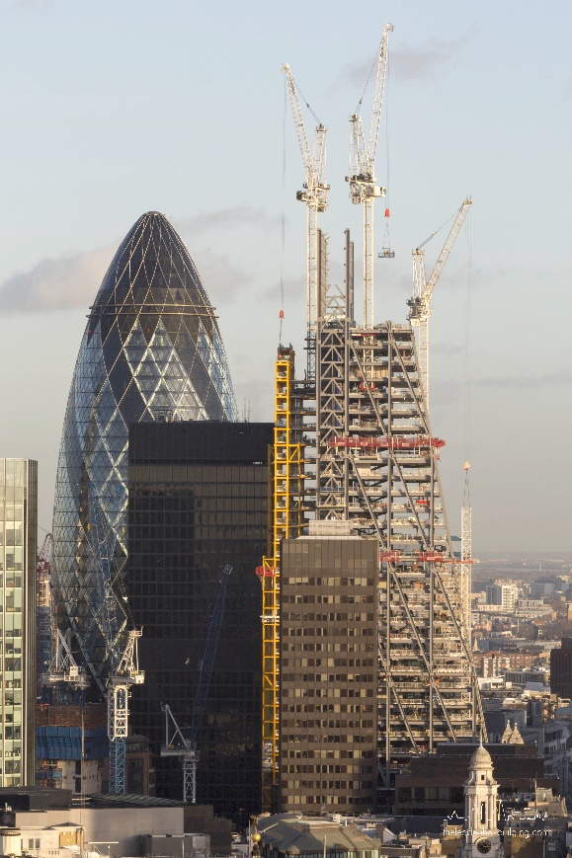

Sustainability
The Leadenhall was designed and built with sustainability in mind because –
“a sustainable approach is essential to delivering high quality buildings”. Leadenhall (Unknown)
The glass was a triple layer system. The system was the outer layer, a cavity with a blind that reacted to the suns movements and had a double glazing inner leaf. In order to minimise mechanical cooling, the glazing system had vents every seven storeys. Having 80% of the materials prefabricated off site it decreased the amount of deliveries, therefore lowering the air pollution and congestion.
“97% of construction waste diverted from landfill (95% target). 26% recycled content (25% target)” Britishland (Unknown)

Steel

Durability and Climate Resistance

Structural steel can be primed to prevent corrosion, which has to be applied on a clean surface. Its duty is to wet the surface and provide a good adhesion for subsequently applied coats. There are two types of primer, one is primer pigmented with metallic elements anodic to steel. The anodic steel would corrode instead of the structural steel if there was a break in the coating. The other method is primers relying on adhesion and chemical resistance. These primers may contain inhibitive pigments to prevent the corrosion process. The durability of steel is proven through its use throughout the world. It has the highest strength to weight ratio. Also, the versatility of steel structures make building with this material easier. Durable steel structures perform well under high speed winds because of their durability.

Environmental Impact

Steel production has its advantages and disadvantages. One advantage is that once a steel is 100% recyclable and can be reused and reused.
“Globally around 85% of construction steel is currently recovered from demolition” Greenspec (Unknown)
A disadvantage is the carbon dioxide, nitrogen oxides, sulphur dioxide emissions and dust from the steel plants. Transporting steel also generates energy consumption, vehicle pollution and noise pollution.

Ease of assembly and adaption

The Leadenhall Building was built with small crews of workers who put together prefabricated components. The ease of assembly is often very simple for a competent contractor. To erect a steel structure is also a lot faster than another method such as concrete, as there is no curing time to wait for. A steel structure also can be adapted by changing some of the existing components within a building or adjusting them. Adaptability is a very important factor in building as it can accommodate future plans of the building.

Trump International Hotel and Tower – Chicago

Design
The Trump International Hotel and Tower in Chicago is the tallest hotel and residential building in North America. The aim was to build the new tower 13 times bigger than the existing building. Because of its purpose, footprint and location in Chicago, the building couldn’t be constructed of steel. This is because Chicago is prone to tornados and extremely high winds and steel skyscrapers can sway up to 6ft. The 415m tower was constructed completely from a brand new top secret concrete mix which made the structure sway less than four inches in high winds. The mix was designed to 16000 pounds per square inch compressive strength. The stability of the tower is down to the 3m deep slab, 57 piles, spines and the lateral supports, all made from reinforced concrete. Using concrete throughout also benefitted the hotel by having thinner floor slabs. With thinner slabs, more floors were added and improved floor to ceiling heights. The external cladding of the building consisted of 63174m2 of glass. The design of the curtain walling also accounted for the of high winds, possible tornados and the debris within tornados by heat strengthening the panels, coating the inside and outside with metallic film, manufacturing the panels into an aluminium frame and finally securing the frames to the concrete structure. This now diverted the oncoming winds to the structure not the glass. The towers shape was also designed to factor in the high winds because its aerodynamic shape prevents the wind hitting the building from three different angles and concequently could not grab and twist the building. The lightening protection of The Trump Tower consists of 150 lightning rods which channels 1 billion volts of electricity to the ground was well thought of as the tower gets hit by lightening up to 100 times per year.

Image 3 – Trump Towers (Google Images – Unknown)

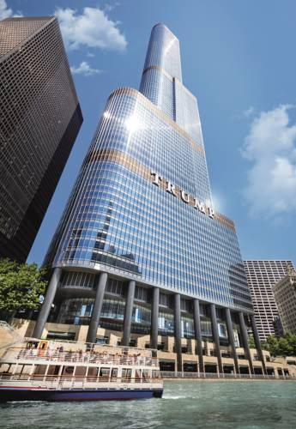

Construction
Bovis Lendlease Construction were the main contractors building Trump Tower and James McHugh Construction were the concrete subcontractors. The pour for the 3m slab took 22 straight hours and consisted of 5000 cubic yards (3822m3) of reinforced concrete. The concrete plant sent out over 20,000 concrete wagons for the whole project. As the building was growing in height, the challenge of getting the concrete up to each floor before the concrete set was a major problem. James McHugh brought in the world’s most powerful pump, which forced 6000 pounds (2722kg) of concrete per minute up the tower. The target for the floors under level 50 was one floor per week and one floor every four days above level 50.
During construction, Chicago’s extreme winds and weather conditions challenged the workers. The tower cranes were sometimes not operational because of the winds and cold weather and in order to protect the materials and workers, a climbing windscreen protection panel was used.

Image 4 – Constructing Trump Towers (Google Images - Unknown)

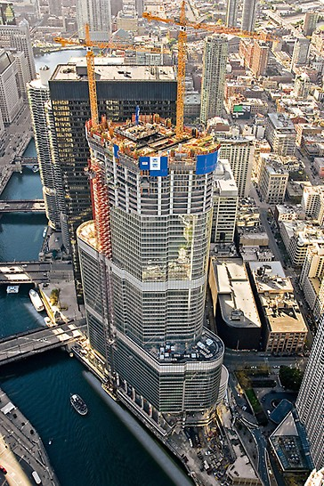

Sustainability
One of the main three sustainable strategies used on Trump Tower was the green roofs located on the terrace levels. This gave the roof membrane a longer life span than normal asphalt because it is protected from Chicago’s weather. These green roofs also helps improve storm water management, reduce energy consumption and purify air and water. Another strategy used was that the Chicago river cools the building. The cooling system allows water to recirculate back into the river, saving on the more standard energy intensive cooling systems used. The last sustainable strategy used was the thermal pane glass panels in the aluminium frames used all around the building. The panes have duel low emissivity coating which retain heat in winter and cool air in summer.

Concrete

Durability and Climate Resistance

Concrete is a very durable material, but different structures require different mixes to achieve their strength. Concrete is also resistant to deterioration because it has no organic content. However, if there is reinforced steel within the concrete and it is exposed to moisture it can cause the concrete to crack and deteriorate.

Environmental Impact

Making cement, which is one of the main elements in concrete, results in high levels of C02 output. 4-5% of the world’s C02 emissions is a result of cement production. Burning fossil fuels and breaking down calcium carbonates is how making cement realises C02. Extraction and processing of concretes other elements also generates a lot of dust, noise, loss of land and visual impact of the environment. Transportation also generates vehicle pollution, energy consumption and noise pollution. Concrete cannot be recycled unless making into recycled hardcore. The disadvantage of recycled hardcore is that it is not clean and does not give engineers the strength they require for building.

Ease of assembly and adaption

One disadvantage of concrete is that once it is set there is very little you can do to adapt the structure unless the structural engineer introduces steelwork. Ease of building with concrete is that the flexibility can adapt to most shapes. A disadvantage is the curing time, contractors would have to wait days before moving forward with the next stage. Concrete pouring also requires a lot of shuttering work which has to be constructed then deconstructed.

Comparison of Steel and Concrete

Advantages of building with steel is that it can achieve wider and higher spans compared to reinforced concrete. There is also a quality guarantee when building in steel because all components must withstand the load the structural engineer has calculated. A big advantage to building with steel is that a buildings services can also be prefabricated into a steel structure like the Leadenhall Building or the use of a castellated beam would help to run pipework and wires through and not compromise the proposed ceiling heights. To run services through a concrete structure the holes would need to be diamond drilled through the floor slabs. An environmental benefit for steel compared to concrete is that steel can be recycled and reused unlike concrete. However, steel production has a far greater environmental impact than concrete production. Steel structures are also able to achieve greater heights and contractors can assemble the buildings quicker than concrete. It is quicker because building in steel has no curing time. As mentioned previously, steel structures can be adapted to accommodate future design changes by replacing components, unlike concrete which would require secondary steelwork because once the concrete is set, it cannot be removed if it is structural.
An advantage of building in concrete is that it costs less than steel. Concrete costs less not only to manufacture but to transport. Even though steel buildings can be assembled quicker, a benefit of pouring concrete is that a pump like the one used at Trump Towers can be used and any weather problems that could cause a crane to be non-operational would be avoided. Concrete structures are also much more stable than steel structures, a steel structure requires stabilising by either diagonal bracing, stairwells or concrete cores. If building with steel, there is a requirement for the steel to be sprayed for it to be fire rated (unlike concrete). Concrete also has a thermal gain compared to steel.

Bibliography

Image 1 – Rogers Stirk Harbour and Partners (Unknown), Available at:
https://www.rsh-p.com/projects/the-leadenhall-building/

Image 2 – Leadenhall Building (Unknown), Available at:
https://www.theleadenhallbuilding.com/galleries/construction-2/

Image 3 – Google Images (Unknown), Available at:
https://www.google.com/search?rlz=1C1DIMC_enGB810GB810&biw=1536&bih=754&tbm=isch&sa=1&ei=KK4zXJqPNqXsxgPC8pzoCQ&q=trump+international+hotel+and+tower+chicago+&oq=trump+international+hotel+and+tower+chicago+&gs_l=img.3..0l2j0i30j0i24.3845.3845..4127...0.0..0.69.69.1......1....1..gws-wiz-img.BvFcOTUrahE#imgrc=7ZUB-mN3CaOHuM: )

Image 4 – Google Images (Unknown), Available at:
https://www.google.com/search?rlz=1C1DIMC_enGB810GB810&biw=1536&bih=754&tbm=isch&sa=1&ei=Lq4zXOiBAtOe1fAP0cev-AE&q=trump+international+hotel+and+tower+chicago+construction&oq=trump+international+hotel+and+tower+chicago+construction&gs_l=img.3...163813.167376..167855...0.0..0.62.701.13......1....1..gws-wiz-img.......0j0i30j0i24.pwL7cpkJGpg#imgrc=G1dhk_BIE52YEM:
The Leadenhall Building (Unknown), The Vision - The Leadenhall Building, Available at:
https://www.theleadenhallbuilding.com/architecture/the-vision/ (Accessed – 05/01/2019)

The Leadenhall Building (Unknown), Construction Overview. Available at https://www.theleadenhallbuilding.com/architecture/construction-overview/
(Accessed – 05/01/2019)

(Laing O’Rourke (Unknown), The Leadenhall Building. Available at http://www.laingorourke.com/our-projects/all-projects/the-leadenhall-building.aspx
(Accessed – 05/01/2019)

The Leadenhall Building (Unknown), Sustainability - The Leadenhall Building Available at:
https://www.theleadenhallbuilding.com/architecture/the-vision/ (Accessed – 05/01/2019)

Britishland (Unknown), Sustainability in action at The Leadenhall Building, Available at:
https://www.britishland.com/sustainability/blogs/articles/2012/sustainability-in-action-at-the-leadenhall-building (Accessed – 05/01/2019)

Npl (Unknown), Available at: http://www.npl.co.uk/upload/pdf/steelwork.pdf
(Accessed 06/01/2019)

General Steel (Unknown), 6 Reasons Why Steel Frame Structures are Safer, Available at:
https://gensteel.com/resources/expert-insights/6-reasons-steel-buildings-are-safer
(Accessed 06/01/2019)

http://www.greenspec.co.uk/building-design/steel-products-and-environmental-impact/ (Accessed 06/01/2019)

Environmental Impact of the Process (Unknown), Available at: https://www.jernkontoret.se/en/the-steel-industry/production-utilisation-recycling/environmental-impact-of-the-processes/ (Accessed 06/01/2019)

Whirlwind (Unknown), 7 Advantages of Structural Steel Frame Construction, Available at:
https://www.whirlwindsteel.com/blog/bid/407580/7-advantages-of-structural-steel-frame-construction (Accessed 06/01/2019)

Edmonton Structural Steel Fabrication (Unknown), Advantages of Steel Frame Structures
Available at: http://northern-weldarc.com/advantages-steel-frame-structures/
(Accessed 06/01/2019)

Reuse-Steel (Unknown),
Available at:
http://www.reuse-steel.org/files/Information%20papers/Adaptability%20IP%2010-5.pdf (Accessed 06/01/2019)

Available at:
http://www.ctbuh.org/LinkClick.aspx?fileticket=krBBJjwsWjo=
(Accessed 06/01/2019)

Lendlease (Unknown), Trump International Hotel Tower, Available at: https://www.lendlease.com/us/projects/trump-international-hotel--tower/?id=442260db-4c49-4aca-87c9-e21e2a4e713c
(Accessed 06/01/2019)

Cement.org (Unknown), Durability, Available at:
https://www.cement.org/learn/concrete-technology/durability (Accessed 06/01/2019)

Available at: http://www.greenspec.co.uk/building-design/environmental-impacts-of-concrete/ (Accessed 06/01/2019)

Available at:
https://www.thegreenage.co.uk/article/concrete-is-bad-for-the-environment/
(Accessed 06/01/2019)

Northan Concrete Construction (Unknown), 5 Benefits of Poured Concrete Walls – A Solid Foundation | Northern Concrete Construction, Available at:
https://northernconcreteinc.com/5-benefits-of-poured-concrete-walls-a-solid-foundation/
(Accessed 06/01/2019)

Designing Buildings (Unknown), Concrete vs Steel, Available at:
https://www.designingbuildings.co.uk/wiki/Concrete_vs._steel
(Accessed 06/01/2019)

