Construction Materials

Introduction

Concrete and steel are widely used to create frames for buildings of various uses. They can be used together or separately. Buildings of their construction are located globally and arguably boast impressive aesthetic features at various scales. This report aims to explore frames of concrete and steel structure to review their construction, the advantages and disadvantages whilst comparing their performances within their climates.
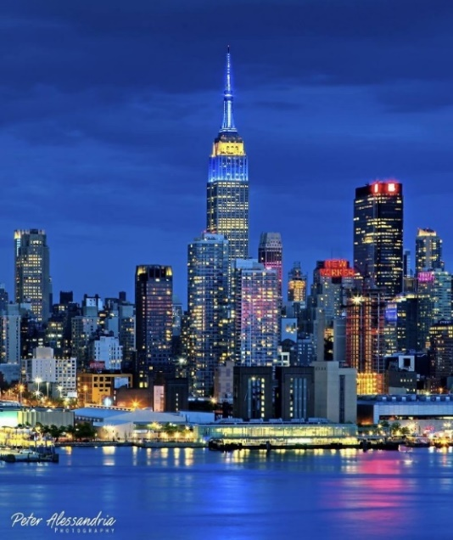
Steel frame structure

The Empire State Building is claimed to be ‘the world’s most famous office building’ by www.citypass.com (accessed 01/11/19). It is located at the fifth avenue between 33rd and 34th streets in Manhattan.

The design planning

The work was carried out by Shreve, Lamb and Harmon to be the architects. The main contractor was the firm Starrett brother and Eken. (Information obtained from Ghosh S (2014), accessed 01/11/19)

https://photo blog.newyorkcityfeelings.com (accessed 31/10/19)

Construction

According to Gosh, S and Robson, K. (2014), ‘The contracts with the architects were signed in September 1929 and the first structural columns were set in April 1930. Only one year later, the building was fully enclosed, with a height equivalent to 102 stories and 1.2 million square feet of rentable space’ (Willis, 1998). It was constructed very efficiently and was in the race to become the world's tallest skyscraper. The building opened to the public 01st May 1931.

Willis (1998) also advises that the fabrication was carried out off site, which improved efficiency. Compared to modern standards, this method of construction logistics is phenomenal. There were 60 trades involved who worked continuously to ensure strict timescales were met. The plan was to construct the building at 85 stories high and leave space in the centre, arranged in a compact manner. This was to contain vertical circulation such as mail chutes, waste services, shaft and corridors. As can be seen in the above image, the size of these floors decreases as the building increases in height.

According to www.size-explorer.com (accessed 01/11/19), the structure is 103 stories tall (1250 feet to the top floor, excludes height of antennae, which is 204 feet). The footings were 55 feet below sea level. 2 acres of solid concrete was poured into the foundations. Furthermore,
Npatou (2016), advises that the building what is built in the shadow of the Great Depression. This proves an optimistic approach of construction during a time of economic diversity. It is now reinventing itself in a new economic climate.

Potential impact with consideration for sustainability

This building is known to have undergone a retrofit as advised by Energy Weekly News (2011). They advise that ‘In addition to Energy Star certification, the work at the Empire State Building would qualify under current standards for LEED-EB Gold certification from the United States Green Building Council. Keywords: Oil & Gas, Wind Energy.’ According to www.theguardian.com (accessed 01/11/19) the retrofit involved ‘stripping out 6514 windows and renovating them with an insulating film and a mixture of inert gases to make them 4 times more efficient at retaining heat or coolness.’

The building has exceeded many of its energy efficiency programs and has reduced consumption by 38% (Warren, K (2008).). It is clear to presume that this structure sets the standard for likewise retrofits. According to Warren, K (2008), the building required 58,000 tons of steel. However, it is lighter than concrete therefore requires less extensive foundations.

Durability of steel structure

Unmaintained facade can lead to water ingress leading to the corrosion of the steel ultimately leading to potential structural damage with the assistance of temperature change (freeze thaw) and weather changes. Should this occur, the building will be unsafe for use and demolished. Geologically Manhattan bedrock is regarded as earthquake proof. The bedrock is unlikely to ever sink under the weight of the Empire State Building. This is further evidenced by Messina, P and Stoffer. P (1997) who claims that ‘The foundation is on solid bedrock 55 feet below street level.’

Climatic resistance

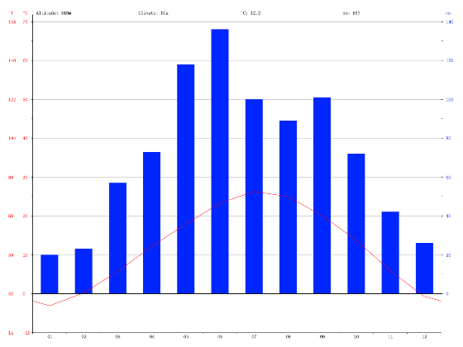
According to (with table and chart produced by) https://en.climate-data.org (accessed 01/11/19), the average temperature in Manhattan in its warmest month of July is 26.3°c. Contrary to this the coldest month, the average temperature -3.1° c.
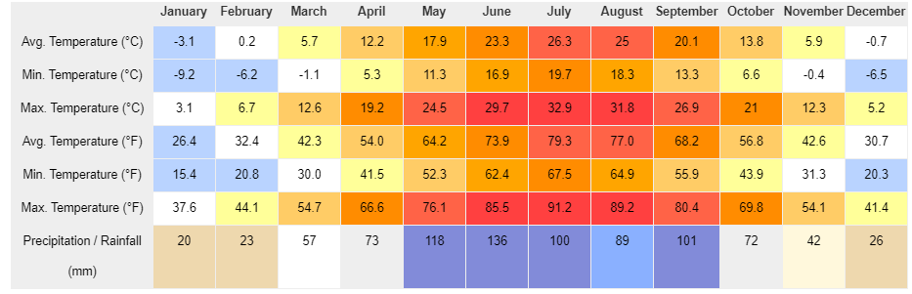

The Empire State Building is hit by lightning, an average of 25 times per year. In one storm it was hit 8 times in 24 minutes (Rennicke, J., 1994). The Empire State Building is designed to flex, this is to cope with high winds, additionally reducing seismic forces that occur during an earthquake. These external forces could potentially destroy such buildings; the structural design engineers incorporate a steel central core and supporting brace of diagonal steel beams around the central elevation shafts.

Overview of affects from environmental conditions

Structures such as the Empire State Building will last if they are maintained, everything is replaceable or can be repaired, as shown during the retrofit. Extreme events like earthquakes, extreme weather have the potential to demolish any structure, but these events are a rare occurrence.

Production process considerations regarding the environment

Steel manufacturer has a high impact on the environment as suggested by www.greenspec.co.uk (accessed 02/11/19). Iron and limestone require mining with heavy plant machinery. These materials then get transported and are burnt at high temperatures releasing harmful gases into the atmosphere. It also causes wastewater contaminants, hazardous waste, and solid waste. The major environmental impacts from steel are coking and iron ore making. C02 emissions related to the energy consumption in steel industry. The wastewater can be filtered and contaminates removed. This slag which is impurities from the burning process is sold to the construction industry, this does not prevent pollution, but is not going to landfill.

Ease of assembly

The erection of steelwork consists of the assembly of components on site. The framework efficiently rose at 4.5 stories a week (Walks of New York Newsletter 02/11/19) with no curing time and can be assembled in any given weather condition. The disadvantage of steel placement is its weight.

Steel can be created in any shape. It is ideal for modernization, reconfiguring, extending or adapting with minimal disruption. This is inexpensive and not harmful to the structure while the demolition and redevelopment takes place.

End of life cycle considerations

Overall, steel is environmentally friendly due to its recyclable attribute and considering very little is wasted. Steel can be recycled many times without compromising on quality as supported by Nallely Montserrat Trejo Rivera, Jesús Torres & Alfredo Flores Valdés, (2019).

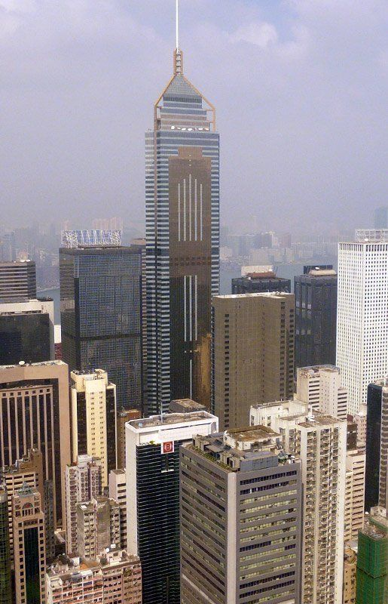
Concrete frame structure

Location

The Central Plaza is located at Hong Kong. The structure is situated centrally to other business occupied structures without compromising its aesthetics.

Design Planning

Skyscraper Center (2019) advises; the architect who designed the building was NG Chunn Man & Associates. The structural design engineer was Arup. There were joint developers; Sino Land Company Ltd and Sun Hung Kai Properties Ltd. Additionally the main contractor was Manloze Ltd.
www.disfrutahongkong.com (accessed 02/11/19)

Construction

Additionally, the early plans for the central Plaza involved having a steel frame. Reinforced concrete was chosen so the lower levels could be made available while construction was carried out on the upper floors. These decision's saved 230million dollars compared to a steel design.

Furthermore, ‘the skyscraper center’ (2019) boasts that the Central Plaza has 78 floors above ground with three floors located below ground with a habitable height of 981ft and to the tip, measures 1227ft. The design of the building considered many different structures, but the completed plan was decided to be of an unusual triangular shape. However, by constructing it with this feature, it utilises the view of the nearby harbour. According to ‘The Ven’s Production’ (13/10/18), the buildings design is labelled as ‘Postmodern’ which was purpose built for ‘commercial and office use’. The Central Plaza is reinforced concrete material and a facade of glass. This glass is triple glazed with gold and silvers patterns throughout. The development began in 1989 and was completed in 1992.

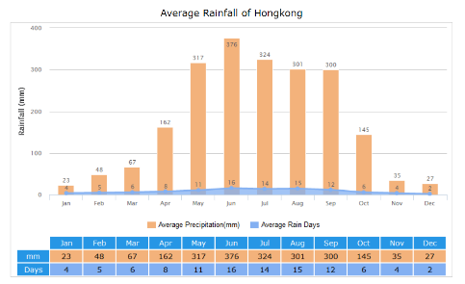
Climatic resistance

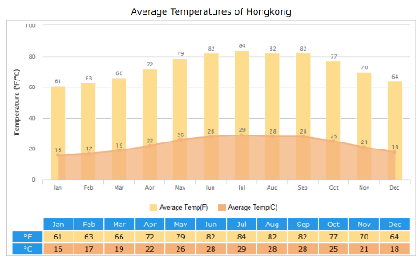
Hong Kong’s climate is humid, subtropical. Typhoons often occur resulting in in flash floods and landslides. Summer average temperature 27°c, winter temperature 17°c as displayed in the chart (right) , as obtained from www.travelchinaguide.com (accessed 03/11/19). Humidity is high in summer and winter at over 80%. The building must perform in strong winds, torrential rain and typhoons can happen at least ten times a year Hong Kong. These extreme events are becoming more frequent and with increasing strength. Therefore, to prepare for these future events, they have installed one of the worlds most advanced underground drainage systems.

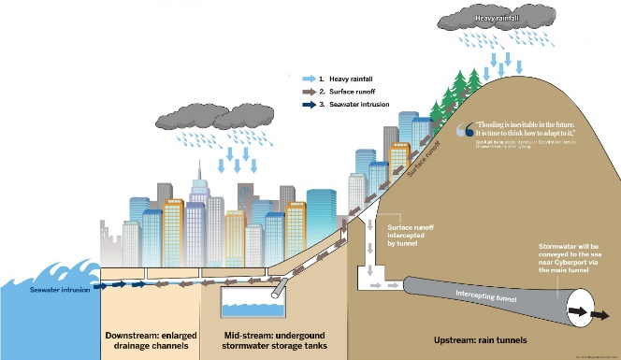
Chang. S (2017) demonstrates the drainage systems (as pictured) it’s made up of a number of large concrete tunnels 5-7 meters in diameter, diverting into storage tanks which can be re used into the city’s water supply or routed to sea. The water table is 2metres below ground level. There is a 6-storey basement. This is constructed with a diaphragm wall design. The diaphragm wall design is used due to its low permeability to water also keeps deformation low. The building is in a densely populated area. This method will protect surrounding buildings.

Overview of affects from environmental conditions

PCA (2019) explains that a concrete structure generally resists weathering, chemical and abrasion damage whilst withholding its purpose. The level of durability can be dependent upon several factors such as its ingredients or varied environmental exposure. The report continues to examine weather attributes such as humidity and rain. However, it’s noted that prolonged resistance to freezing and thawing is stated as ‘The most potentially destructive weathering factor is freezing and thawing while the concrete is wet, particularly in the presence of de-icing chemicals. Deterioration is caused by the freezing of water and subsequent expansion in the paste, the aggregate particles, or both.’

Likely durability
With historical climate patterns in mind, Hong Kong does not reach freezing temperatures. The lifespan off this concrete frame could last many years.

Production process considerations regarding the environment

Concrete has a high global warming potential. The cement industry is known for emitting high C02 emissions.

Ease of assembly

The mixing, casting, placement and curing of reinforced concrete requires high levels of knowledge, because these will affect the final strength. The placement of the concrete frame has many disadvantages when compared to steel. Adverse weather conditions like high and low temperatures and wind can impact the quality and Strength of the finish. To combat this, admixtures can be added to the concrete, air entraining agents will improve work ability, reduce the freeze thaw effect. Water reducing retarders for hot weather use. Accelerators for cold weather, this will speed up the process of hydration. The use of high strength concrete allowed the building to be erected with great efficiency. Once out of the ground the super structure was up within 20 months.

Assembly and adaptations

Modifying a concrete frame often requires some demolition work. This requires high levels of skill to make sure no damage spreads to the existing structure. Compared to a steel frame the risk of deformation is higher.

End of life cycle considerations

Concrete is non-recyclable. At the end of its life cycle it can be crushed and used for subbase applications.

Evaluation

This report has considered many aspects to both the use of steel and concrete frames of skyscrapers which share their similarities of location within harbouring cities and size. However, the era that these were constructed are different (during the great depression vs modern) and affected the potential cost of now developing such structures simultaneously. Alternatively, the following table (obtained from Bifano. A, Mazalewski. M, Wayland. S, 2012), shows that they are closely linked with regards to cost, strength and sustainability.

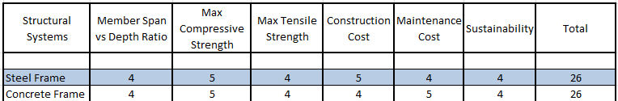

‘The structural system that accumulates the greatest value, is the optimum design based on the 7 design criteria based on a scale from 1-5. This means that a 5 in the criteria matrix shows that the given structural system is very efficient in the given criteria’ (Bifano. A, Mazalewski. M, Wayland. S, 2012).

References

- Anon (2012), Walks of New York Newsletter: Building the Empire State Building: The Daredevil Sky Boys (available at: https://www.walksofnewyork.com/blog/how-was-the-empire-state-building-built, accessed 02/11/19)
- Anon (2019), The skyscraper Centre (available online: http://www.skyscrapercenter.com/pdf/building/277, accessed 29/10/19)
- Anon, 2011. Empire State Building: Empire State Building's Sustainability Retrofit Program Achieves 2010 ENERGY STAR Certification. Energy Weekly News, p.64.
- Bifano. A, Mazalewski. M, Wayland. S (2012), The Structural Selection Process, Criteria for System Selection [online], https://sites.google.com/site/a4lighttruckassembly/overall-design-criteria, accessed 02/11/19.
- Chang. S (2017), Bracing for the flood in Hong Kong, available at https://www.chinadialogue.net/article/show/single/en/9575-Bracing-for-the-flood-in-Hong-Kong , accessed 02/11/19
- Gosh, S and Robson, K. (2014). Analyzing the Empire State Building Project from the Perspective of Lean Project Delivery System. 50th ASC Annual International Conference Proceedings. (1)
- http://www.greenspec.co.uk/building-design/steel-products-and-environmental-impact/
- https://en.climate-data.org/north-america/united-states-of-america/kansas/manhattan-16647/
- https://photoblog.newyorkcityfeelings.com/post/164817873864/empire-state-building-by-peter-alessandria
- https://www.cbsnews.com/pictures/lightning-strikes/27/ (accessed 2/11/10)
- https://www.disfrutahongkong.com/fotos/recorriendo-hong-kong
- https://www.size-explorer.com/en/compare/buildings/empire+state+building
- https://www.theguardian.com/environment/2010/jul/26/empire-state-building-green-refit
- Messina, P and Stoffer. P (1997) EMPIRE STATE BUILDING NEW YORK, NEW YORK, CUNY, Earth & Environmental Science, Ph.D. Program, Hunter College, Department of Geography Brooklyn College, Department of geology
- Nallely Montserrat Trejo Rivera, Jesús Torres & Alfredo Flores Valdés, 2019. A-242 Aluminium Alloy Foams Manufacture from the Recycling of Beverage Cans. Metals, 9(1), pp.1–15.
- Npatou (2016) The Empire State Building, an Engineering Miracle!!!, YouTube video, accessed 29/10/19, available at https://www.youtube.com/watch?v=V1dXcutIGYw
- PCA (2019), Durability, available at: https://www.cement.org/learn/concrete-technology/durability, accessed: 29/10/19
- Rennicke, J., 1994. Swords from the sky. Backpacker, 22(6), p.66.
- The china guide (2019), Hong Kong Weather [online], available at https://www.travelchinaguide.com/climate/hongkong.htm, accessed 02/11/19
- The Ven's Production (2018), Skyscraper Video #245: Central Plaza (Hong Kong), YouTube video, available at: https://www.youtube.com/watch?v=R6n0yF2nMnk, (accessed: 29/10/19)
- Warren, K (2008). Bethlehem Steel, Builder and Arsenal of America. Pittsburgh: University of Pittsburgh Press. 126.
- Willis, C. (1998). Building the Empire State. With essays by Carol Willis and Donald Friedman. New York: W.W. Norton & Company, 11-46.

