

Can Police officers effectively deal with mental health calls?

Hannah Young
2023910
UWTSD Swansea
Degree: BSC Professional Policing Practice

Declaration
This work has not previously been accepted in substance for any degree and is not being concurrently submitted in candidature for any degree.
Signed: H.Young
Date: 08/07/2024

STATEMENT 1
This dissertation is being submitted in partial fulfilment of the requirements for the degree of BA.
Signed: H.Young
Date: 08/07/2024

STATEMENT 2
This dissertation is the result of my own independent work/investigation, except where otherwise stated.
Other sources are acknowledged by footnotes giving explicit references. A bibliography is appended.
Signed: H.Young
Date: 08/07/2024

STATEMENT 3
I hereby give consent for my dissertation, if accepted, to be available for photocopying and for interlibrary loan, and for the title and summary to be made available to outside organisations.
Signed H.Young
Date: 08/07/2024

STATEMENT 4
I hereby give consent for my dissertation, if accepted, to be available on the university’s IT system to those who have consent to use the system.
Signed: H.Young
Date: 08/07/2024

Acknowledgments
I would like to thank the university Staff, namely Sarah Jones and Rhiannon Sandy who have been supportive throughout a sometimes-turbulent course. Without that support I would not have made it this far.
I would also like to thank my Colleagues at SWP, my team who are very supportive and encouraging me going through this process.
And Finally, of course thanks to my family for being there every step of the way.

Abstract.
This dissertation will academically, using a mixture of qualitative and quantitative methods of research, explore and analyse the findings of the objectives of the dissertation which is Can police officer effectively deal with mental Health calls.
Throughout this project the writer will look and numerous research that has already been by a variety of different authors and organisations to find a number of opinions and findings.
The research will also be a mixture of primary and secondary research, the writer will also conduct a questionnaire.
The importance and relevance of efficient training surrounding Police Officers attending calls of people in crisis will be discussed and analyse throughout this project and if the police service are , with all things considered the correct service to attend mental health calls.

Table of Contents

Chapter 1: Introduction to the dissertation
- Introduction
- Research rationale.
- structure of the dissertation
- Summary

Chapter 2: Literature review
- Introduction
- Background information on elements of the dissertation, definitions of mental health illness and the Police officer’s role
- Police dealing with Mental Health calls.
- What training do officers receive to deal with Mental Health calls
- Are police officer the correct service to deal with Mental Health incident.
- Literature Summary

Chapter three - research methodology
- Introduction
- Research Strategy
- Data Collection and analysis
- Limitations and Potential issues
- Chapter Summary

Chapter four - analysis of results
- Introduction
- Participant information
- Does the participant deal with Mental health Calls routinely in their role
- Do Police Officers feel confident to deal with Mental Health Calls
- Have Police Officer had enough training to deal with Mental Health calls adequately?
- How do officers feel they have gained their knowledge in dealing with Mental Health calls
- Is the Police Service the correct service to deal with Mental Health calls?
- Explanation of the above answer to the question
- Are the Police Service equipped enough to support members of the public that are suffering Mental Health issues?
- Are Police Officers equipped correctly to deal with Mental Health
- Do Police Officers need more training in dealing with Mental Health

Chapter Five - Recommendation and Conclusion
- Introduction
- The results
- Objective one- Are Police officers equipped enough to deal with Mental Health Calls
- Objective two - Is the training Police Officers have adequate and do they need more training
- Objective three- Are Police Officers the correct service to deal with Mental Health calls
- Limitations of study in this dissertation
- Recommendations
- Conclusion

Bibliography

Appendix

Chapter one
Introduction to the dissertation
Introduction

The works surrounding Mental health are ever evolving and are developing and knowledge is growing. This applies to how the Police work with Mental health issues in the public. This to is always developing and growing on how best to provide a better service and support to the public.
These works are very fascinating to explore and to investigate, to learn and discover about.

Mental health has been always been an issue that society has faced but only in recent history has it been recognised and steps have been taken to support those in crisis.

Research rationale.
The writer of the dissertation seeks to explore the relationship between the Police Service and how it support the mental health patients, how adequate the Service in doing that.
With that in mind the writer has outlined three objectives that they wish the dissertation to explore, those being;
1 Are Police officers equipped enough to deal with Mental Health Calls
2 Is the training Police Officers have adequate and do they need more training
3 Are Police Officers the correct service to deal with Mental Health calls

structure of the dissertation
Each chapter will explore these objectives, will look at research that has already been discovered , will look to find new research and then analyse the findings , will look to find and recommendations of improvements, it they are indeed any, and finally revealing the founded results.

Summary
This dissertation will hopefully be a great insight into academic research that has been done already, a look into research that has been done by independent and police related agencies. Combining new found information with this and discovering new opinions. The dissertation will begin with the Literature review chapter, this chapter will begin the discussion and finding in the project of answering the above objectives.

Chapter two-
Literature Review
Introduction
This dissertation will take a look at mental health and how effectively Police Services deal with calls involving Mental Health, what reviews and finding have already been done, and they found. The dissertation will be looking and as many resources as possible to get as many views as possible and review them overall.
The project will look at how the response officers deal with Mental health issues, how well trained they are in that area, how equipped they are in dealing with an individual mental health crisis. Over recent years there has been a significant raise in Police officers dealing with and has been widely reported in the media; “Police in England and Wales dealing with more mental health crises than ever. Forces say increase highlights erosion of mental health services in recent years. The police are dealing with increasing demands to intervene with people suffering mental health crises, freedom of information requests have revealed. Some forces across England and Wales have experienced a tripling in mental health requests between 2019 and 2021, data shows.” (Syal, 2023) for example. There has also recently been some changes within certain forces , most notable London Metropolitan Police Service announcing in May 2023 that they will no longer being attending general mental health calls .
The aim and objective are to look at this all and see what the majority believe is the correct way of dealing with mental health calls and who, as which service is the best for responding and why. The project is going to break down what has been read so far and the views that have been found, starting with what is mental health.
Background information on elements of the dissertation, definitions of mental health illness and the Police officer’s role
Firstly, the definitions of the two main elements of the topic of this dissertation, mental health and Police officer role.
According to Every Mind, a resource discovered online, the definition of Mental Health illness is, “A mental illness is the most commonly used term to describe conditions diagnosed by a medical professional that significantly affect how a person thinks, feels and interacts with other people.” (Every Mind, 2024) There are many definitions for this, but they all describe mental health like this, so there is no other opinion or view, so most agree this is what mental health illness is and how it is recognised.
With that explanation in mind, let’s look at the role of a police officer, according to Gov.uk , it describes a Police Officer as “Police officers keep law and order, investigate crime, and support crime prevention.” (Gov.UK, 2023) when describing the role of a police officer. According to College of Policing, it describes the role as “Constables play a critical front-line role in the prevention and detection of crime and the criminal justice system. Constables work in partnership on a day-to-day basis with local communities, stakeholders and colleagues in order to promote law and order, reduce the fear of crime, provide reassurance and build confidence to improve the quality of life for citizens.” (College of Policing , 2023).

Police dealing with Mental Health calls.
With the definitions explained above, in this section, it will discuss and analyse and compare what other people have written about Police dealing with Mental health calls.
Firstly, lets have a look at how Police respond to mental health calls.
A report that has been conducted by (as it was known at the time) Her Majesty’s Incorporate of constabulary and fire and rescue service in November 2018 that looked into police dealing with mental health. It is estimated that one in four people may experience mental crisis at some point in their lives. It is a diverse subject that affects all elements of police service. The police use a variety of tactics when dealing with individuals who have mental health issues. (Billington, 2018)
If a friend, family member, or carer notices that someone they know is acting in crisis, they can use 999 to make emergency contact. If someone is unwell in a public setting or endangering themselves or others, anyone can contact. Alternatively, the individual experiencing a crisis could decide to ask for assistance on their own. (Billington, 2018)
Police officers can convey an individual to hospital on a voluntary basis where officers will take the person to hospital to receive the mental health support they need. Police officers have the power to detain a person who presents as in crisis, this is under the 136 Mental Health Act. Effectively this is like an arrest, so the person is detained and will be assessed by mental a mental health practitioner and doctor and other professionals that are needed.
People are transported to a place of safety by the police fifty percent of the time, not by the ambulance service. Depending on the availability of specialised hospital beds and health agencies, this may need several hours. Alternatively, it can be a very lengthy wait for the person experiencing a crisis and the police officers escorting them in an accident or emergency. (Billington, 2018)
An individual who is suicidal in crisis will be referred to the police, either by an organisation, probation service or even a business company’s customer service, for example. the person in crisis can of course call 999, members of the public can ring the police. In the UK, there were around 6,000 suicides that year. This indicates that 16 people commit suicide every day, and many more attempt it. (Billington, 2018)
Responding to these situations may include a considerable police effort in police resources, closing roads or bridges and sending in specially trained negotiators to speak with the person experiencing a crisis and attempt to keep them safe, talk them down and encourage them to speak to police. This can be very successful saving lives and getting the individual the help, they need. (Billington, 2018)
Reviewing the above so far, the report describes how many incidents of mental health police forces can deal with, it highlights the demand on the police force in dealing with mental health calls , the reports so far however , does highlight that police can be successful in preventing and coming to the aid to people who are suicidal.
What training do officers receive to deal with Mental Health calls
Organisational training involves a broad range of structured activities and lessons that intended to change or improve employees' job-related abilities, knowledge, or attitudes in order to meet the Organisations goals, objectives and standards. (Gutterman, 2023)
There are a variety of mental health training options that are available for police officers. These can range from a few hours during training days or officers can attend a specialised, specific training. (Stuart Thomas, 2017) There can be online training offered whereby officers complete NCLATS.
The courses normally discuss the main topics concerning mental health, the recognition of suicide risk, de-escalation techniques; limit setting and related behavioural management strategies and skills; signs and symptoms of major mental illnesses and related disorders, consideration of the significance of drugs and alcohol being present and how this may effect on police assessments and responses; and how police should use their legal powers when dealing with someone going through a mental health. (Stuart Thomas, 2017)
An article from Stuart Thomas, 2017, says that experience learning has a greater influence on behaviour and development and lecture-based instruction has the least effect on the learners. This is especially logical thoughts when teaching emergency responders. Most people agree that a police officer learns most of their skills "on the job" through a mentorship model in which less experienced officers are paired with more senior, experienced officers. Therefore, it should come as no surprise that scenario-based training approaches are favoured and thought to be more successful and beneficial. (Stuart Thomas, 2017)

Are police officer the correct service to deal with Mental Health incident.
The role of a Police Constable is a diverse one, where anything can happen, the officers can be expected to deal with anything and the officers themselves should accept they should be expected to deal with any type of call, including mental health. Without discussing whether Police should attend mental health calls but rather are they the correct service to do so. Are they the trained and equipped enough to support and help a person suffering crisis? The aim here is to explore this question.
As mentioned above about the London Metropolitan Police service, as of November 2023 have stopped attending mental health calls and has introduced a working model called “Right care, Right Person” (RCRP) which was developed by Humberside Police.
It’s goal is to ensure that, as is presently not the case in most regions, the appropriate agency responds to calls linked to health rather than the police acting as the first responder of choice. It has been thought to enhance results, lower demand for all services, police in particular but if correct services deal with correct issues then it will have an impact on demand on all public services, and guarantee that the appropriate care is provided by the appropriate individual. (Met Police, 2023)
It doesn't preclude the police from carrying out their vital duty of keeping the public safe. When there is a genuine and immediate risk to life or serious harm, such as when someone is attempting to harm themselves or others, officers will react as quickly as they always have done. (Met Police, 2023)
London Commissioner Sir Mark Rowley said in relation to this change “It is important to stress the urgency of needing to implement RCRP in London. Every day that we permit the status quo to remain, we are collectively failing patients and are not setting officers up to succeed.” (Met Police, 2023)
Sir Rowley actually goes on to say how he believes that the Police service is actually failing the public by the police service responding the mental health crisis calls, adding “In fact, we are failing Londoners twice. We are failing them first by sending police officers, not medical professionals, to those in mental health crisis, and expecting them to do their best in circumstances where they are not the right people to be dealing with a patient. We are failing Londoners a second time by taking large amounts of officer time away from preventing and solving crime as well as dealing properly with victims, in order to fill gaps for others.” (Met Police, 2023)
The resource further adds that The Mental Health Act's Section 136 and Section 135 are the two most often utilised powers of detention where there are suspicions that an individual poses a risk to himself or others. In March 2023, Met officers detained 573 people under Section 136 and many more under Section 135. When the police arrive with a patient in London, it typically takes 14.2 hours in A&E and 8.5 hours at a health-based place of safety for medical staff to take over the patient's care. (Met Police, 2023)
According to data from the most recent National Police Chiefs Council (NPCC) Productivity Review, police officers across the country spend slightly less than a million hours annually waiting for assessments while sitting with mental health patients in hospitals. These are valuable hours that aren't being spent combating crime, attending to fundamental police priorities, or utilising the authority that only the police possess to identify offenders and assist victims. (Met Police, 2023)
Reviewing the above it is clear that the Police service does spend a lot of working hours dealing and trying to help those in crisis, and what the London Met Police have started to do is change the response to the mental health calls , the aim of reducing how long it takes the police officer in dealing with the call and resume other duties after dealing.
Another resource, called “Rethink”, does highlight some concern about the Police force taking a step back , saying they believe that people with lived experience, in partnership with mental health experts from the health and social care sector, the mental health volunteer sector, and marginalised communities, should lead any changes made to the way that the response to a mental health crisis call is conducted. In the face of increasing demand, the health and social care system is already straining and understaffed, and if police refuse to help someone in need, we fear that services will cease to exist. (Rethink, 2023)
Adding “This leaves people severely affected by mental illness vulnerable to a lack of support, and the National Partnership Agreement vulnerable to failure. The government must prioritise dedicated health and social care funding to ensure a system is developed and available to respond to people desperately needing support during a mental health crisis.” (Rethink, 2023)
It goes on to say that the RCRP model isn’t completely wrong, saying “people experiencing mental health crisis should be met and supported by trained mental health professionals, not the police. It is also right that the Agreement is implemented over time – and we must not have a situation where the police are stepping back unilaterally without any health and care provision to take its place.” (Rethink, 2023)
So in review for that part, this organisation does support the model and the ultimate aims, which is to support and provide the best care and support for the individual experiencing crisis, it does however highlight the concern that should Police just stop attending, due to mental health services struggling as it is it would make treatment and support even harder and some may not receive the support the need. This can be considered a valid point in supporting police attending mental health calls, as currently the mental health services are struggling themselves and this could see raises in suicide perhaps or people living in serious conditions that are bad for their health, for example.
Met Police has also released some results in how the believe the RCRP triage scheme is going saying that prior to the implementation of “Right Care, Right Person”, Humberside Police found that the force was called to 1,566 incidents per month on average, which had to do with problems including welfare concerns, mental health occurrences, or missing persons. Following the implementation of Right Care, Right Person, Humberside experienced a monthly average reduction in occurrences of 508 deployments, or 1,132 officer hours. The force is now able to distribute resources that were previously saved to used for this to other matters. (Met Police, 2023)

Literature Summary
The literature review chapter , there has been some great definitions, views and results that can be argued the debated on whether police services are the correct service to respond, are the suited and well trained, it provides a lot to digest and explore further as the project goes on.

Chapter three
Research methodology

Introduction
In this chapter, it will be looking at the ways in which research has been conducted for this dissertation, briefly exploring the pros and cons of such methods used and how will it help achieve any results for this project.
Research is a methodical approach to the inquiry process that involves gathering data, documenting important information, then analysing and interpreting that information using appropriate and effective procedures that have been established by academic and professional agencies. Research can be used to Analyse if a theory or framework for understanding is valid, to gather a body of significant data and findings in order to distribute them in suitable ways, and to assist with developing questions for additional research. (Hampsire College, 2024)
For this Dissertation, the research has been exploring whether serving police officers are equipped enough and trained enough to with Mental Health calls. I have taken the opportunity to engage with serving Police Officers and get some opinions about the topic.

Research Strategy
During this dissertation the writer has opted to for a questionnaire method to discover some opinions and gain results about the topic.
With conducting and sending of questionnaires, this is one option that is considered perhaps easier on the researcher, because the researcher would not need to be present when the questionnaires are completed, data can be gathered quickly. For example, if the researcher was to conduct interviews, it would be difficult to collect the same volume of information in this timely manner. The questionnaire can be easily disrupted to a big population in one go. (Mcleod, 2023)
However , one issue with questionnaires is that, because of social desirability and pressure, respondents might lie or create a pretence in their responses. People tend to project a positive image of themselves or organisation, and in order to look good, they may lie or manipulate the reality. (Mcleod, 2023)
The writer of the dissertation has chosen the conduct a questionnaire as a way of obtaining results and answers as this method seemed the most effective and efficient way of obtaining the information I required. I was able to collect responses and collate the information received. I was able to ask direct questions around the objectives of my dissertation.
With conducting a questionnaire, this made the opportunity of being able to reach a wider and larger audience and quickly, via email or text message and so forth. My intended audience were serving Police Officers, those with a range of length service and experience. As my objectives were to find out whether Police Officers were equipped enough to deal with MH calls, it was important to obtain valid opinions from those who serve and attend these calls to see how they felt about the topic.
The process of gathering data is essential for the statistical analysis for this dissertation. There are several ways to collect data for research, and these approaches can be grouped into two: primary and secondary data. Primary data is, as the name suggests, information that is gathered by the researcher for the first time by the researcher, whereas secondary information is information that has previously been gathered or discovered by others. (Victor Oluwatosin Ajayi, 2017).

Data Collection and analysis
With using this method outlined above, considering how the results show be presented at the end, I considered how would be the best way to explain and discuss the results.
There are two main ways that this information can be used and analysed. Quantitative which is looking and evaluating numbers and Qualitative, this way seeks to have a deeper understanding of the information received.
The two approaches are quite different in the way they gain knowledge. While qualitative data analysis may reveal new characteristics and patterns hidden in the data, quantitative data analysis can only discover new patterns that are always related to the variables already present- the information that has been received. When identifying data as either quantitative or qualitative, it should be left till the end of the researching process to see how the results should be viewed rather than assuming the research will produce the result a certain way. (Schoonenboom, 2023)
The Questionnaire that has been presented will be used to produce figures and percentages, this would accurately and effectively display the information received from the questions, this can be shown as tables and graphs also.
In the questionnaire , the main theme is only whether Officers believe they are equipped, trained enough and do they need more training in dealing with Mental Health calls. There is one question asked where it is asking if the Police Service are the correct service to deal with Mental Health calls.
Importantly I have ensured that the questionnaire is not personal , it is anonymous and I have let the reader know what the aim and objectives are on the questionnaire.

Limitations and Potential issues

This topic is one that could be explored in various interesting avenues, the topic is so huge that potentially there was not going to be any gain of new result or information. As Mental Health effects everyone globally, The writer would have liked to have reached more Police Officers and perhaps some from other force areas and maybe even difference countries which could have presented more variety in responses , however this would have taken some organising which unfortunately would not have been able to achievable for this dissertation. Instead, only forwarded the questionnaire to South Wales Police serving officers.
The topic of mental Health needed to be handled sensibly and sensitively the aim was to solely establish how Police Officers feel about dealing with Mental Health calls not to dispute if Police should deal with such calls.
There was no issues with accessing the questionnaire , it was a simple format and could be easily completed and completed anonymously , the only issues was getting officers to respond and take the time to complete it, because of this there were a low response rate to the questionnaire , however the results produced were informative.

Chapter Summary
In this chapter it has been explained how it is intended to achieve the ambitions of this project, of obtaining results for the dissertation objectives, and have explained how the questionnaire method is more suited in obtaining such information and perhaps the best in the practical sense of analysing the information received.

Chapter Four
Analysis of results

Introduction
This chapter of the dissertation will take a look at what results were obtained from the questionnaire.
The objectives for this dissertation are;
- Are Police officers equipped enough to deal with Mental Health Calls
- Is the training Police Officers have adequate and do they need more training
- Are Police Officers the correct service to deal with Mental Health calls
The method used was qualitative approach in analysing the results , below the findings will be seen for analysing
Please note that question 1 is to confirm that the participant understands what the questionnaire is being completed for and that it is anonymous, question 2 is to confirm the participant is a serving Police Officer. These have not been shown below but will be shown in the Appendix.

Participant information
To try and achieve a broad and a variety of responses , an important question was the length of Service of the part taking Police officer, as officers with different lengths of would have different thought process to the questions.
I total there was 10 responses.
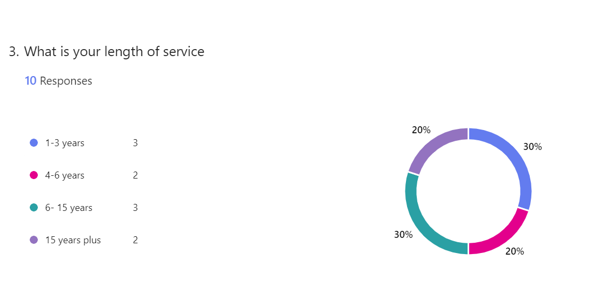
As the chart shows the questionnaire was completed by a variety of officers with length of service.

Does the participant deal with Mental health Calls routinely in their role
It was necessary to ask this question as there are some roles within the Police Service that do would deal with mental Health calls as part of their role on more of a daily basis then other roles would. Having a breakdown of who does and would not, it also offers a difference in responses.
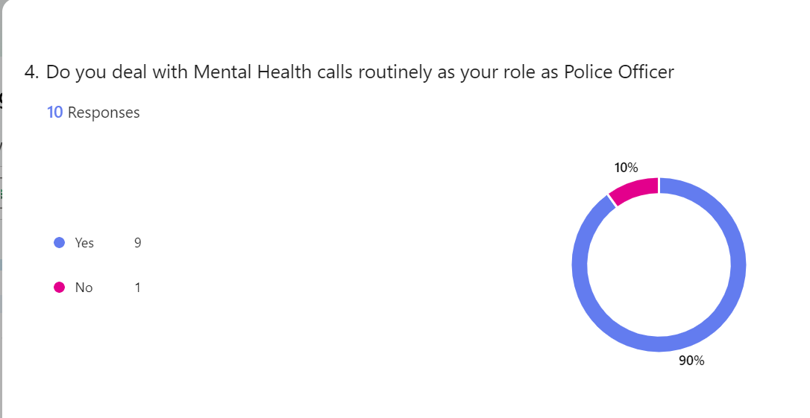

Unfortunately, the questionnaire had not managed to be reached and completed by various roles of the Police.

Do Police Officers feel confident to deal with Mental Health Calls
This question was in regard to the objectives of the dissertation, linking in with the Objectives 1 and 2 , as stated above, it was to explore how confident the Officers felt in dealing with Mental Health calls as a whole, not considering training at this point but how in general they deal with attending these calls.

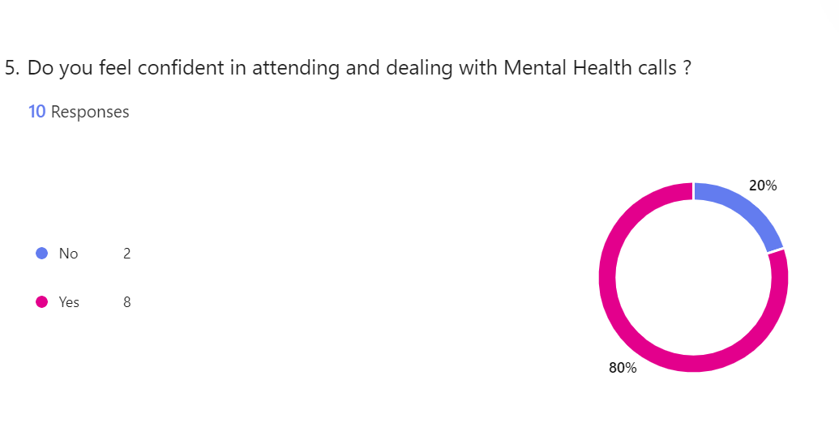
As the chart , out of ten officers only two did not feel confident in dealing with mental health calls.

Have Police Officer had enough training to deal with Mental Health calls adequately?

This question is asking directly about the objective number 2, exploring whether Police Officers believe they have received enough training to effectively and adequately deal with attending mental health calls.
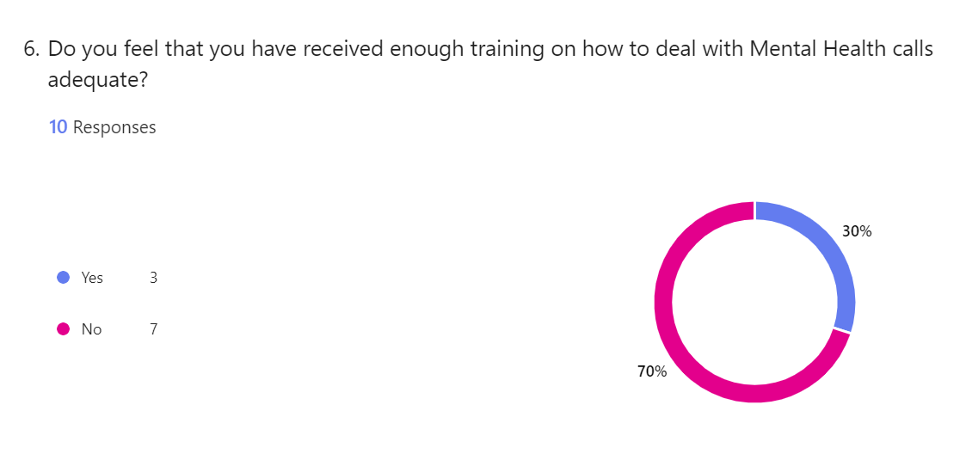
The chart reveals that 30 % of the participants believe that they do receive adequate training to deal with these types of calls, however 70% do not believe so.

How do officers feel they have gained their knowledge in dealing with Mental Health calls
This is in relation to objective 2 , This question has explored how officers felt they learnt the most about dealing with Mental Health calls the most, the options were “NCALTS” which are online tutorials and courses that are normally presented as an slide show presentation and a interaction quiz, “classroom based” the officer may have attended a course and maybe had the chance to listen to speakers from charities and so forth, the next option was “On the job” learning, was it a case they learnt from experience and grew their knowledge from there. The final option was “other” in case there was another way that participant’s had learnt from that was not listed.
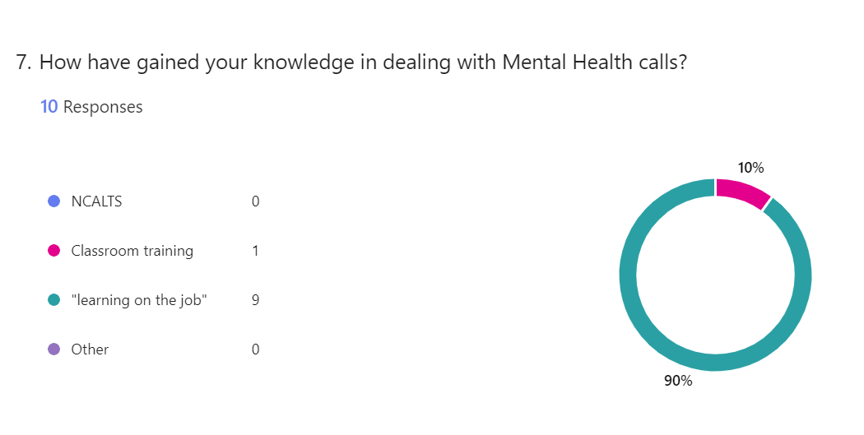
As the chart shows, the overwhelming response is “learning on the job” with 90% saying that. 10% say that they have learnt from classroom training.
As stated by the article by Thomas cited in The Literature Review Chapter, it states that it found that most officers do learn best from scenario based learning or indeed “On the Job” leaning. (Stuart Thomas, 2017)

Is the Police Service the correct service to deal with Mental Health calls?
The question is directly regarding Objective 3, as reminded in the introduction, are the Police the correct service to deal with mental health.
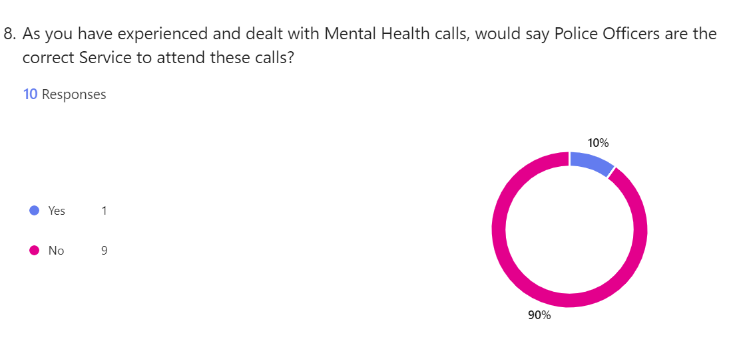
As the chart shows 90% of the participant’s do not believe that Police are the correct service to deal with mental health calls.
Explanation of the above answer to the question
For question 9 on the questionnaire, the participant has been given the chance to write freely as to why they thought the service was not the correct or was the correct service to attend Mental Heath calls.
There was a good mixed responses here for the two responses; just to read two for example – one anonymous response was “I believe police are a good first contact as some mental health calls can turn violent. Police are more equipped due to their tactical equipment. More than the ambulance service.”
Another anonymous response was simply;” Mental health is medical, not criminal. So the police is the wrong service for the job.”
This does support both opinions to findings in in the literature chapter perfectly of whether tle police should or should not attend Mental Health calls.
There were only 7 responses to this question.

Are the Police Service equipped enough to support members of the public that are suffering Mental Health issues?
This question is in relation to Objective 1 , exploring if officers feel the Police can support the members of public who are suffering with their mental health through what they can provide and do to help that person.
As mentioned in Chapter two Literature review there is only two main ways a Police Officer can help someone who is in crisis , and that is if the person agrees to attend hospital to seek help from the Mental Health services or Officer’s can section 136 detain a person in crisis and legally have them seen by the hospital .
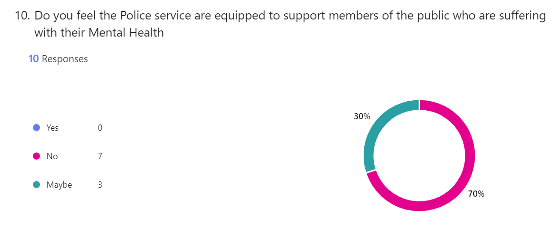
The chart shows 70% of participants think that the Police Service is not equipped to support members of the public in crisis , whereas the remaining 30% chose the response “maybe”.

Are Police Officers equipped correctly to deal with Mental Health

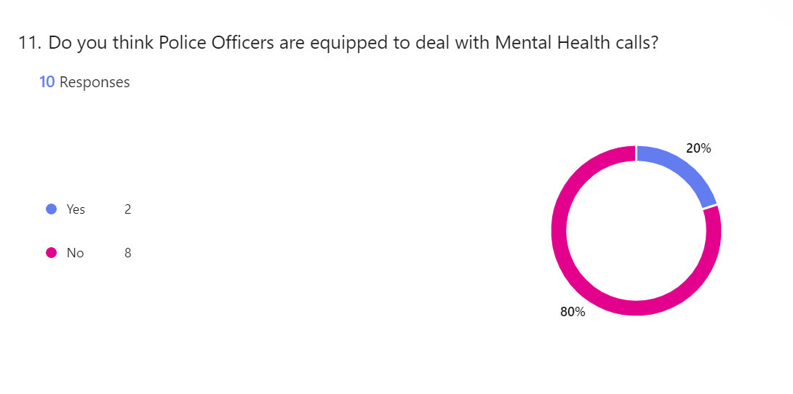The majority , at 80% believe that Officers are not equipped to deal with Mental Health calls.
This does tie in with Objective 3 , as this could offer an explanation as to why Officers may not believe they are the correct service to respond.

Do Police Officers need more training in dealing with Mental Health

This question goes with objective two, do officers need more training.
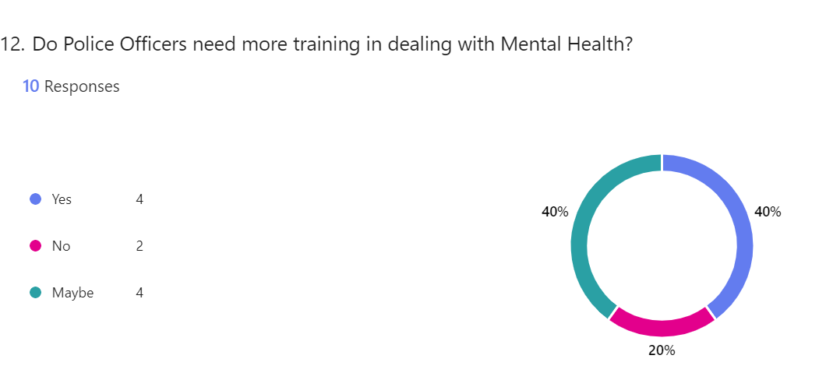

There is a diverse response from participants here , with 40% saying “yes”, 40% responding with “maybe” and 20% responding with “no”.

Chapter Five
Recommendation and Conclusion

Introduction
This chapter is the final chapter of the dissertation, here is where the will results will be revealed, looked at in comparison to what has been discovered before. There will be a brief discussion on what recommendations there have been found.

Here is another reminder of the objectives of the dissertation;
1 Are Police officers equipped enough to deal with Mental Health Calls
2 Is the training Police Officers have adequate and do they need more training
3 Are Police Officers the correct service to deal with Mental Health calls

The results
Objective one- Are Police officers equipped enough to deal with Mental Health Calls

The results from the questionnaire, question 10, states that 70% of Police Officers that completed it , said that they did not believe they the service itself was not equipped enough to deal with mental health issues.
However 30% responded with “maybe”.
As is has been previously reminded in the above chapter, Police only really have two ways to actually help a person in need, that is to convey to hospital either on a voluntary basis or being detained .
What this suggests is that either officers believe those powers are not enough or officers believe that they are not good enough to ensure support of the person in crisis.
In question 11 in the questionnaire, if officers believe Police officers themselves are equipped enough to effectively deal with a person in crisis, similarly 80% believe they are not whereas 20% said they felt they were.

Objective two - Is the training Police Officers have adequate and do they need more training

The results from question 6 in the questionnaire. It states that 30% of the officers believe that they have received enough training, however 70% disagree.
The questionnaire explores this a little further by asking the participants how they have gained the most knowledge about dealing with Mental Health calls, 90% of officers responded by saying “on the job” has been the best and most effective way of leaning how to deal with Mental Health calls , this , as previously mentioned in the above chapter has been discovered by a article by Thomas in 2017.
So, this result has supports this finding, and proves that the best method of learning is “on the job “.

Objective three- Are Police Officers the correct service to deal with Mental Health calls

The results from question 8 from the questionnaire. 90% of officers responded by saying no, they do not believe Police are the correct service.
Again, in the literature review chapter , there are some good points made as to why Police are needed to respond and why other authors or agencies thought they were not the correct service. To it being a medical response and not criminal, to Police being there to ensure safety and also it came to , are the Police service actually equipped enough to deal with people in crisis.
Here are some comments from the responding officers;
Officer 5- “Often when someone is in crisis and requires help the sight of a uniformed police officer turning up doesn’t help that person’s frame of mind and often makes them feel like they are doing something wrong”.
Officer 6- “I believe police are a good first contact as some mental health calls can turn violent . Police are more equipped due to their tactical equipment. More than the ambulance service.”
The majority support the opinion of Police not being the correct service, this supports the view of London Commissioner Sir Mark Rowley in chapter two of this dissertation.

Limitations of study in this dissertation

On reflection, the writer of this dissertation could have asked more detailed questions and discovered perhaps why Officers believed they weren’t equipped enough to deal with Mental Health calls and why the Police service was not.
The questionnaire was, unfortunately only reached by a small sample of Police Officers, thus only giving a small outlook on a very large Service.
The writer of the dissertation believed that it may be too soon to ask questions on the “Right care, right person” initiative.

Recommendations
In this dissertation, it has been discovered that although, as on question 5 of the questionnaire, 80% said they were confident in dealing with Mental Health , but this appears to be done to learning from experiences out dealing with live calls. Whilst this is positive, the writer of this dissertation can see two obvious recommendations
First, a more scenario based training for dealing with mental health and more training is perhaps needed
Secondly, even with the introduction of “Right Care, Right person” perhaps a review of how police and medical services should work together to ensure the full and proper support of the person in need.

Conclusion
Overall, this dissertation has explored many avenues of how the Police works with the Mental Health need of the public.
It has looked at the pros and cons, the for and against, the reason why police should or shouldn’t respond to mental health calls.
From putting together this project , it has been learnt that ultimately, most cited agencies and authors agree that Police are not the correct service to respond to mental heath crisis’- in the first instance, they should go as a last resort or as a preventative measures, to stop the person going missing or harming themselves or others. It would seem Officers understand this themselves.
More training is needed for Police officers and maybe a more multi agency approach could be looked into in the future, to ensure the best service is provided to the member of public.

Bibliography
Billington, z., 2018. Police and mental health. Picking Up the Peices , november .pp. 11-13.
College of Policing , 2023. Police Constable. [Online]
Available at: https://profdev.college.police.uk/professional-profile/police-constable/
[Accessed 11 January 2024].
Every Mind, 2024. Understanding Mental Health. [Online]
Available at: https://everymind.org.au/understanding-mental-health/mental-health/what-is-mental-illness#:~:text=A%20mental%20illness%20is%20the,and%20interacts%20with%20other%20people.
[Accessed 11 January 2024].
Gov.UK, 2023. Police officer. [Online]
Available at: https://nationalcareers.service.gov.uk/job-profiles/police-officer#:~:text=Police%20officers%20keep%20law%20and,crime%2C%20and%20support%20crime%20prevention.
[Accessed 11 Januray 2024].
Gutterman, A. S., 2023. Training and Development , New York: Research Gate .
Hampsire College, 2024. What is Research. [Online]
Available at: https://www.hampshire.edu/what-research
[Accessed 3rd June 2024].
Mcleod, S., 2023. Questionnaire method in research. [Online]
Available at: https://www.simplypsychology.org/questionnaires.html
[Accessed 3 June 2024].
Met Police, 2023. Intriduction to Right care, right person. [Online]
Available at: https://www.met.police.uk/notices/met/introduction-right-care-right-person-model/
[Accessed 12 January 2024].
Rethink, 2023. The role of police in mental health. [Online]
Available at: https://www.rethink.org/news-and-stories/blogs/2023/07/the-role-of-the-police-in-supporting-people-in-mental-health-crisis/#:~:text=The%20National%20Partnership%20Agreement%20is,health%20professionals%2C%20not%20the%20police.
[Accessed 13 january 2024].
Schoonenboom, J., 2023. The Fundamental Difference Between Qualitative and Quantitative Data in Mixed Methods Research. Qualative Social Reserch , 24(1), pp. 1-3.
Stuart Thomas, A. W., 2017. A focus for mental health training for police. Journal of Criminological Research, Policy and Practice, 3(2).
Stuart Thomas, A. W., 2017. A focus on Mental Health Training for police. Journal of Criminological Research, Policy and Practice, 3(2), p. All .
Syal, R., 2023. Police in England and Wales dealing with more mental health crises than ever. The Guardian , Febuary.p. 1.
Victor Oluwatosin Ajayi, P., 2017. Primary Sources of Data and Secondary Sources of Data, Nigeria: s.n.

Appendix

Graphs from the questionnaire conducted by writer of the dissertation

Graph 1 – confirm to participant that it is anonymous and explaining what it is being used for
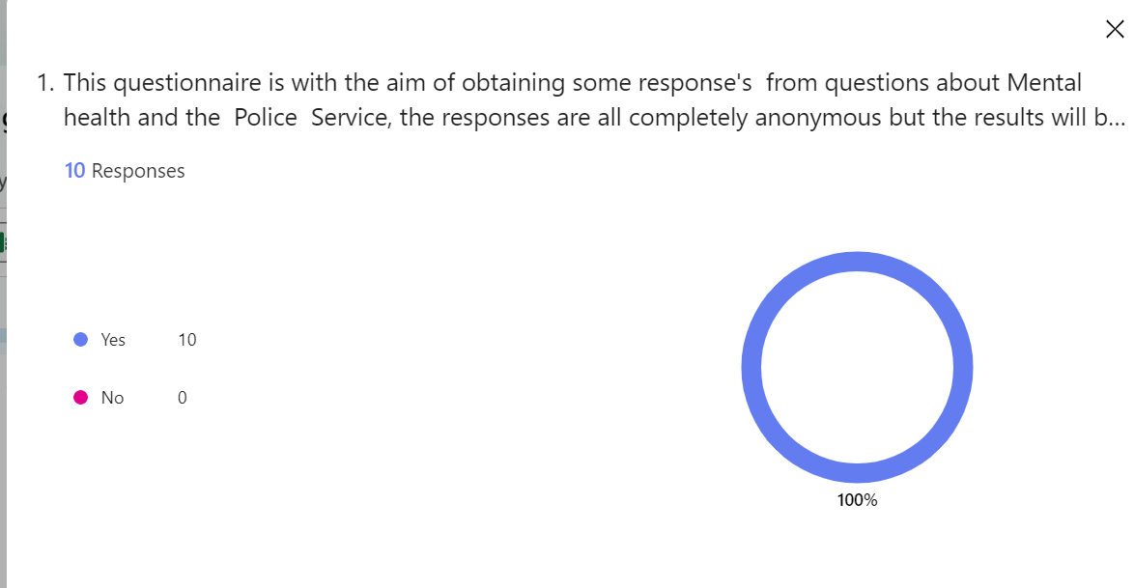

Graph 2 – confirming participant is serving Police Officer

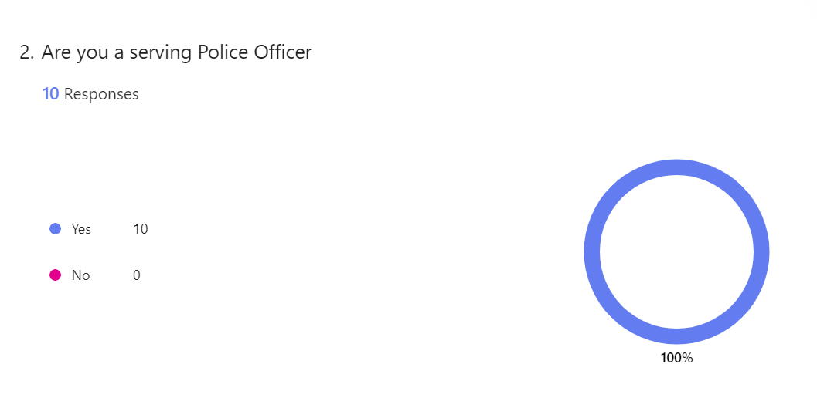

Graph 3 – question 3
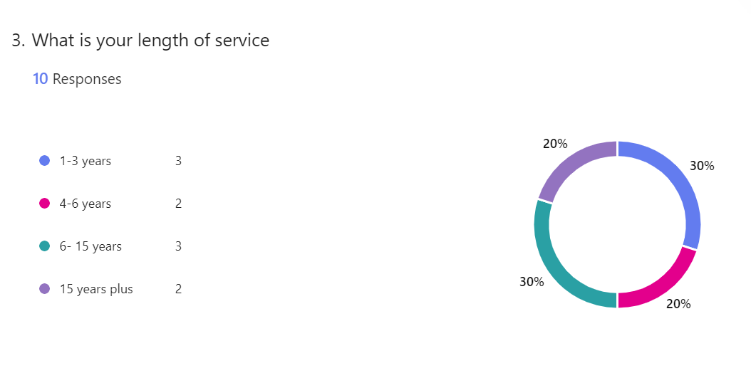

Graph 4 – question 4
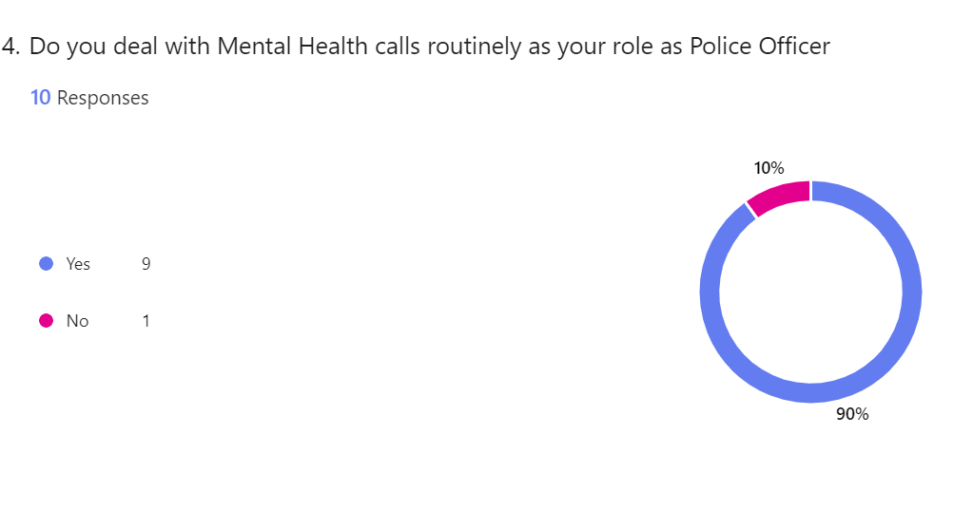
Graph 5- question 5
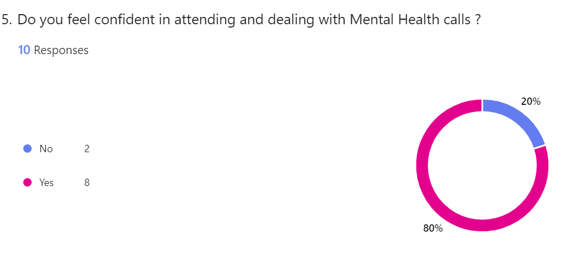
Graph 6- question 6
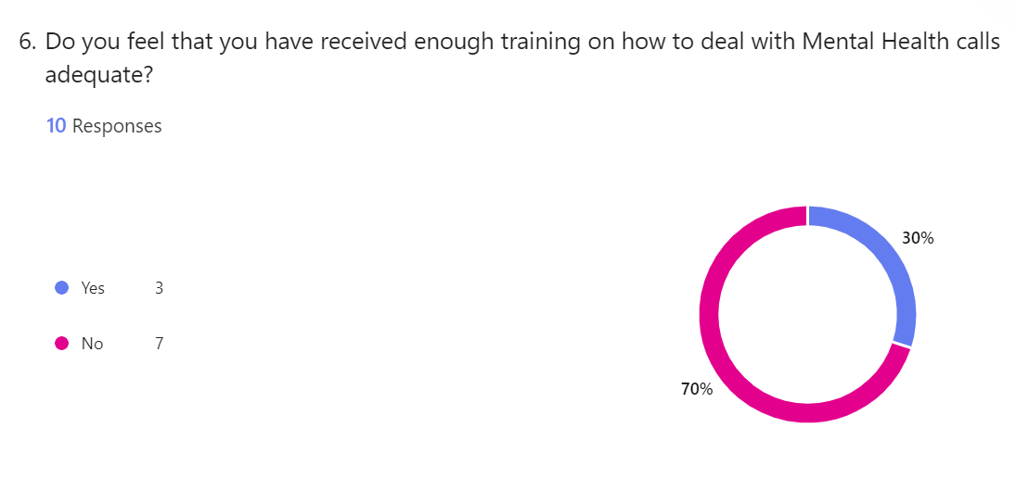

Graph 7 – question 7
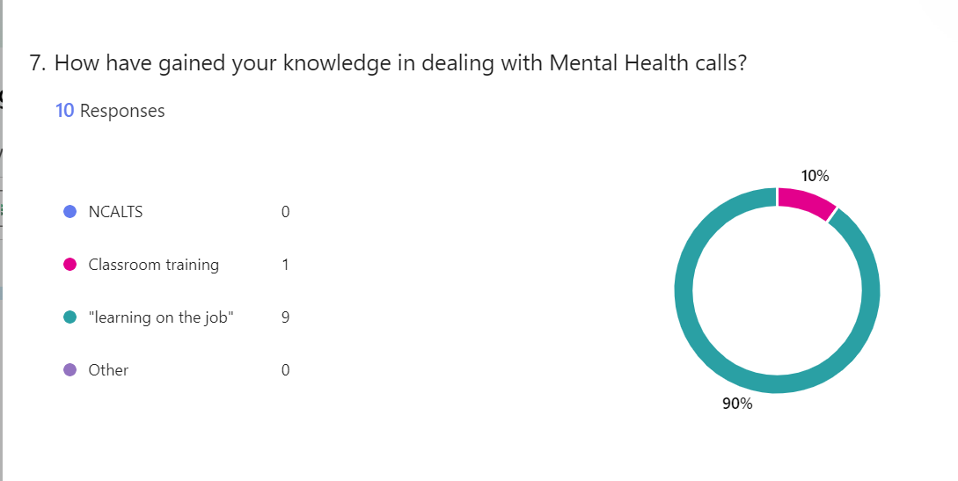

Graph 8 – question 8
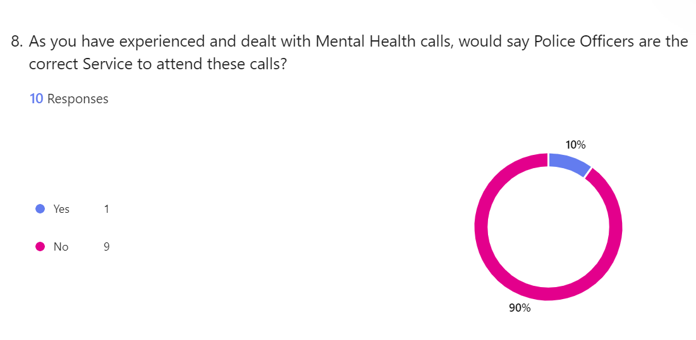
question 9 -written responses
If you would like to, please explain your answer to the above question?

Here are the 7 responses
Officer 1 – “We are very under equipped and under trained to deal with these calls, they can be very complex”
Officer 2 – “Mental health is medical, not criminal. So the police is the wrong service for the job.”
Officer 3 – “Yes if someone is in possession of a weapon and requires disarming however not to deal with the aftermath as a lot of people are fearful of police”
Officer 4- “Mental Health professionals”
Officer 5- “Often when someone is in crisis and requires help the sight of a uniformed police officer turning up doesn’t help that person’s frame of mind and often makes them feel like they are doing something wrong”.
Officer 6- “I believe police are a good first contact as some mental health calls can turn violent . Police are more equipped due to their tactical equipment. More than the ambulance service.”
Officer 7- “Police officers are not trained to deal with mental health illnesses and what care individuals will need.”

Graph 9 question 10
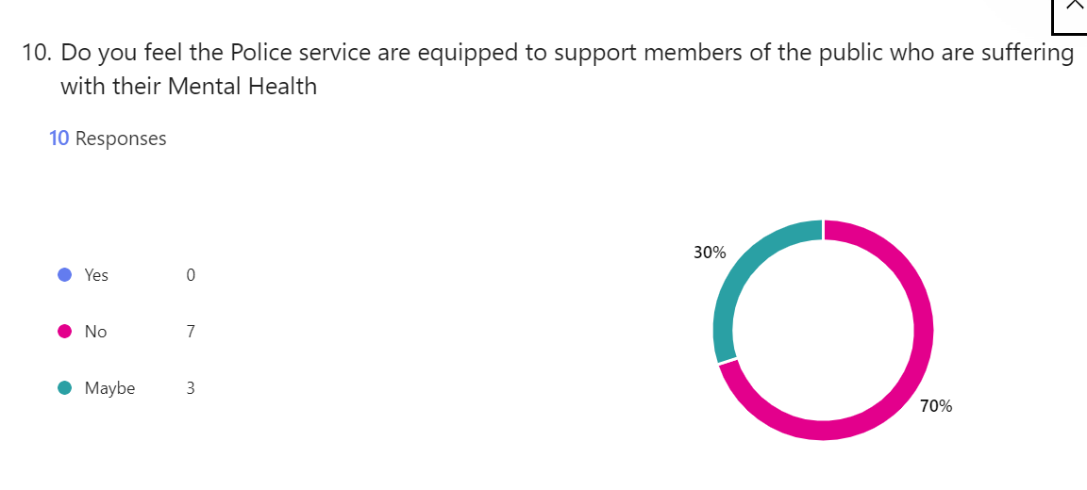

Graph 10 – question 11
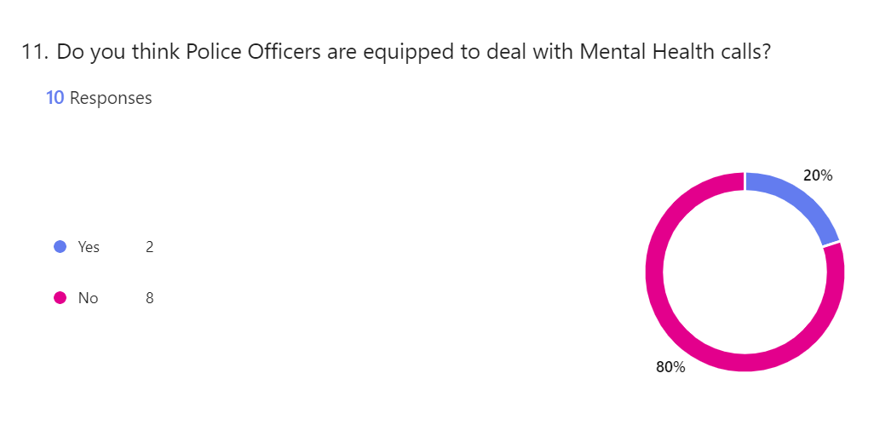
Graph 11 – question 12
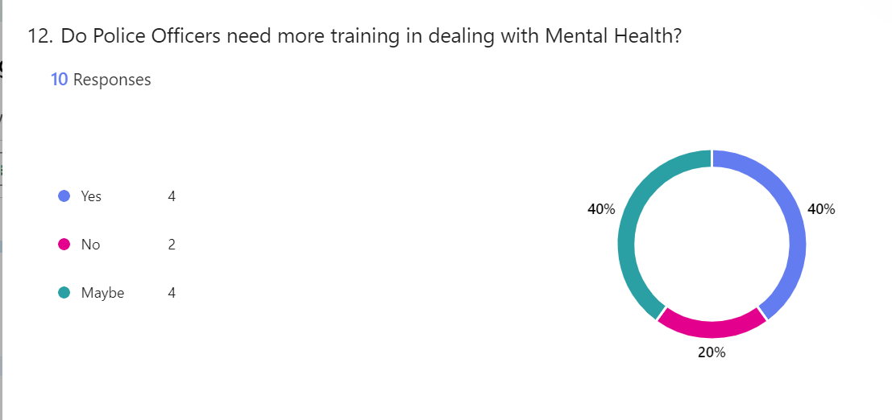

Dissertation end

