Student name and number: | Albena Dimitrova 1814002
Module Title:  Module No: | Digital skills and Research methods  BMSK4003
Lecturer’s name: | Joy Botu

Table of contents

Introduction……………………………………………………………………………..p.3
Evaluation the using of modern technologies: MyGP application…………………………………………………………………………..….p.4-6
Exploring social media…………………………………………………………..…p.7
Facebook as tools for marketing ………………………………………………p.8-9
Evidence of my online presence ………………………………………………p.10
Conclusion …………………………………………………………………………… p.11
References …………………………………………………………………………… p.12

Introduction

The aim of this report is to consider the advantages and disadvantages of using modern technologies. Many companies use modern technology because that is the main role in communication using social media as a tool for successful business. The modern technologies take part in our health as well.
Technology is used in different ways at workplace, such as websites and apps thanks to the Internet. For example Pontes, Szabo and Griffiths in 2015 with their research show that 51,9% of students are addicted to the Internet (Duck and McMahan, 2016,p.105).
This fact show as how many people at workplace or students depend from Internet. I will discuss the advantages and disadvantages of this technology such as MyGP application. I will talk about how useful and easy is to book an appointment with this application. But how difficult can be for patients as well. Modern technology offers a big advantages and source of information. Also I will discuss an application as Facebook how can be used for business and communication. I will talk how you can use Facebook business page to advertise products and services on market.

Evaluation of the effectiveness of using modern technology: MyGP Application

As you know every year many modern technologies appear and one of them is MyGP application.
This application is made it to help the patients easy to book an appointment or to cancel one. The smartphone application connected you with your GP and NHS services. You can download free the application and start used when you are register with GP in England. Another important fact is you needed mobile number to sign up. For an example you can see picture in figure 1 of mobile application home page.

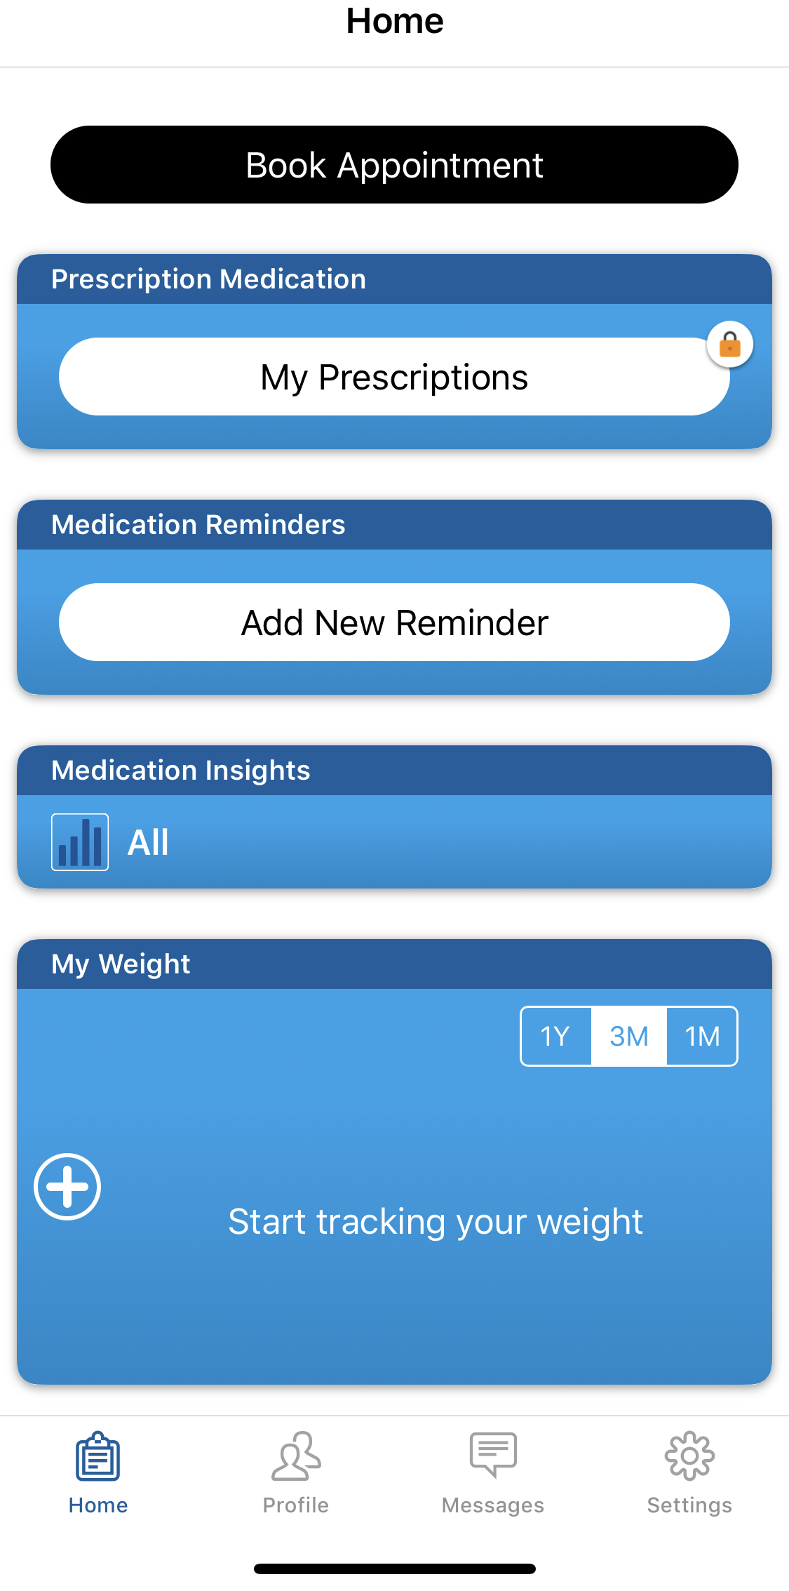Figure 1

First step is to enter your mobile number, then your date of birth and look for your GP surgery by name and postcode. You can access seven days a week everywhere and anytime with your GP.

You can book and cancel your appointment.
First you have to select for who is this appointment because the good thing here that you can add your family in this app and to book appointment for them as well.

Also you have to select your GP location and to choose your type of appointment. Find date and time that is good for you and check if your doctor is accessible. Then select the appointment. In the same time you can see the other doctors available in the practice. Also you can be able to book someone in case your GP is not available.

Next step is to type reason for your appointment.
On your home page you will see confirmation of your booked appointment. From here you can add your details with day and time to your calendar. Than you are ready for your GP.
You have option to change or cancel booked appointment as well.

Advantages of using MyGP application:

Good advantage is you can download the application on your smartphone or android. It is very easy and important for your health.
With one step you can manage appointments for your family and also if you caring for others as well. This application is perfect for example busy mom who work on full time is the best way to have a control over appointments.

Positive fact is that you not loose your time and this is the fast easy way to have your booking done.
If you want to cancel your appointment for any reason simple just select the confirmed appointment of the home page and then press the button for cancel.
Made it so easy to book today and go for next day and no need to phone up.

Good fact about this app is you can easy to order your prescription from your smartphone. No more needed notes handwritten of your doctor.

Also this app gives you an advantage because you can set goal, track your weight, monitor your blood pressure data and checking of your progress.

With this app you can look in your medical record. It is not necessarily to call to your doctor or going to your practice because you can see that you need it. You can share your medication data insights with health care provider.

Sometimes when you have a medication and you forget to take it is easy to use the application because there have a medication reminder. Then you can add your new reminder and never miss your medication.

Disadvantages of using MyGP application:

Most important fact for this application is Internet connection. Without Internet you not will be able to use this application.
This is one of the main disadvantage, because you know how often there is have issue with Internet connection and sometime you may not have network.
In case you feel unwell and no Internet connection than will be impossible to use this application and you have to call to the practice.

Also this application is not for emergency use. It is for normal GP appointment.
Many people find it is more helpful if they go to the practice to talk with someone instead using mobile application. For example some of the older people cannot work well with modern technologies. So that is another disadvantage.

One negative fact is if your computer or mobile phone broke you are not able again to use the application.
And the end you have to look for another way to contact your doctor.

Exploring social media as a marketing tool: Facebook

Introduction

According to Lenhart (2012,p.105) 18% of teenagers sending around 200 text messages every day.
Smith (2011,p.105) said the adults are sending less text messages than teenagers.
“Smartphones position people as being constantly connected and constantly available to others. If you have your smartphone with you, you have your social network with you as well.’’(Duck and McMahan, 2015,p.119). Social media strategies aim to guaranteed growth and success to online customers. Social networking users feeling less isolated according by Hampton et al (2012,p.125). There is no limit to the marketing strategies that social network offers. Using of social network is less expensive.

According to Hampton et al (2011,p.125) Facebook user has met 93% of his or her friends once. The big category of Facebook users is high school friends, followed by college, family, coworkers, volunteer group and neighbors.
Social media is influenced positively from online communication.

Facebook

Facebook is a social networking website, created in 2004 and it is free to join. Anyone with access to the Internet can use the website and open an account.
Also Facebook is created as application and you can download on your smartphone. People may share videos, photos, create business page, join in groups.
Messenger is a part of Facebook so you can easy to contact with your friends. You are able to send message, photo and video.
Facebook is one of the popular website used for communication and marketing as there are a millions of people connected. Most of the people have Facebook to stay in touch and better informed.
Some people use this app because they are not living the same location and they connect with friends, and family, and shared experience through social media.

Facebook as a business tool:

Facebook is used as marketing tool from firms to advertise their products. Also people with big brand or small business can use to promote them as well.
As an example you may open page and promote yourself as a photo model or personal trainer. Than you can find a clients and people who can work for. As many people work for themselves and try to expand theirs on business.

You can advertise product or service. An example if you work at home for company and try to sell their products, but the company is located in different country, you can promote them if you open Facebook page and show them in your country. For another example you have a restaurant you can promote special events and offers, and allow to people see your specialties with pictures in social network.

Once opened business page you can focus on people that are interested of your topic.
When you start your page you can write information about you and what you present or sell. You need to do your page attractive for followers. You need to choose brand name and category of business.
Then you can connect with a lot of people from other background. Facebook gives you to choose your audience.

Also you are able to select and upload photo to use as profile picture and cover photo.
You must spend more time to make an impression with your page visual. People will respond more of visual effect than plain text, because the attention of most of the people is attracted from something creative, interesting and unconventional. So you can try image with high resolution and format for more enchanting.

You have options to advertise your page as well. Moreover you have option to pay and boost your page or picture, event announcement as well. Get more people to reach more likes, shares and comments to increase your sales. Inviting your friend to like also gives you more audience engagement. Even has own marketplace, where you can sell or buy something.
You can share posts about your business every day and keep the audience engage. Facebook can be connection between brands and consumers. Also with messenger will keep better communication even if you answer the question on someone who is interesting of your business. This may give you a chance to be more popular online.
Facebook has become the social media network people cannot without.

Disadvantages of using Facebook:

People using social network give personal information and they are unsecure how they will be protected. You have to be very careful with your data privacy. Too many hours of using Facebook has negative effect of your sleep. Also can create problems with your health, relationship, school and even your career.

Evidence of my online presence

I use Facebook often to promote myself as a photo model and I pay to boost my pictures to reach more followers and likes. With a big audience over the world I can find a good company to represent their products.
Figure 2 is an example of a professional Facebook page.

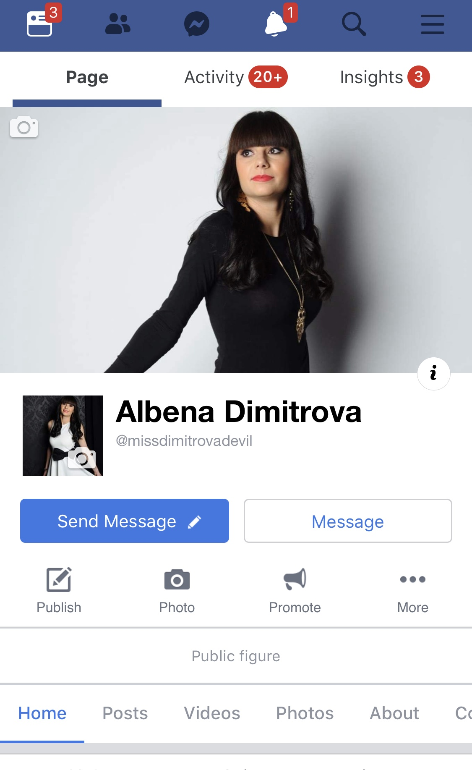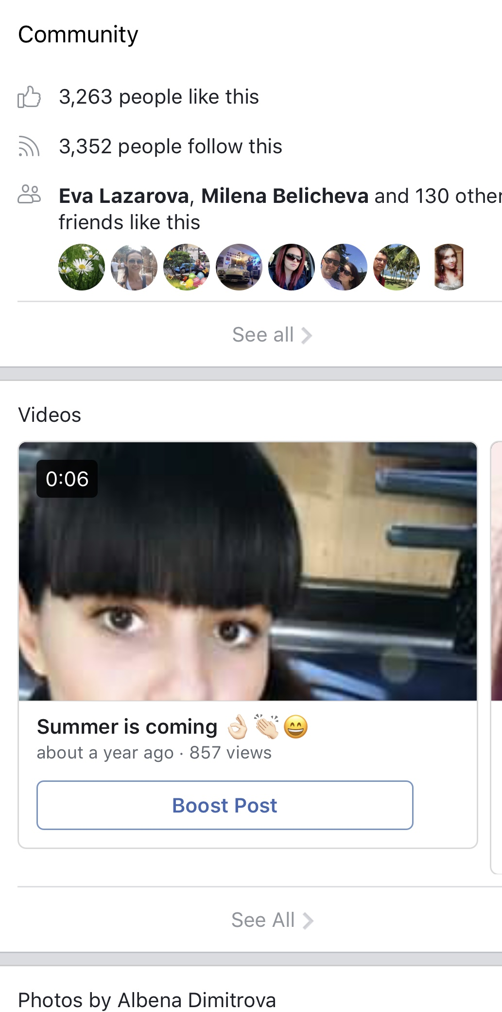Figure2

https://www.facebook.com/missdimitrovadevil/

Conclusion

This report showed you the effectiveness of using modern technology. Modern technology and media general informing people and help them with business and communication. Social media play important role in the world. Technology is everywhere from the workplace to school and home which is important part of our lives. Technology in workplace gives people more opportunities to progress. Modern technology makes our life easy as it affects how we live and work.
The technologies help people live better caring for their health condition.
In 21th century, the world is technology dependent. Everything has its own action and counteraction as the modern applications as well.
Also in university many students rely on social media and technologies.
Facebook allow people to find friends, organisations to set up groups to communicate easily, even to build relationships.
In summary I can say that the social media could help as to improve our life and the technology has change the way we communicate at workplace.

References

Maund, A. Schriek, S. and Tinkler, P. (2017)”Certificate in Higher Education: Skills for the Workplace Student Yearbook’’.
SAGE Publications, London

DigitalUnite(2018) technology guide [online] Available at: https://www.digitalunite.com/technology-guides/social-networking-blogs/facebook/what-facebook [Accessed in 15th April 2019]

MyGP(2016)myGP.com health help[online]
Available at: https://www.mygp.com [Accessed in 3th of April 2019]

Facebook(2019)facebook.com [online] available at: https://www.facebook.com/missdimitrovadevil/ [Accessed in 20th April 2019]
Synotive(2015)5 Unique ways to Explore Social Media for Better Business Performance [online] Available at:
https://www.slideshare.net/synotive/5-unique-ways-to-explore-social-media-for-a-better-business-performance?qid=28292c64-a144-4d26-95d3-c8a6ef966cbc&v=&b=&from_search=3 [Accessed in 29 th Alpril 2019]

