Surveying Problems-

1a) 1.4650

1b) 2.179

1c) 3.976

1d) 0.820

1e) 1.504

2)
BS | I | FS | HOC | RL | Remarks
1.850 |  |  | 51.850 | 50.000 | BM
1.720 |  | 1.500 | 52.070 | 50.350 | A
 | 1.640 |  |  | 50.430 | B
 | 1.590 |  |  | 50.480 | C
2.100 |  | 1.550 | 52.620 | 50.520 | D
 |  | 1.240 |  | 51.380 | E

2a) 51.850
2b) 52.070
2c) 50.350
2d) 50.430
2e) 1.590
2f) 2.100
2g) 50.520
2h) 51.380

3)

Area =37500 ㎡

Workings out-

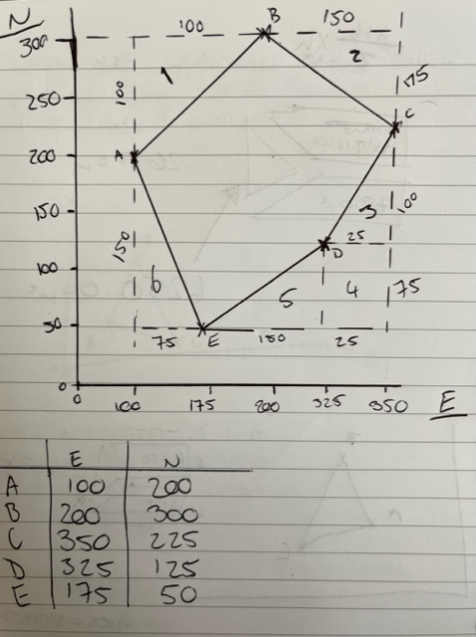
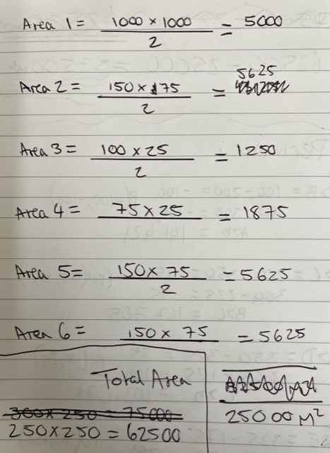

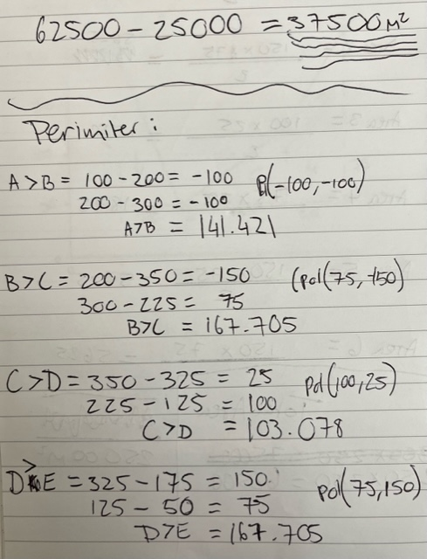

Perimeter= 747.614 m

Workings out-
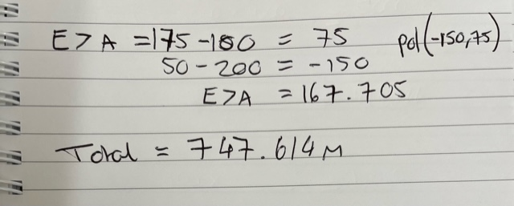

4) INV at existing sewer= 107.050

4a)107.800m Dig= 2.180
4b)108.600m Dig= 1.550
4c)109.250 Dig= 1.020

Workings out-
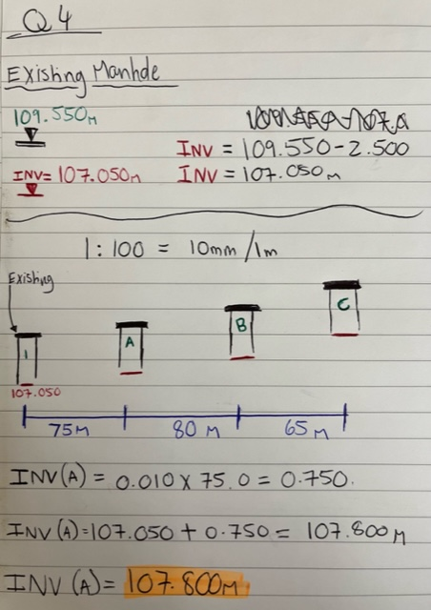

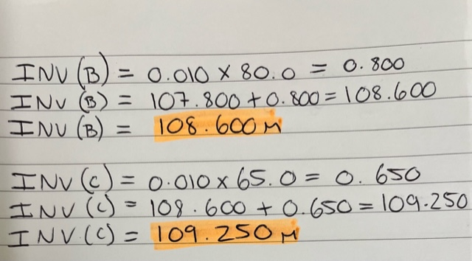

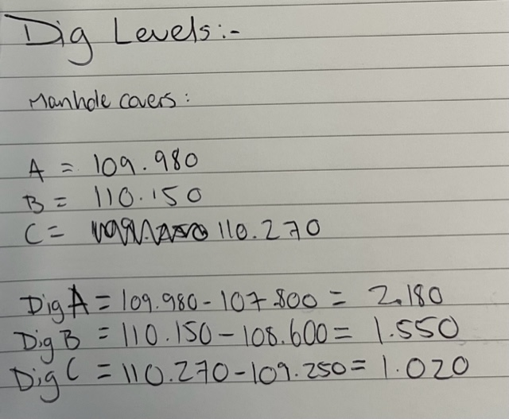
5) Automatic Optical level (dumpy level); this piece of equipment primarily used for surveys to provide horizontal levels of specific points for specific parts of a construction project such as kerb lines, slab levels and ground formation levels. This piece of equipment requires the user to set up on a tripod and level using the foot screws and the circular level bubble, the focus can be adjusted with the optical focus screw usually on the right of the level. The tangent screws on each side of the level can also be used to move the sight horizontally while eying through your target.

