Kara Thomas (2304862)
University of wales trinity st davids
Computer Architecture and Operating Systems ASsignment

Contents Page
Contents
Contents Page 1
Introduction 2
Key functions of general Operating Systems 3
Memory Management 3
Device Management 4
Process management 5
Use of Windows OS CLI commands 6
Cd 6
Tasklist 6
Tree 8
Mkdir 8
Echo 8
Type 9
Dir 9
Ren 9
Copy 9
Del 10
Use of Linux OS CLI commands 11
Pwd 11
Cp 11
Mkdir 11
Ls 11
Touch 12
Echo 12
Cat 12
Chmod +rwx 12
Rm 13
Uname 13
Use of Windows OS scripts. 14
Variables 14
Goto command 15
User Input /p Switch 16
if statement 17
for Loop 17
Array 19
Function 20
Use of Linux OS scripts. 21
Variables 21
User Input 21
If statement 22
For loop 22
Array 23
Case statement 23
Function 25
Conclusion 26
Bibliography 26
Appendices 29
Tutorial Activity on OS Types 29
Bibliography 30
Evidence of engagement with 1 online certified course 32
Learning PowerShell LinkedIn Learning 32
Chapter 1 32
Chapter 2 38
Chapter 2 Quiz 41

Introduction
In this assignment I will be covering the key functions of an operating system, along with that I will be executing Windows and Linux command line commands followed by explaining what they do. Additionally, I will be creating batch scripts that have variables, the goto command, user input, arrays, if statements and loops, then explain what each script does. Finally, I will be creating bash scripts that meet the criteria of having variables, user input, if statements, loops, array, case statement, and functions then proceeding I will explain what each script does.

Key functions of general Operating Systems

Memory Management
General purpose operating systems have a wide range of functions that can be carried out. One of these functions is manging the memory of the operating system. When carrying out this the operating system will focus on the main memory of the system. One of the tasks that is carried out by the operating system is it will check to see if memory locations are free or if they have data assigned to them. Furthermore, if a computer is carrying out a task that requires more memory than it has then it can get more memory as the data of the tasks will be moved between the main memory and the second memory of the system.
If the user wants to see how much memory is being used by applications on a Window’s operating system, then they can use the task manager software. The task manager software can organise the applications in order of which take up the most space. It also allows the user to stop applications running which in turn will free more memory.
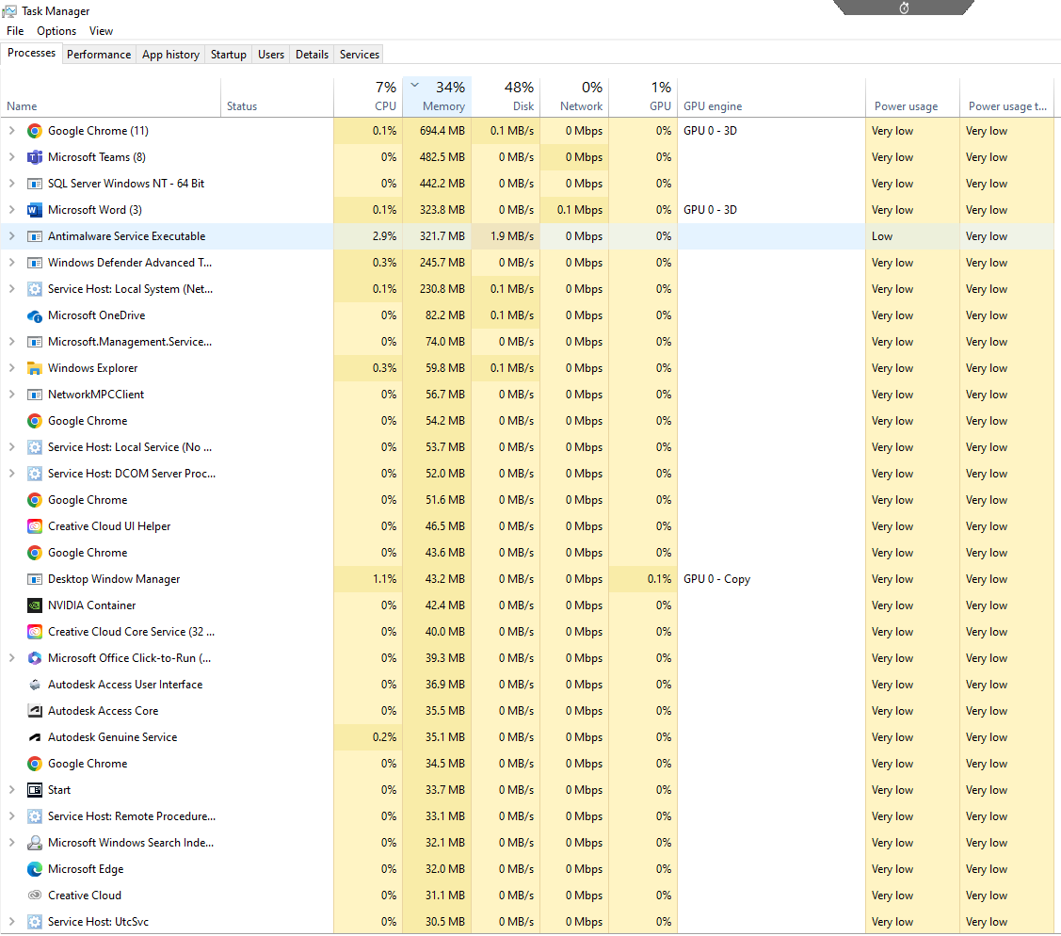
[1]

Device Management
Another function that is used regularly within general purpose operating systems is device management. The operating system is able to carry out device management by using the computers drivers to communicate with the other devices that are connected to the computer. Additionally, a task that the operating system will carry out while managing devices is it will monitor all the devices that are connected to computer system. Also, it is able to effectively allocate devices when they are needed and when devices are no longer needed the operating system will deallocate them. When input and output devices are connected the operating system will be able to control them. [2]

If the user of a windows machine would like to manage the devices that are connected to their machine they would use the device manager software. With this software the user can update the drivers of devices as not doing so can cause frequent and unnecessary crashes on the system. [3]

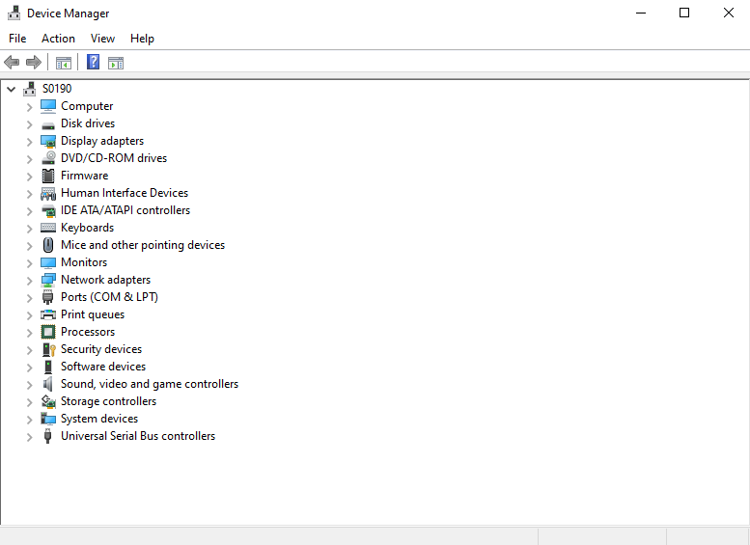

Process management

Process management is another function that is used regularly used within general purpose operating systems. The role of process management is to manage processes and to make sure they are able to achieve their tasks by making sure they are able to access the resources they need to do so. Furthermore process management allows the machine to be able to multitask and lets multiple applications run at once. To do this process management makes use of the systems resources efficiently.
One of the ways process management is beneficial is by creating a scheduled for the processes that need to be carried out. This is done by the process manager deciding which process should run on the CPU first.
Additionally, another way process management is beneficial is by it carrying out process synchronization mechanisms that have the purpose of making sure the processes do not interact with each other or cause any issues when both processes are accessing shared spaces. [4] [5]

Use of Windows OS CLI commands

Cd
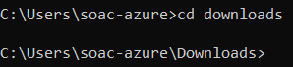
The CD command allows the user to change the current directory to a different directory in the system. [6]
The CD / command will change the directory to the root directory. [7]

Tasklist
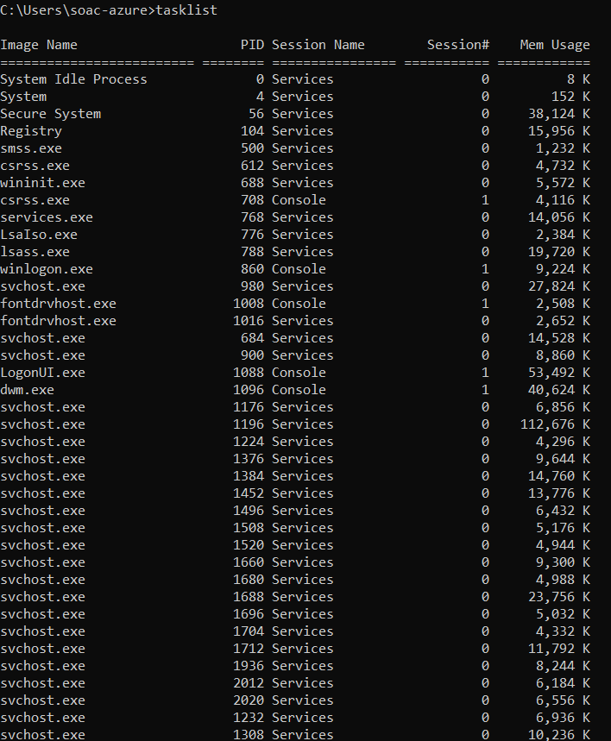
The Tasklist command allows the user to see what processes are currently running on the computer. This also shows how much memory these processes are using up while running.

[8]

Tree
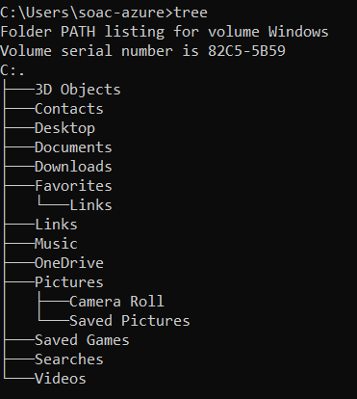
The tree command allows the user to be able to see the structure of the directory specified. If no directory is specified it will show the structure of the directory that the command is inputted in. [9]

Mkdir
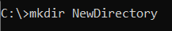
The mkdir command allows the user to create a new directory/folder. [10]
There is a variation which is mkdir -p which allows the user to create a directory tree. [11]

Echo
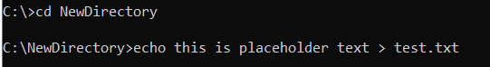
The echo command allows the user to create a file and along with adding text to go within the file. The user needs to specify the which file extension they would like to use. [10]

Type
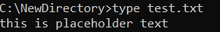
The type command outputs the contents of a text file. The user needs to input the command type followed by the name of the text file and the extension. [10]

Dir
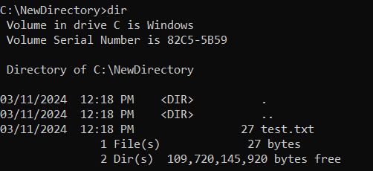

The dir command allows the user to view the contents (including files and folders) within the directory. [12] Dir /q shows information about the user who owns the files. There is also dir /p which shows one screen of files/folders at a time. To continue the user must press enter. [13]

Ren
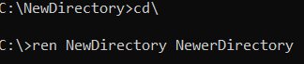
The ren command allows the user to rename folders and files. This done by the user inputting the ren command followed by the name of the current folder/file with the new name of the folder/file. [12]

Copy

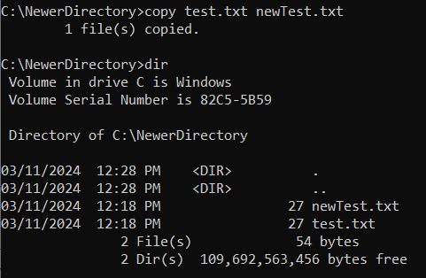
The copy command allows the user to copy a file within the directory and to give a new name to the copied file. This done by the user inputting the copy command followed by the file they wish to copy (with the file extension) and the name of the copy file(with the same file extension).

Del
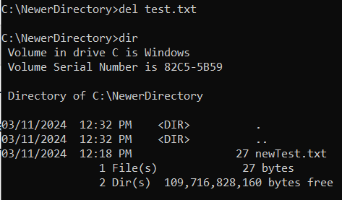
The del command allows the user to delete files and folders. [12]

Use of Linux OS CLI commands

Pwd
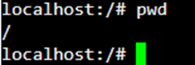
The pwd command outputs what directory the user is in and shows the location from the start of the root.
[14]

Cp

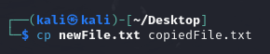

The cp command allows for a file to be copied and to give the new copied file a new name. The cp -r command does the same thing as the regular cp command but instead of copying files you can use it to copy directories. Additionally, each directory needs to end with a forward slash. [14]

Mkdir
The mkidr allows the user to create a new directory within the current directory they are in. [14]

Ls
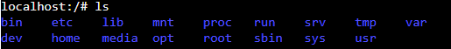
The ls command allows for the user to see all the files and folders within the directory they use the command in. [14]

Ls -l shows all the files with more information such as who created them and the date they are created. [15]

Touch
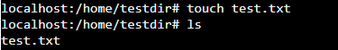
The touch command allows the user to create files within the current directory. The user must specify the name of the file followed by the file’s extension. [14]

Echo
The echo command is used to input and save text into a text file within the same directory through the terminal. [16]

Cat
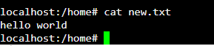
The cat command followed by a text file which contains text, it will output the contents of the text file into the terminal. [17]

Chmod +rwx

The Chmod command allows the user to change the permissions a file has. In this example the Chmod command is followed by +rwx which lets the user read, write and execute the file. [14]

Rm
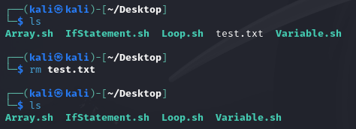

The rm command is used to delete files. If you want to delete a folder you still use rm but you follow it by -r. For example “rm -r newFolder”.
[14]
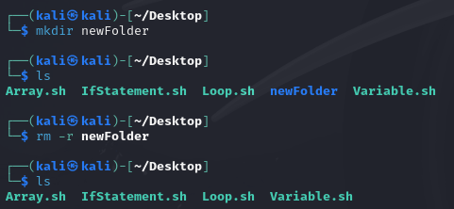

Uname
The uname command with no parameters only outputs the word linux. However when the uname command is followed by the parameter -a it will output all the systems information including the Kernal name and Kernal type.
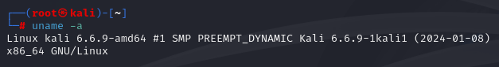
[17]

Use of Windows OS scripts.

Variables
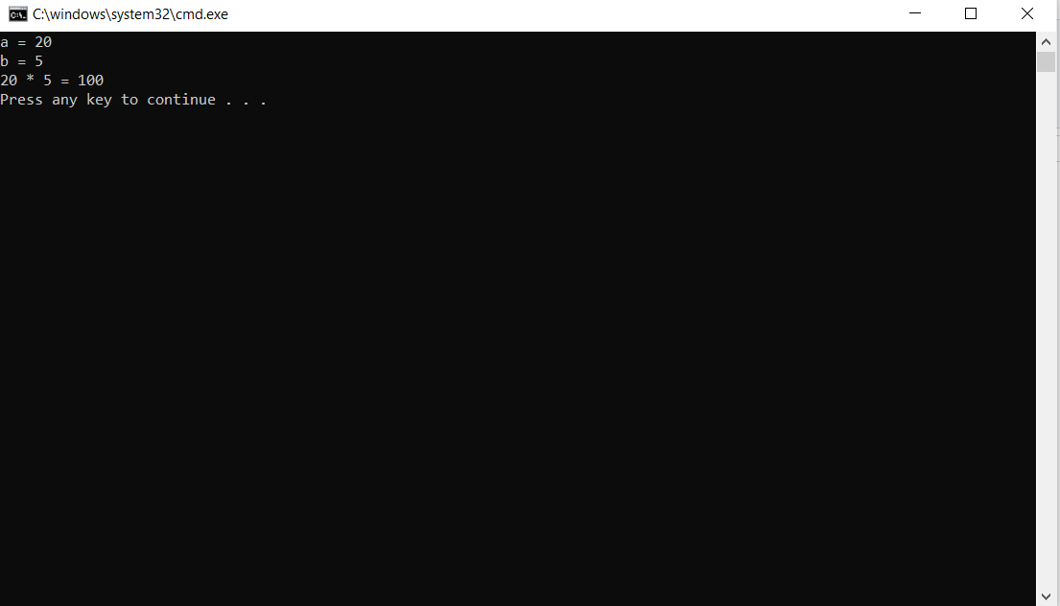
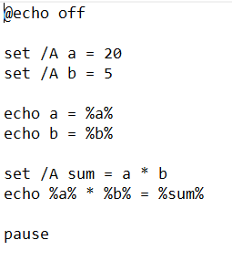

In this script I created two variables, “a” which has a value of 20 and “b” which has a value of 5. Then the variables are outputted. After that I created a variable called sum which has the value of “a” multiplied by “b”. Finally, the contents of the sum variable are outputted.

Goto command
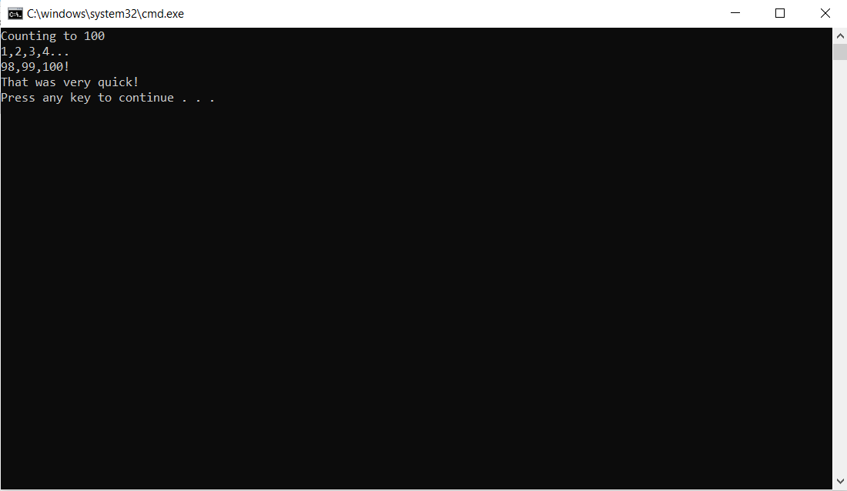
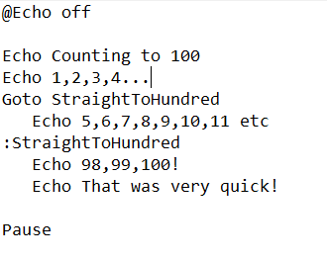

In this script I have the phrases “Counting to 100” and “1,2,3,4…” outputted. Then using the command Goto StraightToHundred I can skip the phrase “5,6,7,8,9,10,11”. Finally underneath the :StraightToHundred the text “98,99,100!” and “That was very quick” are outputted.

User Input /p Switch
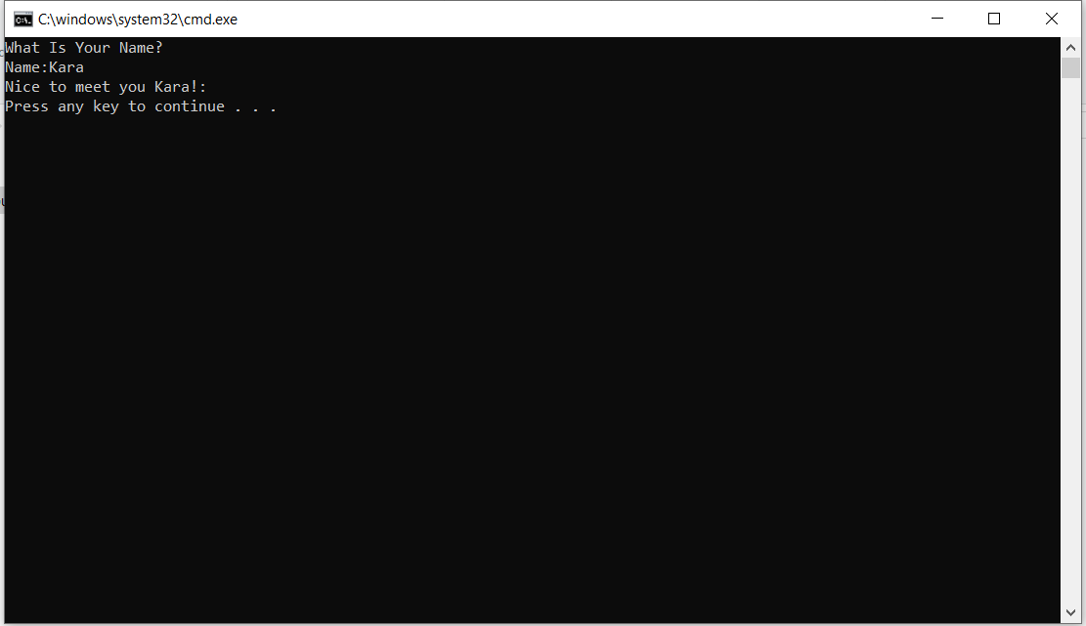

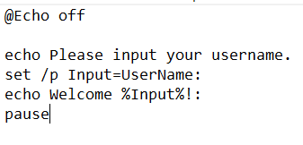
First draft
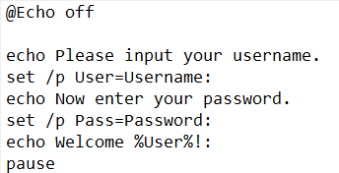
For my current script I added a section for the user to enter their password to better simulate the experience of logging into their system.

The script starts with the phrase “Please input your username”. Then the user can input their username which is then stored in the variable User. After that the user is prompted to enter their password and their input is stored in the variable Pass. Finally, the text “Welcome” followed by the User variable is outputted.
[18]

if statement
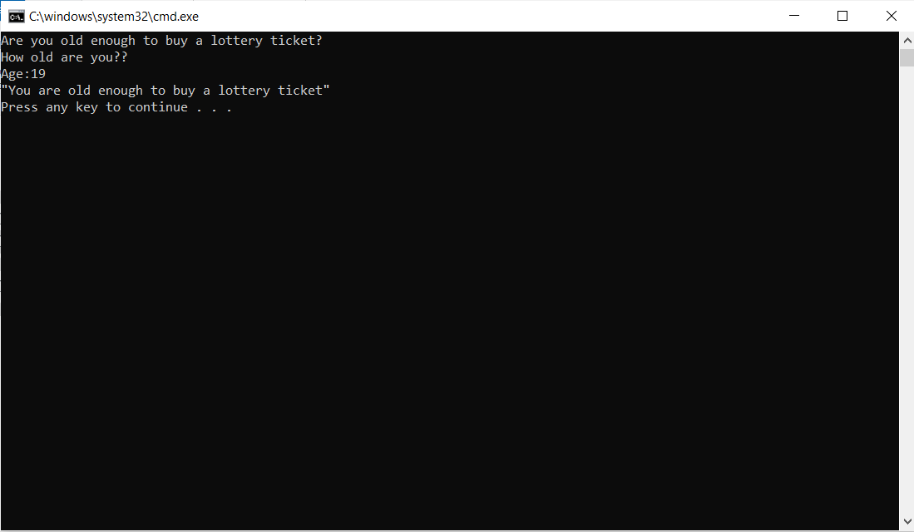
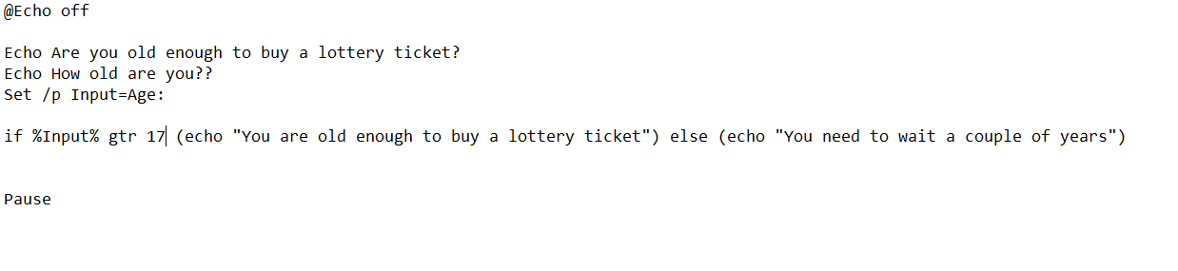
The script starts with the text “Are you old enough to buy a lottery ticket?” and “How old are you” being outputted. Next, the User inputs their age, saved in a variable named input.
After that if the user inputs a number greater than 17 then the text “You are old enough to buy a lottery ticket” will be outputted. However, anything else and it says “You need to wait a couple of years”.
[19]

for Loop

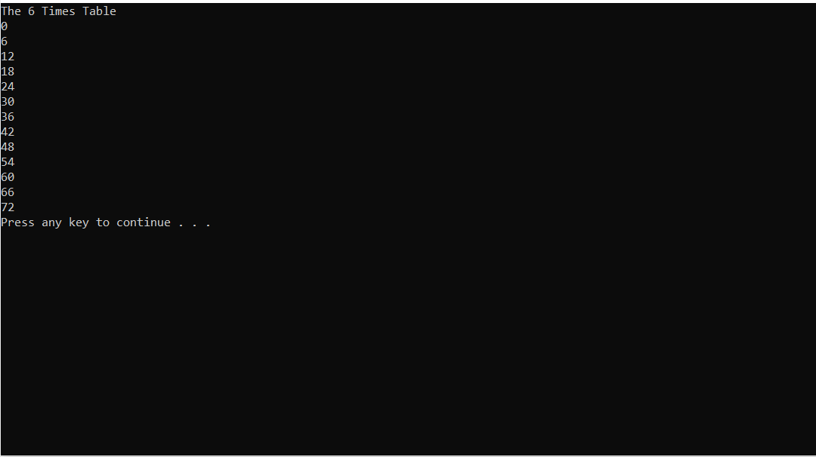

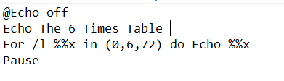
The script outputs the text “The 6 Times Table”. Then with a for loop that starts from 0, the number 6 will be added to the previous number then the result is outputted. This repeats until the loop gets to the number 72. After this the loop stops.
[20]

Array
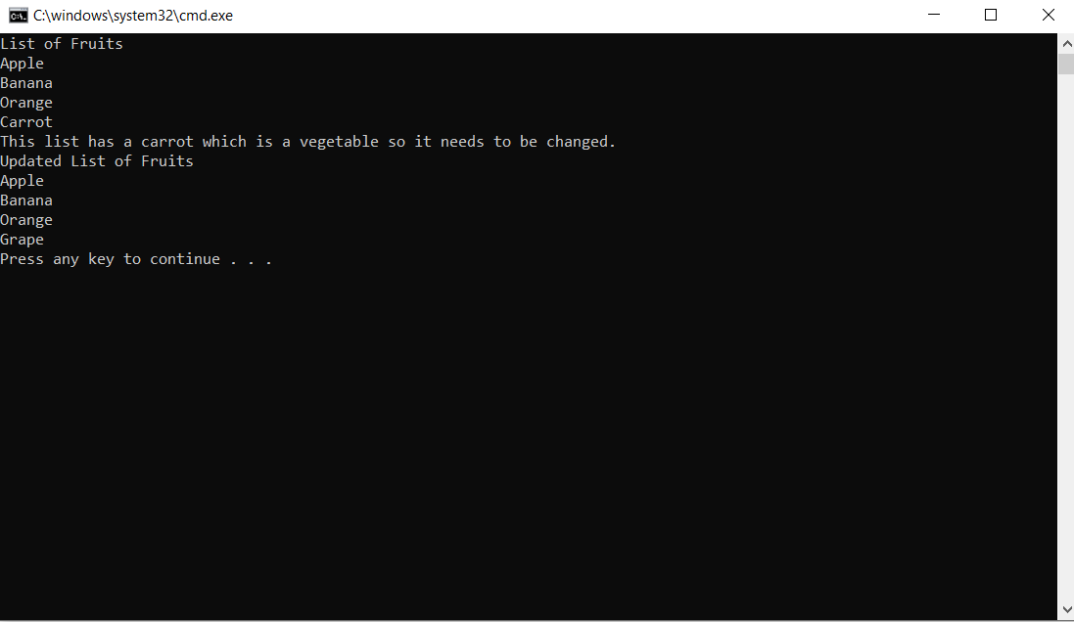
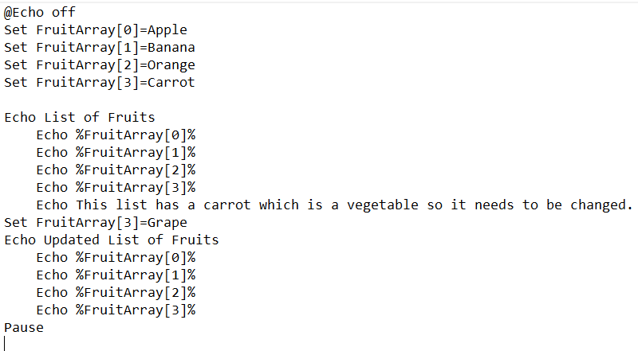
In the script I created an array called FruitArray where the 0 index is apple, the 1 index is Banana the 2 index is Orange and the 3 index is Carrot. I then outputted each of these indexes. After that I changed the 3 index value to Grape. Finally indexes 0,1,2,3 are outputted again. [21]

Function
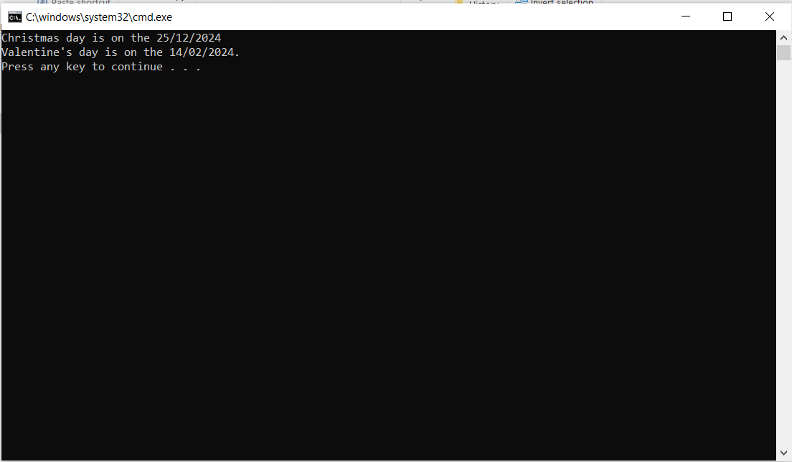
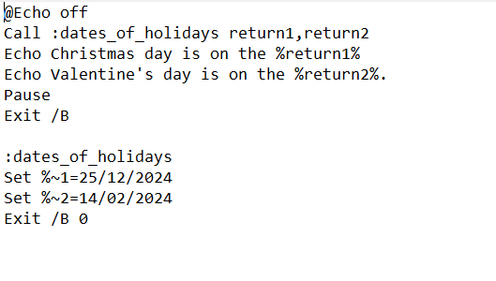
The script starts by calling the date_of_holidays function along with return1 and return2.
In the function it contains two return values which are named 1 and 2. Each of these numbers represent the positional number of the parameter. Finally text “Christmas day is on the” followed by the first return value and “Valentine’s Day is on the” followed by the second return value. [22]

Use of Linux OS scripts.

Variables
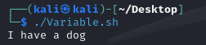
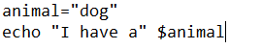
The script starts with a variable called animal being set with the value “dog”. Then the text “I have a” followed by the contents of the variable animal.

User Input
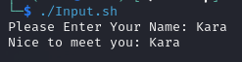
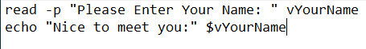

The script starts with “Please enter your name” being outputted, then the user inputs their name and it is stored in a YourName variable. After that the text “Nice to meet you:” will be outputted along with the name that was inputted.

If statement
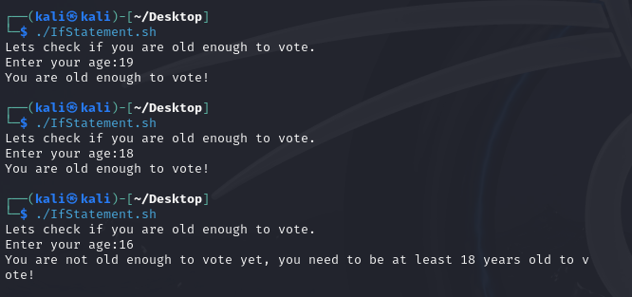
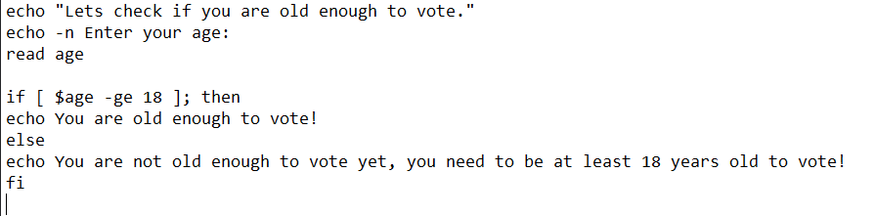
The script starts with “Lets check if you are old enough to vote” and “enter your age:” being outputted. Then the user inputs their age. After that if the value the user inputted is greater than 18 then “You are old enough to vote!” is outputted. However if anything else is inputted if the text is “you are not old enough to vote yet, you need to be at least 18 years old to vote” .
[23]

For loop
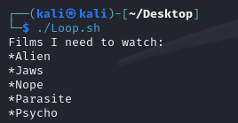
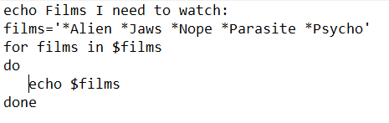
In the script the text “Films I need to watch:” is outputted. Then I create a variable called films that contains “Alien, Jaws, Nope, Parasite, Psycho”. Finally, every film in the film’s variable is outputted one after the other.
[24]

Array
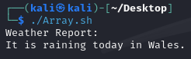
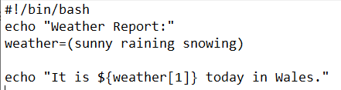

Then I create an array called weather which contains the values “sunny”, “raining”, and “snowing”. After that I output the text “It is raining today in Wales.” To output raining from the array as the index starts from 0 I use index 1.

Case statement

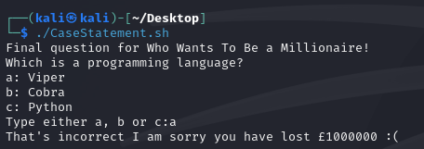
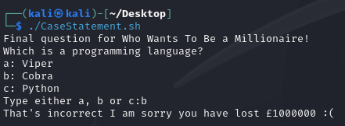
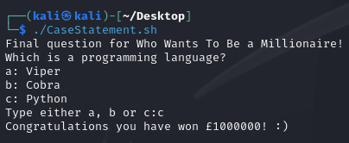
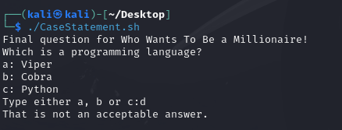
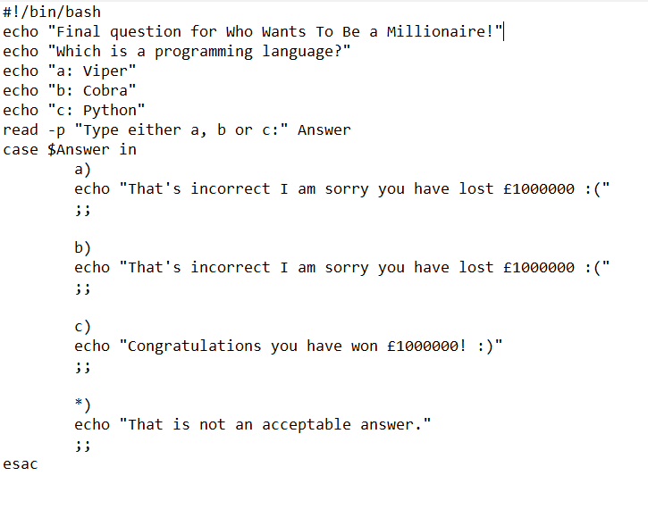
The script starts with “Final question for who wants to be a millionaire” followed by a question and several options being outputted. Then the user can input their answer and using a case statement depending on their answer a response is outputted. If their input is a or b then it says, “That’s incorrect I am sorry you have lost £1000000 ”. If their input is c then it says “Congratulations, you have won £1000000! ” . Finally, if neither of those options then it says “That is not an acceptable answer”. [25]

Function
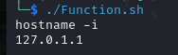
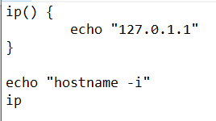

The script starts with a function containing the text “127.0.1.1” which is ready to be outputted. First the text “hostname -i” is outputted to the terminal. Then the ip function gets called which then outputs the text “127.0.1.1” into the terminal.
[26]

Conclusion
In conclusion I have explained the functions of an operating system I have also demonstrated use of Windows and Linux command line commands and explained what they do. Furthermore I created 7 batch scripts which each focus on either variables, user input, the goto command, if statements, arrays, a for loop, or functions. Finally I created 7 more scripts using bash and each script focused on either variables, user input, if statement, for loop, array, case statement, and function.

Bibliography

[1] | javatpoint, “memory-management-operating-system,” N/A. [Online]. Available: https://www.javatpoint.com/memory-management-operating-system. [Accessed 16 April 2024].
[2] | geeksforgeeks, “Functions of Operating System,” 19 January 2024. [Online]. Available: https://www.geeksforgeeks.org/functions-of-operating-system/. [Accessed 16 April 2024].
[3] | PC Fixer Cumbria, “Why You Should Regularly Update Your Computer Drivers,” N/A. [Online]. Available: https://pcfixercomputerrepairs.co.uk/why-you-should-regularly-update-your-computer-drivers/#:~:text=Outdated%20drivers%20can%20lead%20to,malicious%20software%20into%20your%20system.. [Accessed 16 April 2024].
[4] | Javatpoint, “Process Management in OS,” N/A. [Online]. Available: https://www.javatpoint.com/process-management-in-os. [Accessed 16 April 2024].
[5] | A. Dhawan, datatrained, 27 Feburary 2023. [Online]. Available: https://datatrained.com/post/process-management-os/#:~:text=Process%20management%20refers%20to%20the,%2C%20and%20I%2FO%20devices.. [Accessed 16 April 2024].
[6] | Microsoft, “cd,” 02 March 2023. [Online]. Available: https://learn.microsoft.com/en-us/windows-server/administration/windows-commands/cd. [Accessed 11 March 2024].
[7] | R. Haroon, “what-is-cd-in-linux,” educative, [Online]. Available: https://www.educative.io/answers/what-is-cd-in-linux. [Accessed 16 April 2024].
[8] | Microsoft, “tasklist,” 2 March 2023. [Online]. Available: https://learn.microsoft.com/en-us/windows-server/administration/windows-commands/tasklist. [Accessed 11 March 2024].
[9] | Microsoft, “tree,” 2 March 2023. [Online]. Available: https://learn.microsoft.com/en-us/windows-server/administration/windows-commands/tree. [Accessed 11 March 2024].
[10] | Y. Wate, “create-file-using-command-prompt-guide,” techpp, 22 February 2023. [Online]. Available: create-file-using-command-prompt-guide. [Accessed 11 March 2024].
[11] | Simsangcheol, “mkdir -p,” medium, 7 February 2023. [Online]. Available: https://medium.com/@sim30217/mkdir-p-is-a-command-in-linux-and-unix-like-operating-systems-used-to-create-a-new-directory-906a33a24f5c#:~:text=mkdir%20%2Dp%20is%20a%20command,the%20parent%20directories%20already%20exist.. [Accessed 16 April 2024].
[12] | C. Neagu, “command-prompt-how-use-basic-commands,” digitalcitizen, 26 April 2022. [Online]. Available: https://www.digitalcitizen.life/command-prompt-how-use-basic-commands/. [Accessed 11 March 2024].
[13] | Microsoft, “dir,” 2 March 2023. [Online]. Available: https://learn.microsoft.com/en-us/windows-server/administration/windows-commands/dir. [Accessed 16 April 2024].
[14] | D. Diaz, “The 40 Most-Used Linux Commands You Should Know,” Tech Tips, 2 April 2024. [Online]. Available: https://kinsta.com/blog/linux-commands/. [Accessed 16 April 2024].
[15] | D. Mckay, “How to Use the chmod Command on Linux,” howtogeek, 18 August 2023. [Online]. Available: https://www.howtogeek.com/437958/how-to-use-the-chmod-command-on-linux/. [Accessed 16 April 2024].
[16] | V. Gite, “Linux append text to end of file,” cyberciti, 25 April 2023. [Online]. Available: https://www.cyberciti.biz/faq/linux-append-text-to-end-of-file/. [Accessed 16 April 2024].
[17] | A. S. Walia, “Top 50+ Linux Commands You MUST Know,” digitalocean, 16 April 2024. [Online]. Available: https://www.digitalocean.com/community/tutorials/linux-commands. [Accessed 16 April 2024].
[18] | geeksforgeeks, “Batch Script – Input / Output,” 28 November 202. [Online]. Available: https://www.geeksforgeeks.org/batch-script-input-output/. [Accessed 16 April 2024].
[19] | tutorialspoint, “Batch Script - If/else Statement,” N/A. [Online]. Available: https://www.tutorialspoint.com/batch_script/batch_script_if_else_statement.htm. [Accessed 16 April 2024].
[20] | tutorialspoint, “Batch Script - Looping through Ranges,” N/A. [Online]. Available: https://www.tutorialspoint.com/batch_script/batch_script_looping_through_ranges.htm. [Accessed 16 April 2024].
[21] | tutorialspoint, “Batch Script - Arrays,” N/A. [Online]. Available: https://www.tutorialspoint.com/batch_script/batch_script_arrays.htm. [Accessed 16 April 2024].
[22] | tutorialspoint, “Batch Script - Functions with Return Values,” N/A. [Online]. Available: https://www.tutorialspoint.com/batch_script/batch_script_functions_with_return_values.htm#:~:text=The%20return%20values%20are%20set,positional%20number%20of%20the%20parameter.. [Accessed 16 April 2024].
[23] | ryanstutorials, “bash-if-statements,” N/A. [Online]. Available: https://ryanstutorials.net/bash-scripting-tutorial/bash-if-statements.php. [Accessed 16 April 2024].
[24] | V. Gite, “Bash For Loop Examples,” cyberciti, 7 April 2024. [Online]. Available: https://www.cyberciti.biz/faq/bash-for-loop/. [Accessed 16 April 2024].
[25] | geeksforgeeks, “Bash Scripting – Case Statement,” 15 September 2023. [Online]. Available: https://www.geeksforgeeks.org/bash-scripting-case-statement/. [Accessed 16 April 2024].
[26] | linuxize, “Bash Functions,” 30 May 2020. [Online]. Available: https://linuxize.com/post/bash-functions/. [Accessed 16 April 2024].

Appendices

Tutorial Activity on OS Types
What is an operating system?
A computer operating system is a program that is run after the computer is booted up and has the purpose of handling and controlling programs that are also run in the computer. [1]

There are different operating systems for different purposes, these include general purposes and networking purposes.

General Purpose Operating Systems
A general-purpose operating system is an operating system that is designed to carry out a lot of tasks instead of being limited to specific ones. Examples of Computer Operating systems that are used for general purposes are Windows, Linux and Mac OS. Furthermore, examples of Mobile operating systems that are used for general purposes are Android OS and Apple IOS. [2]

Networking purposes
A networking operating system is an operating system that allows devices such as computers and printers to interact and share files with each other on a network. [3]

There are two main types of networking operating systems which are peer to peer and client server. [3]
Peer to peer is when two or more computers share files and applications between each other without the need for a separate server to store the applications and files. [4]

Client server allows users (known as clients) to request files and applications from one dedicated server on a network. [5]
Some examples of networking based operating systems are Microsoft Windows Server 2008, Novell NetWare, and Linux. [6]

Embedded & Real-time Oss
A real time operating system has the purpose of executing tasks within a tight time frame while having the functions of determinism and predictability. These functions allow us to know how long a task will take and that we will get the same result. [7]

Examples of what Real time os’s are used for:
• Heart pacemakers
• Airline traffic control systems
• Robots
[8]
An embedded operating system is an operating system that is made for specific machine that is not a computer. This assists the machine in running the necessary code for it to function. The types of machines embedded operating systems are used with are:
• ATM’s
• Electric vehicles
• Traffic lights
[9]
AI & Quantum Oss
An AI operating system would allow the user to carry out multiple tasks but with the use of AI it would also allow the user to have a personalised experience, allowing each users difference preferences and needs to be met. An example of an AI operating system that is currently being worked on is Kaba OS. [10]

A quantum operating system would allow quantum computers to run. Quantum computing runs on qubits while a normal computer runs on classical bits. This difference allows quantum computers to solve even more complex problems and would be a lot faster. [11]
An example of a quantum operating system is Deltaflow.OS which is the first of its kind. [12]

Bibliography

[1] S. J. Bigelow, “operating system (OS),” TechTarget, [Online]. Available: https://www.techtarget.com/whatis/definition/operating-system-OS. [Accessed 01 Febuary 2024].
[2] Lenvo, “general-purpose-computer,” Lenvo, [Online]. Available: https://www.lenovo.com/us/en/glossary/general-purpose-computer/?orgRef=https%253A%252F%252Fwww.google.com%252F. [Accessed 1 Febuary 2023].
[3] S. L. Kinza Yasar, “network operating system (NOS),” TechTarget, March 2023. [Online]. Available: https://www.techtarget.com/searchnetworking/definition/network-operating-system. [Accessed 1 February 2024].
[4] J. Herrity, “What Is a Peer-to-Peer (P2P) Network? (With Examples),” Indeed, 21 February 2023. [Online]. Available: https://www.indeed.com/career-advice/career-development/what-is-a-peer-to-peer-network. [Accessed 1 February 2024].
[5] D. Motiso, “What Is the Client-Server Model? (Components and Benefits),” Indeed, 16 November 2022. [Online]. Available: https://www.indeed.com/career-advice/career-development/what-is-client-server-model. [Accessed 1 February 2024].
[6] M. A. Venkatachalam, “Network Operating System,” Scaler Topics, 26 October 2022. [Online]. Available: https://www.scaler.com/topics/network-operating-system/. [Accessed 1 February 2024].
[7] windriver, “rtos,” [Online]. Available: https://www.windriver.com/solutions/learning/rtos. [Accessed 8 February 2024].
[8] rajkumar, “real-time-operating-system-rtos,” geeksforgeeks, [Online]. Available: https://www.geeksforgeeks.org/real-time-operating-system-rtos/. [Accessed 8 February 2024].
[9] B. P. W. Ben Lutkevich, “embedded operating system,” TechTarget, December 2021. [Online]. Available: https://www.techtarget.com/iotagenda/definition/embedded-operating-system. [Accessed 8 February 2024].
[10] T. J. Hogan, “AI: The Next Operating System?,” Medium, 30 November 2023. [Online]. Available: https://medium.com/@chaplainhogan/ai-the-next-operating-system-117f17678f7c. [Accessed 8 February 2024].
[11] IBM, “quantum-computing,” IBM, [Online]. Available: https://www.ibm.com/topics/quantum-computing. [Accessed 8 February 2024].
[12] L. Martiradonna, “Riverlane to build radically new operating system for quantum computers,” liverlane, 14 May 2020. [Online]. Available: https://www.riverlane.com/news/riverlane-to-build-radically-new-operating-system-for-quantum-computers#:~:text=OS%3B%20an%20operating%20system%20that,the%20quantum%20operating%20system%2C%20Deltaflow.. [Accessed 8 February 2024].
[13] D. Hemmendinger, “operating system,” Britannica, [Online]. Available: https://www.britannica.com/technology/operating-system. [Accessed 1 February 2024].

Evidence of engagement with 1 online certified course

Learning PowerShell LinkedIn Learning

Chapter 1

Getting help

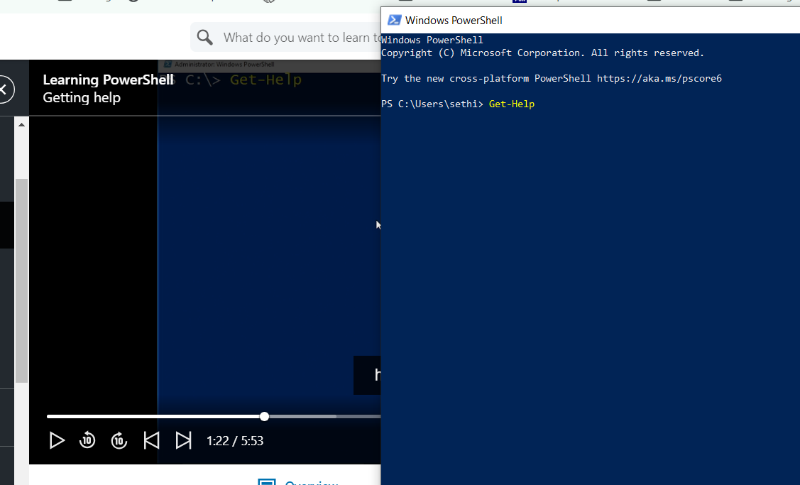

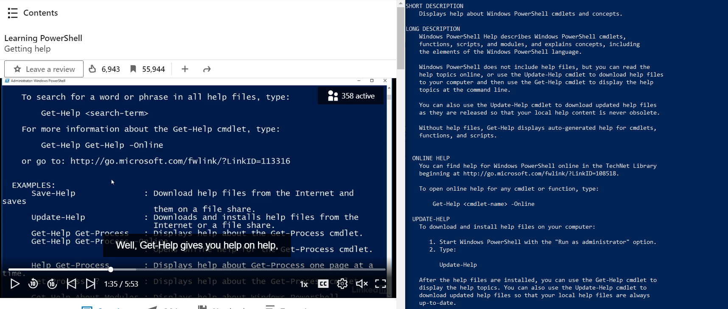

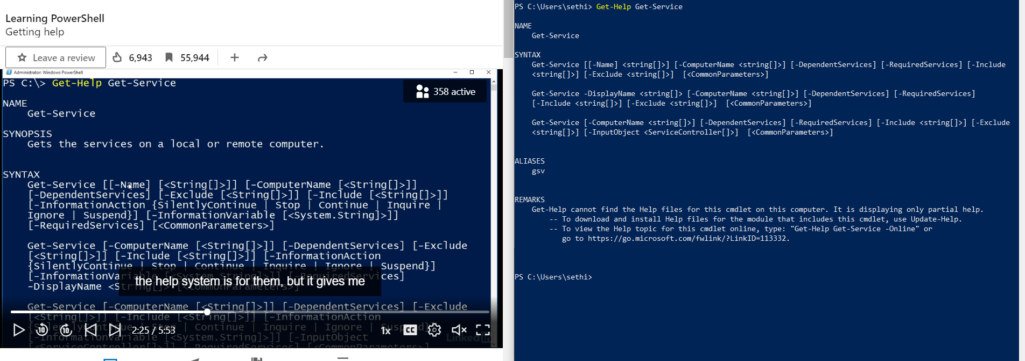

Get-Service and Get-Member
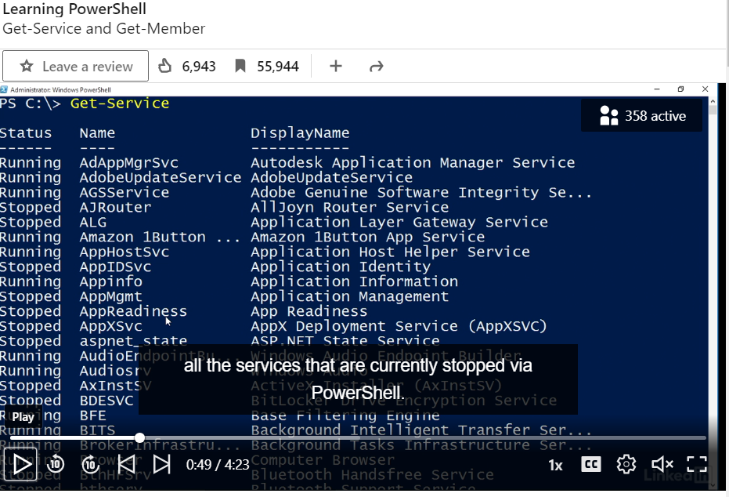
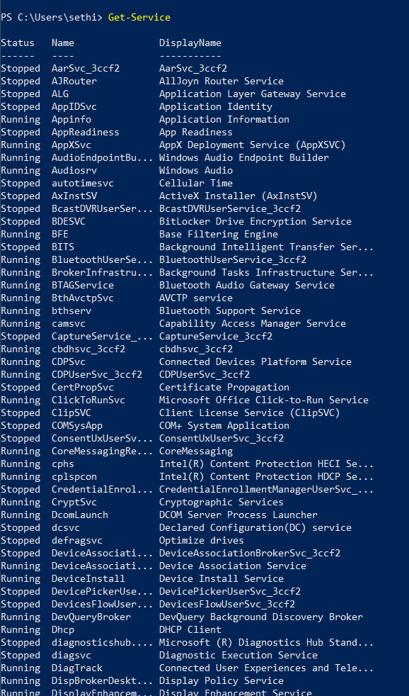

Chapter 1 Quiz
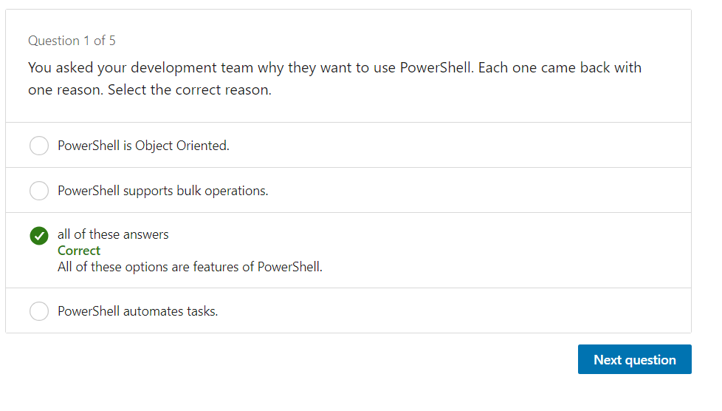

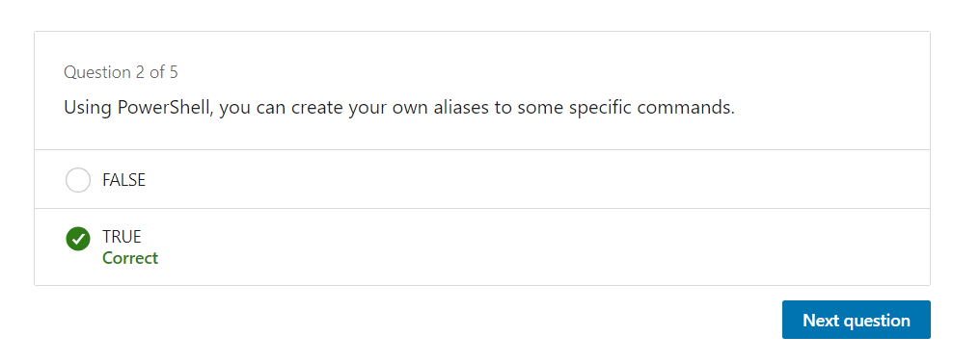

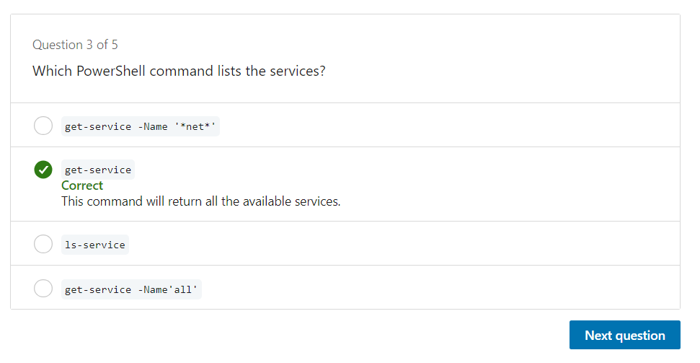
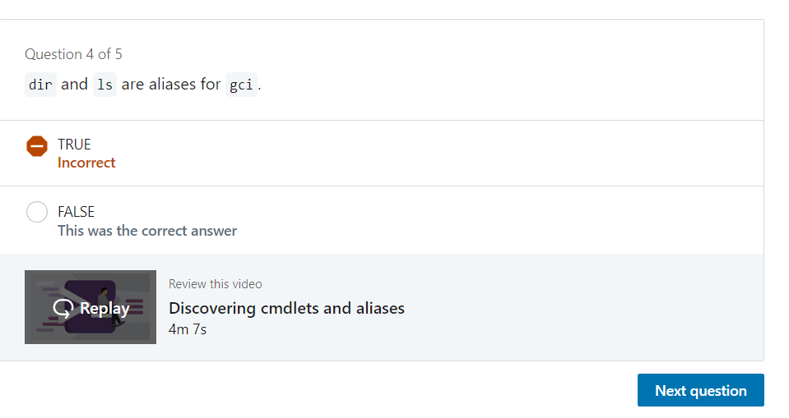

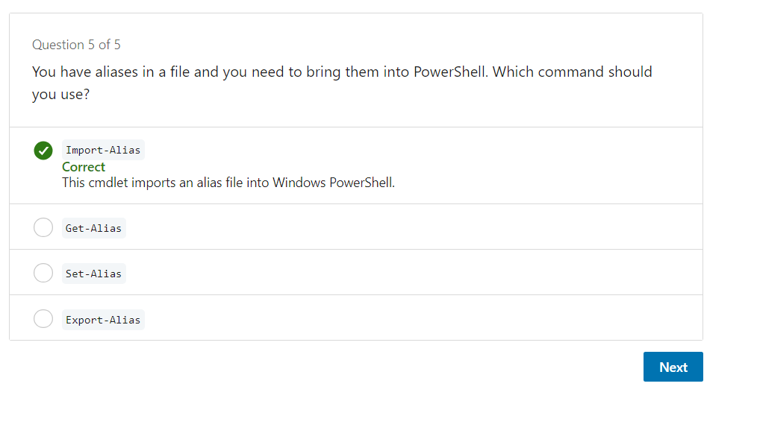

Chapter 2

Working with output
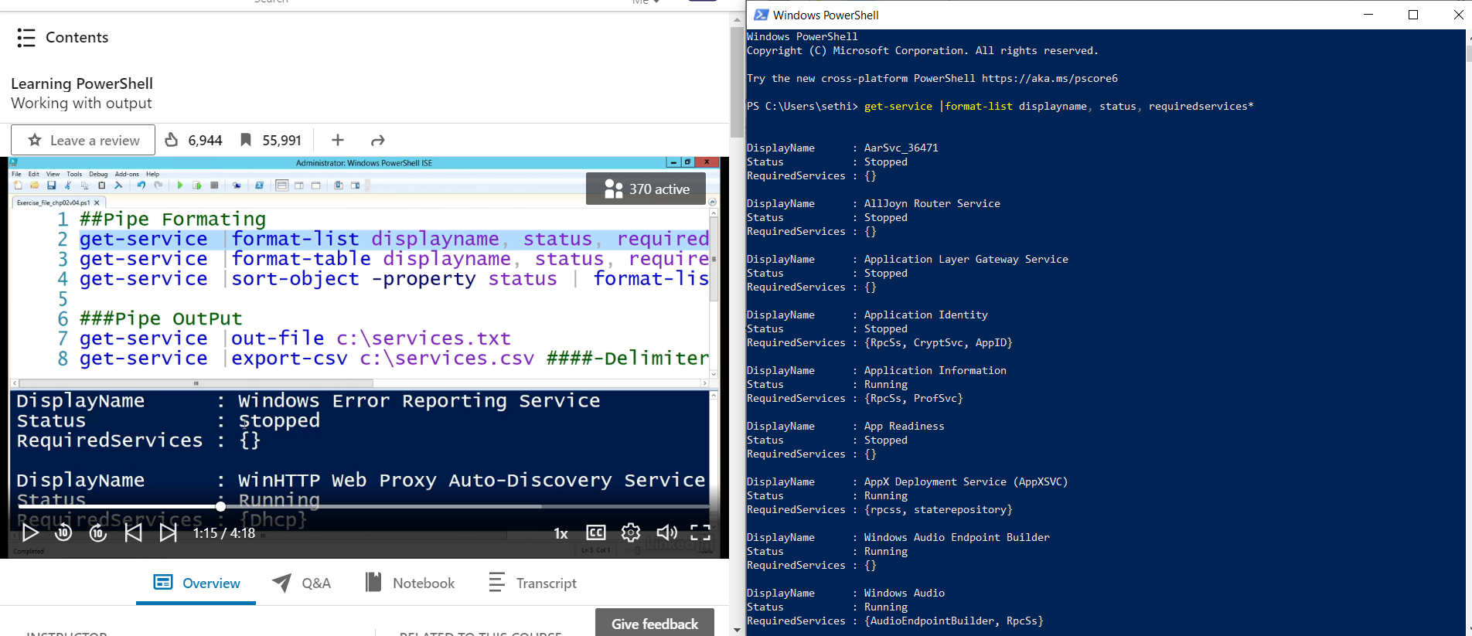

Grid View
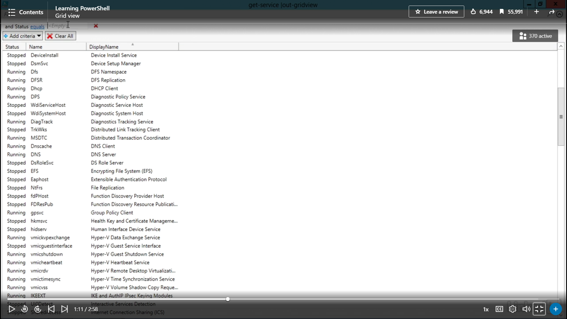
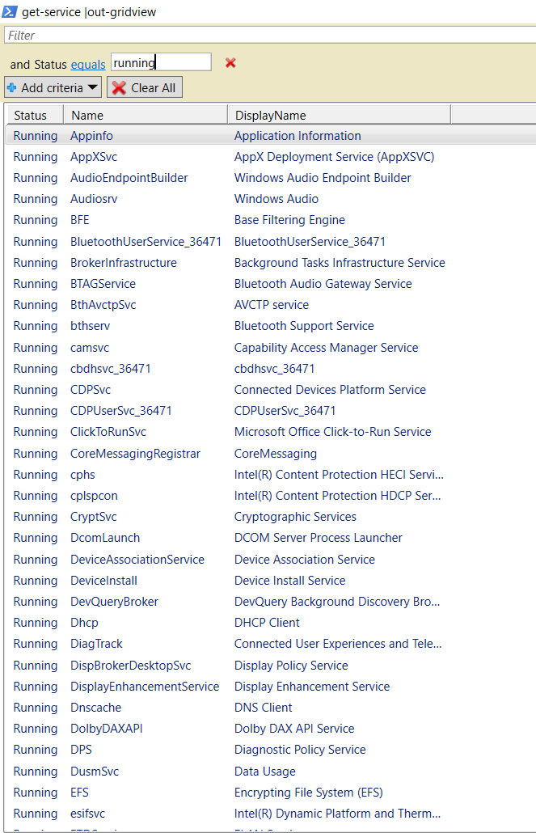

Chapter 2 Quiz


