The Sleeping and the Departed
Changing attitudes to death in a small town

Lampeter boasts an impressive history. Its University is a cornerstone of higher education, it holds the grand titled of the birthplace of rugby in Wales and has a thriving community that can trace its ties to the town back for generations. A key focus of the historic and often quirky community is that of St Peters Church. Perched at a central point of the town, there was a time when you could use its spire to orientate yourself from just about any point in town. Surrounding it is a graveyard with roughly 2000 decaying residents, more added to it monthly, and there is a rich history to be found through the memorials left by the living for their dear departed.

Attitudes change with values and time. Rituals enacted for the dead differ with each refrain of the church bells. And all of it can be seen in the memorials.

Method

To gain a rounded picture of the story given by the graveyard it was immediately necessary to gather as much data as possible given the time constraints. To do so, a plan was needed. I used a satellite image of the church and surrounding area to create a blank plan (appendix 2) that I could use as a guide and record while I completed my survey. I then drew up several pages worth of tables (appendix 1). These tables had headings designed to help connect a grave number and position with the later photographs that were taken of each one, and to give an idea of the dimensions of each.
I took the first appearing name and the date of death mentioned on the gravestone as a way of identification. The measurements were taken at the widest, deepest and tallest points of the monument, taking the base into account too. Some of the heights had to be approximations as I wasn’t tall enough to accurately measure them with the equipment I had. I also included a clumn for notes and used it to make a note of others named on the grave, the general shape and the state of the less cared for graves. I used blanket terms to describe the shape of the grave, including bed, flat and obelisk (which I rarely managed to spell while conducting the survey). Examples of each are shown in fig 1.6-1.8.
I took the details of blocks of 34 graves (the number of lines per page) at a time. I would first take the name, date and other information available, then move to the nearest grave to my right. I tried to keep in as neatly regimented rows as possible for my own ease. Once I had filled a page with this data, I returned to the first stone and took the measurements in the same sequence I had used to record the details. Finally, I would go back to the first stone again and take photographs in the same sequence of the front, back, sides and any inscriptions unclear in a full photo. This method saved me a lot of time as I could work through each task quickly without having to constantly change equipment. This meant I could use time more efficiently and collect more data.
When weather or time demanded that I stop for the day I would immediately digitise the information I collected by putting it into a central spreadsheet. I would also scan in each completed page for safe keeping and upload the photographs into a separate dated folder. This safeguarded the data I had already collected against issues such as a corrupted memory card or accidents.

Results

I originally collected just over 600 examples from the graveyard, with dates ranging from 1800 to the early 2000s. From this initial amount of data I chose 20% to go into the results to be used for the analysis. The sample 20% is below.

Year | Euphemism | Epitaphs | Language | Religious symbols | Foliage
1802 | Died | r | e |  | y
1822 | Died | NR | W | Y
1833 | departed this life | r | e/w | y | y
1842 | departed this life | nr | e/w | y
1846 | Died | n | e |  | y
1851 | Died | R | W | y
1852 | Died | R | W
1856 | Died | n | E | y
1856 | Died | R | W |  | Y
1857 | Died | n | W
1857 | Died | nr | w
1858 | Died | r | w
1858 | Died | n | e
1859 | Died | r | E/W
1860 | Left this life | R | W | Y
1861 | Died | nr | w
1862 | Died | r | w | y
1865 | Died | r | w | y
1866 | Died | nr | w | y
1867 | Died | n | w |  | y
1870 | Died | n | w | y
1871 | Died | r | w
1871 | Died | R | E/W
1872 | Died | r | w |  | y
1873 | Departed this life | NR | E | Y | Y
1873 | Died | n | E
1874 | Fell asleep | R | e | y
1875 | Departed this life | Re | E | Y | Y
1875 | Died | r | e | y
1876 | Died | n | E | Y
1876 | Died | R | E | Y
1876 | Died | r | w | y
1876 | Died | r | w | y
1877 | Died | NR | W |  | y
1878 | Departed this life | R | E
1878 | Died | n | e | y
1878 | Died | nr | w | y
1878 | Died | r | e |  | y
1879 | Died | nr | w |  | y
1880 | Died | n | e
1880 | Died | nr | w
1881 | Departed this life | r | e | y | y
1881 | Left this world | r | w | y
1882 | Died | r | E/W
1882 | Died | nr | e | y
1882 | Died | nr | e/w |  | y
1884 | Died | r | e |  | Y
1884 | Died | n | W
1886 | Died | R | W | Y
1886 | Died | NR | E | Y
1886 | Departed this life | r | e | y | y
1888 | Died | r | w | y
1889 | Died | R | W |  | y
1889 | Died | r | w |  | y
1889 | Died | R | W | Y | Y
1890 | Died | nr | w | y
1891 | Died | NR | W |  | Y
1891 | Died | n | E | Y
1891 | Died | r | w | y
1891 | Died | r | w | y
1893 | Died | r | w |  | y
1895 | Died | nr | w |  | y
1896 | Died | nr | w
1897 | Died | R | E | Y
1897 | Died | r | e | y
1897 | Died | nr | w |  | y
1898 | Died | R | E | Y | Y
1899 | Died | r | e |  | y
1900 | Died | R | E | Y
1900 | Died | r | w | y | y
1901 | Died | R | W |  | Y
1901 | Departed this life | n | E
1901 | Died | R | E | Y
1901 | Died | n | W
1901 | Died | r | w | y
1901 | Died | NR | W | Y
1902 | Died | R | W | Y | Y
1902 | Died | n | W |  | y
1903 | Died | nr | w | y | y
1903 | Died | r | w | y | y
1903 | Died | n | w | y
1905 | departed | n | e
1907 | Died | NR | E | Y | Y
1908 | Died | r | e | y
1908 | Died | NR | w |  | y
1910 | Entered into rest | R | E | Y
1911 | Died | r | w |  | y
1915 | None | R | W | Y | Y
1915 | Died | r | e | y
1918 | Died | nr | w |  | y
1919 | Died | n | w | y
1920 | Who fell asleep in Jesus | NR | W | Y | Y
1920 | Died | NR | E/W |  | y
1921 | Died | NR | w |  | y
1922 | Died | n | e | y
1923 | Died | r | w |  | y
1923 | Died | r | w |  | y
1923 | Died | nr | W |  | y
1927 | Died | R | E
1927 | Died | r | w |  | y
1928 | Died | nr | w |  | y
1929 | Died | R | E
1935 | Died | r | E/W
1936 | None | nr | w
1936 | Who hunted in the procession | NR | w |  | y
1937 | Died | RIP | E
1939 | Died | r | e | y
1940 | None | NR | W |  | Y
1949 | Fell asleep | NR | E | Y
1950 | Passed away | n | E |  | Y
1957 | Died | N | w |  | y
1962 | Died | N | E
1970 | Died | N | w
1970 | Died | N | w
1979 | Died | rip | e | y
1993 | None | N | E
1997 | None | NR | E | Y | Y
2002 | None | R | E
2003 | None | N | E

Not included are the dimensions of the gravestone or extra notes. As these were taken from the accompanying photographs, the data recorded includes Euphemisms for death, Epitaph themes (Religious = R, Non-Religious = NR, None = N, Rest in Peace = RIP), Language (English = E, Welsh = W, English and Welsh = E/W), Religious iconography and plant iconography.

Below are graphs to summaries the information.

Graph 1.1 – Graph to show the distribution of Epitaph themes in the churchyard

The above graph shows that religiosity takes up just under half of the total number of epitaphs. This could be linked to a final demonstration of religious belief for the deceased, but more likely it is a method for the bereaved to demonstrate their own feelings, as many of the translated epitaphs mentioned subjects such as rising again and meeting in heaven. The same can be said about the non-religious epitaphs, as when translating these I found the over whelming majority to be conciliatory.

Graph 1.2 – Graph to show popularity of language over time

The graph, while not wholly representative of the entire graveyard, shows that there was a significant spike in Welsh being used on gravestones in the mid-1800s. English did remain popular, but it never managed to overtake the popularity of using Welsh after this point. This could be linked to national identity being prised more as time went on. Its decline in the early 1900s could be linked to people moving into the town for various reason such as escaping WW1 or for economic reasons. Its around this time that I observed a gravestone written in French, which lends weight to this theory.

Graph 1.4 – Graph to show popularity of euphemisms for death used over the years

The graph above shows that the metaphor of sleeping, despite being reflected in many of the ‘bed head’ shapes of gravestones, experienced only a brief popularity from the mid-1800s to the mid-1900s. While the euphemism of leaving, and the outright statement of ‘died’ remained steady in popularity, indicating a certain inevitability associated with death. Only in the early to mid-1900s did the romantic notion of sleeping become more prevalent.

Graph 1.4 – A graph to show the difference between the popularity of different icons

Religious icons have gradually lost their popularity over the years, which coincides with the general move towards secularism. However, in the early-1900s they experienced a resurgence. This is probably linked to the troubles at the time, that of WW1 and financial troubles. As such, people sought solace and understanding in the Church institutes.

Discussion

The above graphs show a significant trend through the years, trends that coincide with generational shifts, with moves away from religious thoughts in later years and the thought of death becoming more detached as the world progressed. In order to analyse this in depth, I have made a direct comparison below.

Ancient vs Modern: A comparison of the photographic evidence

After surveying the graveyard and recording just over 600 results, it became clear that analysing every single one would not just be very time consuming and dull, but the graduation of the changes would hide the larger differences between them over time.

To demonstrate the shifts in gravestone design over the years, I selected three typical gravestones, one from my earliest range of examples, one from the middle range of examples and one from the most recent graves. I used a visual comparison to decide on which were typical of their time.

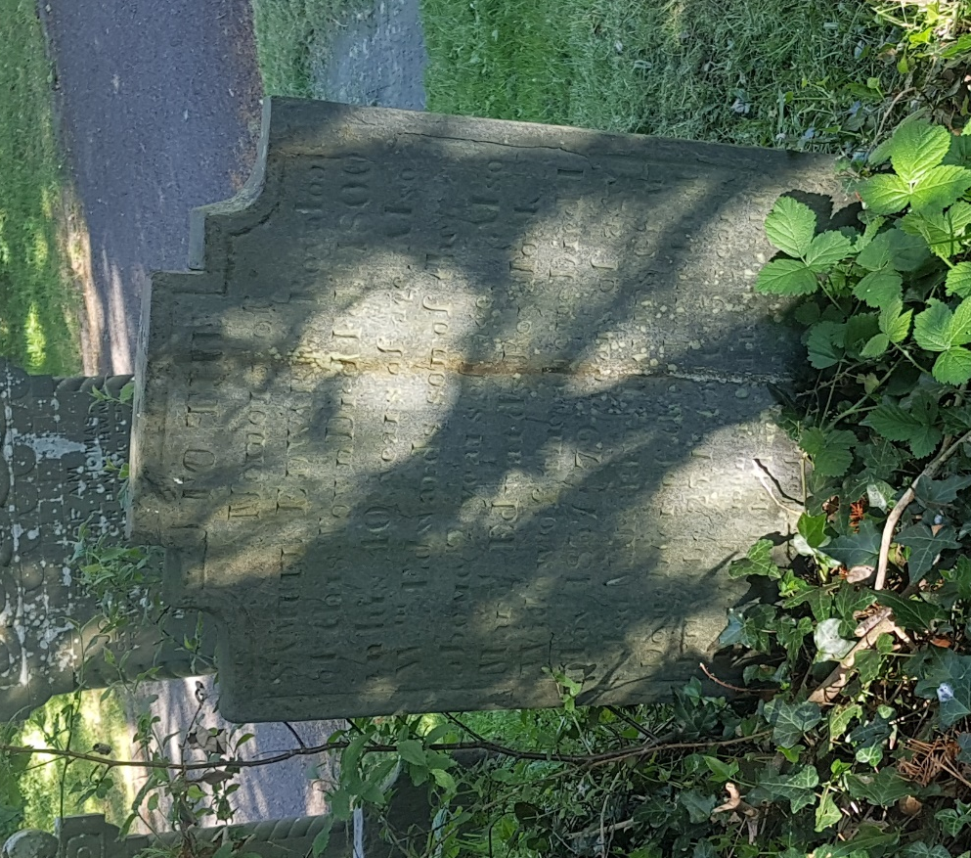
Transcription: To the memory of Samuel Edwards Royaloak of this town Died Feb’ 1800 in his 40 year of age. Also M Edwards son of the above 2 years of age. Also Marg. Edwards Royaloak Wiidow of the above Died 1 May 1837 79 years of age Also MARGARET Davies Gran Daughter of the above Died July the 25 1847 Aged 5 years.

Fig1.1 – Gravestone of Samuel Edwards (1800) 192

Samuel Edwards gravestone sits in the lower part of the South East side of the graveyard. It faces East, and stands 77 by 51 by 5 cms. It can be loosely defined as a ‘bed’ shape, and contains mostly English text, except for a small piece of Welsh text on the bottom (which has become unreadable due to age). It appears to be made of slate, and only has a thin line around the edge of the stone. It mentions three other family members, those of Samuel Edwards son, his wife and granddaughter. There is no evidence of a religious theme aside from the burial direction, although the obscured quote could have that theme.

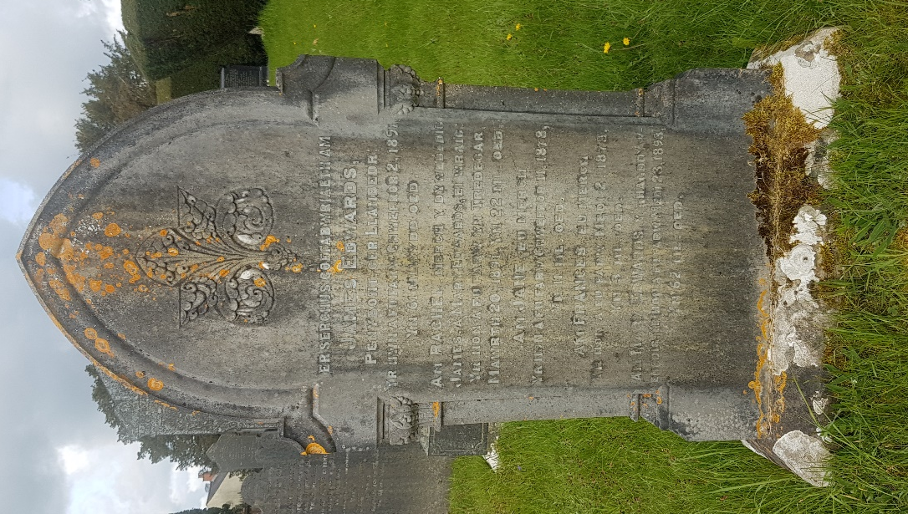

Translation:
A memorial for
James Edwards
Penybont, near Llanbedr
Who died on February 2 1891
At age 61
About Rachel, the daughter of the said
James, and Mary Edwards, his wife
Who died in Tredegar
March 20 1891 at age 22 years old
For Jane their daughter
Who died on February 11 1878
At age 11 years old
For Frances their daughter
Who died on September 2 1878
At age 3 years old
For Mary Edwards the pre-eminent
Who died September 23rd 1893
At age 62 years old

Fig 1.3 – Edwards family gravestone (1891) 38
James Edwards memorial stands with a number of other family memorials, facing East in the South East section of the graveyard. It is the largest of the three at 160 by 91 by 31cms, and the most ornate of all of the three. The family members listed are all immediately related to the first named on the list. It is the only one to feature a motif or the ornate Corinthian column, and reflects the fashion of the time towards more ornate stones. I believe that the leaves in the motif are oak, which is commonly used to represent strength.
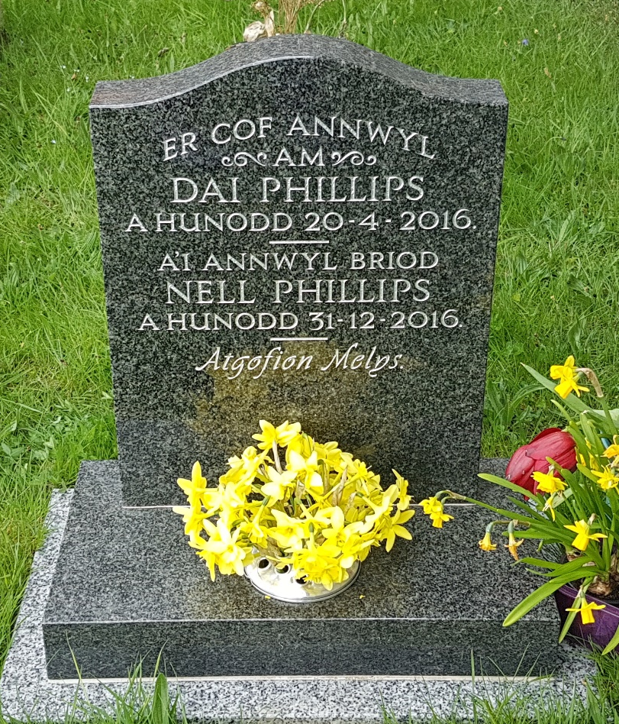

Translation:
In loving memory
Of
Dai Phillips
Slept 20-4-2016.
And his dear spouse
Nell Phillips
Slept 31-12-2016.
Sweet memories
Fig 1.3 – Gravestone of Dai Phillips (2016) 25

Dai Philips gravestone is located right next to the church, among a cluster that was hugging the edge of the building, and directly facing one of the most common entrances to the graveyard to the East. Through speaking to one of the woman that worked in the church, I established that all of those in the cluster were members of the clergy or deeply involved in the church. It stands at 160 by 91 by 31cm. It is made of black marble, with white painted letters and entirely Welsh language. There are no decorations, but it has the relatively modern addition of built in flower holder.

The headstones show a progression from what amounts to little more than carved legal document, to a show of status for the family, to a centre point of remembrance.

The first headstone concentrates on readable, lasting records. It includes ages, relations, places of work and dates, and while it has a small portion of Welsh that may or may not be sentimental, it was placed near the end and was not carved as deeply as the rest of it. In this time, or at least in the nearest possible census data of 1801, the population of Lampeter was 669 people. The small stature of the grave can be taken as a remark on the general size and wealth of the town. The English shows the prevalent situation of schooling at the time. While the Welsh language was largely spoken without exception in rural towns. However, education came from the Church. At the time, most of the clergy spoke English. They would only learn Welsh later if they chose to (and many didn’t). The clergy in their position as an authority figure would have needed the headstones to be written in English for simple clerical purposes.

The second headstone still holds to giving details of where they lived, but they do not hold the importance before. Instead, the name is emphasised through being larger than the rest of the writing, allowing it to be read from a distance. Its carved edges attract attention, although it still hast he names lower the eyelevel, which reinforces the need to bed over in a bowing motion to read them. The change to Welsh implies that the revival of the Welsh language and pride was occurring. This fits with the historical evidence at the time, and the pride displayed by the Welsh at the time. At this time, the population had doubled since the 1801, and with it came the business and the wealth that would have allowed them to make more ostentatious and display their accumulated wealth. This wealth is shown in the church itself, with three of the most spectacular stained glass windows (Peters Commission and St Christopher by Robert Newbery) being commissioned just a few years later. Status is shown as becoming more important as something that is not only demonstrated in death, but lasts for future generations to see.

The third headstone shows a move away from the ostentatious gravestones to the smaller, more regimented gravestones. Along with most other contemporary gravestones it was around knee height. The modern day Lampeter has just under doubled in size from 1891, taking its population to 2970 as of 2011 (this number discounts the 1000 or so students that contribute to the total population). The Welsh language is still prominent, but it is displayed more comfortably. Rather than having a long inscription in Welsh it simply has a few words that shows pride but does not take it too far.

Appendix 1: Original data

The list of 621 gravestones that were recorded during my survey added about 2000 words to my word count and so have been left out. For the simple fact of size restrictions on this document the photographs taken (of which there are about 1000 as I had to sometimes take close ups or photos of specific features) are not all included, but are available on request (1703149@student.uwtsd.ac.uk) Instead I have included a sample of my original record sheets below and a picture of the data.

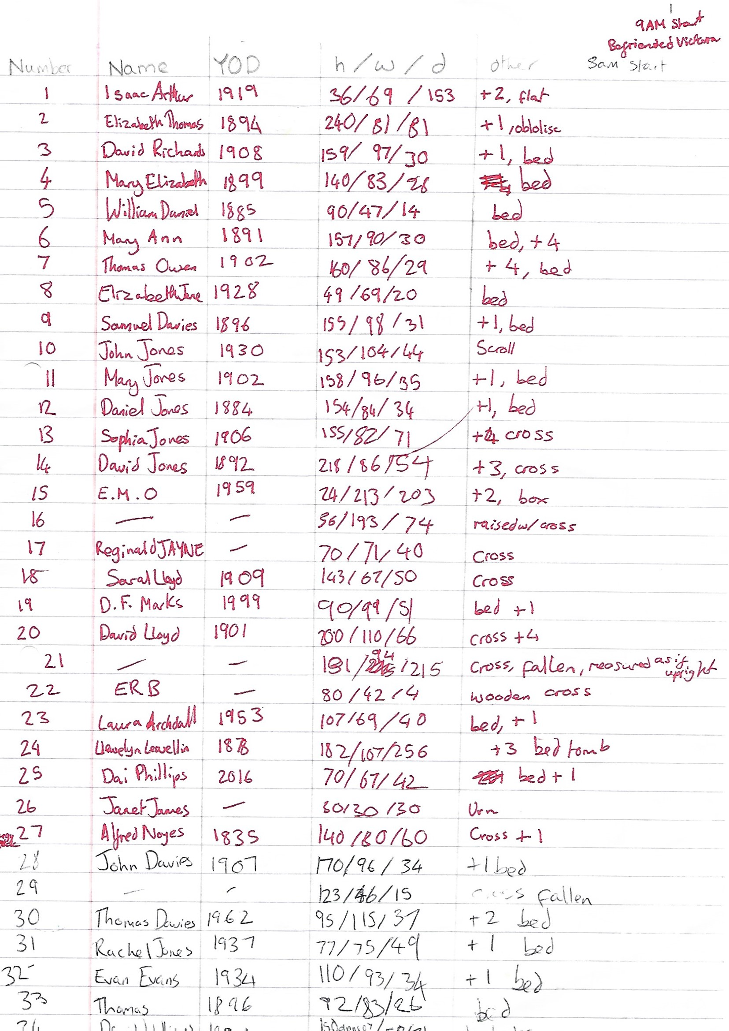
qAM
斗
一
扌

Appendix 2: Graveyard Outline
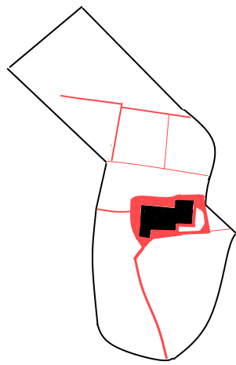
Appendix 3: Acknowledgements
I want to make clear that I received a great deal of advice and information from Victoria Hacket of St Peters Church and from John Pugh, my neighbour. These two people know literally everything about Lampeter, and their help is very much appreciated.

References
Carlson, K. et al., 2010. Plant World. In: K. Martin & A. Ronnberg, eds. The Book of Symbols. Cologne: Taschen, pp. 132-133.
Crampin, M. & Hammond, J., 2017. Stained Glass at the Church of St Peter, Lampeter. Aberystwyth: Sulien Books.
Earnshaw, E., 1970. Modern British History for Schools in Wales. Denbigh: Gee & Son.
Jones, J., 1976. How to record graveyards. London: British Council for Archaeology.
Kristiansen, K. & Rowlands, M., 1998. Social Transformations in Archaeology. London: Routledge.
Lewis, W., 1997. A History of Lampeter. Ceredigion: Ceredigion County Council.
Morgan, K. O., 1995. Modern Wales: Politics Places and People. Cardiff: University of Wales Press.
Roderick, A. & Davies, E., 1994. Llambed Ddoe (Lampeter Yesterday). Lampeter: Gwasg Gomer.
Tarlow, S., 1999. Bereavment and Commemoration. Hodder, Ian ed. Oxford: Blackwell Publishers Inc.
Williams, H., 2003. Archaeologies of Remembrance. New York: Kluwer Academic/Plenum Publishers.
Winter, G., 1975. The Golden Years 1903-1913. Harmondsworth: Penguin.

