REPORT CASE STUDY:THE SEACREST LODGE
STUDENT ID:2018070
STUDENT NAME:EMANUELA IOANA MUNTEAN
LECTURER NAME:JALIYA de SILVA
MODULE CODE:BMIH5007
J
EXECUTIVE SUMMARY
Market analysis helps in evaluating the financial situation of any organisation and at the same time helps in the identification of the opportunities and threats for the organisation. This report aimed to shed light on the business situation of the Seacrest Lodge. From this report, it has been found that the net income of the organisation declined from 300,000 GBP in 2021 to a loss of 150,000 GBP in 2023. However, it has been seen that the REVpr for the hotel increased to 420 GBP in 2023. On the other hand, a downfall in the current and profitability ratios. Brexit and inflation have been identified as the primary reasons for the downfall of the business. In this context, influencer marketing and the inclusion of AI and machine learning have been suggested to Seacrest Lodge concerning the improvement of reputation as a premier vacation destination.

Table of Contents
1. Introduction 3
2. Background Analysis 3
3. Analyse the Seacrest Lodge’s financial performance over the past three years. 3
3.1 Income Statement 3
3.2 Balance Sheet 4
3.3 RevPAR 5
3.4 Liquidity Ratios 5
3.5 Profitability ratio 6
4. Identify the key reasons behind the decline in profitability, taking into consideration real-world events and the current economy 8
5. Develop (if possible) a comprehensive turnaround strategy to revitalise the lodge’s financial health and restore its reputation as a premier vacation destination or the most viable financial outcomes. 9
6. Conclusion 10
References 12

1. Introduction
This study will shed light on the effective assessment of the financial health of the Seacrest Lodge with the analysis of its organisational performance in the competitive business market. Also, it provides the background overview of the firm along with the ratio analysis which will provide an accurate picture of the financial position of the organisation along with the major reason that influences the revenue of the company as well. Apart from this, real-world events will be assessed with the formulation of the turnaround strategy which will enhance the financial health of the organisation and help to deal with the external challenges which create a significant impact on the organisational operational activity as well.

2. Background Analysis
The Seacrest Lodge is a popular restaurant which is based in Scarborough in the UK and this company has a reputation for providing a high standard of service to their targeted audiences to attract more customers towards the firm as well. This place has 8 bedrooms along with a fully equipped kitchen with a dishwasher and an oven. Also, it provides a washing machine and 4 bathrooms with a hot tub and the accommodation is non-smoking (Booking, 2024). Apart from this, Flamingo Land Theme Park is 37 km from the Seacrest Lodge which attracts more tourists to this place.

3. Analyse the Seacrest Lodge’s financial performance over the past three years.

3.1 Income Statement
Based on the income statement, the organisation gets an accurate picture of the profitability of the firm and makes an effective strategic approach for further improvement. In this scenario, it has been identified that the major aim of the profit and loss statement is to track the entire income and expenses of the firm to reduce further expenditure. Currently, a wide range of organisations use the GAAP framework in their income statement to estimate the financial health of the firm and increase their productivity as well (ICAEW, 2023). Therefore, from the below picture, it has been identified that the revenue of the firm has been decreasing from 2021 at £1,2,00,000 to 2023 which stood at £950,000. On the other hand, it seems that the operating expenses have increased in FY 2023 which reached almost £1,100,000. Hence, the numerical value reflects that the management team of the Seacrest Lodge is unable to control their entire expenses which decreases their performance as well. Lastly, it has been found that the value of net income in FY 2021 stood at £300,000 which has fallen at £-150,000 due to the high range of the operating expenses as well.
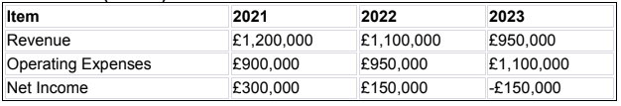
Figure 1: Income statement
(Source: Refer to case study)

3.2 Balance Sheet
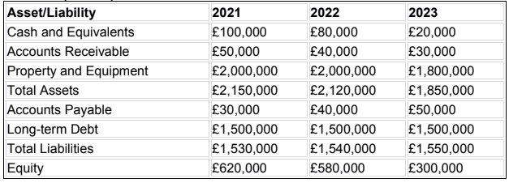
Figure 2: Balance Sheet
(Source: Refer to case study)
From the aforementioned figure, it has been identified that in FY 2021, the total asset value reached approximately £2,150,000 and it has been decreased to £1,800,000 in the financial year 2023. However, in FY 2021, the value of the total liabilities reached almost £1,530,000 which has been increased to £1,550,000. Based on the numerical value, it can be stated that this company has a higher amount of liabilities than its asset value which has a significant impact on the business performance and its profitability as well.

3.3 RevPAR
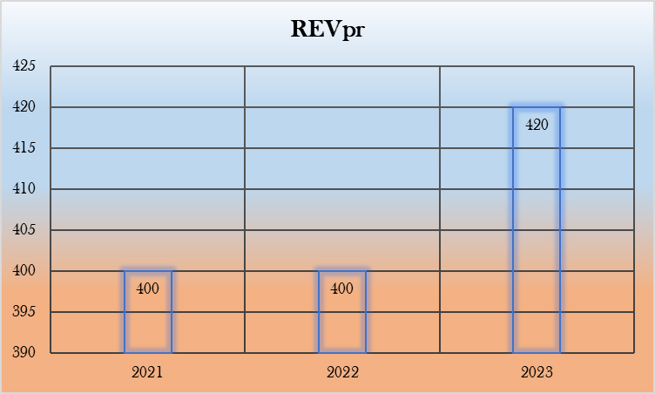
Figure 3: REVpr
(Source: Created by the author)
The above figure 3 reflects that REVpr has increased from 400 British Pound in FY 2021 to 420 British Pound in FY 2023. Therefore, the numerical value indicates that Seacrest Lodge’s revenue per room has increased in the last few years.

3.4 Liquidity Ratios
Current ratio
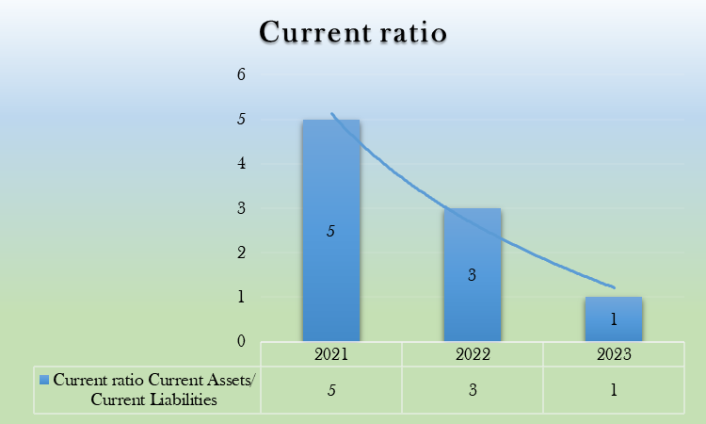
Figure 4: Current ratio
(Source: Created by the author)
The current ratio is also recognised as the working capital ratio which assists in estimating the capability of the entire business to meet the short-term obligations which are due within a year (Corporatefinanceinstitute, 2024a). Based on the aforementioned computation, it has been identified that several calculations have been done in FY 2021, 2022 and 2023 to assess the financial health of the firm. Therefore, in FY 2021 the value of the current ratio stood at 5 which decreased in FY 2023 at 1 time. Based on the numerical value, it seems that Seacrest Lodge faces high short-term debt which declines their current asset value as well.
Cash ratio
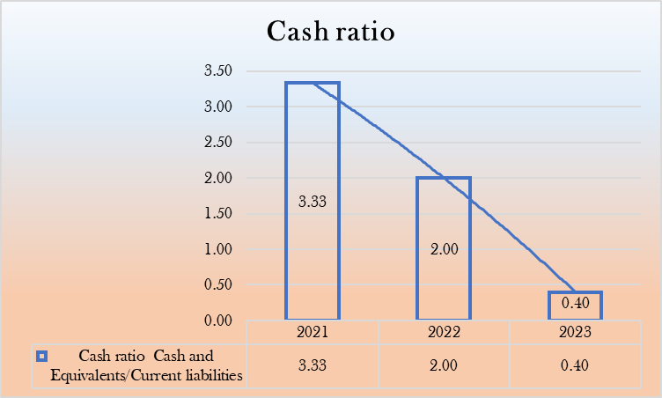
Figure 5: Cash ratio
(Source: Created by the author)
The cash ratio is the financial metric which refers to the ability of the firm to pay off its short-term debt obligations with the cash and cash equivalents (Corporatefinanceinstitute, 2024b). Based on the above bar graph, it has been identified that in FY 2021 the value of the cash ratio reached approximately 3.33 which fell to 0.40 in FY 2023. Based on this, it can be stated that the management team of Seacrest Lodge face high financial difficulty due to the high value of liabilities.

3.5 Profitability ratio
Net profit ratio
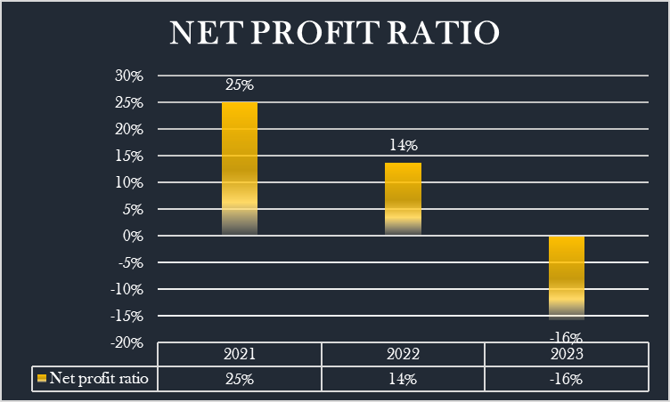
Figure 6: Net profit ratio
(Source: Created by the author)
From the above bar chart, it seems that the calculation has been conducted for the FY 2021, 2022 and 2023. Therefore, in FY 2021, the value of the net profit ratio reached almost 25% which has declined to (16%) in FY 2023. Thus, the numerical value indicated that Seacrest Lodge has inefficient management and is not able to control their overall expenses as well.
Return on equity ratio
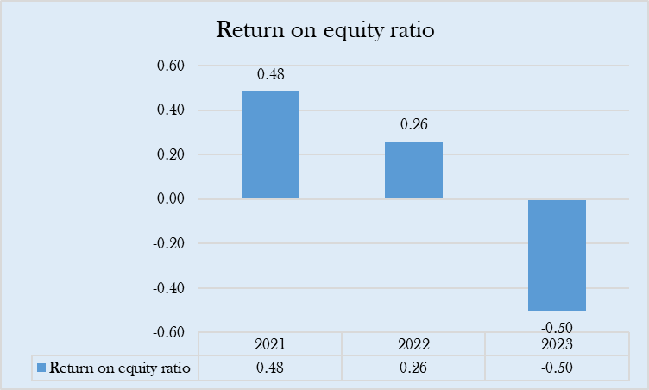
Figure 7: Return on equity ratio
(Source: Created by the author)
ROE is the financial metric which indicates the net income of the organisation which has been divided by the equity. Therefore, from the above bar chart, it seems that in FY 2021, the value of the ROE reached almost 0.48 which declined to (0.50) in FY 2023. Lower ROE reflects that the management team of the firm earns quite little compared to its shareholder's equity

4. Identify the key reasons behind the decline in profitability, taking into consideration real-world events and the current economy
A decline in profitability has been observed in the case of Seacrest Lodge. Certain factors have been assumed as the reasons for the downfall in the profitability of the organisation. These factors will be identified and will be discussed in this section.
Inflation
Inflation in the UK results in increasing the costs of the products in the UK. The change in the inflation rate can be witnessed from the graph below. For example, it can be seen that the inflation rate was much more flexible in the past decade and it gained a sudden rise in 2022. For instance, the inflation rate in the UK was 0.7% in January 2021 and it reached 11.1% in October 2022 (Statista, 2024). This indicates that a rapid increase in the inflation rate has been observed in the UK during 2022. This reflects that the costs of the commodities, products and services increased in 2022 due to the high inflation rate. However, the inflation rate declined to 6.7% in September 2023 and the inflation rate further declined to 4% by December 2023 (Statista, 2024). This indicates that the cost of the products and services declined in 2023.
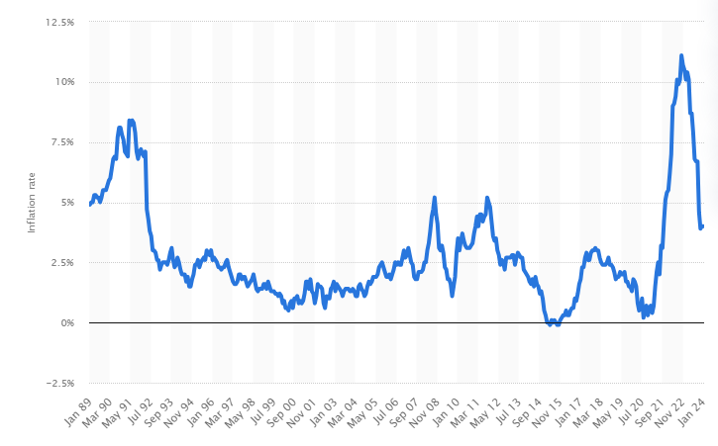
Figure 8: Inflation rate in the UK
(Source: Statista, 2024)
In addition, the impacts of inflation have been observed on food prices as well. For example, it can be seen that the inflation rate on food prices has been observed at 19.1% in 2023 (Tradingeconomics, 2024). The food industry in the UK has witnessed a surge in prices by nearly 25%. Thus, the increase in the prices for the products results in increasing the cost for the hotels and hospitality sector in the UK. Therefore, it can be summed up that the high inflation rate in the UK has resulted in lower profitability in the organisation
Brexit
In this context, Brexit can be considered a reason for the downfall of the profitability of the organisation. Brexit resulted in low availability of skilled labourers in the UK and this resulted in hindering the production and distribution channels in the UK market. In this context, it can be seen that the average income of skilled labourers was down by 2,000 GBP in 2023 and there was a vacancy of nearly 300,000 jobs in the UK (GOV, 2024). Based on the aforementioned information, it was forecasted that the low availability of employees or labourers in the UK might drain away 300 billion GBP for the UK by 2035. This reflects the seriousness of the issue.
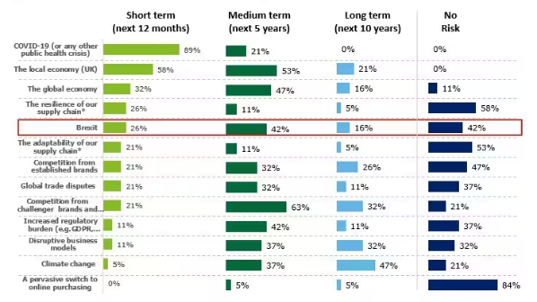
Figure 9: Risk associated with Brexit in the hotel and hospitality sector in the UK
(Source: Deloitte, 2024)
From the figure above, it can be seen that Brexit has a negative impact on the business hotel and hospitality sector in the UK. For example, Deloitte’s C-suite survey in January 2021 revealed that 42% of the respondents mentioned that Brexit has resulted in declining profits for the organisation (Deloitte, 2024). Therefore, it can be summed up that Brexit has a significant impact on lowering the profitability of the Seacrest Lodge.

5. Develop (if possible) a comprehensive turnaround strategy to revitalise the lodge’s financial health and restore its reputation as a premier vacation destination or the most viable financial outcomes.
As mentioned above, the impact of inflation and Brexit has been considered as the primary reason for the downfall in the profitability of the Seacrest Lodge. In this section, certain recommendations will be identified for mitigating such situations and improving the revenue for the organisation.
Recommendation 1: Implement artificial intelligence (AI) and machine learning to assume the change in customer demands and budget forecasting.
The use of technical tools helps in developing business operations in improving the profitability of the organisation. In this context, it has been observed that the use of AI and machine learning helps in the inclusion of the metrics and KPIs associated with business and at the same time helps in forecasting the need for the products and services in the market (Anodot, 2024). Thus, AI can help in forecasting demand and understanding the shifts in customer demands. This helps in understanding the customers buying trends. Machine learning can help in analysing the collated and recorded information of the customers and at the same time AI can help in tracing the changes in employee buying behaviour. Thus, Seacrest Lodge can use AI and machine learning to improve the sales revenue for the organisation.
Recommendation 2: Inclusion of Influencer marketing for developing the customer attraction and sales revenue of Seacrest Lodge
Influencer marketing is an emerging concept in modern days and multiple organisations across the globe are using this form of marketing to add more customers. Thus, it can be stated that influencer marketing helps in attracting customers to the organisation. The influencers on social media can promote the brands among their followers and this can help in attracting more customers to the brands and organisation. Thus, Seacrest Lodge can implement this form of marketing to boost the revenue for the organisation. In this context, Seacrest Lodge can approach various social media users from various social media platforms such as Facebook, Twitter and Instagram to attract additional customers. This strategy can help Seacrest Lodge to get trusted customers. In addition, influencer marketing has been considered suitable as it is time-efficient and cost-efficient.

6. Conclusion
Based on the above explanation, it can be concluded that Seacrest Lodge is a popular restaurant in the UK business market. In this study, profitability and liquidity ratios have been described which reflects that the management team of the firm faced significant losses in FY 2023. Therefore, based on this, organisations get the opportunity to make an effective strategic approach for the further improvement and increase their profitability in the future period of time as well. Apart from this, it has been identified that external factors such as high inflation rate and Brexit have a high impact on the organisational performance which declines the organisational performance and its productivity as well.

References
Anodot, (2024). ‘AI For Business Forecasting’. Available at: https://www.anodot.com/learning-center/business-forecasting/ [Accessed: 25 February 2024]
Booking, (2024). ‘Seacrest Lodge’. Available at: https://www.booking.com/hotel/gb/seacrest-lodge.en-gb.html [Accessed: 23 February 2024]
Corporatefinanceinstitute, (2024a). ‘Current Ratio Formula’. Available at: https://corporatefinanceinstitute.com/resources/accounting/current-ratio-formula/ [Accessed: 21 February 2024]
Corporatefinanceinstitute, (2024b). ‘Cash Ratio’. Available at: https://corporatefinanceinstitute.com/resources/accounting/cash-ratio-formula/ [Accessed: 22 February 2024]
Deloitte, (2024). ‘Brexit: Travel, hospitality and services companies rethink their operational strategies’. Available at: https://www2.deloitte.com/uk/en/pages/consumer-business/articles/brexit-travel-hospitality-and-services.html [Accessed: 25 February 2024]
GOV, (2024). ‘New report reveals UK economy is almost £140billion smaller because of Brexit’. Available at: https://www.london.gov.uk/new-report-reveals-uk-economy-almost-ps140billion-smaller-because-brexit [Accessed: 24 February 2024]
ICAEW, (2023). ‘UK GAAP’. Available at: https://www.icaew.com/technical/corporate-reporting/uk-gaap [Accessed: 20 February 2024]
Statista, (2024). ‘Inflation rate for the Consumer Price Index (CPI) in the United Kingdom from January 1989 to January 2024’. Available at: https://www.statista.com/statistics/306648/inflation-rate-consumer-price-index-cpi-united-kingdom-uk/. [Accessed: 14 February 2024]
Tradingeconomics, (2024). ‘United Kingdom Food Inflation’. Available at: https://tradingeconomics.com/united-kingdom/food-inflation [Accessed: 25 February 2024]

