Digital Transformation of Metro China
BMMB7000
Student Name: Jianmei, Liu
Student Number: 2234055
Submission Date: May 5, 2023
Word Count: 3548

Executive Summary
This report is designed to analyze the digital transformation implemented by Metro China through its cooperation with Wumart Group by selling its majority stocks to Wumart.
In the first section, this report provides a brief introduction to the change and the background of the change. Then, in section two, this report describes the aspects of the change and determines the type of this change by using the Typology of Change developed by Hodges & Jill (2015). Next, Lewin’s force field analysis is adopted to show the driving forces and restraining forces to the change and the measures and actions that Metro China took to overcome the problems. This report also uses stakeholder analysis to identify all the involved stakeholders and determine their influences with their power and interest grid. By analyzing the change process, Lewin’s three-step model and Kotter’s eight-step model are used to give a detailed analysis of the change process, the effectiveness of change and how the leaders contribute to promote the change during each step. At the end of this report, there is a conclusion and some recommendations for the subsequent steps of the digital transformation. In order to make this report critical and convincing, plenty of data and theories from books, journals, articles, companies and useful websites are used.

CONTENTS
1. Introduction 1
2. Metro China’s Digital Transformation 2
2.1 Definition of Change Management 2
2.2 Backgrounds of Change - New Retail Trend in China 2
2.3 Aspects of Change 4
2.4 Type of Change 4
3. Force Field Analysis of Change 5
3.1 Driving Forces 6
3.2 Restraining Forces 7
4. Stakeholder Analysis 8
5. Lewin’s 3-step Models 10
6. Kotter’s 8-step model 13
6.1 Process of Change 13
6.2 Results of Change 16
7. Leadership and the Change 17
8. Conclusion 18
9. Recommendation 19
Reference List 21

1. Introduction
Founded in Germany in 1964, Metro is a leading international food and non-food wholesaler. It entered Chinese market in 1996, with more than 100 stores in over 60 cities by now. Wumart Group is one of the earliest and biggest retailers in China and its technology partner Dmall, is the largest omni-channel retail digitization solution provider in China. Metro China and Wumart reached a strategic-partnership agreement to sell a majority stake in 2019 at 1.9 billion euros ($2.09 billion), forming a new ‘Metro Wumart China’ joint venture, with Wumart holding 80% stake and Metro AG holding 20% in Metro China (Metro, 2019; Wikipedia, 2022).
After Metro China sold its majority stake to Wumart, the digital transformation was being promoted vigorously by the comprehensive cooperation on operations of digital retail system with its technology partner Dmall.
This report will make a critical and comprehensive analysis of the digital transformation change experienced by Metro China, including the reasons, aspects, type, driver factors and resistance factors, progress and results of the change. In this report, some change management models such as Lewin’s three-step model and Kotter’s eight-step model will be used to analyze the change. At the end of this report, there will be a brief conclusion about Metro China’s digital transformation program and several pertinent suggestions as well.

2. Metro China’s Digital Transformation

2.1 Definition of Change Management
The Greek philosopher Heraclitus said, “The only constant in life is change”. Change refers to the process of transitioning an organization, team, or individual from their current state to a new state (Öztürk, 2016). When we talk about organizational change, this could involve various aspects such as the company's organization, technology, strategy, business, or personnel (Stobierski, T., 2020). The history of society’s development shows that no change, no growth. According to Gartner (2020), organizations today have experienced five major changes in the past three years on average. Shrm (2023) defines change management to be the systematic application of structured processes, tools and knowledge to manage the change.

2.2 Backgrounds of Change - New Retail Trend in China
Today, retail in China is developing faster and more technologically than in western countries, which leads China to the New Retail era. The term “New Retail” is created by Jack Ma in 2016, who founded Chinese E-commerce giant Alibaba, which means the integration of online and offline commerce by making use of technology to create seamless shopping experiences, namely “online + offline + logistics” (The New Retail Revolution,2019; Gepard PIM, 2023).
- Thriving of Online Shopping Platforms
China’s social media platforms and online shopping platforms like Douyin (known as TikTok in the West), Kuaishou, Xiaohongshu, Meituan, Pinduoduo, Taobao and Tmall grow rapidly and combine everything that is closely related to the consumers’ lives and all relevant functions in one super app which includes social media, live-streaming selling and digital payments, resulting in a tremendous impact on traditional supermarkets (Developers, 2022; Greeven, 2021).
- Impact of Covid-19 on Consumer Behavior
In fighting the Covid-19 pandemic, China conducted strict measures like travel restrictions and community lock-down, which have reshaped the shopping behavior of Chinese consumers with a shift from physical retail stores to online shopping platforms (Lu et al., 2022). The pandemic also created the need for contactless delivery, accelerating the development of autonomous delivery.
- Change by Competitors
Especially after going through COVID-19, retailers recognized that online to offline service would be the future. Competitors such as Sam’s Club, Costco, Yonghui and Hema Fresh have all joined the membership-only bulk retail bandwagon to offer O2O service (Sun, 2021).
In this New Retail era, Metro China must implement its digital transformation to conform to the industry trend and meet the ever-changing needs of the consumers to survive and achieve sustainable development.

2.3 Aspects of Change
Metro China’s digital transformation since 2019 includes the following aspects: digital online operation (Dmall online grocery platform and online shopping app), updated products (private brand commodities and new brand image), O2O (online and offline) service, B2B+B2C (business clients + end customers) and store upgrading (Dmall DPOS system, integrated logistics and whole digital processes of stores management).

2.4 Type of Change
According to Hodges & Gill’s Typology of Change (Hodges & Gill, 2015), it is concluded that Metro China’s digital transformation is a planned, transformational, strategic, and organizational change.
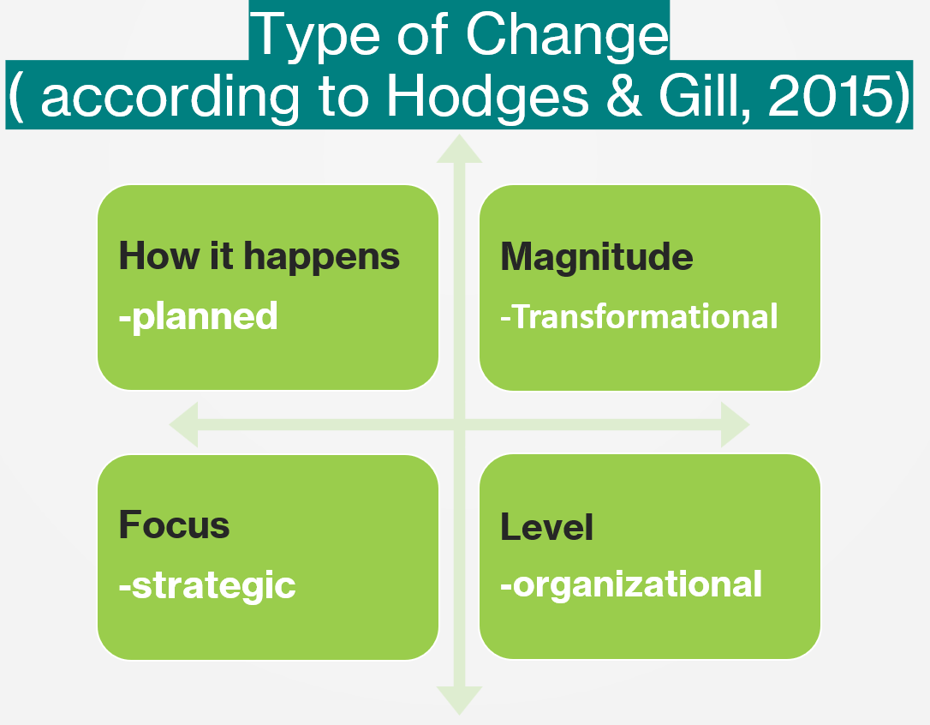
Figure 1- Type of change for Metro China’s digital transformation
- Planned. Metro China has realized the importance of digital transformation and opened online stores at Tmall Supermarket under Alibaba several years ago. The strategic cooperation of Metro China and Wumart Group is a milestone of its digitization process.
- Transformational. Metro China managed to seek a digital transformation by taking advantage of Wumart’s logistics and supply chain and its technology partner Dmall’s strong support. Its operation and service model was transformed into O2O (online and offline) service, which is a huge challenge for traditional retailers.
- Strategic. This change focuses on strategic business transformation, including enlarging its customer group from B2B to BBC, upgrading its brand image, offering O2O service, and upgrading operating systems and processes.
- Organizational. With all Metro stores in China involved, this digitization process has been implemented synchronously with opening new membership-only bulk stores as well as gradually upgrading the existing old ones.

3. Force Field Analysis of Change
Tahir, U. (2023) considers Lewin’s Force Filed Analysis (Lewin, 1951) as a powerful tool widely used to manage organizational change since there are several pressures and forces driving or restraining the change program. According to Lewin’s force field analysis of change, for Metro China’s digital transformation, the driving forces and restraining forces can be summarized as shown in this table.
Driving Forces | Restraining Forces
More membership customers (B2B+B2C) | Culture difference
Resource integration | Fear of learning new procedures and system
Upgraded store images, OS, commodities and shopping experience | Fear of losing jobs
O2O service | More education, training and coordination

3.1 Driving Forces
3.1.1 With the business model shift to serving both business customers and end customers, there will be more membership customers, which leads to a sales increase.
3.1.2 With the integration of their respective resource advantage, especially with Dmall’s digital ability, omnichannel business and service will be provided.
3.1.3 Store image, OS, commodity structure and shopping experience will all be upgraded to meet the customers’ need.
3.1.4 Offer O2O service to adapt to the new retail trend leads to maintain its market position.

3.2 Restraining Forces
3.2.1 There is an enormous difference between the two retail giants, Metro China and Wumart, which leads to slow merging progress for the new combined organization with several challenges faced.
3.2.2 People who get used to the old procedures fear of learning new procedures and systems as well as losing jobs.
3.2.3 In order to promote the digitization process, more education, training and coordination are needed.
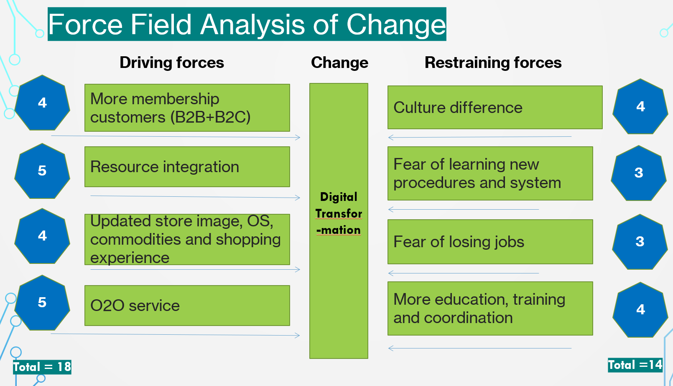
Figure 2-Force filed Analysis of Change for Metro China’s Digital Transformation
As shown in Figure 2, the total score of driving forces is apparently higher than that of the restraining forces. Lewin proposed that when the driving forces outweigh the restraining forces, the status quo will change and organizational change will happen (Burnes, 2004). All the previous analysis shows that the change is a must.

4. Stakeholder Analysis
Wikipedia (2022) defines stakeholder analysis as “the process of assessing a system and potential changes to it as they relate to relevant and interested parties”. Allen and Kilvington (2010) define stakeholder analysis as “a way to identify a project’s key stakeholders, assess their interests and needs, and clarify how these may affect the project’s viability”. Since every stakeholder may have different views and perceptions about the proposed change, stakeholder analysis should be used to identify the stakeholders with positive attitudes and those with opposing attitudes, and formulate appropriate forms of positive engagement. Therefore, the interests of all affected stakeholders will be considered.
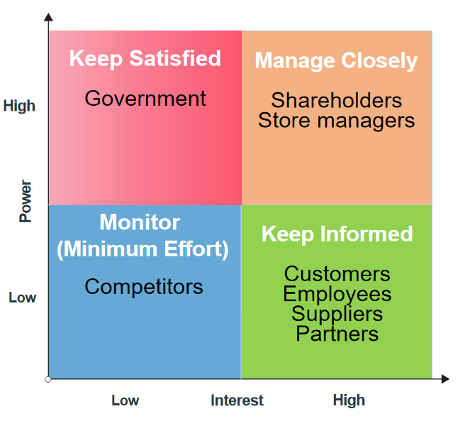
Figure 3-Stakeholder Grid of Metro China
As shown in the above stakeholder power and interest grid figure developed by Eden and Ackermann(1998), for Metro China’s digital transformation, the relevant stakeholders include shareholders, store managers, employees, customers, suppliers, partners, competitors and government. According to their power and interest in the change, these stakeholders can be classified into four categories:
- High power, low interest: the government’s policy and regulation have great influence over the operation of Metro China, but it isn’t directly involved in the digital transformation. Therefore, Metro China needs to keep the government satisfied to avoid undesirable influence on the change.
- Low power, low interest: Metro China’s competitors like Sam’s Club, Yonghui, Costco and Hema Fresh have relatively low influence on the progress of its digitization. Therefore, stakeholders in this category probably need continuous monitoring to keep informed of their trends in marketing and operation.
- High power, high interest: this category includes Metro China’s shareholders and over 100 store managers across the country. These people are the most powerful and influential stakeholders to the change and play the decisive role in complementing a successful change, either strongly supportive or oppositive. Spend more time managing these people closely and try to get their support.
- Low power, high interest: people in this category need to be kept informed, including customers, employees, suppliers and partners of Metro China.
After getting a complete picture of Metro China’s stakeholders, the company can understand the influence they have and develop an effective stakeholder management strategy and communication plan to facilitate the implementation of the change with time saved (Brugha and Varvasovszky, 2000).

5. Lewin’s 3-step Models
In order to best understand and implement change within an organization, Lewin’s three-step change management model should be considered as one of the cornerstones (Channell, 2023). In Lewin’s first Human Relations article, it is summarized that a successful change consists of three aspects: unfreezing, changing and refreezing (Burnes, B., 2020; Lewin, 1947). The following paragraphs describe in detail how Lewin’s unfreeze-change-refreeze model applied to Metro China’s digital transformation.
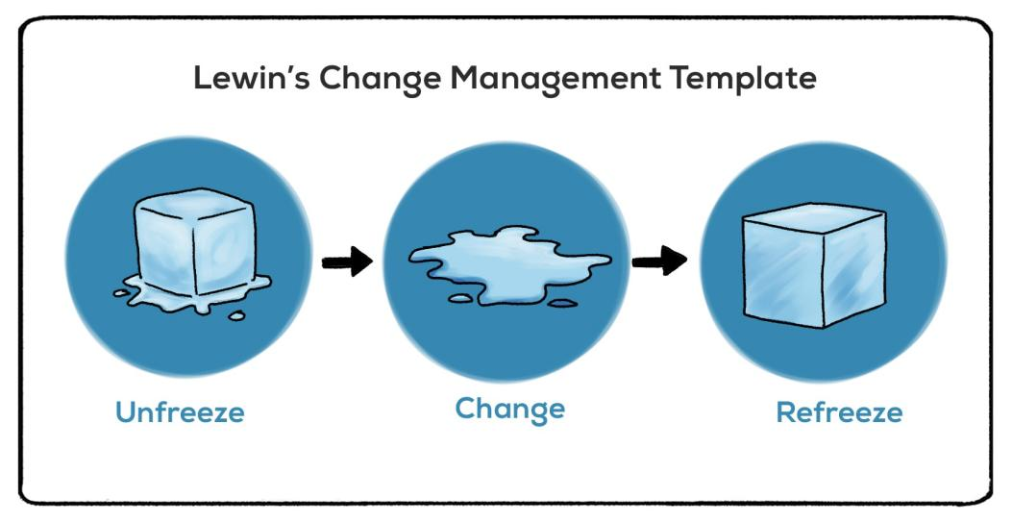
Figure 4-Lewin’s Change Management Template
Source: Psychology (2023)
Stage 1 - Unfreeze
The company needs to create the awareness that a change is needed and make preparation for the change and identify the potential resistance as well (Awati and Contributor, 2022). In this stage, based on the analysis of the new retail market trends in China and the change in customer needs, Metro China’s leaders determined to implement digital transformation in order to adapt to the evolving market environment. To achieve a smooth transition, the senior leaders held online and offline meetings to explain why change needs to happen, establish strategies, schedules and procedures of change about what and how they need to do to foster change, and made every effort to be prepared to provide sufficient support to help them to change.
Stage 2 - Change
After proper communication and preparation, it is time to actually implement the change by taking specific actions. According to Schein (1996), unfreezing creates motivation to seek change but may not be able to control or forecast the progress and outcome. This stage is not easy for the leaders and especially for the employees, since people are learning and managing to adapt to the new conditions. Therefore, it is really important to provide strong support in this stage, such as training and regular communication (Connelly, 2020). In order to successfully implement the digital transformation for all the stores in China, Metro University (its own training department) provides new related online and in-store training. A professional supervision team is assigned to stores all over the country to offer timely instruction and support. Regional coordinators are selected from managers with several years of working experience to assist the new business in stores under administration. Dmall appoints technicians to each store to give support during every step of transformation and teach the employees how to use the updated system (Menafn, 2021).
Stage 3 - Refreeze
Refreezing is the final stage of the three-step model, which means seeking to stabilize the people at a new quasi-stationary equilibrium and prevent employees from regressing to the old state (Burnes, 2004). This stage focuses on developing ways to reinforce and sustain the new change by offering rewards, modifying the organizational structure, culture, policies and norms, and establishing new metrics and criteria to measure progress (Cameron and Green, 2015; Cummings and Huse, 1989). In this stage, celebrating success and achievement is very important to reinforce the original intention of change and encourage the employees to feel willing and proactive to continue the change. For Metro China, in addition to providing strong ongoing support to the employees, the company set up several reward mechanisms to encourage good performance in new e-membership customers development and store upgrading.
Although several scholars have criticized Lewin’s three-step change model for its simplicity, this model is regarded as the fundamental approach to change management with tremendous significance and influences the subsequent change theories and practices (Cummings, Bridgman and Brown, 2016).

6. Kotter’s 8-step model
Kotter’s 8-Step Change Management Model (Kotter, 2009) is a popular framework used to help a company’s leaders smoothly implement the change in an organization. This model precisely provides eight steps that should take through the process of initiating, implementing and sustaining change (Aktas, 2023). The following section will address each step individually that Metro China took in its digital transformation.
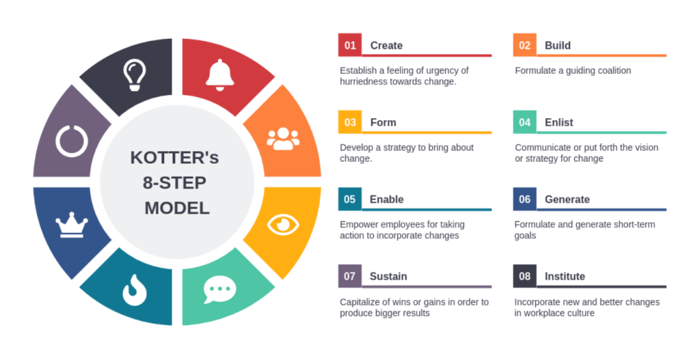
Figure 5-Kotter’s 8-Step Model
Source： Visual-paradigm

6.1 Process of Change
Step 1 - Create urgency. This step is to make all people involved to feel a sense of urgency that the forthcoming change is a must and encourage them to get engaged. Since its business model no longer suits the Chinese retail market, which mainly targets 2B customers such as hotels, catering companies, restaurants, small retailers and institutional buyers without being open to ordinary individual consumers, Metro China’s revenue has gone through a gradual and enormous decrease since 2008. In addition, driven by the rapid growth of China’s online shopping platforms and the change of business strategies developed by the competitors after the breakout of COVID-19, it was extremely urgent for Metro China to change in order to survive. The leaders emphasized the survival crisis the company faced and made the decision to sell Metro China to Wumart in 2019. Olaf Koch, CEO of METRO AG, said this transaction would further enhance Metro China’s role for customers and led to more competitive advantages (METRO AG, 2019; Wang, 2019).
Step 2 - Create a strong team. In this stage, Metro China collaborated with Dmall (its technique partner) and recruited several experienced professionals and talents in the field of digitization to work with its internal department directors and senior staff to give strong guidance and sufficient support.
Step 3 - Develop a clear vision and effective strategies. Metro China made a vision of “Becoming the more trusted and loved partner for our members”. In order to provide a more convenient and satisfying shopping experience to customers and meet their changing needs, Metro China took advantage of the digital ability of its technological partner Dmall to offer better products and services to more consumers and made a series of digital transformation strategies, which include organization structure, business model, commodity composition and store upgrading.
Step 4 - Communicate the vision. This step was achieved by using multiple organizational communication channels such as emails, Wechat and Lark working groups, in-store face-to-face meetings, online regional meetings, individual communication, gathering feedback from stores and providing point-to-point guidance to make sure the digital transformation program was understood and supported.
Step 5 - Remove Obstacles. In this step, Metro China identified the obstacles that would prevent the change from being successfully implemented, including aging operating system, unclear assignment of responsibilities, old employee resistance to change, unclear product positioning and digital platforms. Metro China introduced Wumart’s Dmall online platform, upgraded its own brand products, launched Dmall DPOS system, opening to 2C customers and implemented store upgrading in flagship stores. In addition to online and offline training, regional coordinators and technicians were appointed to each store to provide timely and professional support.
Step 6: Set short-term goals. According to Amabile (2020), the key to motivating people is to help them achieve small wins. Since change occurs as a process, organizational change couldn’t happen instantly (Creasey, 2022). Metro China’s first step to digital transformation was switching the existing outdated operating system to the new DPOS system, which was achieved just in about half a year with 2.5 years ahead of schedule. This small win brought great confidence in the change and laid a good foundation for the subsequent progress.
Step 7: keep the momentum of change going. In this step, Metro China regularly reviewed each victory and identified what to be adjusted in order to continue to produce further change. For example, Metro cut down its commodities to 4,000 products at the beginning of the change and increased the number to 8,000 after half-year because of not being able to meet the customers’ needs.
Step 8: make the change stick. Metro China got a great revenue increase and more new customers since the digital transformation, proving that this change complies with the new retail environment. Metro China continued to provide new training programs to help its employees in improving more skills to facilitate more new changes and made corresponding adjustments to the structures and procedures to match the newly developed culture.

6.2 Results of Change
Thanks to the cooperation between Metro China and its technology partner Dmall, lots of achievements were made during Metro China’s digital transformation, such as digital online operation, in-store Smart LoT solutions, store integrated logistics and the whole digital store management process. Some stores have finished upgrading the DPOS system, switching commodity, trading, membership and coupon systems.
Based on the data reported by Dmall (2021), As of the end of February 2021, there has been a significant increase in the number of e-members (54 times) and a nearly 64 times’ increase in monthly orders compared to June of the previous year. By March 2021, sales through the organization's mobile application have become a significant portion, making up 40% of overall sales.
From the above business growth, it can be concluded that this shift towards digitization aligns with the current market and trade trends and enables the company to retain its competitive position and boost its profits.

7. Leadership and the Change
According to Laurie J. Mullins (2010), leadership refers to a dynamic connection between individuals, where one person uses their influence to guide and shape the behavior and actions of others. Fullan (2020) argues effective change leadership plays a key role in making successful improvements. According to Bass’s (1985) Full Range Leadership Model, Metro China’s leaders can be classified into transformational leaders who stimulate and inspire employees to both achieve the company’s goals and improve their potential. Metro China’s leaders develop an attractive vision and make corresponding strategies. They also break down the vision into small successes until its full implementation. In addition, they attached much importance to employee coaching and training. In order to help the people fast adapt to the change, Metro China built a training alliance team that included Metro University IT, Finance, Dmall, operations and other departments. As a result, Metro China finished switching the Dmall OS system just in 6 months. They also provided more internal promotion opportunities to reward excellent performance during the transformation.
However, Metro China’s leaders should notice that one leadership couldn’t fit all (Amanchukwu, Stanley and Ololube, 2015). In order to implement change successfully, leaders must have the ability to determine and change their leadership styles according to their business situations (Nguyen and Robinson, 2015).
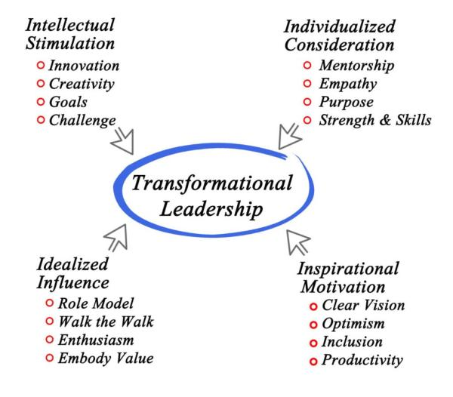
Figure 6-Transformational Leadership
Source: Ugochukwu, 2023

8. Conclusion
In conclusion, this report introduces the background and details of Metro China’s digital transformation program and applies multiple models to analyze Metro China’s digital transformation program, which aims at adapting to the new retail market in China and providing excellent quality and satisfactory experience which is easy to obtain for more customers. Based on the critical and overall analysis, this report clarifies the necessity and significance of digitization and represents the enormous challenge that Metro China faced during its progress. Metro China’s leaders created a clear vision and a well-defined plan, offered effective and frequent communication and provided helpful coaching and training on desired knowledge and skills. Metro China shared its values and vision with all the employees and got all of them involved to make greater success. With all these efforts, Metro China has successfully achieved revenue growth contributed by both online and offline businesses and gained greater customer loyalty.

9. Recommendation
As the business management consultant Estis (2023) said: “change is a process, not an event.” Although Metro China’s digital transformation has gained lots of achievements, there are still several challenges faced and more changes needed. Here are some suggestions for Metro China:
- Focus on further upgrading, which covers the ordering platform, distribution system, welfare and gifting platform, order delivery system and brand commodities.
- Continually develop more useful and powerful features of the Dmall platform according to the business demands.
- Adjust the employees’ job functions to better adapt to the new business model and working procedures.
- Keep on providing different training and coaching in order to help the employees to master desired skills and knowledge to promote the change process.
- Get feedback from the employees and communicate effectively and regularly and offer enough support as well as make necessary adjustments.

Reference List
Aktas, M. (2023) “What is Kotter’s 8 Step Change Management Model (All you need to know),” UserGuiding, 7 March. Available at: https://userguiding.com/blog/kotters-8-step-change-model/ [Accessed: May 1, 2023].
Allen, W.J. and Kilvington, M. (2010) “Stakeholder analysis,” ResearchGate [Preprint]. Available at: https://www.researchgate.net/publication/249995718 [Accessed: April 27, 2023].
Amabile, T.M. (2020) The Power of Small Wins. Available at: https://hbr.org/2011/05/the-power-of-small-wins [Accessed: May 1, 2023].
Amanchukwu, R.N., Stanley, G.J. and Ololube, N.P. (2015) “A Review of Leadership Theories, Principles and Styles and Their Relevance to Educational Management,” Management Science, 5(1): 6-14. Available at: http://site.iugaza.edu.ps/magha/files/2014/05/A-Review-of-Leadership-Theories.pdf [Accessed: April 28, 2023].
Awati, R. and Contributor, T. (2022) “Unfreeze, Change, Refreeze (Kurt Lewin Change Management Model),” WhatIs.com [Preprint]. Available at: https://www.techtarget.com/whatis/definition/Kurt-Lewins-Change-Management-Model-Unfreeze-Change-Refreeze [Accessed: April 29, 2023].
Bass, B. M. (1990) From transactional to transformational leadership: Learning to share the vision. Organizational Dynamics 18, 19-31.
Bass, B.M. (1985), Leadership and Performance Beyond Expectations, Free Press, Collier Macmillan.
Burnes, B. (2004) ‘Kurt Lewin and the planned approach to change: A re-appraisal’, Journal of Management Studies, 41(6), pp. 977–1002. doi: 10.1111/j.1467-6486.2004.00463.x.
Burnes, B. (2004) “Kurt Lewin and the Planned Approach to Change: A Re-appraisal,” Journal of Management Studies, 41(6), pp. 977–1002. Available at: https://doi.org/10.1111/j.1467-6486.2004.00463.x [Accessed: April 29, 2023].
Burnes, B. (2020) “The Origins of Lewin’s Three-Step Model of Change,” The Journal of Applied Behavioral Science, 56(1), pp. 32–59. Available at: https://doi.org/10.1177/0021886319892685 [Accessed: April 29, 2023].
Cameron, E. and Green, M. (2015) Making sense of change management. London: Kogan Page
Channell, M. (2023) “Lewin’s Change Management Model: How To Implement Organisational Change,” TSW Training [Preprint]. Available at: https://www.tsw.co.uk/blog/leadership-and-management/lewis-change-model/ [Accessed: May 1, 2023].
Connelly, M. (2020) The Kurt Lewin Model Of Change. Available at: https://www.change-management-coach.com/kurt_lewin.html [Accessed: April 26, 2023].
Creasey, T. (2022) “Change Is a Process,” Prosci, 24 August. Available at: https://www.prosci.com/blog/change-is-a-process [Accessed: May 1, 2023].
Cummings, S., Bridgman, T. and Brown, K.H. (2016) “Unfreezing change as three steps: Rethinking Kurt Lewin’s legacy for change management,” Human Relations, 69(1), pp. 33–60. Available at: https://doi.org/10.1177/0018726715577707 [Accessed: April 26, 2023].
Cummings, T. G. and Huse, E. F. (1989). Organization Development and Change, 4th edition. St Paul, MN: West Publishing.
Daniel G (2002) The new leaders: Transforming the art of leadership into the science of results. Little brown, Lancaster press, London.
Developers (2022) “5 new retail trends underway in China, that the rest of the world needs to know about,” IMD Business School for Management and Leadership Courses [Preprint]. Available at: https://www.imd.org/research-knowledge/articles/5-new-retail-trends-underway-in-china-that-the-rest-of-the-world-needs-to-know-about/ [Accessed: April 25, 2023].
Dmall (2021). Available at: https://www.dmall.com/en/newsdetailes5.html [Accessed: April 26, 2023].
Eden, C. and Ackermann, F. (1998) Making Strategy: The Journey of Strategic Management, London: Sage Publications, pgs 343 – 347
Brugha, R. and Varvasovszky, Z. (2000) “Stakeholder analysis: a review,” Health Policy and Planning, 15(3), pp. 239–246. Available at: https://doi.org/10.1093/heapol/15.3.239 [Accessed: April 28, 2023].
Estis, R. (2023) Change Is a Process, Not an Event - Ryan Estis. Available at: https://ryanestis.com/personal-growth/change-is-a-process-not-an-event/ [Accessed: May 1, 2023].
Frame, B, Gordon, R, Mortimer, C (2010) Hatched (pp.249-253). Landcare Research
Fullan, M. (2020) Leading in a Culture of Change. Hoboken, NJ, United States: Wiley.
Gepard PIM (2023) “New Retail,” Gepard PIM [Preprint]. Available at: https://gepard.io/glossary/what-is-new-retail [Accessed: May 2, 2023].
Goleman, D. (2017) “Leadership that gets Results,” in Routledge eBooks. Informa, pp. 85–96. Available at: https://doi.org/10.4324/9781315250601-9 [Accessed: May 2, 2023].
Greeven, M.J. (2021) How Chinese Retailers Are Reinventing the Customer Journey. Available at: https://hbr.org/2021/09/how-chinese-retailers-are-reinventing-the-customer-journey[Accessed: May 1, 2023].
Hodges, J. & Roger , G., 2015. Sustaining Change in Organizations. 1 ed. London: Sage Publications Ltd.
Kotter, J.P. (2009a) “Leading change: why transformation efforts fail,” IEEE Engineering Management Review, 37(3), pp. 42–48. Available at: https://doi.org/10.1109/emr.2009.5235501 [Accessed: May 3, 2023].
Kotter’s 8 Step Change Model Templates (2022). Available at: https://online.visual-paradigm.com/diagrams/templates/kotters-8-step-change-model/ [Accessed: May 3, 2023].
Lewin, K., 1947. Frontiers in Group Dynamics. Human Relations, 1 6, pp. 5-41.
Lewin, K., 1951. Field theory in social science. New York: Harper and Row.
Lu, Z. et al. (2022) “The Impact of the COVID-19 Pandemic on Consumer Behavior—Evidence From China’s Stock Market,” Frontiers in Public Health, 10. Available at: https://doi.org/10.3389/fpubh.2022.865470. [Accessed: May 1, 2023]
Menafn (2021) “Metro China and Dmall jointly build retail alliance cloud services in the digital era,” Middle East North Africa Financial Network, 5 March. Available at: https://menafn.com/1101707367/Metro-China-and-Dmall-jointly-build-retail-alliance-cloud-services-in-the-digital-era [Accessed: May 1, 2023].
METRO AG sells majority stake in METRO China to Wumei (2019). Available at: https://newsroom.metroag.de/en/news/2019/10/11/metro-ag-sells-majority-stake-in-metro-china-to-wumei [Accessed: May 2, 2023].
Nguyen, P.A. and Robinson, A.G. (2015), “Continuous improvement in Vietnam: unique approaches for a unique culture”, Journal of Asia Business Studies, Vol. 9 No. 2, pp. 195-211
Organizational Change Management | HR Insights | Gartner.com (2020). Available at: https://www.gartner.com/en/human-resources/insights/organizational-change-management [Accessed: May 1, 2023].
Öztürk, Z. (2016) “Chaos and Complexity Approach in Management,” in Advances in religious and cultural studies (ARCS) book series. Routledge. Available at: https://doi.org/10.4018/978-1-5225-0148-0.ch012 [Accessed: May 2, 2023].
Psychology, P. (2023) Lewin’s Change Theory (Definition + Examples) - Practical Psychology. Available at: https://practicalpie.com/lewins-change-theory/ [Accessed: May 3, 2023].
Schein, E. H. (1996). ‘Kurt Lewin’s change theory in the field and in the classroom: notes towards a model of management learning’. Systems Practice, 9, 1, 27–47.
Shrm (2023) “Managing Organizational Change,” SHRM, 9 January. Available at: https://www.shrm.org/resourcesandtools/tools-and-samples/toolkits/pages/managingorganizationalchange.aspx. [Accessed: May 3, 2023].
Stobierski, T. (2020) What Is Organizational Change Management? | HBS Online. Available at: https://online.hbs.edu/blog/post/organizational-change-management [Accessed: May 3, 2023].
Sun, L. (2021) “China’s members-only retailers flourish, despite growing pressure on bricks-and-mortar stores,” South China Morning Post, 1 August. Available at: https://www.scmp.com/economy/global-economy/article/3143224/chinas-members-only-retailers-flourish-despite-growing [Accessed: May 4, 2023]..
Tahir, U. (2023) “Lewin’s Force Field Analysis (Change Management),” CMI [Preprint]. Available at: https://changemanagementinsight.com/lewins-force-field-analysis-change-management/.[Accessed: May 4, 2023].
The New Retail Revolution (2019). Available at: https://www.cgap.org/research/publication/new-retail-revolution. [Accessed: May 4, 2023].
Trinidad, C. (2022) “Leadership Styles,” Corporate Finance Institute [Preprint]. Available at: https://corporatefinanceinstitute.com/resources/management/leadership-styles/ [Accessed: May 4, 2023].
Ugochukwu, C. (2023) “Transformational Leadership Theory: How to Inspire and Motivate,” Simply Psychology [Preprint]. Available at: https://www.simplypsychology.org/what-is-transformational-leadership.html [Accessed: May 2, 2023].
Wang, Z. (2019) Metro sells majority stake to Wumei. China Daily. Available at: https://www.chinadaily.com.cn/a/201910/15/WS5da51f17a310cf3e355707c9.html [Accessed: May 4, 2023]..
Wikipedia contributors (2022) “Stakeholder analysis,” Wikipedia [Preprint]. Available at: https://en.wikipedia.org/wiki/Stakeholder_analysis [Accessed: May 2, 2023].
Wikipedia contributors (2022) Wumart. Available at: https://en.wikipedia.org/wiki/Wumart [Accessed: April 30, 2023].

