


Software Development
ACCA4017

Assignment on:
Programming in C

Submitted to:
Tim Bashford

Submitted by:
Anthony Smith
1704559
Year 1 semester 2

Contents

Summary Page 2
1.The Games
1.1 High or Low game Page 2
1.1.1 Breaking down the code Page 2
1.2 Treasure Hunt Page 3
1.2.1 Breaking down the code Page 3
Problem Solving Page 3 - 6
Stages of Development Page 6 - 8
Tests and expected Results Page 8 - 12
Conclusion Page 13

Appendix
Appendix A – Treasure Hunt Game - tests and expected results Page 15 - 18
Appendix B – Connect Four Page 19
Appendix C – High or Low guessing game code Page 20 – 22
Appendix D – Treasure Hunt game code Page 23 - 27

References Page 28

Summary
The main aim of this assignment is to show evidence of the fundamental abilities that are required to implement software coding successfully. As a software developer, the need to breakdown code and utilise problem solving before executing a final product in a software package is important, as it can be time efficient and easier to demonstrate to potential employers / work colleagues.
Tasked with three mini games to code and with an increasing difficulty level, each game will allow the opportunity to display the knowledge and the know-how needed in going forward and deliver the necessary coding tools that will be essential to becoming a successful software developer.

1.The Games
1.1 High or Low
A two-player game, in which the first player chooses seven numbers with a value from one to ten in no particular order. Those numbers are then hidden from player-two with the exception of the first chosen number, which the second players choice will be based on. Once the first value has been displayed, player-two then decides to either go higher than the value or lower than it. If he/she is right they will continue to guess the values until they win, but as soon as they get one incorrect guess, the game is over, and player-one wins.
1.1.1 Breaking down the code
Before advancing and getting immersed in the programming of the code, steps to identify what is required for the code to operate successfully is paramount and this can be achieved by listing the operations of the game:
- player-one must enter no more than 7 numbers.
- The value of the numbers must be between 1 -10
- The first value is shown to player-two.
- Player -two must choose to go higher or lower
- Player-two must continue to guess until all 7 values are shown
- When all values are revealed player-two wins
- If player-two makes one incorrect guess, player-one wins
- Hiding the values from player-two
The above list was then solved in the order below, from easy to implement to increasing difficulty.
8, 1, 2, 3, 6, 7, 5, 4.

1.2 Treasure Hunt
A two-player game, where player-one hides 3 treasures on an 8 x8 grid, and player-two then has 3 lives to try and find where the treasure is located. For every correct guess player two retains their lives, for every incorrect guess they lose one. The winner is established when either all the lives have been lost or all the treasure has been found.
1.2.1 Breaking down the code
- Make a grid using an 8 x 8 array
- Player-one enters 3 treasure co-ordinates
- Make grid display after every guess
- Player-two enters a column and row co-ordinate
- Number the grid
- Display a marker on the grid when a hit or miss occurs (also where the treasure is hidden).
- A life is lost when an incorrect guess is given
- Displays messages when treasure has been found or not.
The final order these sections of code where completed in were:
1, 2, 4, 5, 8, 7, 3, 6

Problem Solving
Although trial and error can accomplish results, understanding the logic implemented in the code is very important, as most software professions will include a number of coders who will need to follow the program with an explanation of what is occurring and the desired end result.
Solving problems that hinder the code can take many forms, a flowchart of the operation for high and low was created using Visio (Fig 1.2), while hand written notes were ideal and best suited for the treasure Hunt game (Fig 1.1). Hand written notes can be used as draft editions which can be altered and improved as the planning goes on, the final product however can look slightly different from the notes that were originally taken, as little changes can be made in the programming of the code.

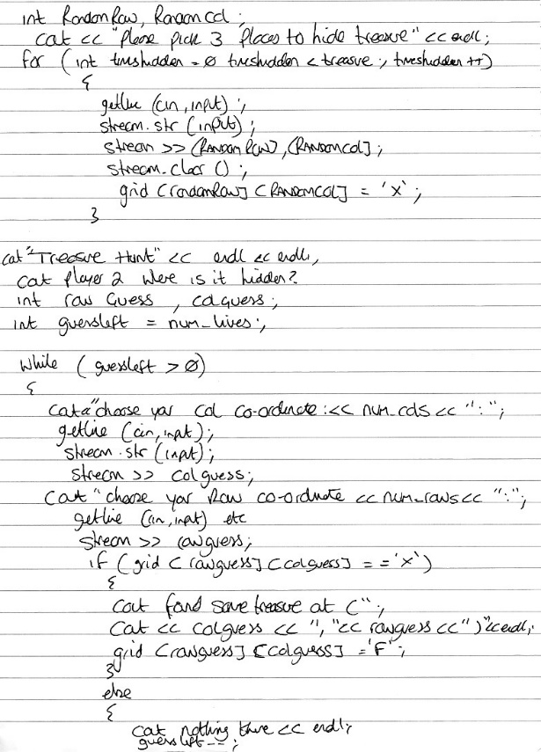
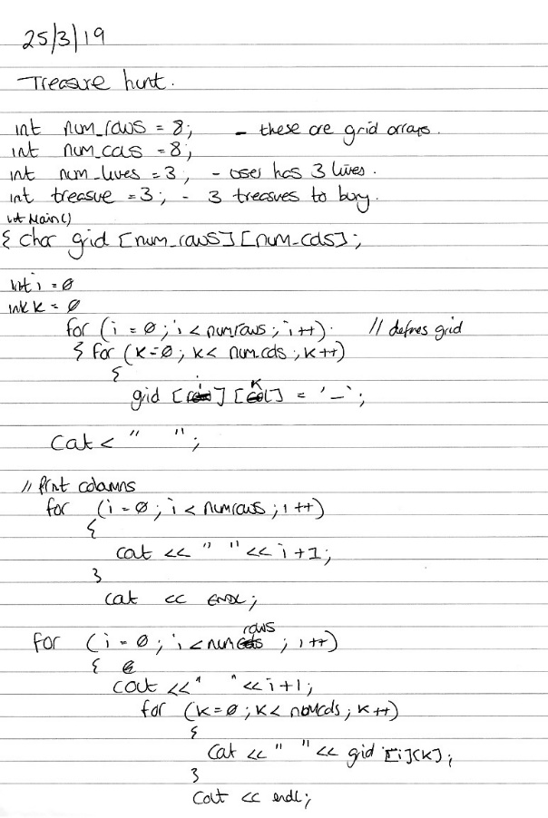

Page 1 Page 2
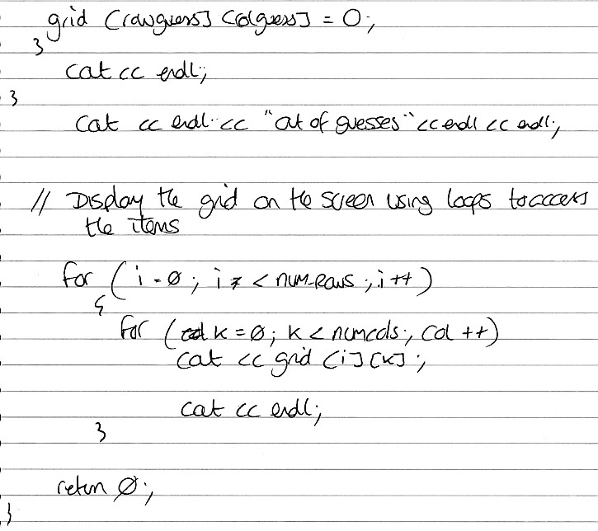

Page 3

(Fig 1.1) Three pages of problem solving for the Treasure Hunt game in hand written notes.
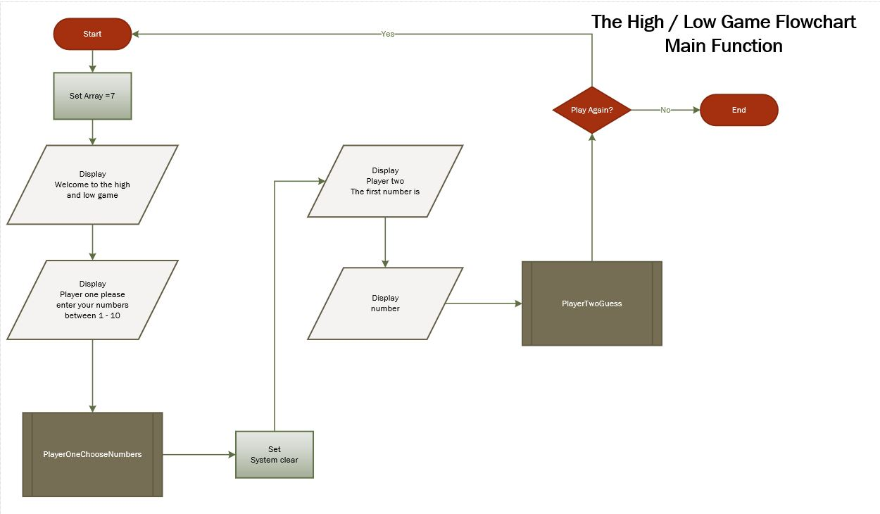

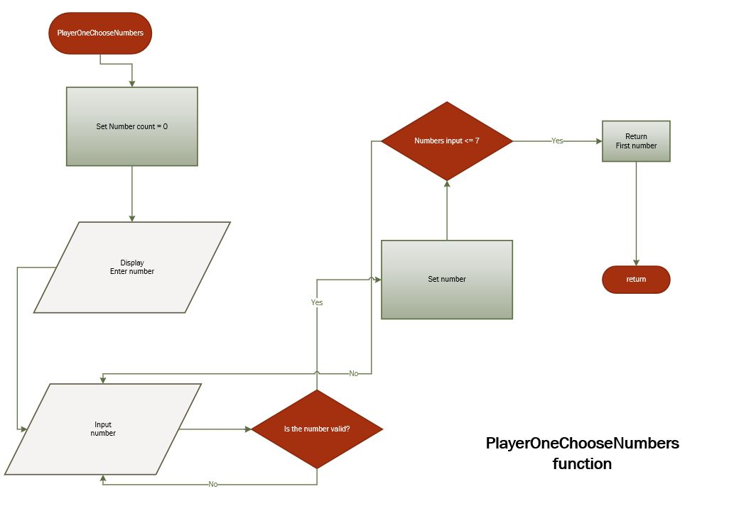
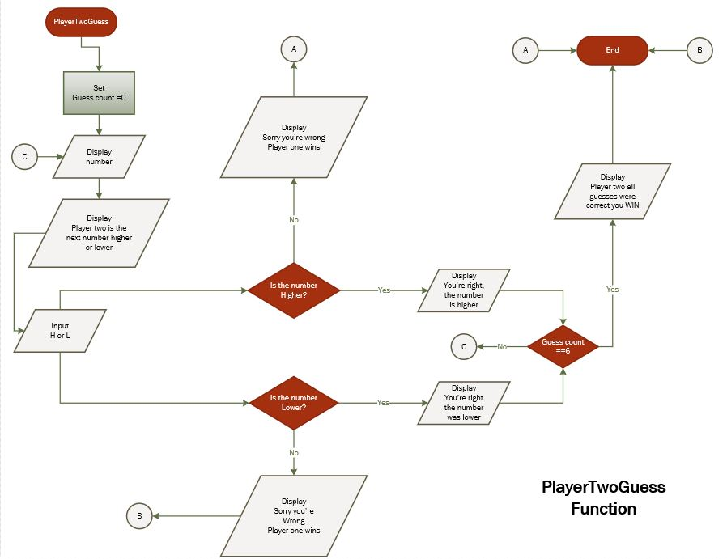

(Fig 1.2) Flowchart for High and Low Game split in to 3 functions - the main, player one and player two.

Stages of Development
Identifying the functions that are needed for the code to operate has to be the major influence when planning and developing the program. The use of arrays and loops take president in all the codes used for the games and can be used multiple times in a single code. User input code is also important as all the games are player v player.
As certain parts of the code need to be used over and over again, it is useful to include them in their own separate functions, which can be called upon when needed. It is bad practise to fill the main function with repeated code and separating the code into functions should be done whenever possible.

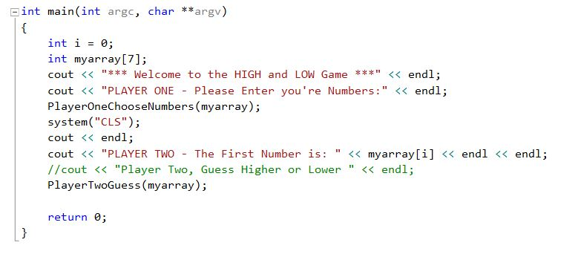
(Fig 1.3) The main function should include mostly separate functions

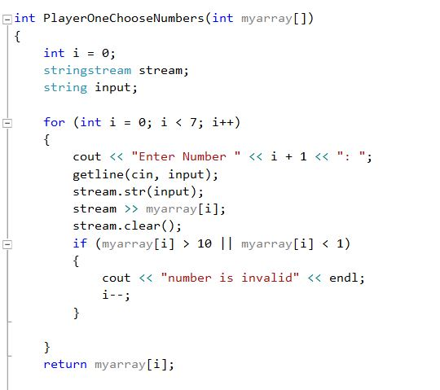
(Fig 1.4) Shows the use of For Loops and how they are commonly used in coding

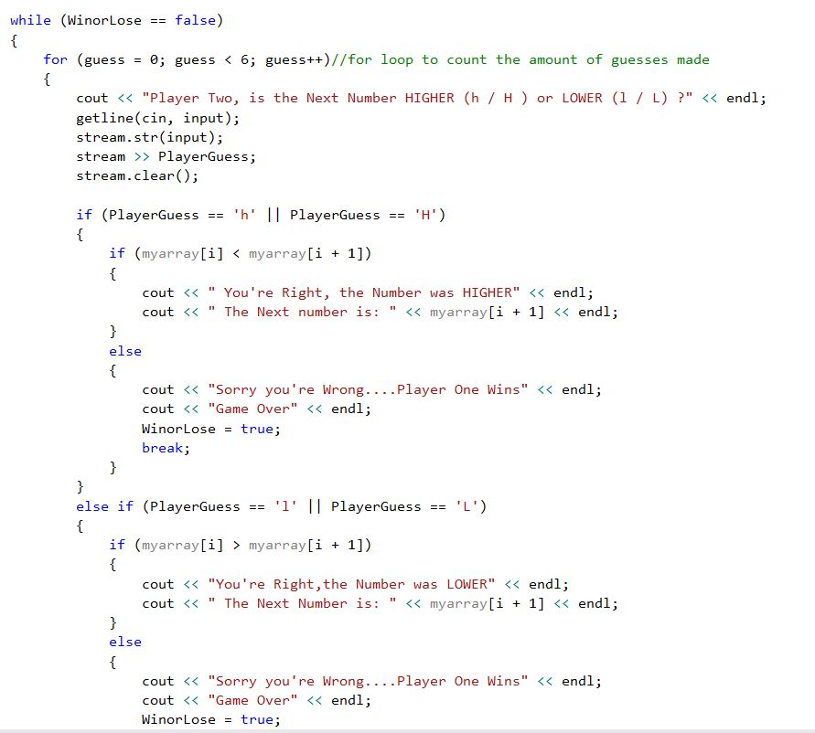
(Fig 1.5) The use of For loops that include nested If statements

Fig 1.3 – 1.5 were taken from the High /low Game, the full code as well as the full code for Treasure Hunt is included in the Appendix of this report.

Tests and Expected Results
For each game, a number of tests are carried out to ensure that the game is functioning like it should, and to kick up any part of the code that is problematic. Vigorous tests at each section of the program can indicate whether a slight alteration to (i.e.) a loop or variable name needs attention.
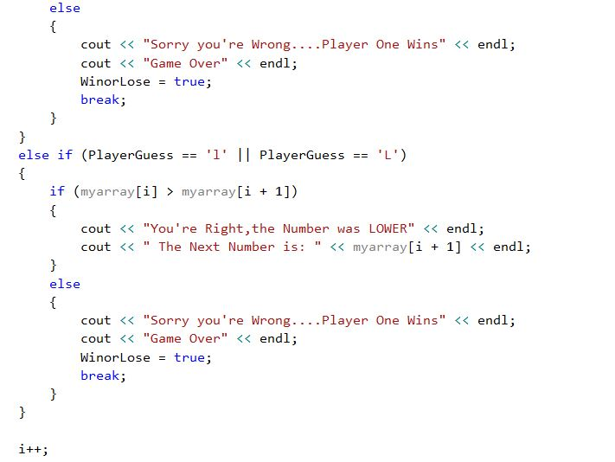

(Fig 1.6) These If statements carry out the function of whether player-two can win or lose. A test was carried out to see if this part of the code was working correctly.

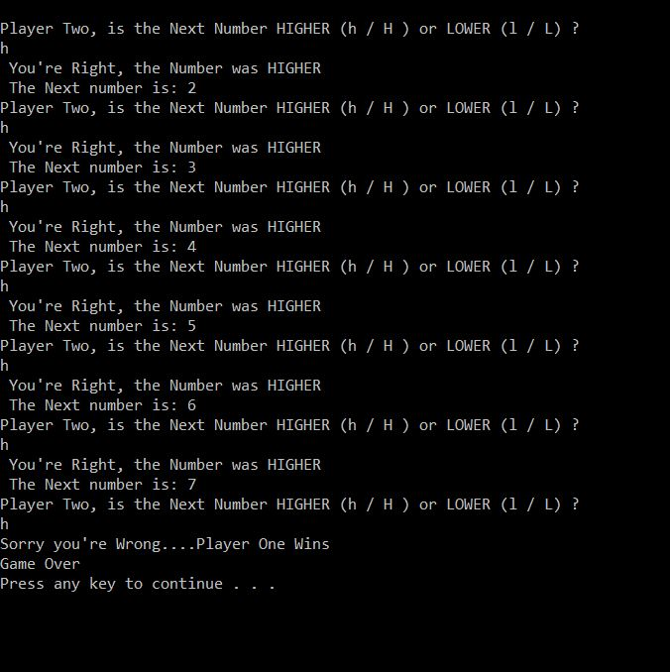
(Fig 1.7) The test above shows that player-two would always lose on their last go, and a fundamental part of the code was missing.

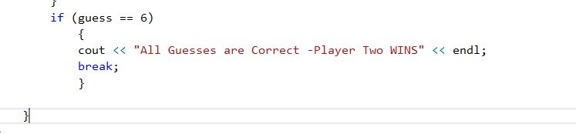
(Fig 1.8) Once this If statement was added, the program ran smoothly.
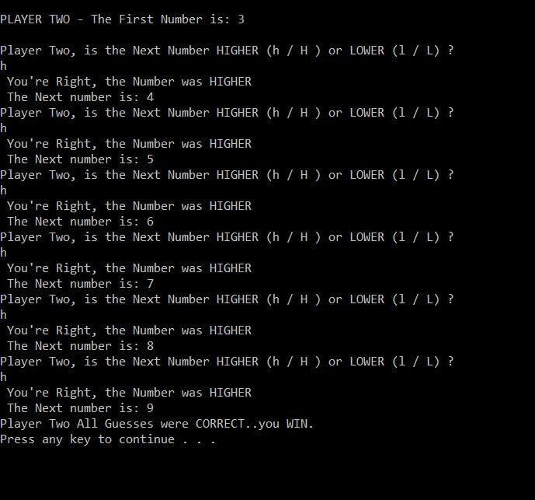
(fig 1.9) It is now possible for player-two to win.
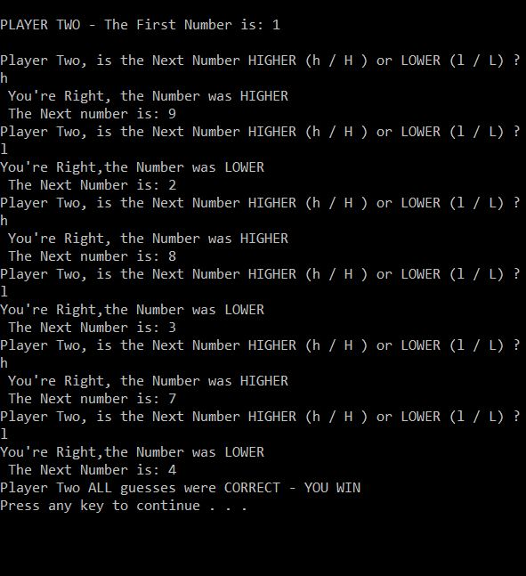
(Fig 2.0) identifying that the high and low selection is working
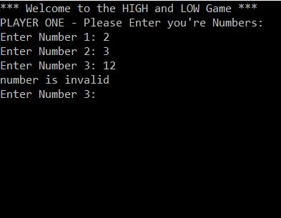
(Fig 2.1) As the number values are between 1-10, a test using a higher number is carried out. The code identifies the higher number and deems it invalid.
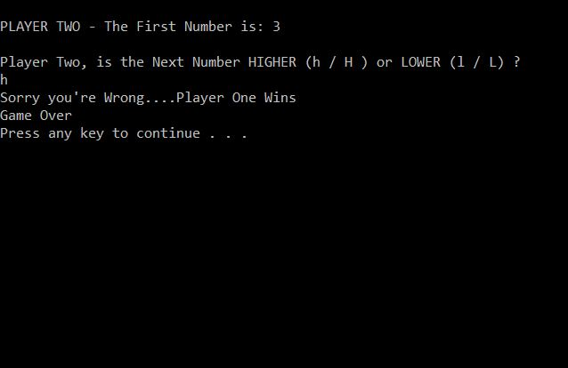
(Fig 2.2) The first number was 3 and the second number was 2. A test was performed to see if an incorrect answer would activate the If statement and it succeeded.
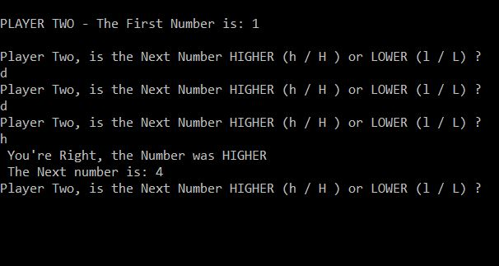
(Fig 2.3) The 4 main inputs for answering high and low are h/H/l/L , a different letter was used to see if that letter would be accepted as an answer. Once the letter used , the game keeps asking the same question until the right character is entered.

The similar tests were carried out for the Treasure Hunt game and can be found in the appendix section of this report.

Conclusion
Overall, the coding for exercise 1 and 2 has worked very well and implemented to a standard that’s currently at the authors level. Thorough checks have been made to identify any problems that may arise, but at this moment in time none are evident. A couple of minor tweaks to the code, which give the games a slight visual enhancement has been made.
It was hoped that all three games would be up and running, but Due to lack of time and fundamental knowledge, exercise 3 was unable to be completed.
Completing the exercises were surprisingly tough and many changes were made to loop structures and the use of logical conditions, but a heighten sense of understanding towards the use of functions and loops has increased the authors knowledge substantially.

Appendix

Appendix A - Treasure Hunt Tests and expected Results

Appendix B – Connect Four

Appendix C - High and Low Game Code

Appendix D - Treasure Hunt Code

Appendix A - Treasure Hunt Game

Tests and expected results
A number of significant tests were carried out on the Treasure hunt game, making sure each action by the user gets a reaction.
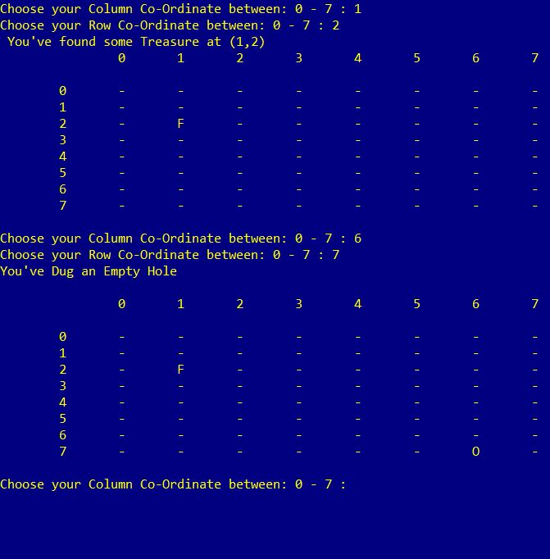
(Fig 2.4) for each turn player-two performs, an indication appears on the grid stating whether they have found some Treasure (F) or not (O).
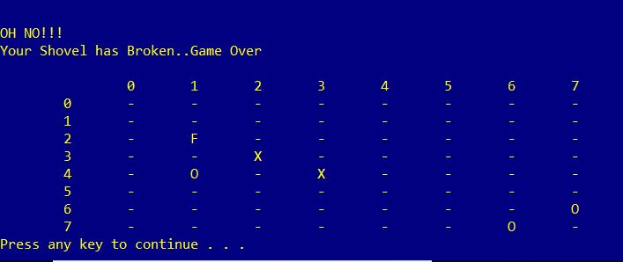
(Fig 2.5) Once the game is over and player-two has lost, the identity of where the treasure was hidden appears on the board (X).
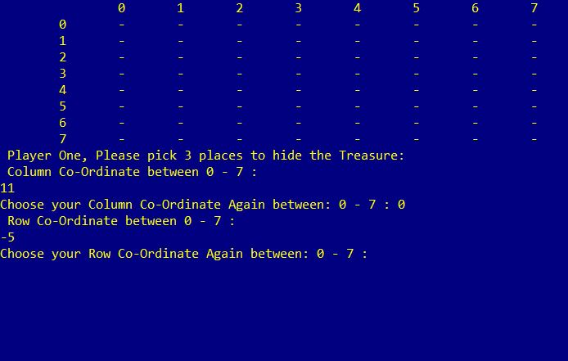
(Fig 2.6) A test to confirm that player-one could not select the wrong value, either above 7 or below zero.
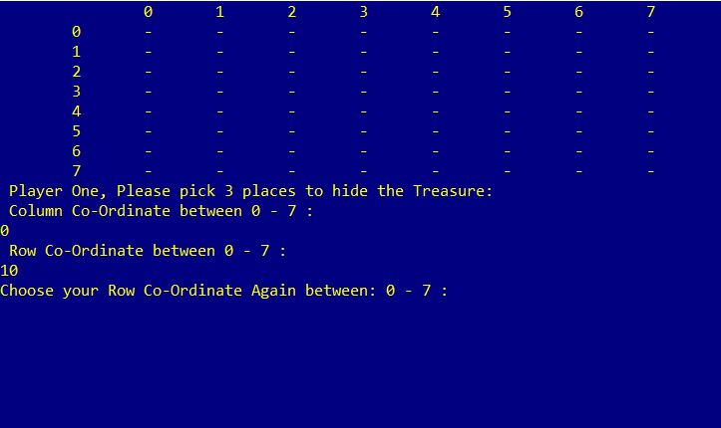
(Fig 2.7) The same test to the row co-ordinate was carried out making sure a value above 7 was identified as invalid and required player-one to re-enter the co-ordinate.

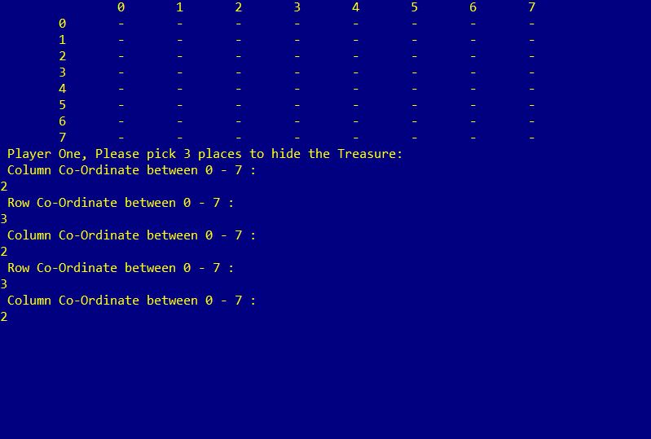
(Fig 2.8) One problem that arose was found accidentally. By using the same co-ordinates player-one could bury all the treasure in the same place on the grid, this had to be rectified by adding an extra Else condition (Fig 2.9) which would discover when the same co-ordinates have been entered and ask player-one to choose a different spot on the grid.

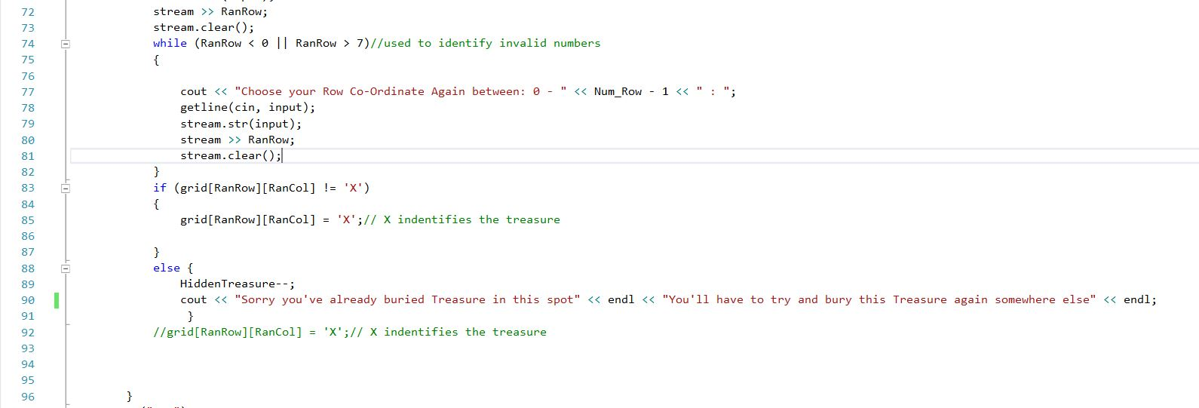
(Fig 2.9) The Else statement that blocked player-one from burying the treasure in the same place.

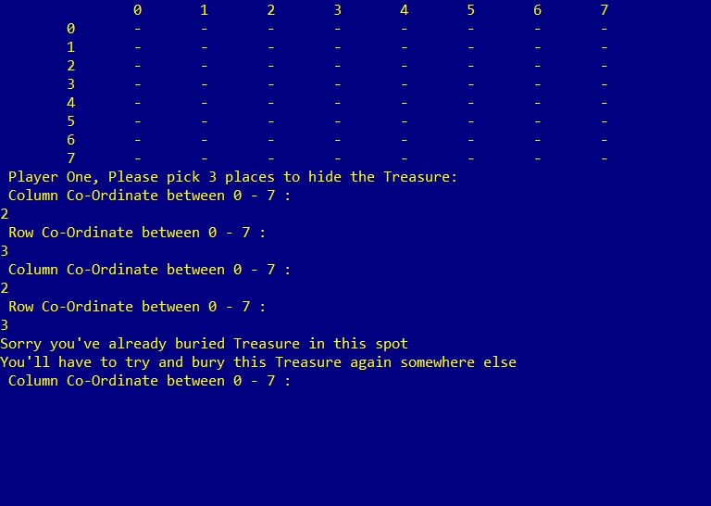
(Fig 3.0) A second test to burying the treasure shows that it is now not possible to use the same place on the grid.

Appendix B – Connect Four
A two-player head to head game, where each player in turn, drops a counter on to a column grid. The first person to get four counters, either horizontal, vertical or diagonal in a row will win.
Breaking down the code
- Make a 6 x 6 grid.
- Add numbers 0-5 for the columns.
- Creating a blitz move – which clears a column once activated by the B key.
- Creating a Time Bomb move – which adds a special counter and clears all surrounding counters horizontally, vertically and diagonally after the next player has two more moves.
- Setting user counters.
- Win by identifying four counters horizontally, vertically or diagonally.
- Player enters column choice.

By recognising the system in which the game is constructed, the above list can then by put into a coding order of difficulty, in this instance, 1 being the easiest to perform up to 6 being the most difficult.
1, 5, 7, 2, 3, 4, 6

Appendix C – High / Low Guessing Game Code
The following is the Visual Studio Enterprise 2015 code for the High/Low game [1]

#include <iostream>
#include <sstream>
#include <string>

using namespace std;

int PlayerOneChooseNumbers(int array[]);//player one function
void PlayerTwoGuess(int myarray[]);//player two function

int main(int argc, char **argv)
{
int i = 0;
int myarray[7];//an array for player one to input 7 numbers
cout << "*** Welcome to the HIGH and LOW Game ***" << endl;
cout << "PLAYER ONE - Please Enter you're Numbers between 1 -10:" << endl;
PlayerOneChooseNumbers(myarray);//calling the player one function
system("CLS");// wipes screen so player two can not see the numbers
cout << endl;
cout << "PLAYER TWO - The First Number is: " << myarray[i] << endl << endl;

PlayerTwoGuess(myarray);//calling the player two function

return 0;
}

int PlayerOneChooseNumbers(int myarray[])//function
{
int i = 0;
stringstream stream;
string input;

for (int i = 0; i < 7; i++)//for loop for player one to enter 7 values
{
cout << "Enter Number " << i + 1 << ": ";
getline(cin, input);
stream.str(input);
stream >> myarray[i];
stream.clear();
if (myarray[i] > 10 || myarray[i] < 1)//if statement - if the selected value is less than 0 or higher than 10 then its invalid
{
cout << "number is invalid" << endl;
i--;//makes sure that the user doesnt move to the next iteration and stays on the one that the invalid value was submitted
}

}
return myarray[i];//returns the first number for player two to see

//cout << myarray[0] << myarray[4] << endl; Testing to see if numbers are being stored in memory and able to call them back.
}

void PlayerTwoGuess(int myarray[])
{
stringstream stream;
string input;

int guess;//count for the guesses
int i = 0;
char PlayerGuess; //choice of high or low
int WinorLose = false;// for the while loop
char h, H, l, L;// these will be used for the PlayerGuess variable and will be used for high and low selection

while (WinorLose == false)//used as a flag to identify when the wrong selection is choosen
{
for (guess = 0; guess < 6; guess++)//for loop to count the amount of guesses made, as the ifrst number has been shown that leaves 6 numbers left
{
cout << "Player Two, is the Next Number HIGHER (h / H ) or LOWER (l / L) ?" << endl;
getline(cin, input);
stream.str(input);
stream >> PlayerGuess;
stream.clear();

if (PlayerGuess == 'h' || PlayerGuess == 'H')//high selection
{
if (myarray[i] < myarray[i + 1])
{
cout << " You're Right, the Number was HIGHER" << endl;
cout << " The Next number is: " << myarray[i + 1] << endl;
}
else
{
cout << "Sorry you're Wrong....Player One Wins" << endl;
cout << "Game Over" << endl;
WinorLose = true;
break;
}
}
else if (PlayerGuess == 'l' || PlayerGuess == 'L')//low selection
{
if (myarray[i] > myarray[i + 1])
{
cout << "You're Right,the Number was LOWER" << endl;
cout << " The Next Number is: " << myarray[i + 1] << endl;
}
else
{
cout << "Sorry you're Wrong....Player One Wins" << endl;
cout << "Game Over" << endl;
WinorLose = true;
break;
}
}

i++;
}
if (guess == 6)//when the number of guesses is equal to the number of values, player two has won
{
cout << "Player Two ALL guesses were CORRECT - YOU WIN" << endl;
break;
}

}
}

Appendix D - Treasure Hunt Code
Below is the Visual Studio Enterprise 2015 Treasure Hunt Game code [2]
#include <iostream>
#include <string>
#include <sstream>

using namespace std;
void printMap(char grid[8][8]);
const int Num_Row = 8;//8 rows
const int Num_Col = 8;//8 columns

int main(int argc,char**argv)
{
system("color 1e");//background colour blue, text white
int Treasure = 3;// 3 treasure chests to look for
int Lives = 3;// user starts with 3 lives
stringstream stream;
string input;
char grid[Num_Row][Num_Col];
int i = 0;
int k = 0;

//GRID SETUP
for (i = 0; i < Num_Row; i++)//creates the 8 x 8 grid
{
for (k = 0; k < Num_Col; k++)
{
grid[i][k] = '-';
cout << "";
}
}
cout << " ";
for (i = 0; i < 8; i++)//setting grid numbers
{
cout << " " << i;
}
cout << endl;
//ROW NUMBERS
for (i = 0; i < Num_Row; i++)//puts row numbers on the board
{
cout << " " << i;
for (k = 0; k < Num_Col; k++)//for the grid
{
cout << " " << grid[i][k];
}
cout << endl;
}

int RanRow=10;// users random choice to hide treasure
int RanCol=10;//users random choice to hide treasure
int HiddenTreasure;
cout << " Player One, Please pick 3 places to hide the Treasure: " << endl;

for (HiddenTreasure = 0; HiddenTreasure < Treasure; HiddenTreasure++)//hidden treasure is the counter/index and treasure =3
{
cout << " Column Co-Ordinate between 0 - "<<Num_Col-1<<" : " << endl;//display for numbers between 0 and 7
getline(cin, input);
stream.str(input);
stream >> RanCol;
stream.clear();
while (RanCol < 0 || RanCol > 7)//player one inputs invalid number,this to put the value in again
{

cout << "Choose your Column Co-Ordinate Again between: 0 - " << Num_Col - 1 << " : ";
getline(cin, input);
stream.str(input);
stream >> RanCol;
stream.clear();
}
cout << " Row Co-Ordinate between 0 - " <<Num_Row-1<<" : "<< endl;
getline(cin, input);
stream.str(input);
stream >> RanRow;
stream.clear();
while (RanRow < 0 || RanRow > 7)//used to identify invalid numbers
{

cout << "Choose your Row Co-Ordinate Again between: 0 - " << Num_Row - 1 << " : ";
getline(cin, input);
stream.str(input);
stream >> RanRow;
stream.clear();
}
if (grid[RanRow][RanCol] != 'X')
{
grid[RanRow][RanCol] = 'X';// X indentifies the treasure

}
else {//to stop player one burying the treasure in the same spot
HiddenTreasure--;
cout << "Sorry you've already buried Treasure in this spot" << endl<<"You'll have to try and bury this Treasure again somewhere else"<<endl;
}
//grid[RanRow][RanCol] = 'X';// X indentifies the treasure

}
system("CLS");// clears screen so player two cant see where the treasure has been hidden
cout << "Welcome Me-Hearty to the treasure Hunt." << endl << "Captain Blackbeard has Hidden 3 Chests of Treasure, and it's your quest to find Them! " << endl;
cout << "Pirate, where are the Chests hidden?" << endl;
int RowGuess;
int ColGuess;
int GuessesLeft = Lives;

while (GuessesLeft > 0)//while loop which identifies how many guesses/lives the user has/has left
{
cout << "Choose your Column Co-Ordinate between: 0 - " << Num_Col-1 << " : ";//user inputs column value3
getline(cin, input);
stream.str(input);
stream >> ColGuess;
stream.clear();
while (ColGuess < 0 || ColGuess > 7)//used to identify invalid column numbers
{

cout << "Choose your Column Co-Ordinate Again between: 0 - " << Num_Col - 1 << " : ";
getline(cin, input);
stream.str(input);
stream >> ColGuess;
stream.clear();
}
cout << "Choose your Row Co-Ordinate between: 0 - " << Num_Row-1 << " : ";
getline(cin, input);
stream.str(input);
stream >> RowGuess;
stream.clear();
while (RowGuess < 0 || RowGuess > 7)//used to identify invalid Row numbers
{

cout << "Choose your Row Co-Ordinate Again between: 0 - " << Num_Row - 1 << " : ";
getline(cin, input);
stream.str(input);
stream >> RowGuess;
stream.clear();
}
if (grid[RowGuess][ColGuess] == 'X')//if statment - user guesses where the treasure is
{
cout << " You've found some Treasure at (";
cout << ColGuess << "," << RowGuess << ")" << endl;
grid[RowGuess][ColGuess] = 'F';//puts an F for found where the treasure was identified
Treasure--;
cout << " ";
for (i = 0; i < 8; i++)//setting grid numbers
{
cout << " " << i;
}
cout << endl;

printMap(grid);

if (Treasure <= 0)//if all treasure has been found
{
cout << " You've FOUND all the Treasure, your one Rich little pirate.....Well done" << endl;
cout << endl;
for (i = 0; i < Num_Row; i++)
{
cout << " ";
for (i = 0; i < 8; i++)//setting grid numbers
{
cout << " " << i;
}
cout << endl;
printMap(grid);

}
return 0;
}

}
else//incorrect guess
{
cout << "You've Dug an Empty Hole" << endl;
GuessesLeft--;//reduces guess by 1, which in turn reduces lives by one.
grid[RowGuess][ColGuess] = 'O';// O identifies a miss
cout << endl;
for (i = 0; i < Num_Row; i++)
{
cout << " ";
for (i = 0; i < 8; i++)//setting grid numbers
{
cout << " " << i;
}
cout << endl;
printMap(grid);// recalls function

}
}
cout << endl;
}
cout << endl << "OH NO!!!"<<endl<< "Your Shovel has Broken..Game Over" << endl << endl;
cout << " ";
for (i = 0; i < 8; i++)//setting grid numbers
{
cout << " " << i;
}
cout << endl;
for (i = 0; i < Num_Row; i++)//shows where the treasure was at the end of the game, and the user misses
{
cout << " " << i;
for (k = 0; k < Num_Col; k++)
cout << " " << grid[i][k];
cout << endl;
}

return 0;
system("pause");

}

void printMap(char grid[8][8])//function showing the grid after each go player two has, and updates to whether they found the treasure or whether they missed.
{
int i, k;
cout << endl;
for (i = 0; i < Num_Row; i++)
{
cout << " " << i;
for (k = 0; k < Num_Col; k++)
{
if (grid[i][k] == 'X')// hides the X treasure from player two
{
cout << " -";
}
else
{
cout << " " << grid[i][k];
}
}
cout << endl;
}
}

References

References

[1] | M. Lee, C++ Programming for Absolute Beginners, 2nd ed., Course Technology, 2009.
[2] | blogspot.com, "Learn to Program using C++ on the raspberry Pi," 2 Nov 2017. [Online]. Available: https://program-using-gnu-cpp.blogspot.com/2017/11/program-treasure-hunt-game-using-2d.html. [Accessed march 2019].

