EFFECTIVE TEAM WORKING AND COMMUNCATION

ALINA PAVLOV-1921481

Executive Summary
This report looks into the aspect of effective communication and the different ways in which they can be used effectively. It indicates the models and the different methods and further it can be understood that the study looks into the prospect of various different verbal, non-verbal and listening channels.

Table of Contents
1. Introduction 3
2. Models of Communication 3
2.1 Shannon Weaver 3
2.2 Schramm 4
2.3 Berlo 5
3.2 Non Verbal 7
3.3 Listening 8
4. Conclusion 8

1. Introduction
Communication is an essential and effective process which helps in improving the overall efficiency of an organisation. It also helps border to generate a large level of capacity in case of the organization in which it is used. It also helps in order to ensure that effective results are achieved through personal communication processes. This report looks into the prospect of communication models which are essentially used in the world and organisations for ensuring communication. It further seeks to define verbal communication, non-verbal communication listening skills essential for communication.

2. Models of Communication

2.1 Shannon Weaver
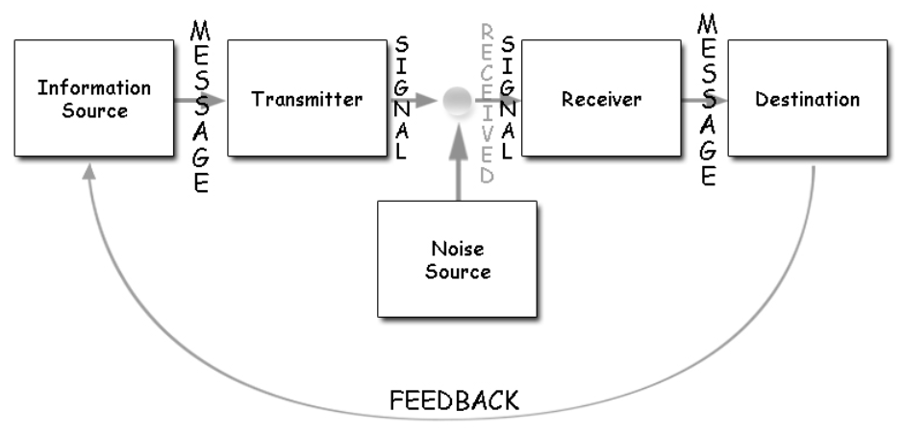
Figure 1: Shannon-Weaver Model of Communication
(Source: As influenced by Cañón Prieto et al. 2020)
The Shannon-Weaver model of communication is one of the major and foundational models of communication which have been created. Wang and Li (2017), indicates that the doel of Shannon Weaver incites that communication is a system which is made up of six separate and distinguishable elements in case of communication. These elements are that of the source, transmitter, receiver, destination, noise and feedback. A better understanding of this model involves understanding each element in a segregated and separate manner. Essentially it can be viewed that the first element of this model is the source of information. Cañón Prieto et al. (2020), has stated that the source of information in this model is the person who made the information or maybe a database. It is essentially the origin from where information needs to travel. The second binding lament in this model is the lament of the transmitter. The transmitter indicates the medium through which the message from the origin is related to another party.
Onobrakpor (2019), indicates that comprehension of the message which is being sent or the signal as described in the model is essential. Thus, the receiver needs a medium which can interpret this message. This interpreter which is interpreting the message is termed as the receiver in this model. In addition to this it can be annoying that the destination is the end terminal of the message. The destination is the location where the message is indeed to reach. Now, in between this the model considers the element of noise. Natalia et al. (2020), noise is defined as any hindrance which may occur in the process of transmitting a message. This is the first barrier which was effectively identified in terms of communication models. Another essential element identified in this model is the model of feedback. As inferred by Shaw (2019), indicates that feedback effectively helps to ensure that the message which is sent is comprehended by cross-checking whether or not the desired meaning has been recorded.

2.2 Schramm
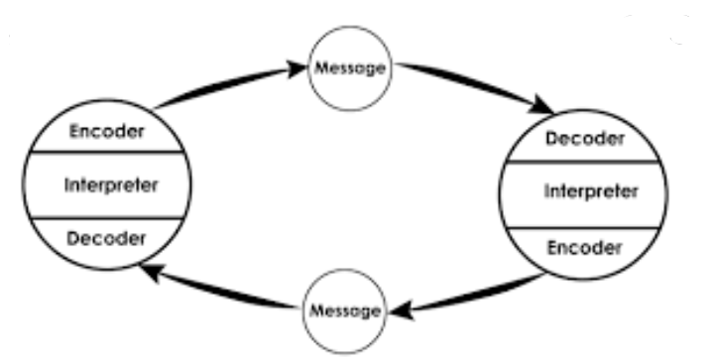
Figure 2: Schramm’s Model of Communication
(Source: As influenced by Li and Zhu, 2020)
Schramm has indicated a codependent price of communication which essentially and effectively can be undertaken to ensure a proper level of efficiency. Schramm indicates that the consideration of a message is the origin of the message essentially. Then further the message is sent and additionally, decoded by the receiver. Li and Zhu (2020), states that Schramm indicated that communication is lost without a proper system feedback which is undertaken through the entire process. This indicates that either party in a communication process has the job of interpretation, decoding and encoding effectively. This model takes into account the element of feedback very seriously and shows how good feedback can work. Additionally, it also views communications as a rather complex process which is generally undertaken. The Schramm model also indicates that people involved in communication are active in the process.
However, there are disadvantages that this model does not effectively consider. One of the major disadvantages of this model is that it fails to consider that not everyone is equal at the task of communication. Hastasari (2016), states that communication is an extremely essential process, however, it needs to be understood that different people communicate on different levels. This causes major disparity in the communication process which is resent It also creates a major level of disparity in the communication process. Another major issue which is present in this model of communication is that it is not apt for multi channeled communication. The model puts a large level of detailed thought into single one-on-one communication scenarios, but in cases of multi channel communication centros it can be understood that the level of appropriateness is low.

2.3 Berlo
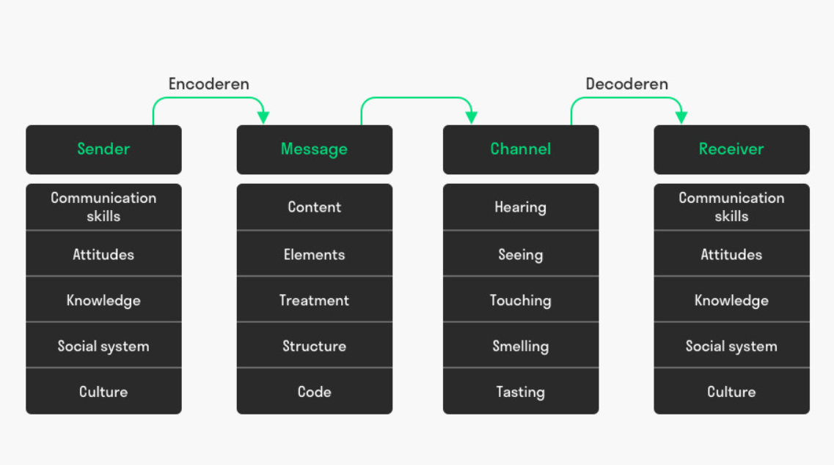
Figure 1: Berlo’s SMCR Model of Communication
(Source: As influenced by Petersons and Khalimzoda, 2016)
Berlo’s model of communication essentially indicates that there are effectively only four elements in a communication process. These are the sender, messenger, channel and receiver. It considers different elements which are braided under the case of all of these elements. Taylor (2017), indicates that the sender in the SMCR model needs to keep a track of the communication skills attitudes, knowledge, social system and culture. All of the elements describe the type of message which will go out. The message has the sub-elements of content, elements, treatment, structure and code effectively. These elements indicate a certain level of effectiveness which is brought to a message. The next element is that of the channel. Bero indicates that according to the study of Petersons and Khalimzoda, (2016), the channel has the sub-elements of hearing, seeing, touching, smelling and tasting. All these sub0elemets define different types of channels which can effectively and efficiently be used for ensuring a prosperous message delivery. In addition to this it can also be understood that the recipient needs to have the same sub-elements such as that of the sender. It can now further be analysed that the receiver and sender in their sub-elements may effectively differ and thus the need for feedback is highlighted here. Different perceptions yield different interpretations and this may lead to miscommunication Thus, feedback effectively helps in holding in place the process of the communication which has been undertaken.
3. Communication
3.1 Verbal Communication
In case of verbal communication it can be viewed that there are different types of communication methods which can be effectively and efficiently used. Jonsdottir and Fridriksdottir (2019), indicates that spoken or oral communication is one of the main methods of verbal communication. Oral communication is also of different types and may be informal or formal. An instance of a formal level of oral communication is the process of communicating in a seminar orally. Informal communication in oral forms indicates that there is an effective rate of communicability which can be gained from the prospect of grapevining. In terms of verbal communication. The advantages of verbal communication are that the feedback which is received from the process is immediate in nature. Petersons and Khalimzoda, (2016), states that immediate feedback ensures that a person can effectively generate a better understanding of the message which is being relayed. This helps in order to ensure a higher level of efficiency in the overall communication process.
Another type of communication is considered as written communication. Doyle (2017), states that written communication is an integral part of the different types of communication processes which are undertaken in an organisation. It also can be indicated that written communication is of different types such as formal and informal. Written communication is generally sent in the form of memos, notices and reports. Memos are for internal affairs of an organisation and notices are for changing policies and guidelines or special rules issues. However reports are for stakeholder communication. A business is required to communicate with its stakeholders and this helps in order to ensure a higher rate of efficiency in its processes.

3.2 Non Verbal
Non-verbal communication is considered to be an indispensable aspect of effective communication within the workplace. It involves communication through actions rather than being dependable on words. Doyle (2017) ascertained that non-verbal communication includes communication through body language. This comprises facial expressions, posture, tone as well as pitch of the speaker’s voice. It is essential for individuals to ensure that they develop appropriate non-verbal communication skills to convey their message appropriately. Doyle (2017) observed that non-verbal communication takes place with signals and signs as well. This indicates the significance of ensuring proper signs and signals are used while communicating within the workplace. Non-verbal communication within the workplace may be one of the strongest communication forms that take place between supervisors and their subordinates in meetings, interviews as well as informal conversations. One of the greatest issues associated with this form of communication is the scope for inaccurate conveyance of messages. Lack of articulate expression through written or spoken forms can lead to increased perceptual and interpretation differences further triggered by cultural variations. Bonaccio et al. (2016) asserted that nonverbal communication is essential within the workplace for ensuring that a better understanding of a scenario is gained. This is facilitated through gaining awareness of the message being communicated through one’s posture, voice and overall demeanour. Once an elaborate understanding of the same has been attained, managers are able to foster stronger workplace relationships leading to the creation of an effective work environment. This is because effective communication enables managers to successfully influence their subordinates towards the attainment of predetermined organisational goals. It is thereby crucial for employees within the workplace to be mindful of their non-verbal communication. This can enable them to create a productive work environment.

3.3 Listening
Development of active listening skills is an integral part of workplace communication. This is because listening enables employees and managers alike to gain a comprehensive understanding of the present situation. It leads to the establishment of a positive rapport between the management and employees thereby enhancing communication within the organisation. According to Kourmousi et al. (2018), listening skills can be categorised into active and empathetic listening. Empathetic listening skills enable an individual to listen to the other person as well as understand what they are going through by putting oneself in the shoes of another. It is essential for creating a comfortable work environment wherein the emotions of others are respected and lack wedges. On the other hand, Jonsdottir and Fridriksdottir (2019) noted that active listening includes paying attention to what is being communicated verbally without fidgeting with oneself. It is an integral professional skill that is required in all careers. Being an active listener enables an employee to develop trust and avoid missing out on critical information. It aids managers to build effective professional relationships and appropriately identify along with mitigating problems. Active listening influences the use of one’s body language to indicate undivided attention to the speaker in order to ascertain their conveyed messages and avoid misinterpretation. Bruhn and Remund (2018) observed that it is essential for managers to overcome barriers to active listening for ensuring that they do not miss out on essential information. Barriers may arise due to outside distractions, personal prejudices, information overload along with rate of speech and language of communication. By ensuring that possible barriers to effective communication are avoided, managers can ensure that they are able to proactively contribute to the raised discussion. It has thereby been established that application of effective active along with empathetic listening skills within an organization enables employees to understand each other in a better manner. This leads to reduction in employee conflicts and clarity of message being communicated.

4. Conclusion
In conclusion to this report it can be gauged that communication is a very integral part of a business communication process. Communication helps in ensuring that there is an effective rate of productivity in an organisation essentially. This also helps to ensure that information is passed from one level of an organisation to another. This helps in order to ensure that there is a higher level of safety and security which can be brought in with better communication processes. Additionally it can be viewed that the different models of communication define different ways in which communication is undertaken. These provide an insight into the reasons as to why feedback is so important. It can also be analysed that there is a need for ensuring that effective communication is undertaken in organizations.
Reference List
Bonaccio, S., O’Reilly, J., O’Sullivan, S.L. and Chiocchio, F., (2016). Nonverbal behavior and communication in the workplace: A review and an agenda for research. Journal of Management, 42(5), pp.1044-1074.
Bruhn, K.B. and Remund, D., (2018). Helping Public Relations Students Develop Active Listening Skills: A Pilot Study. Teaching Journalism & Mass Communication, 8(2), pp.21-24.
Cañón Prieto, C.D., Romero-Gelvez, J.I. and Herrera-Cuartas, J.A., (2020). Using social network analysis to improve enterprise communication.
Doyle, A., (2017). Communication Skills for workplace success. The Balance Careers, 12(1), pp. 89-90.
Hastasari, C., (2016), November. The Religious Pluralism Model of Communication in Interfidei Yogyakarta. In Proceeding of International Conference on Communication, Culture and Media Studies (CCCMS), 3(1), pp. 789-828.
Jonsdottir, I.J. and Fridriksdottir, K., (2019). Active listening: is it the forgotten dimension in managerial communication?. International Journal of Listening, pp.1-11.
Kourmousi, N., Kounenou, K., Yotsidi, V., Xythali, V., Merakou, K., Barbouni, A. and Koutras, V., (2018). Personal and job factors associated with teachers’ active listening and active empathic listening. Social Sciences, 7(7), pp. 110-117.
Li, Z. and Xu, J., (2020). Medicine together with humanities and media: An MHM model to move forward for health communication studies. International Journal of Nursing Sciences, 5(3), pp. 67-82.
Natalia, B., Ganna, O. and Olena, S., (2020). Communication Noise As A Discourse Component. Wisdom, 1(14), pp.98-117.
Onobrakpor, U.D., (2019). Information Transfer in Libraries and Information Centers: Role of Communication. Information Impact: Journal of Information and Knowledge Management, 10(2), pp.99-108.
Petersons, A. and Khalimzoda, I., (2016), May. Communication Models and Common Basis for Multicultural Communication in Latvia. In Proceedings of the International Scientific Conference. Volume IV, 432(1), pp. 400-433.
Shaw, P., (2019). Sadharanikaran Model vs Mathematical Model: Analyzing their Relevance in Context of Social Media. Bodhi: An Interdisciplinary Journal, 7(4), pp.105-126.
Taylor, C.R., (2017). How to avoid marketing disasters: Back to the basic communications model, but with some updates illustrating the importance of e-word-of-mouth research.
Wang, N. and Li, B., (2017). A Model of Deceitful Information Communication: Some Views on Theory and Practice of Semantic Information. In Multidisciplinary Digital Publishing Institute Proceedings, 1(3), pp. 120-127.

