

Importance of self awareness

Student Name: Mehwish Nawaz
Student Number: 2021045

Submission date:
4th of July 2025
Declaration
I confirm that I have not presented any AI generated materials as my own work. I confirm that I have copies of my drafts, notes, and other resources I used, which I may be asked to provide in evidence.

Executive summary
Emotion intelligence (EI) is a crucial competence for managers as it helps with better self-awareness and emotional management. This paves the way for better challenge navigation, improved decision-making and change adaptation. Despite the advantages for managers in modern organisations, they also face challenges in terms of being ignorant to criticism and feedback. Extreme empathetic and understanding nature also imposes difficulties in terms of substantial stress and burnout. In the report a discussion of critical analysis in relation to the importance of managers developing their self-awareness in modern organisations are discussed. This study also pinpoints the reflection based on the identified challenges and discuss a development plan at the end to highlight the areas that need improvement. The study has provided six-month plan for development that will help to overcome the intermittent challenges.

Table of Contents
Introduction 4
1. Critical Analysis of the Importance of Managers Developing their Self-Awareness in Modern Organisations 4
2. Critical Discussion of the Concepts Underpinning the Challenges 6
3. Reflection on the Challenges 7
4. Development Plan for the Next Six Months 9
Conclusion 10
References 11

Introduction
Emotional intelligence or EI is pivotal for accomplishing career and academic success, effective stress management, and establishing strong relationships (García-Martínez et al., 2021). It leverages hope for individuals to significantly account for understanding, using, and managing their emotions for fostering empathy and improving communication. The aspect of EI also contributes towards improved decision-making ability through better navigation of challenges, adaptation to changes, and achieving both professional and personal goals (Mrisho and Mseti, 2024, p.3). On this note, the following report component is aimed at evaluating the importance of emotional intelligence for developing self-awareness among managers. It is also directed towards assessing concepts associated with significant challenges, along with self-reflection on EI competence.

1. Critical Analysis of the Importance of Managers Developing their Self-Awareness in Modern Organisations
Self-awareness and EI are significantly essential for managers in modern organisations as it contribute towards effective leadership, improved decision-making, and better team dynamics. A preliminary reason that makes self-awareness crucial for managers is its contribution towards emotional intelligence or EI. Kaczmarska-Krawczak and Stroińska (2024, p.1) opined that self-motivation, self-awareness, and empathy are some of the crucial components that help managers to develop and shape their emotional intelligence. Self-motivation, self-awareness, and empathy abilities to manage and understand one’s emotions significantly assist with recognising and influencing the emotions of those being surrounded (Drigas et al., 2021, p.2). In this regard, self-awareness forms the core as it describes the ability of understanding strengths and weaknesses in addition to recognising the emotions and their significant impact (Landry, 2020). This becomes crucial for managers as a lack of self-awareness can cater to cutting the success of a team in half, owing to decreased motivation and increased stress.
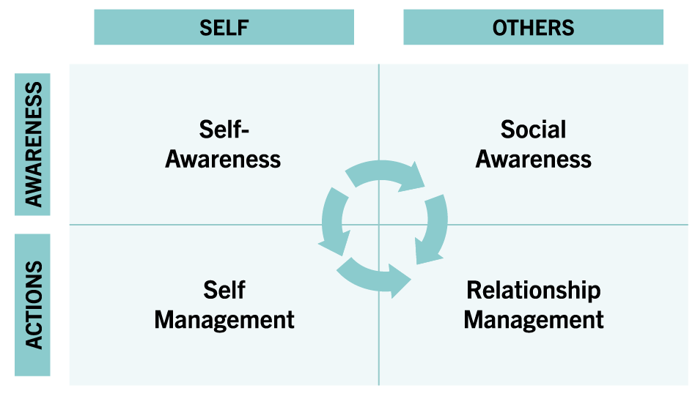
Figure 1: Core Components of Emotional Intelligence
(Source: Landry, 2020)
A comprehensive definition concerning emotional intelligence is determined as its ability to account for recognition, utilisation, and emotion for enabling individuals to comprehend emotional knowledge and experiences. According to Antonopoulou (2024, p.79), emotional intelligence is different from other cognitive capabilities in terms of its capacity towards comprehending and effectively regulating individual emotions for better navigation of others. Highly self-aware managers tend to be better equipped for regulating their emotions in addition to making balanced decisions and creating working environments that are psychologically safe (Singh and Singh, 2025, p,3). This appears to be substantially crucial for modern organisations undergoing continuous changes accompanied by globally diverse teams. However, it is also argued that being too intent on either external or internal self-awareness imposes challenges (Wallbridge, 2023, p.2).
As an example, internal self-awareness can make one extremely confident about oneself, thereby restricting them from accepting positive criticism. Furthermore, high EI and self-awareness also desire persistent self-reflection and the ability to accept feedback from others. Li and Reynolds (2023, p.993) pointed out that giving feedback is a challenge for feedback givers as well in managing their emotions, as feedback tends to be emotionally demanding. In evolving workplace environments, managers not only face challenges in terms of accepting criticism but also giving feedback to others (Miceli et al., 2021, p.3). This also directs the way for an additional difficulty, being maintaining honesty with oneself and having a transparent understanding of emotions (Choudhary, 2023, p.3). Thus, as part of modern organisations, it is substantially crucial for managers to cultivate their self-awareness for accelerating professional and personal growth and be better positioned as a leader.

2. Critical Discussion of the Concepts Underpinning the Challenges
An individual can witness a myriad of challenges in their academics and professional life due to not using their skills and not taking initiative for improving the areas of weaknesses. Additionally, building self-awareness can help an individual cope up with the identified challenges in a deliberate way (Kreibich et al., 2022, p.3). Many individuals are facing issues due to not acknowledging others' efforts that cause serious trouble to build up positive relations in an amicable way. Expressing gratitude to others for their commitment is a virtue that can help to enable a connection making and improve the relationship built- up (Kirca et al., 2023, p.65). Any successful professional needs to wake up and go to bed in a timely manner that brings productivity, more performance outcome and clarity. Getting sufficient sleep is important for healthy living and it also helps an individual to overcome issues of poor performance raising due to poor sleep patterns (Kaminsky et al., 2022, p.3).
Practicing solitude is an important virtue that helps an individual to analyse situations and boost performance by observing rather than spending time with chaos. According to the opinion of Thomas (2023, p.124), solitude is an important skill that helps an individual to cope up with loneliness by its vigorous practice to perform better. Improving solitude skills can help an individual to maintain personal well-being, keeping mental health balance and it also widens the door for professional development. Solitude skills can help an individual to improve resilience and workplace performance by remaining calm and understanding their own values (Nashwan et al., 2024, p.4). Additionally, an individual needs to comprehend the skills of pausing before making a reaction that helps the individual to cope up with the challenges in making impulsive decisions seemingly detrimental towards building a positive relation with others. Emotional control is an important quality that is measured by the endurance reflected by the quality of pausing before making any reaction for a situation (Biggs et al., 2024, p.4). An individual while working in any firm needs to be with the quality of emotional intelligence that helps them to tackle situations with deliberation (Coronado-Maldonado and Benítez-Márquez, 2023, p.1). Additionally, establishing a harmony with nature and surroundings are important as it helps to mitigate the issues related to distraction and improve clarity that most individuals face in recent times with leaving technology.

3. Reflection on the Challenges
In the study, I have taken the “Gibbs reflective cycle” to comprehend the challenges that I have witnessed during the course of my work.
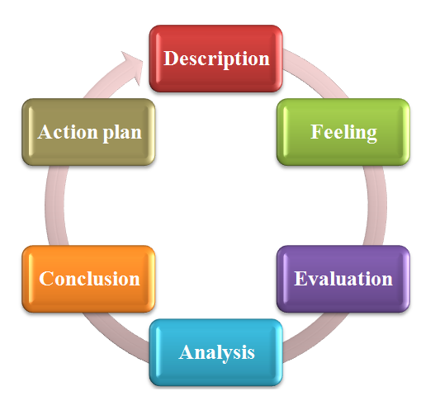
Figure 2: Gibbs reflective cycle
(Source: Self-created)
Description
In my academics, a major challenge that I have experienced is due to not expressing my gratitude to my team members at the group project in university. It acted as a barrier in keeping me distant from them in terms of building a close relationship with team members. According to the opinion of Kirca et al., (2023, p.65), it is crucial to build a positive relation with others by displaying gratitude to them for their deeds help for building a positive as well as amicable relationship. Gibbs reflection model outline the learning practices based on the personal experiences (Zhan et al., 2023, p.3). Being a learner, I have spent most of the time on technology for study as well as recreation purposes and it keeps me distant from nature. During my academics, I have mostly spent time studying at night and it kept me deprived from sufficient sleep. Sometimes, I spend unnecessary time on social media and it can cause my sleep cycle to be disrupted.
Feeling
Being a student, I spend most of the time on technology dependence and it can result in my minimal interaction with nature. Limited interaction with nature also led to the approach of improving mindfulness and acquiring mental clarity (Channawar, 2023, p.3). In my academics, I am not extroverted in nature and always feel that I am facing difficulty in expressing my gratitude to the others of my friends in my course of academic time. The lack of expressing gratitude causes barriers to build a good connection with closed ones which hinder the scope of relation build up (Kirca et al., 2023, p.65). I feel drowsy after waking in the morning as it makes me realize that my sleep is not adequate at night.
Evaluation
I have understood that I need to sleep at night at a certain time and it can help improve my concentration coupled with improving my mental clarity for academics by improving my focus. I understand the need to acknowledge others for their deeds as it helps me to establish a positive connection. Expressing gratitude helps individual to overcome the loneliness and provide the ability of developing collaborative practices (Hansen et al., 2021, p.3). I also need to take a positive vibe from nature by making time for my outdoor work and it will tremendously help me to improve my focus and performance build up during the course of my study.
Analysis
I have analysed that I need to work on giving credit to others especially my friends during my study to build an amicable relationship. I have also analysed that nature is our true companion and I need to spend time in nature to free me from mental exhaustion and frustration of daily mundane work.
Conclusion
I have realised that I need to curtail my time over unnecessary investing time for technology that will help me to improve my sleep pattern.
Action plan
I also think that I need to improve my communication skills and it can help me to acknowledge others by sharing my gratitude for their deeds without any hesitation. I need to wake up and go to sleep in a timely manner that will help me to overcome my drowsiness in the daytime and improve my focus on study. I have also pledged to spend 45 minutes with nature every day to overcome my monotony.

4. Development Plan for the Next Six Months
Development plan for Next 6 months
Skills that I lag behind | What do I want /need to learn | Time period
Acknowledging others for their deeds | Expressing gratitude for others deed by improving the communication skills | 3 to 4 months
Time management skills | Need to improve time management to improve performance and productivity gain with the help of participating in small projects | 4 to 5 months
Decision making skills | Improving my skills of decision making and understand where to pause without unnecessary reacting over trivial matter by participating in simulation games | 3 to 6 months
Communication skills | Attend seminars and group role play act | 4 to 5 months
Collaboration skills | Join internship projects | 3 to 4 months
Table 1: Development plan
(Source: Self-created)

Conclusion
In a nutshell, it can be concluded that an individual needs to work on communication skills by expressing gratitude to others seemingly helpful to build amicable relationships. Spending time in nature is also an important solution that can help to improve clarity and performance. Thus, making a development plan can help an individual to identify the areas of weakness and improve performance more strategically.

References
Antonopoulou, H., (2024). ‘The value of emotional intelligence: Self-awareness, self-regulation, motivation, and empathy as key components’. Technium Education and Humanities, 8, pp.78-92.A
Biggs, A.T., Seech, T.R., Johnston, S.L. and Russell, D.W., (2024). Psychological endurance: How grit, resilience, and related factors contribute to sustained effort despite adversity. The Journal of general psychology, 151(3), pp.271-313.
Channawar, S.N., (2023). Mindfulness practices for stress reduction and mental clarity. International Journal of Futuristic Innovation in Arts, Humanities and Management (IJFIAHM), 2(3), pp.49-59.
Choudhury, A. (2023). The Challenges of Emotional Intelligence: How to Overcome Them and Thrive. Available at: https://www.linkedin.com/pulse/challenges-emotional-intelligence-how-overcome-them-thrive-choudhary/ (Accessed: 25 May 2025)
Coronado-Maldonado, I. and Benítez-Márquez, M.D., (2023). ‘Emotional intelligence, leadership, and work teams: A hybrid literature review’. Heliyon, 9(10).
Drigas, A., Papoutsi, C. and Skianis, C., (2021). Metacognitive and metaemotional training strategies through the nine-layer pyramid model of emotional intelligence. International Journal of Recent Contributions from Engineering, Science & IT (iJES), 9(4), pp.58-76.
García-Martínez, I., Pérez-Navío, E., Pérez-Ferra, M. and Quijano-López, R., (2021). Relationship between emotional intelligence, educational achievement and academic stress of pre-service teachers. Behavioral Sciences, 11(7), p.95.
Hansen, P., Main, C. and Hartling, L., (2021). Dance intervention affects social connections and body appreciation among older adults in the long term despite COVID-19 social isolation: a mixed methods pilot study. Frontiers in psychology, 12, p.635938.
Kaczmarska-Krawczak, J. and Stroińska, E., (2024). ‘Emotional intelligence in managers’awareness and their practical activity–practical implications. Scientific Papers of Silesian University of Technology’. Organization & Management/Zeszyty Naukowe Politechniki Slaskiej. Seria Organizacji i Zarzadzanie, (199).
Kaminsky, L.A., German, C., Imboden, M., Ozemek, C., Peterman, J.E. and Brubaker, P.H., (2022). The importance of healthy lifestyle behaviors in the prevention of cardiovascular disease. Progress in cardiovascular diseases, 70, pp.8-15.
Kirca, A., M. Malouff, J. and Meynadier, J., (2023). ‘The effect of expressed gratitude interventions on psychological wellbeing: a meta-analysis of randomised controlled studies’. International Journal of Applied Positive Psychology, 8(1), pp.63-86.
Kreibich, A., Wolf, B.M., Bettschart, M., Ghassemi, M., Herrmann, M. and Brandstätter, V., (2022). How self-awareness is connected to less experience of action crises in personal goal pursuit. Motivation and Emotion, 46(6), pp.825-836.
Landry, L. (2020). Why Emotional Intelligence Is Important in Leadership. Harvard Business Review. Available at: https://online.hbs.edu/blog/post/emotional-intelligence-in-leadership (Accessed: 25 May 2025)
Li, M. and Reynolds, B.L., (2023). ‘Academic emotions in giving genre-based peer feedback: an emotional intelligence perspective’. Applied Linguistics Review, 14(4), pp.993-1026.
Miceli, A., Hagen, B., Riccardi, M.P., Sotti, F. and Settembre-Blundo, D., (2021). Thriving, not just surviving in changing times: How sustainability, agility and digitalization intertwine with organizational resilience. Sustainability, 13(4), p.2052.
Mrisho, D.H. and Mseti, S., (2024). Emotional intelligence: Concept, theoretical perspectives and its relevance on job performance. East African Journal of Interdisciplinary Studies, 7(1), pp.28-37.
Nashwan, A.J., Alsalamah, Y.S., Abu-Mahfouz, M.S., Palanivelu, P., Masoud, A., Baker, R.A. and Fradelos, E.C., (2024). Resilience in Solitude: A Review of Loneliness and Its Impact on Nurses’ Wellbeing. Perspectives in Psychiatric Care, 2024(1), p.5225026.
Singh, A. and Singh, S., (2025). Elevating Leadership Success: The Long-Term Benefits of Emotional Intelligence. International Journal of Interdisciplinary Approaches in Psychology, 3(1), pp.75-91.
Thomas, V., (2023). ‘Solitude skills and the private self’. Qualitative Psychology, 10(1), p.121.
Wallbridge, A. (2023). The Importance Of Self-Awareness In Emotional Intelligence. Available at: https://www.tsw.co.uk/blog/leadership-and-management/self-awareness-in-emotional-intelligence/ (Accessed: 25 May 2025)
Zhan, T.T., Wang, L.L., Wang, Y. and Sun, C.J., (2023). Master of nursing specialist experiences of an internship through the use of written reflections: A qualitative research study. Heliyon, 9(2).

