Obesity Case Study
By Maria Michael

Student No: 191 38 94
Module: Introduction to Physiology
Module Code: BMHP5003
Professor: Noura Mohamed

University of Wales, Trinity Saint David
uly 26, 2021
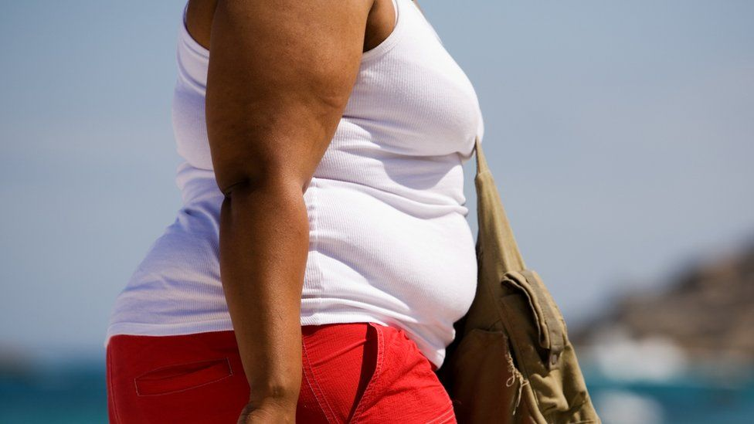
Maria Michael,
BSc Health and Social Care student
University of Wales, Trinity Saint David

---- Obesity: A Case Study ----
,

Introduction
Obesity refers to excessive or abnormal levels of fat in the body that creates risks to an individual’s health. An individual with a body mass index (BMI) that exceeds 30 is classified as obese (NHS, 2019). It causes various systemic difficulties, many of which may cause organ or tissue impairments (Mafort, et al., 2016). Sedentary lifestyle combined with poor eating habits and a lack of physical exercise are leading causes of obesity.
Purpose
This examines the results of an interview conducted Patient A to determine the extent to which her behaviours/ lifestyle is associated with her health outcomes, particularly as it relates to obesity. It covers the effects obesity can have on different organ systems, before recommending suitable health interventions for Patient A.

Physiological Impact
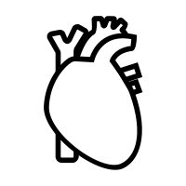 | 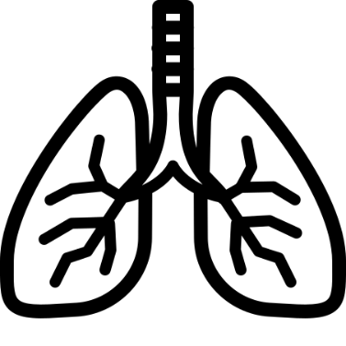 | 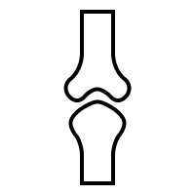 | 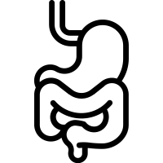
- Increased risk of cardiovascular diseases such as coronary heart disease, heart failure and stroke (Oesch, et al., 2017) (Carbone, et al., 2019). | - Reduced lung function (Peters, et al., 2019 )  - Higher BMI increases the risk of developing asthma (Mafort, et al., 2016). | - Increased fracture risk due to a decline in muscle mass and bone density  - Obesity is associated with increased frequency of osteoarthritis (Segula, 2014) | - Gastroesophageal reflux, where acids in the stomach leaks into the esophagus (Cafasso, 2020)

Patient Presentation
Health Profile |  |  | Lifestyle Risk Factors
- Age:45  - Sex: Female | - Height: 160 cm  - Weight: 80kg | - Blood Pressure: 140/90 | - Sedentary lifestyle; little to no physical exercise  - Diet consists primarily of fast food (burgers, chips, etc.) and sugary drinks
Discussion
Multiple studies have found that lack of physical exercise and a poor diet (particularly one that consists primarily of fast food) are major contributors to individuals’ weight, specifically whether or not they become obese (Xiao & Graf, 2019). Based on Patient A’s weight and height, her BMI is 31.2. This puts her in the obese category. This is expected as she mentioned the fact she eats mainly fast food, and does not exercise. Obesity is a major risk factor for high blood pressure, thus explaining why she is currently in Hypertension Stage 1 (Ridgmount Practice, 2021). High blood pressure is the largest risk factor for stroke. Also, the fact that she is a smoker who regularly drinks alcohol, and her father had suffered a stroke in the past significantly increases her risk of stroke (Stroke Association, 2021).
Interventions
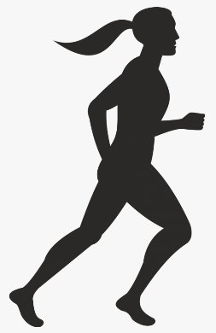
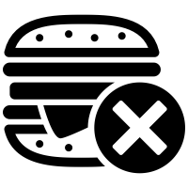
Obesity can negatively affect the functioning of a wide range of organs, and is therefore to be treated as a serious health issue. To tackle this problem, it is recommended that Patient A takes two separate but equally important courses of action: adjust her diet and start exercising.
The leading and most effective obesity treatment is dieting, supplemented by a structured physical exercise plan. As such, Patient A should reduce and eventually eliminate the amount of fast food and sugary drinks she consumes, while incorporating more vegetables and water. Such dieting based on calorie restriction where caloric intake is limited to between 800 and 1500 calories per day tend to work well. Fock & Khoo (2013) recommend that the amount of calories consumed be increased gradually after the desired weight changed is achieved so that there is a balance between calories expended and that consumed.
Additionally, regular physical exercise will heighten the efficiency and effectiveness of dieting, and tends to sustain the weight-loss achieved through dieting (Fock & Khoo, 2013).Patient A should therefore, make physical exercise part of her everyday life. This should, however be done after consulting with a physician so that she is able to set safe, specific, realistic and sustainable fitness and weight-loss goals.
Conclusion
Obesity is a prevalent problem in the United Kingdon that can have harmful effects on different organ systems; cardiovascular, pulmonary, skeletal, and digestive among others. For the most part, it is a lifestyle condition whose impact on our daily lives can be reduced or eliminated by implementing the necessary behavioural and lifestyle changes.

References
Cafasso, J., 2020. How Does Obesity Affect the Body?. [Online] Available at: https://www.healthline.com/health/obesity/how-obesity-affects-body [Accessed 18 July 2021].
Carbone, S. et al., 2019. Obesity paradox in cardiovascular disease: where do we stand?. Vascular Health and Risk Management, Volume 15, p. 89–100.
Fock, K. M. & Khoo, J., 2013. Diet and exercise in management of obesity and overweight. Journal of Gastroenterol Hepatol, pp. 59-63.
Mafort, T. T., Rufino, R., Costa, C. H. & Lopes, A. J., 2016. Obesity: systemic and pulmonary complications, biochemical abnormalities, and impairment of lung function. Multidisciplinary Respiratory Medicine volume, 11(28).
NHS, 2019. Diagnosis: Obesity. [Online] Available at: https://www.nhs.uk/conditions/obesity/diagnosis/ [Accessed 15 July 2021].
Oesch, L., Tatlisumak, T., Arnold, M. & Sarikaya, a. H., 2017. Obesity paradox in stroke – Myth or reality? A systematic review. PLOS ONE, 14 March.12(3).
Peters, U. et al., 2019 . BMI but not central obesity predisposes to airway closure during bronchoconstriction. Respirology, June, 24(6), pp. 543-550.
Ridgmount Practice, 2021. Blood Pressure Calculator. [Online] Available at: https://www.ridgmountpractice.nhs.uk/bp-calculator [Accessed 20 July 2021].
Segula, D., 2014. Complications of obesity in adults: A short review of the literature. Malawi medical journal : the journal of Medical Association of Malawi, 26(1), pp. 20-24.
Stroke Association, 2021. Are You at Risk of Stroke?. [Online] Available at: https://www.stroke.org.uk/what-is-stroke/are-you-at-risk-of-stroke [Accessed 19 July 2021].
Xiao, C. & Graf, S., 2019. Overweight, poor diet and physical activity: Analysis of trends and patterns. In: The Heavy Burden of Obesity : The Economics of Prevention. s.l.:s.n.

References

Baker, C., 2021. Obesity Statistics. [Online]
Available at: https://researchbriefings.files.parliament.uk/documents/SN03336/SN03336.pdf
[Accessed 16 July 2021].
Cafasso, J., 2020. How Does Obesity Affect the Body?. [Online]
Available at: https://www.healthline.com/health/obesity/how-obesity-affects-body
[Accessed 18 July 2021].
Carbone, S. et al., 2019. Obesity paradox in cardiovascular disease: where do we stand?. Vascular Health and Risk Management, Volume 15, p. 89–100..
Fock, K. M. & Khoo, J., 2013. Diet and exercise in management of obesity and overweight. Journal of Gastroenterol Hepatol, pp. 59-63.
Mafort, T. T., Rufino, R., Costa, C. H. & Lopes, A. J., 2016. Obesity: systemic and pulmonary complications, biochemical abnormalities, and impairment of lung function. Multidisciplinary Respiratory Medicine volume, 11(28).
NHS, 2019. Diagnosis: Obesity. [Online]
Available at: https://www.nhs.uk/conditions/obesity/diagnosis/
[Accessed 15 July 2021].
Oesch, L., Tatlisumak, T., Arnold, M. & Sarikaya, a. H., 2017. Obesity paradox in stroke – Myth or reality? A systematic review. PLOS ONE, 14 March.12(3).
Peters, U. et al., 2019 . BMI but not central obesity predisposes to airway closure during bronchoconstriction. Respirology, June, 24(6), pp. 543-550.
Ridgmount Practice, 2021. Blood Pressure Calculator. [Online]
Available at: https://www.ridgmountpractice.nhs.uk/bp-calculator
[Accessed 20 July 2021].
Segula, D., 2014. Complications of obesity in adults: A short review of the literature. Malawi medical journal : the journal of Medical Association of Malawi, 26(1), pp. 20-24.
Stroke Association, 2021. Are You at Risk of Stroke?. [Online]
Available at: https://www.stroke.org.uk/what-is-stroke/are-you-at-risk-of-stroke
[Accessed 19 July 2021].
Xiao, C. & Graf, S., 2019. Overweight, poor diet and physical activity: Analysis of trends and patterns. In: The Heavy Burden of Obesity : The Economics of Prevention. s.l.:s.n.

Speaker’s Notes
Introduction
- Approximately twenty-eight percent of English adults are obese, most of them being in the forty-five to seventy-four age range (Baker, 2021).
- Obesity can lean to the reduced function of a wide variety of organs and organ systems, chief among them being the cardiovascular, pulmonary, skeletal and digestive systems.
Purpose
- This examines the results of an interview conducted Patient A to determine the extent to which her behaviours/ lifestyle is associated with her health outcomes, particularly as it relates to obesity. It covers the effects obesity can have on different organ systems, before recommending suitable health interventions for Patient A.
Physiological Impact of Obesity
Cardiovascular
- The blood vessels in can become constricted or blocked as a result of the build up of fatty materials.
- Fat can build up around the heart, leading to heart failure (Mount Sinai, 2021).
Pulmonary
- The increased weight on the chest cavity reduces the strength of respiratory muscles (Mafort, et al., n.d.).

