ACCA5026 Database Application Development
Tutorial 5 Tasks

Continuation of Tutorial 3: Designing and Implementing a Medical Health Record Database for a Hospital (Focus on Constraints)

Objective:
- To design and implement a medical health record database for a hospital.
- To create the database and tables, insert sample data enforcing data integrity with constraints.
- Use INNER JOIN, LEFT JOIN, and RIGHT JOIN to retrieve meaningful data from the hospital's medical record system.

Materials:
- MySQL Workbench or any MySQL interface

Scenario:
You are tasked with developing a relational database for a hospital to manage patient medical records efficiently. The hospital needs to ensure data integrity by applying the appropriate constraints in the following cases:
- Patient details: (PatientID, Name, Age, Gender, Contact number)
- Doctor details: (DoctorID, Name, Specialization, Contact number)
- Appointments: (AppointmentID, PatientID, DoctorID, AppointmentDate, Time)
- Medical records: (RecordID, PatientID, Diagnosis, Treatment, Prescription)
- Billing information: (BillID, PatientID, TotalBill, PaymentStatus)

Task 1: Using MySQL, Complete Database Creation and Table Setup
Create the database and implement the tables with the necessary constraints.

CREATE TABLE Patient (
PatientID INT PRIMARY KEY AUTO_INCREMENT,
Name VARCHAR(50) NOT NULL,
Age INT,
Gender ENUM('Male', 'Female') NOT NULL,
ContactNumber VARCHAR(15) NOT NULL
);
CREATE TABLE Doctor (
DoctorID INT PRIMARY KEY AUTO_INCREMENT,
Name VARCHAR(50) NOT NULL,
Specialization VARCHAR(50) NOT NULL,
ContactNumber VARCHAR(15) NOT NULL
);

CREATE TABLE Appointment (
AppointmentID INT PRIMARY KEY AUTO_INCREMENT,
PatientID INT,
DoctorID INT,
AppointmentDate DATE NOT NULL,
Time TIME NOT NULL,
CONSTRAINT FK_Patient FOREIGN KEY (PatientID) REFERENCES Patient(PatientID),
CONSTRAINT FK_Doctor FOREIGN KEY (DoctorID) REFERENCES Doctor(DoctorID)
);

CREATE TABLE MedicalRecord (
RecordID INT PRIMARY KEY AUTO_INCREMENT,
PatientID INT,
Diagnosis TEXT,
Treatment TEXT,
Prescription TEXT,
CONSTRAINT FK_MedicalRecord_Patient FOREIGN KEY (PatientID) REFERENCES Patient(PatientID)
);

CREATE TABLE Billing (
BillID INT PRIMARY KEY AUTO_INCREMENT,
PatientID INT,
TotalBill DECIMAL(10,2) NOT NULL CHECK (TotalBill > 0),
PaymentStatus ENUM('Paid', 'Unpaid') NOT NULL,
CONSTRAINT FK_Billing_Patient FOREIGN KEY (PatientID) REFERENCES Patient(PatientID)
);

The DECIMAL(10,2) data type allows storing numbers with up to 10 digits, of which 2 can be after the decimal point, ensuring precision in monetary values.

Task 2: Insert Sample Datasets
Insert some sample records to test the tables.
INSERT INTO Patient (Name, Age, Gender, ContactNumber) VALUES
('John Doe', 45, 'Male', '1234567890'),
('Jane Smith', 30, 'Female', '0987654321'),
('Alice Brown', 52, 'Female', '1112223334');

INSERT INTO Doctor (Name, Specialization, ContactNumber) VALUES
('Dr. Sarah Lee', 'Cardiology', '5556667778'),
('Dr. Mark Johnson', 'Neurology', '4445556667');

INSERT INTO Appointment (PatientID, DoctorID, AppointmentDate, Time) VALUES
(1, 1, '2024-10-15', '09:30:00'),
(2, 2, '2024-10-16', '14:00:00');

INSERT INTO MedicalRecord (PatientID, Diagnosis, Treatment, Prescription) VALUES
(1, 'Hypertension', 'Medication', 'Lisinopril'),
(2, 'Migraine', 'Rest and medication', 'Ibuprofen');

INSERT INTO Billing (PatientID, TotalBill, PaymentStatus) VALUES
(1, 250.00, 'Paid'),
(2, 100.00, 'Unpaid');

Patient:
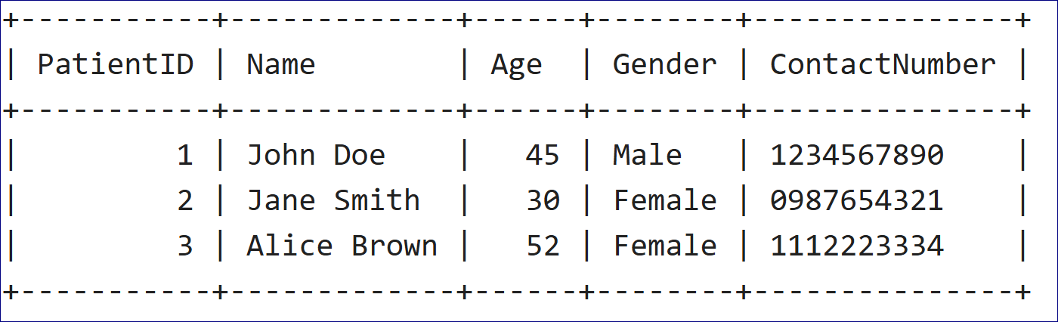Doctor:
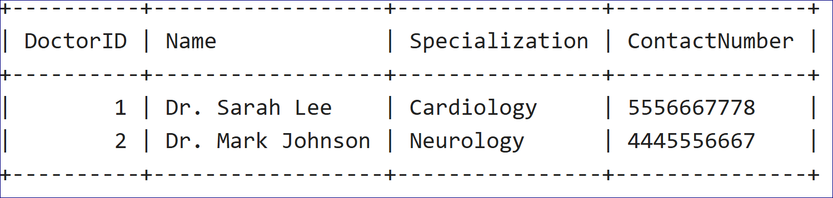

Appointment:
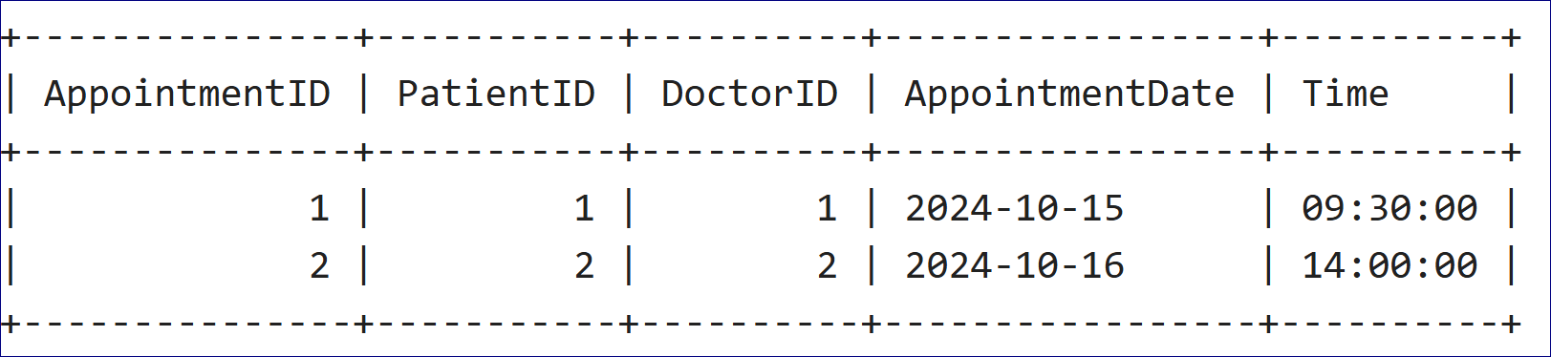

Medicalrecord:

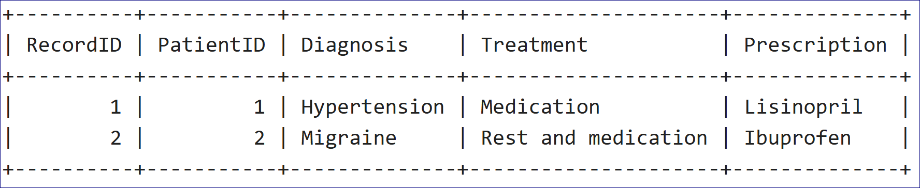

Billing:
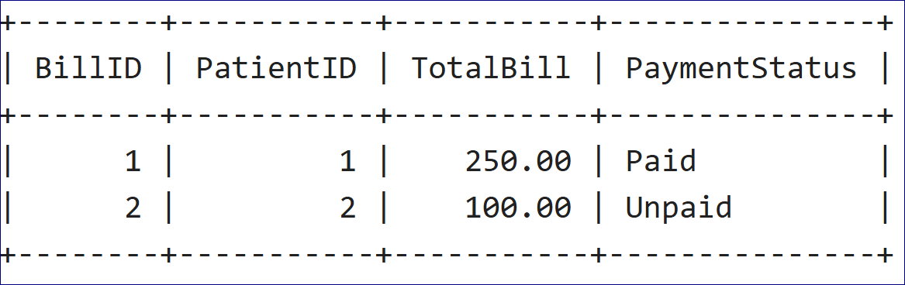

Task 3: Perform the following Queries
Perform the following operations to interact with the database:

3.1 Retrieve Unpaid Billing Records

Show a list of patients who have unpaid bills. Include the patient’s name, total bill amount, and payment status from the Billing table.

SELECT
Patient.Name AS PatientName,
Billing.TotalBill,
Billing.PaymentStatus
FROM Billing
JOIN Patient ON Billing.PatientID = Patient.PatientID
WHERE Billing.PaymentStatus = 'Unpaid';

3.2 Retrieve Patient Appointments with Doctor Details

Combine the Patient and Doctor tables through the Appointment table to show each patient's name, appointment date, and their doctor's name.
SELECT
Patient.Name AS PatientName,
Doctor.Name AS DoctorName,
Appointment.AppointmentDate,
Appointment.Time
FROM Appointment
JOIN Patient ON Appointment.PatientID = Patient.PatientID
JOIN Doctor ON Appointment.DoctorID = Doctor.DoctorID;
3.3 Find Medical Records for Each Patient

Retrieve the medical records of each patient, showing their name, diagnosis, treatment, and prescription from the MedicalRecord table.
SELECT
Patient.Name AS PatientName,
MedicalRecord.Diagnosis,
MedicalRecord.Treatment,
MedicalRecord.Prescription
FROM MedicalRecord
JOIN Patient ON MedicalRecord.PatientID = Patient.PatientID;

3.4 List of All Patients and Their Billing Information (LEFT JOIN)
Get a list of all patients and their corresponding billing information. If a patient does not have any billing record, still include them in the result.
SELECT
Patient.Name AS PatientName,
Billing.TotalBill,
Billing.PaymentStatus
FROM Patient
LEFT JOIN Billing ON Patient.PatientID = Billing.PatientID;

3.5 Doctors Without Appointments (RIGHT JOIN)
Retrieve a list of all doctors and include those who do not have any appointments.
SELECT
Doctor.Name AS DoctorName,
Appointment.AppointmentID
FROM Doctor
RIGHT JOIN Appointment ON Doctor.DoctorID = Appointment.DoctorID
WHERE Appointment.AppointmentID IS NULL;

3.6 Retrieve Total Billing for Each Patient
For each patient, retrieve their total billing amount from the Billing table.
SELECT
Patient.Name AS PatientName,
SUM(Billing.TotalBill) AS TotalBill
FROM Patient
JOIN Billing ON Patient.PatientID = Billing.PatientID
GROUP BY Patient.PatientID;

3.7 List of Patients and Their Doctors (INNER JOIN)
List all patients along with the doctor they are seeing.
SELECT
Patient.Name AS PatientName,
Doctor.Name AS DoctorName
FROM Appointment
JOIN Patient ON Appointment.PatientID = Patient.PatientID
JOIN Doctor ON Appointment.DoctorID = Doctor.DoctorID;

3.8 Retrieve Appointments within a Specific Date Range
Retrieve all appointments scheduled between October 1st, 2024, and October 31st, 2024.

SELECT
Patient.Name AS PatientName,
Appointment.AppointmentDate,
Appointment.Time
FROM Appointment
JOIN Patient ON Appointment.PatientID = Patient.PatientID
WHERE Appointment.AppointmentDate BETWEEN '2024-10-01' AND '2024-10-31';
3.9 Patients with Multiple Appointments (HAVING)
Retrieve patients who have had more than one appointment. Display their name and the number of appointments.
SELECT
Patient.Name AS PatientName,
COUNT(Appointment.AppointmentID) AS AppointmentCount
FROM Appointment
JOIN Patient ON Appointment.PatientID = Patient.PatientID
GROUP BY Appointment.PatientID
HAVING COUNT(Appointment.AppointmentID) > 1;

• Retrieve All Patients:
SELECT * FROM Patient;
• Retrieve Doctor Information Based on Specialization:
SELECT Name, ContactNumber
FROM Doctor
WHERE Specialization = 'Cardiology';
• Retrieve Patient Billing Information:
SELECT PatientID, TotalBill, PaymentStatus
FROM Billing;
• Retrieve Appointments Scheduled on a Specific Date:
SELECT AppointmentID, PatientID, AppointmentDate, Time
FROM Appointment
WHERE AppointmentDate = '2024-10-15';
• Count the Number of Patients:
SELECT COUNT(*) AS TotalPatients
FROM Patient;
• Retrieve All Patients Above a Certain Age:
SELECT Name
FROM Patient
WHERE Age > 40;
• Retrieve Patients with Unpaid Bills:
SELECT PatientID, TotalBill
FROM Billing
WHERE PaymentStatus = 'Unpaid';
• Find the Number of Appointments Each Doctor Has:
SELECT DoctorID, COUNT(AppointmentID) AS TotalAppointments
FROM Appointment
GROUP BY DoctorID;
• Retrieve Patients with Multiple Appointments:
SELECT PatientID, COUNT(AppointmentID) AS AppointmentCount
FROM Appointment
GROUP BY PatientID
HAVING COUNT(AppointmentID) > 1;
• Retrieve Medical Records for a Specific Patient:
SELECT Diagnosis, Treatment, Prescription
FROM MedicalRecord
WHERE PatientID = 1; -- Assuming PatientID is known
• Find Doctors Who Have No Appointments:
SELECT DoctorID
FROM Doctor
WHERE DoctorID NOT IN (SELECT DoctorID FROM Appointment);
• Retrieve Appointments Grouped by Date:
SELECT AppointmentDate, COUNT(AppointmentID) AS TotalAppointments
FROM Appointment
GROUP BY AppointmentDate;
• Retrieve Patients and Their Last Appointment:
SELECT PatientID, MAX(AppointmentDate) AS LastAppointment
FROM Appointment
GROUP BY PatientID;
• Retrieve Billing Information Grouped by Payment Status:
SELECT PaymentStatus, COUNT(BillID) AS TotalBills
FROM Billing
GROUP BY PaymentStatus;
• Retrieve All Patients and Their Assigned Doctors:
SELECT PatientID, DoctorID
FROM Appointment;
• Retrieve Appointments Within a Date Range:
SELECT AppointmentID, PatientID, AppointmentDate, Time
FROM Appointment
WHERE AppointmentDate BETWEEN '2024-10-01' AND '2024-10-31';
• Find Total Billing for Each Patient:
SELECT PatientID, SUM(TotalBill) AS TotalAmount
FROM Billing
GROUP BY PatientID;
• Retrieve All Medical Records Grouped by Diagnosis:
SELECT Diagnosis, COUNT(RecordID) AS TotalRecords
FROM MedicalRecord
GROUP BY Diagnosis;
• Retrieve Patients Who Have Been Prescribed a Specific Medication:
SELECT PatientID
FROM MedicalRecord
WHERE Prescription LIKE '%Lisinopril%';
• Retrieve Patients and Total Appointments Sorted by Appointment Count:
SELECT PatientID, COUNT(AppointmentID) AS TotalAppointments
FROM Appointment
GROUP BY PatientID
ORDER BY TotalAppointments DESC;

