Name: Rubina Akbur
Student Number: 2118370
Module Code: BMHP4003_BIRM
Module Name: Psychology for Health and Social care
Assignment Title: Written Assignment (Case Study)
Lecturer Name: Alice Clayton

Content Page

Introduction …......................................................... Page 3
Social Identity Theory …......................................... Page 3
Theory of Planned behaviour………………………. Page 4
Frustrated Aggression Hypothesis………………… Page 7
Conclusion…………………………………………… Page 8
Reference Page …………………………………….. Page 9

Introduction

The case study of Gareth will be discussed in this report. The potential causes of his actions, as well as which psychological theories can aid in understanding his behaviour and its impact on him. It will also attempt to identify what type of support can be put in place for Gareth for him to achieve positive behaviour and overcome his barriers. To accomplish this, the social identity theory, theory of planned behaviour and frustration aggression hypothesis will be employed.

Social Identity Theory (SIT)

The premise of Social Identity Theory (SIT; Tajfel, 1978; Tajfel and Turner, 1979) is that people take appropriate steps to ensure their own individuality in relation to social groups and that such identifications work to defend and reinforce self-identity. A societal identity, according to social identity theory, is a person's awareness that he or she belongs to a particular ideological category or group. A social group is a number of individuals who have a similar social identity or perceive themselves as belonging to the same social sector. People who are like themselves, are categorised with the self and labelled the in-group; persons who distinguish from the self are classified, the out-group. Gareth's in-group consists of his so-called friends, to whom he feels he belongs because of how they make him feel when he steals cars and abuses illegal drugs, he possesses by selling them to substance users. His out-group is the YOT because they want to support him and find ways to get him away from his in-group, which does him no favours but instead gets him into a significant amount of trouble. According to Stets and Burke (2000), a social group is a group of people who share a common social identity and see themselves as belonging to the same subculture.

Social identity theory includes the important concepts of identity and categorisation and these are standard processes in the human world that are genuine for participants. With collective understanding, identifications emerging in the context of 'external' inter-group relations. This also serves as a reminder that discrepancies between the specific, interactional, and institutional orders are merely heuristic: here we are, under the banner of "the institution," stowing the opinion back into idealist social psychology. (See image 1)

Image 1
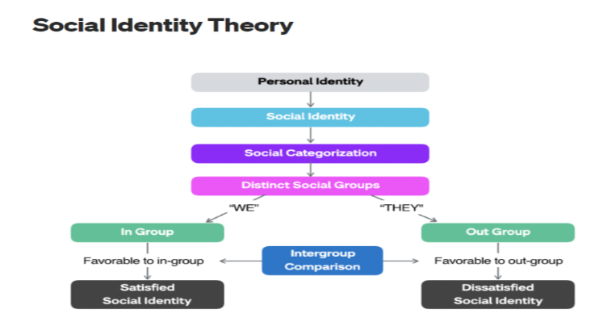
(The Framework Bank 2017)

People categorise components to comprehend and recognise them. We categorise people (along with ourselves) in a comparable way to better understand our cultural world. Because they are useful, we use social categorisation such as black, white, Asian, Catholics, Hindus, Instructors, and tour guides. Gareth and his friends (in-group) are involved in illegal activities that they all enjoy and choose to be around each other for this reason. As for social identification we accept identification of the group to which we have designated oneself. Finally, Gareth in comparison may categorise oneself as a member of his in-group and identity with that group. We typically compare the cohort to other clusters. To main our identity, group must accomplish well in comparison towards other groups. According to Mckeown et al. (2016), intergroup dispute is better described as a form of behaviour driven by basic human intentions and cognitive abilities influenced by people's views about oneself, community, the situational relations, and the instantaneous situations they find individuals and their groups in.

Theory of planned behaviour

The immediate determinant of intentional human behaviour, according to the theory of planned behaviour, is a person’s intention is attitude, subject norm and perceived behavioural, control. In theory Gareth's behaviour is determined from intention if two requirements are met. First and foremost, both behavioural intention and behaviour must be evaluated with the same degree of accuracy in terms of the behaviour's target, action, period, and context of the behaviour that is a concern. (See Image 2)

Image 2
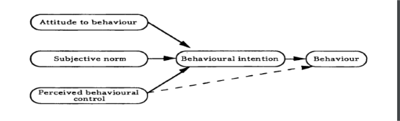
Manstead, et al (1995)

The negative aspects of Gareth’s attitude to behaviour are that at this moment in time Gareth does not care about the repercussions. Then you have the subjective norms which are the normative beliefs and compliance motivations can be used to calculate a belief-based measure of subjective norm. Gareth’s friends encourage him to achieve outcomes that are more beneficial to them and are taking advantage of his vulnerability. Erikson's stage 5 of development, according to Psych-Mental Health Hub (2022), occurs between the ages of 12 and 20 years old, and includes identity vs. role confusion and adolescence. Someone like Gareth will be looking for a sense of belonging, significance, and identification at this stage.

In Gareth's case, he must be able to confront his negative behaviour and be aware of the consequences if he continues to act in this manner. So that he can progress and demonstrate that he can stand up to his friends and be a better person.
I have devised this table to help understand how Gareth’s behaviour is affecting his prospects.
Attitude
- Negative attitudes towards college.
- Positive attitudes towards having fun with his friends.

Perceived Behavioural Control
- internal factors, will Gareth be able to move away from his in group.
- External factors are drug support groups, NHS

Behaviour
His behaviour is causing him to make the wrong decisions that are impacting his life and future.

Subjective Norm
Bad reputation, unable to manage relationships.

Behavioural Intention
Is Gareth determined enough to change and do better for himself. Needs to admit that his bad habits are not looking positive for his future.

The findings support the hypothesis that anger acts as a moderator in the link between systemic risk and intentional negative word of mouth, as well as between crisis responsibility and purchase intent (Emerald Insight, 2022).

The YOT team can assist by looking at the image so that they can implement the appropriate level of support and not focus too much on what he is doing work. I have put together this table to show positive impact that could lead to Gareth’s positive behaviour

It has been said by Emerald insight (2022) because of the strong correlation between the two variables; crisis managers can utilize the cues for assessing crisis responsibility to establish anger. Crisis managers should use phrases and actions to lower anger and the probability of an ineffective communication dynamic.
Frustration Aggression Hypothesis
This theory was originated by Dollard et al. (1939) and they believe that the aggression theory is an outcome of blocking, or frustration, a person’s efforts to generate goals. It was also theorised that frustration always creates aggression. Dollard et al stated (1939) stated that frustration aggression looks into gaining antagonistic (emotional) aggression. Gareth chooses to be aggressive and his actions are negative which has an impact on his mental health and emotions. However, his frustration may be coming from being confused, having a lot of people dictate which leads him to not understand where to turn. His behaviour may come displaced as he maybe turning to the motoring offenses or even the possession of drugs with the intention to supply or is Gareth taking the drugs to release his frustration and forget about what he is experiencing? Gareth needs to release his emotions and does not understand how to as he does not have the skill to socialise, so he feels frustrated with his friends but then lead to catharsis as he may release his anger on the YOT and this is where his displacement comes in. From the case study it shows that on a routine probation visit, Gareth was confronted by the whole force which led him to behave irrationally. O’Sheil (2021) mentions that although it is now clear that many of our emotions automatically engage and interact with the world and its people, the philosophy of thoughts and feelings has cultivated in the last few decades.
The YOT needs to think about a final objective so that Gareth changes his negative energy into positivity so that he learns to engage better with others around him and learns to make the right decision for the present and the future. They need to first start with finding ways in encouraging Gareth to recognise the impact his behaviour is having on him, ways in which they can do this is by working alongside his family and referring him to support agencies like Substance Misuse Service (SMS) where they support in confidentiality, do not judge, they are very professional and they also try to limit the harm caused by drugs. Betsi Cadwaladr University Health Board (No date). The YOT can familiarise themselves with the United Nations Convention on the Rights of the Child (UNCRC) where Families First Programme Guidance (2017) explains that you can guide them and support them with how the Welsh Government is committed to make sure all the young children fulfil their potential no matter what their background or circumstances. The policy also looks at families; first assists in improving the outcomes for the children, young people and their families.
Conclusion
In conclusion, Gareth needs positive rewards and attention as he feels like he is receiving a lot from his in-group, which provides him with a motivational boost and a sense of belonging. Gareth will work on his behaviour and attitude towards others at college and in the community which he lives in. Finally and most importantly, Gareth must first establish positive relationships with his parents in order for them to spend more time together and get to know the real Gareth. Steemit (no date) discussed that humanistic psychology concentrates on human nature that is endowed with the ability to explore their own path to freedom, reach maximum potential, and develop for the satisfaction of a greater purpose.

References

Berkowitz, L. (1989) ‘Frustration-Aggression Hypothesis: Examination and Reformulation’, Psychological bulletin, 106(1), pp. 59–73. Available at: https://doi.org/10.1037/0033-2909.106.1.59.

Betsi Cadwaladr University Health Board (No date) Substance Misuse Service Available at: https://bcuhb.nhs.wales/services/hospital-services/substance-misuse-service/ (Accessed: 16 November 2022)

CAIS, (No Date) CAIS empowered change Available at:
https://www.cais.co.uk/directory/ccbc-social-services-children-and-families-drug-and-alcohol-rapid-response-team/ (Accessed 15 November 2022).

Emerald Insight (2022) The negative communication dynamic: Exploring the impact of Stakeholder effect on behavioural intention Available at:
https://www.emerald.com/insight/content/doi/10.1108/13632540710843913/full/html (Accessed: 18 November 2022).

Families First (2017) Families First Programmed Guidance Available at: https://gov.wales/sites/default/files/publications/2019-07/families-first-guidance-for-local-authorities_0.pdf (Accessed: 16 November 2022)

McKeown, S., Haji, R. and Ferguson, N. (2016) Understanding Peace and Conflict Through Social Identity Theory Contemporary Global Perspectives. 1st ed. 2016. Edited by S. McKeown, R. Haji, and N. Ferguson. Cham: Springer International Publishing. Available at: https://doi.org/10.1007/978-3-319-29869-6.

Manstead, A.S. and Parker, D., 1995. Evaluating and extending the theory of planned behaviour. European review of social psychology, 6(1), pp.69-95.

O’Shiel, D. (2021) ‘Safety Valves of the Psyche: Reading Freud on Aggression, Morality, and Internal Emotions’, Philosophies (Basel), 6(4), p. 86–. Available at: https://doi.org/10.3390/philosophies6040086/ (Accessed 12 November 2022).

Psych-Mental Health Hub (2022) Erikson’s Stages Available at: https://pmhealthnp.com/eriksons-stages/ (Accessed: 12 November 2022).

Stets, J.E. and Burke, P.J.(2000) Identity theory and social identity theory. Social psychology quarterly, pp.224-237 (Accessed: 31 October 2022).

Steemit (No Date) Humanism and Existentialism: Part 3-Humanistic Psychologists-Carl Rogers Availiable at:https://steemit.com/philosophy/@charlie777pt/humanism-and-existentialism-part-3-humanistic-psychologists-carl-rogers (Accessed: 19 November 2022).
The Framework Bank, (2017) Social Identity Theory Availiable at:
https://jenbonhomme.medium.com/social-identity-theory-5307b0d57413
(Accessed: 19 November 2022)

